M I T O C H O N D R I A L M I M I C R Y O F M S A - C

1. Jankovic J, Schwartz K. Response and immunoresistance to botuli- num toxin injections. Neurology 1995;45:1743–1746.
2. Hallett M, Benecke R, Blitzer A, Comella CL. Toxicon. 2009. 54(5):628–633.
3. Jankovic J. Botulinum toxin therapy for cervical dystonia. Neuro- tox Res 2006;9:145–148.

Mitochondrial Mimicry of Multiple System Atrophy of the Cerebellar Subtype

Arpan R. Mehta, B.A., B.M., B.Ch.,1

Susan H. Fox, M.R.C.P., Ph.D.,1

Mark Tarnopolsky, M.D., Ph.D., F.R.C.P.,2

and Grace Yoon, M.D., F.R.C.P., F.C.C.M.G.3*

*1Movement Disorder Clinic, Toronto Western Hospital, University of Toronto, Toronto, Canada; 2Division of Neuromuscular and Neurometabolic Disease, McMaster University Medical Center, Hamilton, Canada; 3Divisions of Clinical/Metabolic Genetics and Neurology, The Hospital for Sick Children, University of Toronto, Toronto, Canada*

patients with diverse clinical presentations that include parkinsonism and cerebellar ataxia.2

Here, for the ﬁrst time, we describe a patient who presented with clinical and radiological ﬁndings sugges- tive of multiple system atrophy (MSA) of the cerebellar subtype (MSA-C), but was shown to have mutations of *POLG1*. This case highlights the importance of consid- ering primary mitochondrial disorders in the differential diagnosis of parkinsonian syndromes.3,4

# Case Report

Written informed consent was obtained from the patient to publish both video and brain imaging results for this case report. This 58-year-old woman had a pro- gressive cerebellar syndrome. Her symptoms had started

9 years prior, with imbalance when getting out of a canoe or when walking up and down stairs. She also noted poor handwriting and mild incoordination of the hands. Her speech had become slurred. Her symptoms worsened toward the end of the day or when she was fatigued. In addition, the symptoms partially improved after excluding dietary gluten and she had lost 18 kg over the previous year. She had mild urinary inconti- nence when coughing. She has type II diabetes mellitus, treated with Pioglitazone. There is no history of epi- lepsy, cognitive problems, visual problems, stroke-like episodes, hearing problems, or menstrual disturbances. Her family history revealed that she had a sister who died at 2 years of age. This child, who was blind, was never able to roll, sit, or walk independently, and she also had intractable seizures. No diagnosis was ever established. The proband’s brother has sensorineural hearing loss, glaucoma, and adult-onset diabetes melli- tus requiring treatment with insulin.



ABSTRACT

Background: We describe a patient with clinical and ra- diological ﬁndings suggestive of multiple system atro- phy of the cerebellar subtype (MSA-C). Methods/ Results: Sequencing of the polymerase-c 1 (*POLG1*) gene revealed the patient had compound heterozygous mutations of the *POLG1* gene. Muscle biopsy revealed the presence of multiple mitochondrial DNA deletions and depletion, conﬁrming the pathogenic nature of the *POLG1* mutations. Discussion: This case expands the spectrum of phenotypes associated with *POLG1* muta- tions to include multiple system atrophy and prompts further consideration regarding whether routine screen- ing for *POLG1* mutations is indicated in this patient population. VC 2011 Movement Disorder Society

Key Words: mitochondrial disease; multiple system atrophy; polymerase gamma gene; parkinsonism; ataxia

On initial examination, 4 years after the onset of her symptoms, she had slight slowing of vertical saccades but a full range of eye movements and normal fundi. She had dysarthria, mild limb dysmetria that was worse on the left, mild slowing of foot taps bilaterally, and a mildly impaired tandem gait; tone and reﬂexes were normal with ﬂexor plantar responses (see Sup- porting Information video). Investigations for coeliac

Mitochondrial disorders can result from either pri- mary defects in the mitochondrial DNA (mtDNA) or defects in nuclear encoded proteins that affect mtDNA structure or function. The maintenance of mtDNA rep- lication is critically dependent upon mtDNA polymer- ase-c,1 encoded by the nuclear genes *POLG1* and *POLG2*. Mutations in *POLG1* have been described in

------------------------------------------------------------

Additional Supporting Information may be found in the online version of this article.

*Correspondence to: Dr. Grace Yoon, Divisions of Clinical/Metabolic Genetics and Neurology, The Hospital for Sick Children, University of Toronto, 555 University Avenue, Toronto, Ontario M5G 1X8, Canada; [grace.yoon@utoronto.ca.](mailto:grace.yoon@utoronto.ca)

Relevant conﬂicts of interest/ﬁnancial disclosures: Nothing to report. Full ﬁnancial disclosures and author roles may be found in the online version of this article.

Received: 23 July 2010; Revised: 22 September 2010; Accepted: 11

October 2010

Published online 21 January 2011 in Wiley Online Library (wileyonlinelibrary.com). DOI: 10.1002/mds.23510

Movement Disorders, Vol. 26, No. 4, 2011 753

M E H T A E T A L .

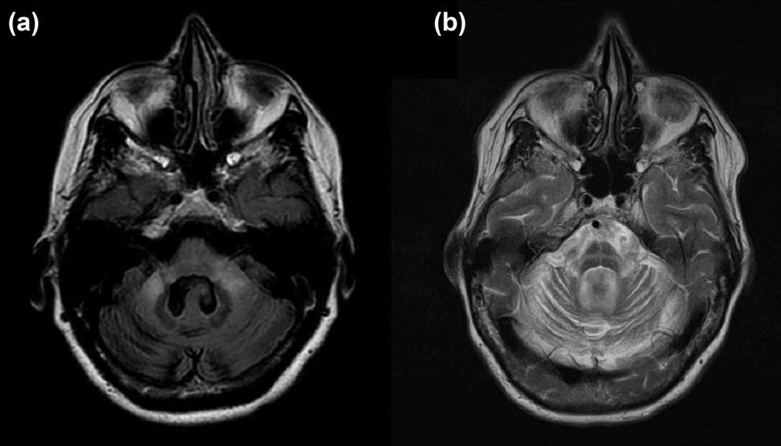

FIG. 1. a: MRI FLAIR brain scan showing an enlarged fourth ventricle because of pontine and cerebellar atrophy, in association with hyperintensities in the middle cerebellar peduncles bilaterally. b: MRI T2-weighted brain scan demonstrating the ‘‘hot-cross bun’’ sign, classically associated with MSA.

disease, including a small bowel biopsy, were negative. Sensory testing was normal and nerve conduction stud- ies were normal. In view of the signiﬁcant weight loss, investigations for a paraneoplastic process were per- formed and the anti-Purkinje cell antibody was nega- tive. Computed tomography of thorax and mammogram were normal. Her Vitamin B12 and E levels were normal. Metabolic studies, including plasma amino acids, urine organic acids, carnitine pro- ﬁle, lactate, ammonia, and leukocyte hexosaminidase A activity, were all normal. Spinocerebellar ataxia (SCA) types 1, 2, 3, 6, and 7 testing were negative. She was found to have an intermediate-range expansion of the CTG repeat of the SCA type 8 (*SCA-8*) gene, with al- lele sizes of 75 and 26 CTG repeats, which were not felt to be clinically signiﬁcant. Her magnetic resonance imaging (MRI) brain scan showed pontine and cerebel- lar atrophy with some T2 hyperintensities in the mid- dle cerebellar peduncles (Fig.1).

~

Her symptoms continued to progress and 7 years af- ter symptom onset her dysarthria and cerebellar ataxia had signiﬁcantly worsened. Despite using a walker, she fell and sustained a right hip fracture. She developed postural dizziness owing to orthostatic hypotension. Moreover, her urinary urgency worsened and she developed nocturia. She had drooling of saliva and intermittent dysphagia for liquids. Examination revealed a supine blood pressure of 110/60 and 90/40 mm Hg after standing for 3 minutes, with no corre- sponding change in pulse rate. She had polyminimyo- clonus of her outstretched hands, a positive glabellar tap and brisk deep tendon reﬂexes with ﬂexor plantar responses. She was unable to walk unaided and required a wheelchair. On recent examination (9 years after onset), she had jerky saccades, marked dysarthria,

limb dysmetria, rigidity in the legs worse than in the arms, brisk reﬂexes, and mild bilateral bradykinesia in association with dystonic posturing of the left hand (see Supporting Information video).

Prompted by reviewing the family history, in particu- lar the sister’s clinical history that was suggestive of Alpers’ syndrome, the patient was evaluated for muta- tions of the mitochondrial polymerase-c 1 (*POLG1*) gene using automated DNA sequencing, and was found to carry the mutations c.2554C>T (p.R852C) and c.32G>A (p.G11D). There was no associated derange- ment of her liver function tests. Long-range polymerase chain reaction (PCR) analysis of a biopsy of the right vastus lateralis muscle revealed evidence of multiple mtDNA deletions, and real-time PCR analysis of the ND1/beta-globulin DNA ratio showed mtDNA deple- tion, conﬁrming the pathological signiﬁcance of the *POLG1* mutations. As both the proband’s parents are deceased, parental genetic studies are not possible.

# Discussion

We describe a patient with adult-onset, progressive cerebellar ataxia, autonomic dysfunction, mild bradyki- nesia, and dystonia. The ataxia initially appeared to respond to gluten exclusion from her diet, although the absence of antigliadin antibodies meant that her ataxia was unlikely to be because of gluten sensitivity.5 She had an expanded CTG repeat of the SCA-8 gene, although this is of doubtful clinical signiﬁcance, as her largest allele falls within a range that is thought not to be clinically signiﬁcant.6 The constellation of symp- toms and signs, in conjunction with the MRI brain scan, are most suggestive of MSA-C.7 However, the signiﬁcant family history, presence of *POLG1*

15318257, 2011, 4, Downloaded from https://movementdisorders.onlinelibrary.wiley.com/doi/10.1002/mds.23510 by The University Of Manchester, Wiley Online Library on [22/05/2025]. See the Terms and Conditions (https://onlinelibrary.wiley.com/terms-and-conditions) on Wiley Online Library for rules of use; OA articles are governed by the applicable Creative Commons License

754 Movement Disorders, Vol. 26, No. 4, 2011

M I T O C H O N D R I A L M I M I C R Y O F M S A - C

mutations, and deletion/depletion of mtDNA in muscle suggest a mitochondrial disorder as the predominant cause of her symptoms.

To date, an association between an MSA-C pheno- type and *POLG1* mutations has not been described. *POLG1* mutations have been described previously in association with infantile fatal encephalopathy and hepatopathy (Alpers’ syndrome),8,9 sensory ataxic neu- ropathy with ophthalmoparesis,10,11 severe axonal neuropathy,12 as well as adult-onset ataxia without progressive external ophthalmoparesis (PEO) or mus- cle involvement.13 Ataxia has been reported secondary to either dorsal column sensory loss13 or cerebellar dysfunction and has been associated with cerebellar atrophy on MRI.14 *POLG1* mutations have been reported in families with PEO, ataxia, and levodopa (L-dopa)-responsive parkinsonism; pathology revealed dopaminergic cell loss in the substantia nigra but not in Lewy bodies.15–17 Our patient has never had a trial of L-dopa. There is no link between common *POLG1* mutations and idiopathic Parkinson’s disease.18

Both the p.R582C and the p.G11D sequence variants found in our proband have been previously reported in association with known *POLG1*-associated disease phenotypes, including Alpers’ syndrome, ataxia, and neuropathy.19,20 To our knowledge, this is the ﬁrst reported case of mutations in *POLG1* causing a MSA phenotype.

Our case also illustrates the extreme clinical variabil- ity that can present within different members of the same family. The proband was a university-educated professional with no clinical symptoms until late adult- hood, whereas her sister presented in the infantile pe- riod with symptoms compatible with a diagnosis of Alpers’ syndrome. Although conﬁrmatory genetic stud- ies are not possible for the deceased sister, other cases of similar intrafamilial clinical variability have been reported.21 We expand the spectrum of phenotypes associated with *POLG1* mutations to include MSA. Clearly blood DNA screening for *POLG1* mutations is indicated in patients with a family history suggestive of a mitochondrial disorder. Whether such screening in other patients with an MSA-C phenotype can be rec- ommended remains to be determined.

# Legends to the Video

Mitochondrial mimicry of MSA-C. The ﬁrst part, recorded 4 years after onset of the disease, illustrates mild dysarthria and very mild gait ataxia. In the sec- ond part, 9 years after onset, the patient has lost weight and her speech is more dysarthric. She has limb ataxia, mild bradykinesia, and ﬁnger dystonia. She is

unable to stand or walk without assistance and has a broad-based stance. 

# References

1. Kaguni LS. DNA polymerase gamma, the mitochondrial replicase. Annu Rev Biochem 2004;73:293–320.
2. Milone M, Massie R. Polymerase gamma 1 mutations: clinical cor- relations. Neurologist 2010;16:84–91.
3. Truong DD, Harding AE, Scaravilli F, Smith SJ, Morgan-Hughes JA, Marsden CD. Movement disorders in mitochondrial myopa- thies. A study of nine cases with two autopsy studies. Mov Disord 1990;5:109–117.
4. Venna N. Mitochondrial neurological diseases: a clinician’s per- spective. Neurol India 2004;52:305–306.
5. Hadjivassiliou M, Grunewald R, Sharrack B, et al. Gluten ataxia in perspective: epidemiology, genetic susceptibility and clinical characteristics. Brain 2003;126 (Pt 3):685–691.
6. Corral J, Genis D, Banchs I, San Nicolas H, Armstrong J, Volpini

V. Giant SCA8 alleles in nine children whose mother has two moderately large ones. Ann Neurol 2005;57:549–553.

1. Gilman S, Wenning GK, Low PA, et al. Second consensus state- ment on the diagnosis of multiple system atrophy. Neurology 2008;71:670–676.
2. Naviaux RK, Nguyen KV. POLG mutations associated with Alpers’ syndrome and mitochondrial DNA depletion. Ann Neurol 2004;55:706–712.
3. Ferrari G, Lamantea E, Donati A, et al. Infantile hepatocerebral syndromes associated with mutations in the mitochondrial DNA polymerase-gammaA. Brain 2005;128 (Pt 4):723–731.
4. Gago MF, Rosas MJ, Guimara˜es J, et al. SANDO: two novel muta- tions in *POLG1* gene. Neuromuscul Disord 2006;16:507–509.
5. Milone M, Brunetti-Pierri N, Tang LY, et al. Sensory ataxic neu- ropathy with ophthalmoparesis caused by POLG mutations. Neu- romuscul Disord 2008;18:626–632.
6. Harrower T, Stewart JD, Hudson G, et al. *POLG1* mutations manifesting as autosomal recessive axonal Charcot-Marie-Tooth disease. Arch Neurol 2008;65:133–136.
7. Van Goethem G, Luoma P, Rantama¨ ki M, et al. POLG mutations in neurodegenerative disorders with ataxia but no muscle involve- ment. Neurology 2004;63:1251–1257.
8. Winterthun S, Ferrari G, He L, et al. Autosomal recessive mito- chondrial ataxic syndrome due to mitochondrial polymerase gamma mutations. Neurology 2005;64:1204–1208.
9. Luoma P, Melberg A, Rinne JO, et al. Parkinsonism, premature menopause, and mitochondrial DNA polymerase gamma mutations: clinical and molecular genetic study. Lancet 2004;364:875–882.
10. Hudson G, Schaefer AM, Taylor RW, et al. Mutation of the linker region of the polymerase gamma-1 (*POLG1*) gene associated with progressive external ophthalmoplegia and Parkinsonism. Arch Neurol 2007;64:553–557.
11. Invernizzi F, Varanese S, Thomas A, Carrara F, Onofrj M, Zeviani M. Two novel *POLG1* mutations in a patient with pro- gressive external ophthalmoplegia, levodopa-responsive pseudo- orthostatic tremor and parkinsonism. Neuromuscul Disord 2008;18:460–464.
12. Hudson G, Tiangyou W, Stutt A, et al. No association between common *POLG1* variants and sporadic idiopathic Parkinson’s dis- ease. Mov Disord 2009;24:1092–1094.
13. Wong LJ, Naviaux RK, Brunetti-Pierri N, et al. Molecular and clinical genetics of mitochondrial diseases due to POLG mutations. Hum Mutat 2008;29:E150–E172.
14. Stewart JD, Tennant S, Powell H, et al. Novel *POLG1* mutations associated with neuromuscular and liver phenotypes in adults and children. J Med Genet 2009;46:209–214.
15. Horvath R, Hudson G, Ferrari G, et al. Phenotypic spectrum asso- ciated with mutations of the mitochondrial polymerase gamma gene. Brain 2006;129 (Pt 7):1674–1684.

15318257, 2011, 4, Downloaded from https://movementdisorders.onlinelibrary.wiley.com/doi/10.1002/mds.23510 by The University Of Manchester, Wiley Online Library on [22/05/2025]. See the Terms and Conditions (https://onlinelibrary.wiley.com/terms-and-conditions) on Wiley Online Library for rules of use; OA articles are governed by the applicable Creative Commons License

Movement Disorders, Vol. 26, No. 4, 2011 755