[Epilepsy & Behavior 21 (2011) 206–210](http://dx.doi.org/10.1016/j.yebeh.2011.03.003)

Contents lists available at [ScienceDirect](http://www.sciencedirect.com/science/journal/15255050)

Epilepsy & Behavior

journal homepage: [www.](http://www/) elsevier. com/ locate/ yebeh

Case Report

Parieto-occipital lobe epilepsy caused by a POLG1 compound heterozygous A467T/W748S genotype

David Roshal, David Glosser, Andro Zangaladze ⁎

*Department of Neurology, Thomas Jefferson University Hospital, Philadelphia, PA, USA*

# a r t i c l e i n f o

*Article history:*

Received 22 December 2010

Revised 3 March 2011

Accepted 4 March 2011

Available online 22 April 2011

*Keywords:*

POLG1 gene mutation Mithochondrial disorder A467T/W748S genotype Somatosensory seizures Status Epilepticus

# a b s t r a c t

We describe a 16-year-old woman with a rare POLG1 A467T/W748S genotype, with a wide range of neurological manifestations, including focal parieto-occipital lobe seizures, migraine headaches, cerebellar ataxia, sensory– motor axonal neuropathy, and impairment of visual perception and cognitive function. Treatment of epilepsy in patients with a POLG1 compound heterozygous A467T/W748S genotype is very challenging; the epilepsy may preferentially respond to sodium channel blockers. The POLG1-related syndrome has a variable clinical course, and disease morbidity and mortality may be correlated with the genotype.

© 2011 Elsevier Inc. All rights reserved.

1. Introduction

The POLG1 gene mutation is a commonly reported gene defect identiﬁed in autosomal recessive mitochondrial DNA depletion disorders [1]. POLG1 gene, located on chromosome 15q25, encodes for the 140-kDa catalytic subunit of DNA polymerase γ, which is responsible for mitochondrial DNA replication [1]. DNA polymerase γ also consists of a

55-kDa accessory subunit, which is encoded by the POLG2 gene on chromosome 17q23–24, and is responsible for tight binding to double- stranded DNA [2]. The POLG1 gene mutation was identiﬁed as a genetic substrate in Alpers’ disease [3], which was described in the early 1930s by Bernard Alpers as diffuse progressive degeneration of the gray matter in children [4]. Since that time many more POLG1 genotypes causing Alpers’ disease have been discovered [5]. More than 150 different homozygous and heterozygous POLG1 mutations have been reported in the literature [2,4,6–8]. They have variable phenotypes, clinical spectra, and natural histories, which depend on the speciﬁc POLG1 gene mutation. Mitochon- drial disorders can have a very insidious clinical course, which can make the diagnosis difﬁcult, especially if the genetic workup for routinely tested mitochondrial disorders is negative. Treatment of epilepsy in patients with POLG1 gene mutations, speciﬁcally the compound heterozygous A467T/W748S genotype, is very challenging, and the epilepsy may selectively respond to only certain antiepileptic drugs [7].

We describe here a patient with a rare POLG1 A467T/W748S compound heterozygous genotype with a wide range of neurological and nonneurological manifestations, including focal seizures, migraine

⁎ Corresponding author at: 900 Walnut Street, Suite 200, Philadelphia, PA 19107, USA. Fax: +1 215 503 2598.

*E-mail address:* [Andro.Zangaladze@jefferson.edu](mailto:Andro.Zangaladze@jefferson.edu) (A. Zangaladze).

headaches, cerebellar ataxia, sensory–motor axonal neuropathy, and deﬁcits in visual perception and other cognitive domains. We discuss the 2-year clinical course of this condition, as well as the focal seizure treatment failures and responses.

1. Case report

A 16-year-old right-handed woman, who was an ex-preemie (gestational age=36 weeks) born to nonconsanguineous parents, devel- oped over a 1-year period progressively worsening focal seizures refractory to multiple antiepileptic drugs. The patient had daily seizures of different semiology, signifying the multifocality of her seizures. The ﬁrst was a focal motor seizure, with right face, arm, and leg twitching infrequently evolving into convulsions. The second type was a visual sensory seizure which was described as either a right homonymous hemianopsia or colored spheres in the right visual ﬁeld, and the third type of seizure was a somatosensory seizure of spreading numbness and tingling sensation on the right side of the body. She was refractory to oxcarbazepine, levetiracetam, and zonisamide, at which point topiramate was started but the patient developed cognitive side effects and, therefore, topiramate was discontinued. Valproic acid was initiated which made the patient's cognitive symptoms and seizures worse, at which time the patient was brought to Thomas Jefferson University epilepsy monitoring unit with focal status epilepticus for video/EEG (VEEG) monitoring.

On admission, VEEG demonstrated multiple focal somatosensory and visual seizures, without impairment of consciousness. The majority of the seizures emanated from the left parietal (P3) region with a tendency to spread within the ipsilateral hemisphere (Fig. 1). Few seizures emanated from the left posterior temporal (T5) region, and most of those showed no spread to the other leads. Interictally the

1525-5050/$ – see front matter © 2011 Elsevier Inc. All rights reserved. doi:[10.1016/j.yebeh.2011.03.003](http://dx.doi.org/10.1016/j.yebeh.2011.03.003)

*D. Roshal et al. / Epilepsy & Behavior 21 (2011) 206*–*210* 207

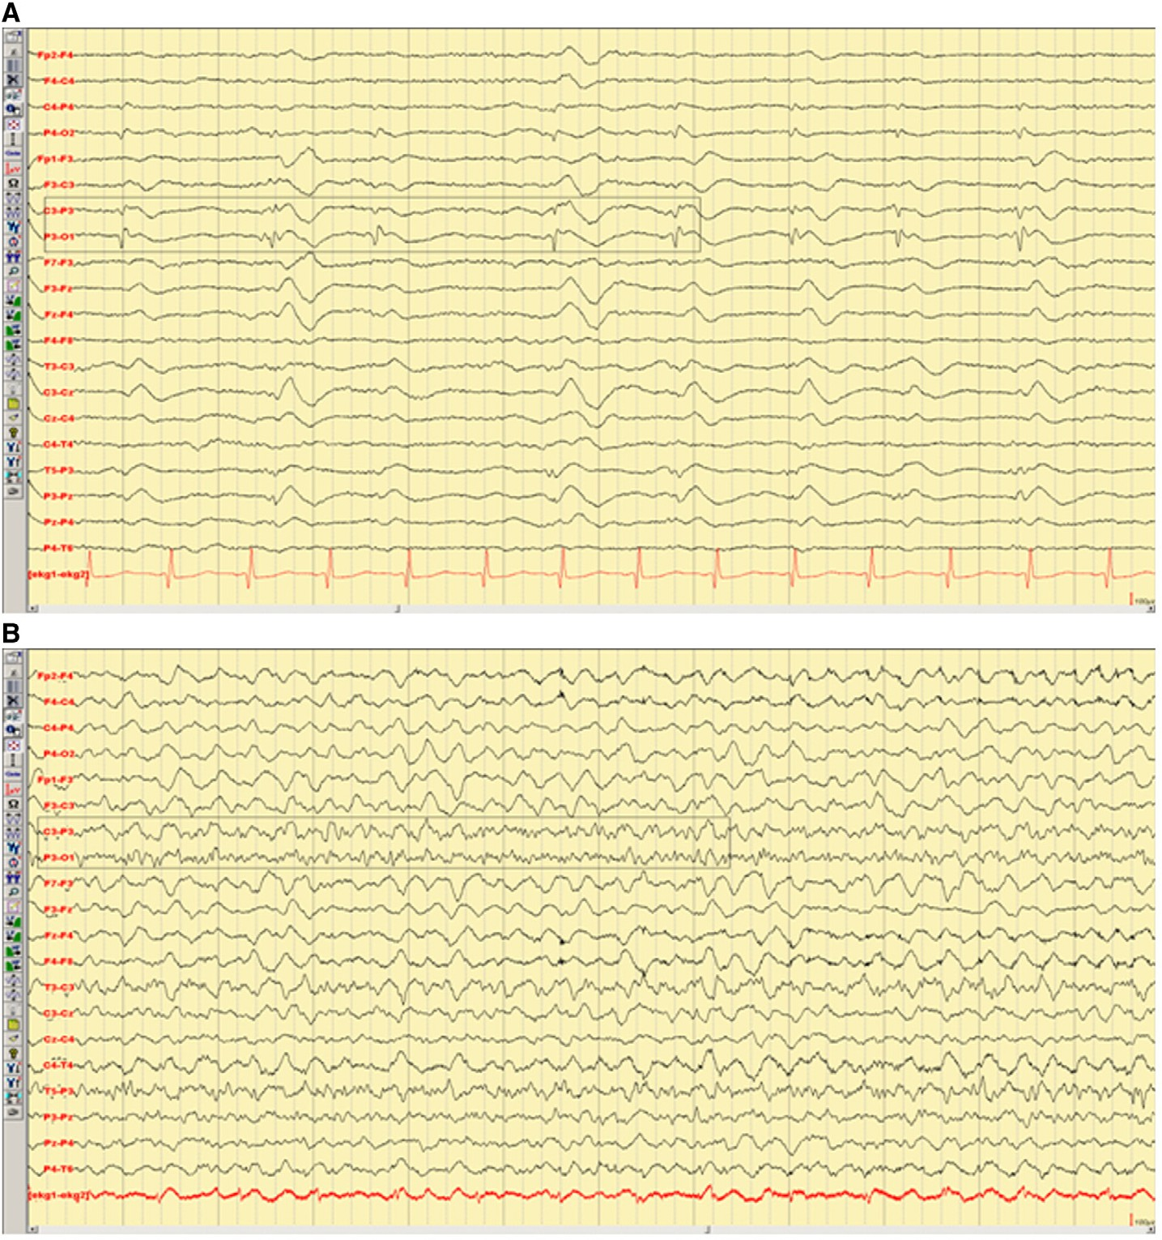

Fig. 1. Electroencephalography. (A) Scalp EEG with interictal left parieto-occipital sharp waves. (B) Scalp EEG with left parieto-occipital seizure.

patient had frequent parieto-occipital sharp waves in wakefulness and sleep. In addition to seizures, the patient also had frequent migraine headaches which were often preceded by a visual aura, making it difﬁcult to differentiate the migraine aura from a visual sensory seizure. Nonneurological chronic symptoms included palpi- tations with a baseline heart rate of 120 bpm and abdominal discomfort with irregular bowel movements.

General physical examination revealed moderate obesity with abdominal striae. Neuropsychological assessment was undertaken during inpatient VEEG monitoring. Though she had an average Full

Scale IQ (88), a signiﬁcant difference prevailed between her Verbal IQ of 112 and Performance IQ of 70. She demonstrated a lexical retrieval defect on the Boston Naming Test and was at only the 1st percentile. Semantic and ﬁrst letter ﬂuency were at the 3rd and 10th percentiles, respectively. Visuoconstructional (dominant parietal) function was assessed with Block Design and Matrix Reasoning subtests of the Wechsler Abbreviated Scale of Intelligence (WASI) and was completed at the 1st and 9th percentiles, respectively. On a test of visual scanning and cancellation, she made predominantly right-sided omission errors. Prose passage recall immediately and on delay (dominant

|  |  |  |
| --- | --- | --- |
| 208 | *D. Roshal et al. / Epilepsy & Behavior 21 (2011) 206*–*210* |  |
| Table 1  Laboratory and diagnostic test. |  |  |
| CBC, CMP, TSH, HgA1C  Serum lactate Serum pyruvate Cerebrospinal ﬂuid |  | Normal  33.1 (4.5–19.8)  0.154 (0.030–0.107) |

Cell count with differential

White blood cells 8 (0–5) with 65% lymphocytes

Red blood cells 9 (0–5)

Glucose 56(50–80)

Protein 85(15–45)

Protein electrophoresis and serum protein electrophoresis Normal with no oligoclonal bands

Myelin basic protein 5.6 (0.07–4.10)

Human T lymphotropic virus 1, lyme antibody, herpes PCR Normal

Pyruvate 0.03 (0.06–0.19)

Lactate dehydrogenase 46 (11–22)

Lactate Normal

CADASIL,a FHM, autosomal dominant ataxia panel Negative

Mitochondrial disorders Athena panel Normal

Vitamin B12 163 (180–900)

Methylmalonic acid Normal

25-Hydroxyvitamin D 8.4 (32–100)

Vitamins A, K, E Normal

Celiac antibody panel Normal

Pancreatic enzymes Normal

Homocysteine Normal

Creatine phosphokinase and aldolase Normal

Muscle biopsy Normal without ragged red ﬁbers

GAD, VGKC, Hu, Ri, Yo, and NMDA antibodies Normal

Urine sulfatides Normal

ANA, ESR, ENA, cANCA, and pANCA Normal

Echocardiogram Normal

Dual-energy X-ray absortiometry (DEXA) scan Osteoporosis

Electromyography/nerve conduction tests Sensory axonal neuropathy

CA-125 tumor marker Normal

EEG Fig. 1

MRI brain scan Fig. 2

POLG1 genetic testing

Patient Compound heterozygous A467T/W748S mutation

Father Heterozygous A467T mutation

Mother Heterozygous W748S mutation

a CADASIL, cerebral autosomal dominant arteriopathy with subcortical infarcts and leukoencephalopathy; FHM, familial hemiplegic migraine; GAD, glutamic acid decarboxylase; VGKC, voltage gated potassium channel; NMDA, *N*-methyl-D-aspartate; ANA, antinuclear antibodies; ENA, extractable nuclear antigens; ESR, erythrocyte sedimentation rate.

temporal lobe dependent) was solidly average, but delayed free recall on supraspan verbal list learning (California Verbal Learning Test II) was at only the 10th percentile. Facial recognition memory (right posterior temporal dependent) was at the 2nd and 10th percentiles relative to age-matched norms. On tests of writing and ﬁnger dexterity she demonstrated pervasive graphomotor control problems. Single- word reading recognition was at the 95th percentile. She also had

difﬁculty with calculations using single- and double digit-numbers as well as right–left confusion. Overall the neuropsychological testing was consistent with a multifocal cognitive dysfunction.

Cranial nerve examination was noteworthy for downbeat and horizontal nystagmus, ocular dysmetria, right homonymous hemi- anopsia, bilateral tilted and atrophic optic nerves, and a mild right central facial nerve palsy, with the rest of the cranial nerves being grossly intact. On motor testing there was a right upper extremity drift with strength of 4/5, and bilateral weakness of foot dorsiﬂexion at 4/5, with normal strength in the rest of her muscles. Sensation was diminished to pain, temperature, vibration, and proprioception in all four extremities. On coordination testing the patient was unable to perform ﬁnger-to-nose or heel-to-shin and had a positive Romberg sign. Gait was unsteady, wide-based, and ataxic, with the patient leaning more to the right. Reﬂexes were hypoactive at + 1/4 in the upper and lower extremities. Plantar cutaneous responses were ﬂexor bilaterally with no clonus or pathological spread.

On the basis of the patient's clinical history of worsening seizures and cognitive function on valproate, and because of evidence of

multisystemic involvement, a mitochondrial cytopathy was sus- pected, though the differential also included cerebral autosomal dominant arteriopathy with subcortical infarcts and leukoencephalo- pathy (CADASIL), familial hemiplegic migraine (FHM), autosomal dominant ataxias, leukodystrophy, and paraneoplastic disorder, as well as diseases of infectious, autoimmune, and neurodegenerative etiology. Valproate was immediately switched to phenytoin and 10% dextrose intravenously with L-carnitine and coenzyme Q-10 was started, which resulted in rapid resolution of the epileptic status and subsequent improvement of the patient's neurological function. Diagnostic workup in addition to scalp VEEG monitoring included: comprehensive blood and spinal ﬂuid testing (Table 1), neuroimaging, echocardiogram, muscle biopsy, genetic testing for mitochondrial disorders, such as mitochondrial encephalomyopathy, lactic acidosis, and strokelike episodes (MELAS), myoclonic epilepsy with ragged-red ﬁbers (MERRF), and genetic testing for CADASIL and FHM. All laboratory tests (Table 1), except for the high serum pyruvate and lactate levels, low vitamin B12 and 25-hydroxyvitamin D levels, brain MRI, and EEG, were normal. MRI of the brain (Fig. 2) revealed T2 hyperintensities in the left thalamus, left parietal and left occipital cortical regions, and right cerebellar white matter, with corresponding restricted diffusion on DWI, as well as associated atrophy of the left parieto-occipital lobe. Over a period of several months, the hyperintense lesions on the MRI resolved, which correlated with improvement of the patient's seizures and neurological function. The patient was discharged from the epilepsy monitoring unit after her seizures had stopped and she was periodically followed in the outpatient clinic.

*D. Roshal et al. / Epilepsy & Behavior 21 (2011) 206*–*210* 209

[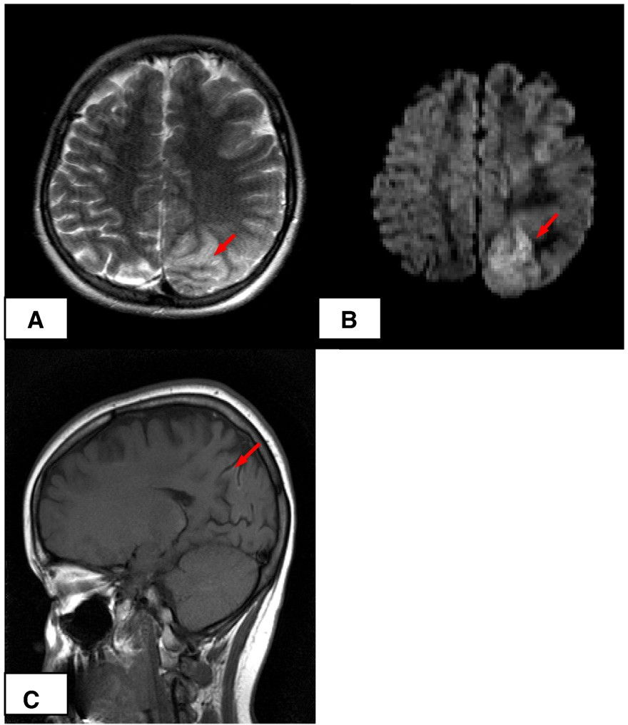](image%20of%20Fig. 2)

Fig. 2. Magnetic resonance imaging. Left parieto-occipital lobe hyperintensity on axial T2 MRI scan of brain (A) with corresponding restricted diffusion signal abnormality (B) during the initial hospital stay. Left parieto-occipital lobe atrophy on sagittal T1 MRI scan of brain (C) on follow-up imaging.

The wide range of neurological and nonneurological manifesta- tions with elevated levels of serum lactate and pyruvate prompted additional genetic testing for a mitochondrial disorder, speciﬁcally a POLG1 gene mutation, which came back positive for a compound heterozygous A467T/W748S genotype. During the 2-year follow-up period the patient's neurological status did not change and she demonstrated no progression of her symptoms. She continued to demonstrate mild cognitive dysfunction with deﬁcits in attention and concentration and difﬁculty with learning, which required home tutoring. The bilateral foot drop and joint position sense slowly improved with regular administration of vitamin B12 shots; however, she continued to have signiﬁcant mixed ataxia that was predominantly cerebellar. An electromyography/nerve conduction study performed several months after vitamin B12 repletion revealed only a sensory axonal neuropathy. She continued to have predominantly visual seizures and frequent migraine headaches which were refractory to conventional migraine-preventive and

-abortive treatments. Seizures were controlled with phenytoin and lamotrigine. Every attempt to change the phenytoin to another antiepileptic drug with a non-sodium or weaker sodium channel- blocking mechanism of action, such as levetiracetam, zonisamide, and topiramate, resulted in signiﬁcant worsening of her seizures and/or worsening of her depression and cognitive function. Follow- up neuroimaging studies showed no hyperintense lesions, but there was evidence of focal left parieto-occipital lobe atrophy without evolution (Fig. 2).

1. Discussion

The compound heterozygous A467T/W748S genotype is rare, and thus far, only a few cases have been reported in the literature [6,7]. The constellation of clinical neurological symptoms includes focal epileptic seizures, migraine headaches, cerebellar ataxia, and sensory–motor axonal neuropathy. Focal epileptic seizures, which could be the ﬁrst manifestation of the disease, usually have a posterior parietotemporal

or occipital lobe predilection. The parieto-occipital lobe seizures and the neuroimaging abnormalities in the posterior brain, as seen in our patient, corroborate with the previous reports [7] of primary involvement of the posterior brain regions in patients with POLG1 genotype. This may also explain the high rate of occurrence of migraines with visual aura in the course of this disease [6]. It is likely that the migraines and focal seizures in these patients represent two different manifestations of the same cortical irritation. In some cases, migraines and seizures have a reciprocal relationship: prolonged migraines can trigger seizures in patients with epilepsy [9,10], and seizures can bring on migraine headaches [10]. The reason for the predominant involvement of the posterior brain regions in POLG1- related mitochondrial disorders or in other mitochondrial diseases (for instance, MELAS) is not clear, but in theory it may suggest a difference in mitochondrial organization of the posterior brain regions.

Chronic progressive external ophthalmoplegia (CPEO), often seen in other POLG1 genotypes [11], is rarely observed in A467T/W748S [6] genotypes and was not seen in our patient. Unlike patients with other

210 *D. Roshal et al. / Epilepsy & Behavior 21 (2011) 206*–*210*

mitochondrial diseases, including other POLG1 genotypes, our patient as well as mostof theother reportedpatients with A467T/W748S genotype had a normal muscle biopsy. In many cases of other mitochondrial diseases, the speciﬁc muscle biopsy ﬁndings of ragged red ﬁbers on Gomori trichrome stain, increased succinic dehydrogenase-stained ﬁbers, or reduced/absent cytochrome oxidase-stained ﬁbers represent a sensitive laboratory tool for diagnosis of mitochondrial disorders; however, this is not the case for patients with a POLG1 A467T/W748S genotype. Therefore, if the clinical ﬁndings suggest the presence of a mitochondrial disorder, a negative muscle biopsy should not dissuade from further testing.

The age at onset of neurological symptoms in patients with a POLG1 A467T/W748S genotype ranges from 2 to 36, with most patients experiencing onset in their teens [6]. Patients with POLG1 gene mutations are at high risk of death from status epilepticus and from liver failure, especially if exposed to sodium valproate [6].

Kaplan–Meier survival analysis from small case series shows that

patients with the compound heterozygous form do signiﬁcantly worse than those who are homozygous for either A467T/A467T or W748S/W748S. The median survival times of patients with the A467T/A467T, W748S/W748S, and A467T/W748S genotypes are 50, 26, and 6 years, respectively [6].

Antiepileptic therapy, which has been shown to be beneﬁcial for reducing seizure frequency, comprises mainly sodium channel blockers, for example, carbamazepine, phenytoin, oxcarbazepine or lamotrigine [7]. As in our patient, other reported patients with a POLG1 gene mutation also achieved greater beneﬁt in seizure control with sodium channel-blocking antiepileptic drugs [7]. The underlying molecular mechanism is not clear, though a voltage-gated sodium channel abnormality may be theoretically implicated in cortical hyperexcitability in these patients, as well as in some patients with other epileptic pathologies [12]. Aggressive treatment of the seizures is imperative for reducing the morbidity and mortality of patients with a POLG1-related epilepsy syndrome [6].

1. Ethical approval

We conﬁrm that we have read the Journal's position on issues involved in ethical publication and afﬁrm that this report is consistent with those guidelines.

1. Conﬂict of interest statement

Dr. Roshal, Dr. Glosser, and Dr. Zangaladze have nothing to disclose.

References

1. Chan S, Longley MJ, Copeland WC. The common A467T mutation in the human mitochondrial DNA polymerase (PLG) compromises catalytic efﬁciency and interaction with the accessory subunit. J Biol Chem 2005;280:31341–6.
2. National Institute of Environmental Health Sciences and National Institutes of Health (NIH). Human DNA polymerase gamma mutation database. Accessed: 28 January 2011. Available at: <http://tools.niehs.nih.gov/polg/index.cfm?do=main.allmutation>.
3. Naviaux RK, Nguyen KV. POLG1 mutation associated with Alpers’ syndrome and

mitochondrial DNA depletion. Ann Neurol 2004;55:706–12.

1. Alpers BJ. Diffuse progressive degeneration of the gray matter of the cerebrum. Arch Neurol Psychiatry 1931;25:469–505.
2. Nguyen KV, Ostergaard E, Ravn SH, et al. POLG1 mutations in Alpers’ syndrome. Neurology 2005;65:1493–5.
3. Tzoulis C, Engelsen B, Telstad W, et al. The spectrum of clinical disease caused by the A467T and W748S POLG1 mutations: a study of 26 cases. Brain 2006;129: 1685–92.
4. Engelsen B, Tzoulis C, Karlsen B, et al. POLG1 mutations cause a syndromic epilepsy with occipital lobe predilection. Brain 2008;131:818–28.
5. Uusimaa J, Hinttala R, Rantala H, et al. Homozygous W748S mutation in the POLG1 gene in patients with juvenile-onset Alpers’ syndrome and status epilepticus. Epilepsia 2008;49:1038–45.
6. Twomey JA, Abbott RJ, Franks AJ, Burt AA, Hakin NJ. Status epilepticus complicating migraine. Acta Neurol Scand 1988;77:335–8.
7. Ekstein D, Schachter SC. Postictal headache. Epilepsy Behav 2010;19:151–5.
8. Longley MJ, Graziewics MA, Bienstock RJ, Copeland WC. Consequences of mutations in human DNA polymerase gamma. Gene 2005;354:125–31.
9. Mantegazza M, Curia G, Biagini G, Ragsdale DS, Avoli M. Voltage-gated sodium channels as therapeutic targets in epilepsy and other neurological disorders. Lancet Neurol 2010;9:413–24.