

**HHS Public Access**

Author manuscript

*Muscle Nerve*. Author manuscript; available in PMC 2018 August 08.

Author Manuscript

Author Manuscript

Author Manuscript

Author Manuscript

Published in final edited form as:

*Muscle Nerve*. 2012 March ; 45(3): 453–454. doi:10.1002/mus.22330.

POLG1 Arg953Cys MUTATION: EXPANDED PHENOTYPE AND RECESSIVE INHERITANCE IN A BRAZILIAN FAMILY

**Juliana Gurgel-Giannetti, MD, PhD**1, **Sarah Teixeira Camargos, MD, PhD**2, **Francisco Cardoso, MD, PhD**2, **Michio Hirano, MD**3, and **Salvatore DiMauro, MD**3

1Neuropediatric Service, Department of Pediatrics, Medical School, Federal University of Minas Gerais, Belo Horizonte, Minas Gerais, Brazil

2Neurology Service, Department of Internal Medicine, Medical School, Federal University of Minas Gerais, Belo Horizonte, Minas Gerais, Brazil

3Department of Neurology, Columbia University Medical Center, New York, New York, USA

Polymerase *γ* (POLG) is a nuclear DNA-encoded enzyme responsible for mitochondrial DNA (mtDNA) replication. A heterodimer composed of one alpha (140 kDa) encoded by *POLG1* and two beta (41 kDa) subunits encoded by *POLG2*, POLG resides in the inner mitochondrial membrane. The alpha subunit is catalytic and contains both polymerase and exonuclease activities, whereas the beta subunit facilitates DNA binding and promotes DNA synthesis.1

The first pathogenic mutation of *POLG1* was described in 2001 in families with autosomal dominant or recessive chronic progressive external ophthalmoplegia (PEO) and multiple deletions of mtDNA in muscle.2 Subsequent reports expanded the clinical spectrum associated with *POLG1* mutations. Autosomal dominant mutations usually cause PEO with or without parkinsonism, whereas autosomal recessive mutations have been associated with Alpers syndrome (hep-atopathy, psychomotor regression, and refractory seizures), SANDO (sensory ataxia, neuropathy, dysarthria, ophthalmoplegia), male infertility, premature menopause, cataracts, or early-onset parkinsonism and neuropathy.3–8

In 2004, Luoma et al. described a heterozygous c.C2857T mutation, which changes an arginine to a cysteine at amino acid position 953 (p.Arg953Cys), in a patient with PEO, muscle weakness, ataxia, asthma, and hypothyroidism.7

We describe a family with 3 affected siblings. The index case was a 33-year-old man with PEO, parkinsonism, neuropathy, and cardiomyopathy who harbored the p.Arg953Cys mutation, as described by Luoma et al., in a homozygous state. He initially presented with gait abnormalities and PEO at 20 years of age. At age 30, he began to have cognitive impairment and depressive and psychotic symptoms. His oldest brother had similar symptoms and died at 30 years of age during abdominal surgery. An older sister had PEO and depression, and she committed suicide at age 29. The other 3 younger siblings were asymptomatic and had normal neurological examinations. The parents were first cousins, but neither had neurological problems. At age 33, a neurological evaluation of the index patient revealed masked face, bradykinesia, action tremor, stooped posture, rigidity, complete ophthalmoplegia, and mild proximal limb weakness. Parkinsonism improved with pra-

Author Manuscript

Author Manuscript

Author Manuscript

Author Manuscript

mipexole 3 mg/day. Electromyography and nerve conduction studies showed a myopathic pattern and a sensory polyneuropathy. Brain MRI showed diffuse cortical atrophy, and echocardiography revealed a moderate cardiomyopathy. Muscle biopsy showed numerous ragged-red fibers, which were COX-negative, and succinate dehydrogenase (SDH)- hyperreactive fibers (“ragged blue” fibers). Multiple mtDNA deletions in muscle were detected by Southern blot analysis. Direct sequencing of *POLG1* showed the p.Arg953Cys mutation in homozygosity. The mutation was heterozygous in the 2 asymptomatic brothers and absent in the asymptomatic younger sister (Fig. 1).

In 2004, Luoma et al. reported an apparently sporadic patient with isolated PEO associated with the p.Arg953Cys mutation. It was not stated whether the mutation was homozygous or heterozygous.8 Also, they were unable to study the parents of the patient and there were insufficient data to define the mode of inheritance. Based on this description, it was assumed that the p.Arg953Cys mutation causes autosomal dominant PEO, until now (see [http://dir-](http://dir-apps.niehs.nih.gov/polg/) [apps.niehs.nih.gov/polg/](http://dir-apps.niehs.nih.gov/polg/)).9

This study has clearly shown that p.Arg953Cys is an autosomal recessive mutation in our family and co-segregates with a more complex clinical phenotype: ophthalmoplegia; gait abnormalities; parkinsonism; sensory neuropathy; cardiomyopathy; and depression.

**References**

1. Ropp PA , Copeland WC . Cloning and characterization of the human mitochondrial DNA polymerase, DNA polymerase gamma. Genomics 1996;36:449–458.8884268
2. van Goethem G , Dermaut B , Lofgren A , Martin JJ , van Broeckhoven C . Mutation of POLG is associated with progressive external ophthalmoplegia characterized by mtDNA deletions. Nat Genet 2001;28: 211–212.11431686
3. Rovio AT , Marchington DR , Donat S , Schupp HC , Abel J , Fritsche E , et al. Mutations at the mitochondrial DNA polymerase (POLG) locus associated with male infertility. Nat Genet 2001;29:261–262.11687794
4. van Goethem G , Martin JJ , Dermaut B . Recessive POLG mutations presenting with sensory and ataxic neuropathy in compound heterozygote patients with progressive external ophthalmoplegia. Neuro-muscul Dis 2003;13:133–142.
5. Naviaux RK , Nguyen KV . POLG mutations associated with Alpers’ syndrome and mitochondrial DNA depletion. Ann Neurol 2004;55: 706–712.15122711
6. Mancuso M , Filosto M , Bellan M . POLG mutations causing ophthalmoplegia, sensorimotor polyneuropathy, ataxia, and deafness. Neurology 2004;62:316–318.14745080
7. Luoma P , Melberg A , Rinne JO , Kaukonen JA , Nupponen NN , Chalmers RM , et al. Parkinsonism, premature menopause, and mitochondrial DNA polymerase gamma mutations: clinical and molecular genetic study. Lancet 2004;364:875–882.15351195
8. Filosto M , Mancuso M , Nishigaki Y , Pancrudo J , Harati Y , Gooch C , et al. Clinical and genetic heterogeneity in progressive external oph-thalmoplegia due to mutations in polymerase γ. Arch Neurol 2003; 60:1279–1284.12975295
9. <http://dir-apps.niehs.nih.gov/polg>. Human DNA Polymerase gamma Mutation Database, 01/07/2011.

Author Manuscript

Author Manuscript

Author Manuscript

Author Manuscript

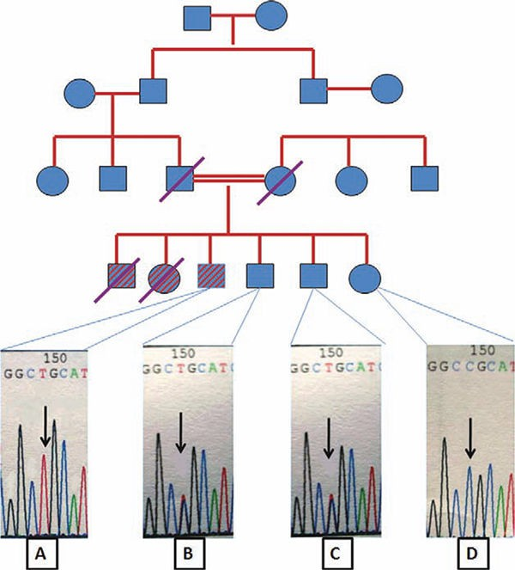

**FIGURE 1.**

Family pedigree and POLG gene sequencing: (**A**) Patient (index case): homozygous for the C2857T mutation. (**B, C**) Asymptomatic siblings: heterozygous for the C2857T mutation.

(**D**) Asymptomatic sibling: absence of the mutation. [Color figure can be viewed in the online issue, which is available at [wileyonlinelibrary.com](http://wileyonlinelibrary.com/).]