Available online at [www.sciencedirect.com](http://www.sciencedirect.com/)





[Neuromuscular Disorders 22 (2012) 401–405](http://dx.doi.org/10.1016/j.nmd.2011.10.017)

Case report

[www.elsevier.com/locate/nmd](http://www.elsevier.com/locate/nmd)

A case of myelopathy, myopathy, peripheral neuropathy and subcortical grey matter degeneration associated with recessive compound heterozygous POLG1 mutations

P. McKelvie a,⇑, R. Marotta b, D.R. Thorburn c, J. Chin b, S. Punchihewa b, S. Collins b,d

a *Department of Anatomical Pathology, St. Vincent’s Hospital Melbourne, Australia*

b *St. Vincent’s Melbourne Neuromuscular Diagnostic Laboratory, Department of Clinical Neurosciences, St. Vincent’s Hospital, Australia*

c *Murdoch Children’s Research Institute and University of Melbourne, Department of Paediatrics, The Royal Children’s Hospital, Parkville,*

*Victoria, Australia*

d *University of Melbourne, Australia*

Received 21 May 2011; received in revised form 6 October 2011; accepted 26 October 2011

Abstract

This 54 year old woman presented with symptoms of sensory ataxic neuropathy, with cerebellar features. She developed further weak- ness, visual disturbances with diplopia, dysarthria and dysphasia. After her death at 66 years, she was found to have compound hetero- zygous mutations of POLG1 gene in muscle, and Southern blot showed low levels of multiple deletions of mitochondrial DNA. Neuropathological examination showed profound dorsal column and dorsal spinocerebellar tract degeneration, degeneration of dorsal root ganglia and Clarke’s nucleus in spinal cord and severe predominantly sensory peripheral neuropathy. The brain showed severe neu- ronal loss and gliosis in substantia nigra, medial posterior thalamus and head of caudate. Excess numbers of COX-negative ﬁbres and “ragged-red” ﬁbres were found in ﬁve skeletal muscles sampled.

© 2011 Elsevier B.V. All rights reserved.

*Keywords:* Compound heterozygous polymerase-gamma (POLG) mutations; Spinal cord degeneration; Dorsal column and dorsal spinocerebellar tract degeneration; Multiple mitochondrial DNA deletions; Peripheral neuropathy; Mitochondrial myopathy; COX-negative ﬁbres; Ragged-red ﬁbres; Subs- tantia nigra degeneration; Thalamic degeneration; SANDO

1. Introduction

Mitochondrial DNA polymerase-c (POLG) is a nuclear encoded protein involved in mitochondrial DNA replica- tion and the only DNA polymerase functional in animal mitochondria [1,2]. In humans the 195 kDa heterotrimer consists of one catalytic subunit which is encoded by *POLG1* located on chromosome 15q25 and two accessory subunits encoded by *POLG2* located on chromosome 17q23-24.

⇑ Corresponding author. Address: Anatomical Pathology, St. Vincent’s Hospital Melbourne, P.O. Box 2900, Fitzroy, VIC 3065, Australia. Tel.:

+61 3 9288 4558; fax: +61 3 9288 4580.

*E-mail address:* [penny.mckelvie@svhm.org.au](mailto:penny.mckelvie@svhm.org.au) (P. McKelvie).

POLG1 has 23 exons and the ﬁrst pathogenic mutations of *POLG1* were identiﬁed in the autosomal dominant syn- drome chronic progressive ophthalmoplegia (adCPEO) [3]. This is characterized by multiple secondary mtDNA dele- tions in skeletal muscle causing cytochrome c oxidase (COX) defects. In some families transmitting dominant *POLG1* mutations, a high incidence of psychiatric disease, a Parkinsonian syndrome and primary gonadal failure have also been reported [4,5].

Compound heterozygous *POLG1* mutations have been identiﬁed in the autosomal recessive syndromes in patients with sporadic and recessive PEO, which are also character- ized by mtDNA deletions [4]. Subsequently, mutations in POLG1 were identiﬁed in patients with Alpers syndrome, ataxia neuropathy syndromes, idiopathic parkinsonism



0960-8966/$ - see front matter © 2011 Elsevier B.V. All rights reserved. doi:[10.1016/j.nmd.2011.10.017](http://dx.doi.org/10.1016/j.nmd.2011.10.017)

402 *P. McKelvie et al. / Neuromuscular Disorders 22 (2012) 401–405*

and others, all characterized by mtDNA deletions or deple- tions in symptomatic tissues [2]. (To date, about 150 dis- ease mutations have been identiﬁed [2].

Studies have indicated that SANDO (sensory, ataxic neuropathy with dysarthria and ophthalmoparesis), is a variant of autosomal recessive progressive external oph- thalmoplegia (arCPEO). In SANDO, ocular manifestions occur at a later stage of disease progression and are less prominent than the sensory ataxic neuropathy, which is distinguishable from the mild generalized sensorimotor peripheral neuropathy in CPEO patients [5–7].

We present a case study showing spinal cord, peripheral nerve and selective nuclear degeneration in the brain due to recessive compound heterozygous mutations of *POLG1*.

1. Case report

A 54 year old woman ﬁrst presented with an eight year history of symptoms including cerebellar features with ataxia in all limbs, a moderate neuropathy with depressed and absent reﬂexes in all limbs, distal weakness and distal sensory loss of proprioception and vibration. A tentative diagnosis of hereditary spinocerebellar degeneration and peripheral neuropathy was made.

Progression of symptoms since initial presentation included dysarthria, slowing with fatigability, urinary stress incontinence and diplopia leading to prism lenses. She underwent bilateral total hip replacements.

Investigations included normal serum phytanic acid and lactate, negative screening for peripheral leukocyte lyso- somal storage disorders in 1994. Spinocerebellar ataxia tests for SCA1, 2, 3, 6 and 7 were all negative. Friedreich’s ataxia screen was negative. Serum vitamin E was within normal limits. ECG showed P-pulmonale and an ACE inhibitor was given. An echocardiogram showed no cardiomyopathy. Sleep studies revealed moderate sleep apnoea, but the patient did not tolerate CPAP. Brain MRI in 2007 revealed mild atrophy of the superior cerebellar vermis. A swallow- ing assessment revealed a delayed pharyngeal phase.

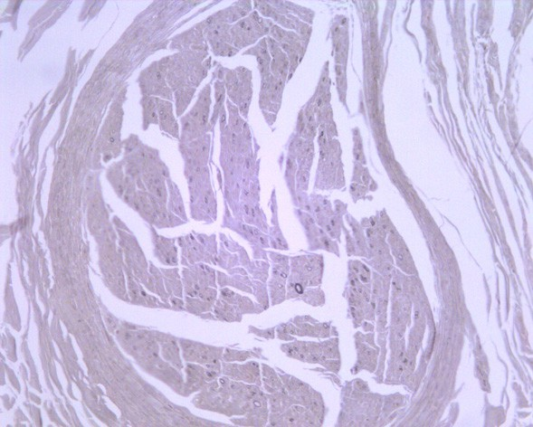

Subsequent examination showed reduced upward gaze, but good binocular vision on lateral gaze. Lower limb hip ﬂexion and extension were grade 4-/5 (Medical Research Council Scale) and she had signiﬁcant distal weakness. Upper limbs were normal. The patient was areﬂexic and used an electric chair for mobilization over six years.

During her last admission, a general deterioration of health had occurred with increasing sacral pains, dysarthria, increased drowsiness, intermittent nausea, worsening mobil- ity and diﬃculty coping. She became progressively drowsy, encephalopathic, and febrile. She died, aged 66 years.

A family history of neuropsychiatric illness in a deceased 39 year old sister was recorded. The sister suﬀered from a “nervous breakdown” and underwent electroconvulsive therapy. She had decreased memory, mobility, lower limb wasting and weakness and decreased sensation in distal upper and lower limbs. She may have also suﬀered from dysarthria and dysphasia and was wheelchair- and frame

bound. The sister’s muscle biopsy revealed a number of cytochrome oxidase negative ﬁbres. Genetic studies were not pursued at the time and post-mortem tissue was not available for further analysis on the patient’s sister.

* 1. *Histological examination*

Muscle biopsy in 1994 (age 52 years) showed extensive type grouping of type 1 ﬁbres with severely atrophic type

2 ﬁbres and increased sarcolemmal nuclear aggregates. Some COX-negative ﬁbres were noted.

* 1. *Postmortem*

Postmortem delay was 24 h. The general autopsy showed bilateral acute bronchopneumonia.

* 1. *Muscle*

Quadriceps, gastrocnemius, deltoid, pectoralis major, psoas, intercostal and diaphragm muscles all showed an excess number (>5%) of COX-negative ﬁbres and ragged- red ﬁbres (>3%). Scattered degenerating and regenerating ﬁbres and increased numbers of sarcolemmal nuclear aggregates were noted in all muscles. Group atrophy of ﬁbres in the quadriceps muscle and marked atrophy and almost end-stage atrophy in gastrocnemius. Poor ﬁbre typ- ing was seen with ATPase stains in all muscles except the deltoid which showed type grouping of type 1 and type 2 ﬁbres.

* 1. *Peripheral nerves*

The sural nerve showed severe loss of myelinated ﬁbres of all diameters with only some residual small diameter ﬁbres (Fig. 1a). Electron microscopy revealed small num- bers of thinly myelinated axons, some axonal atrophy, scat- tered clusters of regenerating ﬁbres but no onion bulbs or Wallerian degeneration. Femoral nerve showed mild loss

Fig. 1. (a) Sural nerve stained with osmium tetroxide showing very few residual myelinated axons. Magniﬁcation x200.

*P. McKelvie et al. / Neuromuscular Disorders 22 (2012) 401–405* 403

of myelinated ﬁbres, especially larger diameter ﬁbres. Electron microscopy showed similar changes to those in sural nerve but less severe.

* 1. *Brain*

There was prominent loss of pigmented neurons in the substantia nigra bilaterally (Fig. 2) with no Lewy bodies or neuroﬁbrillary tangles and negative immunohistochem- istry for Tau, ubiquitin and alpha-synuclein. Mild neuronal loss and gliosis was noted in the vestibular nuclei. There was severe neuronal loss and gliosis in the ventrolateral posterior nuclei of the thalamus. Neuronal loss and atro- phy was seen in the head of the caudate nucleus without overt infarction. There was minimal loss of the Purkinje cells in the superior cerebellar vermis. Dentate nucleus and cerebellum were otherwise normal.

* 1. *Spinal cord*

There was prominent atrophy of the gracile and cuneate nuclei, posterior columns at all levels and the dorsal spinoc- erebellar tract with very atrophic dorsal nerve roots (Figs. 3a and 3b). Luxol fast blue and neuroﬁlament stains conﬁrmed that there was both severe axonal and myelin loss in the dorsal columns. Clarke’s nucleus showed moder- ate depletion of large neurons and reduced size and num- bers of residual neurons. Dorsal root ganglia showed degeneration with loss of neurons with residual islands of satellite cells and a number of degenerating and atrophic neurons (Fig. 3c). The anterior nerve roots also appeared mildly atrophic with some loss of neurons in the anterior horns in lumbar cord.

* 1. *Biochemical studies*

The results for skeletal muscle respiratory chain enzymes were equivocal showing borderline low activities

Fig. 3a. Low power photomicrograph of cervical spinal cord showing severe axonal loss in dorsal columns. Neuroﬁlament immunohistochem- istry Magniﬁcation x25.

Fig. 3b. High power photomicrograph of spinal cord showing severe axonal loss in dorsal spinocerebellar tract indicated by an arrow. Neuroﬁlament immunohistochemistry magniﬁcation x400.

Fig. 2. High power photomicrograph of substantia nigra showing severe loss of pigmented neurons and gliosis but no Lewy bodies or neuroﬁbril- lary tangles in residual pigmented neurons. H&E magniﬁcation x200.

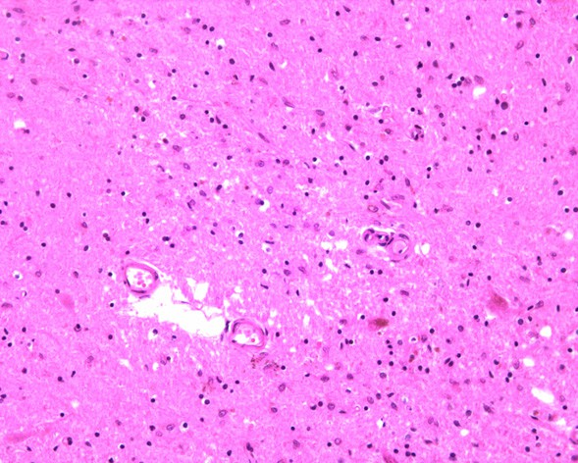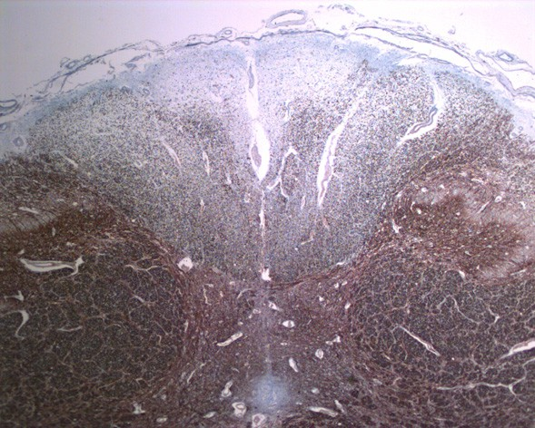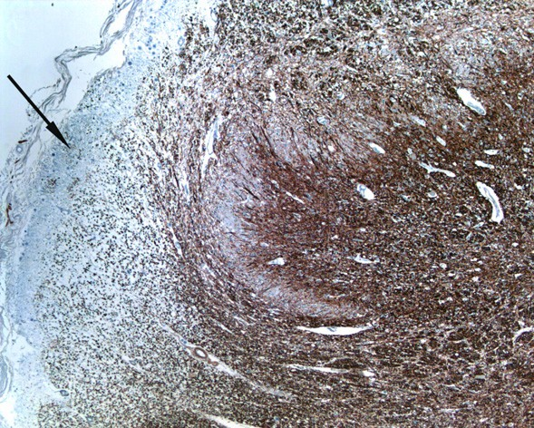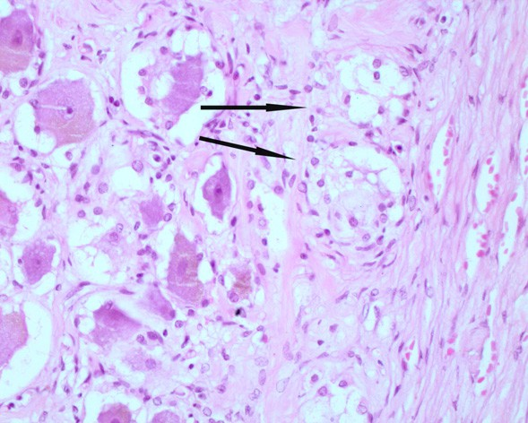

Fig. 3c. High power photomicrograph of dorsal root ganglia with vacuolar degeneration and foci of neuronal dropout with proliferation of satellite cells on right-arrows. Magniﬁcation x400.

404 *P. McKelvie et al. / Neuromuscular Disorders 22 (2012) 401–405*

for the complexes with subunits encoded by mitochondrial DNA (mtDNA).

* 1. *Genetic studies*

The common point mutations for MELAS (MT- TL1m.3243A>G), MERRF (MT-TK m.8344A>G), LHON (MT-ND1m.3460A>G and m.11778G>A) were

not detected in the primary muscle biopsy. A Southern blot showed no mtDNA deletions on the primary muscle biopsy.

Screening for the common point mutation for NARP/ LS MT-ATP6m.8993T>C/G on blood DNA from a Guthrie card was negative.

The tests for spinocerebellar ataxia, SCA 1, 2, 3, 6 and 7 showed normal results.

Friedreich’s ataxia screen and the peripheral leucocyte lysosomal storage disorder screen were also negative.

* 1. *Postmortem genetic studies*

A mitochondrial mutation screen was again carried out on postmortem deltoid muscle. The common point muta- tions for MELAS (MT-TL1m.3243A>G), MERRF (MT- TK m.8344A>G), NARP/LS (MT-ATP6m.8993T>C/G) and LHON (MT-ND1m.3460A>G, m.11778G>A and

m.14484T>C) were not detected in the muscle biopsy. The rarer mutations for MELAS (MT-TL1m.3271T>C and MT-ND5m.13513G>A) were also not detected. Sequencing of the mitochondrial- encoded COX I, II and III genes only revealed reported polymorphisms not associ- ated with pathogenicity.

A Southern blot on postmortem psoas, pectoralis, inter- costal, gastrocnemius, diaphragm, deltoid and quadriceps muscles revealed low levels of multiple mtDNA deletions.

Analysis of quadriceps muscle DNA by qPCR revealed a decreased amount of mtDNA in relative to nuclear DNA, corresponding to 28% and 32% of the normal mean ratio in two independent experiments.

Sequencing of POLG ([http://www.tools.niehs.nih.gov/](http://www.tools.niehs.nih.gov/polg/) [polg/](http://www.tools.niehs.nih.gov/polg/)) exons in genomic DNA did not detect the 3 common pathogenic variants of European origin p.A467T, p.W748S and p.G848S. However, two reported heterozygous sequence variants in the polymerase domain of POLG1 were identiﬁed. The ﬁrst was a heterozygous mutation c.2584G>A in exon 16 predicting a p.A862T change. The second heterozygous mutation was in exon 3, a c.830A>T predicting a p.H277L change. The A 862 nucle- otide and the 277 amino acid, histidine, are highly con- served from humans to neurospora.

* 1. *Genetic studies in family members*

Further studies were carried out on two other siblings and the daughter with no manifestation of disease. Only the c.830A>T mutation was found in heterozygous form in the patient’s 36 year old daughter and the patient’s

72 year old sister. The two variants described in the patient were not detected in the second sibling of 80 years of age.

1. Discussion

This woman presented in middle age with a progressive sensory ataxic neuropathy with later development of pto- sis, dysarthria, dysphagia and external ophthalmoparesis. No deﬁnite diagnosis was made prior to autopsy but a form of hereditary spinocerebellar ataxia with peripheral neuropathy was favoured. Mitochondrial cytopathy was suspected in view of the previous changes of “ragged-red” ﬁbres and cytochrome oxidase-negative ﬁbres on two mus- cle biopsies performed 20 and 14 years prior to death.

Autopsy conﬁrmed that the patient had multiple mtDNA deletions associated with compound heterozygous POLG mutations (p.A862T and p.H277L) in skeletal mus- cle. The p.A862T mutation has been reported previously as a compound heterozygous mutation in a man with late onset PEO and ataxia with a SCA-like illness in siblings [8]. The p.H277L mutation has only been very recently reported as a compound heterozygous mutation in a man with late onset PEO and parkinsonism [9]. Detailed neuro- pathological examination in our case conﬁrmed features of mitochondrial myopathy in multiple skeletal muscles, severe predominantly sensory peripheral neuropathy, but also profound dorsal column and dorsal spinocerebellar tract degeneration in the spinal cord, which has not previ- ously been reported in patients with documented POLG mutations or SANDO. Dorsal root ganglion cells were reduced in number and size with evidence of dropout and ongoing degeneration. Clarke’s nucleus also showed loss of large neurons and reduced size and numbers of residual neurons. However, spinal cord involvement (dorsal column and dorsal spinocerebellar tract degeneration) has been noted in patients with mitochondrial cytopathy with ataxic neuropathy and PEO [10]. Another adult case with multi- ple mtDNA deletions, published prior to the identiﬁcation of POLG [3], but who is likely to have POLG mutation(s) and the clinical scenario of ataxia, PEO, ptosis, peripheral neuropathy, dysphagia and extrapyramidal movement dis- order also had dorsal column and dorsal root ganglia degeneration at autopsy [11]. Posterior column degenera- tion has been reported in a family with a rare autosomal dominant POLG1 mutation with metabolic strokes and multiendocrine disease [12].

Since SANDO was ﬁrst described by Fadic and col- leagues in 1997 [5] and the POLG mutation responsible ﬁrst identiﬁed in 2003 by van Goethem et al. [6] the vari- able clinical phenotype of recessive POLG mutations has been recognized in subsequent case reports [13–18], partic- ularly in the compound heterozygote cases. The sensory ataxic neuropathy has been attributed to pathology in the dorsal root ganglia [5,6] but the reports published to date do not include examination of the spinal cord.

Another autosomal recessive ataxic disorder associated with POLG mutation, mitochondrial recessive ataxia

*P. McKelvie et al. / Neuromuscular Disorders 22 (2012) 401–405* 405

syndrome (MIRAS) has been described, particularly in the Finnish population [19]. The abnormal eye movements in MIRAS were not typical for external ophthalmoplegia but were mainly coordination problems of central origin [19].

Postmortem in our case also showed evidence of degen- eration of speciﬁc nuclei in the brainstem with severe loss of pigmented neurons in the substantia nigra and neuronal loss in vestibular nuclei. Since the ﬁrst report of POLG mutation in idiopathic Parkinson’s disease by Luoma and colleagues [20], Hudson et al. [16] have also reported a case of POLG mutation with PEO and parkinsonism. Chalmers et al. [21] detailed one case of multiple mtDNA deletions with peripheral neuropathy but without clinical parkinson- ism, in whom autopsy showed severe neuronal loss in the substantia nigra.

Our patient also showed neuronal loss and gliosis in the posterior thalamus and head of the caudate nucleus. Pos- terior thalamic pathology has been previously reported in imaging [6,13] and on post-mortem [13] in patients with SANDO and imaging in cases of MIRAS [19].

Mitochondrial cytopathies, particularly those associated with POLG mutations, are increasingly being recognized in adult populations [22,23]. Our patient ﬁrst presented in middle age, although her sister’s symptoms developed about a decade earlier. The oldest patient with compound heterozygous POLG mutation and SANDO was 80 years of age at diagnosis [18], but his symptoms of progressive ptosis dated from seven years earlier. The two previously reported patients, each with one of the compound hetero- zygous mutations involving the same POLG mutations seen in our patient (p.A862T [8] and p.H277L [9]) had symptoms starting at 61 [8] and 60 [9] years, respectively.

The two POLG1 mutations detected in our patient are both in the polymerase domain of the enzyme, in highly conserved areas and have been reported in older adults with a similar clinical scenario [7,8]. Together with the sig- niﬁcant level of multiple mtDNA deletions detected, histo- chemical features of mitochondrial cytopathy, leading to profound dorsal column and dorsal spinocerebellar tract degeneration in the spinal cord and the presence of the c.830A>T mutation in the patient’s daughter and sister, we conclude that these compound heterozygous mutations are pathogenic in our patient.

References

1. Wong L-JC, Naviaux, Brunetti-Pierri N, et al. Molecular and clinical genetics of mitochondrial diseases due to POLG mutations. Hum Mutat 2008;29:E150–72.
2. Chan SSL, Copeland WC. DNA polymerase gamma and mitochon- drial disease. Biochim Biophys Acta 2009;1787:312–9.
3. Van Goethem G, Dermaut B, Lofgren A, Martin JJ, Van Broeckho- ven C. Mutation of POLG is associated with progressive external ophthalmoplegia characterized by mtDNA deletions. Nat Genet 2001;28:211–2.
4. Hudson G, Chinnery PF. Mitochondrial DNA polymerase-c and human disease. Hum Mol Genet 2006;15:244–52.
5. Fadic R, Russell JA, Vedanarayanan VV, Lehar M, Kuncl RW, Johns DR. Sensory ataxic neuropathy as the presenting feature of a novel mitochondrial disease. Neurology 1997;49:239–45.
6. Van Goethem G, Martin JJ, Dermaut B, et al. Recessive *POLG* mutations presenting with sensory and ataxic neuropathy in com- pound heterozygote patients with progressive external ophthalmo- plegia. Neuromuscul Disord 2003;13:133–42.
7. Okun MS, Bhatti MT. SANDO: another presentation of mitochon- drial disease. Am J Ophthalmol 2004;137:951–3.
8. Stewart JD, Tennant S, Powell H, et al. Novel POLG1 mutations associated with neuromuscular and liver phenotypes in adults and children. J Med Genet 2009;46:209–14.
9. Sato K, Yabe I, Yaguchi H, et al. Genetic analysis of two Japanese families with progressive external ophthalmoplegia and parkinson- ism. J Neurol 2011;258:1327–32.
10. Van Domburg PHMF, Gabreels-Festen AAWM, Gabreels FJM, et al. Mitochondrial cytopathy presenting as hereditary sensory neuropathy with progressive external ophthalmoplegia, ataxia and fatal myoclonic epileptic status. Brain 1996;119:997–1010.
11. Cottrell DA, Ince PG, Blakely EL, et al. Neuropathological and histochemical changes in a multiple mitochondrial DNA deletion disorder. J Neuropathol Exp Neurol 2000;59:621–7.
12. Hopkins SE, Somoza A, Gilbert DL. Rare autosomal dominant POLG1 mutations in a family with metabolic strokes, posterior column spinal degeneration, and multi-endocrine disease. J Child Neurol 2010;25:752–6.
13. Van Goethem G, Luoma P, Rantamaki M, et al. POLG mutations in neurodegenerative disorders with ataxia but no muscle involvement. Neurology 2004;63:1251–7.
14. Winterthun S, Ferrari G, He L, et al. Autosomal recessive mito- chondrial ataxic syndrome due to mitochondrial polymerase gamma mutations. Neurology 2005;64:1204–8.
15. Gago MF, Rosas MJ, Guimaraes J, et al. SANDO: two novel mutations in POLG1 gene. Neuromuscul Disord 2006;16: 507–9.
16. Hudson G, Schaefer AM, Taylor RW, et al. Mutation of the linker region of the polymerase gamma-1 (POLG1) gene associated with progressive external ophthalmoplegia and parkinsonism. Arch Neu- rol 2007;64:553–7.
17. Milone M, Brunetti-Perri N, Tan LY, et al. Sensory ataxic neurop- athy with ophthalmoparesis caused by *POLG* mutations. Neuromu- scul Disord 2008;18:626–32.
18. Weiss MD, Saneto RP. Sensory ataxic neuropathy with dysarthria and ophthalmoparesis (SANDO) in late life due to compound heterozygous POLG mutations. Muscle Nerve 2010;41:882–5.
19. Hakonen AH, Heiskanen S, Juvonen V, et al. Mitochondrial DNA polymerase W748S mutation: a common cause of autosomal recessive ataxia with ancient European origin. Am J Hum Genet 2005;77:430–41.
20. Luoma PT, Melberg A, Rinne JO, et al. Parkinsonism, premature menopause and mitochondrial DNA polymerase gamma mutations: clinical and molecular genetic study. Lancet 2004;364:875–82.
21. Chalmers RM, Brockington M, Howard RS, Lecky BR, Morgan- Hughes JA, Harding AE. Mitochondrial encephalopathy with multi- ple mitochondrial DNA deletions: a report of two families and two sporadic cases with unusual clinical and neuropathological features. J Neurol Sci 1996;143:41–5.
22. Horvath R, Hudson R, Ferrari G, et al. Phenotypic spectrum associated with mutations of the mitochondrial polymerase-c gene. Brain 2006;129:1264–74.
23. Milone M, Massie R. Polymerase gamma 1 mutations: clinical correlations. Neurologist 2010;16:84–91.