 

Unusual association of diseases/symptoms

Novel *POLG1* mutations in a patient with adult-onset progressive external ophthalmoplegia and encephalopathy

Mika H Martikainen,1 Reetta Hinttala,2 Kari Majamaa2

1 Department of Neurology, Turku University Hospital, Turku, Finland

2 Department of Neurology, Institute of Clinical Medicine, University of Oulu, Oulu, Finland

**Correspondence to** Kari Majamaa, [kari.majamaa@oulu.fi](mailto:kari.majamaa@oulu.fi)

**Summary**

Mutations in *POLG1* are an important cause of human mitochondrial disease. We describe a woman who presented with bilateral ptosis and external ophthalmoplegia at 64 years of age. Neurological examination revealed symptoms of diffuse encephalopathy. The symptoms were pro- gressive and at 67 years she was severely cognitively impaired, had severe bilateral ptosis and complete external ophthalmoplegia. Frequent cytochrome c oxidase-negative fibres were detected in muscle. Electrophysiological examination revealed myopathic changes and axonal neu- ropathy. Standard laboratory tests were normal. Brain CT showed general, moderate cortical atrophy. Molecular analysis of muscle DNA revealed multiple mitochondrial DNA deletions. Sequencing of the entire *POLG1* gene revealed two changes c.2993C>T (p.998S>L) and c.3550G>C (p.1184D>H). Both mutations are previously unreported and confirmed to be compound heterozygous. Late-onset progressive external ophthalmoplegia with severe encephalopathy is an unusual combination in patients with *POLG1* mutations. *POLG*-associated disease should be considered in any patient with unexplained or unusual neurological features.

# BACKGROUND

This case represents two novel compound heterozygous mutations of the *POLG1* gene causing an uncommon phe- notype with adult-onset progressive external ophthal- moplegia (PEO) and progressive encephalopathy as dominant features. The case depicts the clinical symptoms caused by these novel mutations and further confirms that the possibility of a *POLG*-associated disease should be con- sidered in any patient with unexplained or unusual neuro- logical features.

# CASE PRESENTATION

The patient is a woman with an uneventful medical history until the age of 50 years when she had a breast cancer opera- tion. Axillary lymph node evacuation and postoperative radiation treatment was performed at age 54 years. She also had a history of psychiatric symptoms of unknown quality and she had been on antidepressive medication. Her par- ents had had no known medical conditions. Her father had died at age 75 years and her mother at age 85 years. The patient was her parents’ only child. She had two adult daughters, who were healthy.

At age 64 years she was referred to an ophthalmologist for consideration of surgical treatment of bilateral ptosis. There was no history of diplopia, headache or difficulties with swallowing. At that time, her medication consisted of bisoprolol, losartan, quetiapine and escitalopram. The oph- thalmologist confirmed bilateral ptosis, but diagnosed also external ophthalmoplegia. Neurological examination revealed symptoms of diffuse encephalopathy: echolalia, automatic laughter, depression, general cognitive slowness, problems in understanding and following commands in clinical examination, confusion and disorientation, as well as general clumsiness. There were no signs of hemiparesis,

tendon reflexes were weak but symmetric and she had flexor plantar responses. The disease history and the clini- cal assessment were not suggestive of dementia of Alzhe- imer type. The patient had no history of seizures or other symptoms suggestive of epilepsy. Her Mini-Mental State Examination (MMSE) score at age 64 years was 27 points out of 30, which is decreased but not indicative of demen- tia. MMSE was not repeated, but later clinical notes indicate definite progression of the cognitive problems leading to dementia at age 67 years. The patient had slowly progres- sive symmetric limb muscle weakness. She was not able to move unaided and was not able to live independently. She had severe bilateral ptosis and complete external ophthal- moplegia. She died from pneumonia at age 67 years in a nursing home.

# INVESTIGATIONS

Histological examination of a sample from the right vastus lateralis muscle showed abnormally frequent cytochrome c oxidase (COX)-negative fibres at the age of 64 years (figure 1A). Electrophysiological examination revealed myopathic changes and they were most prominent in facial muscles. Furthermore, sensory more than motor axonal neuropathy was observed. Facial nerve conduction was not studied. An aerobic exercise test was not performed. Ace- tylcholine receptor antibodies were not detected. Fasting blood glucose, transaminase values, creatinine, creatine kinase, thyroid function tests and serum sodium and potas- sium were normal. Blood pyruvate was 172 μmol/litre (laboratory reference 40–70 μmol/litre); blood lactate was not determined. Cerebrospinal fluid analysis was not per- formed. Brain CT and MRI showed general cortical atrophy that was not particularly prominent in temporo-parietal structures, and no focal abnormalities. There were no signs

 

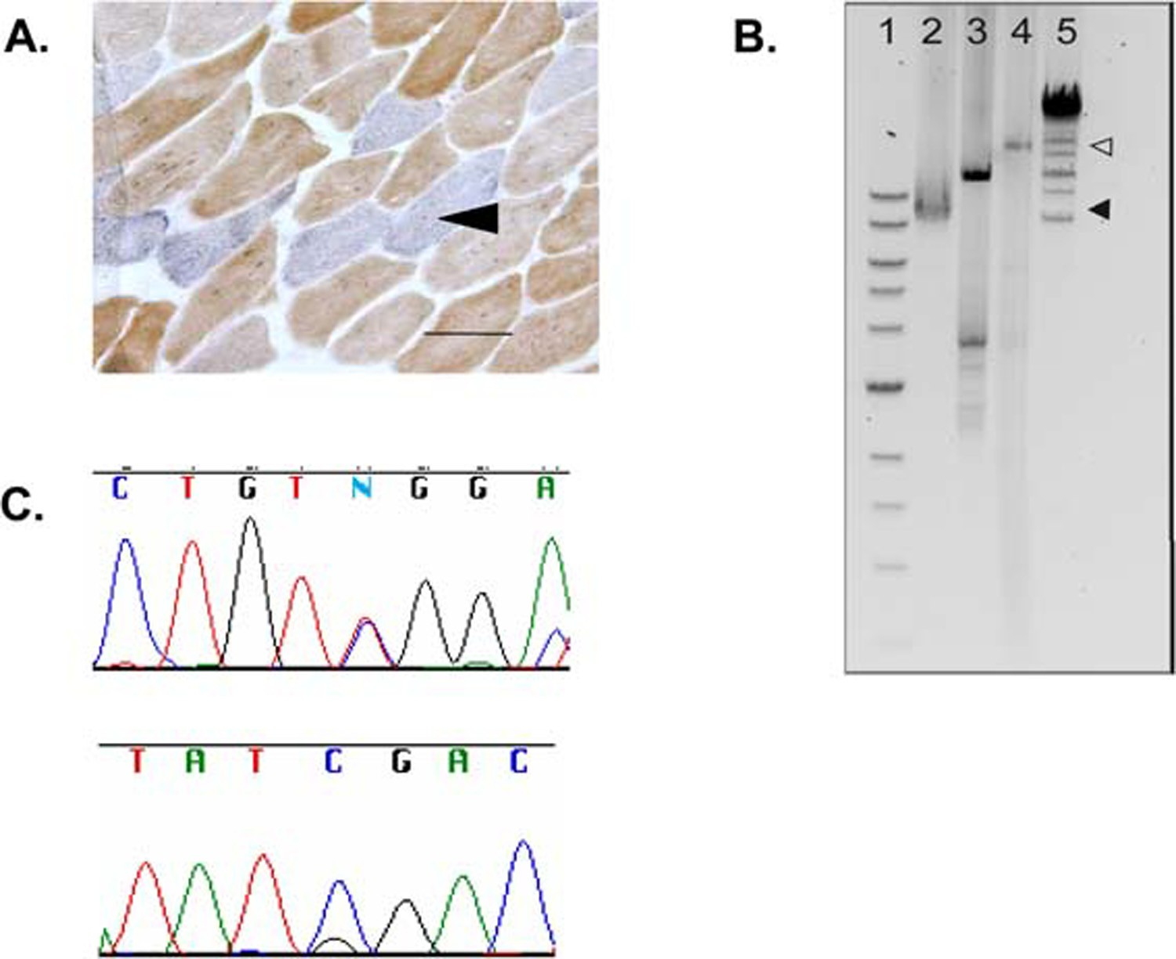

**Figure 1** (A) Dual histochemistry for the mitochondrial DNA-encoded cytochrome c oxidase (COX) and the nuclear DNA-encoded succi- nate dehydrogenase (SDH) on the patient’s vastus lateralis muscle biopsy demonstrates COX-deficient fibres (blue) and muscle fibres expressing both COX and SDH (brown). Scale bar: 100 μm.

1. Long-range PCR amplification of mtDNA from skeletal muscle. Lane1=1 kb ladder (New England Biolabs, Ipswich, Massachusetts, USA), lane 2 = the proband, lane 3 = patient with a sporadic mtDNA deletion, lane 4 = mtDNA from a healthy control, lane 5 = mix ladder (Fermentas Finland; Helsinki, Finland). White arrow head, the full-size 16.5 kb amplicon. Black arrow head, small-sized amplicons on lane 2.
2. Sequence chromatogram showing heterozygous changes in the *POLG1* gene. Above: the Ser998Leu change (c.2993C>T, TCG > TTG) detected with forward primer. Below: the Asp1184His change (c.3550G>C, GAT > CAT) detected with reverse primer.

of vascular lesions or hydrocephalus. Additional central ner- vous system examinations were not performed.

Total DNA was extracted from muscle tissue homoge- nate using the standard sodium dodecyl sulphate- proteinase K method and from blood using QIAamp DNA Blood Mini Kit (Qiagen, Valencia, California, USA). Mito- chondrial DNA (mtDNA) deletions were analysed by long PCR (Expand Long Template PCR System kit; Roche, Man- nheim, Germany). Blood DNA was used as a template to amplify and sequence the 23 coding exons of the *POLG1* gene (NM_002693) in the proband by automated sequenc- ing (ABI PRISM 3100 Genetic Analyzer; Applied Biosys- tems, Foster City, California, USA) using the BigDye Terminator v1.1 Cycle Sequencing Kit (Applied Biosys- tems) after treatment with exonuclease I and shrimp alka- line phosphatase. The novel sequence variants found in *POLG1* were confirmed using restriction fragment length polymorphism analysis. The p.1184D>H substitution destroys a recognition site for TaqI leading to an undigested PCR product of 289 bp in size. The p.998S>L substitution destroys a recognition site for Hpy118I leading to an undi- gested PCR product of 277 bp in size.

# OUTCOME AND FOLLOW-UP

Initial analysis for the common mtDNA point mutations m.3243A>G, m.8344A>G and m.8993T>C, as well as Southern blot analysis to demonstrate large mtDNA dele- tions, were negative. Further molecular analysis revealed multiple mtDNA deletions confirming mitochondrial dis- ease (figure 1B). Sequencing of the entire *POLG1* gene revealed two heterozygous nucleotide substitutions: c.2993C>T (p.998S>L) and c.3550G>C (p.1184D>H) (fig-

ure 1C). Both are previously unreported. The two daugh-

ters of the proband as well as one child of the elder daughter harboured heterozygous p.1184D>H, but p.998S>L was found only in the proband. These findings confirm that the two novel base exchanges in the proband were heterozy- gous in trans.

# DISCUSSION

Since 1989, nuclear defects have been implicated as possible aetiologies of mitochondrial disease.1 *POLG1* gene encodes the catalytic subunit of pol-, the only DNA polymerase in human mitochondria, and its mutations have emerged as an important aetiology of human mitochondrial disease.2–5

 

PEO and encephalopathy are both frequent phenotypic fea- tures in mitochondrial diseases but, in patients with *POLG1* mutations, encephalopathic phenotypes present most often in childhood. The combination of adult-onset PEO and encephalopathy is uncommon.56

▲

▲

Our patient had a PEO-plus phenotype consisting of bilateral ptosis, external ophthalmoplegia and progressive encephalopathy as dominant features. Muscle histology showed COX-negative fibres that were abnormally fre- quent to the age of the patient. Molecular genetic analysis revealed multiple mtDNA deletions in muscle and het- erozygous in trans mutations p.998S>L and p.1184D>H in the *POLG1* gene. Neither of them has been described pre- viously, but another pathogenic mutation, p.1184D>N, has previously been described in the position 1184. The p.1184D>N mutation has been described in trans with the exonuclease domain mutation p.227R>W in children with failure to thrive, mental retardation and hypotonia,7 and in adults with a linker region mutation p.468N>D with PEO and tetraparesis.8 Both p.998S>L and p.1184D>H muta- tions are located in the polymerase domain of pol- in posi- tions that are evolutionarily conserved suggesting that the mutations are pathogenic.

▲

Our patient harboured two novel *POLG1* mutations. Her

clinical features, a relatively late adult-onset symptom com- bination of PEO and prominent, dementing, encephalopa- thy, demonstrate the wide phenotypic variety of the *POLG1* mutations. The possibility of a *POLG*-associated disease should be considered in any patient with unex- plained or unusual neurological features.9

**Learning points**

The variety of clinical features and their combinations in *POLG1*-associated disease is considerable.

The possibility of *POLG1*-associated disease should be

considered in cases with late-onset encephalopathy. When there is strong clinical suspicion of *POLG1*- associated disease, failure to detect the most common point mutations should lead to sequencing of the whole gene.

**Acknowledgements** The authors thank Ms Anja Heikkinen and Ms Pirjo Kerônen for their expert assistance. The work was supported by the Research Council for Health at the Academy of Finland, the Sigrid Juselius Foundation, the National Graduate School of Clinical Investigation (CLIGS) and the North Ostro- bothnia Regional Fund of the Finnish Cultural Foundation.

**Competing interests** None.

**Patient consent** Obtained.

# REFERENCES

1. **Zeviani M,** Servidei S, Gellera C, *et al*. An autosomal dominant disorder with multiple deletions of mitochondrial DNA starting at the D-loop region. *Nature* 1989;**339**:309–11.
2. **Van Goethem G,** Dermaut B, L fgren A, *et al*. Mutation of POLG is

associated with progressive external ophthalmoplegia characterized by mtDNA deletions. *Nat Genet* 2001;**28**:211–12.

1. **Lamantea E,** Tiranti V, Bordoni A, *et al*. Mutations of mitochondrial DNA polymerase gammaA are a frequent cause of autosomal dominant or recessive progressive external ophthalmoplegia. *Ann Neurol* 2002;**52**:211–19.
2. **Hudson G,** Chinnery PF. Mitochondrial DNA polymerase-gamma and human disease. *Hum Mol Genet* 2006;**15**:R244–52.
3. **Horvath R,** Hudson G, Ferrari G, *et al*. Phenotypic spectrum associated with mutations of the mitochondrial polymerase gamma gene. *Brain* 2006;**129**:1674–84.
4. **Wong LJ,** Naviaux RK, Brunetti-Pierri N, *et al*. Molecular and clinical genetics

of mitochondrial diseases due to POLG mutations. *Hum Mutat*

2008;**29**:E150–72.

1. **de Vries MC,** Rodenburg RJ, Morava E, *et al*. Multiple oxidative phosphorylation deficiencies in severe childhood multi-system disorders due to polymerase gamma (POLG1) mutations. *Eur J Pediatr* 2007;**166**:229–34.
2. **Gónzalez-Vioque E,** Blázquez A, Fernández-Moreira D, *et al*. Association of

novel POLG mutations and multiple mitochondrial DNA deletions with variable clinical phenotypes in a Spanish population. *Arch Neurol* 2006;**63**:107–111.

1. **Chinnery PF,** Zeviani M. 155th ENMC workshop: polymerase gamma and disorders of mitochondrial DNA synthesis, 21-23 September 2007, Naarden, The Netherlands. *Neuromuscul Disord* 2008;**18**:259–67

▲ ▲ ▲ ▲

This pdf has been created automatically from the final edited text and images.

Copyright 2010 BMJ Publishing Group. All rights reserved. For permission to reuse any of this content visit [http://group.bmj.com/group/rights-licensing/permissions.](http://group.bmj.com/group/rights-licensing/permissions)

BMJ Case Report Fellows may re-use this article for personal use and teaching without any further permission. Please cite this article as follows (you will need to access the article online to obtain the date of publication).

Martikainen R, Hinttala R, Majamaa K. Novel POLG1 mutations in a patient with adult-onset progressive external ophthalmoplegia and encephalopathy. *BMJ Case Reports* 2010;10.1136/bcr.01.2010.2604, date of publication

Become a Fellow of BMJ Case Reports today and you can: Submit as many cases as you like

Enjoy fast sympathetic peer review and rapid publication of accepted articles Access all the published articles

Re-use any of the published material for personal use and teaching without further permission

For information on Institutional Fellowships contact [consortiasales@bmjgroup.com](mailto:consortiasales@bmjgroup.com) Visit casereports.bmj.com for more articles like this and to become a Fellow