[Autonomic Neuroscience: Basic and Clinical 170 (2012) 70–72](http://dx.doi.org/10.1016/j.autneu.2012.06.002)

Contents lists available at [SciVerse ScienceDirect](http://www.sciencedirect.com/science/journal/15660702)

Autonomic Neuroscience: Basic and Clinical

journal homepage: [www.](http://www/) elsevier. com/ locate/autneu

Short communication

Novel mutation in spacer region of *POLG* associated with ataxia neuropathy spectrum and gastroparesis

Alionka Bostan a,⁎, Gerald Glibert a, Bernard Dachy a, Bernard Dan b

a *Department of Neurology, CHU Brugmann, Universite Libre de Bruxelles, Place A. Van Gehuchten 4, Brussels B 1020, Belgium*

b *Department of Neurology, Hôpital Universitaire des Enfants Reine Fabiola, Universite Libre de Bruxelles (ULB), Brussels, Belgium*

# a r t i c l e i n f o

*Article history:*

Received 17 November 2011

Received in revised form 15 June 2012 Accepted 17 June 2012

*Keywords:* Polymerase gamma Mitochondrial DNA Polyneuropathy Gastroparesis

# a b s t r a c t

Clinical expression of *POLG* mutations is largely variable. We present a patient with a new mutation in spacer region of mitochondrial polymerase gamma protein (P765T). The clinical picture is characterized by the pres- ence of sensory–ataxic neuropathy, ophthalmoplegia, dysarthria and gastroparesis, which had not been pre- viously observed in ataxia neuropathy spectrum.

© 2012 Elsevier B.V. All rights reserved.

1. Introduction

DNA polymerase gamma (POLG), the only DNA polymerase found in mitochondria, is entirely responsible for all DNA synthetic reactions in- cluding mtDNA replication and repair (Hance et al., 2005). POLG is a heterodimeric enzyme containing a Pol I-like catalytic core (PolgA) and an accessory subunit (PolgB), encoded by *POLG* at locus 15q25 and *POLG2* at locus 17q24.1, respectively (Chan and Copeland, 2009). PolgA possesses both polymerase and proofreading exonuclease activities; PolgB increases enzyme's processivity (Lee et al., 2009). Mutations in the catalytic subunit of *POLG* can cause mtDNA instability, inducing its de- letion and/or depletion. Mutation database ([http://tools.niehs.nih.gov/](http://tools.niehs.nih.gov/polg/) [polg/](http://tools.niehs.nih.gov/polg/)) currently lists more than 150 *POLG* mutations, which are evenly distributed over the protein sequence. In addition to the clinical heteroge- neity, *POLG* mutations can be either dominant or recessive, posing a great diagnostic challenge for the clinician.

The phenotypic spectrum is wide, including encephalopathy, epilep- sy, ataxia, ophthalmoplegia, neuropathy, myopathy and hepatopathy. Among neurological features of POLG related disorders, the ataxia neu- ropathy spectrum (ANS) has been deﬁned, comprising mitochondrial recessive ataxia syndrome (MIRAS) and sensory ataxia neuropathy dys- arthria and ophthalmoplegia (SANDO).

We report a P765T *POLG* missense mutation in a patient with sensory–

ataxic neuropathy, ophthalmoplegia, dysarthria and gastroparesis. To our knowledge, this mutation of *POLG* coding region has not been reported previously (Cohen and Naviaux, 2010).

⁎ Corresponding author at: Neurology Department, CHU Brugmann, Université Libre de Bruxelles, Place A. Van Gehuchten 4, 1020 Brussels, Belgium. Tel.: +32 2 477 24 49.

*E-mail address:* [abostan@ulb.ac.be](mailto:abostan@ulb.ac.be) (A. Bostan).

1. Case report

A 52 year-old Moroccan woman, presented with a 10-year history of drooping eyelids (without daytime ﬂuctuation) and slurred speech, she developed over the past six months progressive gait instability, leg numbness and inability to feel the ground under her feet. Several weeks prior to admission, she suffered from anorexia and had a dra- matic weight loss; she lost 15 kg over past two months. She was complaining of early satiety, bloating, upper-abdominal discomfort and tendency to constipation. The patient's deceased mother had a similar bilateral ptosis, without any other ocular signs, her parents were not consanguineous. The patient has one healthy daughter.

On neurological examination, she had unaltered mental status, bi- lateral ptosis, complete ophthalmoplegia, optic discs atrophy. Pupils were equally reactive. A ﬂaccid type dysarthria was noted. She had mild upper and lower limb muscle weakness with distal predomi- nance. Deep tendon jerks were absent, plantar responses were ﬂexor. Muscular tone was normal, no dysmetria was observed. Sensation to touch and pin prick was normal. She had impaired vibratory and po- sition sensation in both feet. Gait was staggering and wide-based, which made the Romberg test impracticable. General examination was otherwise unremarkable.

The patient had normal liver, renal and thyroid functions, normal electrolytes, sedimentation rate, creatine kinase, serum protein elec- trophoresis, serum lactate and urine organic acid proﬁle.

A 1.5 Tesla brain MRI showed mild cortical–subcortical atrophy

without any other parenchymal abnormalities. Sensory nerve con- duction studies showed low amplitude radial sensory nerve action potential (SNAP) (4.8 μV; normal >20 μV) and absent sural SNAP. Motor conduction velocities were decreased in the median nerve

1566-0702/$ – see front matter © 2012 Elsevier B.V. All rights reserved. doi:[10.1016/j.autneu.2012.06.002](http://dx.doi.org/10.1016/j.autneu.2012.06.002)

*A. Bostan et al. / Autonomic Neuroscience: Basic and Clinical 170 (2012) 70*–*72* 71

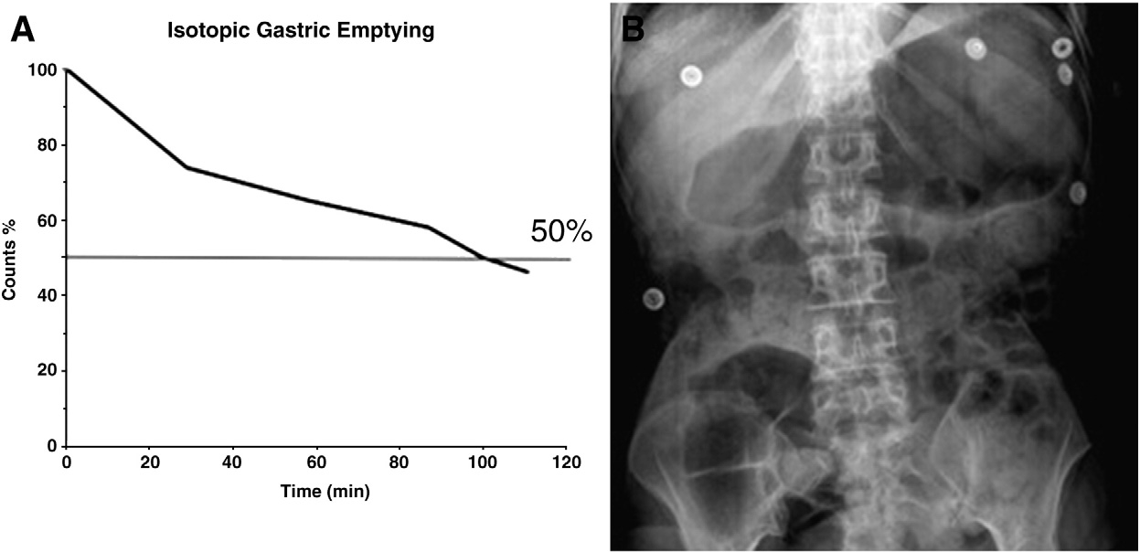

Fig. 1. A — Isotopic gastric emptying study showing markedly delayed gastric emptying with clearance time (*T* ½ or *T*50%) of 100 minutes. Normal range is 50±15 minutes. B — X-ray study showing important gastric and bowel distention.

(44 m/s; normal>48 m/s) and the tibial nerve (35 m/s; normal> 40 m/s). F-wave latencies were mildly prolonged in the tibial nerve (minimal latency 58.8 ms; normalb58 ms). This is suggestive of an axonal sensori-motor neuropathy with sensory predominance. Nee- dle electromyographic studies (EMG) showed some polyphasic motor unit action potentials in upper and lower extremities. These were also found in the orbicularis oris, orbicularis oculi and sternocleidomastoid muscles, which also showed a myogenic EMG pattern with short, low-amplitude motor unit action potentials. Brainstem auditory evoked potentials and blink reﬂex were normal. Neuro-ophthalmologic examination (including electro-retinography) suggested chronic progressive external ophthalmoplegia without retinopathy. X-ray studies demonstrated gastric and bowel disten- tion. Isotope gastric emptying showed markedly delayed empty- ing, consistent with gastroparesis (Fig. 1).

Deltoid muscle immunohistochemistry showed changes character- istic of a muscular dystrophy with COX-negative ﬁbers, suggesting mi- tochondrial disorder. Electron microscopy showed paracrystalline mitochondrial inclusions (Fig. 2). All oxidative phosphorylation enzyme complexes were diminished on mitochondrial enzymatic activity as- says. Analysis of *TYMP* gene demonstrated normal coding sequences. Direct sequencing of *POLG* gene exons showed a homo- or hemizygous

point mutation in 765 codon (P765T) located in exon 14, which is an evolutionary conserved amino acid. The MLPA analysis performed indi- cates the mutation at homozygous state in our patient. The patient's daughter carries the same mutation at heterozygous state.

1. Discussion

We report a patient with dramatic weight loss, gastroparesis, ptosis, ophthalmoplegia and peripheral neuropathy. The latter caused signiﬁ- cant sensory ataxia. The absence of dysmetria and the ﬂaccid character of the dysarthria were inconsistent with additional cerebellar involve- ment. Muscular involvement was proven by the biopsy suggestive of mitochondrial disorder. Most of our patient's features, and particularly

sensory–ataxic neuropathy, dysarthria and ophthalmoplegia, ﬁt best

with SANDO of the ANS, typically associated with *POLG* mutations (Van Goethem et al., 2001; Santoro et al., 2006). Our patient's clinical picture may be also evocative of ‘mitochondrial neurogastrointestinal encephalopathy’ (MNGIE) (Nishino et al., 2000) but was excluded by the absence of white matter abnormalities on MRI and normal *TYMP* sequencing.

The POLG protein maintains mitochondrial DNA integrity and replication (Kasiviswanathan et al., 2010). Its catalytic subunit contains exonuclease and

[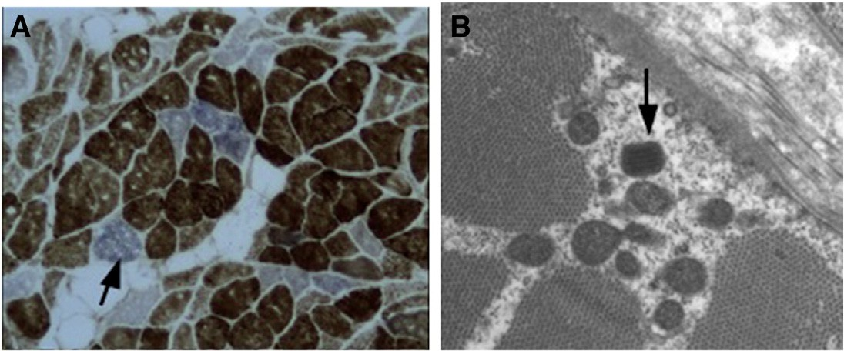](image%20of%20Fig. 2)

Fig. 2. A — COX-SDH staining showing cox negative muscle ﬁbers (arrow) in deltoid muscle biopsy; B— electron microscopy showing paracrystalline inclusions (arrow).

72 *A. Bostan et al. / Autonomic Neuroscience: Basic and Clinical 170 (2012) 70*–*72*

polymerase domains separated by spacer (Lee et al., 2009). This has two subdomains involved in intrinsic processivity and DNA–protein interac- tion, respectively (Lee et al., 2009). Our patient's P765T mutation is situated in the intrinsic processivity subdomain, thought to impart additional enzyme processivity through additional primer-template interactions. Mutations in the spacer region induce varied biochemical

abnormalities and associated clinical manifestations (Wong et al., 2008). Our patient shows features described in other mutations in POLG spacer unit. G763R *POLG* mutation was associated with progres- sive external ophthalmoplegia and sensorimotor neuropathy (Santoro et al., 2006), and A767D mutation with epilepsy without any peripheral nervous system involvement (Horvath et al., 2006). In our patient, a novel *POLG* mutation is associated with ANS plus gastroparesis, which has not been observed previously. The digestive dysregulation could be the result of energy deprivation following mitochondrial loss of function due to accumulation of mtDNA mutations/deletions and decline of respi- ratory chain function with severe consequences for all energy-dependent cellular functions, including gastric nerve cells. Our report illustrates clinical variability of *POLG* mutations and underlines the importance of further biochemical and translational research to better address the pathogenicity of POLG dysfunction. In addition, gastric dysmotility should be more readily searched for in this clinical conjuncture.

Acknowledgements

We thank Prof. H. Kadhim for performing the pathological studies and Prof. G. Van Goethem for genetic studies.

References

Chan, S.S., Copeland, W.C., 2009. DNA polymerase gamma and mitochondrial disease: understanding the consequence of POLG mutations. Biochim. Biophys. Acta 1787, 312–319.

Cohen, B.H., Naviaux, R.K., 2010. The clinical diagnosis of POLG disease and other mito- chondrial DNA depletion disorders. Methods 51, 364–373.

Hance, N., Ekstrand, M., Trifunovic, A., 2005. Mitochondrial DNA polymerase gamma is essential for mammalian embryogenesis. Hum. Mol. Genet. 14, 1775–1783.

Horvath, R., et al., 2006. Phenotypic spectrum associated with mutations of the mitochon- drial polymerase gamma gene. Brain 129, 1674–1684.

Kasiviswanathan, R., Longley, M.J., Young, M.J., Copeland, W.C., 2010. Puriﬁcation and functional characterization of human mitochondrial DNA polymerase gamma harboring disease mutations. Methods 51 (4), 379–384.

Lee, Y.S., Kennedy, W.D., Yin, Y.W., 2009. Structural insight into processive human mito- chondrial dna synthesis and disease-related polymerase mutations. Cell. 139 (2), 312–324.

Nishino, I., et al., 2000. Mitochondrial neurogastrointestinal encephalomyopathy: an autosomal recessive disorder due to thymidine phosphorylase mutations. Ann. Neurol. 47, 792–800.

Santoro, L., et al., 2006. A new POLG1 mutation with peo and severe axonal and demye- linating sensory–motor neuropathy. J. Neurol. 253, 869–874.

Van Goethem, G., Dermaut, B., Löfgren, A., Martin, J.J., Van Broeckhoven, C., 2001. Mu- tation of POLG is associated with progressive external ophthalmoplegia character- ized by mtDNA deletions. Nat. Genet. 28, 211–212.

Wong, L.J., et al., 2008. Molecular and clinical genetics of mitochondrial diseases due to POLG mutations. Hum Mutat. 29 (9), E150–72.