**Clinical commentary**

*Epileptic Disord 2012; 14 (4): 438-41*

Successful treatment

of POLG-related mitochondrial epilepsy with antiepileptic drugs and low glycaemic index diet

Mika H Martikainen 1, Markku Päivärinta 1, Satu Jääskeläinen 2, Kari Majamaa 3

1 Department of Neurology

2 Department of Clinical Neurophysiology, University of Turku and Turku University

Hospital, Turku

3 University of Oulu, Department of Clinical Medicine and Neurology and Oulu

University Hospital, Department of Neurology, Oulu, Finland Received June 29, 2012; Accepted October 22, 2012

**Correspondence:**

Kari Majamaa

**ABSTRACT** – Epilepsy is a common manifestation of mitochondrial disease associated with mutations of the mitochondrial polymerase -y (POLG). Prog- nosis of mitochondrial epilepsy is often poor and there are few reports of successful treatment of POLG-related epilepsy. We describe a 26-year-old woman who experienced severe headache during a three-day period, fol- lowed by symptoms of visual ﬂashing, speech difﬁculty, and generalised seizures. EEG recording showed non-convulsive status epilepticus (left occipital area) and brain MRI revealed parieto-occipital T2-hyperintensities. Visual aura and aphasia persisted despite antiepileptic medication with phenytoin, oxcarbazepine, and levetiracetam. Mitochondrial disorder was clinically suspected and a homozygous c.2243G*>*C mutation (p.Trp748Ser) was discovered in the *POLG1* gene. The patient was then set on a low gly- caemic index treatment (LGIT) variant of the ketogenic diet, after which the headaches, aphasia, and visual aura progressively improved and disap- peared. She returned home two weeks after onset of symptoms and has not had further seizures. She continues to receive levetiracetam monotherapy and LGIT. We conclude that, at least for this patient, the combination of three antiepileptic drugs and LGIT is effective and well tolerated as treatment for severe episodes of POLG-related mitochondrial epilepsy.

**Key words:** epilepsy, ketogenic diet, low glycemic index treatment, mitochondrial disease, POLG

University of Oulu, Department of Clinical Medicine and Neurology,

doi:10.1684/epd.2012.0543

PO Box 5000,

FIN-90014 Oulu, Finland

[<kari.majamaa@oulu.ﬁ>](mailto:kari.majamaa@oulu.fi)

Epilepsy is a prevalent feature of disease related to mutations in the gene encoding the catalytic subunit of human mitochondrial DNA poly- merase -y, POLG (Tzoulis *et**al*., 2006).

Prognosis of mitochondrial epilepsy is often poor and there are only few reports of successful treatment of POLG-related epilepsy. The keto- genic diet (KD) is used as treatment

for intractable epilepsy and beneﬁcial effect of KD in severe POLG-related epilepsy in children has been previously reported (Joshi *et**al*., 2009). Here, we describe successful treatment of a 26-year-old woman with severe episodes of POLG-associated epilepsy (non-convulsive status epilepticus; NCSE) using phenytoin, oxcarbazepine, and levetiracetam medications with a low glycaemic index treatment (LGIT); a modiﬁed KD.

# Case report

The patient was investigated as a result of severe headaches at the age of 22 years. Brain MRI revealed non-speciﬁc white matter T2-hyperintesities in cere- bellar hemispheres. Clinically, horizontal nystagmus and slight problems with balance were noted. The diagnosis of multiple sclerosis was entertained, but not supported by her medical history and CSF exam- ination. No further investigations were performed. At age 26 years, she experienced a severe headache during a 3-day period. On day 4 after symptom onset, she presented to the emergency unit after having two generalised seizures. She also had symptoms of visual ﬂashing, ﬂuctuating visual blurring and ﬁeld defects, and speech difﬁculty. There was no previous history of such symptoms. At presentation, she was

slightly confused, but the neurological examination was otherwise normal. No signs of meningeal irrita- tion were noted. White cell count, myoglobin, and creatine kinase values were elevated, but other rou- tine investigations including CSF were normal. Head CT was normal. Meningoencephalitis or cerebral sinus thrombosis were not considered likely. The patient was admitted to the neurological ward for follow-up, but no antiepileptic medication was started.

On day 5, the patient had yet another seizure and intravenous phenytoin was initiated. She had severe headache with persistent visual aura, despite treatment with conventional analgesics, and a right homonymous hemianopia. She had word ﬁnding dif- ﬁculties but normal comprehension and she was not able to perform simple numerical tasks (*e.g*. count- ing down from 100). On day 6, EEG revealed slight slowing-down of background and continuous epilep- tiform polyspike and slow-wave complexes occurring pseudo-periodically at 0.5 to 2-second intervals within the left temporo-parieto-occipital region, with nega- tive maximum at the occipital electrode O1. These complexes were very similar to the rhythmic, high- amplitude, delta activity with polyspikes (RHADS) previously reported in children with POLG-related sta- tus epilepticus (Wolf *et**al*., 2009); however, in this adult patient, the amplitude of the delta waves only reached 130 µV (*ﬁgure 1*). The clinical condition and

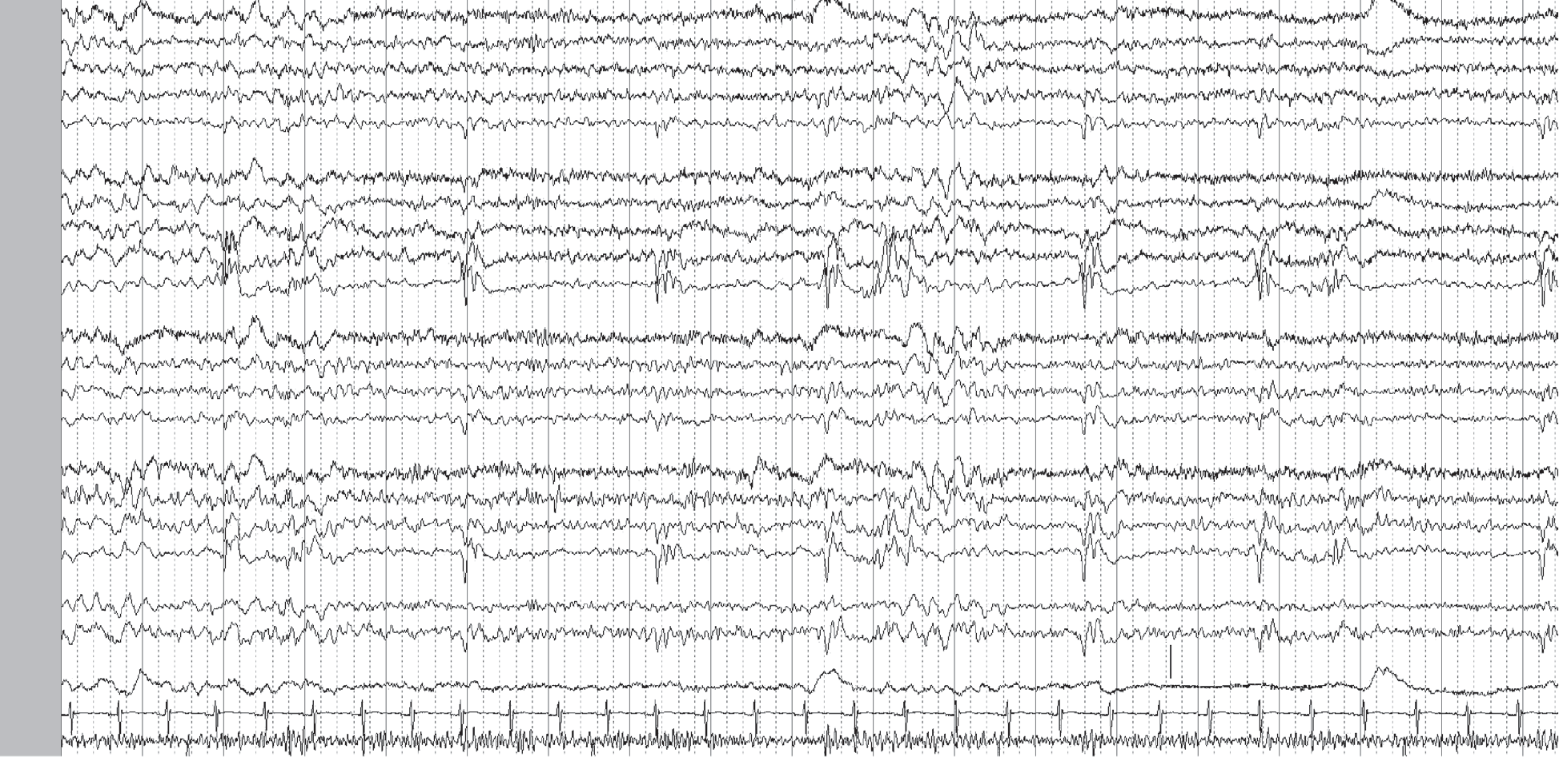

Fp2-F8 F8-T4 Z2-T4 T4-T6 T6-O2

Fp1-F7 F7-Z1 Z1-T3 T3-T5 T5-O1

Fp2-F4 F4-C4 C4-P4 P4-O2

Fp1-F3 F3-C3 C3-P3 P3-O1

Fz-Cz Cz-Pz

**100 µV**

EOG EKG EMG

**Figure 1.** Twenty-three-channel EEG recording obtained during non-convulsive status epilepticus (day 6). Continuous, quasi-rhythmic polyspike-and-delta wave activity was present within the left occipital region (maximum at O1 electrode).

Recording was performed with NicoletOne EEG (Nervus device, Cephalon Ltd., Nørresundby, Denmark), Electrocap with Ag-AgCl- electrodes, and standard international 10/20 electrode placement. The space between each vertical line represents one second and a bar of 100 µV is depicted above the EOG channel on the right-hand side.

EEG ﬁndings were compatible with NCSE. On the same day, brain MRI revealed new T2-hyperintense, oedemic lesions in the left thalamus and left parieto-occipital region (*ﬁgure 2*). Oxcarbazepine and levetiracetam were added to antiepileptic medication. POLG-related mitochondrial disorder was now suspected based on clinical symptoms as well as EEG and MRI ﬁnd- ings (Uusimaa *et**al*., 2008; Wolf *et**al*., 2009) and genetic testing was requested. On day 7, she was given LGIT (*for details, see* *Pfeifer**and**Thiele**[2005]*) which has been reported to be useful in patients with intractable epilepsy (Kossoff and Hartman, 2012; Pfeifer and Thiele, 2005). The diet was well tolerated with no signiﬁcant side effects. The patient’s condi- tion improved such that the headaches, aphasia, and visual aura gradually disappeared during the following four days. There were no further seizures. At discharge on day 12, she still had homonymous right-sided visual ﬁeld defect, which resolved slowly. Two months later, the visual ﬁelds were normal. During the follow-up, the patient did not have further seizures. Phenytoin and oxcarbazepine were gradually discontinued and she continues to receive levetiracetam monotherapy and LGIT. Genetic testing revealed a homozygous c.2243G*>*C mutation of the *POLG1* gene leading to p.Trp748Ser.

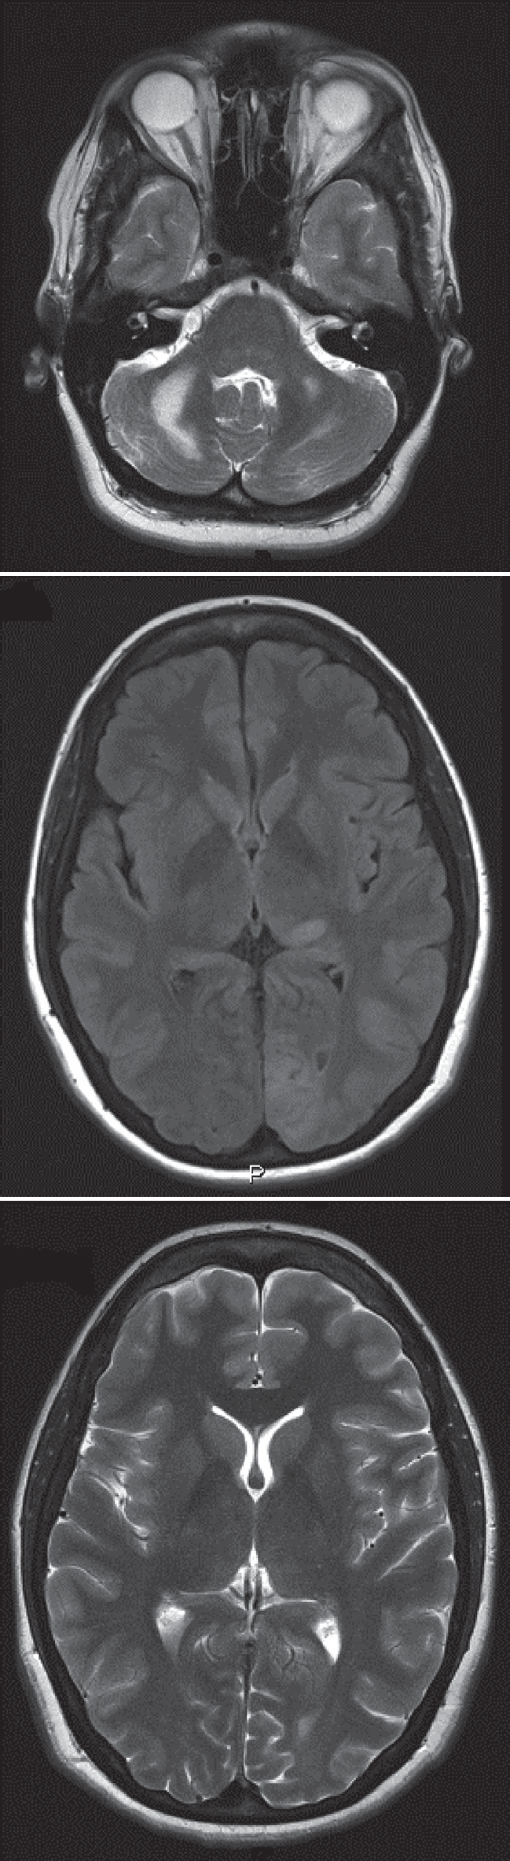

**A**

**B**

**C**

# Discussion

**Figure 2.** 3T brain MRI. (A) Cerebellar T2-hyperintense white matter lesions in T2-weighted sequence three years prior to the epileptic episode. (B) T2-hyperintense lesions in Fluid Attenuated Inversion Recovery (FLAIR) sequence in the left thalamus and the left parieto-occipital region at the time of the epileptic episode (day 6). (C) Resolution of thalamic and parieto-occipital lesions in T2-weighted sequence during treatment with antiepileptic drugs and ketogenic diet (day 74).

The ketogenic diet, including LGIT, has several plau- sible anticonvulsant mechanisms, such as increased energy production and increased -y-aminobutyric acid (GABA) synthesis in the brain (Bough and Rho, 2007; Kossoff and Hartman, 2012). In addition, recent animal study data suggest that a ketogenic diet may have bene- ﬁcial effects for mitochondrial disorders (Ahola-Erkkilä *et**al*., 2010). POLG-related mitochondrial disease is common in the population, *e.g*. in Finland, the carrier frequency of the p.Trp748Ser allele is estimated to be 1:125 (Hakonen *et**al*., 2005). In POLG-related mito- chondrial epilepsy, progression to status epilepticus is common and this condition may be highly resistant to treatment (Tzoulis *et**al*., 2006). Beneﬁt of magne- sium treatment has recently been reported in two patients with refractory status epilepticus and another homozygous *POLG1* mutation (p.Ala467Thr) (Visser *et**al*., 2011). Magnesium treatment was, however, not applied for the treatment of the patient reported here. We conclude that the combination of phenytoin, oxcarbazepine, levetiracetam, and LGIT was effective and well tolerated in a patient with severe episodes of POLG-related mitochondrial epilepsy manifesting as NCSE. We suggest that combining LGIT to antiepileptic drug treatment should be considered in this poten- tially life-threatening condition. □

**Disclosures.**

None of the authors has any conﬂict of interests to disclose.

**References**

Ahola-Erkkilä S, Carroll CJ, Peltola-Mjösund K, *et al*. Keto- genic diet slows down mitochondrial myopathy progression in mice*. Hum Mol Genet* 2010; 19: 1974-84.

Bough KJ, Rho JM. Anticonvulsant mechanisms of the keto- genic diet*. Epilepsia* 2007; 48: 43-58.

Hakonen AH, Heiskanen S, Juvonen V, *et al*. Mitochondrial DNA polymerase W748S mutation: a common cause of auto- somal recessive ataxia with ancient European origin*. Am J Hum Genet* 2005; 77: 430-41.

Joshi CN, Greenberg CR, Mhanni AA, Salman MS. Keto- genic diet in Alpers-Huttenlocher syndrome*. Pediatr Neurol* 2009; 40: 314-6.

Kossoff EH, Hartman AL. Ketogenic diets: new advances for metabolism-based therapies*. Curr Opin Neurol* 2012; 25: 173-8.

Pfeifer HH, Thiele EA. Low-glycemic-index treatment: a lib- eralized ketogenic diet for treatment of intractable epilepsy*. Neurology* 2005; 65: 1810-2.

Tzoulis C, Engelsen BA, Telstad W, *et al*. The spectrum of clin- ical disease caused by the A467T and W748S *POLG* mutations: a study of 26 cases*. Brain* 2006; 129: 1685-92.

Uusimaa J, Hinttala R, Rantala H, *et al*. Homozygous W748S mutation in the *POLG1* gene in patients with juvenile- onset Alpers syndrome and status epilepticus*. Epilepsia* 2008; 49: 1038-45.

Visser NA, Braun KP, Leijten FS, *et al*. Magnesium treatment for patients with refractory status epilepticus due to *POLG1* mutations*. J Neurol* 2011; 258: 218-22.

Wolf NI, Rahman S, Schmitt B, *et al*. Status epilepticus in chil- dren with Alpers’ disease caused by *POLG1* mutations: EEG and MRI features*. Epilepsia* 2009; 50: 1596-607.