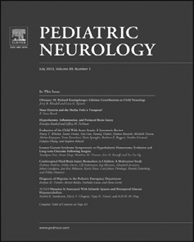[Pediatric Neurology 51 (2014) 734](http://dx.doi.org/10.1016/j.pediatrneurol.2014.06.015)e[736](http://dx.doi.org/10.1016/j.pediatrneurol.2014.06.015)

Contents lists available at [ScienceDirect](http://www.sciencedirect.com/science/journal/08878994)

Pediatric Neurology

journal homepage: [www.elsevier.com/locate/pnu](http://www.elsevier.com/locate/pnu)

Clinical Observations

Cranial Nerve and Cervical Root Enhancement in an Infant With Polymerase Gamma Mutation Mitochondrial Disease



Deanna M. Horst a, Lynne Ruess MD a,b,*, Jerome A. Rusin MD a,b,

Dennis W. Bartholomew MD c,d

a *Department of Radiology, Nationwide Children*’*s Hospital, Columbus, Ohio*

b *Department of Radiology, The Ohio State University College of Medicine and Public Health, Columbus, Ohio*

c *Center for Molecular and Human Genetics, Nationwide Children*’*s Hospital Research Institute, Columbus, Ohio*

d *Department of Pediatrics, The Ohio State University College of Medicine and Public Health, Columbus, Ohio*

abstract

BACKGROUND: Nuclear polymerase gamma (*POLG*) mutations are the most common cause of inherited mito- chondrial disease. *POLG* mutation diseases have a broad spectrum of clinical manifestations; the lethal infantile form is myocerebrohepatopathy spectrum. PATIENT: A 4-month-old boy was referred for poor feeding, emesis, failure to thrive, and hypotonia. RESULTS: Brain computed tomography was normal. Brain magnetic resonance imaging with and without contrast demonstrated bilateral enhancement of cranial nerves III, V-X, and the upper and midcervical nerve roots. Liver biopsy revealed early cirrhosis, steatosis, and focal necrosis. Muscle biopsy did not demonstrate speciﬁc abnormalities of mitochondrial morphology or number. Electron transport chain analysis of both ﬁbroblasts and muscle demonstrated deﬁciencies. Because of suspected mitochondrial depletion disorder, testing was performed for mitochondrial abnormalities including analysis of the *POLG* gene, which revealed two pathogenic mutations, c.1399G>A (p.A467T) and c.3285C>G (p.S1095R). CONCLUSIONS: We report abnormal gad- olinium enhancement of multiple cranial nerves and cervical nerve roots in an infant with myocerebrohepatop- athy spectrum disease whose brain MRI otherwise revealed only mild atrophy. Mitochondrial disease should be included in the differential diagnosis of cranial nerve enhancement. Contrast-enhanced MRI aids in the diagnostic evaluation of infants with developmental delay and suspected neurological disease.

*Keywords:* mitochondrial disease, infant, imaging, MRI

Pediatr Neurol 2014; 51: 734-736

© 2014 Elsevier Inc. All rights reserved.

Introduction

Inherited mitochondrial diseases are most commonly associated with mutations in the mitochondrial DNA (mtDNA) polymerase, polymerase gamma 1 (*POLG*) gene.1 More than 160 pathogenic mutations in the *POLG* gene have been identiﬁed.2 Inheritance is usually autosomal recessive; however, autosomal dominant forms exist. *POLG* disease may present in children or adults. At least six distinct phenotypes with varying hepatic, musculoskeletal,

Presented at the annual meeting for the Society for Pediatric Radiology; May 13-17, 2014; Washington, DC.

*Article History:*

Received April 18, 2014; Accepted in ﬁnal form June 22, 2014

* Communications should be addressed to: Dr. Ruess; Department of Radiology; Nationwide Children’s Hospital; Columbus, Ohio 43205.

*E-mail address:* [lynne.ruess@nationwidechildrens.org](mailto:lynne.ruess@nationwidechildrens.org)

and central and peripheral nervous system involvement are currently recognized.1 More severe and lethal forms of *POLG* disease present in infancy.

We describe abnormal gadolinium enhancement of multiple cranial nerves in an infant with *POLG* disease who otherwise had only mild signs of cortical and white matter atrophies on magnetic resonance imaging (MRI). This child expands the differential diagnosis of cranial nerve enhancement in infants with neurological disease and should prompt evaluation for *POLG* mutations in the appropriate clinical setting.

Patient Description

A 4-month-old boy was referred for poor feeding, emesis, failure to thrive, hypotonia, and elevated transaminases. He was the ﬁrst child of nonconsanguineous parents born at 39 weeks of gestation by vaginal delivery without signiﬁcant prenatal complications. He weighed

0887-8994/$ - see front matter © 2014 Elsevier Inc. All rights reserved. <http://dx.doi.org/10.1016/j.pediatrneurol.2014.06.015>

*D.M. Horst et al. / Pediatric Neurology 51 (2014) 734*e*736* 735

3.209 kg with head circumference in the eighty-eighth percentile. Apgar scores were 9 and 9 at 1 and 5 minutes. Newborn screening test results were negative. Perinatal course was uneventful except hyper- bilirubinemia at 1 week of age treated with phototherapy. Family history was noncontributory.

Examination on admission demonstrated an irritable nondysmorphic child with mild ptosis, poor head control, palpable liver edge 3 cm below the costal margin, decreased muscle mass, central hypotonia, and absent deep tendon reﬂexes. Head circumference had decreased to the thir- teenth percentile. Initial laboratory tests demonstrated elevated levels of direct bilirubin 2.8 mg/dL (normal [nl] <0.6 mg/dL), indirect bilirubin

1.3 mg/dL (nl, 0.1-1.0 mg/dL), aspartate aminotransferase 448 U/L (nl, 5- 105 U/L), alanine aminotransferase 167 U/L (nl, 7-110 U/L), and Lactate dehydrogenase 2221 U/L (nl, 600-1400 U/L). The plasma lactate level peaked at 12.3 mmol/L (nl, 0.5-2.2 mmol/L). The cerebrospinal ﬂuid protein level was 1113 mg/dL (nl, 15-45 mg/dL). An abdominal ultraso- nography demonstrated gallbladder sludge. Noncontrast brain computed tomography scan was normal.

The clinical phenotype of poor head control and progressive weak- ness of the upper extremities suggested a mitochondrial disorder and prompted a brain MRI to investigate the possibility of metabolic stroke or basal ganglia abnormalities. The MRI with and without intravenous contrast demonstrated bilateral enhancement of cranial nerves (CN) III and V-X, as well as dorsal nerve root enhancement in the visualized portion of the cervical spine (Figure A-E). Dedicated spine imaging was not performed. The MRI also revealed prominent subarachnoid spaces and ventricle size indicative of cortical and white matter atrophy (Figure F) in the setting of a small and decreasing head circumference. No additional MRI abnormalities were observed. The myelination pattern was normal for age (Figure F,G). Galactocerebrosidase and arylsulfatase

A activities were normal. Testing for spinal muscular atrophy, tyrosine- mia type 1, galactosemia, mitochondrial genome mutations, pyruvate disorders, Niemann-Pick disease, and peroxisomal defects were also unremarkable.

Three weeks after admission, the child worsened. He developed hypoxia, ascites, tachycardia, intermittent fevers, and sepsis. Liver biopsy revealed ﬁndings of early cirrhosis, steatosis, and focal necrosis. Electron transport chain (ETC) analysis of ﬁbroblasts was consistent with complex III deﬁciency. Muscle biopsy did not demonstrate speciﬁc abnormalities of mitochondrial morphology or number. Type 1 muscle ﬁbers were predominant and shorter than expected. Some severely cytochrome oxidase-deﬁcient muscle ﬁbers were present. No mtDNA mutations or deletions were observed. However, muscle ETC analysis revealed de- ﬁciencies in all ETC complexes except complex II. In particular, de- ﬁciencies in complexes I and IV met major modiﬁed Walker criterion. Because of suspicion for a mitochondrial depletion disorder, testing to include analysis of the *POLG* gene revealed two pathogenic mutations, c.1399G>A (p.A467T) and c.3285C>G (p.S1095R).

The patient died at 7 months of age because of respiratory failure.

Discussion

Polymerase gamma 1 (POLG) is a nuclear-encoded enzyme responsible for the replication and maintenance of the mtDNA genome. Faulty *POLG* activity induces mutations within the mtDNA that translate into depletions of mtDNA copy number, single-nucleotide substitutions, and multiple- nucleotide deletions.2 These alterations correlate with

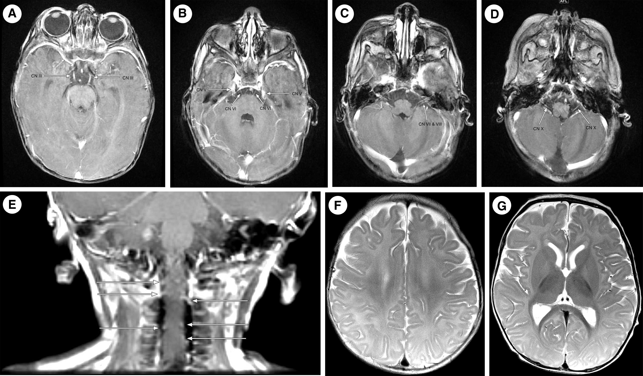

FIGURE.

Magnetic resonance images obtained at 4 months of age. (A-D) Gadolinium-enhanced T1-weighted axial images with abnormal bilateral enhancement of CNs III, V, VI, VII, VIII, and X (arrows). Patient also had bilateral CN IX enhancement (not shown). (E) Gadolinium-enhanced T1-weighted coronal image also reveals abnormal bilateral enhancement of multiple dorsal cervical nerve roots (arrows). (F) Axial T2-weighted image reveals mild cortical atrophy. (G) Axial T2-weighted image with prominent lateral ventricles and mild white matter atrophy with appropriate myelination for age. CN ¼ cranial nerve.

736 *D.M. Horst et al. / Pediatric Neurology 51 (2014) 734*e*736*

severe deﬁcits in functioning of the ETC complex, the facil- itator of oxidative phosphorylation. All the known patho- genic mutations in the *POLG* gene have been compiled into a National Institutes of Health database ([http://tools.niehs.](http://tools.niehs.nih.gov/polg/) [nih.gov/polg/](http://tools.niehs.nih.gov/polg/)). The most common mutation responsible for *POLG*-associated mitochondrial disease is c.1399G>A (p.A467T), either homozygous or compound heterozygous with another mutation.1 Tang et al.2 catalogued a large series of patients with *POLG* mutations, and only our patient had compound heterozygosity for c.1399G>A (p.A467T) and c.3285C>G (p.S1095R). The latter has previously been re- ported as pathogenic, conﬁrming the clinical impression of *POLG* deﬁciency.1

*POLG* mutations have a broad spectrum of clinical man- ifestations and age of onset. Liver, brain, and muscle are most commonly affected. At least six distinct phenotypes are recognized: (1) myocerebrohepatopathy spectrum (MCHS); (2) Alpers syndrome; (3) ataxia neuropathy spec- trum; (4) myoclonus epilepsy myopathy sensory ataxia; (5) autosomal recessive progressive external opthalmoplegia; and (6) autosomal dominant progressive external opthal- moplegia.1 The MCHS phenotype describes the clinical picture of our patient (infantile presentation of hypotonia, myopathy, developmental delay, encephalopathy, and liver dysfunction) and is the form of *POLG* disease with the earliest age of onset.1 MCHS can be distinguished from the more common Alpers syndrome by the lack of seizures, liver pathology, and more severe myopathy.3 MCHS disease has also been attributed to other mitochondrial gene mu- tations, not solely *POLG* mutations.3

Generally, infantile mitochondrial diseases have exten- sive white matter abnormalities including demyelination or delayed myelination, leukodystrophy, and cortical atrophy with or without gray matter nuclei abnormalities.4 Ferrari et al.3 reported a series of nine infants with *POLG* disease. The eight patients with Alpers syndrome had nonspeciﬁc white and gray matter MR abnormalities. One girl with a clinical picture of MCHS and multiple heterozygous *POLG* gene mutations presented at 3 months of age and died at 6 months. Her brain MRI was reportedly normal.

Abnormal cranial nerve enhancement has not been re- ported in a *POLG*-associated mitochondrial disease. Cranial nerve enhancement has been reported along with wide- spread cerebral white matter abnormalities in adult mito- chondrial neurogastrointestinal encephalomyopathy,5 and in childhood metabolic diseases including Krabbe disease and metachromatic leukodystrophy, both cranial nerve and cauda equina enhancement have been observed.6-9 Isolated cranial nerve enhancement signaled early infantile metachromatic leukodystrophy in one child.10

The mechanism behind enhancing cranial nerves has yet to be elucidated. Speculations include the breakdown of the

blood-nerve barrier because of perivascular inﬂammation or inﬁltration and areas of active demyelination.6 Nerve enhancement could also originate from the cytotoxic buildup of metabolites that prevent normal myelination and facilitate demyelination in diseases such as meta- chromatic leukodystrophy.8

Most articles describe MRI without contrast. This may explain the patient with MCHS who had a normal MRI in the study by Ferrari et al.3 Ganeson et al.7 advocated using contrast in the routine evaluation of infants with early onset of developmental delay when they identiﬁed a patient with early infantile Krabbe disease who had multiple enhancing cranial nerves along with nonspeciﬁc white matter changes at MRI. We are in agreement with Morana et al.,9 in hy- pothesizing that abnormal cranial nerve enhancement goes largely undetected because of the lack of administration of MRI contrast when evaluating infants.

In conclusion, the differential diagnosis of abnormal cranial nerve enhancement should be expanded to include *POLG* mutations and, more generally, mitochondrial dis- eases if the appropriate clinical signs are present. We have modiﬁed our MR protocols to include contrast enhance- ment for infants with suspected neurometabolic disease.

References

1. [Wong LJ, Naviaux RK, Brunetti-Pierri N, et al. Molecular and clinical](http://refhub.elsevier.com/S0887-8994(14)00391-9/sref1) [genetics of mitochondrial disease due to POLG mutations. *Hum*](http://refhub.elsevier.com/S0887-8994(14)00391-9/sref1)[*Mutat*. 2008;29:E150-E172](http://refhub.elsevier.com/S0887-8994(14)00391-9/sref1).
2. [Tang S, Wang J, Lee N, et al. Mitochondrial DNA polymerase gamma](http://refhub.elsevier.com/S0887-8994(14)00391-9/sref2) [mutations: an ever expanding molecular and clinical spectrum.](http://refhub.elsevier.com/S0887-8994(14)00391-9/sref2) [*J Med Genet*. 2011;48:669-681](http://refhub.elsevier.com/S0887-8994(14)00391-9/sref2).
3. [Ferrari G, Lamantea E, Donati A, et al. Infantile hepatocerebral](http://refhub.elsevier.com/S0887-8994(14)00391-9/sref3) [syndromes associated with mutations in the mitochondrial DNA](http://refhub.elsevier.com/S0887-8994(14)00391-9/sref3) [polymerase-gammaA. *Brain*. 2005;128:723-731](http://refhub.elsevier.com/S0887-8994(14)00391-9/sref3).
4. [Muñoz A, Mateos F, Simón R, García-Silva MT, Cabello S, Arenas J.](http://refhub.elsevier.com/S0887-8994(14)00391-9/sref4) [Mitochondrial diseases in children: neuroradiological and clinical](http://refhub.elsevier.com/S0887-8994(14)00391-9/sref4) [features in 17 patients. *Neuroradiology*. 1999;41:920-928](http://refhub.elsevier.com/S0887-8994(14)00391-9/sref4).
5. [Petcharunpaisan S, Castillo M. Multiple cranial nerve enhancement](http://refhub.elsevier.com/S0887-8994(14)00391-9/sref5) [in mitochondrial neurogastrointestinal encephalomyopathy.](http://refhub.elsevier.com/S0887-8994(14)00391-9/sref5) [*J Comput Assist Tomogr*. 2010;34:247-248](http://refhub.elsevier.com/S0887-8994(14)00391-9/sref5).
6. [Bernal OG, Lenn N. Multiple cranial nerve enhancement in early](http://refhub.elsevier.com/S0887-8994(14)00391-9/sref6) [infantile Krabbe’s disease. *Neurology*. 2000;54:2348-2349](http://refhub.elsevier.com/S0887-8994(14)00391-9/sref6).
7. [Ganesan K, Desai S, Hegde A. Multiple cranial nerve enhancement:](http://refhub.elsevier.com/S0887-8994(14)00391-9/sref7) [uncommon imaging ﬁnding in early infantile Krabbe’s disease.](http://refhub.elsevier.com/S0887-8994(14)00391-9/sref7) [*J Neuroimaging*. 2010;20:195-197](http://refhub.elsevier.com/S0887-8994(14)00391-9/sref7).
8. [Maia Jr AC, da Rocha AJ, da Silva CJ, Rosemberg S. Multiple cranial](http://refhub.elsevier.com/S0887-8994(14)00391-9/sref8) [nerve enhancement: a new MR imaging ﬁnding in metachromatic](http://refhub.elsevier.com/S0887-8994(14)00391-9/sref8) [leukodystrophy. *AJNR Am J Neuroradiol*. 2007;28:999](http://refhub.elsevier.com/S0887-8994(14)00391-9/sref8).
9. [Morana G, Biancheri R, Dirocco M, et al. Enhancing cranial nerves](http://refhub.elsevier.com/S0887-8994(14)00391-9/sref9) [and cauda equina: an emerging magnetic resonance imaging](http://refhub.elsevier.com/S0887-8994(14)00391-9/sref9) [pattern in metachromatic leukodystrophy and Krabbe disease.](http://refhub.elsevier.com/S0887-8994(14)00391-9/sref9) [*Neuropediatrics*. 2009;40:291-294](http://refhub.elsevier.com/S0887-8994(14)00391-9/sref9).
10. [Singh RK, Leshner RT, Kadom N, Vanderver AL. Isolated cranial](http://refhub.elsevier.com/S0887-8994(14)00391-9/sref10) [nerve enhancement in metachromatic leukodystrophy. *Pediatr*](http://refhub.elsevier.com/S0887-8994(14)00391-9/sref10)[*Neurol*. 2009;40:380-382](http://refhub.elsevier.com/S0887-8994(14)00391-9/sref10).