

[Brain & Development 37 (2015) 719–724](http://dx.doi.org/10.1016/j.braindev.2014.10.013)

Case Report

[www.elsevier.com/locate/braindev](http://www.elsevier.com/locate/braindev)



Myocerebrohepatopathy spectrum disorder due to *POLG* mutations: A clinicopathological report



Hesham Montassir a,b, Yoshihiro Maegaki a,⇑, Kei Murayama c, Taro Yamazaki d, Masakazu Kohda e, Akira Ohtake d, Hiroyasu Iwasa e, Yukiko Yatsuka f, Yasushi Okazaki e,f, Chitose Sugiura a, Ikuo Nagata g, Mitsuo Toyoshima h,

Yoshiaki Saito a, Masayuki Itoh i, Ichizo Nishino j, Kousaku Ohno a

a *Division of Child Neurology, Faculty of Medicine, Tottori University, Yonago, Japan*

b *Department of Family Medicine, Faculty of Medicine, Cairo University, Cairo, Egypt*

c *Department of Metabolism, Chiba Children’s Hospital, Chiba, Japan*

d *Department of Pediatrics, School of Medicine, Saitama Medical University, Saitama, Japan*

e *Division of Translational Research, Research Center for Genomic Medicine, Saitama Medical University, Hidaka, Japan*

f *Division of Functional Genomics & Systems Medicine, Research Center for Genomic Medicine, Saitama Medical University, Hidaka, Japan*

g *Division of Pediatrics and Perinatology, Faculty of Medicine, Tottori University, Yonago, Japan*

h *Department of Pediatrics, Graduate School of Medical and Dental Sciences, Kagoshima University, Kagoshima, Japan*

i *Department of Mental Retardation and Birth Defect Research, National Center of Neurology and Psychiatry, Tokyo, Japan*

j *Department of Neuromuscular Research, National Institute of Neuroscience, National Center of Neurology and Psychiatry, Tokyo, Japan*

Received 8 August 2014; received in revised form 6 October 2014; accepted 26 October 2014

Abstract

We report on the clinical, neuropathological, and genetic ﬁndings of a Japanese case with myocerebrohepatopathy spectrum (MCHS) disorder due to polymerase gamma (*POLG*) mutations. A girl manifested poor sucking and failure to thrive since 4 months of age and had frequent vomiting and developmental regression at 5 months of age. She showed signiﬁcant hypotonia and hepato- megaly. Laboratory tests showed hepatocellular dysfunction and elevated protein and lactate levels in the cerebrospinal ﬂuid. Her liver function and neurologic condition exacerbated, and she died at 8 months of age. At autopsy, fatty degeneration and ﬁbrosis were observed in the liver. Neuropathological examination revealed white matter-predominant spongy changes with Alzheimer type II glia and loss of myelin. Enzyme activities of the respiratory chain complex I, III, and IV relative to citrate synthase in the muscle were normal in the biopsied muscle tissue, but they were reduced in the liver to 0%, 10%, and 14% of normal values, respectively. In the liver, the copy number of mitochondrial DNA compared to nuclear DNA was reduced to 3.3% of normal values as evaluated by quantitative polymerase chain reaction. Genetic analysis revealed compound heterozygous mutations for *POLG* (I1185T/A957V). This case represents the diﬀerential involvement of multiple organs and phenotype-speciﬁc distribution of brain lesions in mitochon- drial DNA depletion disorders.

© 2014 The Japanese Society of Child Neurology. Published by Elsevier B.V. All rights reserved.

*Keywords:* Alpers syndrome; Mitochondrial DNA depletion; Myocerebrohepatopathy spectrum disorder; *POLG*

⇑ Corresponding author at: Division of Child Neurology, Faculty of Medicine, Tottori University, 36-1 Nishi-Cho, Yonago 683-8504, Japan. Tel.: +81 859 38 6777; fax: +81 859 38 6779.

*E-mail address:* [maegaki@med.tottori-u.ac.jp](mailto:maegaki@med.tottori-u.ac.jp) (Y. Maegaki).

<http://dx.doi.org/10.1016/j.braindev.2014.10.013>

0387-7604/© 2014 The Japanese Society of Child Neurology. Published by Elsevier B.V. All rights reserved.

1. Introduction

Mitochondrial DNA (mtDNA) depletion syndrome (MDDS), ﬁrst described in 1991, is deﬁned as a reduc- tion in the mtDNA copy number in diﬀerent tissues, leading to insuﬃcient synthesis of respiratory chain complexes (RCC) [1]. Clinical manifestations of MDDS involve many organ systems including the central and peripheral nervous system, liver, muscle, and gastroin- testinal tract [2]. Human polymerase gamma (*POLG*) is the common causative gene involved in MDDS, whose mutations result in a diverse group of pheno- types, such as Alpers syndrome and myocerebrohepat- opathy spectrum (MCHS) disorders, which typically show disease onset during early childhood. Further, several *POLG*-related phenotypes manifesting during adolescence and adulthood are recognized, including progressive external ophthalmoplegia, ataxia-neuropathy spectrum disorders, myoclonus epilepsy myopathy sensory ataxia, and sensory ataxic neuropathy with dysarthria/dysphagia and ophthalmoplegia. Some overlaps in the symptoms between these adult phenotypes exist, and can be additionally accompanied by tremor, parkin- sonism, hearing loss, stroke-like episodes, and gastroin- testinal symptoms, which are reminiscent of symptoms of mitochondrial diseases with pathomechanisms other than MDDS [3,4].

MCHS, the most severe phenotype of POLG disor- ders, was recently identiﬁed and is deﬁned by the clinical triad of (1) myopathy or hypotonia, (2) developmental delay or dementia, and (3) liver dysfunction [3,5]. Severe, intractable epilepsy is included in the diagnostic hallmarks of Alpers syndrome, but is not characteristic of MCHS. As the number of patients with MCHS disorders is small and detailed clinicopathological ﬁndings are unavailable, we herein report the case of a girl with MCHS disorders due to *POLG* mutations. As far as we know, this is the ﬁrst Japanese case of MCHS disorders with *POLG* mutation.

1. Case report

A girl was born at 40 weeks of gestation to healthy non-consanguineous parents without any abnormalities. The birth weight, height, and head circumference were normative. Early development and growth were unre- markable. At 4 months of age, she developed poor weight gain, emesis, hypotonia, developmental delay, and lethargy. She was admitted to our hospital because of recurrent vomiting at 6 months of age.

On admission, body length was 60.9 cm [-2.2 stan- dard deviation (SD)], body weight was 5600 g (-2.3 SD), and head circumference was 42 cm (+0.2 SD). Hepatomegaly of a hard consistency was observed approximately 3 cm under the costal margin with no associated splenomegaly. She was alert and could

establish good eye contact and smile. She showed severe hypotonia and proximal dominant muscular weakness. She could hold neither her head nor limbs up. All deep tendon reﬂexes were weak.

Although complete blood count and urinalysis were unremarkable, hepatocellular dysfunction was obvious at the time of hospitalization, with the following labora- tory test values: aspartate aminotransferase, 390 U/L; alanine aminotransferase, 218 U/L; total bilirubin,

1.6 mg/dL; total bile acids, 172 lmol/L; c-glutamyl transpeptidase, 179 IU/L; leucine aminopeptidase, 268 IU/L; and cholinesterase, 73 IU/L. Levels of serum creatine kinase and blood glucose were normal. Cerebrospinal ﬂuid (CSF) examination showed elevated protein levels of 304 mg/dL and normal cell count and glucose levels. Lactic acid was elevated in both plasma and CSF, at 15.9 mg/dL and 30.3 mg/dL, respectively. Pyruvic acid was normal in both plasma and CSF. Metabolic screening tests, including urine organic acids, plasma, and urine amino acids, were unremarkable. Initial brain computed tomography (CT) and magnetic resonance imaging performed at 6 months of age were unremarkable. The electroencephalogram showed gen- eralized slow wave activity. Only wave I was identiﬁable on auditory evoked potentials. Motor nerve and sensory conduction were mildly delayed.

Muscle biopsy ﬁndings at 6 months of age showed a variation in ﬁber type; ragged-red ﬁber was not observed. Lipid and glycogen storage were not observed. Cytochrome c oxidase staining showed normal ﬁndings. Analysis of the RCC enzyme activity revealed no abnormality. No mtDNA mutations were identiﬁed.

Soon after admission, diﬃculty in feeding and vomit- ing aggravated, and tube feeding along with parenteral nutrition was required. She experienced bouts of diarrhea. Consciousness level decreased progressively, and myoclonic jerks of the right and left arms were infrequently observed. Follow-up CT revealed mild cerebral atrophy at 7 months of age. Hepatocellular dysfunction exacerbated progressively, and she died of multiple organ failure caused by hepatic failure at 8 months of age, despite supplementation of multiple vitamins and coenzyme Q 10, and was autopsied. Two years later, another girl was born to the parents. She had the same clinical course and laboratory ﬁndings observed in the present patient and died at 7 months of age. Valproic acid was not used in either patient.

* 1. *Postmortem examinations*

Body weight was 6.0 kg (mean ± SD, 8.0 ± 0.88 kg). The weight of the atrophic liver was 200 g, and the sur- face was yellowish, irregular, and hard. The lungs were congested and adrenal glands were atrophic. The other visceral organs were unremarkable on macroscopic

examination. The brain weighed 760 g and showed massive edema and caudal necrosis. Microscopically, hepatocytes and adrenal cortical cells were swollen, and renal tubular cells contained phospholipids and diﬀuse foam cells. Similar foam cells were also seen in the lungs and cardiac muscle ﬁbers. In the liver, hepatic ﬁbrosis, microvesicular steatosis, and fatty degeneration were observed (Fig. 1). In the central nervous system, a spongy change was noted predominantly in the cerebral white matter, and neuronal loss in the cerebral and cerebellar cortex was mild. Alzheimer type II glia was observed in massive numbers in the cerebral and cerebel- lar white matter, with a smaller amount in the cerebral cortex and deep gray matter. Neuronal loss, capillary proliferation, and sponginess were prominent in the substantia nigra (Fig. 2). Recent linear necrosis was present in the bilateral caudate nucleus.

* 1. *Assay of respiratory chain complex enzyme activity in the liver*

The liver samples were immediately frozen at autopsy and stored at -70 °C. Activities of RCC I, II, III and IV were assayed as described previously [6,7]. The percent- ages of RCC I, II, III and IV activities relative to that of citrate synthase (CS) as a mitochondrial enzyme marker

were calculated. Relative enzyme activities of RCC I, III, and IV to CS in the liver were reduced to 0%, 10%, and 14% of normal values, respectively, while that of RCC II was reduced to 29%.

* 1. *Analysis of quantitative polymerase chain reaction of mtDNA and DNA sequence of POLG gene*

Written informed consent was obtained from the patient’s parents in order to perform gene analysis. The quantitative estimation of mtDNA was performed by real-time ampliﬁcation of fragments of *ND1* in the mtDNA genome, as previously described [7,8]. To deter- mine the overall abundance of mtDNA, we compared the real-time ampliﬁcation of *ND1* with a single-copy nuclear reference gene (exon 24 of the *CFTR* gene) [7,9]. The ratio of *ND1* to *CFTR* in the liver was reduced to 3.3% (SD, 1.2%) as compared to the control.

Mutation analysis was performed on the genomic DNA using primers designed to amplify the coding exons and the exon-intron boundaries of *POLG* (NM_002693.2). Fragments were analyzed by direct sequencing using ABI 3130XL (Applied Biosystems, Tokyo, Japan). The genetic analysis revealed compound heterozygous mutations in *POLG* (c.2870C>T, p.A957V and c.3554T>C, p.I1185T). The two DNA mutations

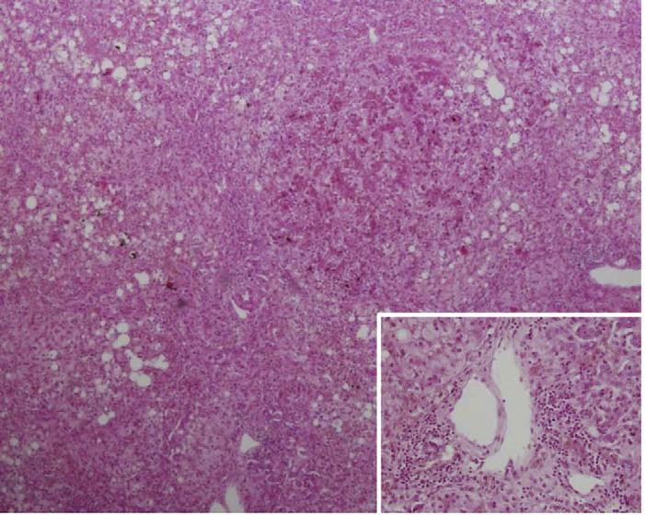

A

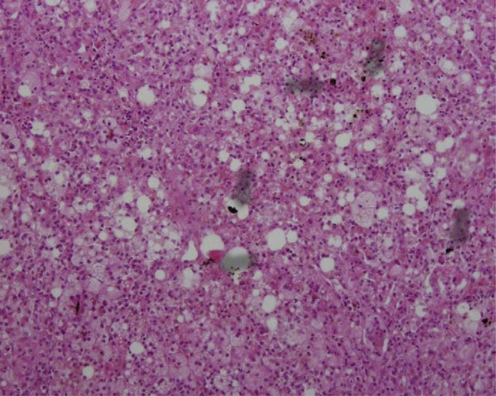

B

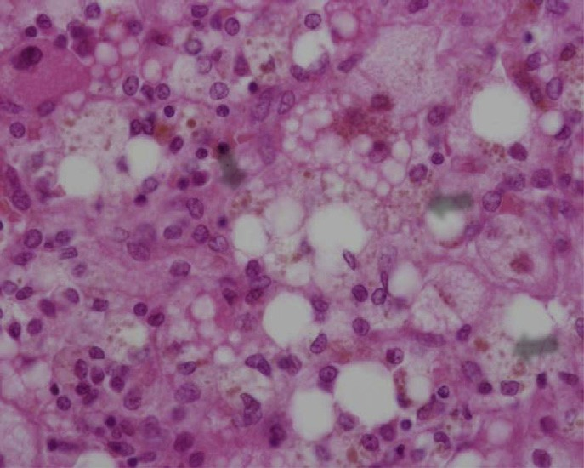

C

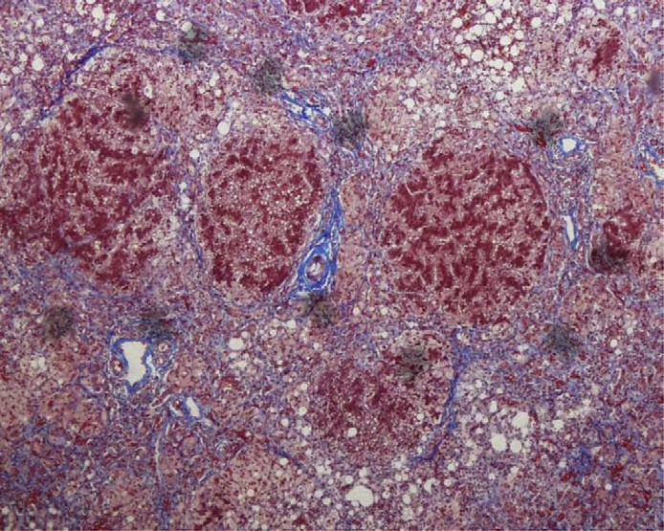

D

Fig. 1. Pathological ﬁndings of the postmortem liver (A–C: hematoxylin & eosin staining, D: Masson trichrome staining). (A) Moderate inﬂammatory cell inﬁltration (inset) with destroyed limiting plates and a rather progressive ﬁbrosis with bridging formation in the portal tracts were observed (original magniﬁcation, x40). (B) Swollen hepatocytes containing lipid droplets of various sizes were found. Bile plugs (white arrows in B and C) were noted in the cytoplasm of hepatocytes and dilated canaliculi (x100). (C) Swollen hepatocytes containing lipid droplets of various sizes were found. Bile plugs were noted in the cytoplasm of hepatocytes (x400). (D) A rather progressive ﬁbrosis with bridging formation (arrows) in the portal tracts was found (x40).

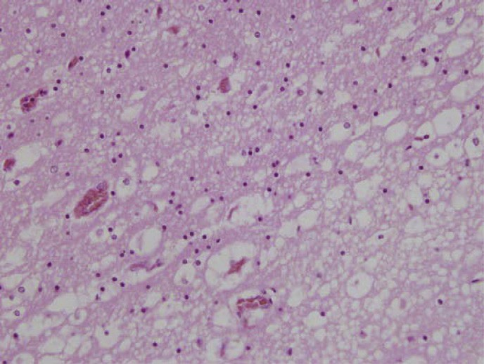

A

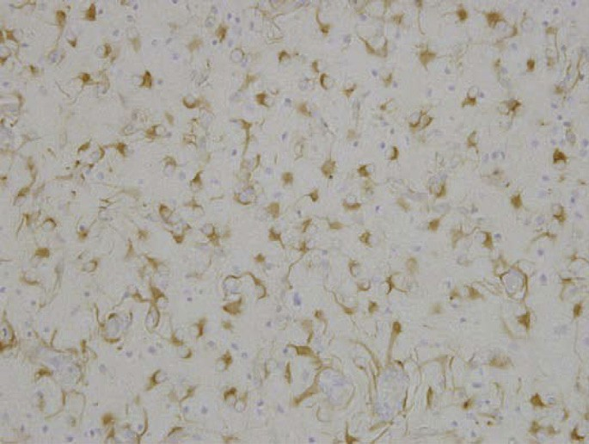

B

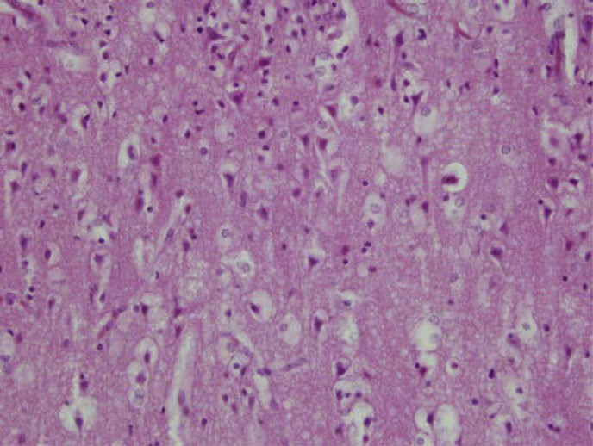

C

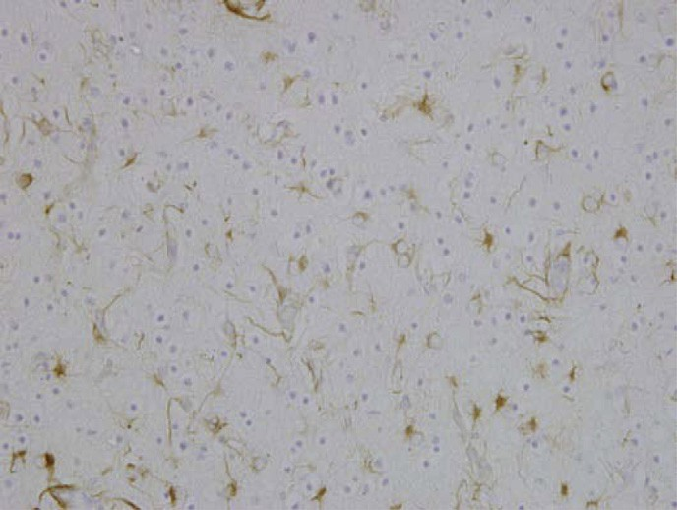

D

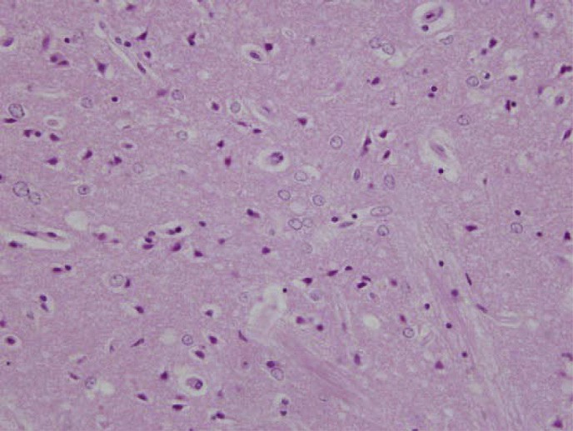

E

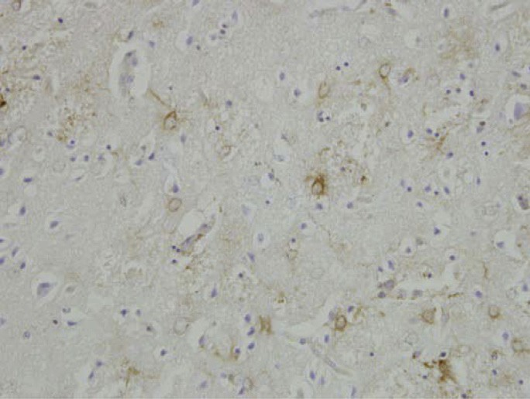

F

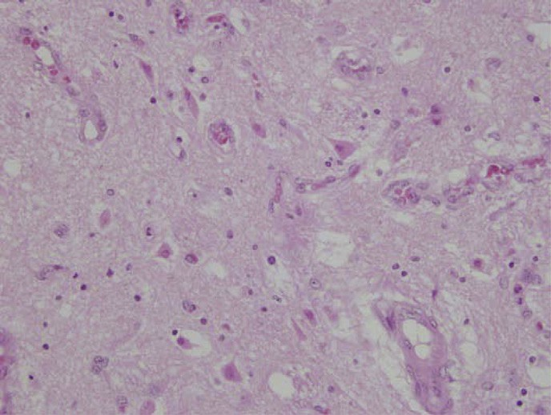

G

Fig. 2. Pathological ﬁndings of the postmortem brain (A, C, E, and G: hematoxylin & eosin staining; B, D, and F: immunohistochemical staining against glial ﬁbrillary acidic protein; original magniﬁcation, x400). Marked spongy changes (A) with Alzheimer type II astrocytosis (B) was observed in the cerebral white matter, and less prominently in the cerebral cortex (C and D) and striatum (E and F). Neuronal loss, sponginess, and capillary proliferation, which were reminiscent of the ﬁndings of Leigh syndrome, were noted in the substantia nigra (G).

were not registered in neither of the 1000 Genomes Project Database (<http://www.1000genomes.org/>), ESP6500 database (<http://evs.gs.washington.edu/EVS/>) or HGVD ([http://www.genome.med.kyoto-u.ac.jp/](http://www.genome.med.kyoto-u.ac.jp/SnpDB/index.html) [SnpDB/index.html](http://www.genome.med.kyoto-u.ac.jp/SnpDB/index.html)). The amino acid sequences of these two sites (p.A957V and p.I1185T) are well conserved across species, suggesting their importance (Fig. 3). *In*

*silico* analyses were performed using the prediction algorithms SIFT ([http://sift.jcvi.org](http://sift.jcvi.org/)) and PolyPhen2 (<http://genetics.bwh.harvard.edu/pph2/>). These muta- tions are predicted to be deleterious by SIFT (0 and 0, respectively) and PolyPhen2 (0.985 and 0.991, respectively) programs. The results of mutation analysis have been reported previously (patient 6 in Ref. [9]).

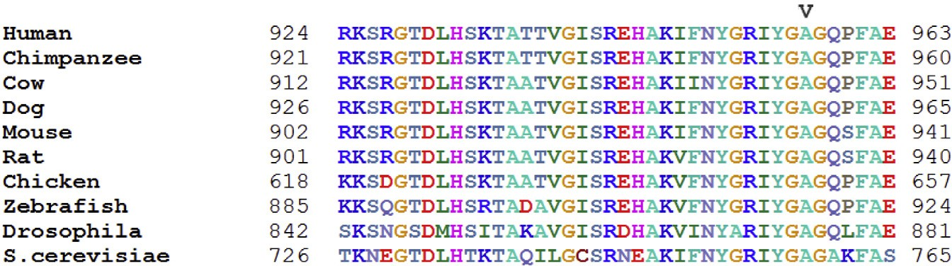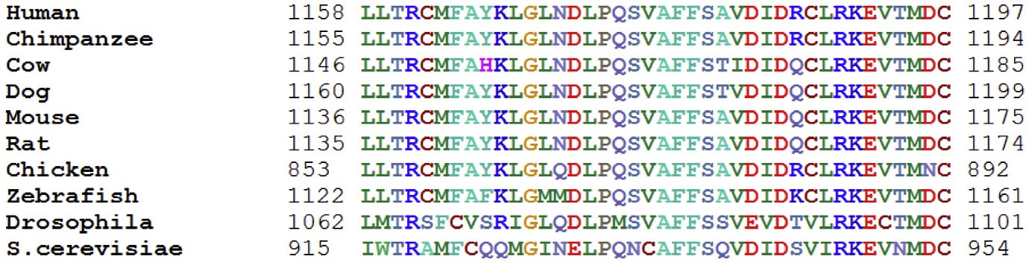

Fig. 3. Conservation analysis of mutation sites in *POLG*. The sites of compound heterozygous amino acid mutations (p.957A and p.1185I) are well conserved across species.

1. Discussion

The hetero compound mutations in *POLG* were not found in either of the 1000 Genomes Project Database, ESP6500 database nor HGVD, suggesting that these are pathogenic mutations. The amino acid sequences of these two sites (p.A957V and p.I1185T) are well conserved across species including *Saccharomyces cerevisiae*, indicating their importance (Fig. 3). *In silico* analyses also predicted that these two amino acid mutations are deleterious. Furthermore A957V has been reported by Tang et al. [10]. They reported A957V allele was shared in three unrelated patients and concluded this mutation is pathogenic. The pathogenic mutations in the ﬂanking region of p.1185I; p.1184D [11,12] and p.1186D [13] have been reported, suggesting this region is also important. Thus, we conclude the compound heterozygous mutations of this patient cause the disease. Alpers syndrome is deﬁned as the clinical triad of (1) refractory, mixed-type seizures that often include a focal component, (2) psychomotor regression, often triggered by intercurrent infection, and (3) hepatopathy with or without acute liver failure. There is an overlap between the phenotypes of MCHS and Alpers syndrome; however, the former usually shows an earlier onset age and more rapid disease progression, while the latter is characterized by intractable epilepsy. Using the “myo-” preﬁx in MCHS may be confusing since the pathological ﬁndings of muscles in this disorder often shows no evidence of mitochondrial myopathy; instead, the hypo- tonia observed in the triad can be regarded as a symptom of brain dysfunction. Thus, the clinical features of the

patient discussed herein were typical of MCHS.

Although Wong et al. [3] “.. .*excluded classical Alpers hepatopathy by liver biopsy*” in MHCS, exact pathologi- cal ﬁndings were not provided by the authors. Diﬀerences in the hepatopathy observed in these two phenotypes have not been established; pathological characteristics of the liver in Alpers syndrome include ﬁbrosis, regenerative nodules, hepatocyte dropout, bile duct proliferation, fatty changes, and bile stasis [14]. The ﬁndings of the present patient were compatible with those of Alpers syndrome, similar to the case of POLG-related MDDS previously observed [15]. As for the neuropathological ﬁndings, Alpers syndrome usually shows a preferential involvement of gray matter, charac- terized by gliosis, nerve cell loss, spongy degeneration, and accumulation of neural lipids in the cerebral cortex [16]. Alzheimer type II glia, representing hepatic encephalopathy, was also distributed predominantly in the gray matter [17].

A patient exhibiting a clinical evolution from MCHS to Alpers phenotype showed gray matter involvement and microscopic ﬁndings similar to those in Leigh syn- drome [5], and brain biopsy in another Alpers patient with prominent white matter signal change revealed pathological characteristics typical of Alpers disease with intractable seizures [18]. On the other hand, marked gliosis and sponginess of the white matter without pathological changes in the cerebral cortex was observed in a patient with probable MCHS [17]. Apart from these, we could not ﬁnd any MCHS cases with a neuropathological description in the literature. The white matter-predominant spongy degeneration with Alzheimer type II astrocytosis in the present patient may therefore be characteristic of MCHS.

POLG disorders often show elevated levels of lactate both in the serum and CSF as well as elevated levels of hepatic enzymes. However, these ﬁndings are not spe- ciﬁc for POLG disorders; rather, they are hallmarks of mitochondrial disorders. Analysis of the RCC enzyme activity is the most valuable test for diagnosis of MDDS. However, RCC enzyme activity varies among muscle, liver, kidney, and brain tissues in the same patient [1,19], presumably due to the diﬀerential degree of DNA depletion among individual organs. The con- stituents of complex II are coded by genes in the nuclear, not mitochondrial DNA. In the present patient, the decreased complex II enzyme activity in the biopsied liver may either result from augmented activity of control CS enzyme due to an increase of mitochondria in number, or may be secondary to the damage of hepatocytes with necrotic and ﬁbrotic changes [19]. It is very important to keep in mind that morphological ﬁndings and RCC enzyme activities in the muscle are sometimes unremarkable in MCHS patients, even though they show hypotonia or muscular weakness, as in the present case [5,15,20]. Therefore, analysis of RCC enzyme activities in the liver should be considered when Alpers syndrome or MCHS disorders are sus- pected, even when the morphological ﬁndings of muscle or enzyme assay results are unremarkable.

Acknowledgements

This study was supported in part by a grant from the Research Program of Innovative Cell Biology by Innovative Technology (Cell Innovation), a Grant-in-Aid for the Development of New Technology from The Promotion and Mutual Aid Corporation for Private Schools of Japan from MEXT (to Y. Okazaki), Grants-in-Aid for the Research on Intractable Diseases (Mitochondrial Disease) from the Ministry of Health, Labour and Welfare of Japan to A. Ohtake. Dr Muray- ama was supported by the Kawano Masanori Memorial Public Interest Incorporated Foundation for Promotion of Pediatrics.

References

1. [Moraes C, Shanske S, Tritschler HJ, Aprille JR, Andreetta F,](http://refhub.elsevier.com/S0387-7604(14)00261-7/h0005) [Bonilla E, et al. mtDNA depletion with variable tissue expression:](http://refhub.elsevier.com/S0387-7604(14)00261-7/h0005) [a novel genetic abnormality in mitochondrial diseases. Am J Hum](http://refhub.elsevier.com/S0387-7604(14)00261-7/h0005) [Genet 1991;48:492–501](http://refhub.elsevier.com/S0387-7604(14)00261-7/h0005).
2. [Sarzi E, Bourdon A, Chre´tien D, Zarhrate M, Corcos J, Slama A,](http://refhub.elsevier.com/S0387-7604(14)00261-7/h0010) [et al. Mitochondrial DNA depletion is a prevalent cause of](http://refhub.elsevier.com/S0387-7604(14)00261-7/h0010) [multiple respiratory chain deﬁciency in childhood. J Pediatr](http://refhub.elsevier.com/S0387-7604(14)00261-7/h0010) [2007;150(531–4):e6](http://refhub.elsevier.com/S0387-7604(14)00261-7/h0010).
3. [Wong L-J, Naviaux RK, Brunetti-Pierri N, Zhang Q, Schmitt ES,](http://refhub.elsevier.com/S0387-7604(14)00261-7/h0015) [Truong C, et al. Molecular and clinical genetics of mitochondrial](http://refhub.elsevier.com/S0387-7604(14)00261-7/h0015) [diseases due to *POLG* mutations. Hum Mutat 2008;29:150–72](http://refhub.elsevier.com/S0387-7604(14)00261-7/h0015).
4. [Cohen BH, Naviaux RK. The clinical diagnosis of POLG disease](http://refhub.elsevier.com/S0387-7604(14)00261-7/h0020) [and other mitochondrial DNA depletion disorders. Methods](http://refhub.elsevier.com/S0387-7604(14)00261-7/h0020) [2010;51:364–73](http://refhub.elsevier.com/S0387-7604(14)00261-7/h0020).
5. [Scalais E, Francois B, Schlesser P, Stevens R, Nuttin C, Martin J-](http://refhub.elsevier.com/S0387-7604(14)00261-7/h0025) [J, et al. Polymerase gamma deﬁciency (POLG): clinical course in a](http://refhub.elsevier.com/S0387-7604(14)00261-7/h0025) [child with a two stage evolution from infantile myocerebrohepat-](http://refhub.elsevier.com/S0387-7604(14)00261-7/h0025) [opathy spectrum to an Alpers syndrome and neuropathological](http://refhub.elsevier.com/S0387-7604(14)00261-7/h0025) [ﬁndings of Leigh’s encephalopathy. Eur J Paediatr Neurol](http://refhub.elsevier.com/S0387-7604(14)00261-7/h0025) [2012;16:542–8](http://refhub.elsevier.com/S0387-7604(14)00261-7/h0025).
6. [Kirby DM, Crawford M, Cleary MA, Dahl HH, Dennett X,](http://refhub.elsevier.com/S0387-7604(14)00261-7/h0030) [Tourburn DR. Respiratory chain complex I deﬁciency. An](http://refhub.elsevier.com/S0387-7604(14)00261-7/h0030) [underdiagnosed energy generation disorder. Neurology 1999;52:](http://refhub.elsevier.com/S0387-7604(14)00261-7/h0030) [1255–64](http://refhub.elsevier.com/S0387-7604(14)00261-7/h0030).
7. [Kaji S, Murayama K, Nagata I, Nagasaka H, Takayanagi M,](http://refhub.elsevier.com/S0387-7604(14)00261-7/h0035) [Ohtake A, et al. Fluctuating liver functions in siblings with](http://refhub.elsevier.com/S0387-7604(14)00261-7/h0035) [MPV17 mutations and possible improvement associated with](http://refhub.elsevier.com/S0387-7604(14)00261-7/h0035) [dietary and pharmaceutical treatments targeting respiratory chain](http://refhub.elsevier.com/S0387-7604(14)00261-7/h0035) [complex II. Mol Genet Metab 2009;97:292–6](http://refhub.elsevier.com/S0387-7604(14)00261-7/h0035).
8. [Pagnamenta AT, Taanman JW, Wilson CJ, Anderson NE,](http://refhub.elsevier.com/S0387-7604(14)00261-7/h0040) [Marotta R, Duncan AJ, et al. Dominant inheritance of premature](http://refhub.elsevier.com/S0387-7604(14)00261-7/h0040) [ovarian failure associated with mutant mitochondrial DNA](http://refhub.elsevier.com/S0387-7604(14)00261-7/h0040) [polymerase gamma. Hum Reprod 2006;21:2467–73](http://refhub.elsevier.com/S0387-7604(14)00261-7/h0040).
9. [Yamazaki T, Murayama K, Compton AG, Sugiana C, Harashi-](http://refhub.elsevier.com/S0387-7604(14)00261-7/h0045) [ma H, Amemiya S, et al. Molecular diagnosis of mitochondrial](http://refhub.elsevier.com/S0387-7604(14)00261-7/h0045) [respiratory chain disorders in Japan: focusing on mitochondrial](http://refhub.elsevier.com/S0387-7604(14)00261-7/h0045) [DNA depletion syndrome. Pediatr Int 2014;56:180–7](http://refhub.elsevier.com/S0387-7604(14)00261-7/h0045).
10. [Tang S, Wang J, Lee NC, Milone M, Halberg MC, Schmitt ES,](http://refhub.elsevier.com/S0387-7604(14)00261-7/h0050) [et al. Mitochondrial DNA polymerase gamma mutations: an ever](http://refhub.elsevier.com/S0387-7604(14)00261-7/h0050) [expanding molecular and clinical spectrum. J Med Genet](http://refhub.elsevier.com/S0387-7604(14)00261-7/h0050) [2011;48:669–81](http://refhub.elsevier.com/S0387-7604(14)00261-7/h0050).
11. Martikainen MH, Hinttala R, Majamaa K. Novel POLG1 mutations in a patient with adult-onset progressive external ophthalmoplegia and encephalopathy. BMJ Case Reports 2010; doi:10.1336/bcr.01.2010.2604.
12. [Gonza´lez-Vioque E, Bla´zquez A, Ferna´ndez-Moreira D, Born-](http://refhub.elsevier.com/S0387-7604(14)00261-7/h0060) [stein B, Bautista J, Arpa J, et al. Association of novel POLG](http://refhub.elsevier.com/S0387-7604(14)00261-7/h0060) [mutations and multiple mitochondrial DNA deletions with](http://refhub.elsevier.com/S0387-7604(14)00261-7/h0060) [variable clinical phenotypes in a Spanish population. Arch](http://refhub.elsevier.com/S0387-7604(14)00261-7/h0060) [Neurol 2006;63:107–11](http://refhub.elsevier.com/S0387-7604(14)00261-7/h0060).
13. [Cheldi A, Ronchi D, Bordoni A, Bordo B, Lanfranconi S, Bellotti](http://refhub.elsevier.com/S0387-7604(14)00261-7/h0065) [MG, et al. *POLG1* mutations and stroke like episodes: a distinct](http://refhub.elsevier.com/S0387-7604(14)00261-7/h0065) [clinical entity rather than an atypical MELAS syndrome. BMC](http://refhub.elsevier.com/S0387-7604(14)00261-7/h0065) [Neurol 2013;13:8](http://refhub.elsevier.com/S0387-7604(14)00261-7/h0065).
14. [Nguyen KV, Sharief FS, Chan SS, Copeland WC, Naviaux RK.](http://refhub.elsevier.com/S0387-7604(14)00261-7/h0070) [Molecular diagnosis of Alpers syndrome. J Hepatol 2006;45:](http://refhub.elsevier.com/S0387-7604(14)00261-7/h0070) [108–16](http://refhub.elsevier.com/S0387-7604(14)00261-7/h0070).
15. [Kurt B, Jaeken J, Van Hove J, Lagae L, Lo¨ fgren A, Everman DB,](http://refhub.elsevier.com/S0387-7604(14)00261-7/h0075) [et al. A novel POLG gene mutation in 4 children with Alpers-like](http://refhub.elsevier.com/S0387-7604(14)00261-7/h0075) [hepatocerebral syndromes. Arch Neurol 2010;67:239–44](http://refhub.elsevier.com/S0387-7604(14)00261-7/h0075).
16. [Boustany R, Zucker A. Degenerative disease primarily gray](http://refhub.elsevier.com/S0387-7604(14)00261-7/h0080) [matter. In: Swaiman KF, Ashwal S, Ferriero D, editors. Pediatric](http://refhub.elsevier.com/S0387-7604(14)00261-7/h0080) [neurology: principles & practice. Philadelphia: Mosby; 2006. p.](http://refhub.elsevier.com/S0387-7604(14)00261-7/h0080) [1326–8](http://refhub.elsevier.com/S0387-7604(14)00261-7/h0080).
17. [Kollberg G, Moslemi AR, Darin N, Nennesmo I, Bjarnadottir I,](http://refhub.elsevier.com/S0387-7604(14)00261-7/h0085) [Uvebrant P, et al. POLG1 mutations associated with progressive](http://refhub.elsevier.com/S0387-7604(14)00261-7/h0085) [encephalopathy in childhood. J Neuropathol Exp Neurol](http://refhub.elsevier.com/S0387-7604(14)00261-7/h0085) [2006;65:758–68](http://refhub.elsevier.com/S0387-7604(14)00261-7/h0085).
18. [Bao X, Wu Y, Wong LJ, Zhang Y, Xiong H, Chou PC, et al.](http://refhub.elsevier.com/S0387-7604(14)00261-7/h0090) [Alpers syndrome with prominent white matter changes. Brain](http://refhub.elsevier.com/S0387-7604(14)00261-7/h0090) [Dev 2008;30:295–300](http://refhub.elsevier.com/S0387-7604(14)00261-7/h0090).
19. [de Vries M, Rodenburg RJ, Morava E, van Kaauwen E, ter Laak](http://refhub.elsevier.com/S0387-7604(14)00261-7/h0095) [H, Mullaart R, et al. Multiple oxidative phosphorylation](http://refhub.elsevier.com/S0387-7604(14)00261-7/h0095) [deﬁciencies in severe childhood multi-system disorders due to](http://refhub.elsevier.com/S0387-7604(14)00261-7/h0095) [polymerase gamma (*POLG1*) mutations. Eur J Pediatr 2007;166:](http://refhub.elsevier.com/S0387-7604(14)00261-7/h0095) [229–34](http://refhub.elsevier.com/S0387-7604(14)00261-7/h0095).
20. [Ferrari G, Lamantea E, Donati A, Filosto M, Briem E, Carrara](http://refhub.elsevier.com/S0387-7604(14)00261-7/h0100) [F, et al. Infantile hepatocerebral syndromes associated with](http://refhub.elsevier.com/S0387-7604(14)00261-7/h0100) [mutations in the mitochondrial DNA polymerase-gamma A.](http://refhub.elsevier.com/S0387-7604(14)00261-7/h0100) [Brain 2005;128:723–31](http://refhub.elsevier.com/S0387-7604(14)00261-7/h0100).