Acta Neurol Belg (2017) 117:399–401 DOI 10.1007/s13760-016-0672-8



LETTER TO THE EDITOR

Late-onset of Alpers-Huttenlocher syndrome: an unusual cause of refractory epilepsy and liver failure

Fre´de´ric London1 • Nawal Hadhoum1 • Olivier Outteryck1,2 • Patrick Vermersch1,3 •

He´le`ne Ze´phir1,4

Received: 3 June 2016 / Accepted: 8 July 2016 / Published online: 15 July 2016

© Belgian Neurological Society 2016

Keywords Refractory epilepsy · Liver failure ·

Valproic acid · POLG mutation

## Introduction

Alpers-Huttenlocher syndrome (AHS) is an uncommon inherited mitochondrial disease characterized by a clinical triad: refractory epilepsy, hepatopathy and progressive psychomotor regression [1]. It usually occurs in infancy or early childhood while juvenile-onset is rare. We present a 16 years old girl with refractory epilepsy in whom the diagnosis was suspected because of acute liver dysfunction.

& Fre´de´ric London [londonfrederic@gmail.com](mailto:londonfrederic@gmail.com)

Nawal Hadhoum [nawal.hadhoum@chru-lille.fr](mailto:nawal.hadhoum@chru-lille.fr)

Olivier Outteryck [olivier.outteryck@chru-lille.fr](mailto:olivier.outteryck@chru-lille.fr)

Patrick Vermersch [patrick.vermersch@univ-lille2.fr](mailto:patrick.vermersch@univ-lille2.fr)

He´le`ne Ze´phir [helene.zephir@chru-lille.fr](mailto:helene.zephir@chru-lille.fr)

1 De´partement de Neurologie, Poˆle des neurosciences et de l’appareil locomoteur, Hoˆpital Roger Salengro, Universite´ de Lille, 1 rue Emile Laine, 59037 Lille Cedex, France

2 Univ. Lille, INSERM U1171, CHU Lille, 59045 Lille, France

3 Univ. Lille, CHU Lille, LIRIC-INSERM U995,

FHU Imminent, 59000 Lille, France

4 Univ. Lille, LIRIC UMR 995, CHU Lille, 59045 Lille, France

## Case report

This previously healthy 16-year-old female patient with normal psychomotor development was admitted in December 2014 because of a de novo status epilepticus. She had influenza-like symptoms 3 weeks ago and reported a 1-week history of unusual headaches with visual disturbances (flashing lights). Electroencephalo- gram (EEG) demonstrated continuous rhythmic (1–1.5 Hz) high amplitude delta with superimposed spikes which over the parieto-occipital regions. Brain MRI showed hyperintensities in T2-weighted and diffu- sion-weighted sequences: in the right thalamus, right occipital cortex and left cerebellum, without gadolinium- enhancement. Comprehensive workup including exten- sive autoimmune laboratory tests was normal, as well as the tests for HIV, syphilis, EBV, CMV, HSV, HZV and Borrelia burgdorferi. Lumbar puncture revealed a lym- phocytic pleocytosis (16 cells/lL) without oligoclonal bands, cerebrospinal fluid culture was sterile. Whole-body computed tomography was normal. Due to a refractory status epilepticus, valproic acid (VPA) was administrated improving EEG and clinical status.

In April 2015, while she remains free of seizures, systematic blood tests revealed progressive liver failure with repeated hypoglycaemias leading to urgent liver transplantation despite VPA discontinuation. Serum markers of autoimmune and viral hepatitis were negative. Wilson disease was considered because of a low cerulo- plasmin and copper levels but was finally ruled out. Histopathological study of liver showed a marked necrosis with diffuse fibrosis around central veins and focal accumulation of polymorphonuclear leukocytes. Microvesicular steatosis was also observed but there was no iron overload.

# 1 3

400 Acta Neurol Belg (2017) 117:399–401

A few days later, she developed neurological deterio- ration with tetraparesis, hypotonia, cognitive impairment and multifocal myoclonus. Refractory partial seizures required levetiracetam, clonazepam and topiramate to obtain seizure control. Brain MRI follow-up demonstrated new T2/FLAIR hyperintensities arguing for metabolic lesions (bilateral cerebellum, right frontal cortex and bilateral parietal cortex) associated with post-seizure hypersignals in thalami (Fig. 1a–d). Proton magnetic res- onance spectroscopic imaging showed a lactate doublet peak. Mitochondriopathy was considered. Laboratory findings showed elevated lactate concentration (8 mmol/L) but analysis of respiratory chain complexes in muscle biopsy was negative. AHS was suspected and mutation analysis of the *polymerase gamma gene* (*POLG*) revealed compound heterozygotes mutations A467T/W748S. Fam- ily history did not provide any evidence of mitochondrial dysfunction, especially in her two old brothers. At 1 year of follow-up, she has severe disability requiring constant nursing care and attention. Recurrence of simple partial status epilepticus required adding lacosamide to achieve a seizure-free status.

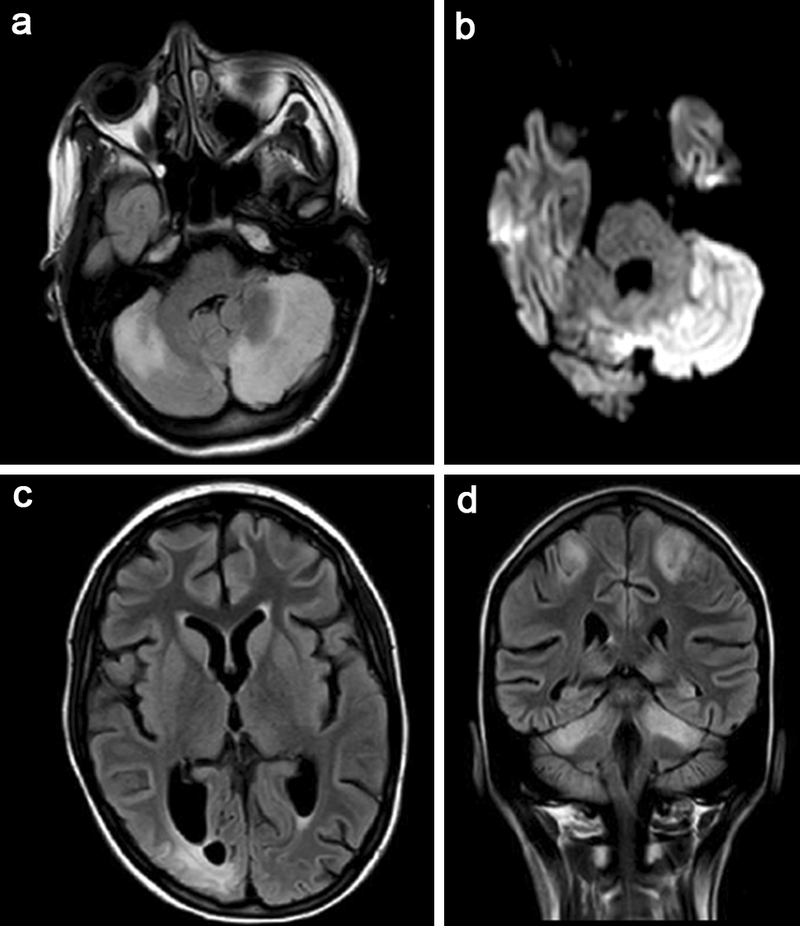

Fig. 1 Brain MRI performed 6 months after disease onset and 8 days after recurrence of seizures. Axial FLAIR image (a) and DWI- weighted image (b) showing hyperintensities in cerebellum. c Axial FLAIR image showing hyperintense lesion in right occipital lobe. d Coronal FLAIR image demonstrating bilateral and symmetrical hyperintense lesions in cerebellum and parietal cortex

## Discussion

AHS is caused by mutations in mitochondrial DNA *POLG* and is associated with high and early mortality since death usually occurs within 4 years when revealed by seizures [1]. Onset is far more common in infancy or early childhood (range 3 months to 8 years), whereas juvenile or young adult-onset is rare, as we found few reported cases with a range of 10–27 years at clinical presentation [1, 2]. All patients are healthy before they developed a rapid-onset of intractable epilepsy, usually associated with headache, fol- lowed by liver failure and developmental regression. Clinical course is always fatal within years and sometimes rapidly fulminant [1]. As AHS is an autosomal recessive disorder, the inheritance of two pathogenic alleles (mutations *in trans*) of *POLG* is required for disease expression [1, 3]. Although segregation of the two mutations in *POLG* within the family of our patient was not done and we cannot thus validate that the mutations found are *in trans*, these mutations are most likely found *in trans* and therefore pathological [1, 4].

Homozygous mutations are associated with a later onset and less severe disease, whereas patients with heterozygous mutations have an early onset, a more severe disease including an increased incidence of liver failure [1, 5]. The presence of heterozygous mutations in our patient, who presents a severe disease with late onset, demonstrates that genotype is not sufficient to explain the phenotypic vari- ability. Environmental factors are probably involved, as viral illness can precipitate onset of AHS, whereas expo- sure to VPA can promote liver failure, which is a typical feature of AHS [1]. As liver dysfunction is one of the two leading causes of death in AHS, the other one is uncon- trolled seizures, VPA must be strongly contraindicated in this disorder. Although the risk of VPA-induced toxicity is intrinsically related to *POLG* mutation, the mechanisms leading to high risk of VPA-induced hepatotoxicity are not fully understood. [6]

The MRI abnormalities observed in our patient are consistent with the predominant and progressive involve- ment of occipital regions and cerebellum previously described in AHS [7].

In conclusion, *POLG* gene testing should be considered in teenagers-young adults with sudden-onset of refractory epilepsy of unknown origin before instituting VPA therapy, especially when MRI reveals brain changes in regions suggestive of a mitochondriopathy. Although there is cur- rently no specific therapy for AHS, recognition of the diagnosis is also of importance for genetic counselling.

Compliance with ethical standards

Conflict of interest The authors declare no conflict of interest related to this publication.

# 1 3

Acta Neurol Belg (2017) 117:399–401 401

Financial support No financial support was received for this submission.

Ethical standard This article does not contain any studies with human participants or animals performed by any of the authors.

Informed consent For this type of study formal consent is not required.

## References

1. Saneto RP, Cohen BH, Copeland WC, Naviaux RK (2013) Alpers- Huttenlocher syndrome. Pediatr Neurol 48:167–178
2. Uusimaa J, Hinttala R, Rantala H, Pa¨iva¨rinta M, Herva R, Ro¨ytta¨ M, Soini H, Moilanen JS, Remes AM, Hassinen IE, Majamaa K (2008) Homozygous W748S mutation in the POLG1 gene in patients with juvenile-onset Alpers syndrome. Epilepsia 49:1038–1045
3. Nguyen KV, Østergaard E, Ravn SH, Balslev T, Danielsen ER, Vardag A, McKiernan PJ, Gray G, Naviaux RK (2005) POLG mutations in Alpers syndrome. Neurology 8:1493–1495
4. Chan SS, Longley MJ, Copeland WC (2005) The common 1467T mutation in the human mitochondrial DNA polymerase (POLG) compromises catalytic efficiency and interaction with the acces- sory subunit. J Biol Chem 280:31341–31346
5. Tzoulis C, Engelsen BA, Telstad W, Aasly J, Zeviani M, Wintherthun S, Ferrari G, Aarseth JH, Bindoff LA (2006) The spectrum of clinical disease caused by the A467T and W748S POLG mutations: a study of 26 cases. Brain 129:1685–1692
6. Stewart JD, Horvath R, Baruffini E, Ferrero I, Bulst S, Watkins PB, Fontana RJ, Day CP, Chinnery PF (2010) Polymerase gamma gene POLG determines the risk of sodium-valproate-induced liver toxicity. Hepatology 52:1791–1796
7. Engelsen BA, Tzoulis C, Karlsen B, Lillebø A, Laegreid LM, Aasly J, Zeviani M, Bindoff LA (2008) POLG1 mutations cause a syndromic epilepsy with occipital lobe predilection. Brain 131:818–828

1 3