Case report

Late-onset presentation of POLG1-associated mitochondrial disease

Bruna Meira,1 rafael roque,2 Miguel pinto,1 andré Caetano1

1Neurology Department, Centro Hospitalar de Lisboa ocidental epe, Lisboa, portugal 2Neuropathology Unit - Neurology Department, Centro Hospitalar Lisboa Norte epe, Lisboa, portugal

**Correspondence to** Dr Bruna Meira, [bmeira.rmm@gmail.com](mailto:bmeira.rmm@gmail.com)

accepted 8 March 2019

# Summary

Mutations in the nuclear poLG1 gene compromise the integrity of mitochondrial DNa and show great

allelic and clinical heterogeneity. among adult poLG1- associated mitochondrial disease, the main clinical feature is chronic progressive external ophthalmoplegia. other related clinical manifestations are sensory or cerebellar ataxia, peripheral neuropathy, myopathy

or extrapyramidal symptoms. We report the case of a 72-year-old man who presented with a late onset sensory neuronopathy, chronic progressive external

ophthalmoplegia, gait ataxia and parkinsonism. Genetic studies showed a compound heterozygosity of known pathogenic mutations in the poLG1 gene (variant t252I/p587 L in cis configuration in allele 1 and variant r807C in allele 2). Late life presentation highlights that mitochondrial disorders should be considered regardless of age of onset of symptoms.

# BaCkground

Mutations in the nuclear gene encoding the cata- lytic subunit of mitochondrial DNA polymerase  1 (POLG1 gene located on chromosome 15) are associated to phenotypically heterogeneous mito- chondrial diseases.1 Evidence shows that mutations

on this gene cause an inability to replicate mito- chondrial genomes (mtDNA) and, consequently, an accumulation of multiple deletions of mito- chondrial DNA.1 2 Among adult POLG1-associated mitochondrial diseases, the main clinical feature is chronic progressive external ophthalmoplegia (CPEO).1 2 Frequently, CPEO is associated with a large spectrum of others manifestations (CPEO- plus disorders), including the triad of sensory ataxic neuropathy, dysarthria/dysphagia and ophthalmo- paresis (SANDO syndrome).3 4 Only a few cases of SANDO associated to POLG1 mutations have been reported,3–9 however, the combination of CPEO and sensory ataxic neuropathy (incom- plete SANDO) has been more often reported.8 Although POLG1 mutations are associated with a wide range of clinical manifestations and age of onset disease, previously reported patients with CPEO or SANDO presented generally before the fifth decade of life1–4 7 8 and seldom after the sixth decade of life.5 9 10 Parkinsonism is another clinical feature of patients with POLG1 mutations, usually presenting as a rare and late-onset complication of CPEO or SANDO.10 11 Until this moment, over 200 mutations on POLG gene were identified but there is still some uncertainty regarding the pathogenic

[](http://crossmark.crossref.org/dialog/?doi=10.1136/bcr-2018-228482&domain=pdf&date_stamp=2019-03-29)

© BMJ publishing Group Limited 2019. No commercial re-use. see rights and permissions. published by BMJ.

**To cite:** Meira B, roque r, pinto M, *et al*. *BMJ Case Rep* 2019;**12**:e228482.

doi:10.1136/bcr-2018- 228482

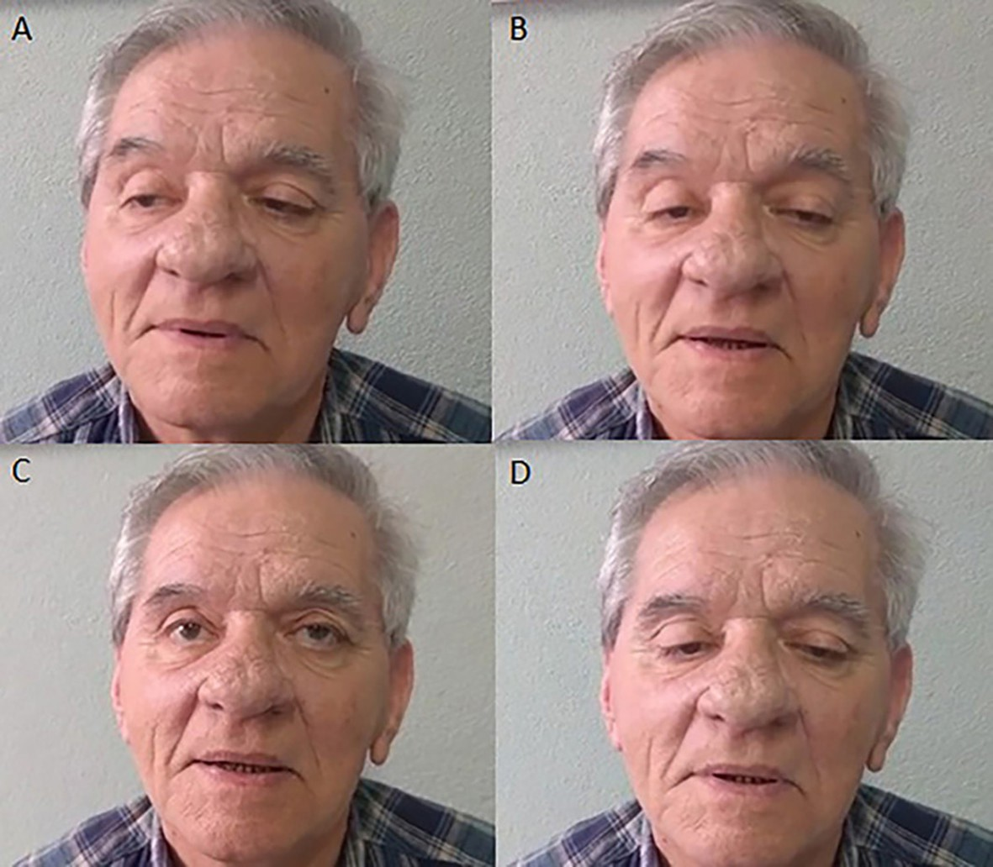**Figure 1** Bilateral ptosis and ocular movements examination showing a severe external ophthalmoplegia. (A) dextroversion, (B) levoversion, (C) supraversion, (D) infraversion.

[](http://casereports.bmj.com/)

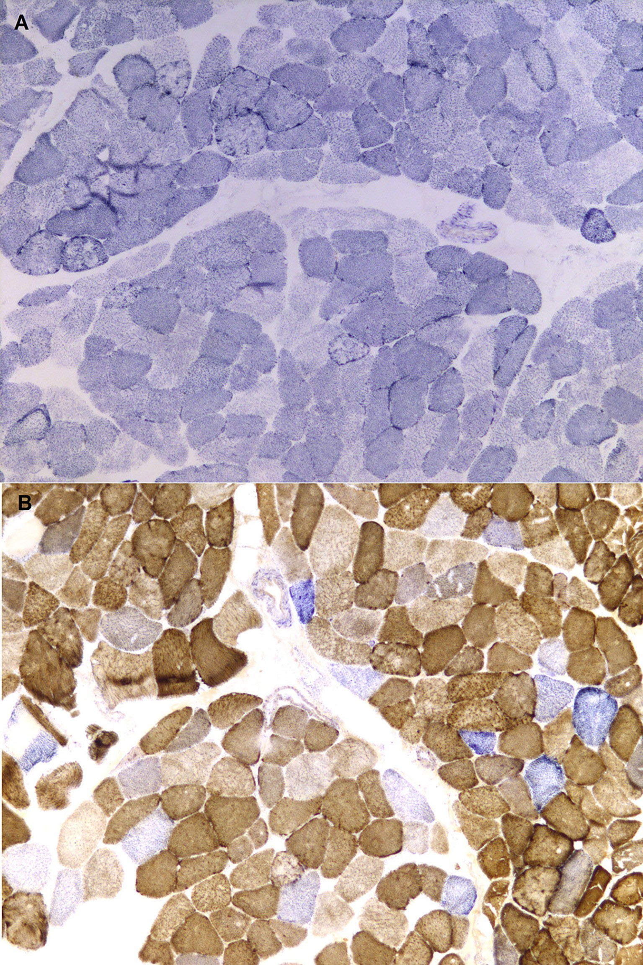

**Figure 2** Muscle biopsy findings. Succinate Dehydrogenase (SDH) stain (10×10) - Biopsy from the deltoid muscle showing dark peripheral areas suggestive of clustered mitochondria (A); cytochrome c oxidase (COX)/SDH stain (10×10) showing several COX negative fibres (B); No ragged-red-fibres were seen in haematoxylin/eosin or Gomori trichrome stains (not shown).

contribution of each of these mutations to disease presentation as well as any obvious genotype-phenotype correlation.1 2 4

We report the case of a 72-year-old man who presented with a late onset mitochondrial disease whose genetic studies showed known pathogenic mutations in the POLG1 gene. This case

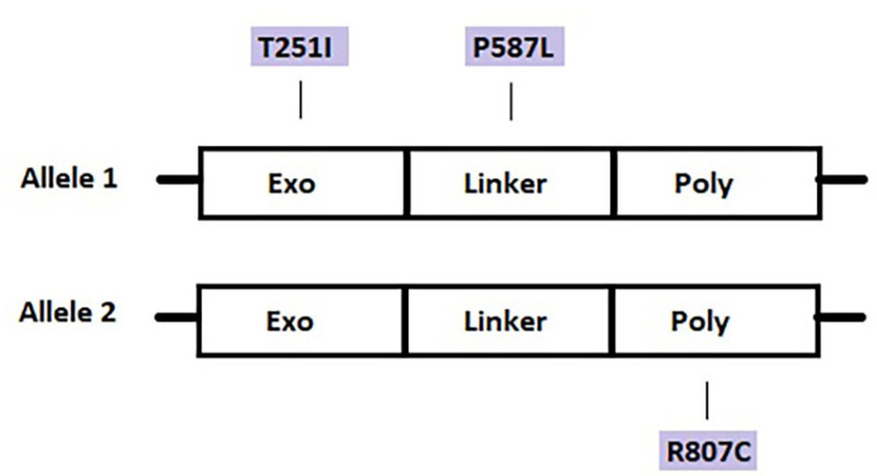

**Figure 3** Location of mutations in the POLG gene. T251I and P587L mutations in cis configuration were found in the exonuclease motif and linker regions, respectively, in allele 1. R807C mutation was identified in the polymerase motif in allele 2.

highlights the importance of considering the diagnosis of a mito- chondrial disorder regardless of age of onset of symptoms.

# CaSe preSenTaTion

We present the case of a 72-year-old man, with type 2 diabetes (with good metabolic control) and arterial hypertension, who presented with a 3 year history of progressive distal lower limb weakness and bilateral partial ptosis. He also claimed driving had become progressively difficult due to a limitation in lateral eye version as well as due to a decreased sensation on the plantar surface of the feet. Additionally, he had slight dysphagia. Family history was unremarkable (born of non-consanguineous parents, four healthy siblings). Observation in the neurology clinic disclosed slight gait ataxia, with inability to walk in tandem; minor proximal paraparesis; generalised areflexia; distal hypoes- thesia and hypopallesthesia of upper and lower limbs; severe external ophthalmoplegia and bilateral ptosis (figure 1); vertical diplopia in upgaze; mild dysarthria; and a pill-rolling tremor of the upper right limb. There was no pathological muscle fatigability.

# inveSTigaTionS

Laboratory results revealed a normal complete blood count and comprehensive metabolic panel, with normal CK, myoglobin and serum ACE levels. Brain MRI showed mild scattered periventric- ular white matter disease. Neurophysiology evaluation showed a generalised absence of sensory nerve action potentials (both upper and lower limbs); without changes in motor conduction studies, suggestive of a sensory neuronopathy. Needle electromy- ography study of the frontalis muscles demonstrated myopathic potentials. There was no pathological decremental response with low frequency (3 Hz) repetitive stimulation. Anti-acetylcholine receptor, -MuSK, -LRP4 and voltage gated calcium channel antibodies were negative. Thoracic CT showed no relevant changes, namely, no mediastinal lymphadenopathies suggestive of sarcoidosis. Negative anti-ganglioside and anti-neuronal anti- bodies, normal immunologic study and absence of toxic contact, excluded other possible aetiologies of sensory neuronopathy.

A deltoid muscle biopsy demonstrated signs of oxidative stress with multiple cytochrome c oxidase (COX) negative muscle fibres (in a percentage higher to that expected for the patient age) but no ragged red fibres (figure 2). Analysis of mitochon- drial respiratory chain complex activity by spectrophotometry was otherwise normal. The patient underwent genetic testing (specific gene study by direct sequencing and bidirectional allele specific PCR) that confirmed the presence of pathogenic muta- tions on POLG gene: variant T251I/P587 L in cis configuration in allele 1 and variant R807C in allele 2 - compound heterozy- gosity of three known pathogenic mutations (figure 3).

# diFFerenTial diagnoSiS

Our patient was initially considered to have possible ocular myasthenia gravis, as well as a concomitant (severe) sensory diabetic polyneuropathy. Despite not having a clear clinical fati- gability, given the age of our patient and his ocular findings, a diagnosis of ocular myasthenia gravis was our first diagnostic hypothesis. The peripheral neuropathy is a well-known compli- cation of diabetes and therefore it was not unreasonable to think about this initial diagnosis since the patient had suffered from diabetes for several years. However, his neurophysiology evalua- tion was not in favour of a post-synaptic neuromuscular junction disorder, the autoantibodies for autoimmune myasthenia gravis

were negative and treatment with pyridostigmine was ineffective prompting us to consider other diagnosis.

We considered oculopharyngeal muscular dystrophy as a possible diagnosis, given the slight dysphagia, eyelid ptosis, and proximal limb weakness as well as late life presentation. However, the prominence of sensory ataxia, ophthalmoplegia and tremor found in our patient as well as absent family history did not support this diagnosis.12

Based on the patient's presentation, and given the multiple neurological systems involved, namely sensory nerves, muscle fibres, parkinsonism and external ophthalmoplegia, we consid- ered the possibility of a mitochondrial disease. The mitochon- drial disorders are an inherited group of diseases, maternally transmitted or autosomal recessive or due to sporadic mutations, compatible with the lack of family history in our patient.

# TreaTmenT

Under the clinical suspicion of ocular myasthenia gravis, the patient started treatment with pyridostigmine without any rele- vant response. More recently, after the diagnosis of mitochon- drial disease, our patient was treated with coenzyme Q10 but he did not tolerate this drug due to side-effects. Considering the worsened parkinsonism, the patient was started on levodopa, although with little clinical response. The patient and his primary care physician were informed about the risk of taking valproic acid, since it may precipitate fulminant liver disease.2

# ouTCome and Follow-up

Although there is no specific treatment for mitochondrial disease, our patient has a moderate, but stable, disability after 2 years of follow-up. Parkinsonism associated with mitochon- drial disease usually does not have a good response to treatment with L-dopa and progressive worsening can lead to a marked disability. He maintains regular follow-up in our outpatient clinic for continued clinical monitoring and supportive care.

# diSCuSSion

The wide phenotypical variation among patients with mito- chondrial disorders makes the diagnosis difficult. Patients can present with sensory or cerebellar ataxia, ophthalmoparesis, ptosis, peripheral neuropathy, cognitive impairment, myopathy, seizures, encephalopathy, hepatopathy, psychiatric disorders, pyramidal or extra-pyramidal symptoms and headaches, either isolated or combined.1 2 POLG mutations are a major cause of mitochondrial diseases, accounting for up to 25% of them.13 Interestingly, despite the large number of pathogenic muta- tions reported in POLG1-associated mitochondrial disease, the common final pathway seems to be an accumulation of errors on mtDNA, with a subsequent abnormal oxidative phosphory- lation leading to clinical symptoms.1 POLG1-related disorders are grouped within five major phenotypes: Alpers–Hutten- locher syndrome, childhood myocerebrohepatopathy spectrum disorders, myoclonic epilepsy myopathy sensory ataxia, ataxia neuropathy spectrum, autosomal dominant progressive external ophthalmoplegia and autosomal recessive progressive external ophthalmoplegia with or without SANDO.2 Irrespective of the phenotype, levodopa responsive parkinsonism has been described as a rare and late-onset complication of POLG muta- tions, preceded several years by the onset of CPEO or SANDO manifestations.10 11 In fact, mitochondrial dysfunction, leading to reduced ATP production or oxidative stress, has emerged as one of the neurodegenerative pathogenic mechanism associ- ated with Parkinson disease,10 and according to Luoma *et al*,11

parkinsonism seems to significantly coseggregate with POLG mutations (p<0.0001). Muscle fibres of patients with CPEO due to POLG1 mutations seem to have more COX-negative fibres than RRF, which could contribute to misdiagnosis, especially in older patients, considering that age-related changes in human skeletal muscle mitochondria result in an accumulation of dele- tions of mtDNA and in the natural appearance of ragged-red fibres (RRF) and COX-negative fibres. Still, despite the natural ageing alterations, that prevail after 40–50 years old, the overall percentage of RRF and COX-negative fibres should remain at around 1% in individuals without mitochondrial disorders.14

In the specific case of SANDO, Fadic *et al* in 1997,6 with the description of four patients, hypothesised, for the first time, that SANDO could represent a novel mitochondrial disease associ- ated with multiple mitochondrial DNA deletions. Since then a small number of cases has been reported and as such, the real prevalence of this syndrome is unknown but it is believed as quite rare. More recently, Hanisch *et al*8 reported nine patients and two additional family members fulfilling the clinical criteria for SANDO. Within this group, six of the 11 patients had POLG mutations. The average age of onset in this group was 38.3 years (23–59 years old, although among patients with POLG muta- tions detected, the oldest patient was 49 years old). The majority of the patients sought medical advice because of gait ataxia and all patients with SANDO had mild dysarthria. None of the 11 patients had parkinsonism. The most frequent mutation on their cohort was the A467T mutation followed by the W748S muta- tion. According to the same paper, these results were consis- tent with previous studies on SANDO syndrome (number of patients=29) concerning age of onset, symptoms and detected POLG mutations.8 Other previous reported POLG1 mutations linked with the SANDO phenotype include P587L, T257I, R807C (our patient carries these three mutations), L304R, R627W, R3P, R1138C, E1143G, G737R, G848S, P648R, and

A627Q.3–9 Most mutations are found in compound heterozy- gotes containing multiple mutations in cis and in trans or in homozygosity.1 2

In our particular case, there was already a high clinical suspicion for mitochondrial disease before muscle biopsy was performed. Milone *et al*4 reported five cases of adult onset autosomal recessive sensory ataxic neuropathy with ophthal- moparesis and concluded that given the inconsistency of muscle findings, the molecular analysis of POLG gene remains the most informative and definitive diagnostic test. They suggest that genetic testing for POLG mutations should be included among first line tests in patients with high suspicion for mitochondrial disorders. In line with that, according to Tchikviladzé *et al*,15 the presence of more than three different clinical signs (neuropathy, ptosis/ophthalmoplegia, axial/limb muscle weakness, cerebellar syndrome, movement disorder, psychiatric symptoms, hypo- acousia, cognitive defect) and the absence of pyramidal involve- ment is sufficient to directly perform POLG sequencing.

Mutations found in our patient were considered autosomal recessive in inheritance or sporadic since neither his parents nor siblings had symptoms. All mutations were reported before in other cases involving either SANDO syndrome or parkin- sonism.5 7 10 To our knowledge, our patient is a compound heterozygote with a combination of mutations not previously described. The age of disease onset in our patient is highly unusual making this case a unique presentation. A combination of genetic, epigenetic and environmental factors may explain the delayed onset.1

There is no specific treatment for mitochondrial diseases related to POLG1 mutations. They tend to be progressive and

can lead to marked disability in some patients. Neurological symptoms may worsen during infections or other physiologic stressors.1

* Mitochondrial disease can manifest with multi systemic dysfunction.
* Mitochondrial disease should be considered in cases of progressive external ophthalmoplegia.
* Mitochondrial disease can have late-onset presentation.
* In the face of inconsistent muscle biopsy findings, genetic testing for POLG mutations should be considered earlier in the appropriate clinical context.

**learning points**

**Contributors** all authors have contributed to the manuscript. BM: planning, drafting and revising of the manuscript and image edition. rr: interpretation and reporting muscle biopsy, revising of the manuscript. Mp and aC: revising of the manuscript for intellectual content.

**Funding** the authors have not declared a specific grant for this research from any funding agency in the public, commercial or not-for-profit sectors.

**Competing interests** None declared.

**patient consent for publication** obtained.

**provenance and peer review** Not commissioned; externally peer reviewed.

# RefeRences

1. Cohen BH, Naviaux rK. the clinical diagnosis of poLG disease and other mitochondrial DNa depletion disorders. [*Methods*](http://dx.doi.org/10.1016/j.ymeth.2010.05.008)2010;51:364–73.
2. stumpf JD, saneto rp, Copeland WC. Clinical and molecular features of poLG-related mitochondrial disease. [*Cold Spring Harb Perspect Biol*](http://dx.doi.org/10.1101/cshperspect.a011395)2013;5:a011395.
3. Van Goethem G, Martin JJ, Dermaut B, *et al*. recessive poLG mutations presenting with sensory and ataxic neuropathy in compound heterozygote patients with progressive external ophthalmoplegia. [*Neuromuscul Disord*](http://dx.doi.org/10.1016/S0960-8966(02)00216-X)2003;13:133–42.
4. Milone M, Brunetti-pierri N, tang LY, *et al*. sensory ataxic neuropathy with ophthalmoparesis caused by poLG mutations. [*Neuromuscul Disord*](http://dx.doi.org/10.1016/j.nmd.2008.05.009)2008;18:626–32.
5. Weiss MD, saneto rp. sensory ataxic neuropathy with dysarthria and ophthalmoparesis (saNDo) in late life due to compound heterozygous poLG mutations. [*Muscle Nerve*](http://dx.doi.org/10.1002/mus.21636)2010;41:882–5.
6. Fadic r, russell Ja, Vedanarayanan VV, *et al*. sensory ataxic neuropathy as the presenting feature of a novel mitochondrial disease. [*Neurology*](http://dx.doi.org/10.1212/WNL.49.1.239)1997;49:239–45.
7. Gago MF, rosas MJ, Guimarães J, *et al*. saNDo: two novel mutations in poLG1 gene.

[*Neuromuscul Disord*](http://dx.doi.org/10.1016/j.nmd.2006.05.016)2006;16:507–9.

1. Hanisch F, Kornhuber M, alston CL, *et al*. saNDo syndrome in a cohort of 107 patients with Cpeo and mitochondrial DNa deletions. [*J Neurol Neurosurg Psychiatry*](http://dx.doi.org/10.1136/jnnp-2013-306748)2015;86:630–4.
2. Lovan a, Ihtsham ul Haq, Balakrishnan N. Diagnostic challenges in movement disorders: sensory ataxia Neuropathy Dysarthria and ophthalmoplegia (saNDo) syndrome. [*BMJ Case Rep*](http://dx.doi.org/10.1136/bcr-2013-010343)2013;2013:bcr2013010343.
3. Miguel r, Gago MF, Martins J, *et al*. poLG1-related levodopa-responsive parkinsonism. [*Clin Neurol Neurosurg*](http://dx.doi.org/10.1016/j.clineuro.2014.08.020)2014;126:47–54.
4. Luoma p, Melberg a, rinne Jo, *et al*. parkinsonism, premature menopause, and mitochondrial DNa polymerase gamma mutations: clinical and molecular genetic study. [*Lancet*](http://dx.doi.org/10.1016/S0140-6736(04)16983-3)2004;364:875–82.
5. Brais B. oculopharyngeal muscular dystrophy. [*Handb Clin Neurol*](http://dx.doi.org/10.1016/B978-0-08-045031-5.00014-1)2011;101:181–92.
6. scuderi C, Borgione e, Castello F, *et al*. the in cis t251I and p587L poLG1 base changes: description of a new family and literature review. [*Neuromuscul Disord*](http://dx.doi.org/10.1016/j.nmd.2015.01.004)2015;25:333–9.
7. pesce V, Cormio a, Fracasso F, *et al*. age-related mitochondrial genotypic and phenotypic alterations in human skeletal muscle. [*Free Radic Biol Med*](http://dx.doi.org/10.1016/S0891-5849(01)00517-2)2001;30:1223–33.
8. tchikviladzé M, Gilleron M, Maisonobe t, *et al*. a diagnostic flow chart for poLG- related diseases based on signs sensitivity and specificity. [*J Neurol Neurosurg*](http://dx.doi.org/10.1136/jnnp-2013-306799)[*Psychiatry*](http://dx.doi.org/10.1136/jnnp-2013-306799)2015;86:646–54.

Copyright 2019 BMJ publishing Group. all rights reserved. For permission to reuse any of this content visit [https://www.bmj.com/company/products-services/rights-and-licensing/permissions/](http://www.bmj.com/company/products-services/rights-and-licensing/permissions/)

BMJ Case report Fellows may re-use this article for personal use and teaching without any further permission.

Become a Fellow of BMJ Case reports today and you can:

* submit as many cases as you like
* enjoy fast sympathetic peer review and rapid publication of accepted articles
* access all the published articles
* re-use any of the published material for personal use and teaching without further permission For information on Institutional Fellowships contact [consortiasales@bmjgroup.com](mailto:consortiasales@bmjgroup.com)

Visit casereports.bmj.com for more articles like this and to become a Fellow