# Leukoencephalopathy in Mitochondrial Neurogastrointestinal Encephalomyopathy‑Like Syndrome with Polymerase‑Gamma Mutations

**Hongyan Huang*, Xinglong Yang1,*, Ling Liu, Yanming Xu**

Department of Neurology, West China Hospital, Sichuan University, Sichuan Province, 1Department of Geriatric Neurology, The First Affiliated Hospital of Kunming Medical University, Kunming, Yunnan, PR China

*These author contribute equally to this research

**Abstract**

Mitochondrial neurogastrointestinal encephalomyopathy (MNGIE) syndrome, caused by mutations in the thymidine phosphorylase gene, manifests as a multisystemic disorder characterized by severe gastrointestinal dysmotility, cachexia, ptosis and ophthalmoparesis, peripheral neuropathy, and leukoencephalopathy. These clinical manifestations, with the exception of leukoencephalopathy, are mimicked by MNGIE-like syndrome, linked to polymerase-gamma (*POLG*) gene. Here, we report a 49-year-old Chinese man with MNGIE-like syndrome involved leukoencephalopathy and was associated with novel *POLG* mutations. This case expands the clinical spectrum of MNGIE-like syndrome.

**Keywords:** Leukoencephalopathy, mitochondrial neurogastrointestinal encephalomyopathy-like, mitochondrial disorders, polymerase-gamma gene

**IntroductIon**

Mitochondrial neurogastrointestinal encephalomyopathy (MNGIE) syndrome is caused by mutations in the thymidine phosphorylase (*TYMP*) gene that lead *TYMP* deficiency and elevated plasma thymidine levels.[1] Clinical manifestations include severe gastrointestinal dysmotility, cachexia, ptosis and ophthalmoparesis, peripheral neuropathy, and leukoencephalopathy.[1] Patients with a clinical phenotype indistinguishable from MNGIE have been reported in the absence of *TYMP* gene mutations; their condition has been called MNGIE-like syndrome.[2-6] A handful of cases of MNGIE-like syndrome have been reported in association with polymerase-gamma (*POLG*) gene.[2-4] van Goethem *et al.* first described two sisters with clinical features mimicking MNGIE linked to mutations in *POLG*.[2] Tang *et al*.[3] and Prasun *et al*.[4] reported four patients presenting MNGIE with mutations in *POLG*. All cases shared similar brain magnetic resonance imaging (MRI) findings indicating the absence of leukoencephalopathy.[2-4] Here, we report, for the first time, a patient with MNGIE-like syndrome involving leukoencephalopathy and associated with novel *POLG* mutations.

**case rePort**

The Chinese male had a history of good health until 42 years old when he developed mild gastrointestinal dysmotility leading to diarrhea and episodes of abdominal pain. At age 48, he was hospitalized for ptosis, diplopia, and weakness in the extremities. At the same time, gastrointestinal manifestations developed significantly, such that he began to suffer chronic

diarrhea and persistent abdominal distention, leading to loss of 22 kg.

Colonoscopy revealed colonic diverticulum. Abdominal computed tomography showed gastroduodenal expansion. Peripheral nerve conduction velocity findings were consistent with demyelinating and axonal sensory motor neuropathy. Protein in the cerebrospinal fluid was elevated (119 mg/dL; normal: 15–45 mg/dL) while no leukocytes were detected. The patient was initially diagnosed with chronic inflammatory demyelinating polyneuropathy and given corticosteroids and intravenous immunoglobulin. These treatments had no effect.

At age 49, the patient was hospitalized again for progressive limb weakness. His appearance was cachectic, body mass index was 13.8 kg/m2, and he showed muscle atrophy. Neurological examination showed ophthalmoplegia, ptosis, muscle weakness, and absence of deep tendon reflexes. In light of his disease course, we suspected that he suffered from MNGIE or MNGIE-like syndrome.

**Address for correspondence:** Dr. Yanming Xu, Department of Neurology, West China Hospital, Sichuan University, 37 Guo Xue Xiang, Chengdu, Sichuan Province, 610041, PR China.

E‑mail: [neuroxym999@163.com](mailto:neuroxym999@163.com)

This is an open access journal, and articles are distributed under the terms of the Creative Commons Attribution‑NonCommercial‑ShareAlike 4.0 License, which allows others to remix, tweak, and build upon the work non‑commercially, as long as appropriate credit is given and the new creations are licensed under the identical terms.

**For reprints contact:** [reprints@medknow.com](mailto:reprints@medknow.com)

**DOI:** 10.4103/aian.AIAN_34_18

Subsequently, we arranged the muscle biopsy, and the result revealed ragged-red fibers and cytochrome oxidase (COX)-negative fibers. Brain MRI showed bilateral periventricular white matter hyperintensities in fluid-attenuated inversion recovery and T2-weighted images [Figure 1]. The medical history of the patient did not suggest alternative causes of leukoencephalopathy, such as intoxication, infections, or hypertension. Next-generation sequencing of mitochondrial and nuclear genomes from skeletal muscle tissues identified two novel heterozygous variants in *POLG*: c.3643 + 1G > A (splicing), near exon 23 and c.2396C > A (p. S799Y), in exon 14. These mutations are located in the polymerase domain and were verified by direct DNA sequencing.

Neither variant was found in any of the databases consulted, including dbSNP, HapMap, and 1000 Genomes, or among 500 healthy Chinese samples. Protein function prediction using Polyphen-2, SIFT, and MutationTaster suggested that the missense variant is likely to be damaging.

**dIscussIon**

Here, we report a Chinese man with clinical features of MNGIE. Histological examination showed ragged-red fibers and COX-negative fibers. Moreover, the clinical manifestations could not be attributed to other phenotypes of *POLG*-related disorders, such as Alpers-Huttenlocher syndrome, myoclonic epilepsy myopathy sensory ataxia, ataxia neuropathy spectrum, or chronic progressive external ophthalmoplegia.[7]

The patients carried two novel variants in *POLG* which were not detected in 500 normal control DNA samples. We considered the two variants are likely pathogenic. Other *POLG* mutations have been shown to cause MNGIE-like syndrome

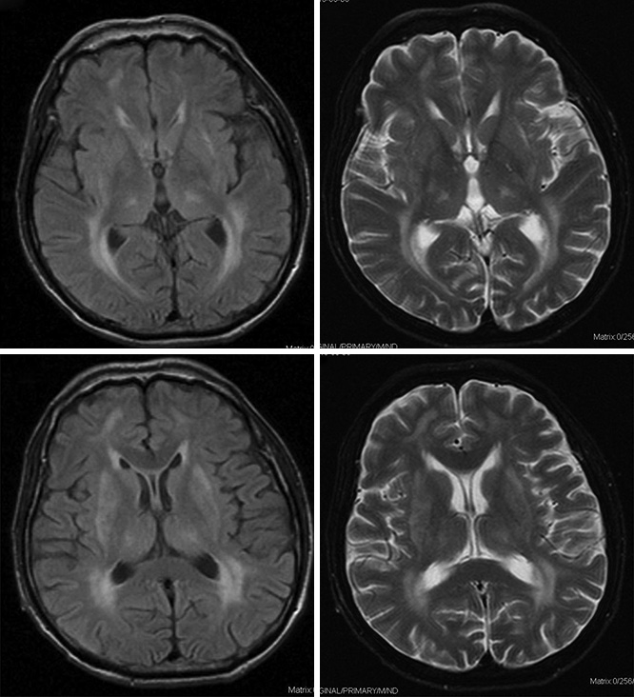

a

b

c

d

**Figure 1:** Leukoencephalopathy in a man with mitochondrial neurogastrointestinal encephalomyopathy‑like associated with polymerase‑gamma gene mutations and fluid‑attenuated inversion recovery (a and c) and T2‑weighted (b and d) axial brain magnetic resonance images show bilateral periventricular white matter hyperintensity

through autosomal recessive or dominant transmission.[2-4] The patient has no family history. We do not know whether the two *POLG* variants in our patients occurred in *trans* since no DNA from their relatives was available. Further work is needed to establish a clear genotype–phenotype correlation and to confirm the pathogenicity of these two novel *POLG* variants.

The leukoencephalopathy in our patient appeared as patchy white matter lesions in contrast to the confluent leukoencephalopathy usually observed in MNGIE.[8] In recent years, white matter lesions have been increasingly recognized in mitochondrial disorders.[9] Other mutations in the *POLG* gene have similarly been linked to leukoencephalopathy, such as in Alpers syndrome.[9,10] Encephalopathy is closely related to mitochondrial dysfunction resulting in energy deficiency.[9]

To our knowledge, this is the first case of MNGIE-like syndrome with leukoencephalopathy involving *POLG* variants. Our findings expand the clinical spectrum of MNGIE-like syndrome linked to *POLG* variants and challenge the previous view that the presence or absence of leukoencephalopathy differentiates MNGIE from MNGIE-like syndrome associated with *POLG* variants.[2-4]

Diagnosis of MNGIE or MNGIE-like is challenging. Appropriate attention to gastrointestinal manifestations and brain MRI may help identify these syndromes in the early stage.

## What is Known?

Polymerase-gamma gene mutations have been linked to mitochondrial neurogastrointestinal encephalomyopathy-like (MNGIE-like) syndrome, which shares the manifestations of classical MNGIE syndrome except leukoencephalopathy.

## What is New?

Two novel polymerase-gamma mutations have been linked to mitochondrial neurogastrointestinal encephalomyopathy-like syndrome that involves leukoencephalopathy.

## Acknowledgments

We wish to acknowledge the patient and his family for their participation in this study and their efforts to help us.

## Financial support and sponsorship

Nil.

## Conflicts of interest

There are no conflicts of interest.

**reFerences**

1. Hirano M, Nishigaki Y, Martí R. Mitochondrial neurogastrointestinal encephalomyopathy (MNGIE): A disease of two genomes. Neurologist 2004;10:8-17.
2. Van Goethem G, Schwartz M, LöfgrenA, Dermaut B, Van Broeckhoven C, Vissing J, *et al.* Novel POLG mutations in progressive external ophthalmoplegia mimicking mitochondrial neurogastrointestinal encephalomyopathy. Eur J Hum Genet 2003;11:547-9.
3. Tang S, Dimberg EL, Milone M, Wong LJ. Mitochondrial neurogastrointestinal encephalomyopathy (MNGIE)-like phenotype: An expanded clinical spectrum of POLG1 mutations. J Neurol 2012;259:862-8.
4. Prasun P, Koeberl DD. Mitochondrial neurogastrointestinal encephalomyopathy (MNGIE)-like phenotype in a patient with a novel heterozygous POLG mutation. J Neurol 2014;261:1818-9.
5. Shaibani A, Shchelochkov OA, Zhang S, Katsonis P, Lichtarge O, Wong LJ, *et al.* Mitochondrial neurogastrointestinal encephalopathy due to mutations in RRM2B. Arch Neurol 2009;66:1028-32.
6. Lehnhardt FG, Horvath R, Ullrich R, Kracht L, Sobesky J, Möller-Hartmann W, *et al.* Altered cerebral glucose metabolism in a family with clinical features resembling mitochondrial neurogastrointestinal encephalomyopathy syndrome in association

with multiple mitochondrial DNA deletions. Arch Neurol 2008;65:407-11.

1. Stumpf JD, Saneto RP, Copeland WC. Clinical and molecular features of POLG-related mitochondrial disease. Cold Spring Harb Perspect Biol 2013;5:a011395.
2. Scarpelli M, Ricciardi GK, Beltramello A, Zocca I, Calabria F, Russignan A, *et al.* The role of brain MRI in mitochondrial neurogastrointestinal encephalomyopathy. Neuroradiol J 2013;26:520-30.
3. Wong LJ. Mitochondrial syndromes with leukoencephalopathies. Semin Neurol 2012;32:55-61.
4. Milone M, Wang J, Liewluck T, Chen LC, Leavitt JA, Wong LJ, *et al.* Novel POLG splice site mutation and optic atrophy. Arch Neurol 2011;68:806-11.

# An Unusual Combination of Neurological Manifestations and Sudden Vision Loss in a Child with Familial Hyperphosphatemic Tumoral Calcinosis

**Lokesh Lingappa, Shoji Ichikawa1, Amie K. Gray1, Dena Acton1, Michael J. Evans1, Rajsekara Chakravarthi Madarasu2, Ramesh Kekunnaya3, Sirisharani Siddaiahagari**

Department of Neurology and Hemato‑Oncology, Rainbow Children’s Hospital and Birthright, 2Department of Nephrology, Star Hospital, 3Jasti V Ramanamma Children’s Eye Care Centre, LV Prasad Eye Institute, Hyderabad, Telangana, India, 1Department of Medicine, Indiana University School of Medicine, Indianapolis, Indiana, USA

**Abstract**

Hyperphosphatemia in the absence of renal failure is an unusual occurrence, particularly in children, but is a common primary feature of familial hyperphosphatemic tumor calcinosis. We report a child with hyperphosphatemia who presented with multiple episodes of neurologic dysfunction involving lower motor neuron facial nerve palsy along with sequential visual loss. He also had an episode of stroke. There was an extensive metastatic calcification of soft tissue and vasculature. Hyperphosphatemia with normal serum alkaline phosphatase, calcium, parathyroid hormone, and renal function was noted. He was managed with hemodialysis and sevelamer (3 months) without much success in reducing serum phosphate level, requiring continuous ambulatory peritoneal dialysis (3 years). Intact fibroblast growth factor 23 (*FGF23*) was undetectable, with C-terminal *FGF23* fragments significantly elevated (2575 RU/ml, normal <180 RU/ml). Sequencing demonstrated homozygous c.486C >A (p.N162K) mutation in *FGF23 exon 3*, confirming the diagnoses of primary *FGF23* deficiency, the first case to be reported from India.

**Keywords:** Continuous ambulatory peritoneal dialysis, familial hyperphosphatemic tumor calcinosis, primary *FGF23* deficiency, sevelamer, sudden vision loss

**IntroductIon**

Hyperphosphatemia in children is an unusual finding, especially in the absence of renal failure, and when reported, it is generally due to vitamin D intoxication, tumor lysis syndrome which is transient and situation specific; isolated hypoparathyroidism and pseudohypoparathyroidism are two other conditions to be evaluated in such cases.

Familial hyperphosphatemic tumoral calcinosis (FHTC OMIM211900) is a rare autosomal recessive disease,[1] although the exact prevalence rate is unknown.[2] Most reported pediatric cases (78%) have been 2–13 years of age.[3] It is associated with disturbed mineral metabolism and hyperphosphatemia as a prominent manifestation.[4] If untreated, this may lead to

metastatic calcification around the major joints, in soft tissues and arterial walls, which is a common sequaele. There have been around 200 cases of FHTC since its first report by Duret in 1899.

**Address for correspondence:** Dr. Lokesh Lingappa, Rainbow Children’s Hospital and Birthright, Banjara Hills,

Hyderabad ‑ 500 034, Telangana, India.

E‑mail: [siriloki@gmail.com](mailto:siriloki@gmail.com)

This is an open access journal, and articles are distributed under the terms of the Creative Commons Attribution‑NonCommercial‑ShareAlike 4.0 License, which allows others to remix, tweak, and build upon the work non‑commercially, as long as appropriate credit is given and the new creations are licensed under the identical terms.

**For reprints contact:** [reprints@medknow.com](mailto:reprints@medknow.com)

**DOI:** 10.4103/aian.AIAN_191_18