实 验 报 告
课 程 | Java EE开发技术 | 实验项目 | 框架开发应用 | 成 绩
专业班级 | 软件工程1908 | 班内序号 | 2398 | 指导教师 | 杨云
姓 名 | 柳均 | 学 号 | 201931101137 | 实验日期 | 2021/12/12
实验目的及要求：
- 掌握JAVA框架设计的基本思想，并能应用框架进行软件开发
- 对原来使用Jsp和Servlet的网站进行重构，使用框架开发网站
实验内容：
- 使用类似Spring,SpringMVC,Mybatis的框架一种或多种，重构实验三所完成的web应用
实验步骤：
- 实验代码
- 控制层：LoginController
@Controller
public class LoginController {
@PostMapping("/login")
public String login( HttpServletRequest request, HttpServletResponse response){
String username = request.getParameter("username");
String password = request.getParameter("password");
if("admin".equals(username) && "123456".equals(password)){
// 创建cookie并将成功登陆的用户保存在里面
//一个浏览器只有一个用户
Cookie cookie1 = new Cookie("username" , username);
Cookie cookie2 = new Cookie("password",password);
//有效时长为24h
cookie1.setMaxAge(24*60*60);
cookie2.setMaxAge(24*60*60);
response.addCookie(cookie1);
response.addCookie(cookie2); // 服务器返回给浏览器cookie以便下次判断
//创建session
HttpSession session=request.getSession();
session.setAttribute("username",session.getId());
return "redirect:/stuManager/all";
}else{
return "login";
}
}
@GetMapping("/logout")
public String logout(HttpServletRequest request){
//销毁session
request.getSession().invalidate();
return "login";
}
@GetMapping("/loginPage")
public String logPage(){
return "login";
}
@GetMapping("/listener")
public String listener(HttpServletRequest request){
return "listener";
}
}

- 控制层：StudentController
@RequestMapping("/stuManager")
@Controller
public class StudentController {
@Qualifier("studentServiceImpl")
@Autowired
StudentServiceImpl studentServiceImpl;
@GetMapping("/all")
public String list(Model model){
List<Student> students=studentServiceImpl.getAllStudent();
model.addAttribute("stus",students);
return "/index";
}
@GetMapping("/delete/{sid}")
public String deleteStu(@PathVariable("sid") int sid){
studentServiceImpl.deleteStudent(sid);
return "redirect:/stuManager/all";
}
@PostMapping("/add")
public String addMan(Student student){
studentServiceImpl.addStudent(student);
return "redirect:/stuManager/all";
}
@GetMapping("/toUpdate")
public String toUpdate(Model model,int sid){
Student student = studentServiceImpl.getStudentById(sid);
model.addAttribute("stu",student);
return "/updateStudent";
}
@PostMapping("/update")
public String updateStu(Student student){
studentServiceImpl.updateStudent(student);
return "redirect:/stuManager/all";
}
@GetMapping("/toAdd")
public String toAdd(){
return "/addStudent";
}
}

- Dao层：student-mapper.xml
<mapper namespace="com.liujun.dao.StudentMapper">
<select id="getAllStudent" resultType="com.liujun.entity.Student">
select * from student
</select>
<update id="updateStudent">
update student set sno =#{sno}, sname = #{sname}, age = #{age}
where sid = #{sid}
</update>
<delete id="deleteStudent" parameterType="int">
delete from student where sid = #{sid}
</delete>
<select id="getStudentById" resultType="com.liujun.entity.Student">
select sid, sno, sname, age from student where sid = #{sid}
</select>
<insert id="addStudent" parameterType="com.liujun.entity.Student">
insert into student(sid, sno, sname, age) values (#{sid}, #{sno},#{sname},#{age})
</insert>
</mapper>

- Dao层：StudentMapper
public interface StudentMapper {
int addStudent(Student student);
int deleteStudent(int sid);
int updateStudent(Student student);
List<Student> getAllStudent();
Student getStudentById(int sid);
}

- interceptor层：EncodingInterceptor
public class EncodingInterceptor implements HandlerInterceptor {
@Override
public void afterCompletion(HttpServletRequest arg0, HttpServletResponse arg1, Object arg2, Exception arg3)
throws Exception {
// 执行完毕，返回前拦截
}
@Override
public void postHandle(HttpServletRequest arg0, HttpServletResponse arg1, Object arg2, ModelAndView arg3)
throws Exception {
// 在处理过程中，执行拦截
}
@Override
public boolean preHandle(HttpServletRequest request, HttpServletResponse response, Object arg2) throws Exception {
// 在拦截点执行前拦截，如果返回true则不执行拦截点后的操作（拦截成功）
// 返回false则不执行拦截
request.setCharacterEncoding("UTF-8");
response.setCharacterEncoding("UTF-8");
return true;
}
}

- interceptor层：LoginInterceptor
public class LoginInterceptor implements HandlerInterceptor {
@Override
public void afterCompletion(HttpServletRequest arg0, HttpServletResponse arg1, Object arg2, Exception arg3)
throws Exception {
// 执行完毕，返回前拦截
}
@Override
public void postHandle(HttpServletRequest arg0, HttpServletResponse arg1, Object arg2, ModelAndView arg3)
throws Exception {
// 在处理过程中，执行拦截
}
@Override
public boolean preHandle(HttpServletRequest request, HttpServletResponse response, Object arg2) throws Exception {
// 在拦截点执行前拦截，如果返回true则不执行拦截点后的操作（拦截成功）
// 返回false则不执行拦截
String servletPath = request.getServletPath();
System.out.println(servletPath);
//登陆页面不用防止非登录用户访问
String username = (String)request.getSession().getAttribute("username");
if( username != null ) {
return true;
}else{
response.sendRedirect("/loginPage");
return false;
}
}
}

- 监听器：MySessionListener
public class MySessionListener implements HttpSessionListener {
private static int userCount = 0;
@Override
public void sessionCreated(HttpSessionEvent httpSessionEvent) {
userCount++;
ServletContext context = httpSessionEvent.getSession().getServletContext();
context.setAttribute("count",userCount);
}
@Override
public void sessionDestroyed(HttpSessionEvent httpSessionEvent) {
userCount--;
ServletContext context = httpSessionEvent.getSession().getServletContext();
context.setAttribute("count",userCount);
}
}

- 服务层：StudentService
public interface StudentService {
boolean addStudent(Student student);
boolean deleteStudent(int sid);
boolean updateStudent(Student student);
List<Student> getAllStudent();
Student getStudentById(int sid);
}

- 服务层：StudentServiceImpl
@Component
@Service("studentServiceImpl")
public class StudentServiceImpl implements StudentService {
@Autowired
public StudentMapper studentMapper;
@Override
public boolean addStudent(Student student){
int ok = studentMapper.addStudent(student);
return ok == 1;
}
@Override
public boolean deleteStudent(int sid){
int ok = studentMapper.deleteStudent(sid);
return ok == 1;
}
@Override
public boolean updateStudent(Student student){
int ok = studentMapper.updateStudent(student);
return ok == 1;
}
@Override
public List<Student> getAllStudent() {
boolean k = studentMapper == null;
System.out.println(k);
return studentMapper.getAllStudent();
}
@Override
public Student getStudentById(int sid) {
return studentMapper.getStudentById(sid);
}
}

- 资源：applicationContext.xml
<beans xmlns="http://www.springframework.org/schema/beans"
xmlns:xsi="http://www.w3.org/2001/XMLSchema-instance"
xsi:schemaLocation="http://www.springframework.org/schema/beans
http://www.springframework.org/schema/beans/spring-beans.xsd">
<import resource="classpath:dispatcher-servlet.xml"/>
<import resource="classpath:spring-dao.xml"/>
</beans>

- 资源：database.properties
jdbc.driver = com.mysql.jdbc.Driver
jdbc.url = jdbc:mysql://localhost:3308/javaee?serverTimezone=GMT%2B8&useUnicode=true&characterEncoding=UTF-8&useSSL=false
jdbc.username = root
jdbc.password =

- 资源：Dispatcher-servlet.xml
<beans xmlns="http://www.springframework.org/schema/beans"
xmlns:xsi="http://www.w3.org/2001/XMLSchema-instance"
xmlns:context="http://www.springframework.org/schema/context"
xmlns:mvc="http://www.springframework.org/schema/mvc"
xsi:schemaLocation="http://www.springframework.org/schema/beans http://www.springframework.org/schema/beans/spring-beans.xsd http://www.springframework.org/schema/context https://www.springframework.org/schema/context/spring-context.xsd http://www.springframework.org/schema/mvc https://www.springframework.org/schema/mvc/spring-mvc.xsd">
<!--spring-mvc-->
<mvc:annotation-driven/>
<mvc:default-servlet-handler/>
<context:component-scan base-package="com.liujun.Controls"/>
<bean class="org.springframework.web.servlet.view.InternalResourceViewResolver" id="viewResolver">
<property name="viewClass" value="org.springframework.web.servlet.view.JstlView"/>
<property name="prefix" value="/WEB-INF/jsp/"/>
<property name="suffix" value=".jsp"/>
</bean>
<mvc:interceptors>
<mvc:interceptor>
<mvc:mapping path="/stuManager/*"/>
<bean class="com.liujun.interceptor.LoginInterceptor"/>
</mvc:interceptor>
</mvc:interceptors>
</beans>

- 资源：mybatis-config.xml
<configuration>
<typeAliases>
<package name="com.liujun.entity.Student"/>
</typeAliases>
<mappers>
<mapper resource="com/liujun/dao/student-mapper.xml"/>
</mappers>
</configuration>

- 资源：spring-dao.xml
<beans xmlns="http://www.springframework.org/schema/beans"
xmlns:xsi="http://www.w3.org/2001/XMLSchema-instance"
xmlns:context="http://www.springframework.org/schema/context"
xsi:schemaLocation="http://www.springframework.org/schema/beans
http://www.springframework.org/schema/beans/spring-beans.xsd
http://www.springframework.org/schema/context
https://www.springframework.org/schema/context/spring-context.xsd">
<context:component-scan base-package="com.liujun.Service"/>
<!-- 引入配置文件 -->
<context:property-placeholder location="classpath:database.properties"/>
<bean id="dataSource" class="com.alibaba.druid.pool.DruidDataSource">
<property name="url" value="${jdbc.url}"/>
<property name="driverClassName" value="${jdbc.driver}"/>
<property name="username" value="${jdbc.username}"/>
<property name="password" value="${jdbc.password}"/>
</bean>
<bean id="sqlSessionFactory" class="org.mybatis.spring.SqlSessionFactoryBean">
<!-- 指定MyBatis全局配置文件 -->
<property name="configLocation" value="classpath:mybatis-config.xml"/>
<property name="dataSource" ref="dataSource"/>
</bean>
<bean class="org.mybatis.spring.mapper.MapperScannerConfigurer">
<property name="basePackage" value="com.liujun.dao" />
</bean>
<bean id="transactionManager" class="org.springframework.jdbc.datasource.DataSourceTransactionManager">
<property name="dataSource" ref="dataSource"/>
</bean>
</beans>

- 数据库设计
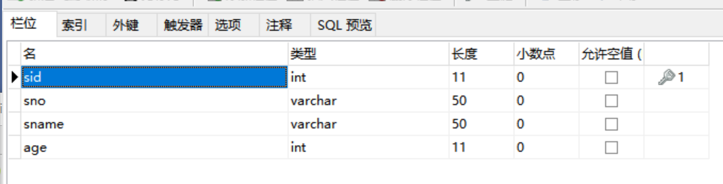
- 项目目录展示
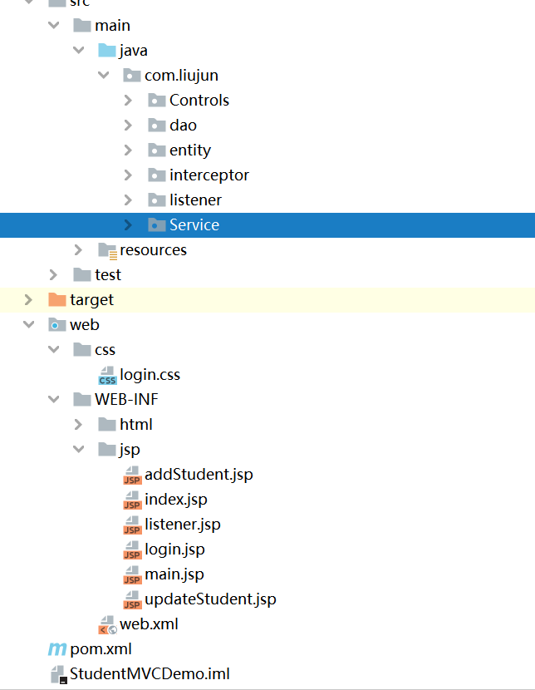
二、实现效果截图
1. 登录界面
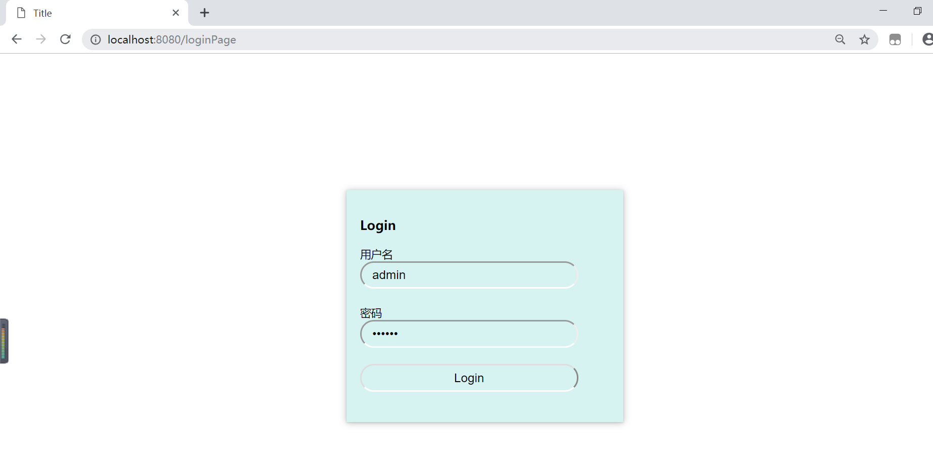
- 展示界面
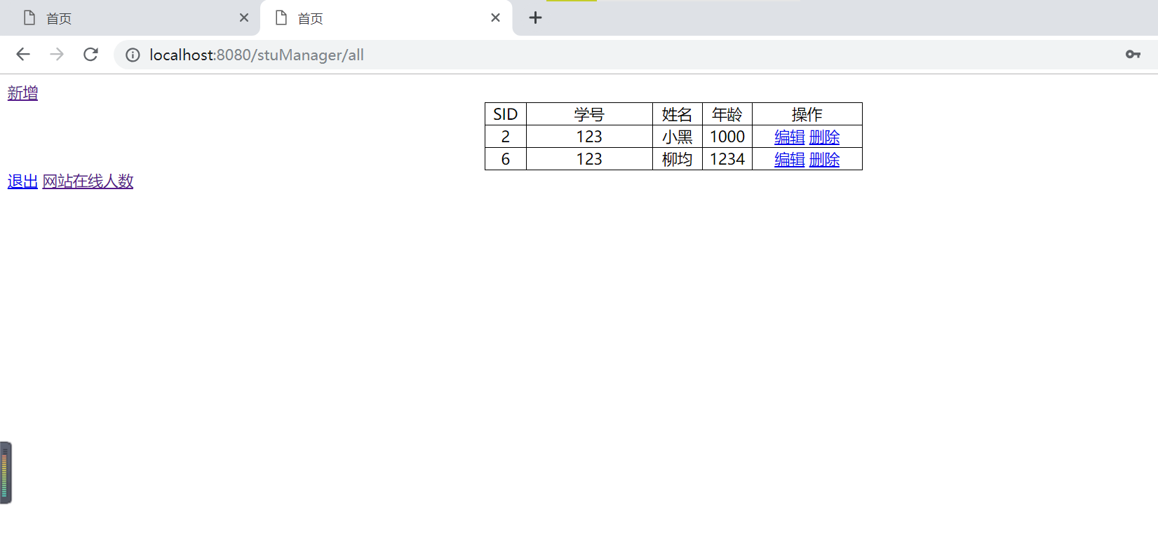
- 添加页面
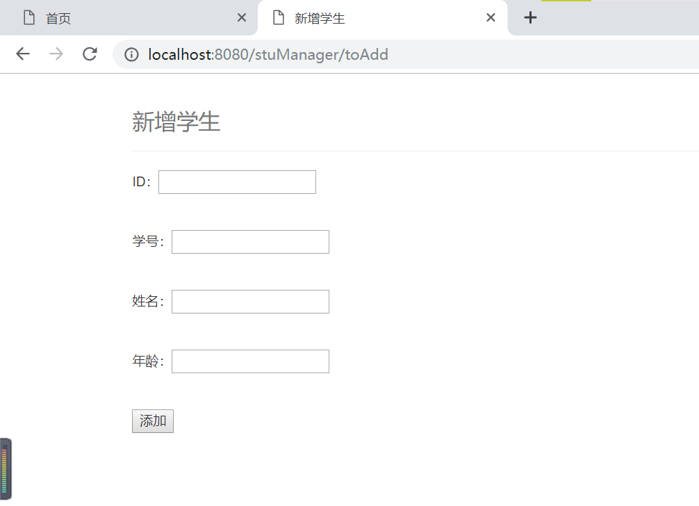
- 删除页面
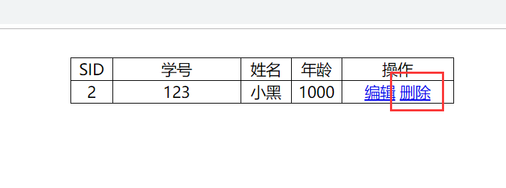
- 修改页面
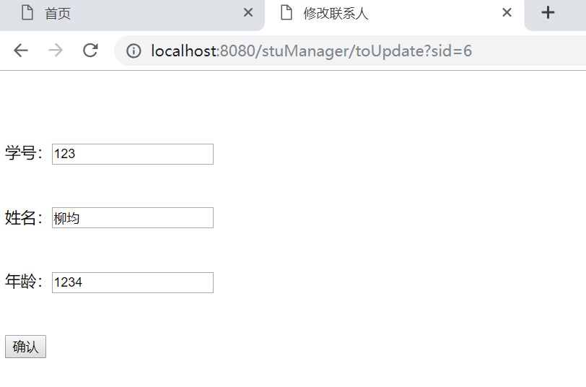
6. 在线人数展示页面
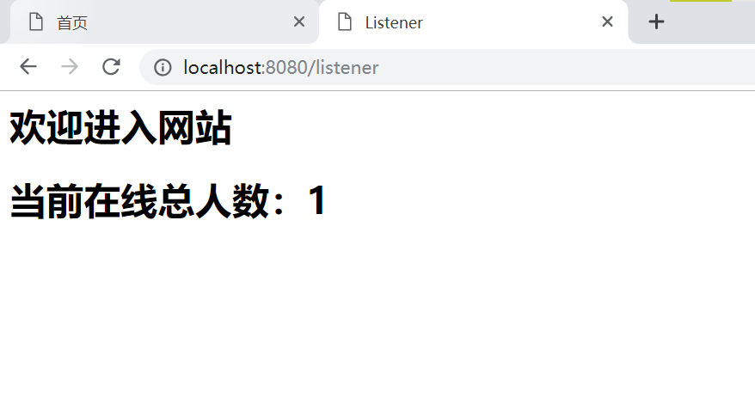
实验总结：
在本次实验中，我使用了SpringMVC框架，其中SpringMVC的原理是：SpringMVC是一个MVC的开源框架，SpringMVC是Spring的一个后续产品，其实就是Spring在原有基础上，又提供了web应用的MVC模块，可以简单的把SpringMVC理解为是spring的一个模块（类似AOP，IOC这样的模块），所以经常会说SpringMVC和Spring无缝集成，其实SpringMVC就是Spring的一个子模块，所以根本不需要同spring进行整合。然后SpringMCM的组件有前端控制器（DispatcherServlet）：接收请求，响应结果，相当于电脑的CPU；处理器映射器（HandlerMapping）：根据URL去查找处理器；处理器（Handler）：（需要程序员去写代码处理逻辑的）；处理器适配器（HandlerAdapter）：会把处理器包装成适配器，这样就可以支持多种类型的处理器，类比笔记本的适配器（适配器模式的应用）；视图解析器（ViewResovler）：进行视图解析，多返回的字符串，进行处理，可以解析成对应的页面。通过本次实验，我更叫深入了解了前后端交互的过程，也了解了SpringMVC框架的运行流程，这次实验我收获颇多。

