**객체지향프로그래밍 LAB #01&02 <기초문제>______________________________________________________________________________________**

1.

#include <iostream>

using namespace std;

int main() {

int x, y;

x = 10;

y = 20;

cout << x << endl;

cout << y << endl;

}

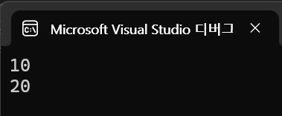

2.

#include <iostream>

using namespace std;

//sizeof()은 자료형 또는 변수를 가지고 크기를 byte 단위로 반환하는 연산자다.

int main() {

unsigned short siX; // (int) 생략 가능

unsigned iX;

long liX;

long long lliX;

cout << "sizeof(siX):" << sizeof(siX) << endl;

cout << "sizeof(iX):" << sizeof(iX) << endl;

cout << "sizeof(liX):" << sizeof(liX) << endl; // 64bit 환경에서 8로 출력

cout << "sizeof(lliX):" << sizeof(lliX) << endl;

}

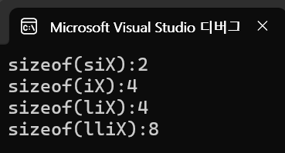

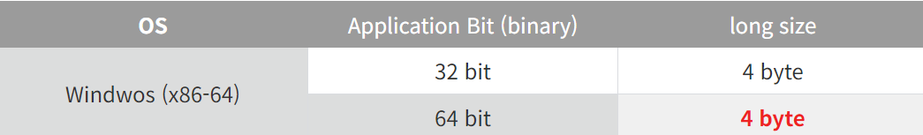

3.

#include <iostream>

using namespace std;

int main() {

int a = 7 == 5 ? 1 : 0;

int b = 7 >= 5 ? 1 : 0;

int c = 7 != 5 ? 1 : 0;

int d = 7 <= 5 ? 1 : 0;

int e = 7 >= 5 ? 100 : -100;

cout << "(7 == 5):" << a << endl;

cout << "(7 >= 5):" << b << endl;

cout << "(7 != 5):" << c << endl;

cout << "(7 <= 5):" << d << endl;

cout << "(7 >= 5 ? 100 : -100): " << e << endl;

}

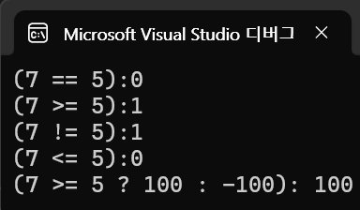

4.

#include <iostream>

using namespace std;

int main() {

const double PI = 3.14;

char ch1 = 65;

char ch2 = ch1+32;

cout << PI << endl;

cout << ch1 << endl;

cout << ch2 << endl;

}

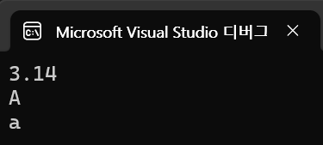

5.

#include <iostream>

using namespace std;

int main() {

int x, y, sum, mult;

float div;

cin >> x >> y;

sum = x + y;

mult = x * y;

div = (float (x)) / (float (y));

cout << x << '\t' << y << endl;

cout << "x + y = " << sum << endl;

cout << "x * y = " << mult << endl;

cout << "x / y = " << div << endl;

}

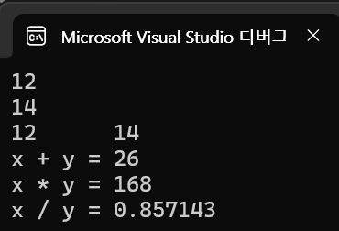

**<응용문제>_________________________________________________________________________________________**

1.

#include <iostream>

using namespace std;

int main() {

cout << "My name is 이준용" << endl;

}



2.

#include <iostream>

using namespace std;

int main() {

int A, B, s, m, mul, n;

cout << "Please enter two integer values: ";

cin >> A >> B;

cout << A << " + " << B << " = " << A + B << endl;

cout << A << " - " << B << " = " << A - B << endl;

cout << A << " * " << B << " = " << A * B << endl;

cout << A << " / " << B << " = " << (float(A)) / (float(B)) << endl;

cout << A << " % " << B << " = " << A % B;

}

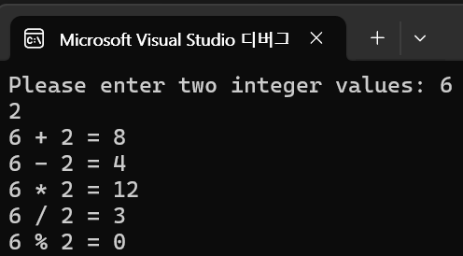

3.

#include <iostream>

using namespace std;

int main() {

int i1 = 2, i2 = 5, i3 = -3;

double d1 = 2.0, d2 = 5.0, d3 = -0.5;

cout << i1 + (i2 * i3) << endl;

cout << i1 * (i2 + i3) << endl;

cout << i1 / (i2 + i3) << endl;

cout << (i1 / i2) + i3 << endl;

cout << 3 + 4 + (5 / 3) << endl;

cout << (3 + 4 + 5) / 3 << endl;

cout << d1 + (d2 * d3) << endl;

cout << d1 + (d2 * d3) << endl;

cout << (d1 / d2) - d3 << endl;

cout << d1 / (d2 - d3) << endl;

cout << d1 + d2 + (d3 / 3) << endl;

cout << (d1 + d2 + d3) / 3;

}

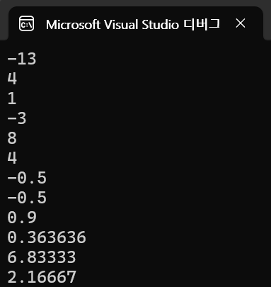

4.

#include <iostream>

using namespace std;

int main() {

int A, B;

cout << "Plase enter two integer values:" << endl;

cout << "A : ";

cin >> A;

cout << "B : ";

cin >> B;

int T = A;

A = B;

B = T;

cout << "value of A is : " << A << endl;

cout << "value of B is : " << B;

}

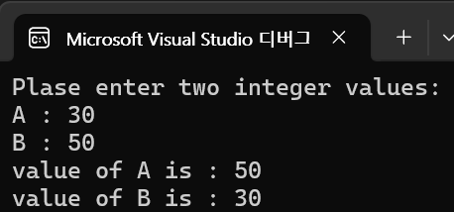

5.

#include <iostream>

using namespace std;

int main() {

int B;

cout << "plase enter Fahrenheit value: ";

cin >> B;

double A = 5.0 / 9.0 * (B - 32);

cout << "Celsius value is " << A;

}

