Proposal
Of
Enhancing Product Quality Through Vibration Signals in Turning Operations

A project submitted
by
Ajay Boddu (359962)
Bharadwaja Rangavajjula (360915)

For IME690 Capstone Project

Advisor
Dr. Joseph Chen


Department of Data Science and Engineering Analytics

Peoria, IL

Table of Contents

- Abstract….….…………………….………………………….3
- Literature Review…………………….………………………4
- Introduction………………………….……………………….5
- Objectives…………………………….………………………6
- Assumptions and Constraints………….…………………......7
- Methodology & Flow Diagram………………………………9
- Regression Modelling………………………………………...15
- Define Accuracy……………………………………………...17
- Regression Model Results……………………………………18
- Fuzzy Logic Model…………………………………………...20
- Fuzzy Prediction Results……………………………………...22
- Convolution Neural Network (CNN)…………………………24
- CNN Model Results…………………………………….…….26
- Conclusion…………………………………………….………27
- Future Work Enhancements………………………….……….28
- References…………………………………………….………30

- Abstract

This research presents a hybrid approach for predicting surface roughness in CNC turning operations by integrating signal processing techniques with fuzzy logic-based and deep learning-based modelling. Vibration data was acquired from the cutting process using tri-axial accelerometers, and features were extracted from three distinct domains: time, frequency (FFT), and time-frequency (STFT). A total of 36 statistical and spectral features were computed across all channels to represent the dynamic behaviour of the machining process.
To enhance predictive accuracy, R²-based evaluation was conducted to identify the top 12 most relevant features strongly correlated with surface roughness (Y_true). Subsequently, all possible 4-feature combinations were analysed using linear regression to determine the optimal subset of variables. The best-performing combination, selected based on maximum accuracy and R² score, was then employed as input for both fuzzy logic and deep learning systems.
The fuzzy inference system was constructed with membership functions and an expert-defined rule base to handle uncertainty and nonlinear relationships inherent in machining signals. In parallel, a Convolutional Neural Network (CNN) model was trained using the same optimal features to investigate its capability in learning complex, non-linear patterns through a data-driven approach. Both modelling strategies demonstrated the ability to accurately predict surface roughness values (Y_pred), offering complementary perspectives on machining signal interpretation.
This study not only demonstrates a robust methodology for real-time condition monitoring in turning operations but also highlights the synergy between statistical feature extraction, fuzzy logic reasoning, and deep learning for intelligent manufacturing applications. The framework offers valuable insights for future development in predictive maintenance, process optimization, and quality assurance in modern manufacturing environments.

- Literature Review

Surface roughness prediction in CNC turning operations has been extensively researched due to its critical impact on product quality, tool life, and manufacturing efficiency. Traditional surface evaluation methods, such as contact profilometry and optical inspections, although reliable, are limited by their offline nature, significant time requirements, and inability to facilitate real-time monitoring during production [1]. As the manufacturing industry advances towards smart and autonomous production, there is an increasing demand for predictive systems leveraging real-time sensor data for quality estimation.
Vibration-based condition monitoring has emerged as a viable approach to achieve this objective. Vibrations produced during the cutting process encapsulate valuable information regarding machining dynamics, tool wear, and surface finish characteristics. Capturing these vibration signals using high-frequency accelerometers, followed by advanced signal processing, allows for the extraction of features that exhibit strong correlation with surface roughness [2].
Studies have shown that features derived from multiple domains—time-domain statistics, frequency-domain spectra through Fast Fourier Transform (FFT), and time-frequency representations such as Short-Time Fourier Transform (STFT)—effectively characterize machining conditions [2]. Metrics like Root Mean Square (RMS), Peak, Crest Factor, Power Spectral Density (PSD), and Spectral Entropy have been particularly useful for capturing variabilities associated with surface roughness and tool behaviour.
Despite advancements, modelling the nonlinearities and uncertainties inherent in real-world machining environments remains challenging. Conventional regression models, though effective in capturing linear trends, often fail to handle complex, overlapping patterns in sensor signals. In contrast, fuzzy logic-based approaches offer a robust alternative by modelling imprecise relationships through linguistic rules and membership functions [3]. Fuzzy systems can accommodate minor fluctuations in input data, providing resilient and interpretable predictions.
In recent years, deep learning techniques—particularly Convolutional Neural Networks (CNNs)—have emerged as powerful tools for surface roughness prediction in turning operations. CNNs can automatically extract and learn complex feature representations from input data, reducing the need for manual rule formation or statistical selection. Srivastava et al. [4] applied an ANN model to CNC turning of EN8 steel and achieved a prediction error of less than 8%, validating the effectiveness of neural networks in capturing surface behaviour under varying cutting conditions. Similarly, Karayel [5] developed a neural network control framework in CNC turning and demonstrated accurate roughness prediction using input machining parameters. These studies demonstrate that deep learning models, when applied alongside signal-based feature extraction, offer high adaptability and predictive precision.
Integrating multi-domain feature extraction with regression, fuzzy logic, and CNN-based deep learning thus presents a comprehensive and scalable framework for intelligent surface roughness prediction. This study builds upon these foundations to develop an adaptive, high-accuracy prediction system tailored for CNC turning operations under variable machining conditions
- Introduction

Computer Numerical Control (CNC) turning is a widely adopted manufacturing process for producing high-precision cylindrical components across industries such as automotive, aerospace, and tooling. One of the key quality parameters in CNC turning is surface roughness, which directly affects the functional performance, tolerance levels, and lifespan of machined parts. Accurate surface quality is critical for ensuring optimal assembly, wear resistance, and aesthetic standards.
Traditionally, surface roughness is assessed using contact-based profilometers or non-contact optical devices after the machining process is completed. Although these methods provide precise measurements, they are inherently time-consuming, reactive rather than proactive, and unsuitable for real-time monitoring during production. This limitation creates a demand for intelligent in-process monitoring systems capable of predicting surface quality in real time.
Vibration signals generated during machining operations carry rich information about cutting conditions, tool wear, material deformation, and machine dynamics. Analysing these signals through advanced signal processing techniques enables the extraction of meaningful features that correlate with surface integrity. Features derived from time-domain, frequency-domain, and time-frequency analyses offer a comprehensive understanding of the machining process.
Recent research has shown that integrating statistical feature extraction with machine learning models such as regression analysis and fuzzy logic systems can provide robust surface roughness prediction under variable cutting conditions. While regression models are effective for capturing linear relationships, fuzzy logic systems offer enhanced resilience against uncertainties and nonlinearities inherent in real-world manufacturing environments.
To further improve predictive accuracy and automate feature representation, this study also explores the application of Convolutional Neural Networks (CNN). CNNs are capable of learning complex spatial relationships between extracted features without the need for manual rule definition or tuning. By leveraging CNNs alongside regression and fuzzy logic models, the proposed framework aims to enhance the system’s ability to generalize across varying cutting conditions and provide scalable, high-performance surface roughness prediction for CNC turning operations.
Advancements in data-driven manufacturing and the emergence of Industry 4.0 initiatives are further accelerating the integration of real-time monitoring systems into production environments. Predictive models leveraging sensor data not only enable early detection of quality deviations but also support adaptive process control and predictive maintenance strategies, ultimately enhancing manufacturing efficiency and competitiveness.

- Objectives

The primary goal of this project is to enhance product quality in CNC turning operations through the analysis of vibration signals. To achieve this, the project is structured around the following key objectives:
- To capture real-time vibration signals during CNC turning operations
- Acquire tri-axial acceleration data (X, Y, Z) using sensors mounted on the machine setup.
- Ensure signal collection under varied machining conditions to represent diverse surface roughness outcomes.
- To preprocess and segment the vibration signals for feature extraction
- Filter the time series data to eliminate noise and focus on steady state cutting (typically between 1.0s to 4.0s).
- Apply windowing techniques for consistent feature computation across parts.
- To extract significant features across different domains
- Time-domain: RMS, Peak, Crest Factor, Skewness, Kurtosis.
- Frequency-domain: Power Spectral Density, Dominant Frequency.
- Time-frequency domain: Spectral Entropy, Wavelet Kurtosis, etc.
- To select the most relevant features using statistical analysis
- Compute R² correlation scores for each feature against the surface roughness (Y_true).
- Select the top 12 features and evaluate all possible 4-feature combinations for model input.
- To develop a multilinear regression model for surface roughness prediction
- Train the regression model using selected features.
- Evaluate model performance using accuracy metrics.
- To implement a fuzzy logic-based model for predicting surface roughness
- Design membership functions and rules based on selected features.
- Compare fuzzy logic predictions with actual surface roughness values.
- Evaluate the accuracy of the fuzzy model under varying input conditions.
- To apply a Convolutional Neural Network (CNN) model for deep learning-based prediction
- Reshape selected 4-feature input into 2D format suitable for CNN architecture.
- Design and train a 1D CNN using convolutional, pooling, and dense layers.
- Evaluate model performance using R² score and custom accuracy metrics.
- Compare CNN results with those from regression and fuzzy logic to determine improvement in prediction performance.
- Assumptions and Constraints

Assumptions
- The CNC machine operates under stable temperature and mechanical conditions.
- Workpiece and tool material properties remain consistent throughout the trials.
- Accelerometers are properly calibrated and accurately capture vibration data.
- Surface roughness measurements (Y_true) are accurate and consistent.
- Fuzzy logic is suitable for modelling uncertainty in vibration-based quality prediction.
- Convolutional Neural Networks (CNNs) are assumed capable of learning non-linear relationships between features and surface roughness without manual feature engineering.

Constraints
- Experimental Analysis
  - The experimental setup is limited to a controlled machining environment, which may not represent real-world industrial variability.
  - External influences like temperature fluctuations or tool wear progression during longer production cycles are not evaluated.

- Dataset Information
  - The dataset used in the project is utilized vibration data from 27 parts for training and 16 parts for testing consisting of a limited number of parts and parameters.
  - The real solution is by extracting the features and finding the most relevant features to perform the model.
  - This restricts the model's ability to generalize across a broader range of machining conditions or part geometries.

- Data Analysis Technology and Prediction Modelling
  - Through statistical, data, and regression analysis, we pinpointed the four features which used to perform model. Following the analysis of these top four features, we made predictions for dependent variables(Y) and evaluated in the model accuracy.

- Regression Model Limitations
  - A multilinear regression model was developed using the top four vibration features selected based on R² scores.
  - The challenge lies in accurately predicting the accuracy based on these variables.
  - This assumes a linear relationship between inputs and surface roughness, which may oversimplify the true machining dynamics.

- Creating Rule Bank Using Data Sets
  - The fuzzy logic rule base is manually crafted using selected feature combinations.
  - The rule generation process is static and lacks adaptive tuning based on incoming data, which limits scalability.

- Calculation of Membership Functions
  - Membership functions are generated using manually defined input ranges (min, max, average), and are not self-optimized.
  - This task is accomplished in the membership function called calculateMU, where it takes the input of min, max and avg. values from row iteration values of corresponding x variable values and internally calculates the membership values and returns the mu_values whether it consists of S and M, or M and H.

- Calculation of prediction[y_pred] and Accuracy
- The goal is to calculate the y_pred and final accuracies of the y_pred and y.
- With the help of the function named calculateAccuracy we are using the predefined functions calculate MU and rules which calculates the MU values and gives us the rules for each iteration.
- Basing on these values we calculate the y_pred values. By using these y_pred values we further calculate the accuracy using the fuzzy logic formula.

- Reshaping Input Features for CNN
- The top 4 selected features were reshaped from a 1D feature vector (shape: 4,) into a 2D array (shape: 4×1) to make the data compatible with the CNN architecture.
- This transformation simulates spatial input for convolutional processing, even though the features are statistical rather than image based.

- CNN Architecture Design
- One 1D Convolutional layer for feature extraction
- One Max Pooling layer for dimensionality reduction
- A Flatten layer to prepare the output for dense connections
- One or more Dense layers with ReLU activation
- A final output layer with a linear activation function for regression (Y_pred)

- Model Training and Prediction
- The model is compiled using the Mean Squared Error (MSE) loss function and the Adam optimizer for efficient weight updates.
- It is trained over a fixed number of epochs (e.g., 150) with a small batch size (e.g., 2), using internal data splitting for validation.
- After training, the model performs prediction on the test data to generate surface roughness values (Y_pred).
- These predicted values are then compared with actual surface roughness measurements (Y_true) to evaluate the model’s performance.

- Methodology & Flowchart

The methodology followed in this project involves a systematic approach to predict surface roughness using vibration signals collected from CNC turning operations.

  - Data Acquisition using CNC Lathe Machine
The experimental data for this study was collected using a CNC lathe machine (as shown in Fig. 1), where cylindrical workpieces were machined under controlled laboratory conditions.
A total of 43 parts were produced by varying key machining parameters such as spindle speed, feed rate, and depth of cut to generate a diverse range of surface finish outcomes. Out of these, 27 parts were allocated for model training and the remaining 16 were used for testing and evaluation.
During each machining operation, tri-axial vibration signals (X, Y, and Z directions) were captured in real time using high-sensitivity accelerometers mounted on the cutting tool assembly. These vibration signals served as the raw input for signal processing, feature extraction, and subsequent modelling.

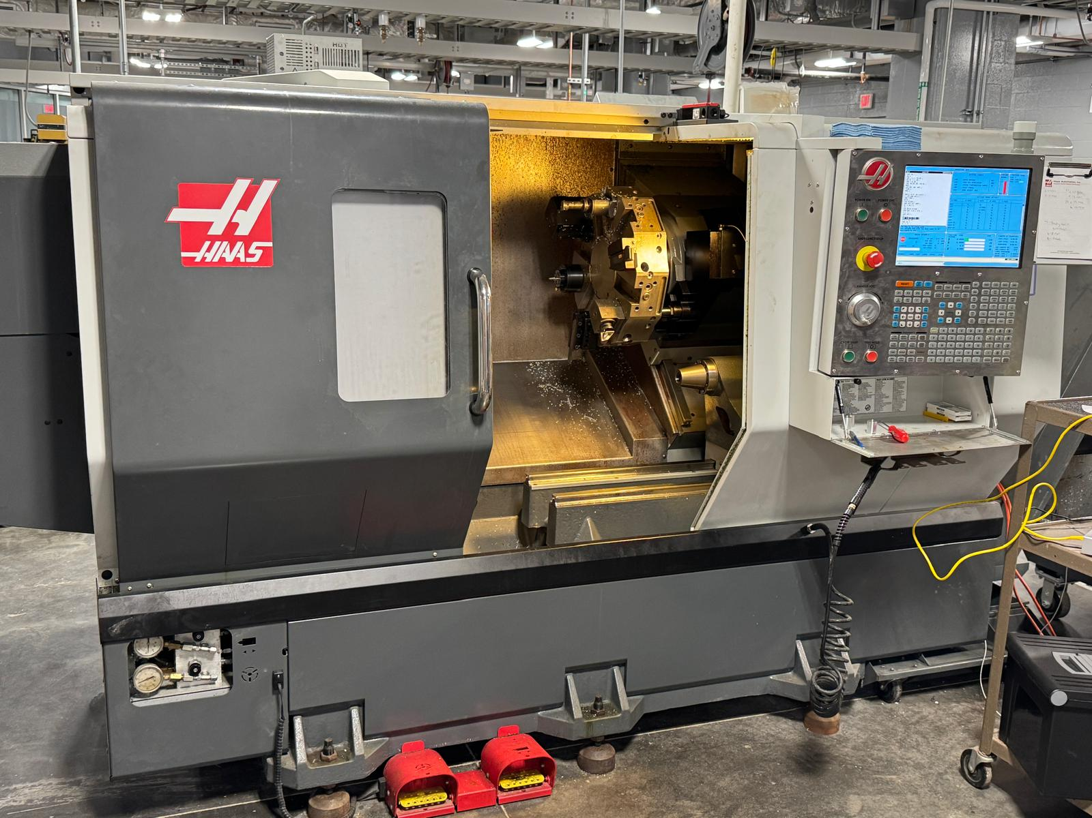
Fig. 1: CNC Lathe Machine

  - Surface Roughness Measurement (Y_True)
Following the machining process, the surface roughness (Ra) of each part was measured using a surface roughness measurement device (Fig. 2). To ensure accuracy and consistency, three readings were taken from different locations on each machined part. The average of these three values was computed and recorded as the ground truth surface roughness (Y_True) for that sample. This value served as the reference for evaluating prediction accuracy in all subsequent modelling stages.
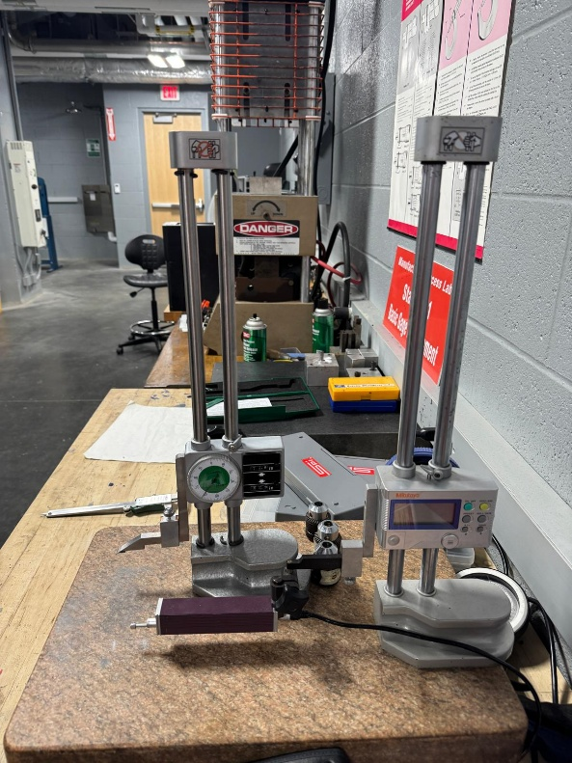
Fig. 2: Surface Roughness Tool

  - Feature Extraction from Vibration Signals
The raw vibration signals collected were pre-processed and features were extracted across three signal analysis domains:

    - Time Domain
Time-domain analysis involves analysing raw signals over time — that is, observing how a signal changes with time without converting it to frequency or other domains.
- Root Mean Square (RMS): It is a feature which provides a measure of the energy content in the signal by calculating the square root of the average of the squared signal values. RMS reflects the overall power of the signal and is widely used to assess general vibration severity. The mathematical representation of this is as follows
$RMS=\sqrt{\frac{1}{N}⋅\sum_{i=1}^{N}{x_{i}^{2}}}$ ------------(1)
- Peak Value: The peak value represents the maximum absolute amplitude in the signal and is useful for identifying sudden impacts or transient events. It is sensitive to anomalies and often indicates the presence of mechanical shocks, such as cracks or misalignments.

$Pⅇak=\max\left(\left|x\left(t\right)\right|\right)$ ------------(2)

- Crest Factor: Crest factor is derived by dividing the peak value by the RMS. It quantifies the ratio of the highest peak to the overall energy level of the signal. A high crest factor typically suggests the presence of impulses or sharp transients, which are characteristic of faults such as bearing defects or looseness.

Crest Factor = $\frac{pⅇak}{RMS}$ -----------(3)

- Kurtosis: Kurtosis measures the sharpness or peakiness of the signal distribution by evaluating the fourth standardized moment. It captures how often extreme values occur relative to a normal distribution. Signals with high kurtosis usually contain infrequent but extreme peaks, indicating potential faults or defects in the machinery.
Kurtosis = $\frac{\frac{1}{N}\sum_{i=1}^{N}{{\left(x_{i}-μ\right)}^{4}}}{{\left(\frac{1}{N}\sum_{i=1}^{N}{{\left(x_{i}-μ\right)}^{2}}\right)}^{2}}$ ----------(4)

    - Frequency Domain (FFT)
The frequency domain (Fast Fourier Transform) analyzes how different vibration frequencies contribute to the signal. It helps in identifying periodic vibration patterns that might indicate chatter or structural resonances. By analyzing the signal in the frequency domain, we can isolate key frequencies related to defective machining conditions.
- Power Spectral Density (PSD) quantifies how the signal's power is distributed across frequency. It highlights energy concentration and helps detect abnormal vibrations or imbalances.
$PSD\left(f\right)=\frac{\left|x\left(f\right)\right|}{N}$ -----------(5)

- Dominant Frequency pinpoints the frequency with the highest amplitude, often corresponding to a mechanical fault or system resonance.

$f_{d}=\arg{\max{PSD\left(f\right)}}$ ------------(6)

- Total Energy in the frequency domain captures the overall energy content, offering a comprehensive measure of vibration intensity.

$E_{freq}=\sum_{f=0}^{F}{{\left|x\left(f\right)\right|}^{2}}$ -------------(7)

- Spectral Entropy reflects the complexity or disorder in the frequency components. A higher entropy value indicates more randomness, which may be associated with unpredictable or degraded machine conditions.

$H=-\sum_{f=0}^{F}{P\left(f\right)\log{p\left(f\right)}}$ -------------(8)

    - Time-Frequency Domain (STFT)
The Short-Time Fourier Transform (STFT) is a powerful signal processing technique that extends the capabilities of FFT by analyzing how frequency content evolves. STFT provides a way to track frequency variations over time, unlike FFT, which provides only a static frequency representation.
- Spectral Entropy in STFT measures the randomness or complexity of frequency components over time, helping identify erratic or unstable behaviours in machine operation.
$H\left(t\right)=-\sum_{f=0}^{F}{P\left(f,t\right)\log{P\left(f,t\right)}}$ -------------(9)
- Spectral Centroid indicates the average frequency or the "centre of mass" of the spectrum in each window. It shifts higher or lower depending on the dominant frequency content in time.
$C\left(t\right)=\frac{Σ_{f}f⋅\left|X\left(f,t\right)\right|}{Σ_{f}\left|X\left(f,t\right)\right|}$ -------------(10)
- Spectral Bandwidth describes the spread of the frequencies at each point in time, revealing how wide or narrow the energy is distributed. Broader bandwidths often signal complex or fault-induced vibrations.
$B\left(t\right)=\sqrt{\frac{Σ_{f}{\left(f-C\left(t\right)\right)}^{2}⋅\left|X\left(f,t\right)\right|}{\sum_{f}{1}X\left(f,t\right)}}$ -------------(11)
- Spectral Kurtosis measures the peakiness of the frequency distribution over time, making it sensitive to transient impulses or extreme vibrations that are important in fault diagnosis.
K $\left(t\right)=\frac{\frac{1}{N}Σ_{f}{\left(X\left(f,t\right)-μ_{f}\right)}^{4}}{{\left(\frac{1}{N}Σ_{f}{\left(X\left(f,t\right)-μ_{f}\right)}^{2}\right)}^{2}}$ ------------(12)

  - Feature Selection using R² Analysis
- To avoid overfitting and redundancy, a feature selection process was implemented based on statistical correlation analysis. Each extracted feature was individually regressed against surface roughness (Y_true), and its coefficient of determination (R²) value was calculated.
- The top 12 features exhibiting the highest R² scores were shortlisted for further modelling. Subsequently, all possible 4-feature combinations (C(12,4) = 495 combinations) were generated and evaluated to identify the optimal feature subset based on prediction performance.

Stage 1: Multilinear Regression Modelling (MLR)
  - Regression Model Development
- A Multilinear Regression (MLR) model was developed using the selected four features. The model was trained on the 27-part training dataset and validated using the 16-part testing dataset. The regression equation established a quantitative relationship between the selected vibration features and surface roughness.
  - Prediction and Accuracy Calculation
- The model predicted surface roughness values (Y_Pred) for test samples.
- Accuracy was evaluated by comparing Y_Pred with Y_True using standard metrics such as R² score and a custom-defined fuzzy accuracy formula.

$Accuracy=100-\left(\left|\frac{Y_{true}-Y_{pred}}{Y_{true}}\right|\right)$ -------------(13)

Stage 2: Fuzzy Logic Model Development
  - Fuzzification: Membership Function Definition
- Triangular membership functions were defined for each input feature, categorized into three linguistic levels: Low, Medium, and High. Membership ranges were determined using statistical quantiles (minimum, average, maximum values).
  - Rule Base Design
- An expert-defined rule base comprising 81 fuzzy rules (3⁴ combinations) was constructed to map input feature combinations to output surface roughness categories.
  - Defuzzification
- The fuzzy output generated from the rule-firing strength is converted back into a crisp value using centroid-based defuzzification.
- This method calculates the centre of gravity of the aggregated fuzzy set, resulting in a single predicted surface roughness value (Y_Pred) for each test part.
  - Prediction and Accuracy Evaluation
- The fuzzy logic model was executed for all test samples using the selected feature values.
- Predicted surface roughness values (Y_Pred) were compared with actual (Y_True), and accuracy was computed using a custom-defined formula.

Stage 3: Convolutional Neural Network (CNN) Model Development
  - Input Preparation and Feature Reshaping
- The four optimal features selected from R²-based statistical analysis were reshaped into a 2D format to serve as input for the CNN model.
- Each feature vector of shape (4,) was converted to a (4,1) input, treating the features as a spatial sequence.
- This format enables the convolutional layer to scan feature patterns using a 1D filter.

  - CNN Model Architecture
A custom-built 1D CNN architecture was defined to learn non-linear patterns in the vibration feature space:
- A Conv1D layer with a fixed number of filters and kernel size processes the reshaped input to capture localized feature interactions.
- A MaxPooling1D layer reduces the dimensionality of the feature map while preserving important activations.
- The Flatten layer converts the pooled output into a single feature vector.
- One or more Dense layers with ReLU activation functions allow deeper learning of complex relationships.
- A final output layer with a linear activation predicts the continuous surface roughness value (Y_Pred).
  - Model Compilation and Training Procedure
- The CNN model was compiled using the Mean Squared Error (MSE) as the loss function and optimized using the Adam optimizer.
- Training was conducted on the full dataset of 43 parts using 150 epochs and a batch size of 2.
- During training, the model continuously evaluated loss reduction and adjusted weights accordingly to minimize error.

  - Prediction and Accuracy Evaluation
- After the training phase, the CNN model was used to predict surface roughness values (Y_Pred) for all parts in the dataset. These predictions were then compared with the actual measured values (Y_True) to evaluate model performance.
- A custom-defined accuracy formula, consistent with earlier stages, was applied to assess the prediction quality:
- The CNN results were benchmarked against the multilinear regression and fuzzy logic models to assess their effectiveness in capturing non-linear relationships and improving predictive reliability.

Evaluating Predictions and Accuracy
Output Layer (1 Neuron, Linear Activation
Flatten Layer

1D Convolutional Layer (32 filters)

Stage 3: Convolution Neural Network Model
Normalize and Reshape data (4*1)
Stage 1: Regression Model
Construct Rule Bank
Defuzzification
Fuzzy Inference System
Calculate Membership functions

Stage 2: Fuzzy Logic Model
Y_True
Surface Roughness Tool
X
Yes
No
Tri-accelerometer
START
Input Parameters
CNC Lathe Machine
Grooved Cylinder
Surface Roughness Measure
Finding $R^{2}$ Values
Pick top 12 $R^{2}$ Values
Perform Linear Regression analysis
Generate 4 -featured Combinations
Calculate Accuracy If >= 95%
END
Data Collection
Frequency Domain Features
Time Domain Features
Wavelet Features
Feature Extraction
Calculate Accuracy If >= 95%
END
Yes
No
Calculate Accuracy
Dense Layer (16 Neurons, RelU Activation)
END
Perform necessary actions

Fig. 3: Model Flowchart
- Regression Modelling – Prediction of Y

After identifying the best four predictive features based on their strong correlation with the surface roughness output (Y_True), a regression model was developed to establish the mathematical relationship between these input features and the target variable. The regression approach used in this project falls under supervised learning, where the model is trained on labelled data—that is, vibration features (inputs) paired with known surface roughness values (outputs). The goal is to learn a function that accurately maps input variables to the desired output.

In this context, the regression model enables the prediction of surface roughness based on values of the selected vibration features. The relationship is modelled using a multiple linear regression equation of the form:

Y = β₀ + β₁X₁ + β₂X₂ + β₃X₃ + β₄X₄ + ϵ ----------(14)

Where:
- Y is the surface roughness (output)
- X₁ to X₄ are the selected features from vibration data
- β₀ to β₄ are the regression coefficients learned during training
- ϵ is the error term representing prediction noise

Once the model is trained, these coefficients quantify the influence of each feature on the output, allowing prediction of surface roughness for new unseen data based on the corresponding feature values. The predicted values (Y_Pred) provide insight into machining quality under various vibration conditions. The model was evaluated on both training and testing datasets to assess its accuracy and generalization.

In summary, by utilizing the top four predictor variables and performing a Fit Regression model, we establish a predictive relationship between the predictor variables and the response variable. This allows for the calculation of predicted values of the response variable, enhancing our ability to forecast outcomes and make data-driven decisions.

- From the final model trained in Minitab, the following regression equation was obtained using the best four features from Channel 2:
Y_Pred =( –3.16 + 579· (Channel 2 RMS) + 5.91· (Channel 2 Peak) + 0.000025· (Channel 2 Dominant Frequency) – 0.01583· (Channel 2 Total Energy))

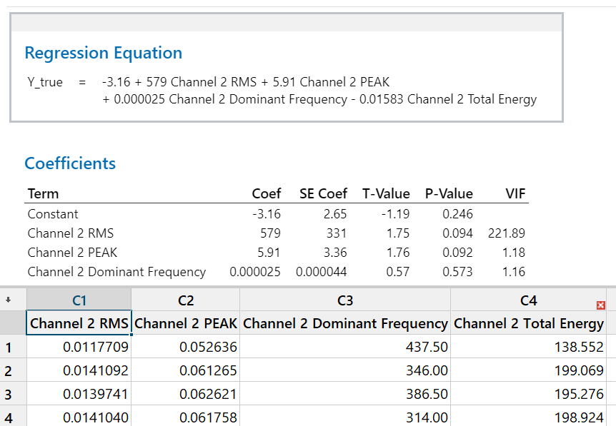
Fig. 4: Regression Equation
- This equation represents how each selected vibration feature contributes to predicting the surface roughness. Features with positive coefficients, such as RMS and Peak, show a direct relationship, while those with negative coefficients (e.g., Total Energy) have an inverse impact. The intercept (–3.16) captures the base level of surface roughness in the absence of vibration input.

- Define Accuracy

In the context of this project, accuracy refers to how closely the predicted surface roughness values (Y_Pred) match the actual measured values (Y_True). While the term “accuracy” is traditionally associated with classification tasks, in regression modelling, we adopt specialized metrics to evaluate prediction performance.

The following metrics were used in this study:

- Coefficient of Determination (R-squared):
R² measures the proportion of variance in the surface roughness (Y_True) that is explained by the selected vibration features in the regression model. It ranges from 0 to 1, with higher values indicating stronger predictive power and better model fit.

- Custom Prediction Accuracy Formula:
In addition to R², a custom-defined formula was used to calculate the prediction accuracy for each instance. This formula evaluates the percentage deviation of the predicted value from the actual value and converts it into a simple accuracy percentage.

The formula used is:

Prediction Accuracy = 100 - [mod (Y_true - Y_Pred) / Y_true 100]

Where:
- YTrue​ = Actual surface roughness value (measured from test parts)
- YPred​ = Predicted surface roughness value (from regression)

This accuracy metric provides an intuitive understanding of how close the model's predictions are to actual values, expressed as a percentage. An accuracy close to 100% indicates highly reliable predictions. The combination of R² and prediction accuracy offers a comprehensive evaluation of the model’s performance in capturing the relationship between vibration features and machining surface quality.

- Regression Analysis Results

Training Data Testing Data
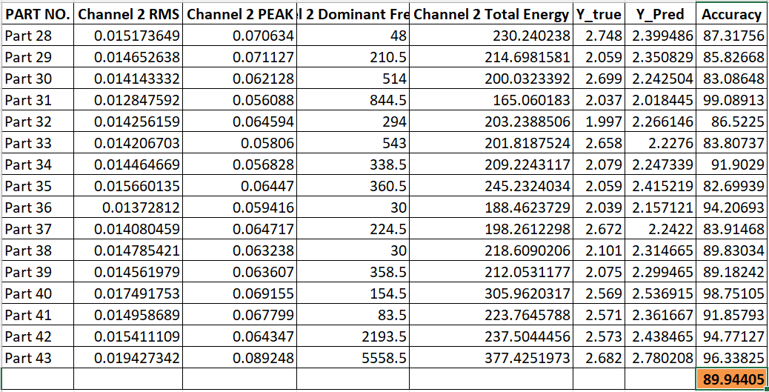
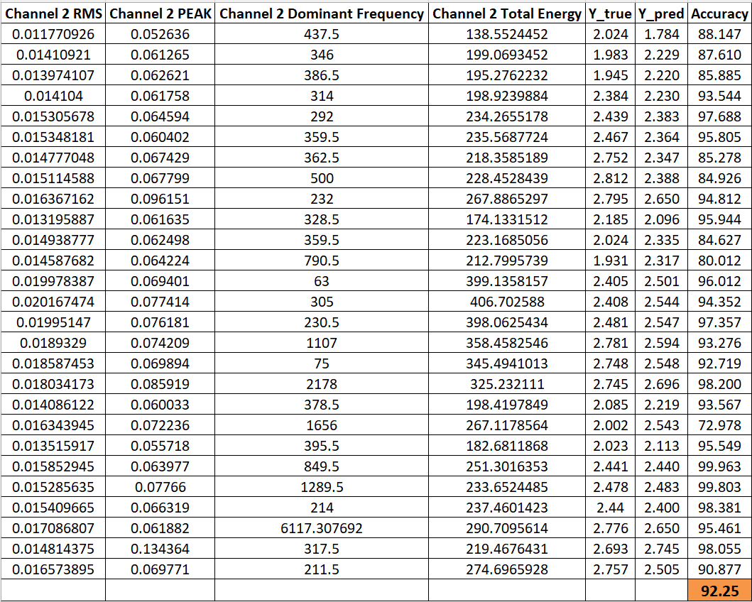

Fig. 5: Regression model Results

Fig. 6: Average Accuracy

- Comparison of Ytrue and Y Pred:
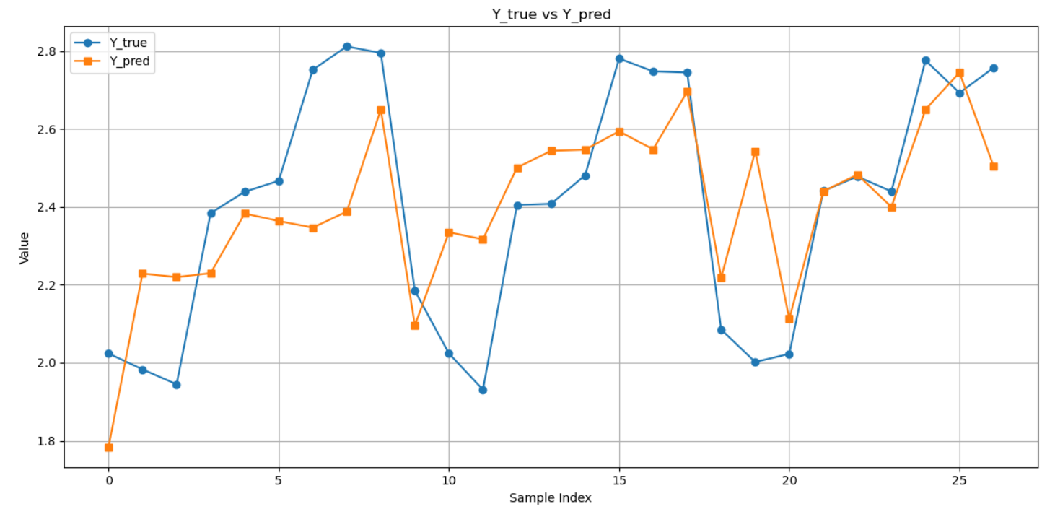
Fig. 7: Training Result Comparison
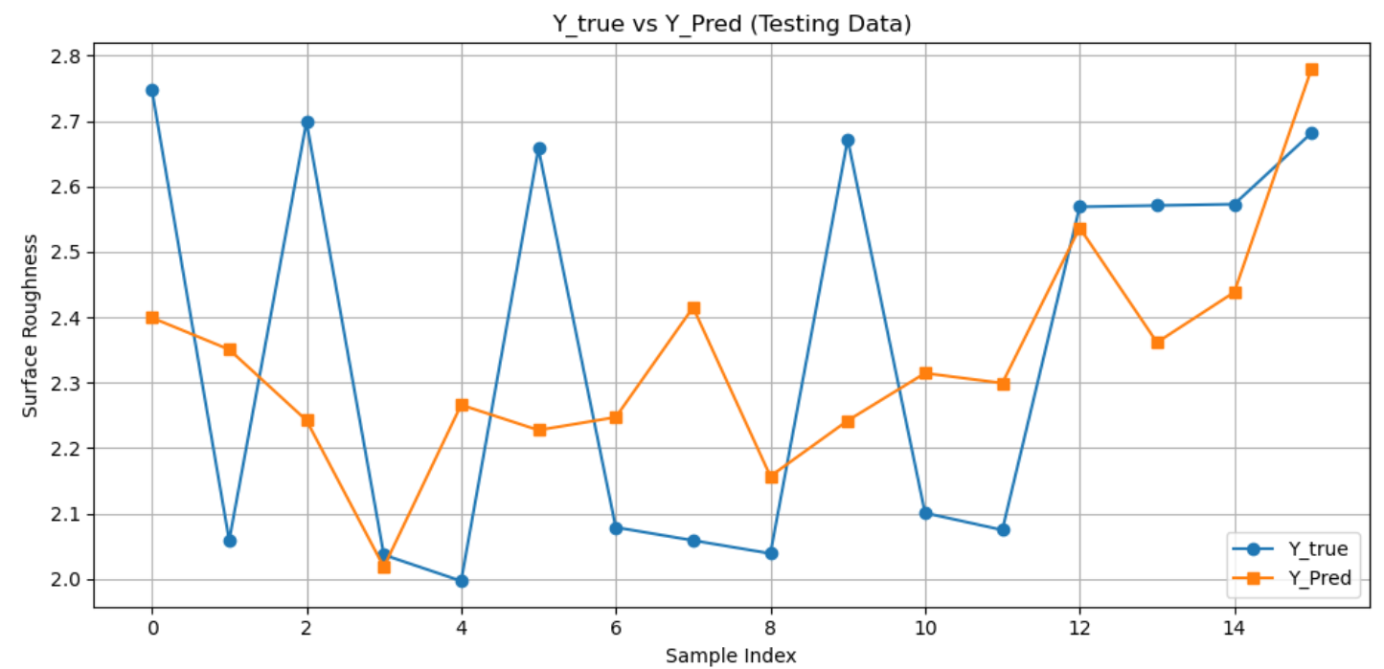
Fig. 8: Testing Result Comparison

- Fuzzy Logic – Supervised Learning

Fuzzy logic is not a conventional supervised learning method like linear regression or decision trees, but rather a powerful approach for modelling uncertainty and imprecision in complex systems. It uses linguistic rules and membership functions to handle data that may not be easily quantifiable. In this project, fuzzy logic was integrated with supervised learning techniques to predict surface roughness (Y_True) based on selected vibration features.

Although fuzzy logic is rule-based and heuristic by nature, when applied in a supervised context with labelled input-output data, it can function as a predictive model trained to estimate the target variable—in this case, surface roughness.

- Fuzzy Input Variables:

The four most relevant features selected through R² analysis were used as inputs for the fuzzy model:
- Channel 2 RMS
- Channel 2 PEAK
- Channel 2 Dominant Frequency
- Channel 2 Total Energy

These continuous input variables were represented using fuzzy linguistic terms (Low, Medium, High) instead of exact numerical thresholds, allowing the model to better handle noise and overlap in machining behaviour.

- Membership Functions:

Each input variable was mapped to triangular membership functions, divided into three linguistic levels—Low, Medium, and High—based on minimum, average, and maximum values calculated from the training dataset. The general form of the triangular function is

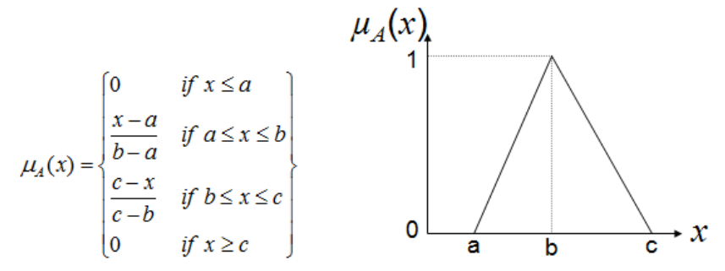
Fig. 9: Triangular Membership function
Where:
a = minimum value, b = average value, c = maximum value of the feature.

The table below shows the fuzzy ranges used:
Feature | Min | Avg | Max
Channel 2 RMS | 5.033 | 7.287 | 8.045
Channel 2 PEAK | 5.354 | 7.626 | 8.398
Channel 2 Dominant Freq. | 2046 | 2985.1 | 3347.5
Channel 2 Total Energy | 516.16 | 2918.7 | 8053.3

Fig.10: Fuzzy Ranges

- Fuzzy Inference System (FIS):

The fuzzy inference system uses IF-THEN rules to model how combinations of input linguistic values affect the output surface roughness. Rule activation is computed using fuzzy set intersections based on the degree of membership

μF1×F2×F3×F4​=μF1​(x1​)⋅μF2​(x2​)⋅μF3​(x3​)⋅μF4​(x4​)

Where the product operator is used to simulate logical AND operations.
The output membership values are computed using fuzzy implications of the form:

μRule Output​(Y)=[μF1​(x1​)⋅μF2​(x2​)⋅μF3​(x3​)⋅μF4​(x4​)]→μG​(Y)

- Rule Bank:

A total of 81 fuzzy rules (3⁴ combinations) were defined manually based on domain knowledge. Each rule follows the structure:

- IF (x₁ is Medium) AND (x₂ is High) AND (x₃ is Low) AND (x₄ is Medium)
THEN (Y is Rough)

This rule bank allows the system to model non-linear and complex relationships in a way that is interpretable and adaptable.

- Defuzzification:

After computing the strength of each rule and its associated output level, centroid-based defuzzification was applied to convert the fuzzy output into a single crisp predicted value:

Predicted_Y = Calculated values from Triangular function * Rule bank values
Sum of Calculated values from Triangular Function
This method ensures that the final prediction reflects all contributing rules, weighted by their confidence.

- Final Output and Accuracy:

Using the above fuzzy system, predicted surface roughness values (Y_Pred) were generated for all test samples. The prediction accuracy was computed using the same formula as the regression model:

Prediction Accuracy = 100 - [mod(Y_true - Y_Pred) / Y_true * 100]

This approach allowed us to evaluate how well the fuzzy logic model captured machining patterns and surface quality, especially under noisy or uncertain conditions.

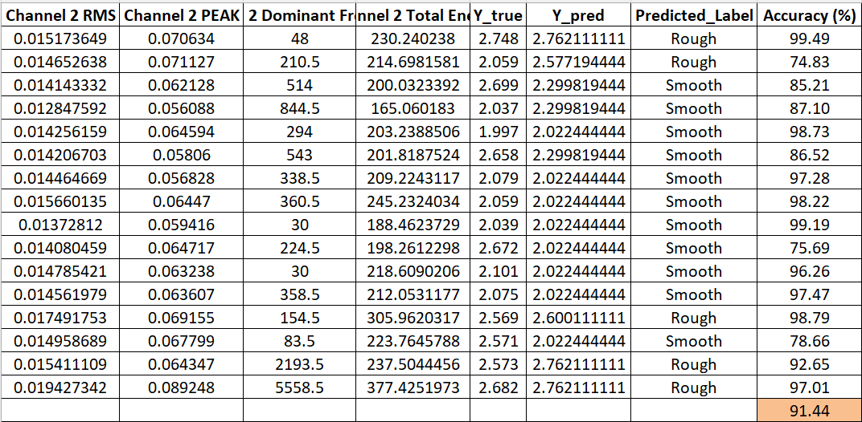
- Fuzzy Prediction Results
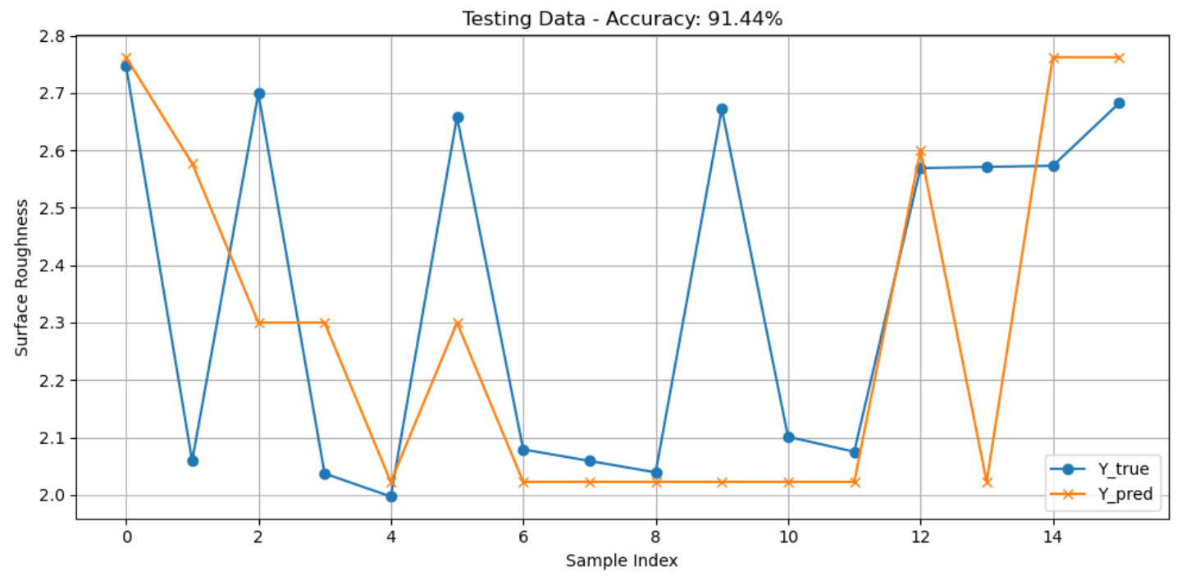
Fig. 11: Fuzzy Results
Fig. 12: Comparison for fuzzy result
- Convolution Neural Network (CNN) Modelling

Artificial Neural Networks (ANNs) and Convolutional Neural Networks (CNNs) are foundational models in deep learning, widely used for predicting outcomes in complex systems. ANNs are structured in layers, where each neuron in a layer performs a weighted sum of its inputs, adds a bias term, and passes the result through an activation function. This operation can be expressed as:

$z=\sum_{i=1}^{n}{ω_{i}x_{i}}+b and a={∅\left(z\right)}^{1}$ ----------(15)

Where:
- xi​ are the input features,
- wi​ are the associated weights,
- b is the bias term,
- ϕ(z) is the activation function (e.g., ReLU or Sigmoid),
- a is the final output of the neuron.
ANNs are composed of layers of neurons that learn relationships between input and output data through weighted connections and activation functions. They are highly versatile and have been successfully applied to tasks such as regression, classification, and forecasting. However, traditional ANNs treat input features independently and may not fully capture local dependencies or spatial patterns within structured data.
CNNs, on the other hand, are a specialized type of ANN that incorporate convolutional layers to detect patterns by applying filters across the input. This architecture allows CNNs to automatically learn feature hierarchies and spatial relationships, making them especially effective for image analysis, time-series classification, and sensor signal interpretation. The use of shared weights and local receptive fields also makes CNNs more computationally efficient compared to fully connected networks.

$s\left(t\right)=\left(x*w\right)\left(t\right)=\sum_{i=0}^{k-1}{x}\left(t+ⅈ\right)⋅w\left(ⅈ\right)$ ---------(16)
Where:
- x is the input feature sequence,
- w is the convolution filter (kernel),
- s(t) is the resulting feature map at position t,
- k is the filter size.
In this project, both ANN and CNN methodologies are applicable due to the structured nature of the input—statistical features extracted from vibration signals during CNC turning. While ANN can model the global relationship between features and surface roughness, CNN offers an advantage by learning localized interactions between the features. By reshaping the feature vector into a 2D format, the CNN captures spatial patterns that may indicate machining conditions affecting surface finish. This enhances the model’s ability to generalize across different cutting scenarios, providing more accurate and robust predictions. Integrating deep learning models such as ANN and CNN into surface quality monitoring represents a significant step toward intelligent and adaptive manufacturing systems.
Advantages of CNN:
- Data-driven learning: CNN does not require manual rule definition or assumptions about linearity.
- Pattern discovery: Capable of automatically identifying complex non-linear relationships among features.
- Improved accuracy: In this project, CNN achieved higher prediction accuracy compared to traditional models, especially in capturing subtle variations across test samples.

  - CNN Model Architecture and Training Configuration
In this project, a Convolutional Neural Network (CNN) was implemented to predict surface roughness using the four most influential vibration features identified through R²-based selection. The input features—RMS, Peak, Dominant Frequency, and Total Energy—were reshaped from a 1D vector of shape (4,) to a 2D format (4,1) to make them compatible with the 1D convolutional layer.
The CNN architecture comprised a single 1D convolutional layer with 32 filters and a kernel size of 2, followed by a Flatten layer and two dense layers, including a final output layer with linear activation for regression. A dropout layer (rate = 0.2) was added after the convolutional layer to reduce overfitting and enhance generalization on a small dataset.
The model was compiled using the Adam optimizer with the default learning rate of 0.001 and the Mean Squared Error (MSE) loss function. The entire dataset of 43 parts was used for training to maximize the utilization of available data, with early stopping applied based on training loss to prevent overfitting.
The key training configurations were as follows:
Number of epochs: 300 (with early stopping to halt when performance plateaued)
Batch size: 8
Optimizer: Adam
Loss function: Mean Squared Error (MSE)
Input shape: (4, 1)

- CNN Model Results
To evaluate the performance of the Convolutional Neural Network (CNN) model for surface roughness prediction, the output values (Y_pred_CNN) were compared against actual surface roughness values (Y_true) for each part. The accuracy for each prediction was calculated using the following formula

Prediction Accuracy = 100 - [mod(Y_true - Y_Pred) / Y_true * 100]

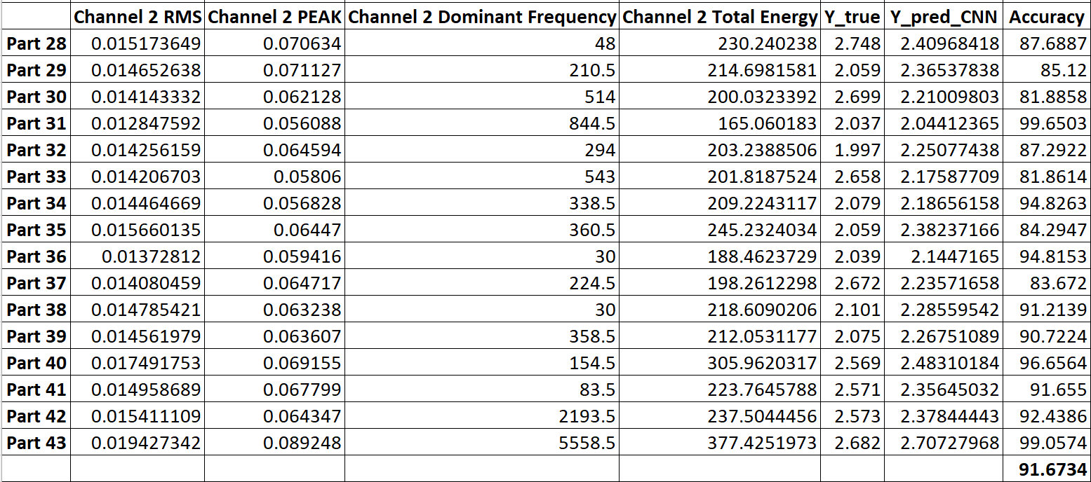
The output result:

Fig. 13: CNN Results

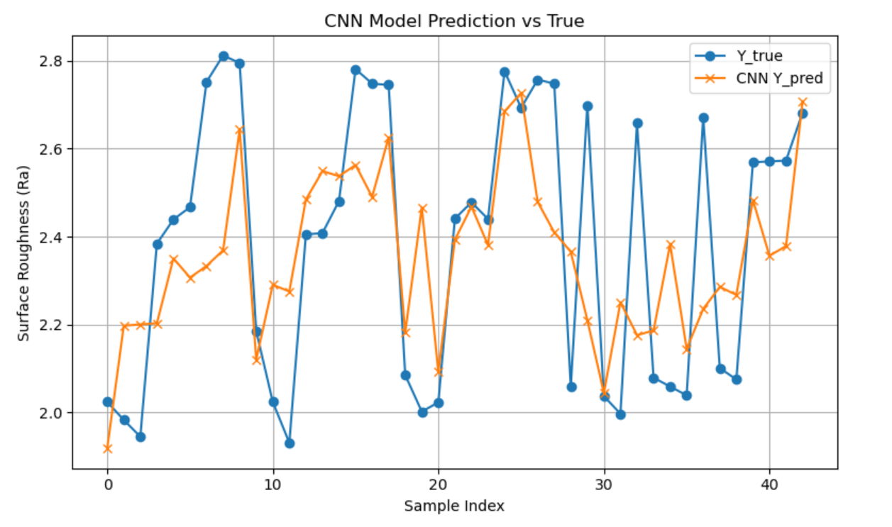
The CNN model achieved an average prediction accuracy of 91.67% and a coefficient of determination (R² score) of 0.381.
Fig. 14: Comparison for CNN Result

- Conclusion

This project explored a hybrid methodology for predicting surface roughness in CNC turning operations by utilizing vibration signals processed through statistical, fuzzy logic, and deep learning techniques. Vibration data were collected from 43 parts using tri-axial accelerometers, and 36 features were extracted across time, frequency, and time-frequency domains.
Using R²-based evaluation, the 12 most relevant features were identified, and all 495 possible 4-feature combinations were analysed. The best-performing feature combination was selected for model development. Initially, a supervised regression model was implemented, which established a mathematical relationship between vibration features and surface roughness. It offered a transparent, interpretable prediction mechanism and produced satisfactory results.
To improve resilience to nonlinear behaviour and uncertainty in signal patterns, a fuzzy logic model was implemented using the same four input features. The model incorporated triangular membership functions and a rule base of 81 combinations. This approach improved prediction accuracy and interpretability, particularly in cases where surface behaviour was difficult to model linearly.
Building on these methods, a Convolutional Neural Network (CNN) model was implemented to explore the benefits of deep learning in predictive surface monitoring. CNNs learn hierarchical patterns within structured data and are especially suitable for modelling complex relationships without requiring explicit rules or assumptions. In this project, the CNN autonomously learned spatial dependencies among vibration features, offering a data-driven alternative to the previous rule-based and linear models.
These three modelling strategies collectively demonstrate the strengths and trade-offs between interpretable models (regression and fuzzy logic) and data-driven models (CNN). The integration of vibration signal processing with machine learning provides a promising approach for real-time surface quality monitoring and intelligent decision-making in modern manufacturing.

Comparison between the models:

Criteria | Regression Model | Fuzzy Logic Model | CNN Model
Model Type | Supervised linear regression | Rule-based fuzzy inference | Deep learning (CNN)
Input Features Used | 4 (RMS, PEAK, Dominant Freq., Total Energy) | Same 4 features | Same 4 features (reshaped)
Training Accuracy (R²) | 91.94% | 92.16% | 92.16%
Testing Accuracy (%) | 89.94% | 91.44% | 91.67%
R² Score (Testing) | ~0.40 | ~0.42 | 0.38
Interpretability | Moderate (coefficients) | High (linguistic rules) | Low (black box)
Best Use Case | Linear patterns | Nonlinear/uncertain patterns | Complex nonlinear interactions
- Future Enhancements

While the current methodology effectively predicts surface roughness using regression, fuzzy logic, and convolutional neural networks (CNNs), several opportunities remain to further improve the model’s performance, scalability, and industrial applicability:

- Adaptive Rule Base Generation for Fuzzy Logic
In the current fuzzy system, 81 rules were manually defined based on domain knowledge. Future implementations can leverage data-driven techniques such as decision trees, reinforcement learning, or neuro-fuzzy systems to automatically generate and optimize fuzzy rules. This will improve model adaptability and reduce the dependency on expert input.

- Dynamic Membership Function Tuning
The fuzzy model presently uses triangular membership functions based on static min-average-max values. Optimization algorithms such as genetic algorithms, particle swarm optimization, or backpropagation in adaptive neuro-fuzzy systems (ANFIS) can be employed to automatically tune membership ranges, enhancing the model's responsiveness to varied machining conditions.

- Integration of Real-Time Prediction Systems
Implementing the trained models—especially the CNN and fuzzy logic systems—into real-time monitoring setups can enable dynamic feedback control in CNC turning operations. Real-time prediction and process correction would support closed-loop manufacturing systems aligned with Industry 4.0 objectives.

- Cross-Process Generalization
The developed models are specific to CNC turning operations. Future work could involve extending the methodology to other machining processes such as milling, drilling, or grinding. This will assess the transferability of the feature extraction and prediction framework across diverse manufacturing environments.

- Larger and More Diverse Dataset
The current model is based on data from 43 parts. Expanding the dataset to include various materials, cutting conditions, tool geometries, and machine configurations will increase generalization ability, reduce overfitting, and improve statistical robustness.

- Advanced Model Benchmarking
Beyond CNNs, other machine learning models such as Support Vector Machines (SVM), Random Forests, Gradient Boosting, and Deep Neural Networks (DNNs) can be explored and compared against the current models. A multi-model benchmarking study can help identify trade-offs between interpretability, computational complexity, and prediction performance.

- End-to-End Deep Learning Using Raw Signals
As an advanced step, future studies could investigate direct input of raw time-domain vibration signals into CNN or hybrid CNN-LSTM models. This approach bypasses manual feature extraction and allows the network to learn hierarchical signal representations, potentially improving prediction accuracy and simplifying the workflow.

- References

[1] R. Teti, K. Jemielniak, G. O’Donnell, and D. Dornfeld, “Advanced monitoring of machining operations,” CIRP Annals, vol. 59, no. 2, pp. 717–739, 2010.

[2] A. Sharma, R. Tiwari, and P. M. Pandey, “Prediction of surface roughness in turning operations using vibration signals,” Measurement, vol. 127, pp. 240–250, 2018.

[3] A. Sharma, P. Kumar, and R. Tiwari, “Application of fuzzy logic for surface roughness prediction in machining processes,” Procedia CIRP, vol. 91, pp. 733–738, 2020.

[4] M. Khan, M. A. Lajis, and S. Sharif, “A review on the application of deep learning in machining processes,” Journal of Advanced Manufacturing Technology, vol. 16, no. 2, pp. 53–67, 2022.

[5] M. Islam, A. M. S. Hamouda, and R. T. Farouki, “Surface roughness prediction in CNC end milling based on artificial neural network trained with genetic algorithm,” Journal of Mechanical Engineering and Sciences, vol. 15, no. 3, pp. 8392–8404, 2021.

[6] S. M. Shujaee, M. Bagheri, and R. Vafaeipour, “Tool wear monitoring and prediction using a deep learning-based model in turning process,” Journal of Intelligent Manufacturing, vol. 33, pp. 1823–1836, 2022.

