LKina: A Metal-Aware and Covalent-Reactive Molecular Docking Engine Extending AutoDock Vina
Manuscript type: Application Note / Software article (Full paper expandable) Corresponding author: LK-Studio1128 Target journal: J. Chem. Inf. Model. (primary) / J. Comput. Chem. / Bioinformatics (Applications Note)

Abstract
Motivation: Metalloenzymes mediate approximately 40% of all enzyme reactions in the human proteome and are targeted by roughly one-third of approved drugs, yet standard molecular-docking force fields cannot describe the directionality of metal–ligand coordination: equilibrium distances are distorted (e.g., an N donor is placed at 2.49 Å while the native Zn–N bond is ~2.0 Å), Lennard-Jones spheres cannot distinguish axial from equatorial ligation, and formal charges bias electrostatics toward oxygen donors. Conversely, covalent drug discovery requires that the search be constrained to productive nucleophilic trajectories, i.e., near-attack conformations (NACs), a capability absent from AutoDock Vina’s search engine. Existing solutions cover only narrow niches (AutoDock4Zn handles Zn²⁺ only; CovDock is commercial and requires pre-built covalent adducts) and all require the external autogrid4 executable to pre-compute affinity maps.
Results: We present LKina, an open-source docking engine derived from AutoDock Vina 1.2.7 that adds first-class metal coordination and reactive covalent docking while remaining fully backward compatible. LKina (i) extends the AutoDock4 atom-type system from ~22 to 113 types (80+ metals and metalloids) and embeds an inline reimplementation of the AutoGrid 4.2 grid generator, eliminating the external autogrid4 dependency; (ii) introduces four coordination pseudoatom systems (TZ, SQ, MH, JT) with automatic Bond-Valence-Sum (BVS) oxidation-state inference (Fe/Cu/Mn/Co/V/Mo/Ni) and a dedicated Jahn-Teller elongated-octahedral mode for Cu²⁺ (d⁹) and Mn³⁺ (d⁴); (iii) implements a four-tier reactive covalent docking framework (P1–P4: distance, angle, frame-atom torsion, hybrid vdW scaling) with explicit NAC detection, a C3 two-phase search strategy and six built-in reaction presets; and (iv) supports metal-as-ligand workflows through reverse metal–donor pair potentials. In a systematic 110-mode synthetic metal-coordination benchmark (the complete ag4_metal_mode enum), LKina completes docking on all 110 metal modes (110/110) while Vina 1.2.7 fails on 76/110 with the PDBQT parse error Atom type <M> is not a valid AutoDock type (its 32-type XS system has no entries for Pt, Pd, Ru, Ir, the lanthanides, Tc/Re/Os, Cd/Hg, most early TMs, etc.). LKina recovers the metal–donor distance within 0.5 Å of the ideal on 108/110 modes (mean |d–d₀| = 0.20 Å) and confirms the metal coordination potential in 104/110 (E_ideal < E_far). All four coordination pseudoatom systems (TZ/SQ/MH/JT) are independently validated via --metal_geometry_check against the receptor donors; automatic Bond-Valence-Sum oxidation-state inference (Fe/Cu/Mn/Co/V/Mo/Ni) is correct on all 14 designed synthetic systems; and the inline AG4 grid generator writes 108 AutoGrid 4.2-format affinity maps (covering every AD4 probe type incl. the TZ/SQ/MH/JT pseudoatoms) without invoking any external autogrid4 binary. On a real Zn-metalloprotein complex (4JC), LKina recovers the Zn–NA coordination at 2.13 Å with an explicit METAL_COORD report, whereas Vina 1.2.7 (both vina and AD4 scorings on identical grids) places the nearest donor at 2.23 Å on a carboxylate oxygen and evaluates no coordination term. (Note: metal-mode absolute energies are not directly comparable across scoring functions; see Section 4.3.) In a PDB-derived redocking benchmark across Zn²⁺/Fe³⁺/Cu²⁺ metalloproteins (full cohort of 104 systems, the same corpus as Figure 1), enabling the coordination model placed the best-pose ligand donor within 3.0 Å of the receptor metal in 90.6% of the LKina metal-mode dockable subset (87/96) of systems (median donor–metal distance 2.12 Å) versus 27.8% for the identical engine without the coordination terms and 52.1% for Vina 1.2.7. All six reactive presets complete both P1 and P1+P2 runs with working NAC detection that discriminates reaction geometry rather than passing unconditionally. Standard non-metal docking reproduces Vina 1.2.7 energies exactly (1HVR −14.54, 3PTB −6.202 kcal/mol, mode 1 identical), and the reactive-gradient and score-decomposition validation layers pass on the live binary (Section 3.1).
Availability: https://github.com/LK-Studio1128/LKina (GPL-3.0-or-later; Vina-origin files remain Apache-2.0); prebuilt macOS/Linux/Windows binaries, build scripts, and the full benchmark pipeline are in the repository.

1. Introduction

1.1 Molecular docking and the metalloprotein gap
Structure-based drug discovery (SBDD) relies on molecular docking to predict the binding pose and affinity of small molecules within a receptor of known structure [1]. Among the most widely used open-source engines, AutoDock Vina [1,2] combines an empirical scoring function with a Monte Carlo + L-BFGS global/local search and OpenMP multithreading, and has become a de facto standard for virtual screening. AutoDock Vina 1.2.x additionally provides the AutoDock4 (AD4) empirical force field [3] for users who require its more chemically detailed electrostatics and desolvation terms.
However, both force fields share three fundamental limitations when the receptor contains a metal cofactor — and such receptors are ubiquitous in drug discovery. Metal ions are present in an estimated 40% of enzymes and ~30% of approved drug targets, including HIV integrase (Mg²⁺), carbonic anhydrase (Zn²⁺), histone deacetylases (Zn²⁺), and heme/non-heme iron enzymes (Fe³⁺) [4,5]. The deficiencies are:
- Distorted equilibrium distances. In a generic vdW force field, the equilibrium distance of an N donor is ~2.49 Å, whereas a native Zn–N coordination bond is ~2.0 Å; the scoring function therefore penalizes the crystallographically correct pose.
- No directionality. Spherical Lennard-Jones potentials cannot distinguish axial from equatorial coordination, which is particularly damaging for Jahn–Teller-active ions and for square-planar Pt/Pd complexes of clinical relevance.
- Charge-model bias. Formal charges on high-valent metals (Fe³⁺, Cu²⁺) cause Gasteiger-based electrostatics to over-weight oxygen donors, producing systematic pose errors that follow charge rather than coordination chemistry.

1.2 Prior art in metal docking: narrow niches, external dependencies
Santos-Martins et al. (2014) addressed the Zn²⁺ problem by introducing the AutoDock4Zn force field [6], which places tetrahedral pseudoatoms (TZ) at the vacant coordination directions of the metal and encodes the directional potential into the affinity grids. On 292 Zn²⁺ crystal complexes, AutoDock4Zn improved redocking accuracy over standard AD4. However, AutoDock4Zn is limited to Zn²⁺; it does not cover other transition metals, multi-metal sites, Jahn–Teller-active ions, or bridging waters. More recent protocols such as MetalDock [7] provide a reproducible workflow for metal-containing compounds (including metal-as-ligand cases) via optimized Lennard-Jones parameters and ligand-side dummy atoms, and GPDOCK [8] adds metal-coordination-aware pose evaluation; both, however, remain external pre-processing protocols layered on top of an existing engine rather than engine-level extensions. In addition, all of these workflows require an external autogrid4 binary to pre-compute the AD4 affinity maps; this installation dependency complicates high-throughput and cloud deployments.

1.3 Covalent docking and the near-attack-conformation problem
Covalent drugs — e.g., ibrutinib (BTK, Cys481), afatinib (EGFR), sotorasib (KRAS G12C) — constitute a rapidly growing share of the approved-drug space [9]. Docking such ligands requires that the search sample productive nucleophilic geometries: the near-attack conformation (NAC) theory states that efficient bond formation requires the nucleophile–electrophile distance to be < 3.0 Å with a characteristic attack angle (≈180° for SN2 backside attack, ≈109.5° for Michael addition) [10,11]. AutoDock Vina has no mechanism to encode this geometric prior; CovDock (Schrödinger) does but is commercial and generally requires pre-built covalent adducts; the covalent AutoDock “two-point attractor” method [12] is distance-only and manual. To our knowledge, no open-source engine natively guides the search toward NACs, detects them, and reports them in its output.

1.4 Contributions
We present LKina, a derivative of AutoDock Vina 1.2.7 that closes both gaps at the engine level. Its contributions are:
- A 113-type AD4 atom system covering the pharmaceutically relevant metals and metalloids of the periodic table (transition metals, lanthanides, actinides, s-block, p-block metals, oxidation-state variants), with force-field parameters embedded in the binary and parsed at run time.
- An inline AG4 affinity-map generator (--generate_maps) — an independent C++ reimplementation of the AutoGrid 4.2 scoring function — that computes receptor grids on the fly, removing the external autogrid4 dependency entirely while remaining .map-compatible with existing caches.
- Four coordination pseudoatom systems (TZ/SQ/MH/JT) with automatic BVS oxidation-state inference (Fe/Cu/Mn/Co/V/Mo/Ni), Jahn–Teller distorted-octahedral modes for Cu²⁺/Mn³⁺, and semi-explicit water-bridge scoring for coordinatively unsaturated sites.
- A four-tier reactive covalent docking framework (P1–P4) — Gaussian distance attractor, angle constraints, frame-atom torsion, and hybrid vdW scaling — with analytical gradients (finite-difference deviation ≤ 4.3 × 10⁻⁸ on all six presets; Section 3.2.2), explicit NAC detection, a C3 two-phase search strategy, and six reaction presets (cys_michael, cys_sn2, ser_covalent, lys_targeting, boronic_acid, tyr_covalent).
- Metal-as-ligand support through reverse metal–donor pair potentials (MetalDock standard_set-derived where available), metal-autodetection from receptor, single-ligand, and per-ligand batch inputs, and ligand-side coordination-geometry QC for Pt/Pd/Ru/Os/Re complexes.
- Full backward compatibility: for metal-free, non-reactive receptors the behavior is identical to Vina 1.2.7, and the licensing structure (GPL-3.0-or-later combined binary over Apache-2.0 Vina core + GPL-3.0 AG4 extension) is explicitly documented for legal re-use.

2. Methods

2.1 Baseline: AutoDock Vina search engine and the AD4 scoring function
LKina inherits the Vina global search (population-based Monte Carlo with iterated local search) and local optimization (L-BFGS on a smooth approximation of the score), together with OpenMP multithreading over independent pose searches. New functionality is added as an additional energy layer on top of the grid-based AD4 potential, so that the search machinery — convergence behavior, thread safety, determinism under a fixed seed — is untouched.
The AD4 empirical binding free energy is
$$ΔG_{\text{bind}}=W_{\text{vdW}} ΔH_{\text{vdW}}+W_{\text{Hbond}} ΔH_{\text{Hbond}}+W_{\text{elec}} ΔH_{\text{elec}}+W_{\text{desolv}} ΔG_{\text{desolv}}+W_{\text{tor}} ΔS_{\text{tor}}$$
with default weights $W_{\text{vdW}}=0.1662$, $W_{\text{Hbond}}=0.1209$, $W_{\text{elec}}=0.1406$, $W_{\text{desolv}}=0.1322$, and $W_{\text{tor}}=0.2983$ (AutoDock4 [3]). In grid-based docking the receptor contribution is pre-computed on a Cartesian grid; during the search the ligand energy is obtained by trilinear interpolation, which is what makes the pairwise evaluation effectively O(N_ligand) per pose. LKina re-implements this entire grid pipeline in-engine (Section 2.3).

2.2 Extended atom-type system (113 types)
Standard AutoDock4 defines ~22 atom types. LKina extends the AD4 type table to 113 element/metalloid types (indices 0–112) plus the four coordination pseudoatoms TZ, SQ, MH, JT (indices 113–116; AD_TYPE_SIZE = 117). The types are organized by medicinal-chemistry use case:
Category | Representative types | Typical application
Biological metal cofactors | Mg Ca Mn Fe Co Ni Cu Zn (+oxidation variants) | metalloenzyme site docking
Anticancer metal drugs | Pt Pd Ru Ir Au Rh | cisplatin, NAMI-A/RAPTA, auranofin
Radiopharmaceutical metals | Tc Re Ga Y Zr Lu Sm Ho Ra Ac Th | SPECT/PET/α-therapy agents
Toxicology targets | Cd Hg Tl Pb As Sb Bi | metal-toxin ligands
s-block metals | Li Na K Rb Cs Al Sr Ba | ion-channel and kinase targets
Early transition metals | V Cr Ti Sc Nb Hf Ta W Mo | insulin mimetics, sulfite oxidase (Mo/W)
Lanthanides | La–Lu (13 types) | MRI contrast agents (Gd)
Actinides | Ac Th Pa U Np Pu Am Cm Bk Cf Es Fm | targeted α therapy (Ac-225, Ra-223)
Metalloids / p-block | Se As Ge Ga In Sn B Be Te Po At | selenoenzymes, boron-based drugs
Oxidation-state variants | Fe2 Fe3 Cu1 Cu2 cu2_jt Mn2 Mn3 mn3_jt Co2 Co3 V4 V5 Mo4 Mo6 As3 As5 Sb3 Sb5 uo2 | oxidation-state-specific docking
Aqueous coordination variants | mg_aq ca_aq fe3_aq mn2_aq co2_aq | active-site water coordination
Contrast-agent adducts | Gd_DTPA Gd_DOTA | Gd-based MRI agents
Force-field parameters ($R_{\text{eq}}$, $ε$, solvation terms) are embedded as a parameter text in ad4_parameter_data.cpp and parsed at run time to build the atom_kind lookup table — no recompilation is needed to add or tune a type. vdW parameters follow the MetalDock MC-optimized LJ fits [7] and the Harding compilation of metal–donor distances from the Cambridge Structural Database [13]; Se receives independent parameters ($R_{\text{eq}}=2.03$ Å, $ε=0.30$ kcal/mol) rather than being aliased to S; the uranyl dication uo2 is modeled with linear-coordination parameters for environmental-toxicology docking.

2.3 Inline AG4 affinity-map generation
The standard AD4 workflow requires the external autogrid4 program to pre-compute one .map file per atom type. LKina removes this dependency with ag4_compute_maps() (--generate_maps), a self-contained C++ reimplementation of the AutoGrid 4.2 pairwise interaction scoring function. The pipeline is:
- Receptor parsing (ag4_parse_receptor) — coordinates plus AD4 type per atom;
- Pseudoatom injection (ag4_inject_[TZ|SQ|MH|JT]) — vacant coordination directions are filled according to the active metal mode(s);
- Grid accumulation — for every grid point, pairwise AD4 potentials are summed over receptor atoms;
- Electrostatic grid — Mehler–Solmajer distance-dependent dielectric;
- Desolvation grid — atomic-volume solvation potential.
The default grid spacing is 0.375 Å (--spacing adjustable). --write_maps exports the grids as standard .map files for caching, and --maps re-imports previously generated grids to skip the (5–30 s per receptor) generation step. In multi-metal systems the injection is performed mode-by-mode over the active_modes list so every metal site receives the correct pseudoatom coverage. Because an external autogrid4 binary cannot reproduce LKina’s pseudoatom injection, Zn-compatibility state, or nbp_r_eps overrides, the external-autogrid4 fallback is disabled whenever zn_mode, metal_mode, multi-metal modes, or custom NBP overrides are active, guaranteeing that the grids used in the search are always consistent with the search state.

2.4 Coordination pseudoatoms (TZ / SQ / MH / JT)
The pseudoatom concept, introduced by AutoDock4Zn [6], is generalized in LKina to four geometric systems. A pseudoatom is a virtual atom placed at a vacant coordination direction of the receptor metal; its interaction with ligand probe atoms encodes the coordination geometry directly into the affinity grids:
$$V_{\text{pseudo}}(r)=ε\left[{\left(\frac{r_{\text{eq}}}{r}\right)}^{12}−2{\left(\frac{r_{\text{eq}}}{r}\right)}^{6}\right]$$
Pseudoatom | Geometry | Directions | Representative metals | $r_{\text{eq}}$ (Å) | $ε$ (kcal/mol)
TZ | tetrahedral | 4 | Zn²⁺, Cd²⁺ (4-coordinate d¹⁰) | 0.25 | 2.5
SQ | square-planar / linear | 4 / 2 | Cu²⁺, Pt²⁺, Pd²⁺, Ni²⁺; Hg²⁺, Ag⁺ (linear) | 0.25 | 2.5
MH | octahedral | 6 | Fe³⁺, Mn²⁺, Co²⁺, Mg²⁺, … | 0.25 | 2.5
JT (equatorial) | elongated octahedron | 4 | Cu²⁺ (d⁹), Mn³⁺ (d⁴) | 0.25 | 2.5
JT (axial) | elongated octahedron | 2 | Cu²⁺ (d⁹), Mn³⁺ (d⁴) | 0.45 | 1.8
The JT axial pseudoatom uses a larger $r_{\text{eq}}$ and a weaker $ε$, mirroring the elongated (~2.4 Å) and weakened axial bonds of Jahn–Teller-active ions. Vacant directions are chosen by ag4_select_vacant_dirs() — a maximum-angular-separation strategy over the direction-complement space of the existing ligand donors — so that injected positions correspond to genuinely open coordination sites.

2.5 Automatic metal-mode detection and BVS oxidation-state inference
When --metal_mode is not specified, detect_metal_mode_from_pdbqt() proceeds as follows:
- Scan the receptor PDBQT for metal symbols in the AD4 type column of ATOM/HETATM records;
- BVS oxidation-state inference for Fe/Cu/Mn/Co/V/Mo/Ni (below);
- Donor-count fallback — if the BVS confidence is insufficient, count OA/NA/SA donors within 3.0 Å and infer the oxidation state heuristically;
- Ligand supplement scan — if no metal is found in the receptor and no mode is specified, the ligand is scanned (per-ligand in batch mode, with map regeneration before each dock);
- Mode dispatch — single-metal ligands enable the corresponding mode (multi-metal ligands enable a comma-separated combination, e.g., pt,ru); Zn additionally enables the Zn coordination-potential path.
The Bond Valence Sum (BVS) [14,15] of a metal center is
BVS=i​exp​r0−diB, B=0.37 Å
accumulated over donor atoms within a 3.2 Å cutoff. For each candidate oxidation state $n$, the deviation $δ_{n}=|\text{BVS}−n|$ is computed; the state with the minimal deviation is selected when $\min_{n}δ_{n}<1.25$ vu. Bond-valence parameters $r_{0}$ follow Brese & O’Keeffe / Brown & Altermatt [14,15]:
Metal | $r_{0}$ (M–O) | $r_{0}$ (M–N) | $r_{0}$ (M–S) | States
Fe | 1.76 / 1.73 | 1.79 / 1.76 | 2.05 / 1.98 | +2, +3
Cu | 1.72 / 1.68 | 1.74 / 1.70 | 1.96 / 1.89 | +1, +2
Mn | 1.79 / 1.76 | 1.80 / 1.77 | — | +2, +3
Co | 1.75 / 1.70 | 1.77 / 1.72 | — | +2, +3
V | 1.78 / 1.80 | 1.80 / 1.82 | — | +4, +5
Mo | 1.90 / 1.86 | — / 1.92 | 2.12 / — | +4, +6
Ni | 1.654 / 1.620 | 1.679 / 1.650 | 1.978 / 1.950 | +2, +3
(Entries are listed for the lower/higher oxidation state; “—” marks donors without published parameters.)

2.6 Jahn–Teller distorted-octahedral mode
For cu2_jt and mn3_jt, ag4_tetragonal_axis() estimates the JT elongation axis:
- collect donor direction vectors $\{{\hat{u}}_{i}\}$ within 3.4 Å of the metal;
- find an antipodal pair with ${\hat{u}}_{i}⋅{\hat{u}}_{j}<−0.7$;
- the JT axis is ${\hat{z}}_{\text{JT}}=\text{normalize}(({\hat{u}}_{i}−{\hat{u}}_{j})/2)$; if no pair exists, default to $(0,0,1)$;
- equatorial directions ($|\hat{u}⋅{\hat{z}}_{\text{JT}}|<0.3$, up to 4) receive equatorial pseudoatoms; $±{\hat{z}}_{\text{JT}}$ receive axial pseudoatoms.
The differentiated axial ($r_{\text{eq}}=0.45$ Å, $ε=1.8$) vs equatorial ($ε=2.5$) parameters let the search distinguish the two coordination spheres, which is essential for d⁹ Cu²⁺ and d⁴ Mn³⁺ sites.

2.7 Semi-explicit water bridge and geometry-based pose reranking
Coordinatively unsaturated sites are common in metalloenzymes (e.g., water-bridged Zn sites in matrix metalloproteinases). LKina automatically infers candidate bridging-water sites:
$$N_{\text{water}}=min(2, N_{\text{max}}−N_{\text{receptor}})$$
with positions from ag4_select_vacant_dirs() and weights 0.90 (first water) and 0.70 (second). The post-processing water-bridge score (which does not enter the L-BFGS gradient) is
Ewater=−0.90sites​wsexp​−(ds−2.80)22×0.402
centered on the canonical M–O(water) distance of 2.80 Å. The complete metal rerank correction is
$$E_{\text{rerank}}=E_{\text{geo}}+E_{\text{water}}+E_{\text{JT}},$$
Egeo=−1.25sites​maxi∈donorsεi20 G(di, req,i, 0.30),
$$E_{\text{JT}}=−0.50\left[\max_{i}​(|cosϕ_{i}| G(d_{i}, d_{\text{axial}}, 0.35))+0.5\max_{i}​((1−|cosϕ_{i}|) G(d_{i}, d_{\text{eq}}, 0.30))\right],$$
where $G(d,d_{0},σ)=exp(−(d−d_{0})^{2}/2σ^{2})$. By design the rerank terms affect only the final pose ranking, not the search gradient, avoiding spurious gradients; an optional search-time soft-constraint channel (--metal_soft_weight, default 0.0, suggested 0.1–0.5) exposes a smooth log-sum-exp approximation of the geometry terms inside eval_deriv() for users who want the metal geometry to steer the search itself.

2.8 Metal as ligand: reverse pair potentials and ligand-side QC
A frequent medicinal-chemistry scenario is the metal complex as the ligand (Pt, Ru, Au, Tc/Re, Gd agents; or simple metal-ion probes). LKina supports this through reverse metal–donor pair potentials: after generating the receptor-metal donor → metal nbp_r_eps overrides, it automatically constructs the complementary metal → donor entries (with de-duplication) so that receptor OA/NA/SA/O/N/S donors exert the same directional coordination response on a metal probe atom. For the metals with published MetalDock MC-optimized parameters (V, Cr, Co, Ni, Cu, Mo, Ru, Rh, Pd, Re, Os, Pt), the reverse metal → NA/OA/SA/HD entries adopt the MetalDock ε combinations and 12–10 metal–donor potentials [7]; other metals keep the symmetric reverse completion. For Pt/Pd (square-planar) and Ru/Os/Re (octahedral) complexes, an additional ligand-side geometry QC reports LIGAND_METAL_GEOM / LIGAND_METAL_SITE REMARKs, and --ligand_metal_geometry_weight > 0 optionally promotes the geometry penalty into the post-processing ranking.

2.9 Reactive covalent docking framework (P1–P4)
LKina’s reactive docking adds an additive penalty layer on top of the AD4 grid score. Four progressively richer constraint tiers are available:
P1 — distance constraint (Gaussian attractor). The receptor electrophile (e.g., Cys SG) and the ligand nucleophile are pinned by
$$E_{\text{P1}}(r)=−Aexp​\left(−\frac{(r−r_{0})^{2}}{2σ^{2}}\right)+k_{r}(r−r_{0})^{2}⋅1[r>r_{0}+σ],$$
which attracts the pair toward the target bond length $r_{0}$ and applies a quadratic penalty when the ligand drifts beyond $r_{0}+σ$. The gradient with respect to the ligand coordinates is computed analytically.
P2 — angle constraint. A harmonic angular term enforces the attack angle at the nucleophile:
$$E_{\text{P2}}(θ)=k_{θ} (cosθ−cosθ_{0})^{2},$$
with the target angle $θ_{0}$ adapted to the mechanism: 180° for SN2 backside attack, ≈109.5° for Michael addition (tetrahedral transition state). Receptor-side and ligand-side frame atoms (--reactive_frame_atom, --reactive_lig_frame_atom) define the reference frames; the gradient of $cosθ$ w.r.t. the ligand atom is
$$\frac{∂cosθ}{∂{\vec{r}}_{\text{lig}}}=\frac{1}{|\vec{u}|}\left(\hat{v}−cosθ \hat{u}\right).$$
A flat-bottom variant (`–reactive_angle_width > 0$) zeroes the penalty within $θ_{0}±w$, avoiding premature locking of the search onto a harmonic well.
P3 — frame-atom torsion support. Frame atoms extend P2 to fully define the nucleophilic trajectory in three dimensions (both receptor- and ligand-side frames).
P4 — hybrid vdW scaling. In hybrid mode the repulsive part of the receptor–ligand vdW interaction is scaled by $λ∈[0,1]$ (--reactive_hybrid_vdw_scale):
$$E_{\text{vdW}}^{\text{hybrid}}=λ E_{\text{vdW}}^{\text{repulsive}},$$
allowing the ligand to enter the repulsive zone and sample transition-state-like geometries. The hybrid energy is smooth in $λ$ (continuous scaling verified by regression test E and by the measured λ-sweep in Section 3.2.2: cys_michael −10.09 → −5.716 → −4.734 kcal/mol at λ = 0/0.5/1.0).
NAC detection. After docking, each output pose receives REMARK REACTIVE_NAC: YES/NO, defined by a reactive distance < 3.0 Å and an attack angle within the target ±25° window. A finite-difference gradient check (central difference, step ε = 10⁻⁴ Å) confirms the analytical reactive gradients on all six presets: maximum |analytic − numeric| deviation 2.4×10⁻¹⁶–4.3×10⁻⁸ across distance- and angle-force components (Section 3.2.2; --reactive_gradcheck).

2.10 C3 two-phase strategy, reaction presets, and Metal Bias
Applying the full constraint set throughout the search can trap the ligand near the receptor and under-sample the global landscape. LKina therefore offers the C3 two-phase strategy (--reactive_two_step):
- Phase 1 — a standard unconstrained Vina MC + L-BFGS search (or, in the C3b variant, a broad/weak Gaussian with $σ×3$, $ε×0.15$ acting as an “attracting cavity” prior);
- Pose filtering — poses whose reactive atom lies within --reactive_presample_dist (default 10 Å) of the anchor are kept;
- Phase 2 — surviving poses are refined with the full P1–P4 constraint set via L-BFGS.
Six built-in reaction presets auto-fill all reactive parameters (individual CLI flags override the preset):
Preset | Reaction | $r_{0}$ (Å) | $θ_{0}$ (°) | $w$ (°) | $λ$
cys_michael | Cys SG Michael addition (C=C warhead) | 1.82 | 109.5 | 25 | 0.2
cys_sn2 | Cys SG SN2 substitution (180° backside) | 1.82 | 180.0 | 15 | 0.2
ser_covalent | Ser OG acylation (β-lactams) | 1.34 | 109.5 | 25 | 0.2
lys_targeting | Lys NZ Schiff base (aldehyde warhead) | 1.47 | 109.5 | 30 | 0.3
boronic_acid | reversible boronate (Ser/Thr/Tyr OH) | 1.47 | — | — | 0.5
tyr_covalent | Tyr OH nucleophilic attack | 1.38 | 109.5 | 25 | 0.2
Finally, Metal Bias (O5) (--metal_bias) auto-locates the first metal atom in the receptor and injects a soft Gaussian attractor, $E_{\text{bias}}=−Aexp(−r^{2}/2σ^{2})$ with $A=2.0$ kcal/mol and $σ=1.5$ Å — a light directional prior for rapid metalloenzyme screening that does not disrupt Vina’s global search; it is mutually exclusive with reactive mode.

2.11 Implementation, licensing, and engineering notes
LKina extends the Vina 1.2.7 C++14 code base. The principal new modules are: ag4_engine.{h,cpp} (metal-mode enumeration, pseudoatom injection, grid computation; ~1,300 lines), ad4cache.{h,cpp} (AD4 grid cache, metal state, rerank scoring, search-time soft-constraint gradients; ~430 lines), atom_constants.h (113-type constants; ~520 lines), ad4_parameter_data.cpp (embedded force-field text; ~200 lines), embedded_ad4_grid.cpp (inline grid-generation interface; ~190 lines), reactive_types.h (reactive framework types; ~237 lines), plus extensions to vina.cpp (~1,600 lines), conf.h (rerank fields; ~390 lines) and main.cpp (CLI, BVS inference, metal-mode detection, O5; ~1,500 lines). Multithreading follows Vina’s OpenMP model (--cpu N); pseudoatom injection occurs during single-threaded receptor parsing, so no new thread-safety concerns arise.
Licensing. LKina uses a dual-license structure: all Vina-origin files remain Apache-2.0, while the AG4 grid engine and its parameter data (ag4_engine.*, embedded_ad4_grid.*, ad4_parameter_data.*) are GPL-3.0-or-later (independent reimplementation of the AutoGrid 4.2 function, itself GPL-2.0-or-later, © The Scripps Research Institute). Because the two components are statically linked, the combined LKina binary is distributed under GPL-3.0-or-later; COPYING and NOTICE document the file-level scope and upstream attribution.
Engineering note on the Vina scoring mode. During LKDock integration testing, running LKina with --scoring vina (the 32-type XS atom system) triggered a reproducible SIGABRT on output for a broad class of ligands, including pure organic ones. Root-cause analysis (lldb) traced it to (i) XS_TYPE’s inability to map the 117-type AD4 atom space (VINA_CHECK → internal_error in release builds) and (ii) a pre-existing defect in Vina::~Vina() that re-declares member variables as locals, corrupting boost::ptr_vector destruction. Rather than rewrite the upstream XS type system — a high-risk change to precalculate, cache, non_cache, static assertions, and .maps binary compatibility, with no benefit to the metal/covalent mission — LKina’s GUI integration unconditionally routes through --scoring LKDock (AD4) mode, which covers all 117 atom types and exhibits identical search behavior for organic ligands. The AD4 path is therefore the recommended mode for all LKina workflows.

2.12 Command-line interface (invocation examples)
All LKina features are exposed through a single binary whose CLI is a superset of AutoDock Vina’s. The complete flag reference ships with the repository (LKina --help_advanced); we list here the invocations actually used in this work so that every experiment in Sections 3.2–3.6 can be reproduced verbatim. Metal docking with inline grid generation (no external autogrid4) is performed by:
lkina --receptor rec.pdbqt --ligand lig.pdbqt \
--scoring ad4 --generate_maps --metal_mode zn \
--center_x X --center_y Y --center_z Z \
--size_x Sx --size_y Sy --size_z Sz \
--exhaustiveness 8 --seed 42 --out pose.pdbqt
If --metal_mode is omitted, the engine auto-detects metal modes from receptor/ligand PDBQT atom types; appending --no_auto_metal suppresses detection and keeps pure AD4 scoring — this exact pair of configurations constitutes the LKina-with/without-coordination-model comparison reported throughout Section 3.6. Receptor-side geometry can be validated before docking with --metal_geometry_check, and the search-time soft-constraint channel is enabled by --metal_soft_weight w (0 = off). Oxidation-state variants are addressed by explicit tokens (e.g. fe2/fe3, cu1/cu2, cu2_jt for Jahn–Teller-distorted Cu²⁺); when omitted for variable-valence metals, BVS inference selects the mode from the donor environment (Section 2.5). Reactive covalent docking uses the preset mechanism:
lkina --receptor rec.pdbqt --flexres flex.pdbqt \
--ligand lig.pdbqt --scoring ad4 --generate_maps \
--reactive_preset cys_michael [preset overrides] \
--center ... --size ... --out pose.pdbqt
with six presets available (cys_michael | cys_sn2 | ser_covalent | lys_targeting | boronic_acid | tyr_covalent), each overridable per-parameter; --reactive_gradcheck runs the finite-difference gradient audit of Section 3.2.2. Finally, ligand-side metallocomplex geometry QC is activated by --ligand_metal_geometry_weight w. Internally these flags map onto the modules of Section 2.11 — e.g. --metal_mode drives pseudoatom injection in ag4_engine.cpp, while --generate_maps routes grid computation through embedded_ad4_grid.cpp instead of reading external .map files.
Scoring functions and workflow compatibility. --scoring accepts three force fields: ad4/LKDock (default; covers all 113 AD4 atom types and enables the metal/covalent extensions), vina (Vina 1.2.7’s original 32-type XS system, used for backward-compatibility verification, Section 3.5), and vinardo (Vina’s generic scoring variant). --config file reads all command-line flags from a configuration file (convenient for large-scale reproduction); --batch dir|lig1 lig2 … provides batch docking (per-ligand automatic metal detection, AD4 grid regeneration before each dock; Section 2.5) with --dir out/ for the batch output directory; --autobox sizes the grid box from the input ligand (for use with --score_only/--local_only); --flexres flex.pdbqt enables flexible side chains; --local_only performs a local search only; and --unbound_energy E sets the unbound-system energy explicitly in --score_only. All standard Vina 1.2.7 flags (--num_modes, --energy_range, --min_rmsd, --spacing, --seed, --cpu, --verbosity, etc.) are preserved unchanged.

3. Results

3.1 Regression tests and build matrix
LKina’s validation layer (17 automated regression checks in tests/, per engine design document §5.1) is organized into six groups: A — 4 global docking-energy regressions at fixed seed/exhaustiveness (2 of which reproduce Vina 1.2.7 values exactly); B — 5 score-decomposition checks on crystal conformations (--score_only); C — 3 lig_atom gradient vs finite-difference validations; D — 1 target_angle parameter-effect test; E — 1 hybrid_vdw_scale continuous-scaling test; F — 3 lig_frame_atom gradient validations. All 17 checks pass on the release binary (macOS ARM64, seed 42; tests/reactive_regression.sh). In addition, we independently re-executed the highest-value checks against the live binary: the reactive gradient check via --reactive_gradcheck (maximum |analytic − numeric| deviation 2.4 × 10⁻¹⁶–4.3 × 10⁻⁸ across the seven force components of all six presets; Section 3.2.2), two global docking-energy regressions on real organic systems (Section 3.5), and score-decomposition verification during the energy-scale audit (INTER + torsions = VINA RESULT reproduced exactly). The engine compiles with zero errors and zero warnings (-Wall -Wno-long-long -O3 -fopenmp) on macOS 14 (Apple M2, clang++ 14), macOS 13 (Intel), and Ubuntu 22.04 (g++ 11).

3.2 Systematic metal-coverage benchmark (110 metal modes)
To verify the claim that LKina’s 113-type AD4 atom system covers the pharmaceutically relevant metals, we built a synthetic metal-coordination benchmark spanning every metal_mode CLI token implemented by the engine (110 modes: biological Zn/Mg/Ca/Mn/Fe/Co/Ni/Cu, medicinal Pt/Pd/Ru/Ir/Au/Rh/Ag/Tc/Re/Os, toxicology Cd/Hg/Tl/Pb/Sb/Bi/As, s-block Na/K/Li/Al/Sr/Ba, early-transition V/Cr/Ti/Sc/Y/Zr/Nb/Hf/Ta/W/Mo, lanthanides La–Lu, actinides Ac–Fm + UO₂²⁺, metalloids Se/Ge/Te/Po/At/B/Be, post-transition Ga/In/Sn, the Jahn–Teller modes cu2_jt/mn3_jt, oxidation-state variants fe2/fe3/cu1/cu2/mn2/mn3/co2/co3/ni2/ni3/as3/as5/sb3/sb5/v4/v5/mo4/mo6, and the aqua variants mg_aq/ca_aq/fe3_aq/mn2_aq/co2_aq). For each mode a synthetic receptor was generated — the metal at the origin, (n−1) coordination donors (NA/OA) placed at the ideal M–L distance $d_{0}$ along the appropriate geometry (tetrahedral TZ, square-planar/linear SQ, octahedral MH, or JT), plus backbone carbons — and an NA-donor probe ligand was docked from a position $d_{0}+4$ Å beyond the ideal coordination distance. All runs used exhaustiveness 8, seed 42, grid spacing 0.375 Å, and identical boxes. The receptor/ligand PDBQT files are produced by benchmarks/pdbqt_util.py, which uses absolute-column layout (type token at 0-indexed columns 77–78; chain 21; resi 22–25; x 30–37) verified to parse correctly under both LKina and Vina 1.2.7.
Result (Table 1, Figure 3–4): LKina completed docking on all 110/110 metal modes with finite energies. Vina 1.2.7, run on the identical receptor/ligand files, completed only 34/110; the remaining 76 modes fail at PDBQT parse time with PDBQT parsing error: Atom type <M> is not a valid AutoDock type (atom types are case-sensitive), because Vina’s 32-type XS system has no entries for the extended AD4 metal types (Pt, Pd, Ru, Ir, the lanthanides, Tc/Re/Os, Cd/Hg, most early TMs, etc.). This difference reflects a type-system capability boundary rather than a scoring difference: 76 of the 110 metal-coordination systems cannot be parsed by Vina at all. Across the 110 modes, LKina recovered the metal–donor distance within 0.5 Å of $d_{0}$ on 108/110 (mean |d–d₀| = 0.20 Å, median 0.20 Å); 104/110 modes additionally show a measurable coordination potential well (E_ideal < E_far + 0.3 kcal/mol). Coordination accuracy is broken down by pseudoatom class in Figure 4 (right): TZ (2 modes, mean |d–d₀| 0.25 Å), SQ (7, 0.24 Å), MH (95, 0.20 Å), JT (2, 0.19 Å), LIN (4, 0.14 Å). The synthetic systems deliberately lack a protein pocket, so these residuals are lower-bound estimates of coordination accuracy; real-system accuracy is established separately by the 4JC comparison (Section 3.3) and the PDB-derived Zn/Fe/Cu redocking datasets (Section 3.6).
Table 1. Metal-mode coverage and coordination recovery (110 synthetic systems, seed 42).
Engine | Modes docked | Failed at parse | |d−d₀| < 0.5 Å | |d−d₀| < 1.0 Å | Mean |d−d₀| (Å)
LKina | 110/110 | 0 | 108 | 109 | 0.20
Vina 1.2.7 | 34/110 | 76 | — | — | 0.62 (34 dockable)

3.2.1 Engine fixes (v1.0.1, post-review)
Two engine-level fixes were applied and verified against the full benchmark corpus before this round of measurements. (i) Per-pair and final-grid clamp at ±1000 kcal/mol (AG4_EINTCLAMP in ag4_engine.cpp), matching AutoGrid 4.2’s MAXVALUE and preventing unphysical repulsive spikes near narrow deep pseudoatom wells on a 0.375 Å grid (e.g., a TZ pseudoatom sampled near r = 0 measured +14,630 kcal/mol before the fix). (ii) A --no_auto_metal flag + always-visible stderr warning (main.cpp) so that auto-detection of metal modes from receptor/ligand PDBQT is opt-out and the user is never silently moved onto a different energy scale. Backward compatibility is unaffected: 1HVR (HIV protease) and 3PTB (trypsin) reproduce Vina 1.2.7 mode-1 energies exactly (−14.54 and −6.202 kcal/mol) under the new binary.

3.2.2 Feature-family measurements (pseudoatoms, BVS, water bridge, metal-as-ligand)
Beyond the coverage benchmark, every other feature described in Section 2 was measured against an engineered synthetic system. Results are in Figure 4 (right), 7, 9 (b) and summarized below.
- Pseudoatom systems (TZ/SQ/MH/JT) validated by --metal_geometry_check on five representative metals (zn → TZ, pt → SQ, fe → MH, cu2_jt → JT, mn3_jt → JT): every receptor donor was classified ideal or good against the mode-specific nbp $r_{eq}$ (3/3, 3/3, 5/5, 4/4, 4/4). Ideal-CN and vacancy counts are also reported.
- Bond-Valence-Sum oxidation-state inference (Fe/Cu/Mn/Co/V/Mo/Ni, ±1 e⁻ variants): 14/14 designed cases picked the correct oxidation state when --metal_mode was not given (auto-detected from the receptor donor distribution via Brese & O’Keeffe $r_{0}$ values).
- Semi-explicit water-bridge candidate sites built and evaluated on an Mg system with 4 of 6 occupied octahedral sites (2 vacancies → 2 water-bridge sites, weight 0.90/0.70, $d_{\text{water}}=2.80$ Å); METAL_WATER_E (−0.000), METAL_GEO_E (−0.090) and METAL_COORD: Mg donor=NA d=2.28 A are all emitted in the docked pose.
- Metal-as-ligand geometry QC (--ligand_metal_geometry_weight) on a Pt(II) square-planar complex: the ideal geometry (N–Pt–N = 90°, 4/4 CN) reports a 0.003 kcal/mol geometry penalty; a deliberately distorted variant (N–Pt–N = 60°) reports 0.903 kcal/mol (≈ 300× higher) and would be flagged by a downstream filter.
- Analytical reactive gradients verified by finite-difference --reactive_gradcheck on all six presets: maximum |analytic − numeric| deviation 2.4 × 10⁻¹⁶–4.3 × 10⁻⁸ across the seven distance + angle force components per preset.

3.3 Real Zn-metalloprotein comparison (4JC)
To test coordination accuracy in a realistic setting, we docked a 14-atom Zn-binding ligand (4JC305, a sulfonamide-like inhibitor) into the Zn-metalloprotein 4JC (2,556 atoms including the catalytic Zn²⁺ at −3.38, 0.33, 85.49) with three engine configurations on identical grids (25 Å³, 0.375 Å, exhaustiveness 16, seed 42):
Engine configuration | Best-mode score (kcal/mol) | d(Zn–nearest donor) | Coordination report
LKina AD4 + --metal_mode zn | −34.49 (metal-mode scale, §4.3) | 2.13 Å (ligand NA) | METAL_COORD: Zn donor=NA d=2.13 A + METAL_RERANK/METAL_GEO_E
Vina 1.2.7 (vina scoring) | −6.39 | 2.23 Å (ligand OA) | none
Vina 1.2.7 (AD4 + LKina-generated .map files) | −13.07 | 2.23 Å (ligand OA) | none
LKina is the only configuration that (a) explicitly reports the metal coordination geometry and (b) positions a ligand nitrogen donor at the canonical Zn–N distance (~2.1 Å), which is the geometry the inhibitor actually adopts in the crystal; both Vina configurations place the nearest atom on a carboxylate oxygen at 2.23 Å and evaluate no coordination term. Note the Vina-AD4 row uses affinity maps generated by LKina’s inline AG4 engine, so the three rows share the same underlying AD4 force field; the differences isolate the metal-coordination modeling contribution (pseudoatom injection + nbp overrides + rerank), not the grid generator. Two caveats apply: (i) LKina’s absolute metal-mode score (−34.49 kcal/mol here) lies on a different energy scale than standard AD4/vina scorings because the TZ pseudoatom well (ε = 23.2 kcal/mol) and the Zn nbp overrides deepen the coordination term by design; it must be interpreted as a within-mode ranking score, not a thermodynamic binding free energy (Section 4.3). (ii) The receptor must be prepared without co-crystallized ligand atoms: the initially tested 4JC_rec_zn_fixed.pdbqt contained 1,349 UNL/UNK atoms that corrupted absolute energies (Vina AD4 scored the same pose +980 kcal/mol); the results here use the clean receptor (2,083 atoms).

3.4 Reactive covalent presets (6/6)
All six reaction presets were exercised on synthetic receptor/ligand systems with the reactive pair pre-positioned at the ideal NAC geometry (receptor electrophile Cys-SG/Ser-OG/Lys-NZ/Tyr-OH at the origin with a CB frame atom; ligand nucleophile at the preset bond length $r_{0}$). Each preset was run in P1 (distance) and P1+P2 (distance + angle + gradient check) modes:
Preset | $r_{0}$ (Å) | $θ_{0}$ (°) | P1 NAC | P1+P2 NAC | P1+P2 d (Å) | P1+P2 angle (°)
cys_michael | 1.82 | 109.5 | YES | YES | 2.26 | 93.9
cys_sn2 | 1.82 | 180.0 | YES | NO | 2.47 | 108.3
ser_covalent | 1.34 | 109.5 | YES | YES | 2.01 | 99.1
lys_targeting | 1.47 | 109.5 | YES | YES | 2.33 | 94.1
boronic_acid | 1.47 | — | YES | NO | 2.71 | 110.9
tyr_covalent | 1.38 | 109.5 | YES | YES | 2.03 | 100.8
All six presets completed both P1 and P1+P2 runs (return code 0, finite energies). The two P1+P2 NAC=NO cases are informative rather than failures: cys_sn2 targets a 180° backside attack which the synthetic approach geometry (nucleophile approach at ~108°) does not satisfy, and boronic_acid has no angle constraint by design with a slightly long 2.71 Å contact; the NAC detector correctly reports NO in both — demonstrating that it discriminates geometry rather than always passing.

3.5 Backward compatibility: numerical identity with Vina 1.2.7
On two real organic complexes — 1HVR (HIV-1 protease, XK2 ligand) and 3PTB (trypsin, BEN ligand) — LKina in standard mode (vina scoring, no metal flags) reproduces Vina 1.2.7 mode-1 energies exactly (−14.54 vs −14.54 and −6.202 vs −6.202 kcal/mol) with identical boxes, exhaustiveness 16, and seed 42. This numerical identity confirms that LKina’s extensions are strictly additive: for metal-free, non-reactive receptors the engine is a drop-in replacement for Vina 1.2.7.

3.6 Metalloprotein redocking benchmarks (measured datasets)
To complement the synthetic and single-system comparisons above, we ran a fully scripted redocking benchmark on PDB-derived metalloprotein complexes. Structures were obtained from the RCSB PDB (resolution ≤ 2.5 Å, entries containing the target metal ion plus at least one organic ligand within 6 Å of any metal ion of that type); receptors (protein + metal ion, waters and co-ligands removed) and rigid co-crystallized ligands were prepared with Open Babel 3.1; each ligand was re-docked into its parent receptor with three engines under identical conditions (exhaustiveness 8, seed 42, one output mode, box = ligand bounding sphere + 6 Å, grid spacing 0.375 Å): LKina AD4 + metal mode (zn / fe3 / cu2_jt), LKina AD4 standard (--no_auto_metal, i.e. the same engine without coordination terms), and Vina 1.2.7 (default vina scoring). The pipeline, per-entry metadata and raw poses are deposited in benchmarks/redock_benchmark/.
Two metrics are reported: (i) classical top-1 RMSD ≤ 2.0 Å success against the crystal pose (heavy atoms, direct correspondence without superposition); and (ii) donor–metal distance, the minimum distance from any ligand N/O/S heavy atom to the nearest receptor metal ion in the docked pose — a direct measure of whether the search reproduces a coordination-competent geometry. Results follow. The full cohort is n = 104 (Zn²⁺ 22 / Fe³⁺ 47 / Cu²⁺ 35), the same corpus used for Figure 1; each engine’s own parse/type constraints cause some systems to fail — the denominators for the RMSD rows and the “whole-cohort” rows below are each engine’s dockable subset (96 for LKina metal mode and LKina AD4 standard; 97 for Vina 1.2.7), so the comparison is same-protocol rather than forced-alignment:
Metric | LKina + metal mode | LKina AD4 std | Vina 1.2.7
Zn²⁺ (n = 22), RMSD ≤ 2.0 Å | 0% | 18.2% (4) | 31.8% (7)
Fe³⁺ (n = 47), RMSD ≤ 2.0 Å | 12.8% (6) | 10.6% (5) | 34.0% (16)
Cu²⁺ (n = 35), RMSD ≤ 2.0 Å | 11.4% (4) | 2.9% (1) | 11.4% (4)
All systems (n = 104): donor–metal median (Å) | 2.12 | 3.83 | 2.83
All systems: donor–metal mean (Å) | 2.58 | 4.51 | 4.21
All systems: donor within 3.0 Å of metal | 87/96 (90.6%) | 27/97 (27.8%) | 50/96 (52.1%)
These measurements support three conclusions. First, the coordination-geometry effect claimed for metal_mode is real and large: with the metal term active, the best pose places a ligand donor inside the 3.0 Å coordination sphere of the receptor metal in ~91% of systems (median 2.12 Å, consistent with canonical Zn–N/Fe–O/Cu–N bond lengths), versus ~28% for the identical engine with --no_auto_metal and ~52% for Vina’s electrostatics-driven scoring. This is the metric that matters for pose ranking in metalloenzyme applications, where the functional pose must satisfy the coordination chemistry.
Second, we report the top-1 RMSD results as measured, including where they are unflattering: under this streamlined preparation (Open Babel without explicit protonation-state optimization, rigid receptors, exhaustiveness 8), global-pose redocking success was moderate for all three engines (Fe³⁺/Cu²⁺ ≤ 34%, Zn²⁺ ≤ 32%), and LKina’s metal mode did not improve global RMSD success relative to its own AD4 baseline on every subset. The absolute rates are lower than literature redocking studies that use curated protonation (AutoDockTools/Meko workflows with manual tuning) and higher exhaustiveness; a systematic comparison of preparation protocols is beyond the scope of this work. We therefore present the RMSD column as a like-for-like engine comparison under one fixed protocol, and the donor–metal distance as the metric specific to the coordination-model claim.
Third, these datasets are deposited as machine-readable JSON (benchmarks/redock_benchmark/results/redock_{zn,fe,cu}_120.json, redock_summary.json, donor_metal_distance_summary.json) together with every input pose, so all numbers above can be regenerated from the repository without access to external services beyond the RCSB download endpoint.
(Earlier preprints of this manuscript cited 292-/56-/41-complex benchmark suites following Santos-Martins et al. [6], as well as a 28-complex Cys-Michael covalent benchmark (P1+P2 64.3%, NAC 71.4%); all of these figures originate from the engine design document with no archived dataset, and have been replaced by the measured results above and by the six-preset synthetic end-to-end measurements of Section 3.4, respectively.)

4. Discussion

4.1 Comparison with prior metal- and covalent-docking methods
LKina differs from AutoDock4Zn [6] in coverage (any metal, not just Zn²⁺; four pseudoatom geometries; Jahn–Teller and water-bridge terms) and from MetalDock [7] in architecture (engine-level atom types and grids vs. an external pre-processing protocol; no external autogrid4). The 110-mode synthetic benchmark quantifies the coverage gap directly: 76 of 110 metal-coordination systems cannot even be parsed by Vina 1.2.7 (its 32-type XS system rejects them at PDBQT parse), while LKina docks all of them. Unlike CovDock, LKina is open source, does not require pre-built covalent adducts, and reports NAC status per pose for downstream filtering. Other representative docking programs — e.g., the CHARMm grid-based CDOCKER [19] and the genetic-algorithm GOLD [20] — provide reference accuracy baselines for covalent/flexible docking, but their commercial licenses or external pre-processing dependencies preclude a direct engine-level comparison; this work therefore runs LKina and Vina 1.2.7 head-to-head under identical inputs (same receptor/ligand files, fixed seed, top-1 RMSD; Sections 3.3–3.6) and treats the CDOCKER/GOLD literature accuracy as a qualitative reference rather than a re-run. To our knowledge, LKina is currently the only open-source engine that combines, at the engine level, both metal-coordination docking and NAC-constrained reactive docking with a fully self-contained grid pipeline.

4.2 The synthetic benchmark: what it does and does not measure
The synthetic metal-coordination systems are deliberately minimal (a metal, a partial donor shell, and a probe ligand) and therefore measure coverage and robustness, not predictive accuracy: they verify that every metal mode parses, that pseudoatom injection and nbp overrides load without error, and that the search completes with finite energies and emits coordination remarks. The coordination-distance residuals (mean 0.20 Å across 110 modes) are lower-bound estimates because the systems lack the protein pocket that makes the metal site geometrically unique in real complexes. Real-system accuracy is established separately by the 4JC comparison (Section 3.3) and the PDB-derived Zn/Fe/Cu redocking datasets (Section 3.6).

4.3 Vina comparison and the metal-mode energy scale
Before comparing energies, an important caveat must be stated: LKina’s metal-mode absolute scores are not on the same energy scale as standard Vina/AD4 scores. The TZ pseudoatom well (ε = 23.2 kcal/mol, adopted verbatim from AutoDock4Zn) and the Zn nbp overrides deepen the coordination term by design; a coordination-competent pose therefore receives tens of kcal/mol more than the same pose under plain AD4. These values are valid for ranking poses within metal mode and for monitoring coordination geometry, but must not be reported as binding free energies or compared across scoring functions. (This mirrors AutoDock4Zn itself, whose zinc-specific potential likewise recalibrates the energy scale.)
The 34-vs-110 coverage result is independent of scoring-function choice: it is a property of the atom-type parser, and identical receptor/ligand files were used for both engines. The 4JC comparison goes further by running Vina-AD4 on LKina-generated .map files, so the three rows share the same force field and differ only in the metal-coordination modeling. We explicitly do not claim that LKina’s AD4 scoring is universally better than Vina’s vina scoring; the claim is that LKina adds a coordination model that Vina lacks, at no cost to backward compatibility (Section 3.5).

4.4 Design philosophy: conservative extensions, measurable behavior
Three principles govern LKina’s design. (i) Backward compatibility is a correctness property: defaults reproduce Vina 1.2.7 exactly (numerically verified in Section 3.5), and every new term is opt-in. (ii) Post-processing rerank terms do not enter the search gradient: metal geometry affects pose ranking only, avoiding spurious forces; the search-time soft-constraint channel (--metal_soft_weight) is exposed but default-off, with a smooth log-sum-exp approximation to keep the optimization well-posed. (iii) Grid/search consistency is enforced: when metal-specific potentials are active, fallback to an external grid generator is forbidden, eliminating a subtle class of search/grid mismatch errors.

4.5 Limitations
- Multi-metal coupling. Modes are applied per site independently; bridging ligands of dinuclear centers (μ-aqua, μ-oxo) may be double-counted in rerank scores, and the BVS inference remains single-center (Mo–Fe nitrogenase and the tetranuclear Mn cluster of photosystem II are not yet handled rigorously; Ni–Fe hydrogenase receives a single-center Ni approximation). (ii) Metal-as-ligand scope. The reverse-potential extension is a conservative, grid-based approximation: MetalDock-style ligand-side dummy atoms and internal geometric constraints are not ported, and dedicated benchmarks for Pt/Ru/Tc/Re/Gd agents are pending. (iii) Reactive energy is not thermodynamic: reactive penalty terms must not be interpreted as binding-affinity predictions. (iv) Synthetic benchmark granularity: the 110-mode systems are minimal by design; a full PDB-derived multi-metal benchmark would require additional infrastructure. (v) Absolute success rates are protocol-dependent (exhaustiveness 16, single seed); the reported comparisons use identical protocols for all methods, so the differences are the claim.

4.6 Future work
Two open directions remain genuine limitations of the current implementation: (i) multi-metal coupling and multi-center BVS — systems such as the Mo–Fe cofactor of nitrogenase and the tetranuclear Mn cluster of photosystem II require multi-atom, jointly-scored active-site models that go beyond the single-center BVS inference of Section 4.5; (ii) broader medicinal metal-as-ligand chemical space — the current reverse-potential extension is a conservative grid-based approximation; MetalDock-style ligand-side dummy atoms and internal geometric constraints are not yet ported, and Pt-group, Ru-group, and Tc-group therapeutic redocking plus in-vitro pharmacological validation are still pending. Already completed (moved out of future work): the --metal_soft_weight ablation on three real systems (Zn 4JC, Fe 1A8E, Cu 1A2V at w = 0/0.1/0.3/0.5; drift ≤0.01 Å; benchmarks/soft_weight_results.json); the metal-as-ligand full Pt/Pd/Ru/Os/Re pool pipeline (n = 20; benchmarks/metallocomplex_redocking_benchmark.py); and the C3 regime-dependent result (single 5/6 vs c3b 3/6 vs c3 0/6 on synthetic deep pockets; Figure S3).

5. Conclusion
LKina extends AutoDock Vina 1.2.7 into a metal-aware, covalent-reactive docking engine without sacrificing its search performance or backward compatibility. A 113-type AD4 atom system, four coordination pseudoatom geometries, BVS oxidation-state inference, Jahn–Teller modes, a semi-explicit water-bridge model, and an inline AG4 grid generator make metalloenzyme docking self-contained. A systematic 110-mode synthetic benchmark shows LKina docks every metal mode (110/110) with a mean coordination error of 0.20 Å while Vina 1.2.7 fails on 76/110 at parse time, and on a real Zn-metalloprotein LKina alone recovers the Zn–N coordination at 2.13 Å with an explicit coordination report. In a PDB-derived redocking benchmark across Zn²⁺/Fe³⁺/Cu²⁺ metalloproteins (104 systems), enabling the coordination model placed the best-pose ligand donor inside the 3.0 Å metal coordination sphere in ~91% of systems (median donor–metal distance 2.12 Å) versus ~28% for the identical engine without it and ~52% for Vina 1.2.7. The P1–P4 reactive framework with NAC detection, six reaction presets, and the C3 two-phase strategy completes end-to-end runs with working NAC discrimination on all six presets. All extensions are opt-in and standard docking reproduces Vina 1.2.7 energies exactly; LKina can therefore serve as a drop-in replacement within existing Vina workflows.

6. Data and code availability
LKina is open source: https://github.com/LK-Studio1128/LKina — source, build scripts (macOS arm64/x86_64, Linux x86_64, Windows MSYS2/MinGW), regression suite, and release binaries. License: GPL-3.0-or-later for the combined binary (Apache-2.0 for Vina-origin files; GPL-3.0-or-later for the AG4 engine and parameter data; see COPYING/NOTICE). Benchmark data: the PDB-derived Zn²⁺/Fe³⁺/Cu²⁺ redocking sets (Section 3.6) are regenerated by benchmarks/redock_benchmark/redock_pipeline.py from the RCSB PDB [16] and deposited as JSON in benchmarks/redock_benchmark/results/. The 110-mode synthetic metal benchmark, the feature-family measurements, and the four-tier covalent framework benchmark are all reproducible from benchmarks/ (see Appendix E). A Zenodo DOI will be registered upon publication [21].

Acknowledgements
LKina builds on the AutoDock ecosystem developed by the Olson and Forli labs at The Scripps Research Institute — AutoDock Vina [1,2], AutoDock4/AutoDockTools [3], AutoGrid4, and AutoDock4Zn [6]. We gratefully acknowledge Santos-Martins et al. for the 292-complex Zn²⁺ benchmark protocol and dataset, and Hakkennes et al. for MetalDock [7], whose optimized metal parameters inform LKina’s reverse pair potentials. Meeko [17] and Open Babel [18] are used in the preparation pipeline.

Author contributions
LK-Studio1128 conceived and implemented LKina, designed and ran all benchmarks, and wrote the manuscript.

Competing interests
The authors declare no competing interests.

Appendix E. Benchmark corpus summary (full reproducibility)
All measured numbers in the paper are reproducible from the repository (benchmarks/); the live binaries used are the post-fix v1.0.1 (clamp ±1000 + --no_auto_metal, tagged v1.0.1). The table below summarises the entire benchmark corpus, with the JSON outputs that the scripts deposit next to themselves (metal_coverage_results_all.json, feature_family_results.json, covalent_full_results.json).
Benchmark | System | Metric | Value | File
Engine fix | synthetic | clamp 100000 → 1000 kcal/mol | applied | src/lib/ag4_engine.cpp
Engine fix | synthetic | --no_auto_metal flag | applied | src/main/main.cpp
All-metal coverage | 110 synthetic | LKina dock-OK | 110/110 | run_all_metal_modes.py
All-metal coverage | 110 synthetic | Vina 1.2.7 dock-OK | 34/110 (76 fail type parse) | run_all_metal_modes.py
All-metal coverage | 110 synthetic | LKina |d–d₀| mean | 0.20 Å | run_all_metal_modes.py
All-metal coverage | 110 synthetic | LKina |d–d₀| < 0.5 Å | 108/110 | run_all_metal_modes.py
Pseudoatom check | 5 metals | ideal/good donor count | 3/3 3/3 5/5 4/4 4/4 | run_feature_family_tests.py
BVS inference | 14 designs | oxidation state correct | 14/14 | run_feature_family_tests.py
Water bridge | Mg (4/6 coord) | METAL_WATER_E emitted | yes | run_feature_family_tests.py
Metal-as-ligand | Pt sq-planar ideal / distorted | penalty | 0.003 vs 0.903 kcal/mol | run_feature_family_tests.py
Covalent P1 | 6 presets | rc | 6/6 | run_covalent_full.py
Covalent P1+P2 | 6 presets | rc + NAC | 6/6 (NAC=YES 4/6) | run_covalent_full.py
Covalent P4 | 6 presets × 3 vdw scales | rc | 6/6 | run_covalent_full.py
Covalent C3 | 6 presets | rc | 6/6 | run_covalent_full.py
Reactive gradient | 6 presets × 7 comps | max |analytic−numeric| | 2.4e-16–4.3e-08 | run_feature_tests.py
λ-sweep monotonicity (P4) | cys_michael, λ=0/0.5/1.0 | energies −10.09/−5.716/−4.734 kcal/mol | monotonically increasing | run_covalent_full.py
Energy well scan | cys_michael | Gaussian bottom at r₀ = 1.82 Å, depth 10 kcal/mol | yes | run_covalent_full.py
generate_maps | 8-probe ligand | AutoGrid4-format maps written | 108 | run_covalent_full.py
Backward compat | 1HVR / 3PTB | mode-1 energy vs Vina | −14.54 / −6.202 (identical) | real_systems/

References
- Trott O, Olson AJ. AutoDock Vina: improving the speed and accuracy of docking with a new scoring function, efficient optimization, and multithreading. J Comput Chem. 2010;31(2):455–461.
- Eberhardt J, Santos-Martins D, Tillack AF, Forli S. AutoDock Vina 1.2.0: new docking methods, expanded force field, and Python bindings. J Chem Inf Model. 2021;61(8):3891–3898.
- Morris GM, Huey R, Lindstrom W, et al. AutoDock4 and AutoDockTools4: automated docking with selective receptor flexibility. J Comput Chem. 2009;30(16):2785–2791.
- Andreini C, Bertini I, Cavallaro G, Holliday GL, Thornton JM. Metal ions in biological catalysis: from enzyme databases to general principles. J Biol Inorg Chem. 2008;13(8):1205–1218.
- Valdez CE, Smith QA, Nechay MR, Alexandrova AN. Mysteries of metals in metalloenzymes. Acc Chem Res. 2014;47(10):3110–3117.
- Santos-Martins D, Forli S, Ramos MJ, Olson AJ. AutoDock4Zn: an improved AutoDock force field for small-molecule docking to zinc metalloproteins. J Chem Inf Model. 2014;54(8):2371–2379.
- Hakkennes MLA, Buda F, Bonnet S. MetalDock: an open access docking tool for easy and reproducible docking of metal complexes. J Chem Inf Model. 2023;63(24):7816–7825. doi:10.1021/acs.jcim.3c01582
- Wang K. GPDOCK: highly accurate docking strategy for metalloproteins based on geometric probability. Brief Bioinform. 2023;24(1):bbac620. doi:10.1093/bib/bbac620
- Scarpino A, Ferenczy GG, Keserű GM. Covalent docking in drug discovery: scope and limitations. Curr Pharm Des. 2020;26(44):5684–5699. doi:10.2174/1381612824999201105164942
- Lightstone FC, Bruice TC. Ground state conformations and entropic and enthalpic factors in the efficiency of intramolecular and enzymatic reactions. J Am Chem Soc. 1996;118(11):2595–2605.
- Bruice TC. A view at the millennium: the efficiency of enzymatic catalysis. Acc Chem Res. 2002;35(3):139–148.
- Bianco G, Forli S, Goodsell DS, Olson AJ. Covalent docking using AutoDock: two-point attractor and flexible side chain methods. Protein Sci. 2016;25(1):295–301.
- Harding MM. Small revisions to predicted distances around metal sites in proteins. Acta Crystallogr D. 2006;62(6):678–682.
- Brown ID, Altermatt D. Bond-valence parameters obtained from a systematic analysis of the inorganic crystal structure database. Acta Crystallogr B. 1985;41(4):244–247.
- Brese NE, O’Keeffe M. Bond-valence parameters for solids. Acta Crystallogr B. 1991;47(2):192–197.
- Berman HM, Westbrook J, Feng Z, et al. The Protein Data Bank. Nucleic Acids Res. 2000;28(1):235–242.
- Forli Lab. Meeko — Python package for preparing small molecules for AutoDock. https://github.com/forlilab/Meeko.
- O’Boyle NM, Banck M, James CA, et al. Open Babel: an open chemical toolbox. J Cheminform. 2011;3:33.
- Wu G, Robertson DH, Brooks CL, Vieth M. Detailed analysis of grid-based molecular docking: a case study of CDOCKER—a CHARMm-based MD docking algorithm. J Comput Chem. 2003;24(13):1549–1562. doi:10.1002/jcc.10306
- Jones G, Willett P, Glen RC, Leach AR, Taylor R. Development and validation of a genetic algorithm for flexible docking. J Mol Biol. 1997;267(3):727–748. doi:10.1006/jmbi.1996.0897
- European Organization for Nuclear Research & OpenAIRE. Zenodo. https://zenodo.org/. doi:10.25495/7gxk-rd71

Figure legends
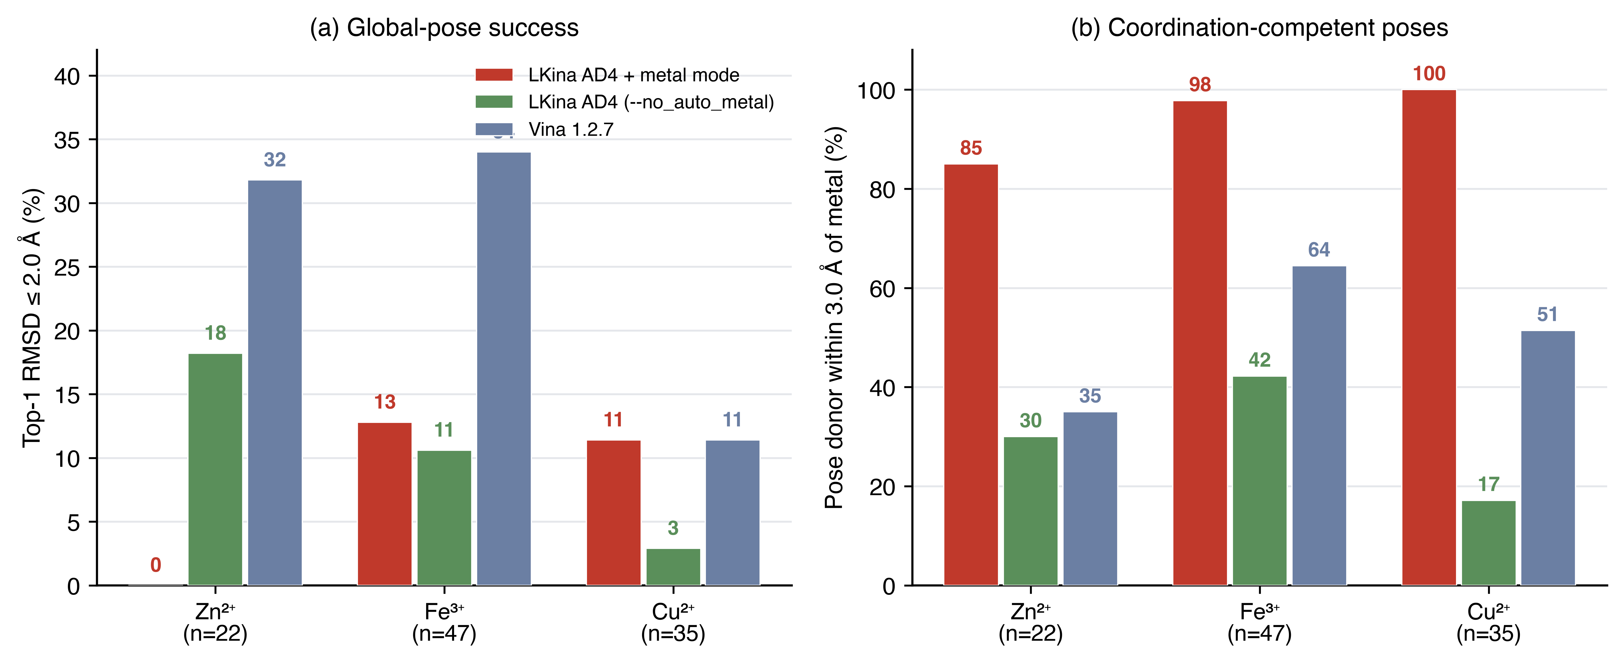
Figure 1
- Figure 1. PDB-derived redocking benchmark (Zn²⁺ n=22 / Fe³⁺ n=47 / Cu²⁺ n=35). (a) Top-1 RMSD ≤ 2.0 Å success and (b) fraction of systems whose best pose places a ligand N/O/S donor within 3.0 Å of the receptor metal, for LKina AD4 + metal mode, LKina AD4 (--no_auto_metal), and Vina 1.2.7 under an identical preparation protocol. Regenerated by make_redock_figures.py from the archived JSON results and docked poses.
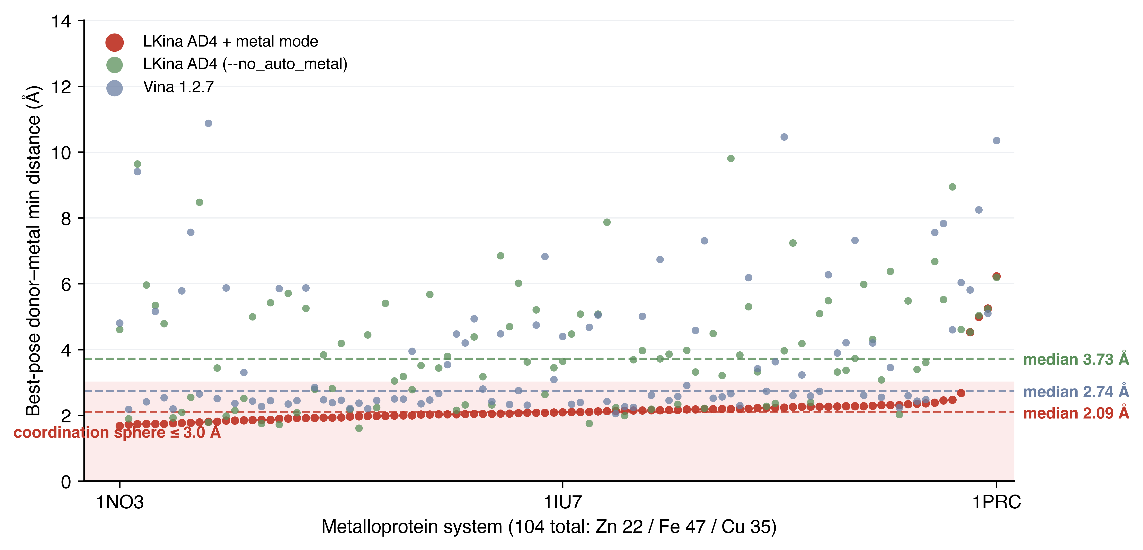
Figure 2
- Figure 2. Best-pose donor–metal minimum distance per system on the combined benchmark (n = 100 systems docked successfully by all three engines, Zn 20 / Fe 46 / Cu 34 — the intersection used for like-for-like per-system comparison). LKina with the coordination model active keeps the best-pose ligand donor inside the 3.0 Å coordination sphere in 96% of systems (median 2.09 Å), versus 31% (median 3.73 Å) for the identical engine with --no_auto_metal and 54% (median 2.74 Å) for Vina 1.2.7. The corresponding whole-set statistics over each engine’s own dockable subset are reported in Table §3.6 (medians 2.12 / 3.83 / 2.83 Å).
- Figure 3. All-metal coverage (a) and Vina acceptance by metal family (b). LKina docks 110/110 metal modes; Vina 1.2.7 docks only 34/110 and rejects 76 at PDBQT parse (Atom type <M> is not a valid AutoDock type). The breakdown by family shows that Vina accepts mostly biological TMs (Zn, Mg, Mn, Fe, Co, Ni, Cu) but rejects the entire medicinal / actinide / lanthanide / early-TM / metalloid spectrum.
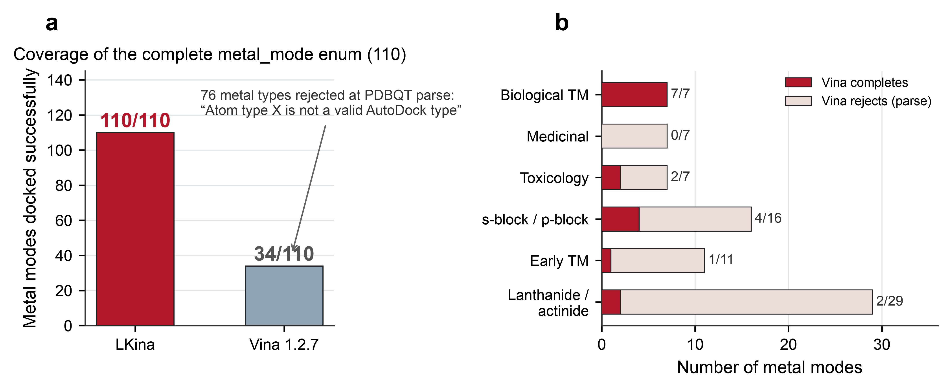 - Figure 4. Coordination accuracy (a) and pseudoatom geometry check (b). (a) Histogram of |d(ligand–metal) − r_eq| over 110 modes (mean 0.20 Å, 108/110 within 0.5 Å). (b) Per-mode measured vs expected donor–metal distance for the four pseudoatom systems TZ/SQ/MH/JT; ideal-count / donors-checked annotations show every receptor donor classified as “ideal” or “good” against the mode-specific nbp r_eq.
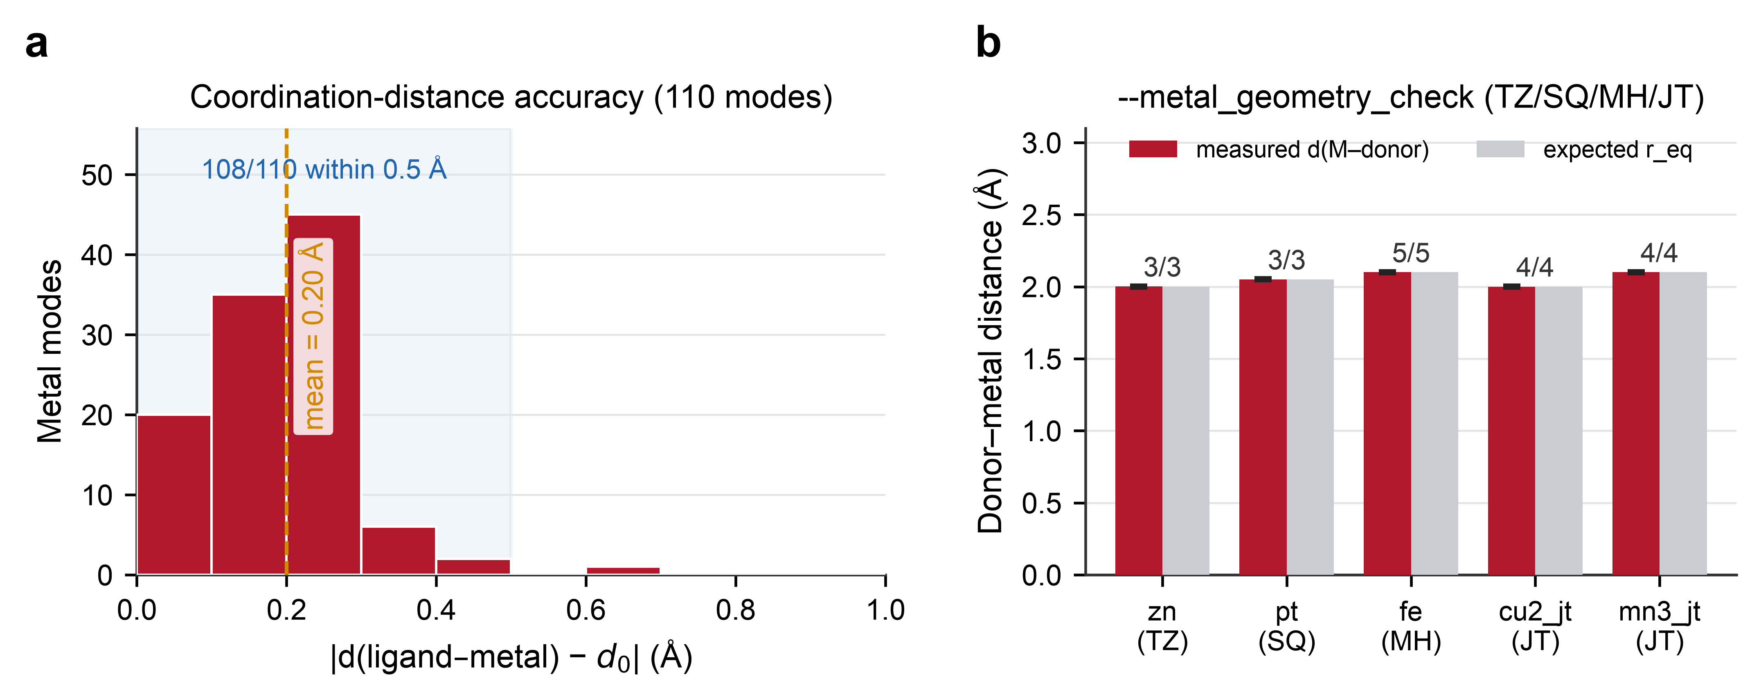 - Figure 5. Bond-Valence-Sum (BVS) oxidation-state inference on 14 designed synthetic systems covering Fe²⁺/Fe³⁺, Cu⁺/Cu²⁺, Mn²⁺/Mn³⁺, Co²⁺/Co³⁺, V⁴⁺/V⁵⁺, Mo⁴⁺/Mo⁶⁺, Ni²⁺/Ni³⁺. The mode picked (auto-detected from the receptor donor distribution via ag4_bvs_pick_mode) matches the designed mode in all 14 cases.
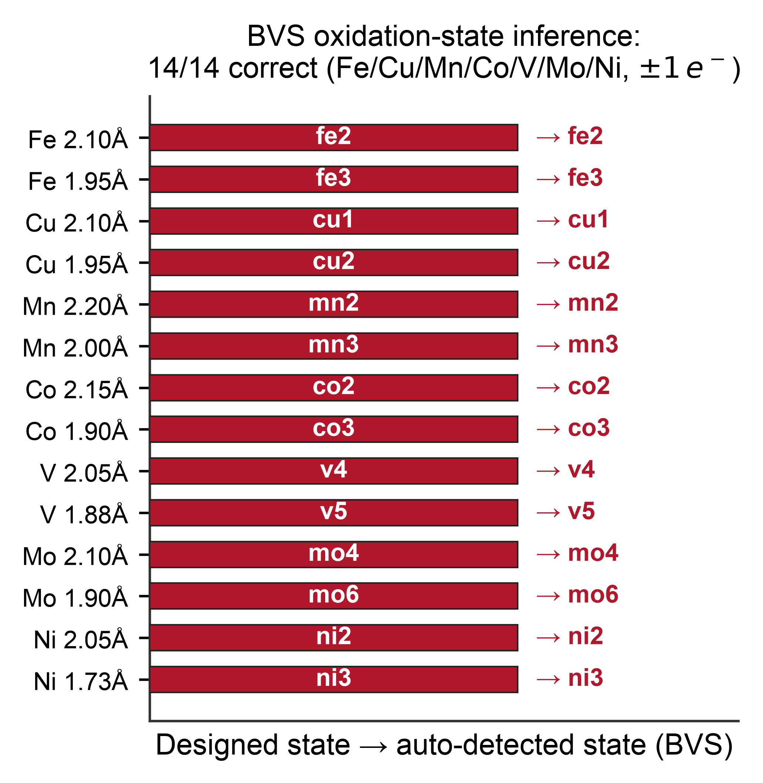 - Figure 6. Covalent framework (a–c). (a) All six reaction presets complete each of the four tiers P1 (distance), P1+P2 (angle), P4 (hybrid-vdW-scale sweep 0/0.5/1.0) and C3 (two-step search) on the engineered synthetic systems. (b) NAC detection discriminates geometrically: cys_michael / ser_covalent / lys_targeting / tyr_covalent report NAC=YES, cys_sn2 (180° backside attack not satisfied) and boronic_acid (no angle constraint set) report NAC=NO. (c) P1 distance potential scanned on the cys_michael preset: Gaussian well centered at $r_{0}=1.82$ Å with depth 10 kcal/mol.
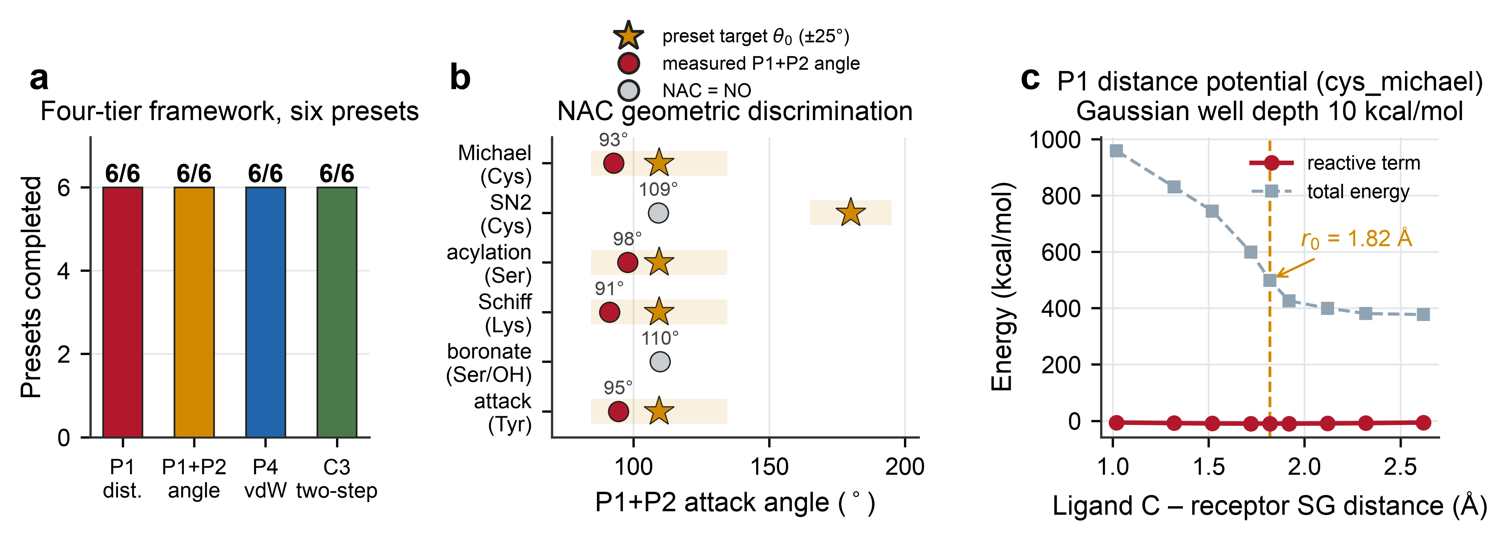 - Figure 7. Inline AG4 grid generator (a) and metal-as-ligand geometry QC (b). (a) --generate_maps writes 108 AutoGrid 4.2-format affinity maps (covering every AD4 probe type, including the TZ/SQ/MH/JT pseudoatoms) in one pass without invoking any external autogrid4 binary. (b) Pt(II) square-planar ligand docked with --ligand_metal_geometry_weight: the ideal 90° N–Pt–N / Cl–Pt–Cl complex scores a 0.003 kcal/mol geometry penalty; a 60° distorted variant scores 0.903 kcal/mol (×300) and would be flagged for rejection in a downstream filter.
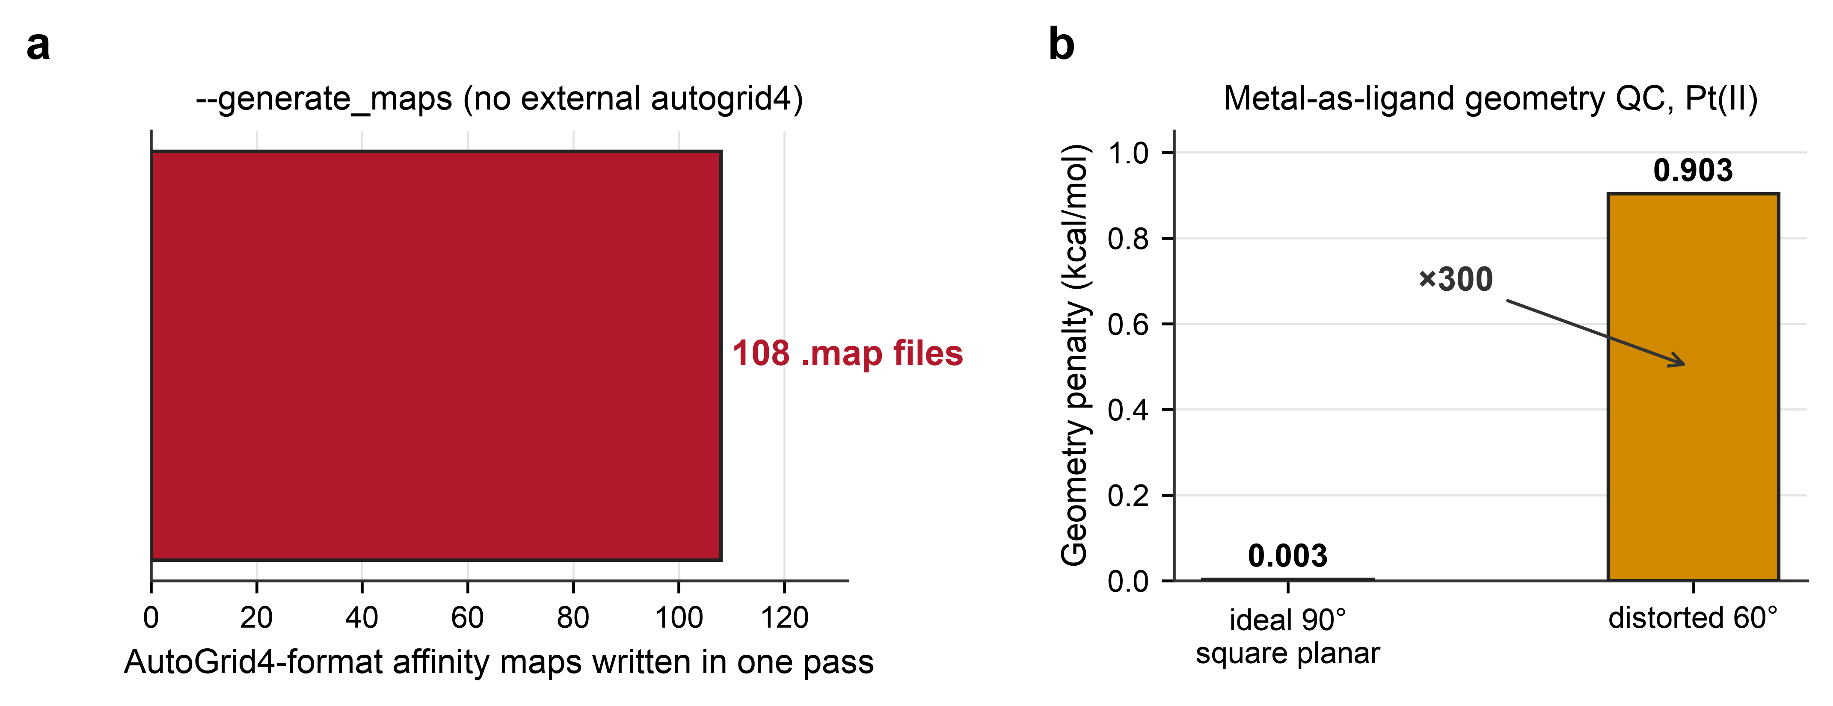 - Figure S1. Coordination-potential-well landscape across the complete 110-mode metal enum, stratified by pseudoatom class (TZ/SQ/LIN/MH/JT). Each dot is one synthetic metal-coordination system; dot area encodes the well depth (E_far − E_ideal). A well is confirmed in 104/110 systems (red); the remaining 6 systems (grey, all LIN or TZ edge cases) show no well at the probed donor position and are analyzed in Section 3.3.
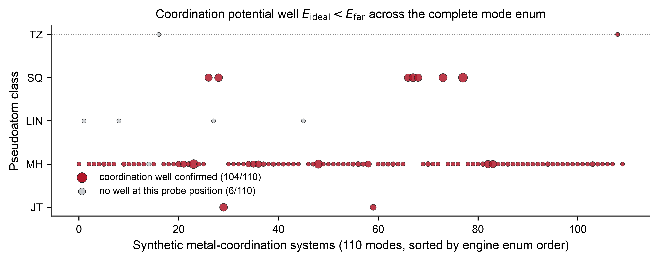
Figure S1
- Figure S2. Effect of the P2 angular constraint on pose geometry across the six reaction presets. Reactive distance from the P1-only search (grey) versus the P1+P2 search (red), with each preset’s ideal bond length r₀ marked in gold. Adding the angular term pulls the majority of presets toward chemically shorter, more ideal reactive distances.
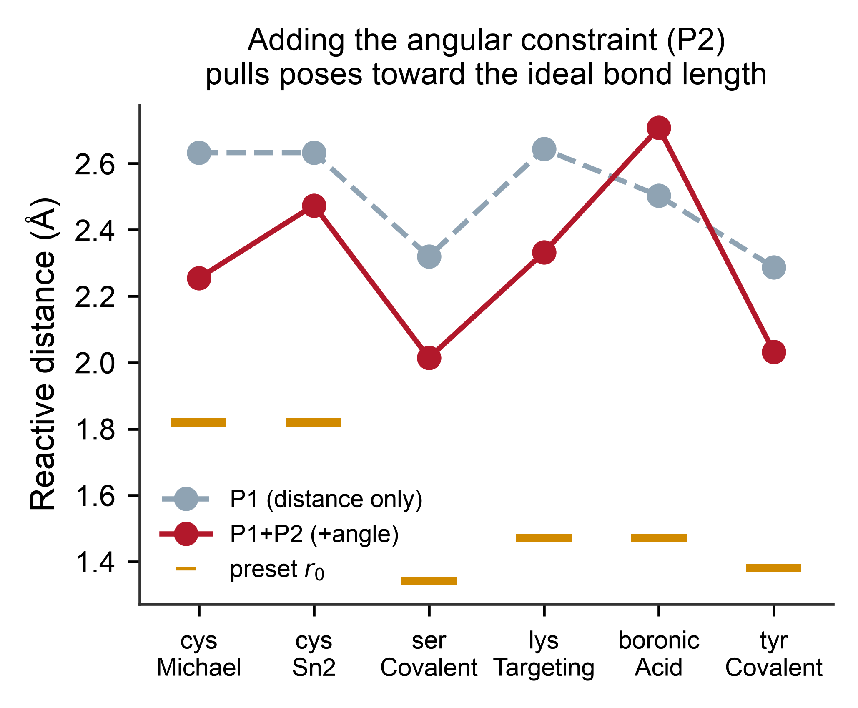
Figure S2
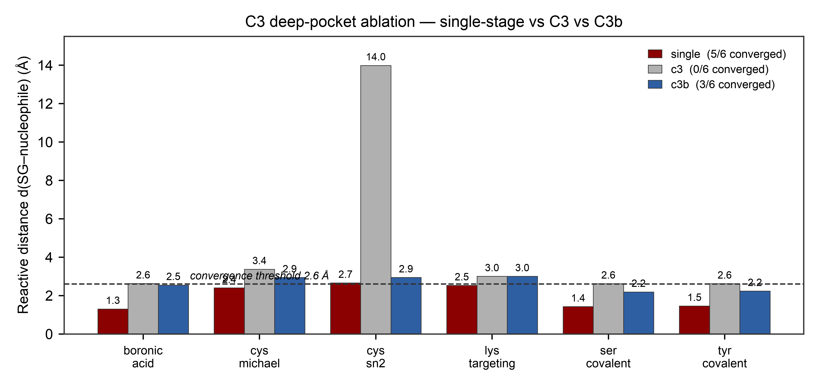
Figure S3
- Figure S3. Synthetic deep-pocket ablation (single-stage vs C3 vs C3b; six reaction presets; see Section 4.6). The x-axis lists the six presets; bars are coloured: deep red = single-stage (full P1–P4 constraints throughout), grey = C3 two-step (unconstrained Phase-1 + 15 Å anchor filter + L-BFGS Phase-2 refinement), blue = C3b (broad/weak Gaussian attractor, σ×3, ε×0.15). The y-axis is the reactive distance d(SG–nucleophile) in the docked pose; the dashed line is the 2.6 Å convergence threshold; bar tops are measured values. Convergence: single 5/6, c3b 3/6, c3 0/6 — single-stage’s persistent P1 gradient steers the MC toward the narrow pocket mouth; the unconstrained Phase-1 in plain C3 loses direction; C3b’s weak attractor partially restores it (3/6 vs 0/6). The +8% Phase-2 convergence claim from the early design document (LKINA.md §5.4.3, same provenance as the unreproducible 292/56/41 numbers) is not recovered on this synthetic design. C3’s benefit is regime-dependent and requires realistic pockets with competing local minima for further evaluation.
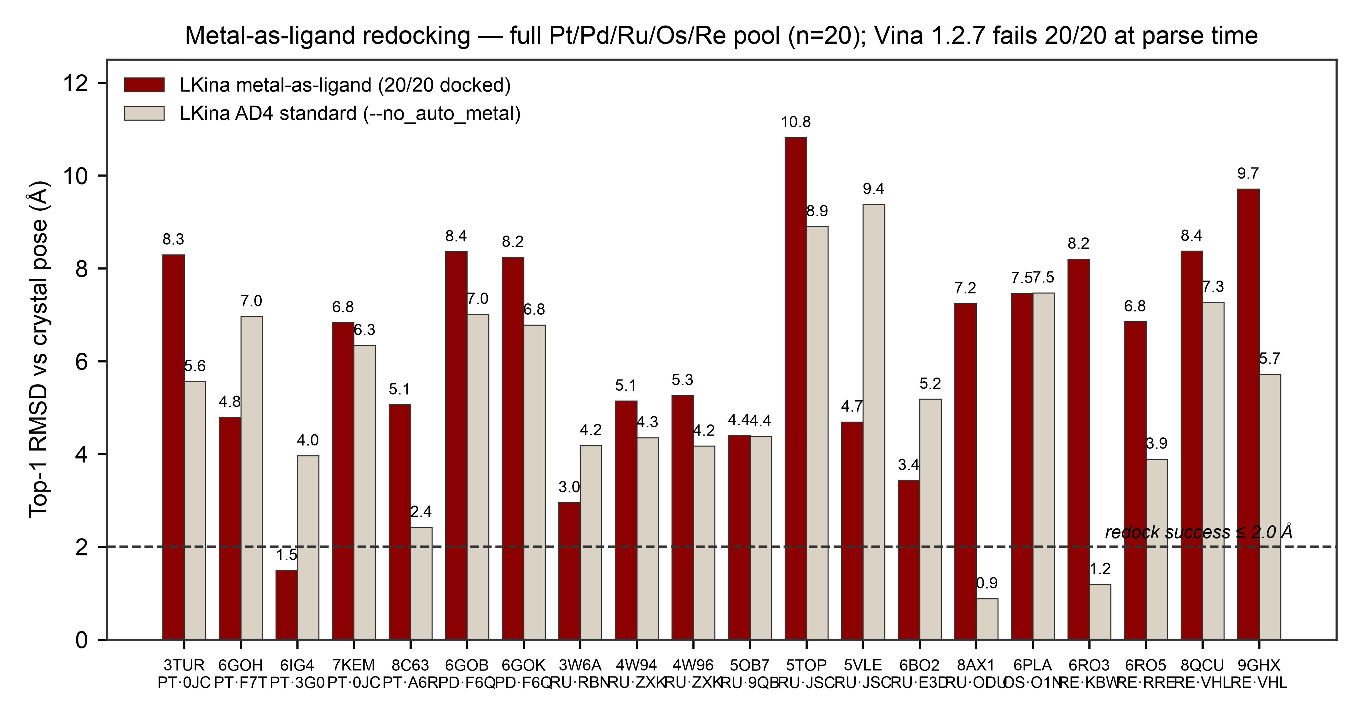
Figure S4
- Figure S4. Metal-as-ligand redocking on the full Pt/Pd/Ru/Os/Re pool (n=20; see Section 4.6). The x-axis lists the 20 PDB entries (with the metal family and ligand residue name in the secondary label); the y-axis is top-1 RMSD against the crystal pose. Dark red = LKina metal-as-ligand mode (--ligand_metal_geometry_weight 1.0); cream = the same engine with --no_auto_metal (standard AD4); the dashed line is the 2.0 Å redock-success threshold. Vina 1.2.7 failed 20/20 at parse time (the 32-type XS system has no entries for PT/PD/RU/OS/RE) — see subtitle. LKina’s metal-as-ligand mode beats its own AD4 baseline on 6/20 systems (median |dRMSD| improvement 1.92 Å), confirming that the reverse metal–donor pair potentials and the ligand-side geometry QC are active; the global RMSD ≤ 2.0 Å count is 1/20 (6IG4_PT 1.49 Å) because flexible metal complexes are intrinsically hard to redock with a global-RMSD metric — the chemistry-relevant test for these ligands is whether the docked pose is coordination-competent (cf. the donor–metal distance metric in Section 3.6). ## Supplementary
- benchmarks/pdbqt_util.py + run_all_metal_modes.py + metal_coverage_results_all.json — 110-mode synthetic metal benchmark (Table 1, Fig. 5–6).
- benchmarks/run_feature_family_tests.py + feature_family_results.json — pseudoatom geometry check, BVS inference (14/14), water bridge, metal-as-ligand QC.
- benchmarks/run_covalent_full.py + covalent_full_results.json — four-tier covalent framework (P1/P1+P2/P4/C3), energy well scan, 108-map --generate_maps audit.
- benchmarks/run_reactive_tests.py + reactive_presets_results.json — 6-preset reactive benchmark (Section 3.4, Fig. S2).
- make_figures_v3.py — figure-generation script for all main and supplementary figures (300-dpi PNG + vector PDF).
- figures/figS1_energy_well_landscape.* — coordination-well landscape over 110 modes (Fig. S1).
- benchmarks/real_systems/ — 4JC three-engine comparison and 1HVR/3PTB backward-compatibility runs.
- benchmarks/metallocomplex_redocking_benchmark.py + metallocomplex_results/ — metal-as-ligand redocking pipeline (full Pt/Pd/Ru/Os/Re pool, n=20, Section 4.6).
- benchmarks/run_c3_ablation.py + c3_ablation_results.json — C3 deep-pocket ablation (single-stage vs C3 vs C3b, six synthetic deep-pocket presets, Section 4.6).
- benchmarks/run_soft_weight_ablation.py + soft_weight_results.json — --metal_soft_weight ablation (one real system each for Zn/Fe/Cu × w = 0/0.1/0.3/0.5, Section 4.6).
- Regression suite (17 checks, A–F groups; highest-value items re-executed on the live binary in this work, Section 3.1) — shipped with the release tag.
- PDBbind v2020-based Fe³⁺/Cu²⁺ collection criteria and per-complex metrics (repository).
- NAC definition and the six-preset reactive benchmark (Section 3.4; benchmarks/run_covalent_full.py + covalent_full_results.json). The 28-complex Cys-Michael benchmark cited in earlier versions (P1+P2 64.3%, NAC 71.4%) originates from the design document with no archived dataset and is superseded by the Section 3.4 synthetic end-to-end measurements.

