Problem 1
First line: two-day package (weight: 10, cost per ounce: 0.9, fee: 15)
Second line: overnight package (weight: 25, cost per ounce: 0.4, flat fee: 0.6)
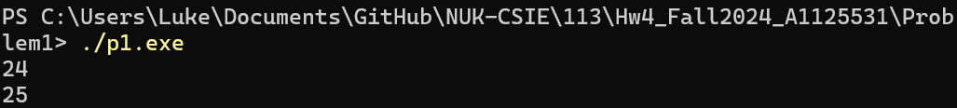

Problem 2
