Problem1
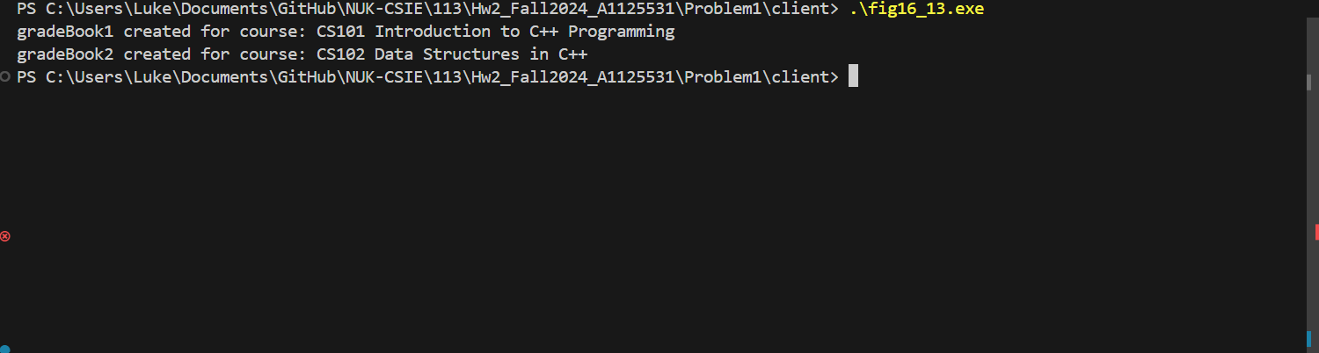

Problem 2
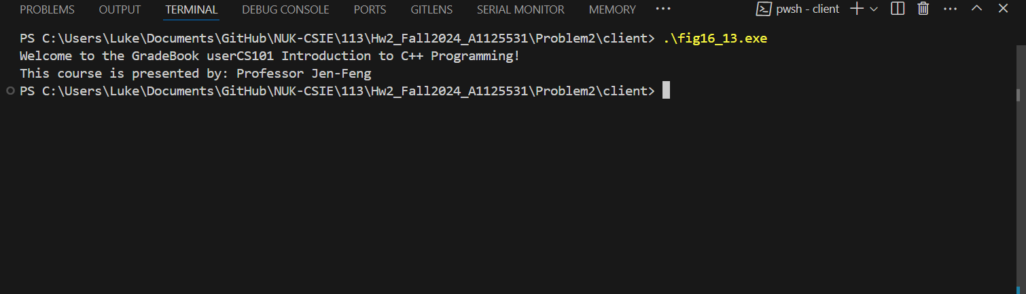

Problem 3
