General Aviation DIRECT TO Functions
The functions described in this document are available exclusively in GA Aircraft mode. To select the aircraft category: Config (gear icon) → Pilot Configuration → Category → GA Aircraft. After changing category LK8000 must be restarted.

Direct To — Navigation to an Off-Task Fix
In GA Aircraft mode, LK8000 allows temporarily deviating to a waypoint outside the task without losing the flight plan. This function is called Direct To and works with a context switching: the task is paused, navigation points to the chosen fix, and upon reaching the fix the task resumes automatically from the remaining point closest to the current position.

The flight plan
In the example the flight plan follows the route SIBARI FLY - POLICORO - LAGO LAVELLO - NORTH LUCERA - SAN VITO CHIETI - ROSETO DEGLI ABRUZZI - CIVITANOVA - ANCONA, viewable from the Task Overview screen.
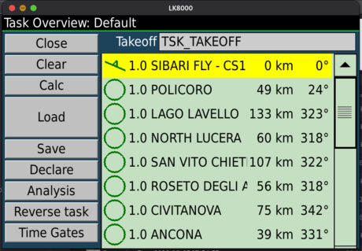

Task navigation towards POLICORO
The aircraft departs from SIBARI. The next task waypoint is POLICORO, shown as T>POLICORO with distance 47.8 km, track 24°. The bottom strip shows eHDG, Brg, Dist, NxAvETE and NxAvETA referenced to POLICORO.
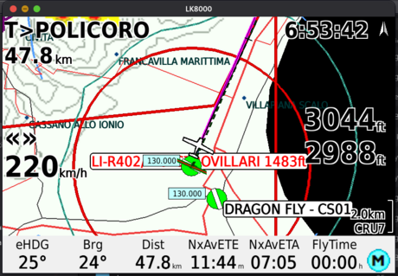

Selecting the off-task waypoint
The pilot needs to divert to FALCONE - PZ01, an airport not in the task. From the waypoint list filter with *FAL*: select FALCONE - PZ01 (155 km, 342°). In the quick window the Goto button (non-GA mode) becomes Direct To.
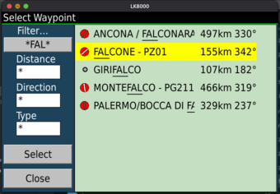 | 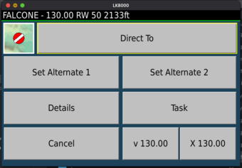

Confirming with the countdown
Pressing Direct To brings up the confirmation popup with a 10 secondi-second countdown and the fix name. The pilot can wait for automatic expiry or press Cancel. The task remains unchanged in memory.
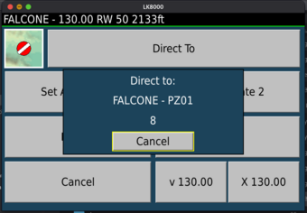

Direct To active: navigating to FALCONE
When the countdown expires navigation switches to FALCONE - PZ01. Top-left now shows T>FALCONE. The bearing line points directly to the fix; the strip shows Dist, NxAvETE and NxAvETA calculated on FALCONE. The task is intact in memory, simply paused.
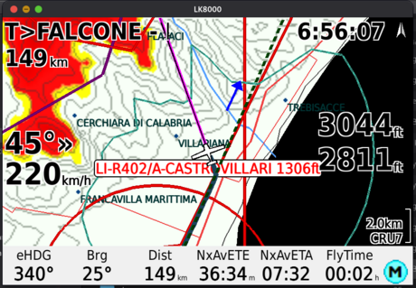

Target window during Direct To
Opening the finestra Target the panel adapts: the title shows Direct To: FALCONE, the task selector is hidden and the fields Dist, AvETE, AvETA are calculated on FALCONE (148.1 km, 36:20, 07:32). The Approach button is available as FALCONE is a certified airport.
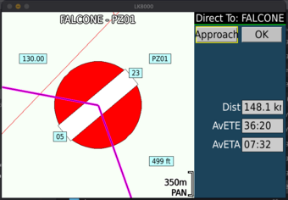

Arrival at FALCONE: automatic task resumption
When the distance to FALCONE drops below the arrival radius, LK8000 identifies the remaining task point closest to the current position and switches navigation to it. In the example POLICORO is automatically skipped because it is farther than LAGO LAVELLO, which becomes the new target.
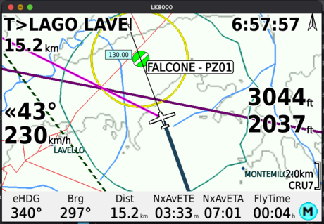 | 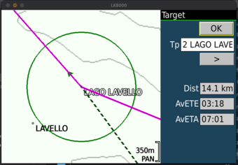

Continuing towards LAGO LAVELLO
The task continues normally towards LAGO LAVELLO with distance 10.8 km, track 280° and NxAvETE 02:39. All subsequent points remain in sequence.
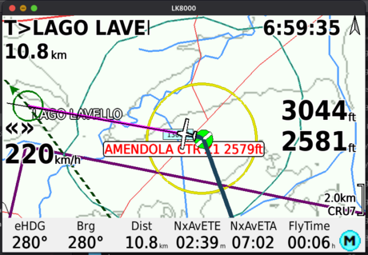

Direct To — Skip to a Task Point
In addition to deviating to off-task fixes, the Direct To function allows jumping directly to any remaining task point, activated from the finestra Target.
Pilot’s own decision: the pilot decides to skip intermediate waypoints to optimise the route based on weather, fuel or time available.
ATC instruction: the controller asks “Are you able to proceed direct to [waypoint]?” and the pilot must set the new target in a few seconds without leaving the flight screen.

Task navigation towards NORTH LUCERA
The pilot is flying towards NORTH LUCERA (T>NORTH LUC, 25.1 km, Brg 317°, NxAvETE 06:18, NxAvETA 07:21). In the task SAN VITO CHIETI and ROSETO DEGLI ABRUZZI follow.
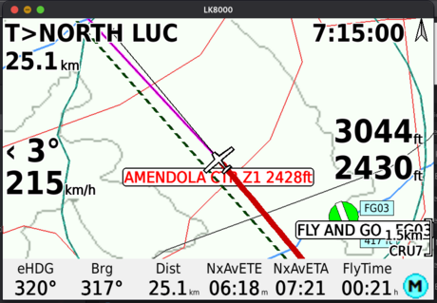

Selecting the task point from the Target window
The pilot opens the finestra Target. The panel shows the active point: Tp 3 NORTH LUCERA, Dist 24.0 km, AvETE 06:01, AvETA 07:21. Using the > button the pilot advances to Tp 5 ROSETO DEGLI ABRUZZI, skipping Tp 4 SAN VITO CHIETI. As soon as the selected point differs from the active task point the Direct To button appears and the map centres on ROSETO (Dist 185.5 km, AvETE 46:35).
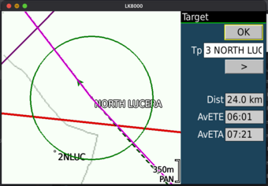 | 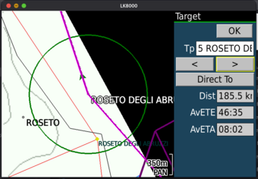

Confirming with the countdown
Pressing Direct To brings up the popup Direct to: ROSETO DEGLI ABRUZZI / 7. When the countdown ends ActiveTaskPoint advances to Tp 5: NORTH LUCERA and SAN VITO CHIETI are skipped and navigation switches to ROSETO DEGLI ABRUZZI.
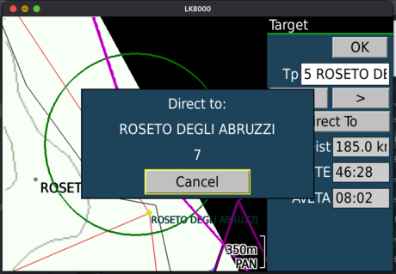

Direct To confirmed: navigating to ROSETO
Navigation switches to ROSETO DEGLI ABRUZZI (T>ROSETO DE..., 182 km, Brg 321°, NxAvETE 45:46). The bearing line points directly to ROSETO. Re-opening the finestra Target the title remains Target — not Direct To: … as in the off-task case — because the point is already in the task and ActiveTaskPoint has simply advanced to Tp 5 (Dist 181.0 km, AvETE 45:27, AvETA 08:02).
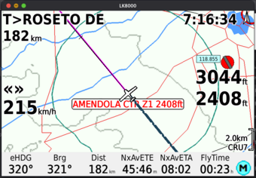 | 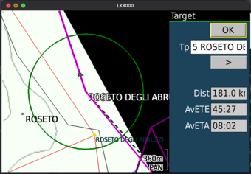

Note — Effects on the LK8000 Generic Autopilot Driver
Le manovre Direct To descritte in questo capitolo agiscono direttamente sul driver Generic Autopilot driver, which generates the NMEA $GPRMB NMEA messages transmitted to the connected autopilot.
NB: the pilot does not need to change any settings on the autopilot during these manoeuvres. LK8000 automatically updates destination and XTE at the time of Direct To and at the time of task resumption.
Normal task: $GPRMB contains the next task waypoint as destination; XTE is calculated relative to the active leg track.
Direct To towards off-task fix: non appena il countdown conferma il Direct To, il $GPRMB commuta immediatamente sul fix come destinazione. L'XTE viene calcolato rispetto alla rotta diretta dalla posizione di attivazione al fix.
Automatic task resumption: upon reaching the fix $GPRMB switches to the new next task waypoint. XTE is calculated from the fix position towards the new target, ensuring continuity of lateral guidance.
Direct To towards task point: $GPRMB immediately switches to the selected task point; XTE starts from the activation position towards that point.

