Direct To — Navigation to an Off-Task Fix
In GA Aircraft, LK8000 allows temporarily deviating to a waypoint outside the task without losing the flight plan. This function is called Direct To and works with a mechanism of context switching: the task is paused, navigation points to the chosen fix, and upon reaching the fix the task resumes automatically from the first logically-forward waypoint in the route — not the geometrically nearest point.

The flight plan
In the example the flight plan follows the route SIBARI FLY → POLICORO → LAGO LAVELLO → NORTH LUCERA → SAN VITO CHIETI → ROSETO DEGLI ABRUZZI → CIVITANOVA → ANCONA, viewable from the Task Overview screen.
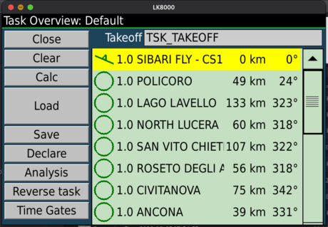

Task navigation towards POLICORO
The aircraft departs from SIBARI. The next task waypoint is POLICORO, shown top-left as T>POLICORO with distance 47.8 km, track 24°. The bottom strip shows eHDG, Brg, Dist, NxAvETE and NxAvETA — all referenced to POLICORO.
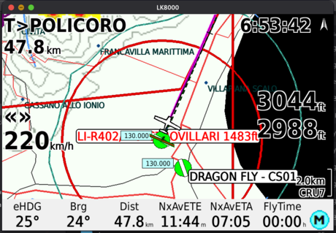

Selecting the off-task waypoint
The pilot needs to divert to FALCONE - PZ01, an airport not in the task. From the waypoint list filter with *FAL*: LK8000 shows all matching waypoints with distance and bearing. Select FALCONE - PZ01 (155 km, 342°): in the waypoint quick window the "Goto" button (non-GA mode) becomes Direct To.
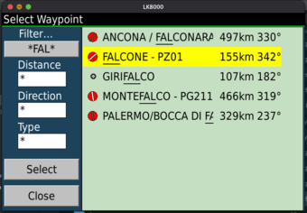 | 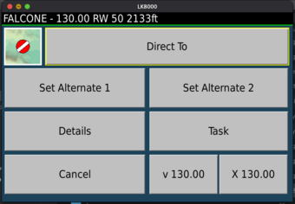

Confirming with the countdown
Pressing Direct To brings up the confirmation popup with a 10 seconds and the fix name. The popup shows bearing (BRG) and distance (DIST) to the fix from the current position, together with estimated time en-route (ETE) and estimated time of arrival (ETA). The pilot can wait for automatic expiry or press Cancel. The task remains unchanged in memory. The autopilot stays on the previous target for the entire countdown duration: it switches to the new fix only on confirmation.
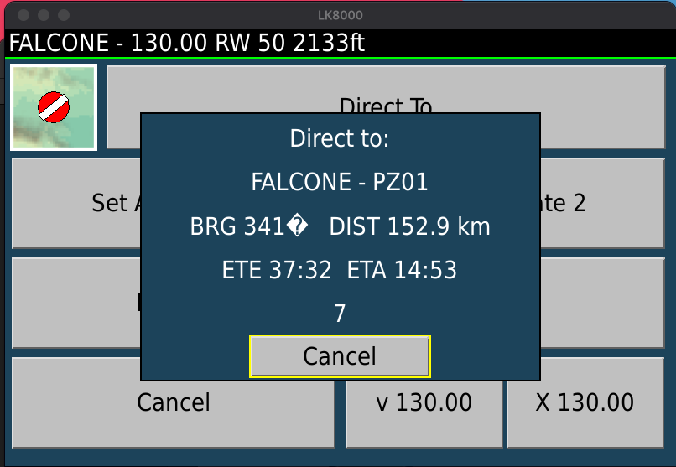

Direct To active: navigating to FALCONE
When the countdown expires all navigation switches to FALCONE - PZ01. Top-left now shows T>FALCONE. The bearing line on the map points directly to the fix and the strip shows Dist, NxAvETE and NxAvETA calculated on FALCONE. The task is intact in memory, simply paused.
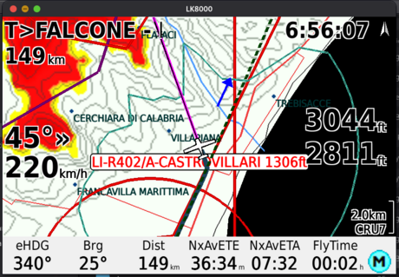

Target window during Direct To
Opening the Target window during an off-task Direct To the panel adapts automatically: the title shows Direct To: FALCONE, the task point selector is hidden and the fields Dist, AvETE and AvETA are calculated on FALCONE (148.1 km, 36:20, 07:32). The Approach button is available as FALCONE is a certified airport. The map is centred on the fix.
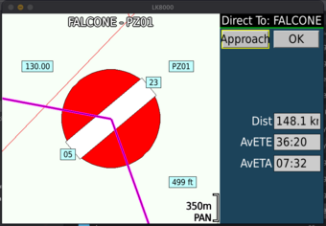

Arrival at FALCONE: automatic task resumption
When the distance to FALCONE drops below the configured arrival radius (1000 m), LK8000 automatically selects the first logically-forward task waypoint in the route — not the geometrically nearest point. The algorithm compares the direction of the inbound leg to each waypoint with the fix→aircraft vector: if the position is in the "forward" half-plane, that waypoint is already behind and is skipped. In this way, if the aircraft is near LAGO LAVELLO during the diversion, the task resumes from LAGO LAVELLO and not from POLICORO, which is already behind.
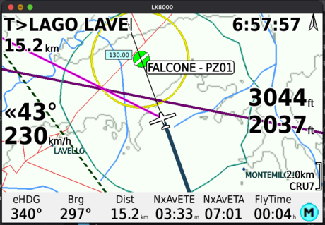 | 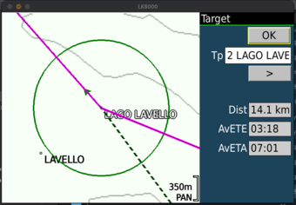

Continuing towards LAGO LAVELLO
The task continues normally towards LAGO LAVELLO with distance 10.8 km, track 280° and NxAvETE 02:39. All subsequent task points remain in sequence.
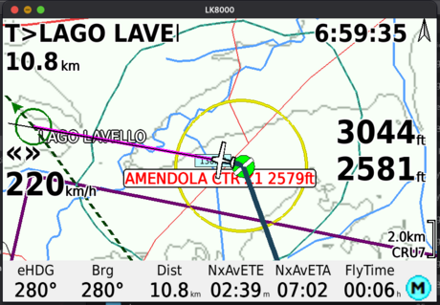

Direct To — Skip to a Task Point
In addition to deviating to off-task fixes, the Direct To function allows jumping directly to any remaining task point. This mode is activated from the Target window and is useful in two typical situations.
Pilot's own decision: the pilot decides to skip one or more intermediate waypoints to optimise the route based on weather, fuel consumption or time available.
ATC instruction: the controller asks "Are you able to proceed direct to [waypoint]?" and the pilot must set the new target in a few seconds without leaving the flight screen.

Task navigation towards NORTH LUCERA
The pilot is flying towards NORTH LUCERA (T>NORTH LUC, 25.1 km, Brg 317°, NxAvETE 06:18, NxAvETA 07:21). SAN VITO CHIETI and ROSETO DEGLI ABRUZZI follow in the task.
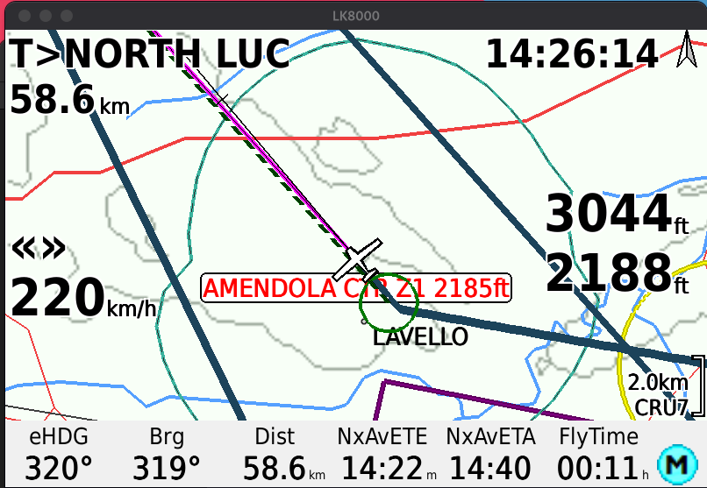

Selecting the task point from the Target window
The pilot opens the Target window. The panel shows the active point: Tp 3 NORTH LUCERA, Dist 58.6 km, AvETE 14:22, AvETA 14:40. Using the > button the pilot scrolls through the subsequent waypoints.
For each selected waypoint the map centres on the point and the bearing line always shows the direct bearing from the aircraft to the waypoint — regardless of which task point is currently active. The fields Dist, AvETE and AvETA are updated in real time based on the current position toward the displayed waypoint: the pilot immediately knows distance, estimated time and arrival time without confirming anything.
Advancing to Tp 4 SAN VITO CHIETINO (Dist 164.3 km, AvETE 40:19, AvETA 15:06) the Direct To button appears. Pressing > again reaches Tp 5 ROSETO DEGLI ABRUZZI (Dist 218.7 km, AvETE 53:40, AvETA 15:20). The < and > buttons allow scrolling freely through all task waypoints.
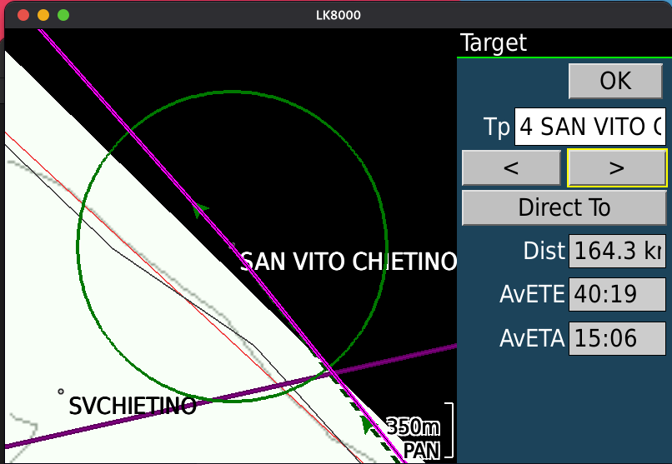
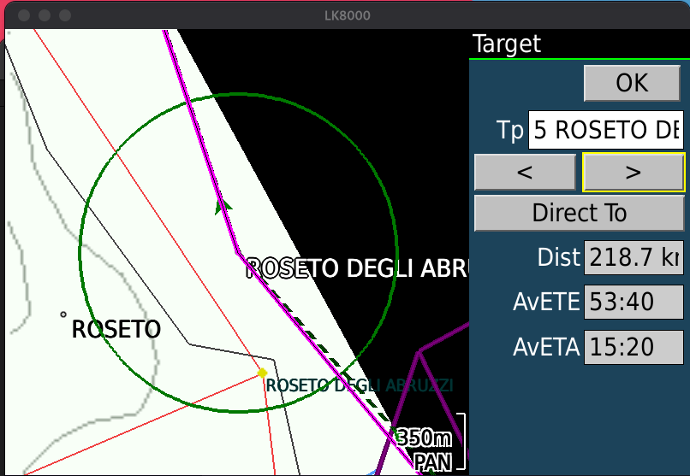

Confirming with the countdown
Pressing Direct To in the Target window brings up the confirmation popup with a 10 seconds. As with the off-task Direct To, the popup shows BRG, DIST, ETE and ETA calculated from the current position to the selected task waypoint. When the countdown ends navigation switches immediately to the new task point.
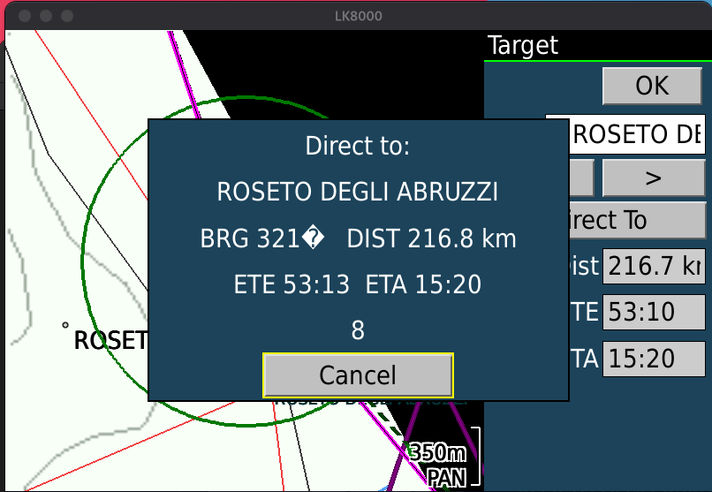

Direct To confirmed: navigating to ROSETO
Navigation switches to ROSETO DEGLI ABRUZZI (T>ROSETO DE..., 182 km, Brg 321°, NxAvETE 45:46). The bearing line points directly to ROSETO ignoring intermediate points. Re-opening the Target window the title remains "Target" — not "Direct To: ..." as in the off-task case — because the point is already in the task and ActiveTaskPoint has simply advanced to Tp 5 (Dist 181.0 km, AvETE 45:27, AvETA 08:02).
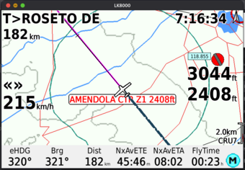 | 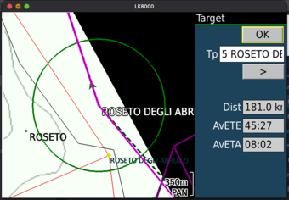

Note — Effects on the LK8000 Generic Autopilot driver
The Direct To manoeuvres described in this document act directly on the LK8000 Generic Autopilot driver, which generates the NMEA $GPRMB messages transmitted to the connected autopilot.
NB: The pilot does not need to change any autopilot settings during these manoeuvres. LK8000 automatically updates destination and XTE at the time of Direct To and at the time of task resumption.
Normal task: $GPRMB contains the next task waypoint as destination; XTE is calculated relative to the active leg track.
Direct To towards off-task fix: as soon as the countdown confirms the Direct To, $GPRMB switches immediately to the fix as destination. XTE is calculated relative to the direct track from the activation position to the fix.
Automatic task resumption: upon reaching the fix $GPRMB switches to the new next task waypoint. XTE is calculated from the fix position towards the new target, ensuring continuity of lateral guidance without discontinuity.
Direct To towards task point: the system immediately activates a DIRECT leg from the confirmation position to the selected fix; $GPRMB transmits XTE and bearing to intercept and maintain the direct track, minimising the residual distance.
LK8000 Tactical Flight Computer — GA Direct To Function · Draft EN · June 2026

