LK8000 version 7.0
What's new and what has changed since v6.0

© 2018 The LK8000 Development Team
December 2018

LiveTracking

Now live tracking on www.livetrack24.com uses a more reliable communication protocol (API version 2). This new version is activated only if the server name is WWW.LIVETRACK24.COM. For using the old API version 1 use T1.LIVETRACK24.COM or any other server that uses that old protocol. Live tracking is activated only if the “LiveTracker log internal “ is not 0 and the starting mode can be chosen between :
Permanent : data will always been sent.
In flight Only (default) : data will be sent only after takeoff.
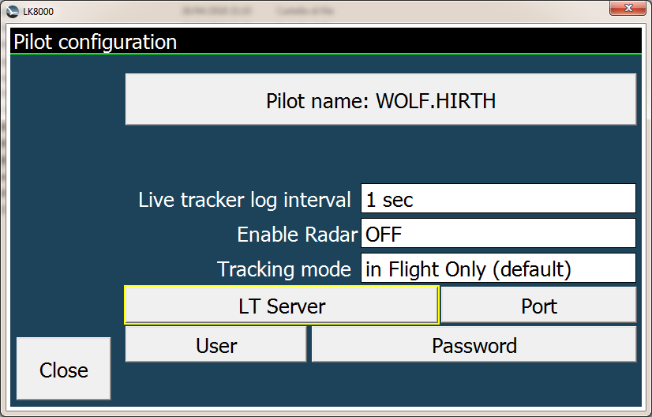
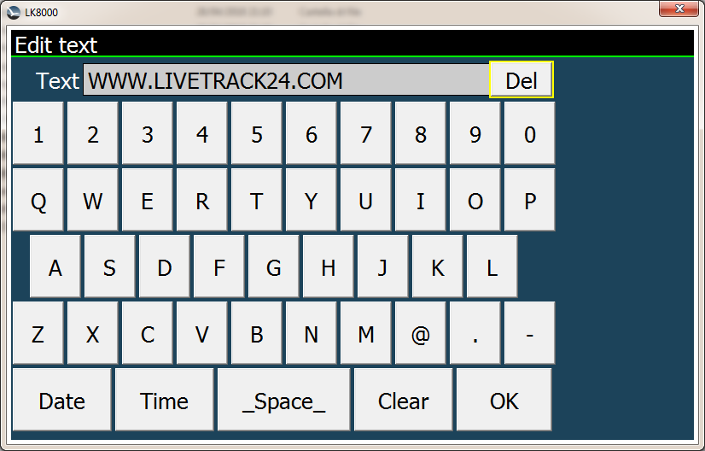

LiveTracking.com Radar

This feature works with the WWW.LIVETRACK24.COM server and feeds LK8000 flarm system with data coming from your friends on that server . Only pilots what have a friendship with you on livetrack24.com ( use the friendship mechanism on livetrack24 web page) will be visible on the map or in the FLARM pages.

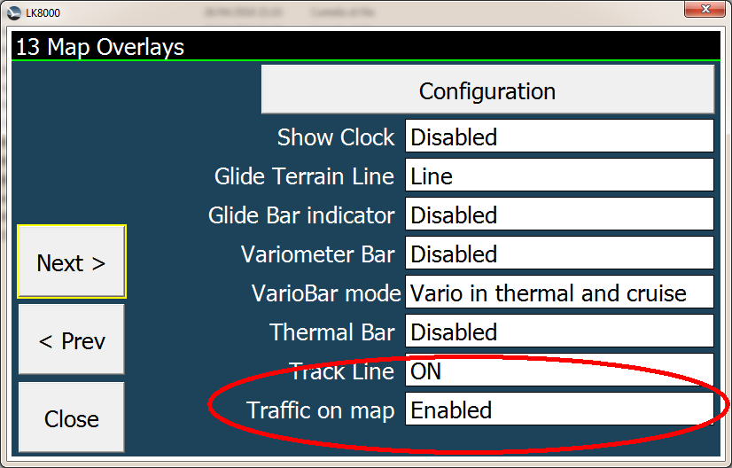
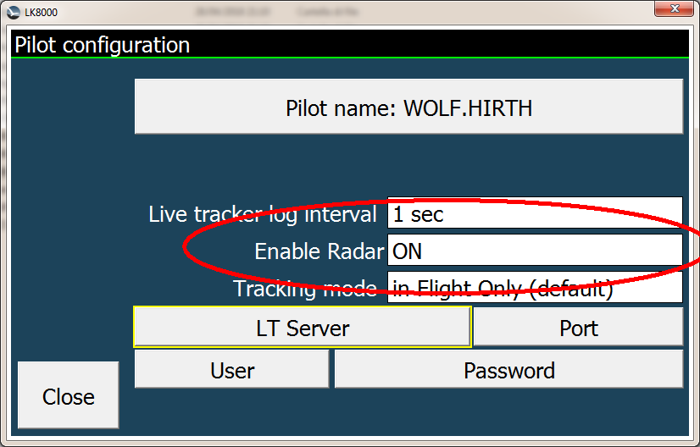
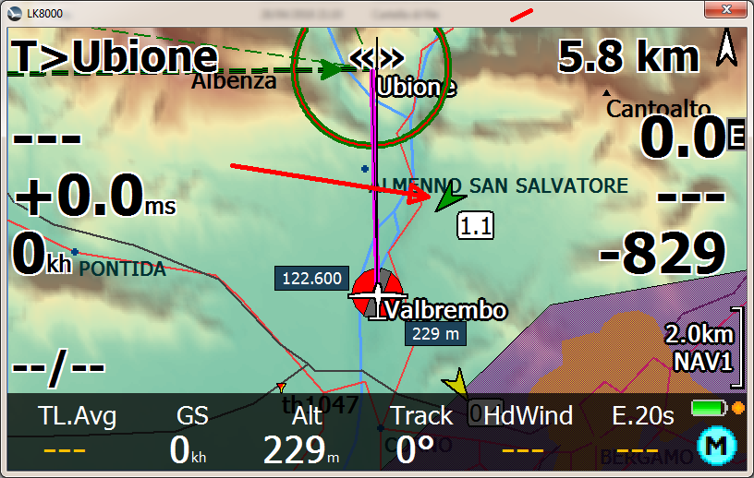

This is NOT INTENTED to be an anti-collision system but use is only for information about approx. position of other pilots in the sky in a range of 30km. Data are updated from the server every 5 seconds (not configurable).

LKMAPS on Android
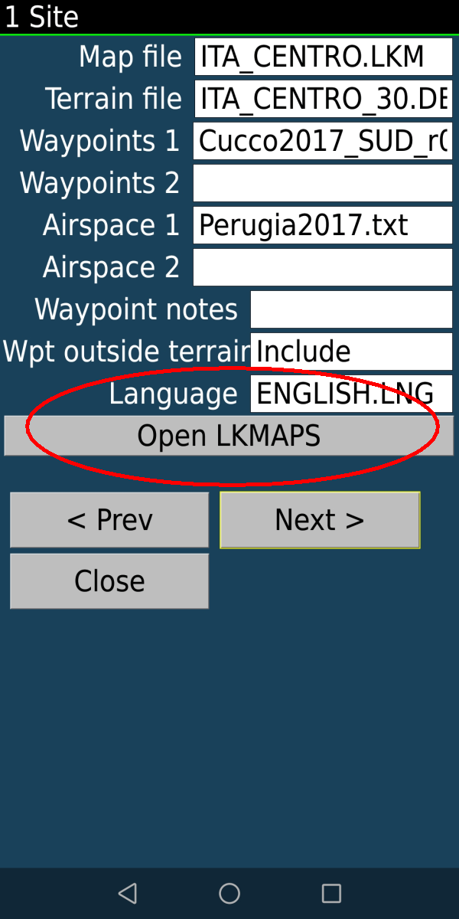
This features is available only on Android version and permits
to download maps, airspace and waypoints directly from the device.
A new button is available on system menu n. 1 to install ( if
not yet installed ) or to open LKMAP .

LiveTracking 2
LiveTracking.com Radar 3
LKMAPS on Android 4

