**Jobs planet Production Server Architecture: -**

**Jobs planet Development Server Architecture: -**

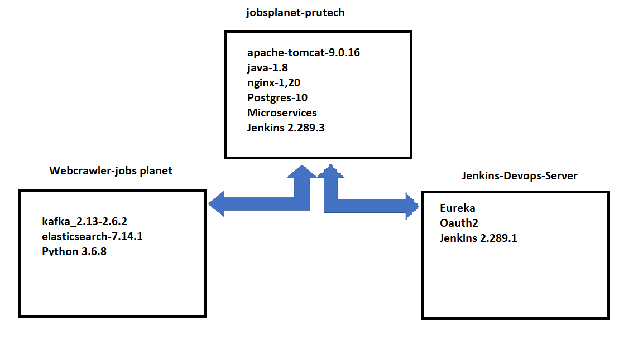

**Ports: -**

Eureka : 8761

Oauth2 : 8888

Nginx : 443(for dev 80)

Jenkins : 8899

Micro services : 8080

Elastic search : 9200

Kafka : 9092

Postgres : 5432