DSAA Project Intake Form

The DSAA is a service based healthcare data analytics group at Unity Health Toronto. We make sense of healthcare data so our partners can make better decisions, increase hospital efficiency, and improve patient care. We are not a research group – we focus on creating practical solutions that can be directly implemented in the hospital.

Our project intake process consists of two phases. In the first phase we work to gain an understanding of the specified problem, explore the available data, and consider potential solutions and project feasibility. This phase will result in a Data and Process Exploration Report. If the project is not considered feasible, the process will end here. If the project is considered feasible, it will move onto Phase 2, during which we will work with you to build, implement and evaluate a software product.

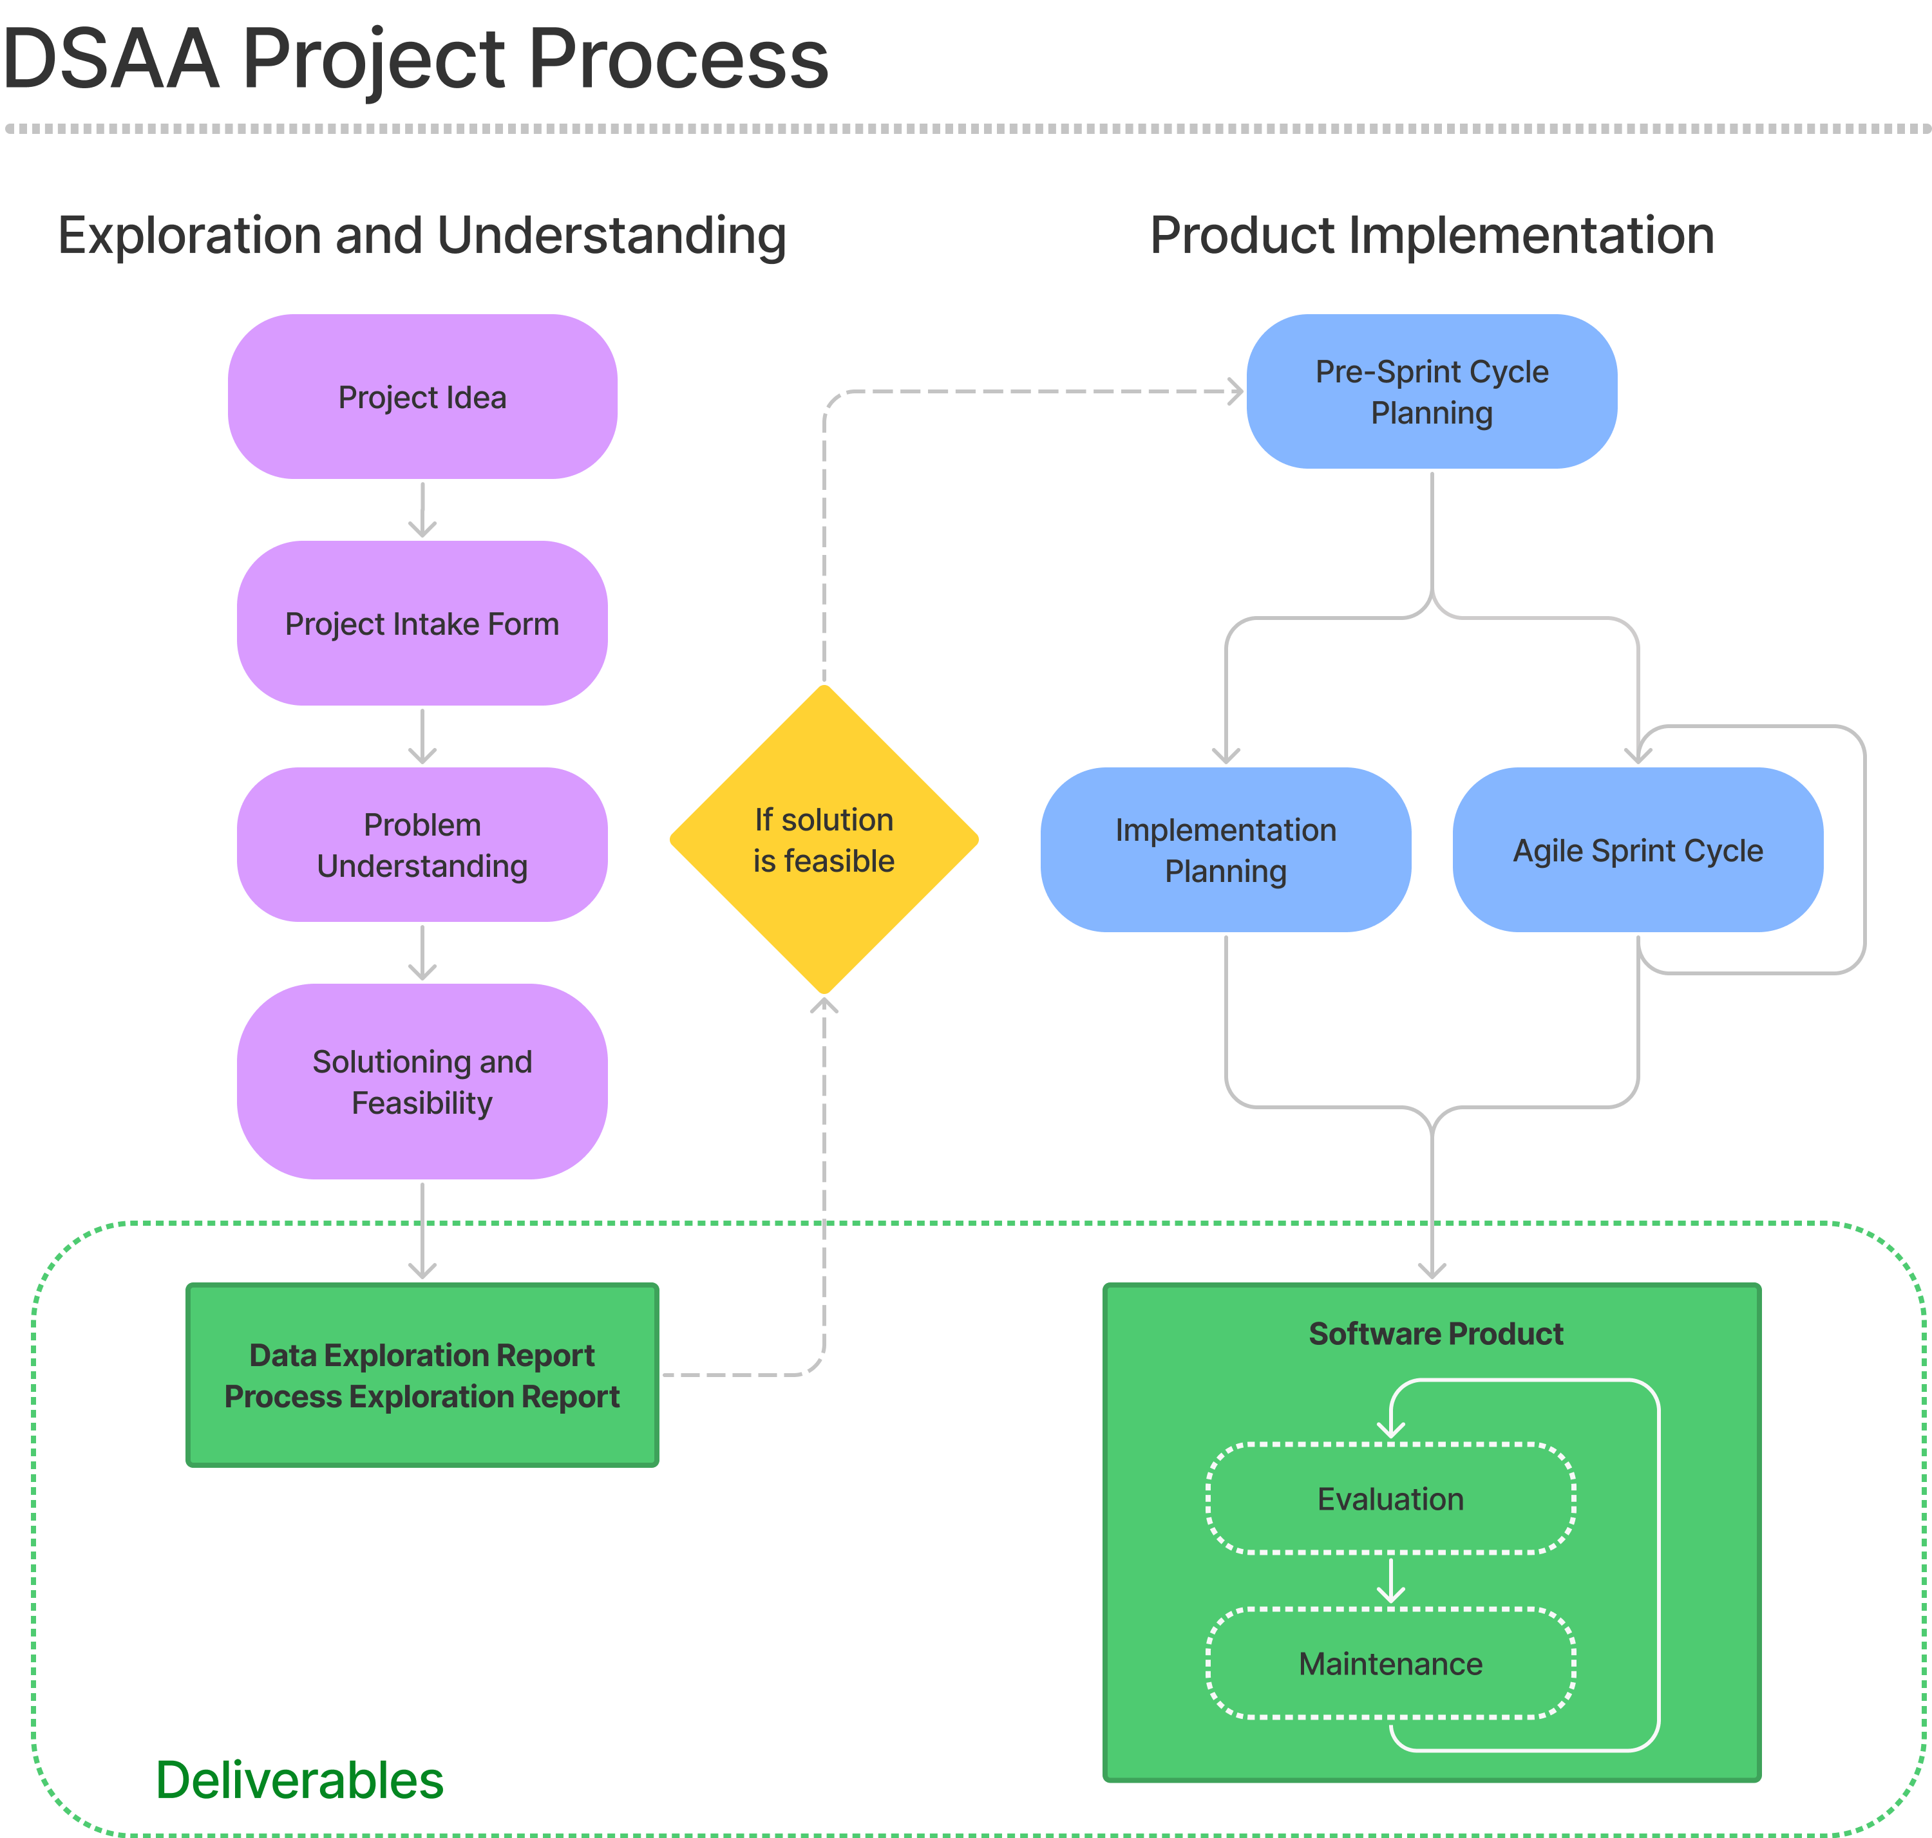

PROJECT DETAILS
Project Name:
Proposal Prepared By:
Site/System/Program/Unit:
Does this project have external funding?

PROJECT TEAM
Clinical Lead or Program Director | Oversees the project and implementation of a delivered product from clinical and cross-system viewpoint.
Subject Matter Experts | Support project implementation. Meet regularly (bi-weekly) with DSAA to provide subject-matter expertise and validate work and progress.

PROBLEM DEFINITION
Identify the problem:
What problem will this project address? Try to quantify the issue as much as possible (e.g. this problem was observed in X patient visits in the last year). Did anything change in the recent past leading to a problem?

What is the objective of the project?
Without focusing on specific solutions, describe the end state that the project would be trying to achieve.

CURRENT CONDITIONS
Current Processes:
Describe the current state of the processes that will be targeted to make improvements. Include where and when/how often these processes take place.

Process Steps:
Include a list of steps/flow diagram/illustration that describes the processes outlined above (e.g. steps for triaging patients in the ED, steps taken to schedule staff, steps taken to confirm a diagnosis, etc.). Clearly indicate at which point(s) in the processes the pain points/issues occur.

FUTURE STATE
Proposed Solution:
At a high level, describe the envisioned data analytics or AI solution and how you think it will help address the identified problem.

Proposed Intervention(s) to Accompany the Solution (if any):
Describe the required implementation interventions that would accompany the solution (i.e. what would be done differently if the solution was deployed?). Are there evidence-based estimates of their expected impacts of these interventions? If so, what is the expected magnitude of the outcome change?

Stakeholders:
List all types of staff currently involved in the processes (e.g. physician, RN, admin, EVS) and describe their role in the process. Please also include a list of stakeholders who will be impacted by the process, but are not directly involved in it (e.g. patients, family members).

Existing Data:
What data sources are available (e.g. systems, databases, spreadsheets)?

Data Variables:
What variables will be important to include in data exploration and modelling efforts? Please indicate whether these are currently available from existing systems or will need to be collected.

Existing Solutions:
What are best practices globally in this space? Are there existing / commercially available solutions that could help address the situation? If so, what are the barriers to adoption (e.g. process/workflow, technical, financial)?

Existing Literature:
Are there existing publications on this topic that could help address the situation or inspire a solution?

EVALUATION METRICS
Metrics:
Which of the metrics below do you anticipate your initiative will impact (check all that apply)?
Mortality | Readmission | Length of Stay | Financial | Human Effort | Other
☐ | ☐ | ☐ | ☐ | ☐ | ☐
If other, please specify:

PRIMARY METRIC
Primary metric:
Identify one primary metric (quantitative or qualitative) you would like to improve related to the above section.

Primary metric and target level of improvement:
Indicate the desired target for the primary metric (e.g. reduce mortality by 10%).

Primary metric details (if currently measured):
If the primary metric is already measured by existing hospital processes, please provide those details here, including how it is measured, who has access to those data, and the current level.

Primary metric details (if NOT currently measured):
If the primary metric is not measured, provide the following details:
- What steps are required to measure the primary metric?
- What data/data sources are required to measure the primary metric?
- What data are currently available?
- Who has access to these data?

ADDITIONAL METRICS
Additional metrics:
Indicate what secondary metrics you would like to improve. Consider incorporating patient experience, staff experience and key organizational metrics as appropriate.

Additional metrics and target levels of improvement:
Indicate the desired target for the additional metrics (e.g. 30% increase in staff satisfaction).

Additional metrics details (if currently measured):
If additional metrics are already measured by existing hospital processes, please provide those details here, including how they are measured, who has access to those data, and the current levels.

Additional metrics details (if NOT currently measured):
If the additional metrics are not measured, provide the following details:
- What steps are required to measure these metrics?
- What data/data sources are required to measure these metrics?
- What data are currently available?
- Who has access to these data?

IMPLEMENTATION RISKS
Risks to Stakeholders and End-Users:
Describe any risks the project may have to patients (e.g. health, safety, privacy, autonomy, stigma, etc.), staff (RNs, physicians, administrators), or other stakeholders who will be impacted by the solution.

Risks to Successful Implementation:
Describe any potential barriers to project success (e.g. change management challenges, workflow integration, time-window for impact, etc.).

END USER & COMMUNITY ENGAGEMENT
Stakeholder Support:
Refer to the ‘Stakeholders’ section in ‘Current Conditions’. Please ensure one or two representatives from all types of staff involved in the current process (e.g. physician, RN, admin, EVS) have reviewed the above sections of this form and had the opportunity to provide their perspectives.

Please list all the roles that have been consulted:

CONTRIBUTOR ROLES AND IP POLICY
Check the box to the right to affirm that all stakeholders have reviewed Unity Health Toronto’s intellectual property policy | ☐
DSAA follows the CRediT system (https://credit.niso.org/) to identify roles of contributors to product and research outputs. Check the box to the right to affirm that you have reviewed and understand the CRediT system | ☐

Parameters for Solution Sunset
If your proposal is selected for development by the DSAA team and goes into production, the following guidelines will help the DSAA team to assess when it is time to take the solution offline. Please check the box to indicate you have read and understood these parameters.
- User Engagement: No utilization for 3 months OR utilization has dropped to an amount determined by clinical champion pre-deployment that warrants sunset OR end user communicates it is no longer used/required  - Impact Assessment: If expected impact measure returns to or exceeds pre-deployment levels in the wrong direction, then solutions are investigated and/or sunset (e.g. increase in mortality rates, readmission, etc.)  - Maintenance Requirements: If maintenance requirements exceeds approximately 0.1FTE / week averaged over 2 months, then consider sunsetting if impact is unclear and/or user engagement is poor  - When major infrastructure changes occur sunset questions are invoked. Otherwise, sunset questions are monitored quarterly. | ☐

Sign off by Executive Sponsor:
Name and Signature
Title

Sign off by Program Director:
Name and Signature
Title

Sign off by VP/EVP:
Name and Signature
Title

This work is licensed under a Creative Commons Attribution 4.0 International License
https://creativecommons.org/licenses/by/4.0/deed.en

