Practical
Data Structure
Long Hoang Bui
2022CSC1042

#1 Single Linked List
#include <bits/stdc++.h>

using namespace std;

class Node {
public:
int data;
Node* next;

Node(int value) : data(value), next(nullptr) {}
};

class SinglyLinkedList {
public:
Node* head;
SinglyLinkedList() : head(nullptr) {}
//___________________________________
//Insert an element x at the beginning of the singly linked list
void insertAtBeginning(int data) {
Node* newNode = new Node(data);
newNode->next = head;
head = newNode;
}
//___________________________________
//Insert an element x at position of the singly linked list
void insertAtPosition(int data, int position) {
if (position == 0) {
insertAtBeginning(data);
return;
}

Node* newNode = new Node(data);
Node* current = head;
for (int i = 0; i < position - 1; ++i) {
if (current == nullptr) {
std::cerr << "Position out of bounds" << std::endl;
return;
}
current = current->next;
}
newNode->next = current->next;
current->next = newNode;
}
//_____________________________________
//Remove an element from the beginning of the singly linked list
void removeFromBeginning() {
if (head == nullptr) {
cout << "List is empty" << endl;
return;
}
Node* temp = head;
head = head->next;
delete temp;
}
//___________________________________
//Remove an element from the position of the singly linked list
void removeFromPosition(int position) {
if (position == 0) {
removeFromBeginning();
return;
}

Node* current = head;
for (int i = 0; i < position - 1; ++i) {
if (current == nullptr || current->next == nullptr) {
cout << "Position out of bounds" << endl;
return;
}
current = current->next;
}
Node* temp = current->next;
current->next = temp->next;
delete temp;
}
//_______________________________
//Search for an element x in the singly linked list and return its pointer
Node* search(int data) {
Node* current = head;
while (current != nullptr) {
if (current->data == data) {
return current;
}
current = current->next;
}
return nullptr;
}
//_________________________________
//Concatenate two singly linked lists
void concatenate(SinglyLinkedList& otherList) {
if (head == nullptr) {
head = otherList.head;
} else {
Node* current = head;
while (current->next != nullptr) {
current = current->next;
}
current->next = otherList.head;
}
otherList.head = nullptr;
}
//__________________________________
// Destructor to free memory
~SinglyLinkedList() {
Node* current = head;
while (current != nullptr) {
Node* temp = current;
current = current->next;
delete temp;
}
}
};
int main() {
//_________________________________
SinglyLinkedList list1;
//Insert at beginning
list1.insertAtBeginning(3); // 3
list1.insertAtBeginning(2); // 2 -> 3
list1.insertAtBeginning(1); // 1 -> 2 -> 3
//_ _ _ _ _ _ _ _ _ _ _ _ _ _ _ _ _
//Output
cout << "List 1 after inserting at beginning: ";
Node* current = list1.head;
//Print list 1
while (current != nullptr) {
cout << current->data << " -> ";
current = current->next;
}
cout << "nullptr" << endl;
//________________________________
SinglyLinkedList list2;
//Insert at beginning list 2
list2.insertAtBeginning(6); // 6
list2.insertAtBeginning(5); // 5 -> 6
list2.insertAtBeginning(4); // 4 -> 5 -> 6
//_ _ _ _ _ _ _ _ _ _ _ _ _ _ _ _ _ _ _ _ _
cout << "List 2 after inserting at beginning: ";
current = list2.head;
//Print list 2
while (current != nullptr) {
cout << current->data << " -> ";
current = current->next;
}
cout << "nullptr" << endl;
//_______________________________
//Concatenate two singly linked lists
list1.concatenate(list2);
//_ _ _ _ _ _ _ _ _ _ _ _ _ _ _
cout << "List 1 after concatenating with List 2: ";
current = list1.head;
//Print list concatenate
while (current != nullptr) {
cout << current->data << " -> ";
current = current->next;
}
cout << "nullptr" << endl;
//___________________________________
list1.insertAtPosition(7, 2);// (value,position)
//1 -> 2 -> 7 -> 3 -> 4 -> 5 -> 6 -> nullptr
//_ _ _ _ _ _ _ _ _ _ _ _Output
cout << "List 1 after inserting at position 2: ";
current = list1.head;
//Print list 1
while (current != nullptr) {
cout << current->data << " -> ";
current = current->next;
}
cout << "nullptr" << endl;
//_______________________________________
//Remove an element from the beginning of the singly linked list
list1.removeFromBeginning();
//2 -> 7 -> 3 -> 4 -> 5 -> 6 -> nullptr
//_ _ _ _ _ _ _ _ _ _ _ _ _ _ _Output
cout << "List 1 after removing from beginning: ";
current = list1.head;
while (current != nullptr) {
cout << current->data << " -> ";
current = current->next;
}
cout << "nullptr" << endl;
//_______________________________________
//Remove an element from the position of the singly linked list
list1.removeFromPosition(2);//Remove at position
//2 -> 7 -> 4 -> 5 -> 6 -> nullptr
//_ _ _ _ _ _ _ _ _ _ _ _ _ _ _ _ _ _ Output
cout << "List 1 after removing from position 2: ";
current = list1.head;
while (current != nullptr) {
cout << current->data << " -> ";
current = current->next;
}
cout << "nullptr" << endl;
//______________________________________________
//Search for an element x in the singly linked list and return its pointer
long pos = 3;
Node* foundNode = list1.search(pos); //Search
//Check and output
if (foundNode != nullptr) {
cout << "Element " << pos << " found in List 1" << endl;
} else {
cout << "Element " << pos << " not found in List 1" << endl;
}
//______________________________________________
return 0;
}
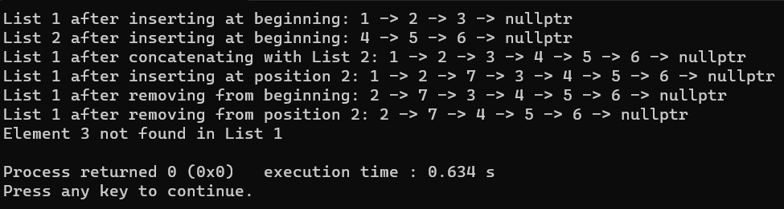
#2 Double Linked List
#include <bits/stdc++.h>

using namespace std;

class Node {
public:
int data;
Node* prev;
Node* next;

Node(int val) : data(val), prev(nullptr), next(nullptr) {}
};

class DoublyLinkedList {
private:
Node* head;
Node* tail;

public:
DoublyLinkedList() : head(nullptr), tail(nullptr) {}

//_______________________________________________________________________
// (i) Insert an element x at the beginning of the doubly linked list
void insertAtBeginning(int x) {
Node* newNode = new Node(x);
if (!head) {
head = tail = newNode;
} else {
newNode->next = head;
head->prev = newNode;
head = newNode;
}
}

//_______________________________________________________________________
// (ii) Insert an element x at ith position in the doubly linked list
void insertAtPosition(int x, int i) {
Node* newNode = new Node(x);
if (i == 0) {
insertAtBeginning(x);
} else {
Node* current = head;
int count = 0;
while (current && count < i) {
current = current->next;
count++;
}
if (current) {
newNode->prev = current->prev;
newNode->next = current;
current->prev->next = newNode;
current->prev = newNode;
} else {
cout << "Position " << i << " not found." << endl;
delete newNode;
}
}
}

//_______________________________________________________________________
// (iii) Insert an element x at the end of the doubly linked list
void insertAtEnd(int x) {
Node* newNode = new Node(x);
if (!tail) {
head = tail = newNode;
} else {
newNode->prev = tail;
tail->next = newNode;
tail = newNode;
}
}

//_______________________________________________________________________
// (iv) Remove an element from the beginning of the doubly linked list
void removeFromBeginning() {
if (head) {
Node* temp = head;
head = head->next;
if (head) {
head->prev = nullptr;
} else {
tail = nullptr;
}
delete temp;
} else {
cout << "The list is empty." << endl;
}
}

//_______________________________________________________________________
// (v) Remove an element from ith position in the doubly linked list
void removeFromPosition(int i) {
if (i == 0) {
removeFromBeginning();
} else {
Node* current = head;
int count = 0;
while (current && count < i) {
current = current->next;
count++;
}
if (current) {
current->prev->next = current->next;
if (current->next) {
current->next->prev = current->prev;
} else {
tail = current->prev;
}
delete current;
} else {
cout << "Position " << i << " not found." << endl;
}
}
}

//_______________________________________________________________________
// (vi) Remove an element from the end of the doubly linked list
void removeFromEnd() {
if (tail) {
Node* temp = tail;
tail = tail->prev;
if (tail) {
tail->next = nullptr;
} else {
head = nullptr;
}
delete temp;
} else {
cout << "The list is empty." << endl;
}
}

//_______________________________________________________________________
// Print the doubly linked list
void display() {
Node* current = head;
while (current) {
cout << current->data << " ";
current = current->next;
}
cout << endl;
}
};

int main() {
DoublyLinkedList d;

d.insertAtBeginning(1);

d.insertAtEnd(2);
d.insertAtEnd(3);
d.insertAtEnd(4);
d.insertAtEnd(5);

d.insertAtPosition(6, 1);
cout << "Double linked list after insert: ";
d.display(); // Output: 1 6 2 3 4 5

d.removeFromBeginning();

d.removeFromPosition(2);

d.removeFromEnd();
cout << "Double linked list after remove: ";
d.display(); // Output: 6 2 4

return 0;
}

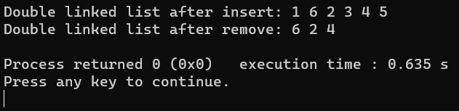

#3 Circular Linked List
#include <bits/stdc++.h>

using namespace std;

// Define Node structure for circular linked list
struct CircularNode {
int data;
CircularNode* next;
};

// Function to insert an element at the beginning of a circular linked list
CircularNode* insertAtBeginning(CircularNode* head, int x) {
CircularNode* newNode = new CircularNode();
newNode->data = x;

if (head == nullptr) {
newNode->next = newNode; // Point to itself in an empty list
return newNode;
}

CircularNode* current = head;
while (current->next != head) {
current = current->next;
}

current->next = newNode;
newNode->next = head;
return newNode;
}

// Function to insert an element at the end of a circular linked list
CircularNode* insertAtEnd(CircularNode* head, int x) {
CircularNode* newNode = new CircularNode();
newNode->data = x;

if (head == nullptr) {
newNode->next = newNode; // Point to itself in an empty list
return newNode;
}

CircularNode* current = head;
while (current->next != head) {
current = current->next;
}

current->next = newNode;
newNode->next = head;
return head;
}

// Function to remove an element from the beginning of a circular linked list
CircularNode* removeFromBeginning(CircularNode* head) {
if (head == nullptr)
return nullptr;

CircularNode* current = head;
while (current->next != head) {
current = current->next;
}

if (current == head) {
delete head;
return nullptr; // Last element removed, list is empty now
}

current->next = head->next;
CircularNode* temp = head;
head = head->next;
delete temp;
return head;
}

// Function to display a circular linked list
void displayList(CircularNode* head) {
if (head == nullptr) {
cout << "Circular Linked List is empty." << endl;
return;
}

CircularNode* current = head;
do {
cout << current->data << " ";
current = current->next;
} while (current != head);
cout << endl;
}

int main()
{
CircularNode* circularLinkedList = nullptr;
int circularChoice;
do {
cout << "Circular Linked List Operations:\n";
cout << "1. Insert at the beginning\n";
cout << "2. Insert at the end\n";
cout << "3. Remove from the beginning\n";
cout << "4. Display the list\n";
cout << "5. Exit\n";
cout << "Enter your choice: ";
cin >> circularChoice;

switch (circularChoice) {
case 1: {
int x;
cout << "Enter the element to insert: ";
cin >> x;
circularLinkedList = insertAtBeginning(circularLinkedList, x);
break;
}
case 2: {
int x;
cout << "Enter the element to insert: ";
cin >> x;
circularLinkedList = insertAtEnd(circularLinkedList, x);
break;
}
case 3: {
circularLinkedList = removeFromBeginning(circularLinkedList);
break;
}
case 4: {
cout << "Circular Linked List: ";
displayList(circularLinkedList);
break;
}
case 5:
break;
default:
cout << "Invalid choice. Try again.\n";
}
} while(circularChoice != 5);
return 0;
}
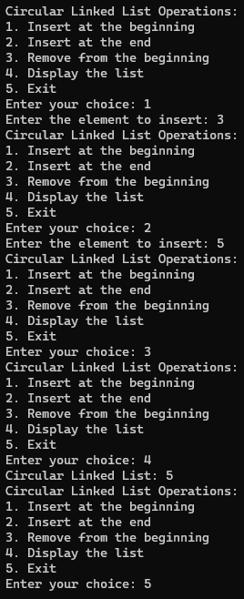
#4 Stack using Array
#include <bits/stdc++.h>
using namespace std;
int stackk[100], n=100, top=-1;
void push(int val) {
if(top>=n-1)
cout << "Stack Overflow" << endl;
else {
top++;
stackk[top] = val;
}
}
void pop() {
if(top<=-1)
cout << "Stack Underflow" << endl;
else {
cout << "The popped element is " << stackk[top] << endl;
top--;
}
}
void display() {
if(top>=0) {
cout << "Stack elements are: ";
for(int i = top; i >= 0; i--)
cout << stackk[i] <<" ";
cout << endl;
} else
cout<<"Stack is empty";
}
int main() {
int ch, val;
cout << "1) Push in stack" << endl;
cout << "2) Pop from stack" << endl;
cout << "3) Display stack" << endl;
cout << "4) Exit" << endl;
do {
cout << "Enter choice: "<<endl;
cin >> ch;
switch(ch) {
case 1: {
cout << "Enter value to be pushed:" << endl;
cin >> val;
push(val);
break;
}
case 2: {
pop();
break;
}
case 3: {
display();
break;
}
case 4: {
cout << "Exit" << endl;
break;
}
default: {
cout << "Invalid Choice" << endl;
}
}
}while(ch!=4);
return 0;
}
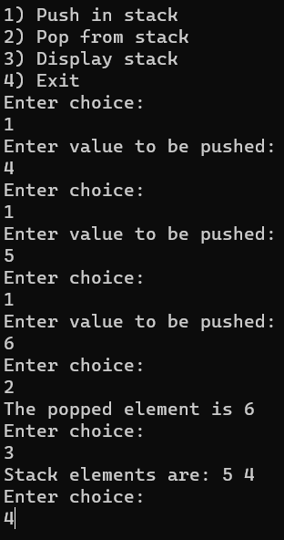

#5 Stack using Linked List
// Implement a stack using singly linked list
#include <bits/stdc++.h>
using namespace std;

// creating a linked list;
class Node {
public:
int data;
Node* link;

Node(int n)
{
this->data = n;
this->link = NULL;
}
};

class Stack {
Node* top;

public:
Stack() { top = NULL; }

void push(int data)
{

// Create new node temp and allocate memory in heap
Node* temp = new Node(data);

// Check if stack (heap) is full.
// Then inserting an element would lead to stack overflow
if (!temp) {
cout << "Stack Overflow" << endl;
exit(1);
}

// Initialize data into temp data field
temp->data = data;

// Put top pointer reference into temp link
temp->link = top;

// Make temp as top of Stack
top = temp;
}

// Utility function to check if the stack is empty or not
bool isEmpty()
{
// If top is NULL it means that there are no elements are in stack
return top == NULL;
}

// Utility function to return top element in a stack
int peek()
{
// If stack is not empty , return the top element
if (!isEmpty())
return top->data;
else
exit(1);
}

// Function to remove a key from given queue q
void pop()
{
Node* temp;

// Check for stack underflow
if (top == NULL) {
cout << "Stack Underflow" << endl;
exit(1);
}
else {

// Assign top to temp
temp = top;

// Assign second node to top
top = top->link;

// This will automatically destroy the link between first node and second node

// Release memory of top node
// ex: delete the node
free(temp);
}
}

// Function to print all the elements of the stack
void display()
{
Node* temp;

// Check for stack underflow
if (top == NULL) {
cout << "Stack Underflow" << endl;
exit(1);
}
else {
temp = top;
while (temp != NULL) {

// Print node data
cout << temp->data;

// Assign temp link to temp
temp = temp->link;
if (temp != NULL)
cout << " -> ";
}
cout << endl;
}
}
};

int main()
{
long n;
// Creating a stack
Stack s;

// Push the elements of stack
//s.push(11);
//s.push(22);
//s.push(33);
//s.push(44);
cout<< "Enter -1 to cancel" << endl;
while (n != -1){
cout << "Enter element of stack: ";
cin >> n;
if (n != -1)
s.push(n);
}
// Display stack elements
cout << "Stack: ";
s.display();

// Print top element of stack
cout << "Top element is " << s.peek() << endl;

// Delete top elements of stack
int cont = 1;
while(cont == 1)
{
cout << "Do you want to delete top element? 1/Yes 2/No " << endl;
cin >> cont;
if (cont == 1)
s.pop();
}
;

// Display stack elements
cout << "Stack: ";
s.display();

// Print top element of stack
cout << "Top element is " << s.peek() << endl;

return 0;
}
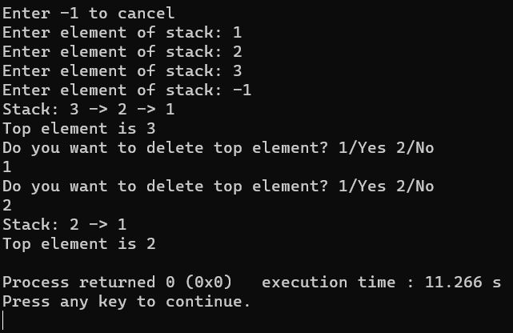

#6a Postfix
#include <bits/stdc++.h>
using namespace std;

int evaluatePostfix(char* exp)
{
stack<int> st;
int i;

for (i = 0; exp[i]; ++i) {

if (exp[i] == ' ')
continue;

else if (isdigit(exp[i])) {
int num = 0;

while (isdigit(exp[i])) {
num = num * 10 + (int)(exp[i] - '0');
i++;
}
i--;

st.push(num);
}

else {
int val1 = st.top();
st.pop();
int val2 = st.top();
st.pop();

switch (exp[i]) {
case '+':
st.push(val2 + val1);
break;
case '-':
st.push(val2 - val1);
break;
case '*':
st.push(val2 * val1);
break;
case '/':
st.push(val2 / val1);
break;
}
}
}
return st.top();
}

int main()
{
//Input
char exp[] = "10 20 + 4 / 5 * 4 +";
//Output
cout << "Answer is: ";
cout << evaluatePostfix(exp);
return 0;
}
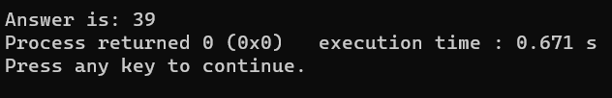

#6b Prefix
#include <bits/stdc++.h>
using namespace std;

bool isOperand(char c)
{
// If the character is a digit then it must be an operand
return isdigit(c);
}

double evaluatePrefix(string exprsn)
{
stack<double> Stack;

for (int j = exprsn.size() - 1; j >= 0; j--) {

// Push operand to Stack
// To convert exprsn[j] to digit subtract'0' from exprsn[j].
if (isOperand(exprsn[j]))
Stack.push(exprsn[j] - '0');

else {

// Operator encountered
// Pop two elements from Stack
double o1 = Stack.top();
Stack.pop();
double o2 = Stack.top();
Stack.pop();

// Use switch case to operate on o1
// and o2 and perform o1 Or o2.
switch (exprsn[j]) {
case '+':
Stack.push(o1 + o2);
break;
case '-':
Stack.push(o1 - o2);
break;
case '*':
Stack.push(o1 * o2);
break;
case '/':
Stack.push(o1 / o2);
break;
}
}
}

return Stack.top();
}

int main()
{
//string exprsn = "+5*10";
string exprsn;
cout << "Please enter Prefix input: ";
cin >> exprsn;
cout << endl;
cout << "Answer is: ";
cout << evaluatePrefix(exprsn) << endl;
return 0;
}
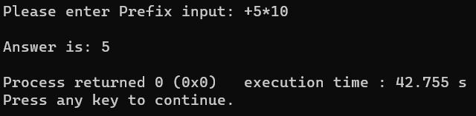

#7 Queue Circular Array
#include <bits/stdc++.h>

using namespace std;

class CircularQueue {
private:
vector<int> items;
int front;
int rear;
int size;
int capacity;

public:
CircularQueue(int capacity){
this->capacity =capacity;
this->items.resize(capacity);
this->front = 0;
this->rear = -1;
this->size = 0;
}

bool isFull(){
return size == capacity;
}

bool isEmpty(){
return size == 0;
}

void enqueue(int item){
if(isFull()){
cout << "Queue is Full. Cannot enqueue." << endl;
return;
}
rear = (rear + 1) % capacity;
items[rear] = item;
size++;
}
int dequeue(){
if(isEmpty()){
cout<< "Queue is empty. Cannot dequeue." << endl;
return -1;
}
int dequeuedItem = items[front];
front = (front + 1) % capacity;
size--;
return dequeuedItem;
}
int peek(){
if(isEmpty()){
cout<< "Queue is empty. Cannot peek." << endl;
return -1;
}
return items[front];
}
int getSize(){
return size;
}
};
int main(){
CircularQueue queue(5);
queue.enqueue(1);
queue.enqueue(2);
queue.enqueue(3);
queue.enqueue(4);

cout << "Dequeued: " << queue.dequeue() << endl;
cout << "Peek: " << queue.peek() << endl;
cout << "Size: " << queue.getSize() << endl;
return 0;
}
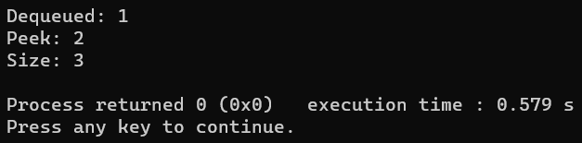

#8 Queue Circular Linked List
#include <iostream>

using namespace std;

class Node {
public:
int data;
Node* next;

Node(int value) : data(value), next(nullptr) {}
};

class CircularQueue {
private:
Node* front;
Node* rear;

public:
CircularQueue() : front(nullptr), rear(nullptr) {}

bool isEmpty() {
return front == nullptr;
}

void enqueue(int data) {
Node* newNode = new Node(data);
if (isEmpty()) {
front = rear = newNode;
} else {
rear->next = newNode;
rear = newNode;
}
rear->next = front; // Make it circular
}

int dequeue() {
if (isEmpty()) {
cout << "Queue is empty." << endl;
return -1; // Assuming -1 is an invalid value for the queue
}

int removedItem = front->data;
if (front == rear) {
delete front;
front = rear = nullptr;
} else {
Node* temp = front;
front = front->next;
rear->next = front; // Adjust the rear to maintain circular structure
delete temp;
}

return removedItem;
}

void display() {
if (isEmpty()) {
cout << "Queue is empty." << endl;
return;
}

Node* current = front;
do {
cout << current->data << " ";
current = current->next;
} while (current != front);

cout << endl;
}
};

int main() {
CircularQueue cq;

int n=0;
while(n != -1)
{
cout << "Please enter for enqueue, -1 for cancel: ";
cin >> n;
if (n != -1)
cq.enqueue(n);
}

cout << "Queue: ";
cq.display(); // Output: 1 2 3

cout << "Dequeue: " << cq.dequeue() << endl; // Output: Dequeue: 1

cout << "Queue: ";
cq.display(); // Output: 2 3

return 0;
}
