Quotation No: 20261015QJ01
Quotation Prepared Date: 2026/10/15
Quotation Expire Date: 2026/10/18
Payment Method: Full Payment
Prepared by: [Jasintha / Sales]

QUOTATION TO -
Mr. Prasath
0775003251

No. | Image | Product/Service | Quantity | Unit Price | Total Price
1 | 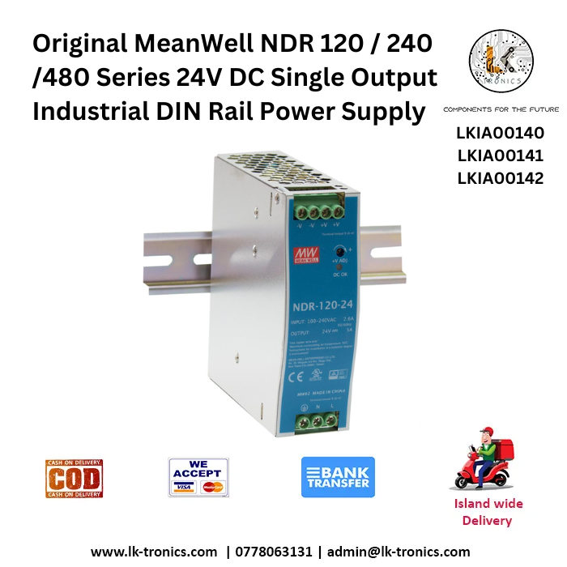 | Original MeanWell NDR 120 Series 24V DC Single Output Industrial DIN Rail Power Supply (5A)  (instocks)  (06 months warranty) | 1 | Rs 15,270.00 | Rs 15,270.00
 | Total Amount |  |  |  | Rs 15,270.00

General Terms and Conditions for the Client

- Ownership of goods shall remain with LK TRONICS until full payment is settled.
- Orders once confirmed cannot be cancelled. In the event of cancellation, any advance paid will be non-refundable.
- The company shall not be held liable for delays or failures due to events beyond reasonable control, including natural disasters, riots, pandemics, or supply chain disruptions.
- This quotation and its pricing are confidential and intended solely for the client. Sharing or distributing it without consent is prohibited.

Validity of Quotation
This quotation is valid for a period of Three (03) days from the date of issue. Upon expiry of this period, the prices, availability, and terms specified herein shall be subject to change and may be adjusted based on market conditions, supplier revisions, or other applicable factors.

Lead Time & Stock Status
For products sourced from overseas, the standard delivery lead time ranges from 12–21 business working days, calculated from the date of advance payment or receipt of an official purchase order. Items currently in stock at our Homagama warehouse will be delivered within 2–5 business working days. The stock availability status for each product is clearly specified in the respective product description column of this quotation. (Availability of in-stock products may change without prior notice. Customers are advised to confirm the current stock status with our sales team before issuing a purchase order or making any advance payment.)

Warranty Terms
Warranty coverage shall be granted based on the manufacturer’s or supplier’s policy. Damages arising from misuse, mishandling, improper installation, modifications, or external environmental factors are not covered under any circumstances. Where applicable, the warranty period and conditions will be specified in the respective product table within this quotation.

Delivery from Homagama Warehouse
If delivery charges are not specified in the quotation table, the client shall be responsible for either arranging collection of the goods from our store or bearing the applicable delivery cost, should delivery be required.

Payment Terms
Payment shall be effected based on the agreed payment method (Full Payment / 80% Advance Payment / Credit) selected by the client and confirmed at the time of order. No processing or delivery will commence until the agreed payment terms are fulfilled.

Bank Details
Account Name LK TRONICS TRADING PVT LTD
Account Number 047010021564
Bank Name Hatton National Bank
Bank Branch Biyagama

…………………………………
Authorized by

We sincerely appreciate the opportunity to submit this quotation and look forward to supporting your requirements.

