**MEMORANDUM**

**TO:** The Massachusetts Department of Public Health

**FROM:** Lindsay Kastner, MPH Candidate at the Boston University School of Public Health

**DATE:** May 5, 2025

**SUBJECT:** Addressing Disparities in Maternal PM2.5 Exposure in Boston: Utilization and Expansion of Current Initiatives at the State Level

**EXECUTIVE SUMMARY**

Maternal exposure to fine particulate matter (PM2.5) in Boston is an emerging environmental health issue, disproportionately affecting Black and Hispanic pregnant individuals. Exposure to PM2.5 is linked to adverse birth and maternal health outcomes spanning the entire length of the pregnancy. This memo presents the evidence of this issue, examines potential avenues for intervention, and recommends a solution aimed at leveraging existing public health initiatives to mitigate these disparities. Key recommendations include integrating PM2.5 exposure information into Massachusetts Department of Public Health (MassDPH) programs and expanding environmental health education within prenatal care in the Boston area.

**BACKGROUND**

In the past two decades, the body of literature on the linkages between ambient air pollution and adverse pregnancy outcomes has grown exponentially. Epidemiological studies suggest that PM2.5 exposure in all trimesters significantly increases the odds of adverse birth outcomes, including low birth weight and preterm birth, as well as maternal outcomes including preeclampsia, eclampsia, and gestational diabetes.1-3 PM2.5 enters the bloodstream after inhalation, leading to oxidative stress which causes decreased placental circulation, inflammation and endocrine disruption in the mother (see Appendix A. Exposure Disease Model).4-6

The current EPA NAAQS for PM2.5 is 9 µg/m2,7 which is above the annual average PM2.5 concentration (7 µg/m3) reported in the Massachusetts 2023 Air Quality Report.8 However, the Air Quality Guidance for annual PM2.5 concentrations from the World Health Organization is currently 5 µg/m3, supported by epidemiologic evidence that has found adverse health outcomes at chronic, low-level exposure to PM2.5.9

***Disparities in Particulate Matter Exposure***

While Boston, Massachusetts has robust data collection efforts for air pollution and maintains traffic pollution that is under annual National Ambient Air Quality Standards (NAAQS),8 large disparities in exposure patterns exist for Asian, Hispanic, and Black populations in the city,10 both in terms of air pollution exposure11 *and* maternal birth outcomes.12 A fact sheet released in 2019 by the Union of Concerned Scientists found that in Boston, concentrations of PM2.5 exposure were higher for Asian, Black, and Hispanic Americans by 25% or more than their white counterparts.10

Boston’s urban setting, air pollution, and maternal health statistics warrant improved maternal health education and policies. The latest *Health of Boston*: *Maternal and Infant Health Report* published in 2023 by the Boston Public Health Commission reported that the rate of low birth weight for Black infants was twice that of White infants, and the percentage of preterm birth for Black mothers was also double that of White mothers.12 Additionally, neighborhoods with higher percentages of Black residents, including Mattapan, Dorchester, and Roxbury have the highest percentages of low birth weight and infant mortality.12,13

Additionally, evidence using 2000 and 2010 census data suggests that non-Hispanic Black and urban Hispanic populations experienced annual average PM2.5 concentrations of 8.4 µg/m3 and 13.0 ppb (or 7.3 µg/m3) in 2010, respectively.11 According to 2020 US Census Data, Boston’s racial makeup is approximately 48% White, 21% Black, 19% Hispanic, and 10% Asian.10 Histories of redlining and income inequality have significantly contributed to reduced health status for minority communities and specifically impacting measures like infant mortality in low-income, historically Black neighborhoods like Mattapan, North Dorchester, and Roxbury.11

**INTERVENTION AVENUES**

The aforementioned disparities combined with relatively high levels of past PM2.5 concentrations in Boston as well as the known relationship between PM2.5 exposure and adverse pregnancy outcomes suggests a possible gap in the current guidance given during the prenatal period to pregnant individuals in Boston, MA. To address this issue, two interventions should be explored, both of which utilize and expand upon current Massachusetts Department of Public Health bureaus (highlighted in the Appendix B. Relevant Stakeholders):

1. **Bureau of Family Health and Nutrition, Pregnancy, Infancy, and Early Childhood Division**
   1. Within the Prenatal Health Initiatives section, there are resources on various indicators and topics dealing with maternal health, ranging from doula initiatives to egg retrieval resources.14
   2. Notably, this site includes a “Maternal Mortality and Morbidity Review” section, which provides more information about activities from the Maternal Mortality and Morbidity Review Committee (MMMRC) and touches on the persisting racial inequities for Black birthing people in the United States.14
   3. This section contains the MMMRC reports and publications and could provide an ample opportunity to include more information including an infographic* and links to published work on the impacts of air pollution on pregnancy outcomes.14
2. **Bureau of Climate and Environmental Health’s Environmental Health Fact Sheets**
   1. The bureau states that the Environmental Health Fact Sheets offer an “…answer [to] some of the environmental health questions that have been brought to the attention of our bureau.”15
   2. By incorporating a fact sheet* on maternal PM2.5 exposure or a section with more resources on maternal environmental health during pregnancy, this presents a way for maternal and child health resources to gain traction in the environmental health side of MassDPH.

*A proposed fact sheet/infographic on the topic of racial disparities in PM2.5 exposure and maternal health outcomes can be found in the attached Appendix C. Fact Sheet/Infographic.

The implication for both initiatives is that eventually, MassDPH would be instrumental in elevating this emerging body of literature on the threat of air pollution exposure, especially to PM2.5, during pregnancy to both clinical and public health practitioners across the state of Massachusetts. The state department of public health must play an instrumental role in the elevation of maternal environmental health awareness, education, and care to address both acute and chronic exposure to ambient air pollution during pregnancy.

**RECOMMENDATION**

To effectively address maternal PM2.5 exposure, MassDPH should integrate air pollution risk information into both the Prenatal Health Initiatives and the Environmental Health Fact Sheets. While the information may need to be presented differently across the two different bureaus, both topic areas warrant a more dedicated space to environmental hazards during pregnancy.

The ideal long-term outcome would be that, following leadership from the state, healthcare providers in Boston and throughout Massachusetts would integrate environmental health education into their OB/GYN care. An example of current efforts to make environmental health more central to perinatal and children’s healthcare is the Pediatric Environmental Health Specialty Units (PEHSUs), as the Region 1 service area for all of New England affiliation is with the Children’s Hospital Boston, Harvard Medical School, Cambridge Hospital, and Harvard School of Public Health.16 The PEHSUs focus on offering expertise on environmental health topics from medical professionals to patients across the country.17

The limitations associated with the proposed intervention strategy stem from the fact that educational materials alone are not a comprehensive solution to limiting maternal exposure to PM2.5. Posting infographics and fact sheets on the MassDPH website, while relatively accessible to most MA residents with computer access, fails to take the burden off of the individual. Partnerships between MassDPH, policy makers, and hospitals and their providers will be needed to comprehensively address the issue of PM2.5 exposure during pregnancy. This proposal highlights a critical first step towards this ultimate goal.

**CONCLUSION**

It is clear that the outcomes found in Boston are reflective of a larger issue with racial and socioeconomic disparities in air pollution exposure and thus, adverse pregnancy outcomes. Massachusetts’ reputation for being at the forefront of health research and healthcare urges a state body like MassDPH to use this moment to elevate the recent findings from the latest *Health of Boston Report* and the supporting literature.

By embedding environmental health education into public health initiatives and clinical practice, Massachusetts can lead in mitigating these disparities and improving birth outcomes statewide.

**Appendix**

1. **Exposure Disease Model**

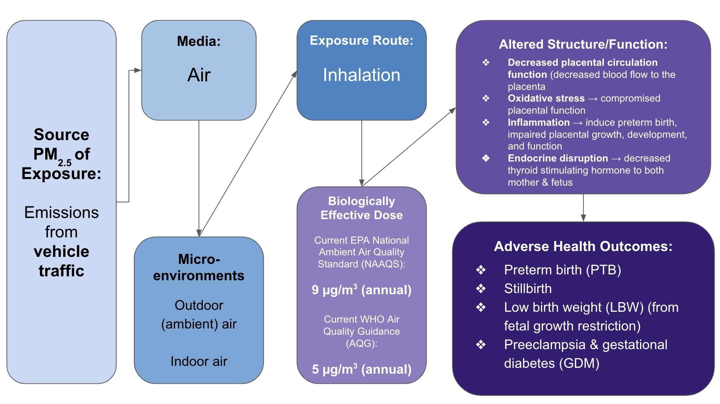

1. **Relevant Stakeholders**

1. **Fact Sheet/Infographic**

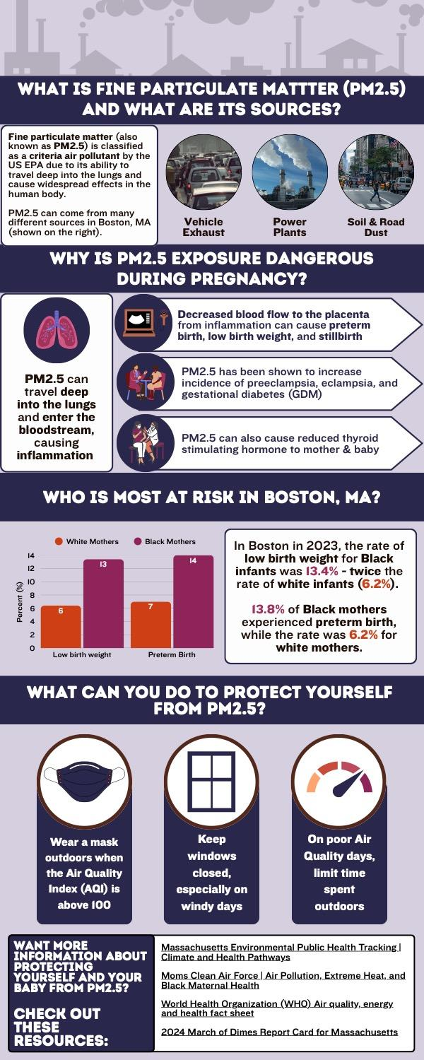

**References**

1. Veras MM, Damaceno-Rodrigues NR, Guimarães Silva RM, et al. Chronic exposure to fine particulate matter emitted by traffic affects reproductive and fetal outcomes in mice. *Environmental Research*. 2009;109(5):536-543. doi:[10.1016/j.envres.2009.03.006](https://doi.org/10.1016/j.envres.2009.03.006)

2. Ritz B, Wilhelm M, Hoggatt KJ, Ghosh JKC. Ambient air pollution and preterm birth in the environment and pregnancy outcomes study at the University of California, Los Angeles. *Am J Epidemiol*. 2007;166(9):1045-1052. doi:[10.1093/aje/kwm181](https://doi.org/10.1093/aje/kwm181)

3. Bell ML, Ebisu K, Belanger K. Ambient air pollution and low birth weight in Connecticut and Massachusetts. *Environ Health Perspect*. 2007;115(7):1118-1124. doi:[10.1289/ehp.9759](https://doi.org/10.1289/ehp.9759)

4. Kim JY, Lee EY, Choi I, Kim J, Cho KH. Effects of the Particulate Matter2.5 (PM2.5) on Lipoprotein Metabolism, Uptake and Degradation, and Embryo Toxicity. *Molecules and Cells*. 2015;38(12):1096-1104. doi:[10.14348/molcells.2015.0194](https://doi.org/10.14348/molcells.2015.0194)

5. Deyssenroth MA, Rosa MJ, Eliot MN, et al. Placental gene networks at the interface between maternal PM2.5 exposure early in gestation and reduced infant birthweight. *Environ Res*. 2021;199:111342. doi:[10.1016/j.envres.2021.111342](https://doi.org/10.1016/j.envres.2021.111342)

6. Sun X, Luo X, Zhao C, et al. The associations between birth weight and exposure to fine particulate matter (PM2.5) and its chemical constituents during pregnancy: A meta-analysis. *Environmental Pollution*. 2016;211:38-47. doi:[10.1016/j.envpol.2015.12.022](https://doi.org/10.1016/j.envpol.2015.12.022)

7. US EPA O. National Ambient Air Quality Standards (NAAQS) for PM. April 13, 2020. Accessed February 27, 2025. <https://www.epa.gov/pm-pollution/national-ambient-air-quality-standards-naaqs-pm>

8. Massachusetts Department of Environmental Protection. Massachusetts 2023 Air Quality Report. Published September 2024. Accessed February 28, 2025. <https://www.mass.gov/doc/2023-annual-air-quality-report/download>

9. Agency for Toxic Substances and Disease Registry. ATSDR Particulate Matter Guidance. Published April 2023. Accessed February 28, 2025. <https://www.atsdr.cdc.gov/pha-guidance/resources/ATSDR-Particulate-Matter-Guidance-508.pdf>

10. Union of Concerned Scientists. Inequitable Exposure to Air Pollution from Vehicles in Massachusetts. Published May 2020. Accessed February 28, 2025. <https://www.ucsusa.org/sites/default/files/2020-05/inequitable-exposure-to-vehicle-pollution-ma.pdf>

11. Rosofsky A, Levy JI, Zanobetti A, Janulewicz P, Fabian MP. Temporal trends in air pollution exposure inequality in Massachusetts. *Environmental Research*. 2018;161:76-86. doi:[10.1016/j.envres.2017.10.028](https://doi.org/10.1016/j.envres.2017.10.028)

12. Ojikutu B. THE MATERNAL AND INFANT HEALTH REPORT. Published online 2023. Accessed February 28, 2025. <https://www.boston.gov/sites/default/files/file/2023/10/HOB_2023_Maternal_Infant_Final_Oct3.pdf>

13. Chen JT, Rehkopf DH, Waterman PD, et al. Mapping and Measuring Social Disparities in Premature Mortality: The Impact of Census Tract Poverty within and across Boston Neighborhoods, 1999–2001. *J Urban Health*. 2006;83(6):1063-1084. doi:[10.1007/s11524-006-9089-7](https://doi.org/10.1007/s11524-006-9089-7)

14. Prenatal Health Initiatives | Mass.gov. Accessed March 20, 2025. <https://www.mass.gov/prenatal-health-initiatives>

15. Environmental Health Fact Sheets | Mass.gov. Accessed March 20, 2025. <https://www.mass.gov/environmental-health-fact-sheets>

16. Region 1 - Pediatric Environmental Health Specialty Units. Accessed March 20, 2025. <https://www.pehsu.net/findhelp/region1/>

17. Home - Pediatric Environmental Health Specialty Units. Accessed March 20, 2025. <https://www.pehsu.net/>