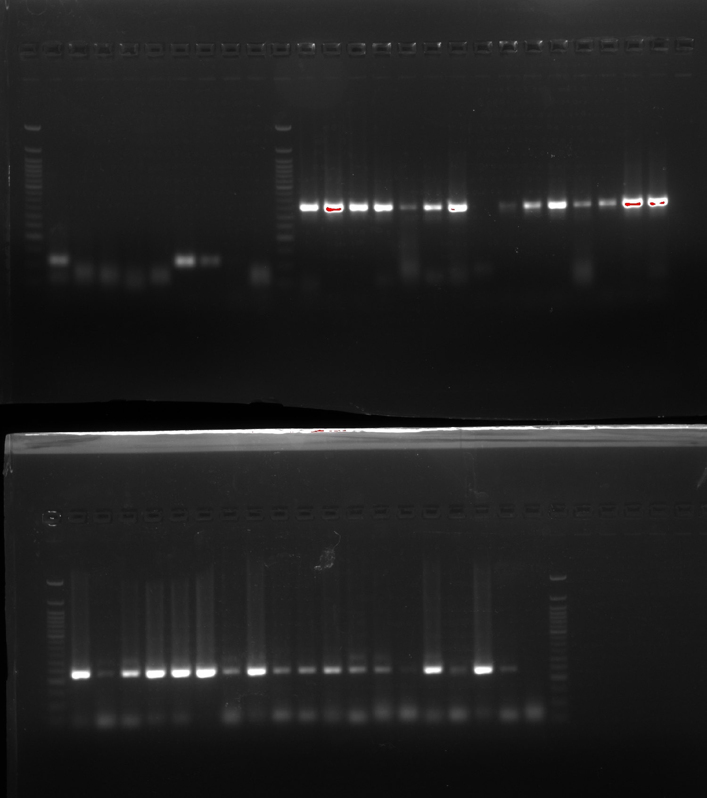

Key:

Gel 1:

Set 1: RpL32

|  |  |
| --- | --- |
| Sample Name | Positive by Gel? |
| OH_F_1 | Y |
| OH_F_2 | N |
| OH_F_3 | N |
| OH_M_3 | N |
| OH_M_4 | N |
| OH_M_5 | Y |
| OH_M_7 | Y |
| OH_M_8 | N |
| OH_M_9 | N |

Set 2: Galbut A- 1600/1601

|  |  |
| --- | --- |
| Sample Name | Positive by Gel? |
| Penn_F_7 | Y |
| Penn_F_10 | Y |
| Penn_F_11 | Y |
| Penn_M_3 | Y |
| Penn_M_8 | Y |
| Penn_M_11 | Y |
| Penn_M_16 | Y |
| cDNA_neg | N |
| ME_F_7 | Y |
| ME_F_12 | Y |
| ME_M_7 | Y |
| ME_M_8 | Y |
| ME_M_9 | Y |
| ME_M_11 | Y |
| OH_M_5 | Y |

Gel 2:

Galbut A/B- 2165-2170

|  |  |
| --- | --- |
| Sample Name | Positive by Gel? |
| Penn_F_5 | Y |
| Penn_M_1 | Y |
| Penn_M_5 | Y |
| Penn_M_6 | Y |
| Penn_M_17 | Y |
| Penn_M_18 | Y |
| ME_F_2 | Y |
| ME_F_3 | Y |
| ME_F_6 | Y |
| ME_F_9 | Y |
| ME_F_11 | Y |
| ME_M_6 | Y |
| ME_M_8 | Y |
| ME_M_12 | N |
| ME_M_14 | Y |
| ME_M_16 | Y |
| OH_M_5 | Y |
| OH_M_6 | Y |
| OH_M_12 | N |

