**Documentation**

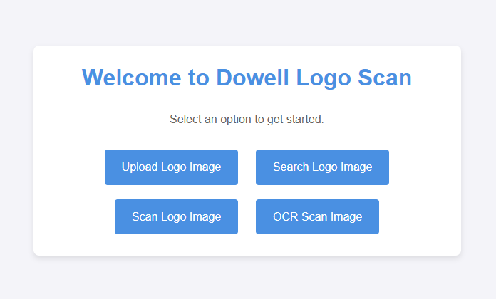

**Button 1: (Upload Logo Image)**

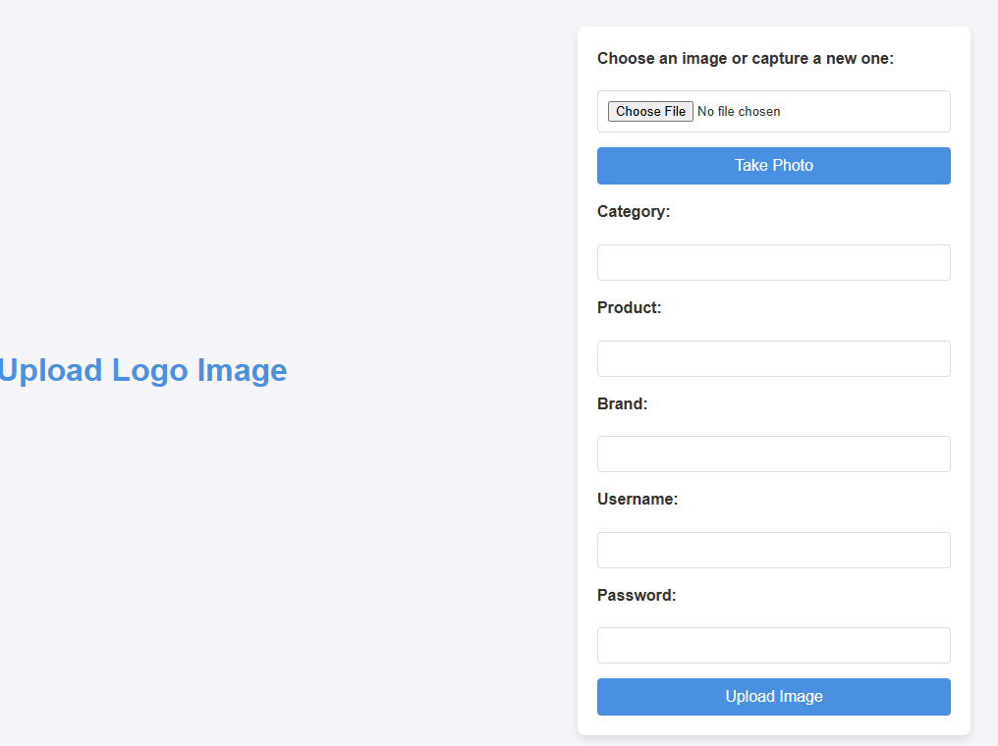

It has functional to upload image and extract the features in the database.

**Choose File Button:**  Select image from your local machine.

OR

**Take Photo Button:** Capture Image from your camera

**Category:**  Which category does your image belong to?

**Product:**  What is the product?

**Brand:** What is the brand?

**Username: for Admin** ( “dowell” )

**Password: for Admin** ( “dowell” )

( if “dowell” both username & password is not satisfied, It will considered as “user_upload” )

**Upload Image Button:** Send all the data and image to backend Api that will store the data and extracted image features it self in the database.

**Button 2: (Search Logo Image)**



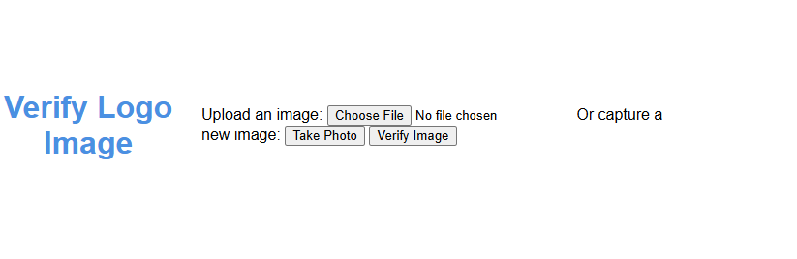

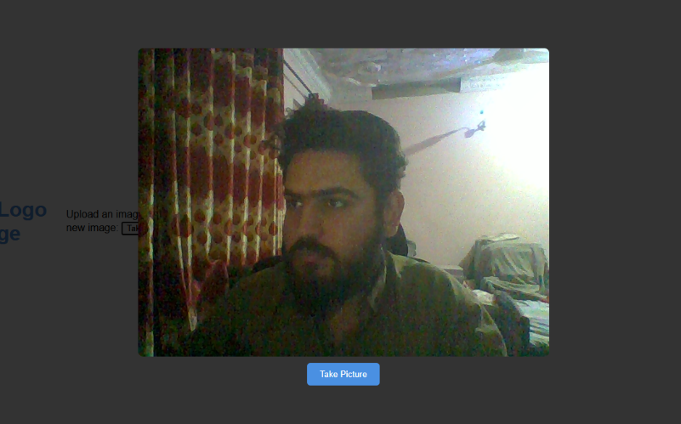It has the functionality to search for an image in the database and retrieve the most similar image with the highest accuracy using an AI model.

**Choose File Button:**  Select image from your local machine.

OR

**Take Photo Button:** Capture Image from your camera

**Verify Image button:** It will show 3 similar images as result.



**Button 3: (Scan Logo Image)**

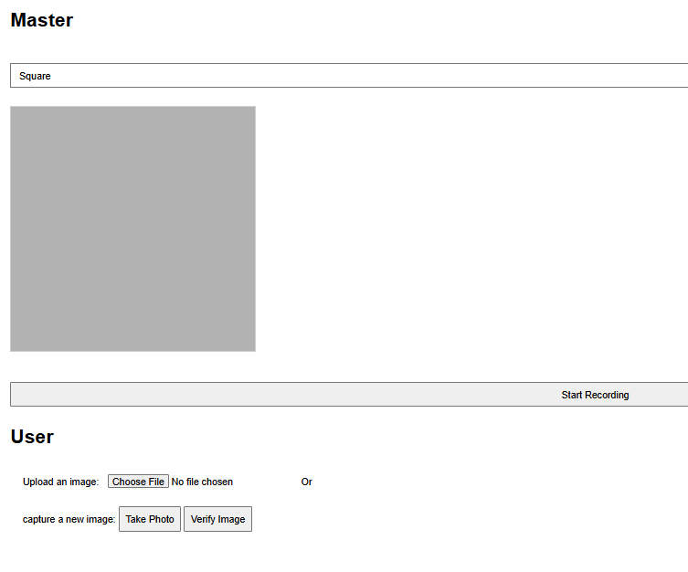

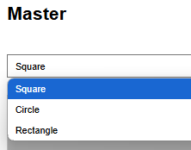**Master Section (Only for Admins):**

**Shape Drop down List :**  To select canvas for the image Square , Circle & Rectangle.

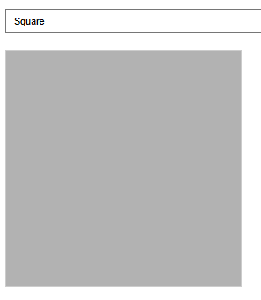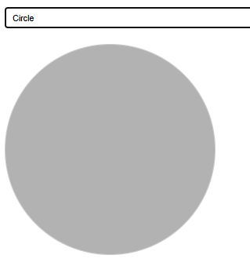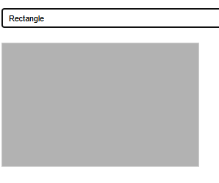

**Start Recording Button:** It wil start recording for 10 secs with the selected canvas**,**

**( It will also give direction to tile tilt image Up, Down, Left & Right )**

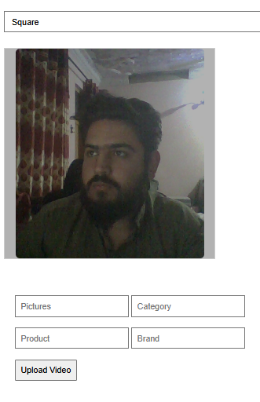

**Up**

**Down**



**Right**

**Left**

The recording will automatically stop after 10 secs and show additional forms

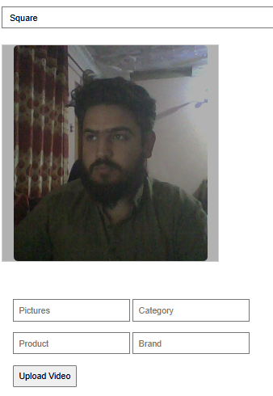**Pictures Form:**  How many total pictures you the want extract from the captured video.

**Category:**  Which category does your image belong to?

**Product:**  What is the product?

**Brand:** What is the brand?

**Upload Video Button :** This button will extract total pictures from the video and extract features of extracted images and store to database along with data in the forms.

**User Section:**

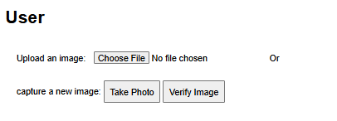

It has the functionality to search for an image in the database and retrieve the most similar image with the highest accuracy using an AI model.

**Choose File Button:**  Select image from your local machine.

OR

**Take Photo Button:** Capture Image from your camera

**Verify Image button:** It will show 3 similar images as result.

**Button 4: ( OCR Scan Image )**



It has the functionality to detect text from the image an AI model.

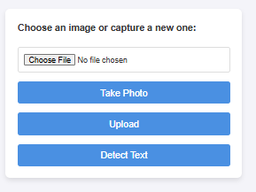**Choose File Button:**  Select image from your local machine.

OR

**Take Photo Button:** Open camera

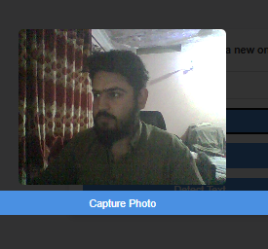

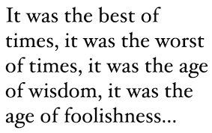

**Capture Photo Button:** Capture Image from your camera

**Upload Button:** This button will send the image and store to database and show the detected text from the image

**Detect Text Button:**  It will not upload the image to database and only show the detected text from the image.

