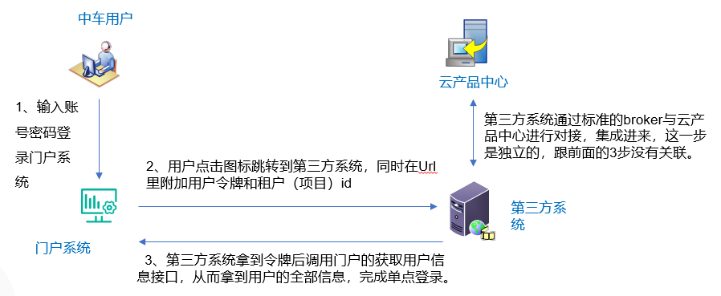

跳转示例：http://ip:port/index?sessionId=aegaegtatetaetettaettaetwt&projectId=fadsf4d25

sessionId:当前登录用户令牌

projectId：项目id或租户id

门户获取用户信息接口:

<http://ip:port/indnet/portalUser/getUserPermit> post请求

参数为空，注意要把获取到的令牌放到请求的Header里。

格式为：

Authorization:令牌的值

调用成功后，门户返回的格式如下：

{

"state": true,

"message": "",

"value": {

"userId": "用户id",

"account": "用户帐号",

"userName": "用户名",

"email": "邮箱",

"orgId": "公司id",

"orgName": "\*\*公司名",

"deptId": "部门id",

"deptName": "部门名",

"roles": [

{

"id": "角色id",

"name": "角色名",

"code": "角色编码",

"enabled": "是否可用0-不可用，1可用",

"isCommon": "是否公共角色0-否1是",

"orgId": "所属组织"

}

],

"roleCodes": "所有角色编码",

"roleName": "所有角色名",

"menuCheck": [

"菜单名1",

"菜单名1"

],

"authorization": "当前token",

"userKey": "加密key",

"userCheckKey": "加密key",

//用户所属租户信息 数组类型

"tenants": [

{

                "id": "租户id",

                "name": "租户名",

                "description": "隆轩项目D",

                "orgId": "所属组织id",

                "status": 1, // 是否启用0-否；1-是

                 //用户所属租户下的项目信息 数组类型

"projects": [

                    {

                        "id": "项目id",

                        "name": "项目名",

                        "code": "项目编码",

                        "status": 1, // 是否启用0-否；1-是

                        "userProRoles": [用户在此项目的角色编码],

                    }

]

}

]

}

}