2. Air drum block

The air drum block includes three major parts, the first part is three Tom-Tom Drums(hand drums) and one cymbal, the second part is Hi-Hat and Bass Drum (foot drums), the last part is the UART communication. There are two acceleration sensors working as three Tom-Tom Drums(hand drums) and one cymbal. Two light sensors are working as Hi-Hat and Bass Drum (foot drums). And one USB to TTL module working for UART communication

2.1 Tom-Tom Drums and cymbal

2.1.1 Acceleration sensors

The acceleration sensor we used is the GY-61 ADXL335 module. They are placed on the drumsticks.

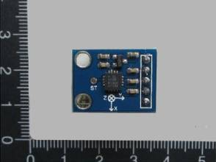

Figure 2.1.1.1 GY-61 ADXL335 module

It can detect the angle position in X,Y,Z three directions. We setup a certain sample time and use ADC scan mode to detect the difference between the angles in X,Y,Z. When the difference reaches the critical value, the program will generate a signal to indicate that the drum is hit. Also the magnitude of the difference will be recorded and send through UART to allow matlab to generate sound with different volume. Since we have six analog inputs, so we use the ADC scan mode two make sure that every hit on the drum will be detected. The ADC setup is as followed.

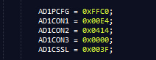

Figure 2.1.1.2 ADC scan mode setup

2.1.2 Control button

The control buttons are also placed on the drumsticks.

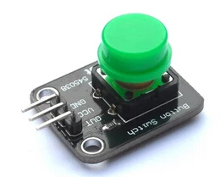

Figure 2.1.2.1 Control button

It is used to control which drum the drum stick is hitting. For the left hand, the control button determines if you are hitting a higher pitch drum or a lower pitch drum. For the right hand, the control button determines if you are hitting a high pitch drum or a cymbal.

2.1.3 LED indicator

There are two led indicators on each drumstick to indicate that if the drum is hit or not.

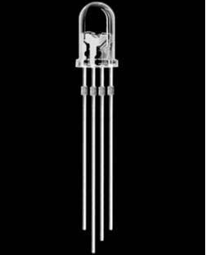

Figure 2.1.3.2 The RGB LED

For the left hand it is basically a digital output controlled LED. But for the right hand, the LED is controlled by a PWM output. So the light intensity will be strong when the drum is hit hardly. And the light intensity will be weak when the drum is hit weakly. The PWM setup is as followed.

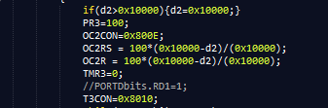

Figure 2.1.3.2 The PWM setup

2.2 Hi-Hat and Bass Drum

2.2.1 Light sensor

There are two light sensors on two feet to control the Hi-Hat and Bass Drum.

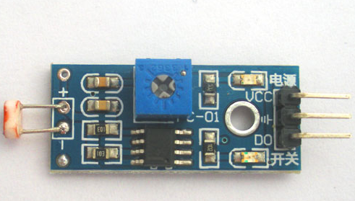

Figure 2.2.1.1 Light sensor

The left foot is Hi-Hat the right feet is Bass Drum. It is placed under the feet. I can detect the change of the light intensity so that when the drum is hit, the change on the light intensity will be detected be the light sensor. We use the Change Notice interrupt to capture the change on the sensors’ output pins.



Figure 2.2.1.2 Change Notice setup

2.2.2 LED indicator

There are also two led indicator on the breadboard to indicate if on drum is hit or not.

2.3 UART communication

2.3.1 TTL/USB converter module

We use the TTL/USB converter module to facilitate the communication between computer and the PIC32 board.

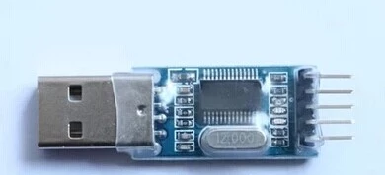

Figure 2.3.1.1 TTL/USB converter module

2.3.2 UART communication

We use the UART to communicate between the computer and PIC32. We used UART1A, with 8bits data, 1 even parity bits and 2 stop bits mode to ensure the communication is stable and error free.

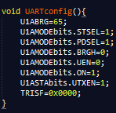

Figure 2.3.2.1 UART setup

Also to ensure the speed and stability, we used DMA to help UART communication, So that the UART communication will not take kernel’s resources and time.

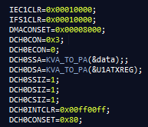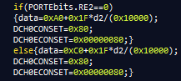

Figure 2.3.2.2 DMA setup and DMA usage