3. Air piano block

The air piano block includes two parts, one part is an ultrasonic distance detector and another one is an 8-key LED keypad.

3.1 Ultrasonic block

The ultrasonic sensor is HC-SR04, which is shown in the plot.

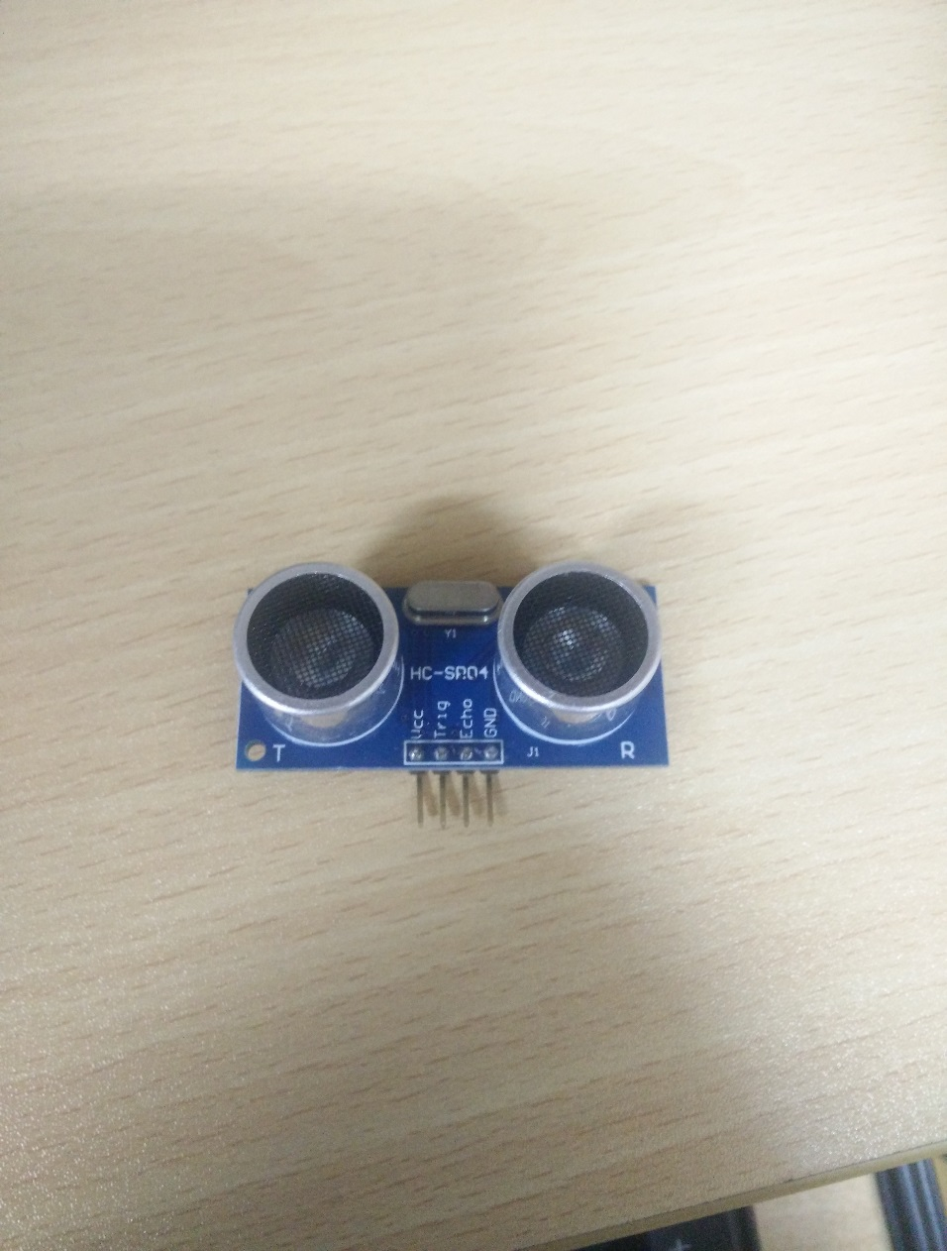

Figure 3.1.1 HC-SR04 ultrasonic sensor

Its functionality is illustrated with the following plot.

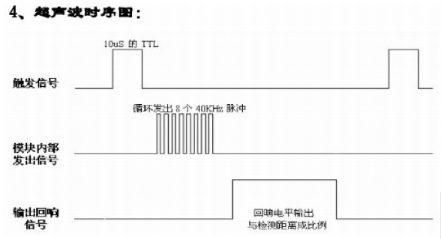

Figure 3.1.2 HC-SR04 function principle

When we need a distance, MCU will generate a pulse with minimum width 10us and output it to the trigger port of HC-SR04. Then ultrasonic sensor, when an echo response comes back, will transmit the received square wave back to MCU through echo port.

At the MCU part, we use input capture to capture the rising edge and falling edge.

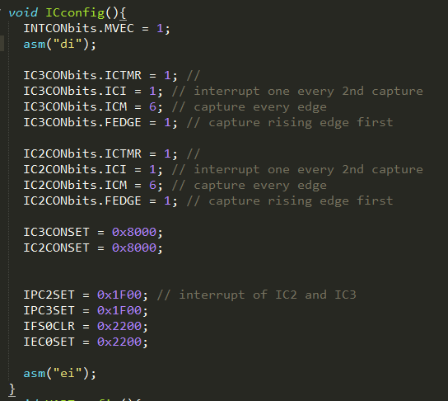

Figure 3.1.3 Setup of IC

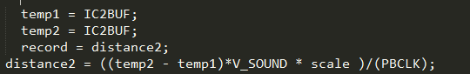

Figure 3.1.4 interrupt of IC

Two temporary variables, temp1 and temp2, are used to read out the buffer. Then the distance value is calculated using the equation of distance2. We use timer2 to be capture source.

3.2 Big structure

The full air piano prototype is shown here:

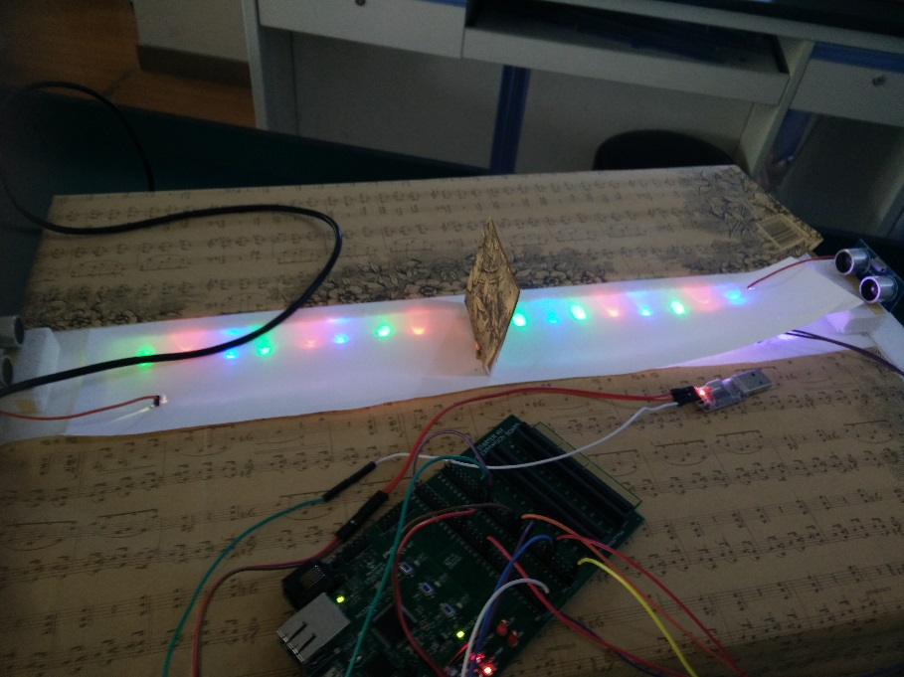

Figure 3.2.1 Air piano

LEDs are used to denote the location of different keys like a real piano. When some objects stands in front of one ultrasonic sensor, this sensor will detect it and respond with a distance calculated by the equation in Figure 3.1.4. In order to transfer the distance to corresponding sound, we use UART module of PIC32 to transmit data to computer and then compute will decode the data and play correct sound file.

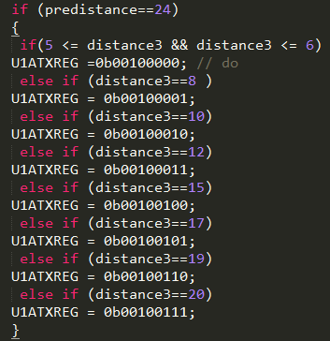

Figure 3.2.2 Data transmission

Predistance is used as a reference because we want to avoid the scenario that when one keeps putting his/her finger in one position, there will be just one sound output which is how a real piano does. When one moves out finger, predistance will be the fixed value from ultrasonic sensor to that vertical board in the middle of the keypad as shown in Figure 3.2.1.

3.3 Error discussion

When we finish this air piano, the performance is limited. The major reason is that the accuracy of ultrasonic sensor is just 1cm which is far from enough for a piano. What happened is that when one put a finger in adjacent two keys, it possible that two different would be played.

3.4 Possible improvement

After a few discussion with TAs and other students, we guess that infrared light sensor might be a better choice because of better accuracy and less inferences.