College of Business, Government and Law
Inspiring Achievement

**LLAW3301 Law in a Digital Age**

Semester 1, 2020

Access to Docassemble and GitHub

A central part of this topic is learning how to code. In order to do so you will need to access the Flinders University Docassemble server. You will also need to create an account on GitHub.

This document walks you through both processes.

Access to Docassemble

[Docassemble](https://docassemble.org) is a web-based software automation system. In order to access Docassemble, you will need a computer with a modern web browser, such as the latest versions of Chrome, Firefox, Safari or Edge.

Internet Explorer should not be used to access Docassemble (in fact, Internet Explorer should not be used for anything!).

An account has been created for you on the Flinders University Docassemble server. The table below contains the information you need to access the server.

|  |  |
| --- | --- |
| Docassemble server | <https://docassemble.flinders.edu.au> |
| Your login email address | {{MJFrecipient.email}} |
| Your login email password | {{MJFrecipient.password}} |

It is strongly recommended that you change your password after you have logged in. Follow these steps:

1. access your user profile from the right-side drop-down menu; and…

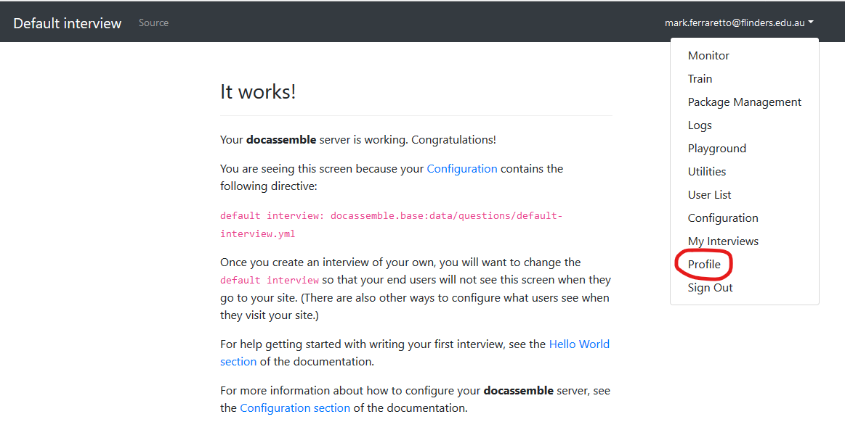

1. …select ‘Change Password’ from the ‘Other Settings’ menu.

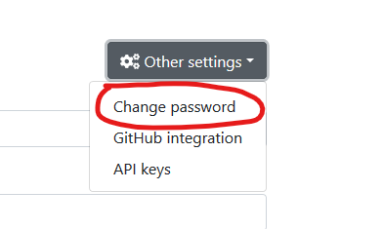

Access to GitHub

You must set up a GitHub account and connect it to your Docassemble account.

Follow these steps:

1. Navigate to <https://education.github.com/pack>
2. Click on the ‘Get the Pack’ button

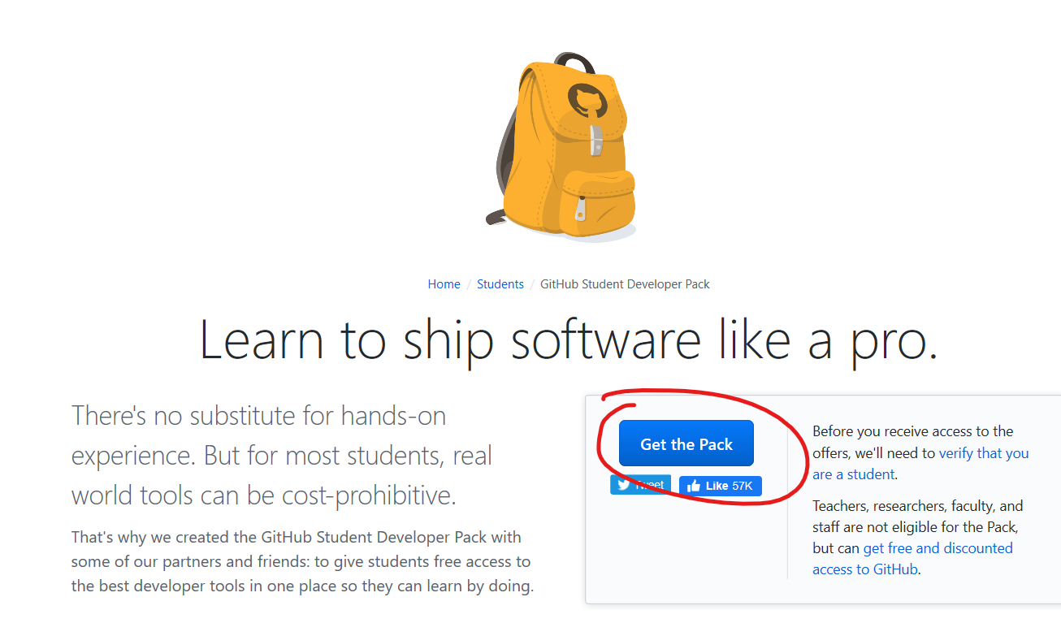

1. Sign up for GitHub

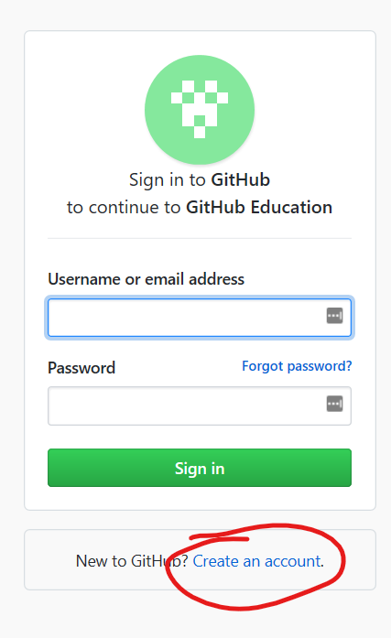

1. Work through the signin process
   1. Your username should be your FAN (eg: ferr0182)
   2. Your email should be the same as your Docassemble login (eg: [ferr0182@flinders.edu.au](mailto:ferr0182@flinders.edu.au))
   3. Choose your own unique password – don’t forget it!
   4. Work through any verification options until you are logged into GitHub
2. Go back to your profile on Docassemble



1. Select ‘GitHub integration’ from the ‘Other settings’ menu

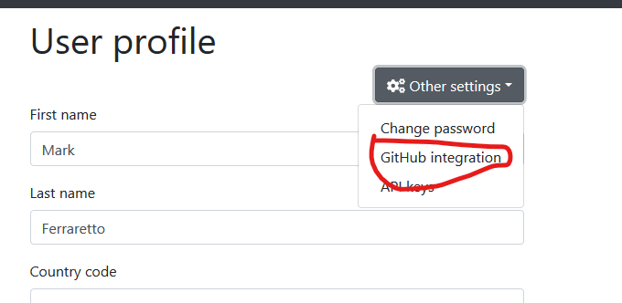

1. Click on ‘Configure’

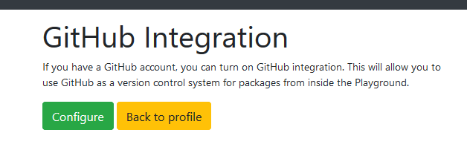

1. You will be asked to sign into GitHub

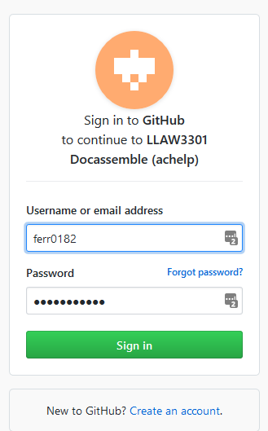

1. You may be asked to grant access to the LLAW3301 GitHub account. Accept this
2. You will be taken back to a screen that looks like this:

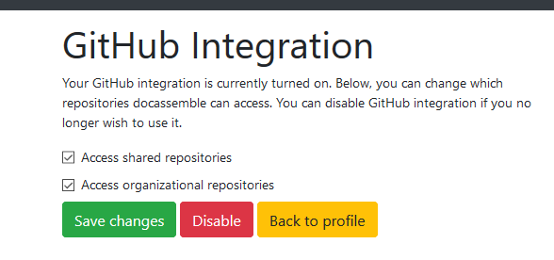

1. If the checkboxes aren’t checked, check them and ‘Save changes’.
2. Click ‘Back to Profile’
3. You’re done!

If you have any questions, please see the Topic Co-ordinator.



|  |
| --- |
| CRICOS No. 00114A ABN 65 542 596 200 |