Monte Carlo Simulation for Classical Heisenberg Model in Various Lattice

Abstract

We used Monte Carlo simulation based on Metropolis algorithm to calculate the Curie temperature of classical Heisenberg model on 2D square lattice, 3D cubic lattice and 2D hexagonal lattice. The boundary condition was dealt with helical boundary condition[1]. The results had good agreement with literatures and it shows our codes are very effective.

The Hamilton of classical Heisenberg model can be expressed by:

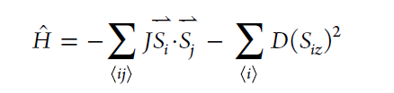

Where J is the exchange interaction parameter, D is the single-site magnetic anisotropy parameter. In the classical Heisenberg model, we ignore the quantum effect of the system and the spin S can be seen as a 3D vector with constant absolute value $\left|S\right|$.

The detail of the Metropolis algorithm can be found in the reference[1]. Herein, we only emphasize the method of choosing random $θ,φ$ (this can be found in reference[1] pp. 399).

In order to generate our random, spherically symmetric unit vectors, we should choose:

$$θ=\cos^{-1}(1-2r_{1})$$

$$φ=r_{2}∙2π$$

Where r is the random number between 0 to 1.

The two method for choosing $θ,φ$ are compared in Fig. 1

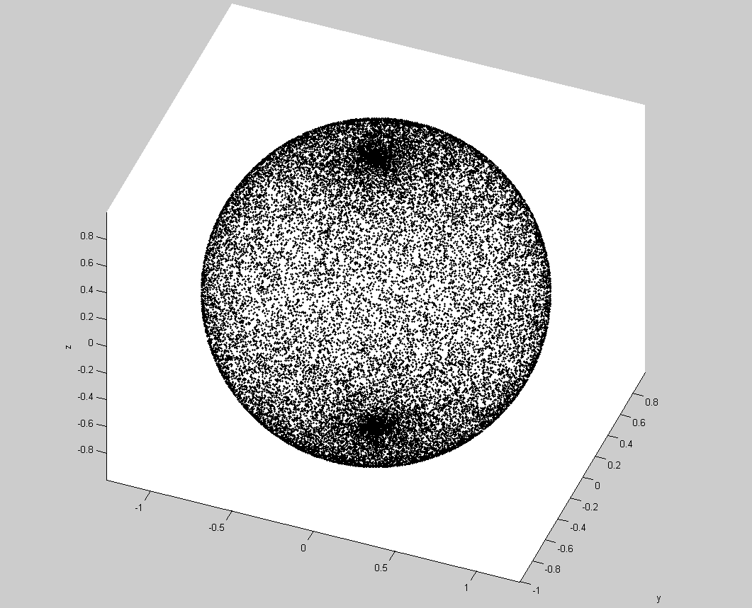 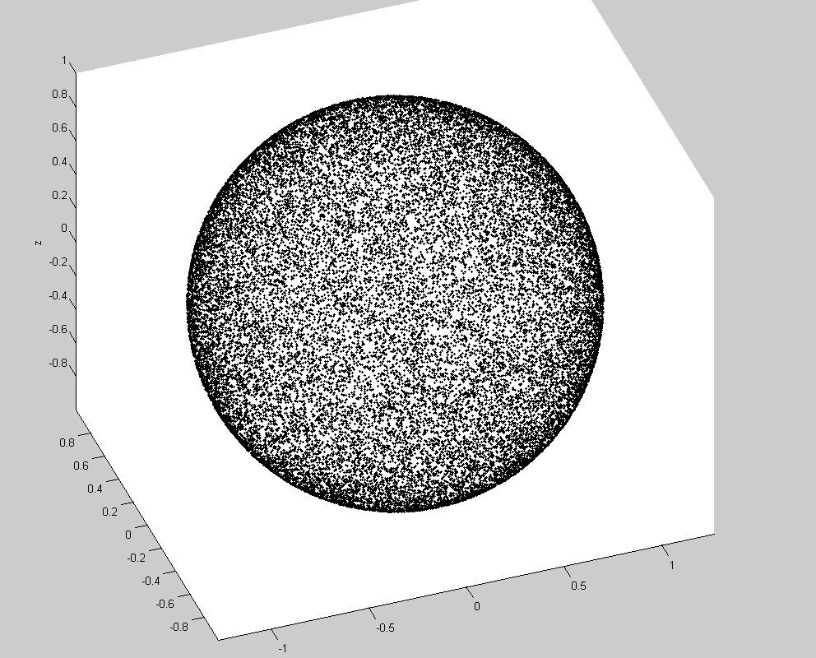

$θ=r_{1}∙π$ $φ=r_{2}∙2π$ $θ=\cos^{-1}(1-2r_{1})$ $φ=r_{2}∙2π$

Nonuniform uniform

Square lattice:

J = 1, S = 1, k_b = 1;

Supercell: 20*20

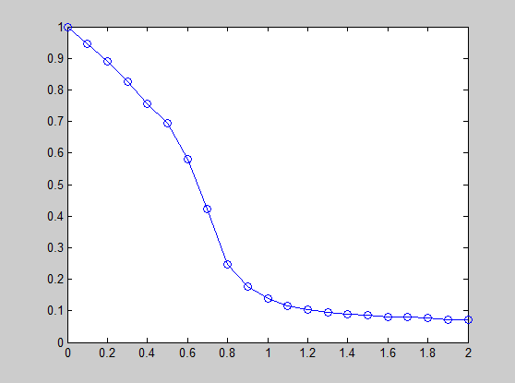 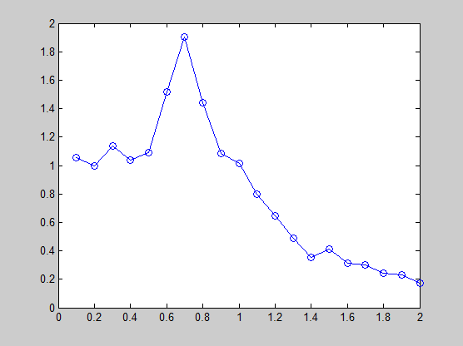

S vs. T $C_{v}$ vs. T

Tc = 0.7

Cubic lattice[3]:

J = 1, S = 1, k_b = 1;

Supercell: 10*10*10

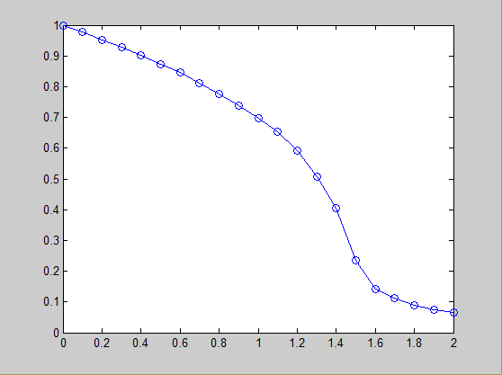 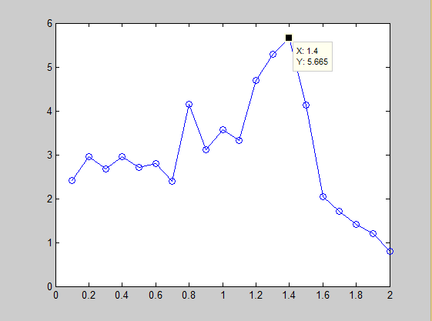

Tc = 1.4

Hexagonal lattice[4]:

Cr $I_{3}$

J = 4 meV D = 0.35 meV S = $\frac{3}{2}$ k_b = k_b

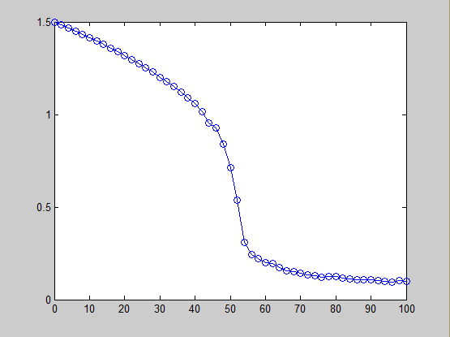 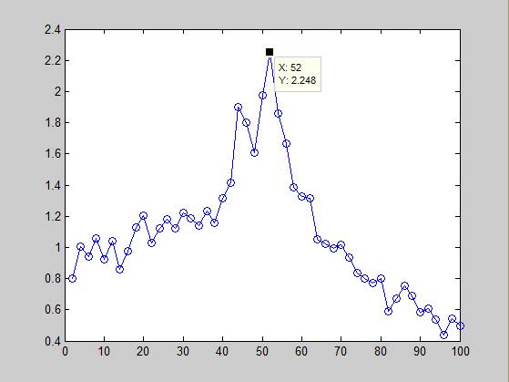

Tc = 52 K

Reference:

[1] M. E. J. Newman and G. T. Barkema, Monte Carlo Methods in Statistical Physics

[2] D.P. Landau, K.K. Mon, and H.-B. Schiittler, Computer Simulation Studies in Condensed-Matter Physics V, pp. 151-153

[3] Wolfhard Janke, Computational Physics pp 10-43, Monte Carlo Simulations of Spin Systems

[4] Huang, C. et al. Toward Intrinsic Room-Temperature Ferromagnetism in Two-Dimensional Semiconductors. Journal of the American Chemical Society, doi:10.1021/jacs.8b07879 (2018).