INTRODUCTION TO DATA SCIENCE
- WHAT IS DATA SCIENCE?
- Extracting useful conclusion from large datasets with:
  - Processes
  - Problem definition
  - Set of principles
  - Analysis
  - Computer
- Data Scientist vs all
“A data scientist is someone who knows more statistics than a computer scientist and more computer science than a statistician.
- DATA SCIENCE PROCESS
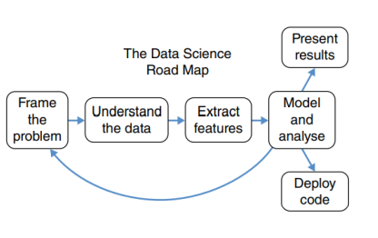
Bảng Dễ bị bias (Do ds có thể không có kiến thức về chủ đề của problem Xác định vấn đề/ thu thập dữ liệu không chính xác.
- Give the question to answer
- Collecting data
- Data discovery & preprocessing to obtain data that can be analyzed.
- Data analysis (in statistics, visualizations, machine learning) answer (hypotheses) for the question.
- Evaluation
- Decision making
From one step you will probably need to go back to the previous steps to go to the retreat a number of times.

DATA COLLECTION
- What kinds of data?
- How many samples are sufficient?
Greater or equal to the number of columns. (Thực tế thì số lượng mẫu thực tế lớn hơn).
- Tại sao thu thập thêm dữ liệu sẽ cho những kết quả khác nhau?
  - Data có thể bị sai (sai số, …)
  - Nhiễu (Không phản ánh dữ liệu thực tế)
  - Sai tự nhiên (e.g Ở giai đoạn khác nhau, data có thể khác nhau)
- Để giải quyết vấn đề overfitting Chọn rất nhiều data.
  - Data đúng hội tụ gần kết quả đúng
  - Data sai Phân tán xa kết quả đúng
  - Nhiều data Xấc suất hội tụ gần điểm chính xác hơn (Phải có điểm dừng vì thời gian giới hạn và giới hạn budget)
  - Chuyển sang giai đoạn tiếp theo: Kiểm tra đủ data chưa. Chưa đủ thì lặp lại quá trình thu thập thêm data.
- Is collecting such data valid? Does it affect others?
  - It is not always valid, and it may affect others.
- WAYS TO COLLECT DATA
- Data is available in company, organization: ok, use it
  - Pros: Fast
  - Cons:
    - May not answer the problem
    - Not understand the context
- Data is available but out there (online): Pre-packaged data (file csv, excel, ...): download, Data provided through the website's API: use AI, Data is on the site but no API: parse HTML
  - Pros: Understand the context
  - Cons:
    - Expensive (Tốn sức)
    - Noise
    - Wrong
- The data is not yet available: created by yourself in ways such as conducting surveys, using sensor devices, ...
  - Pros: Control from the beginning
    - Data quality
    - Understand the context
  - Cons: Costly, laborious, and resource intensive. (Tốn nhiều chi phí, công sức, nguồn lực)
Check if it is crawl? Legit? Affect other people?
- API:
  - Pros:
    - Phục vụ bên thứ 3.
    - Điều hướng người dùng.
    - Cho phép người dùng lấy dữ liệu sau đăng nhập
  - Cons:
    - Giới hạn dữ liệu
    - Những gì user thấy parse HTML

BASIC STATISTICS
- Population:
  - An individual or group that represents all the members of a certain group or category of interest.
  - Parameters are numerical descriptions of population characteristics.
- Sample:
  - A subset drawn from the larger population
  - Statistic are numerical descriptions from sample data.
QUESTION:
- Quiz. Which is population and sample?
  - Mr.Thanh wanted to know the average height of the students in his data science class this term. He collects the height of each student and then calculates them.
    - Population
  - Lucio wants to know whether the food he serves in his restaurant is within a safe range of temperatures. He randomly selects 70 entrees and measures their temperatures just before he serves them to his customers.
- The population is all of the entrees Lucio serves; the sample is the 70 selected entrees.

- Which kind of statistics for the following scenarios?
  - The average weekly income for all students in our class is $405.
Descriptive Statistics
  - The average weekly income for a sample of 450 college students is $325.
Descriptive Statistics
  - A recent survey of a sample of 450 college students reported that the average weekly income for students is $325.
Inferential Statistics (Thống kê suy luận)
      - SAMPLING
- Random sampling: the most useful, but also the most difficult
  - Random means that every member of a defined population has an equal chance of being selected into a sample.
  - Unbiased or biased sampling? - Reduces selection bias if the sample size is sufficiently large.
- Representative sampling: selects cases so that they will match the larger population on specific characteristics.
  - Unbiased or biased sampling?

QUESTION
Identify color of leaves in September with the following ways. Which is biased or unbiased sampling?
- 100 fallen leaves collected from the ground
    - Biased (Excludes leaves still on branches)
- 100 leaves on tree branches
    - Biased (Excludes fallen leaves)
- 50 fallen leaves and 50 leaves on branches
    - Unbiased
- 50 fallen oak leaves and 50 oak leaves on branches
    - Biased (Focuses only on oak leaves)

- VARIABLE AND CONSTANT
- A variable is pretty much anything that can be codified and has more than a single value.
  - Example: income, gender, age, height, etc.
- A constant has only a single score.
  - Example: male, female, 25, etc.
- Types of variables
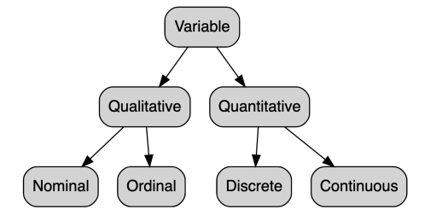
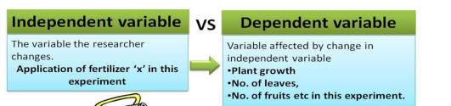
- Biến Danh Nghĩa (Nominal Variable):
  - Là biến phân loại các đối tượng thành các nhóm hoặc danh mục mà không có thứ tự hoặc cấp bậc cụ thể nào.
  - Ví dụ:
    - Giới tính (Nam, Nữ, Khác).
    - Quốc tịch (Việt Nam, Mỹ, Nhật Bản, …).
    - Màu sắc (Đỏ, Xanh, Vàng, …).
- Biến Thứ Tự (Ordinal Variable):
  - Là biến phân loại các đối tượng theo một thứ tự hoặc cấp bậc nhất định, nhưng khoảng cách giữa các cấp bậc không cần phải bằng nhau.
  - Ví dụ:
    - Mức độ hài lòng (Rất không hài lòng, Không hài lòng, Trung lập, Hài lòng, Rất hài lòng).
    - Xếp hạng học sinh (Giỏi, Khá, Trung bình, Yếu).
    - Cấp bậc trong quân đội (Trung úy, Đại úy, Đại tá, …).
- Biến Khoảng (Interval Variable):
  - Là biến số lượng với các khoảng cách đều nhau giữa các giá trị, nhưng không có điểm zero thực sự (zero không đại diện cho sự vắng mặt hoàn toàn của đặc tính được đo).
  - Ví dụ:
    - Nhiệt độ theo Celsius hoặc Fahrenheit (0 độ không đại diện cho sự vắng mặt nhiệt độ).
    - Năm sinh (ví dụ: 1990, 2000, 2020).
- Biến Tỉ Lệ (Ratio Variable):
  - Là biến số lượng với các khoảng cách đều nhau và có điểm zero thực sự, cho phép so sánh tỉ lệ giữa các giá trị.
  - Ví dụ:
    - Chiều cao (cm, m).
    - Trọng lượng (kg, gram).
    - Thu nhập hàng tháng.
    - Thời gian (giờ, phút, giây).

- Mean
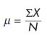 or 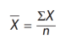
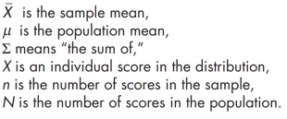
- Median
To find the median (P50 and Mdn) of a distribution:
- Arrange all of the scores in the distribution in order, from smallest to largest.
- Find the middle score in the distribution if there is an odd number.
- If there is an even number of scores in the distribution, the median is the average of the two scores in the middle of the distribution
- Mode
- The mode is simply the category in the distribution that has the highest number of scores, or the highest frequency.
- Skewed Distribution
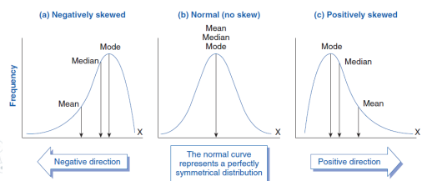
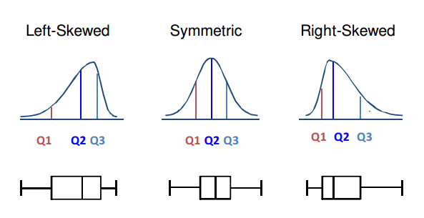
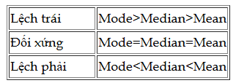
- Outliers
- Distributions have a few scores that are very far away from the mean, they are called outliers.
- Range
- The range is the difference between the largest score (the maximum value) and the smallest score (the minimum value) of a distribution.
- Interquartile Range
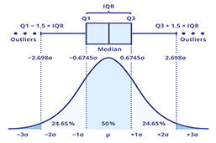
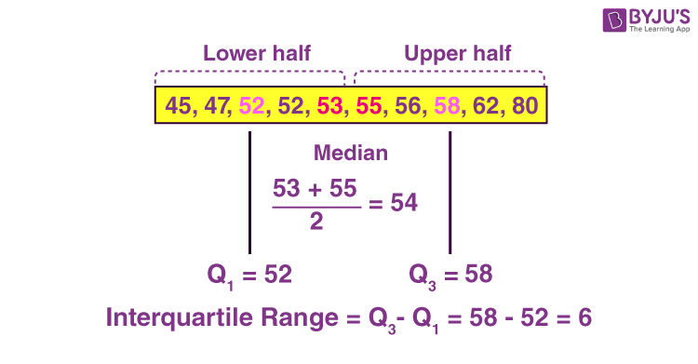
- Q1: The median of the lower half.
- Q3: The median of the upper half.
- Variance (Phương sai) và Standard Deviation (Độ lệch chuẩn)
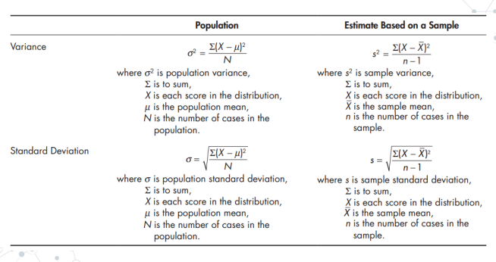

DATA VISUALIZATION
- FEATURES OF VISUALIZATION
- Indicators: They highlight the most important information.
- Simplicity: The information is clear. The reader understands the information at hand immediately.
- Brevity: The message is short and clear, and no unnecessary information is visible.
- Originality: types of data are collected and displayed in a way that offers readers a new perspective on the subject.
- Colour: to draw the reader’s attention to the most important pieces of information, clear and easy-to-understand color palettes are used.
- TYPES OF DATA

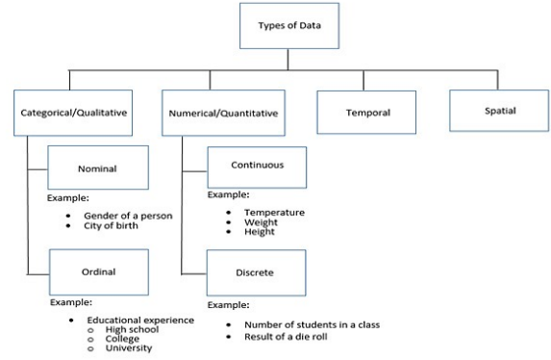

- TYPES OF VISUALIZATION
- Comparison plots
- So sánh nhiều biến/ một biến nhiều lần.
- Line chart
- Nhiều biến
- Trends
- Many time periods ( > 10)
  - Smaller Better choice: Vertical bar chart
- Tránh nhiều liên trên một chart
- Điều chỉnh thang đo sao cho xu hướng có thể nhìn thấy rõ ràng
- Bar chart
- So sánh lẫn nhau
- 2 variants of bar charts:
  - Vertical bar charts
  - Horizontal bar charts Khi có quá nhiều thứ để so sánh
- Radar chart (Spider/ Web chart)
- Nhiều biến, mỗi biến được vẽ trên một trục riêng

- Relation plots
- Relationships among variables
- Scatter chart
- Can detect whether a correlation (relationship) exists between two variables.
- Can plot the relationship for multiple groups or categories using different colors.
- A bubble plot, which is a variation of the scatter plot, is an excellent tool for visualizing the correlation of a third variable.
- Bubble chart
- A bubble plot extends a scatter plot by introducing a third numerical variable.
  - To show a correlation between three variables.
  - The value of the variable is represented by the size of the dots. The area of the dots is proportional to the value.
  - A legend is used to link the size of the dot to an actual numerical value.
- Correlation
- A correlogram is a combination of scatter plots and histograms.
  - A correlogram or correlation matrix visualizes the relationship between each pair of numerical variables using a scatter plot.
  - The diagonals of the correlation matrix represent the distribution of each variable in the form of a histogram.
- Heatmap
- A heatmap is a visualization where values contained in a matrix are represented as colors or color saturation.
- Heatmaps are great for visualizing multivariate data
  - Categorical variables are placed in the rows and columns
  - Numerical or categorical variables are represented as colors or color saturation.

- Composition plots
- Something as a part of a whole.
- Pie chart
- Nên sắp xếp theo thứ tự tăng dần
- Donut chart Khi có nhiều pie chart lồng nhau
- Stacked bar chart
- Stacked bar charts are used to show how a category is divided into sub-categories and the proportion of the sub-category, in comparison to the overall category.
- A 100% stacked bar chart makes it easier to see relative differences between quantities in each group.
- Venn diagram
- Venn diagrams, also known as set diagrams, show all possible logical relations between a finite collection of different sets.
  - Each set is represented by a circle.
  - The circle size illustrates the importance of a group.
  - The size of an overlap represents the intersection between multiple groups.

- Distribution plots
- Histogram
- A histogram visualizes the distribution of a single numerical variable.
  - Each bar represents the frequency for a certain interval.
  - Either plot a histogram with absolute frequency values or alternatively normalize your histogram.
  - To compare distributions of multiple variables, use different colors for the bars.
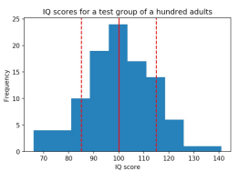

- Density plot
- A density plot shows the distribution of a numerical variable.
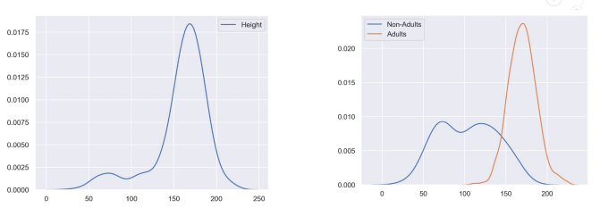
- Box plot
- The box plot shows multiple statistical measurements.
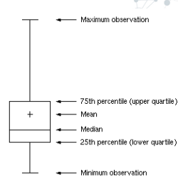
- Box plot
- Violin plots are a combination of box plots and density plots.

DATA PREPROCESSING
.Dữ liệu đủ chưa?
.Tập sample tốt sử dụng Random sampling khó Representative sampling
.Thiếu sample Thu thập thêm dữ liệu
.Thiếu features Process sai, not understand the context, model sai
- DATA CLEANING
- Fill in missing values
- Identify and eliminate discrepancies and noise data.
- Resolve conflicting data.
- Fill the missing values
- Delete missing items:
  - Đơn giản
  - Thực hiện khi mà sau khi xóa dữ liệu vẫn đủ
- Fill manually: tasteless and not feasible
- Fill automatically: Replace by a common constant.
  - Replaced with the property's mean
  - Replaced with the property’s mean in a class
  - Replace with the most likely value: infer from a Bayesian formula, decision tree or EM algorithm (Expectation Maximization)
- Identify and eliminate noise data
- Basic methods: Binning, clustering, regression
  - Binning method:
    - Sort and divide data into equal-width or equal-depth bins
    - Noise reduction by mean, median, margin, ...
    - Equal-width bins:
      - Divide the range of values into N about the same size
      - The width of each interval = (maximum value - minimum value) / N
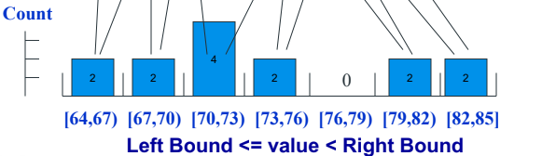
    - Equal-depth bins:
      - Divide the range of values into N ranges that each contain approximately the same number of samples
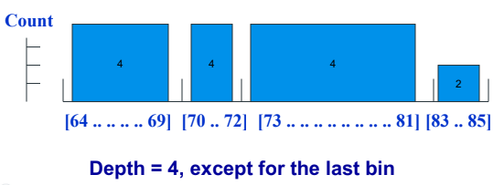
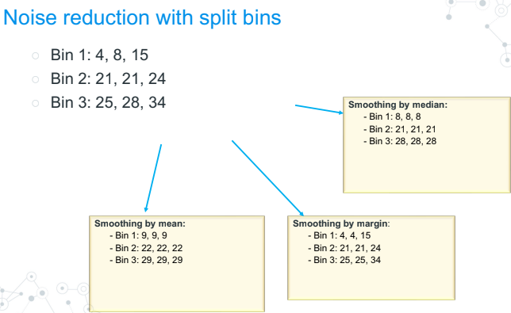
  - Clustering method:
    - Detect and remove outliers
  - Regression method:
    - Fit data into the regression function

- DATA INTEGRATION
- Synthesize, integrate DL from many databases, different files.
- Select and aggregate data from many different sources into one database.
- Process:
  - Select only required data for the data mining process.
  - Matches the data schema
    - Entity recognition problem
      - How do entities from multiple data sources become relevant
      - US=USA; customer_id = cust_number
    - Metadata
  - Eliminate redundant and duplicate data
    - An attribute is redundant if it can be inferred from other properties
    - The same property can have multiple names in different databases
    - Some records in the data are repeated
    - Use correlation analysis
      - r=0: X and Y are not correlated
      - r>0: positive correlation. X tăng <-> Y tăng
      - r<0: negative correlation . X giảm <-> Y tăng
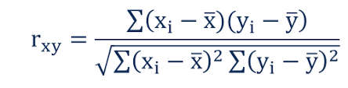
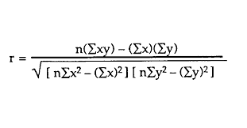
  - Detect and resolve data inconsistencies
    - For example, weight is measured in kilograms or pounds
    - Define standards and mapping based on metadata
- DATA TRANSFORMATION
- Aggregation.
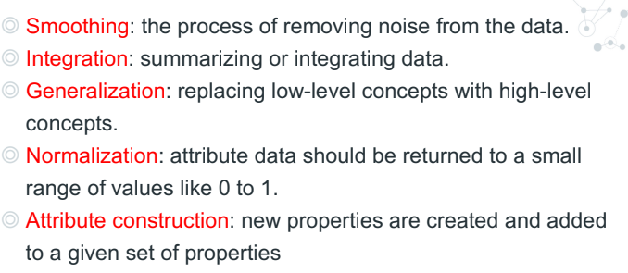
- DATA REDUCTION
- Reduce the data size but ensure analytical results.
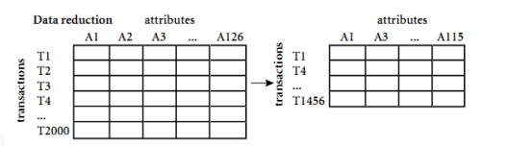
- Methods:
  - Aggregation
  - Dimensionality reduction
    - Feature selection (subset of attributes)
      - Choose m from n attributes
      - Remove irrelevant, redundant attributes
    - How to define irrelevant attributes?
      - Statistics
      - Information gain
    - How to reduce the data dimension?
      - Brute Force
        - There are 2d attribute subsets of d attributes
        - Computational complexity is too high
      - Heuristic method
        - Stepwise forward selection
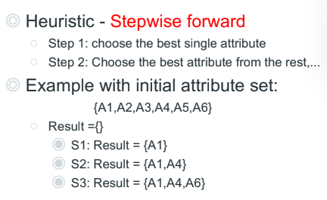
        - Stepwise backward elimitation
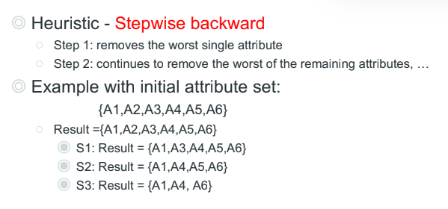
        - Combine two methods
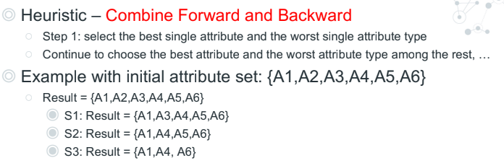
        - Inductive decision tree
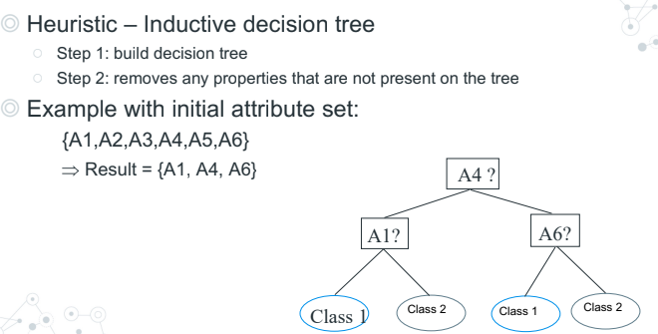
  - Data compression
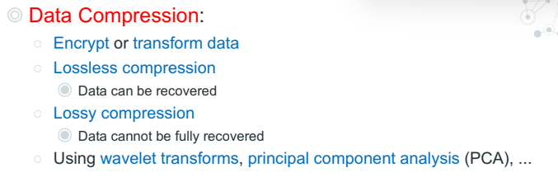
  - Numerosity reduction
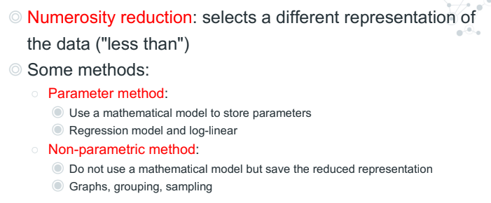
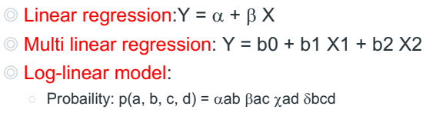
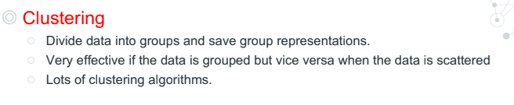
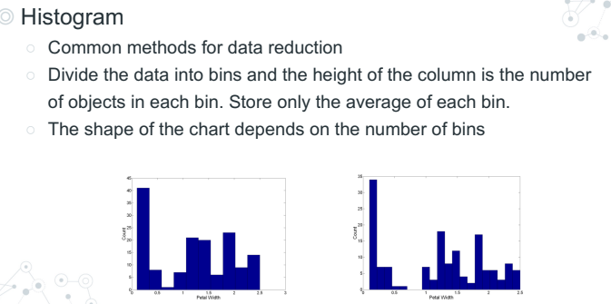
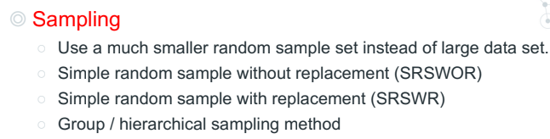
  - Discretization and Concept hierarchies
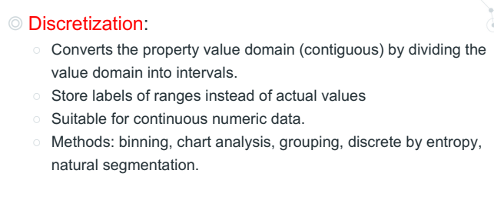
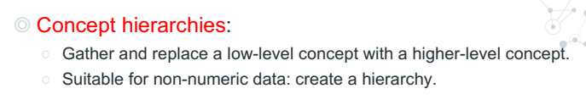

DATA MODELING
