Name: Linda Lee
Course: CST-105
Date: January 21, 2018
Instructor: Mohamed Mneimneh
My NFL Storyboard-Milestone 1
A storyboard is a sequence of drawings or diagrams which illustrates the categorization of steps to create a GUI application. It illustrates the flow of how the program will work with visual screens that show buttons or radio buttons to control each screen.
In my NFL draft pick Milestone 1 assignment I created five screens. First screen shows the home page. It will contain buttons that when clicked it will open to their perspective screens.

MY NFL DRAFT PICK SCREENSHOTS of STORYBOARD
This is my Home Screen. Buttons will control which screen to go to. There will also be a search box.
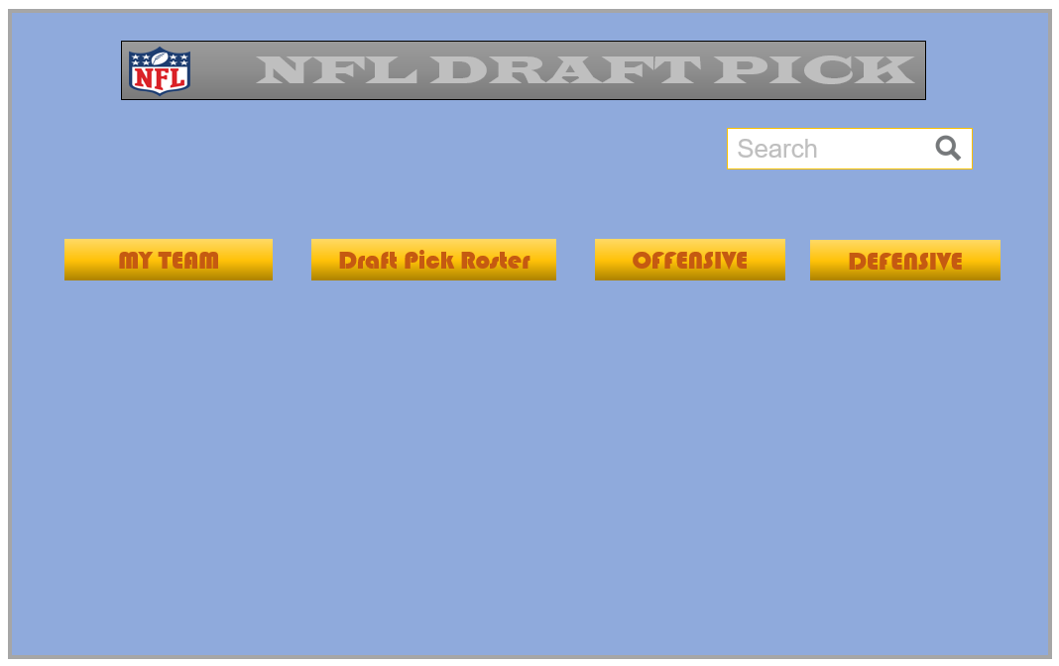
When MY TEAM is clicked on the following screen will pop up. Here I can delete players or go back to Home.
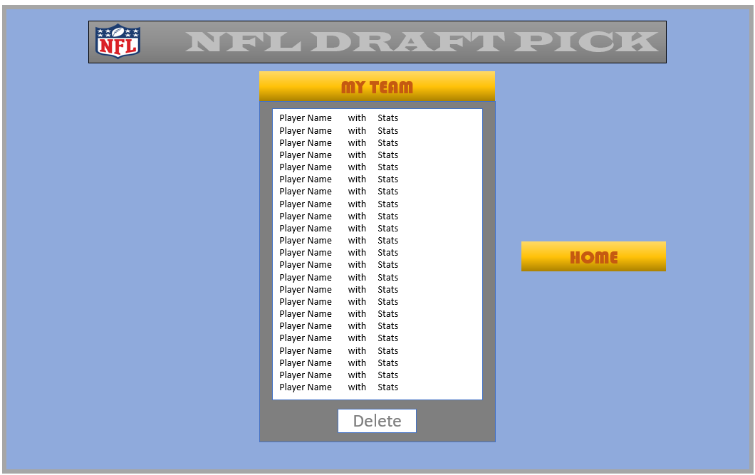
When DRAFT PICK ROSTER is clicked on the following screen will pop up. Once a choice is made to pick player it is added to the MY TEAM ROSTER. If no choice is made I can go back to Home.
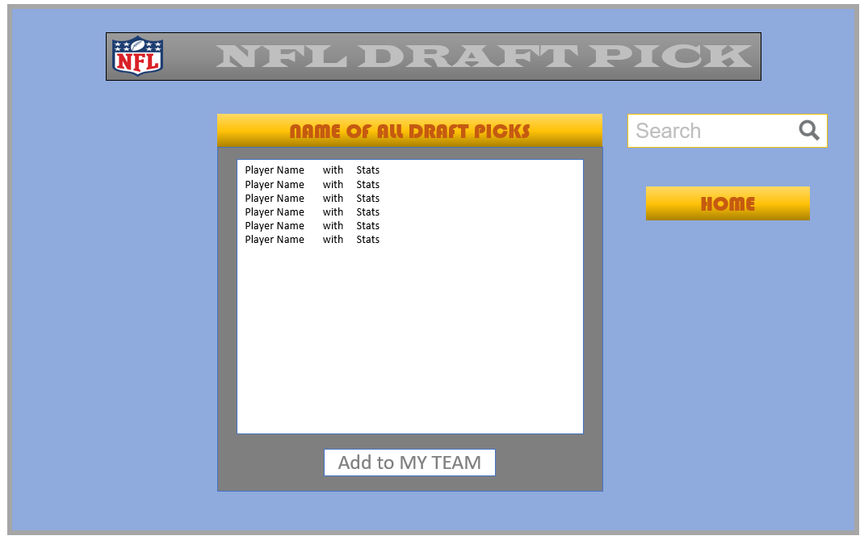
From the Home screen, if I click on the DEFENSIVE or OFFENSIVE buttons it will direct me to choose a player from the lists in the separate screens.
Offensive Screen: Here I choose a player and pick. If not, I can go back to Home.
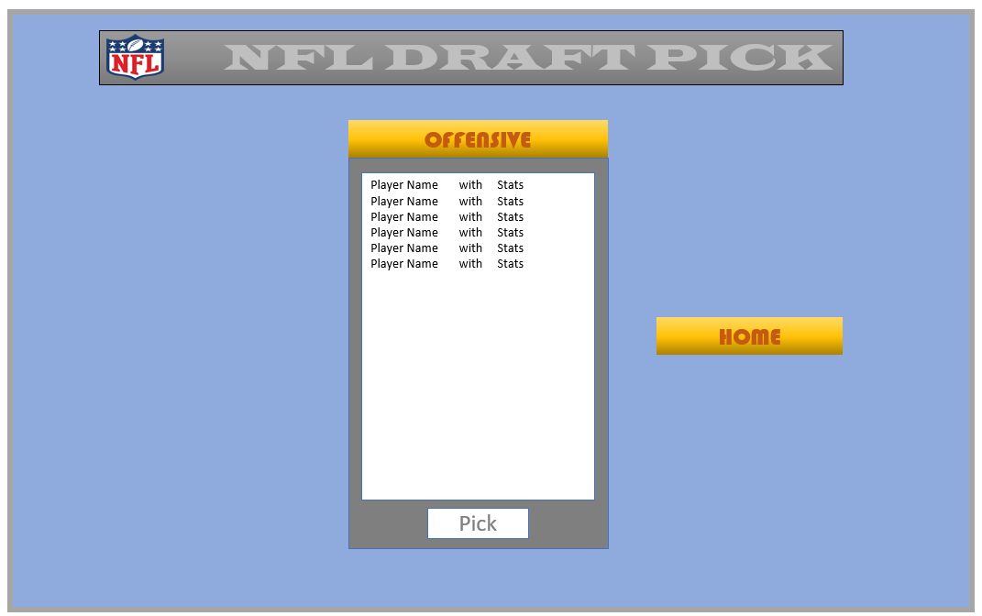

Defensive Screen: : Here I choose a player and pick. If not, I can go back to Home.
