Winpcap环境搭建
本实验采用visual studio 10.0

1.View->Property Manager
Debug|Win32 -> Mircrosoft.Cpp.Win32.user（右键）->Properties
2.设置环境目录：VC++ Directiories -> Include Directories和Library Directories中添加路径。
假如将wpdpack放到c盘。则：
Include Directories:c:\wpdpack\Include;
Library Directories:c:\wpdpack\Lib;
3.Linker（连接器）下的Command Line（命令行）
Additional Options （附加项）中输入：
wpcap.lib ws2_32.lib（注：用空格分隔。）

上述方法可以只设置一次

- 首先建立一个工程networkstack;
文件- 新建 – 项目 – ， 选中 “WIN 32 控制台应用程序”，输入项目名称(networkstack)和指定存储目录（D:\）-在应用程序设置对话框中
应用程序类型选择：WIN 32 控制台应用程序
附加选项：空项目；
添加公共头文件以用于： 不选；
（2）在解决方案标签，增加或产生新文件；
（3） 对环境进行配置
1） 安装WINPCAP.EXE;
2) 将WpdPack_4_1_2.zip解压，拷贝到d:\根目录；
3）在属性管理器标签，点击刚创建的工程文件名，双击“debug|win32”,在弹出的“debug”属性对话框中，双击“VC++目录”，在包含目录，加入WpdPack拷贝的INCLUDE目录路径；在库目录中，加入WpdPack拷贝的LIBARY目录路径；

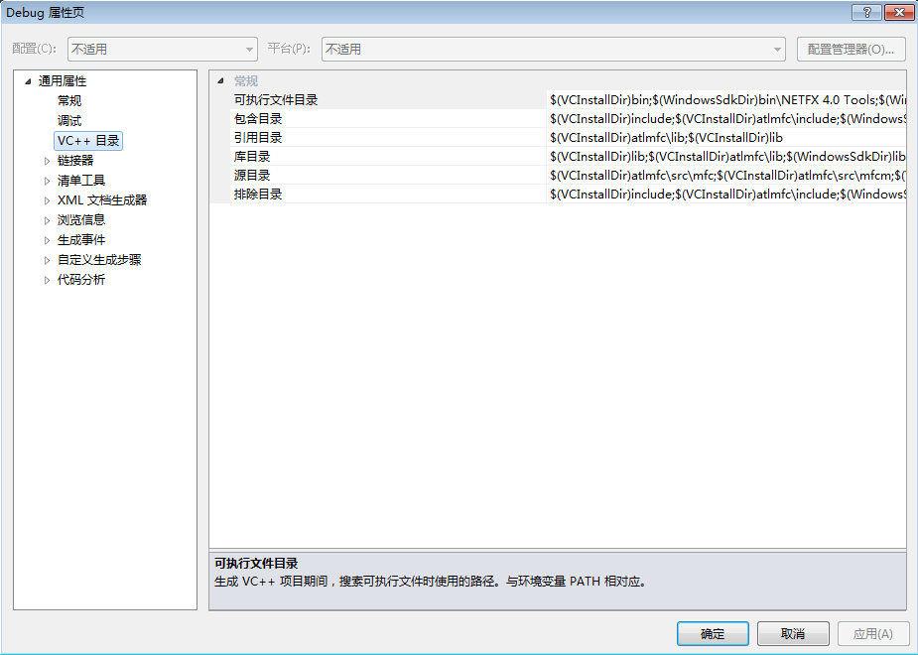

在“debug”属性对话框中，双击“链接器”-“输入”属性，
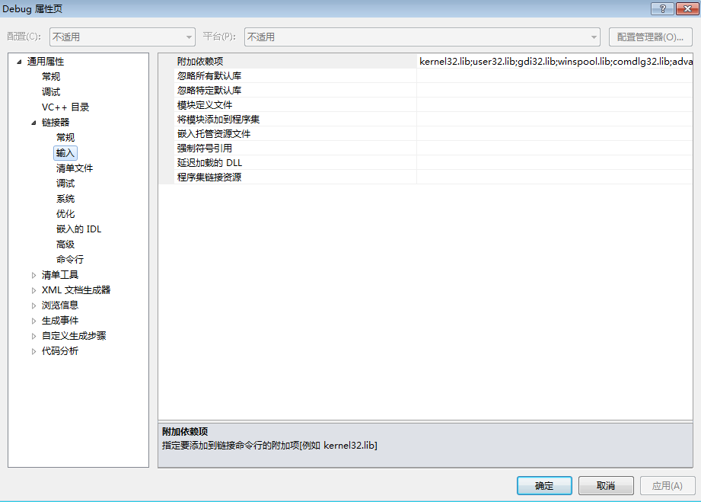
在上图的“附件依赖项”中，加入“wpcap.lib” 和“ws2_32.lib”两个库文件即可。

VC++6.0 环境配置
- 下载Winpcap 安装包;

地址http://www.winpcap.org/install/default.htm。
- http://www.winpcap.org/devel.htm 下载WinPcap developer's pack 包解压，里面有配置好的例子和include library, 以及docs, include, lib, example等文件夹；
- 在VC中设置 include和 library 目录，具体方法是：

打开VC, 点击 “TOOLS- option-directories”, 在include files 中 添加…\wpdpack\include目录（步骤2中得到的目录）， 在 library fillies中添加 …\wpdpack\lib目录；
- 点击“ project-settings-link”, 在object\library modules 中添加wpcap.lib和Packet.lib ws2_32.lib

数据帧发送
- 设计思路：
现有一个字节数组2048字节长，因为数据帧最小64，最大1518，作为数据帧的载体，
然后依次加上以太网数据头，要发送的数据，计算循环冗余码（采用查表法），这样符合数据帧
最后是发送数据帧，打开适配器，选择混杂模式，发送封包。
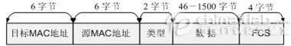

- 代码实现：
#include<stdio.h>
#include<stdlib.h>

#define HAVE_REMOTE
#include<pcap.h>

#pragma warning(disable:4996)
#define ETHERNET_IP 0x0800
#define MAX_SIZE 2048

int size_of_packet = 0;
u_int32_t crc32_table[256];

//ethernet header
struct ethernet_header
{
u_int8_t dest_mac[6];
u_int8_t src_mac[6];
u_int16_t ethernet_type;
};

//generate table
void generate_crc32_table()
{
int i, j;
u_int32_t crc;
for (i = 0; i < 256; i++)
{
crc = i;
for (j = 0; j < 8; j++)
{
if (crc & 1)
crc = (crc >> 1) ^ 0xEDB88320;
else
crc >>= 1;
}
crc32_table[i] = crc;
}
}

u_int32_t calculate_crc(u_int8_t *buffer, int len)
{
int i, j;
u_int32_t crc;
crc = 0xffffffff;
for (i = 0; i < len; i++)
{
crc = (crc >> 8) ^ crc32_table[(crc & 0xFF) ^ buffer[i]];
}
crc ^= 0xffffffff;
return crc;
}

void load_ethernet_header(u_int8_t *buffer)
{
struct ethernet_header *hdr = (struct ethernet_header*)buffer;
int i = 0;
for (i = 0; i < 6; i++)
{
hdr->dest_mac[i] = 0x11;//this is where you can define the mac address
}
for (i = 0; i < 6; i++)
{
hdr->src_mac[i] = 0x22;//source mac address
}
hdr->ethernet_type = ETHERNET_IP;
size_of_packet += sizeof(ethernet_header);
}

int load_ethernet_data(u_int8_t *buffer, FILE *fp)
{
int size_of_data = 0;
char tmp[MAX_SIZE], ch;
while ((ch = fgetc(fp)) != EOF)
{
tmp[size_of_data] = ch;
size_of_data++;
}
if (size_of_data < 46 || size_of_data>1500)
{
printf("Size of data is not satisfied with condition!!!\n");
return -1;
}

u_int32_t crc = calculate_crc((u_int8_t*)tmp, size_of_data);
//printf("%d\n", crc);
int i;
for (i = 0; i < size_of_data; i++)
{
*(buffer + i) = tmp[i];
}
*(u_int32_t*)(buffer + i) = crc;
size_of_packet += size_of_data + 4;
return 1;
}

int main()
{
u_int8_t buffer[MAX_SIZE];//as a carrier of packet
generate_crc32_table();

//generate a packet
size_of_packet = 0;
FILE *fp = fopen("data.txt", "r");
if (load_ethernet_data(buffer + sizeof(ethernet_header), fp) == -1)
{
return -1;
}
load_ethernet_header(buffer);

//send the packet
pcap_t *handle;
char *device;
char error_buffer[PCAP_ERRBUF_SIZE];
device = pcap_lookupdev(error_buffer);
if (device == NULL)
{
printf("%s\n", error_buffer);
return -1;
}
handle = pcap_open_live(device, size_of_packet, PCAP_OPENFLAG_PROMISCUOUS, 1, error_buffer);
if (handle == NULL)
{
printf("Open adapter is failed..\n");
return -1;
}
pcap_sendpacket(handle, (const u_char*)buffer, size_of_packet);;
//printf("%d", *(int*)(buffer + size_of_packet - 4));
pcap_close(handle);
return 0;

}

数据接收
#include<stdio.h>
#include<stdlib.h>

#define HAVE_REMOTE
#include<pcap.h>
#include<WinSock2.h>

#pragma warning(disable:4996)

void ethernet_protocol_packet_callback(u_char *argument, const struct pcap_pkthdr *packet_header, const u_char *packet_content);

//ethernet protocol header format
struct ethernet_header
{
u_int8_t ether_dhost[6];//destination mac
u_int8_t ether_shost[6];//src mac
u_int16_t ether_type;
};

u_int8_t accept_dest_mac[2][6] = { { 0x11, 0x11, 0x11, 0x11, 0x11, 0x11 }, { 0x33, 0x33, 0x33, 0x33, 0x33, 0x33 } };
u_int32_t crc32_table[256];
//generate table
void generate_crc32_table()
{
int i, j;
u_int32_t crc;
for (i = 0; i < 256; i++)
{
crc = i;
for (j = 0; j < 8; j++)
{
if (crc & 1)
crc = (crc >> 1) ^ 0xEDB88320;
else
crc >>= 1;
}
crc32_table[i] = crc;
}
}

u_int32_t calculate_crc(u_int8_t *buffer, int len)
{
int i, j;
u_int32_t crc;
crc = 0xffffffff;
for (i = 0; i < len; i++)
{
crc = (crc >> 8) ^ crc32_table[(crc & 0xFF) ^ buffer[i]];
}
crc ^= 0xffffffff;
return crc;
}

//ethernet protocol analysis
void ethernet_protocol_packet_callback(u_char *argument, const struct pcap_pkthdr *packet_header, const u_char *packet_content)
{
u_short ethernet_type;
struct ethernet_header *ethernet_protocol;
u_char *mac_string;
static int packet_number = 1;
ethernet_protocol = (struct ethernet_header*)packet_content;
int len = packet_header->len;
int i, j;

////check the mac address
////if the packet is sended to my pc or broadcast
int flag = 2;
for (i = 0; i < 2; i++)
{
flag = 2;
for (j = 0; j < 6; j++)
{
if (ethernet_protocol->ether_dhost[j] == accept_dest_mac[i][j])
continue;
else
{
flag = i;
break;
}
}
if (flag != 2)continue;
else
break;
}
if (flag != 2)
{
return;
}
if (i == 0)
{
printf("It's broadcasted.\n");
}
// if the source is acceptable
u_int8_t accept_source_mac[2][6] = { { 0x11, 0x11, 0x11, 0x11, 0x11, 0x11 }, { 0x22, 0x22, 0x22, 0x22, 0x22, 0x22 } };
for (i = 0; i < 2; i++)
{
flag = 1;
for (j = 0; j < 6; j++)
{
if (ethernet_protocol->ether_shost[j] == accept_source_mac[i][j])
continue;
else
{
flag = 0;
break;
}
}
if (flag)
break;
}
if (flag == 0)return;

//see if the data is changed or not
u_int32_t crc = calculate_crc((u_int8_t*)(packet_content + sizeof(ethernet_header)), len - 4 - sizeof(ethernet_header));
if (crc != *((u_int32_t*)(packet_content + len - 4)))
{
printf("The data has been changed.\n");
return;
}

printf("----------------------------\n");
printf("capture %d packet\n", packet_number);
printf("capture time: %d\n", packet_header->ts.tv_sec);
printf("packet length: %d\n", packet_header->len);
printf("-----Ethernet protocol-------\n");

ethernet_type = ethernet_protocol->ether_type;
printf("Ethernet type: %04x\n", ethernet_type);
switch (ethernet_type)
{
case 0x0800:printf("Upper layer protocol: IPV4\n"); break;
case 0x0806:printf("Upper layer protocol: ARP\n"); break;
case 0x8035:printf("Upper layer protocol: RARP\n"); break;
case 0x814c:printf("Upper layer protocol: SNMP\n"); break;
case 0x8137:printf("Upper layer protocol: IPX\n"); break;
case 0x86dd:printf("Upper layer protocol: IPV6\n"); break;
case 0x880b:printf("Upper layer protocol: PPP\n"); break;
default:
break;
}

mac_string = ethernet_protocol->ether_shost;
printf("MAC source address: %02x:%02x:%02x:%02x:%02x:%02x\n", *mac_string, *(mac_string + 1), *(mac_string + 2), *(mac_string + 3),
*(mac_string + 4), *(mac_string + 5));
mac_string = ethernet_protocol->ether_dhost;
printf("MAC destination address: %02x:%02x:%02x:%02x:%02x:%02x\n", *mac_string, *(mac_string + 1), *(mac_string + 2),
*(mac_string + 3), *(mac_string + 4), *(mac_string + 5));

/*if (ethernet_type == 0x0800)
{
ip_protocol_packet_callback(argument, packet_header, packet_content + sizeof(ethernet_header));
}
*/
//show the data;
for (u_int8_t *p = (u_int8_t*)(packet_content + sizeof(ethernet_header)); p != (u_int8_t*)(packet_content + packet_header->len - 4); p++)
{
printf("%c", *p);
}
printf("\n");

printf("----------------------\n");
packet_number++;
}

int main()
{
generate_crc32_table();

pcap_if_t *all_adapters;
pcap_if_t *adapter;
pcap_t *adapter_handle;
char error_buffer[PCAP_ERRBUF_SIZE];

if (pcap_findalldevs_ex(PCAP_SRC_IF_STRING, NULL, &all_adapters, error_buffer) == -1)
{
fprintf(stderr, "Error in findalldevs_ex function: %s\n", error_buffer);
return -1;
}
if (all_adapters == NULL)
{
printf("\nNo adapters found! Make sure WinPcap is installed!!!\n");
return 0;
}

int id = 1;
for (adapter = all_adapters; adapter != NULL; adapter = adapter->next)
{
printf("\n%d.%s\n", id++, adapter->name);
printf("--- %s\n", adapter->description);
}
printf("\n");

int adapter_id;
printf("Enter the adapter id between 1 and %d: ", id - 1);
scanf("%d", &adapter_id);
if (adapter_id<1 || adapter_id>id - 1)
{
printf("\n Adapter id out of range.\n");
pcap_freealldevs(all_adapters);
return -1;
}

adapter = all_adapters;
for (id = 1; id < adapter_id; id++)
{
adapter = adapter->next;
}
adapter_handle = pcap_open(adapter->name, 65535, PCAP_OPENFLAG_PROMISCUOUS, 5, NULL, error_buffer);
if (adapter_handle == NULL)
{
fprintf(stderr, "\n Unable to open adapter: %s\n", adapter->name);
pcap_freealldevs(all_adapters);
return -1;
}

pcap_loop(adapter_handle, NULL, ethernet_protocol_packet_callback, NULL);
pcap_close(adapter_handle);
pcap_freealldevs(all_adapters);
return 0;
}

这个没有考虑大小端的问题。

