>> x=-5:0.01:5;

for C1=-5:5;

for C2=-5:5

y=C1\*exp(-x)+C2\*exp(x);

plot(x,y)

axis([-5 5 -1000 1000])

hold on

end

end

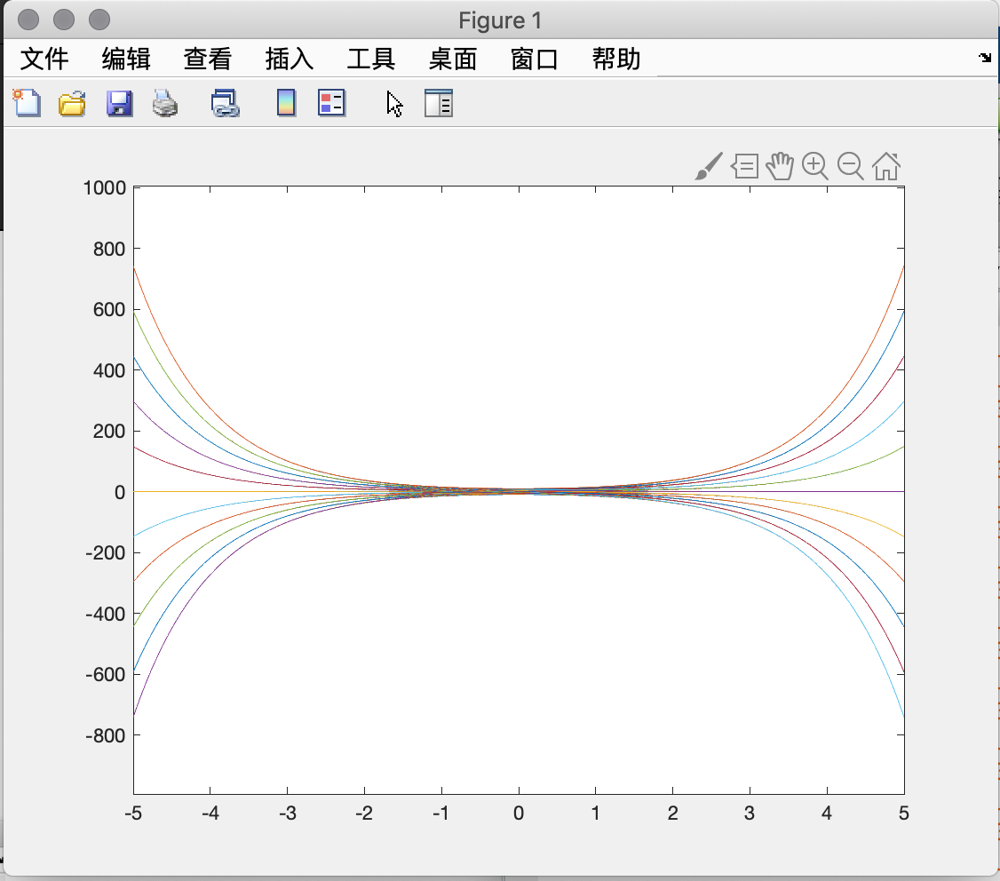

2.

fun.m

function f = fun(x, y)

f = (-1 -x^2\*y\*sin(x))/x;

end

>> x = 1:0.2:4;

>> [x, y] = ode45('fun', [1,4],1);

>> plot(x,y,'ro')

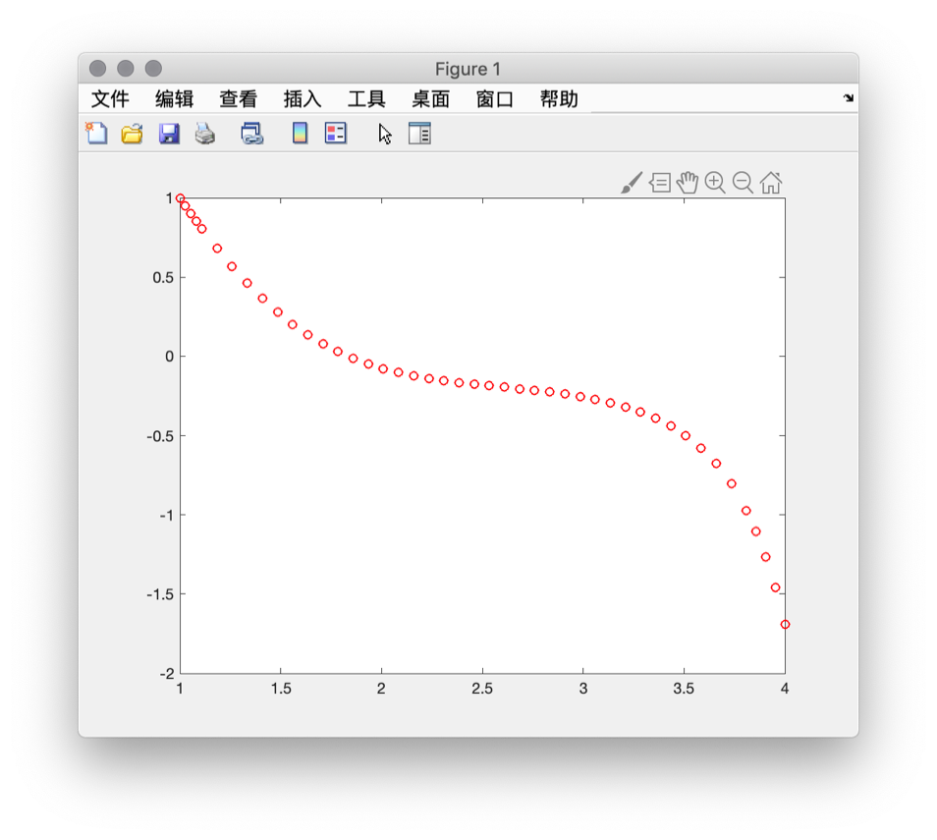

3. [x,y]=meshgrid(-4:0.01:4);

z=(x.^2-y.^2)^1/2;

mesh(x,y,z)

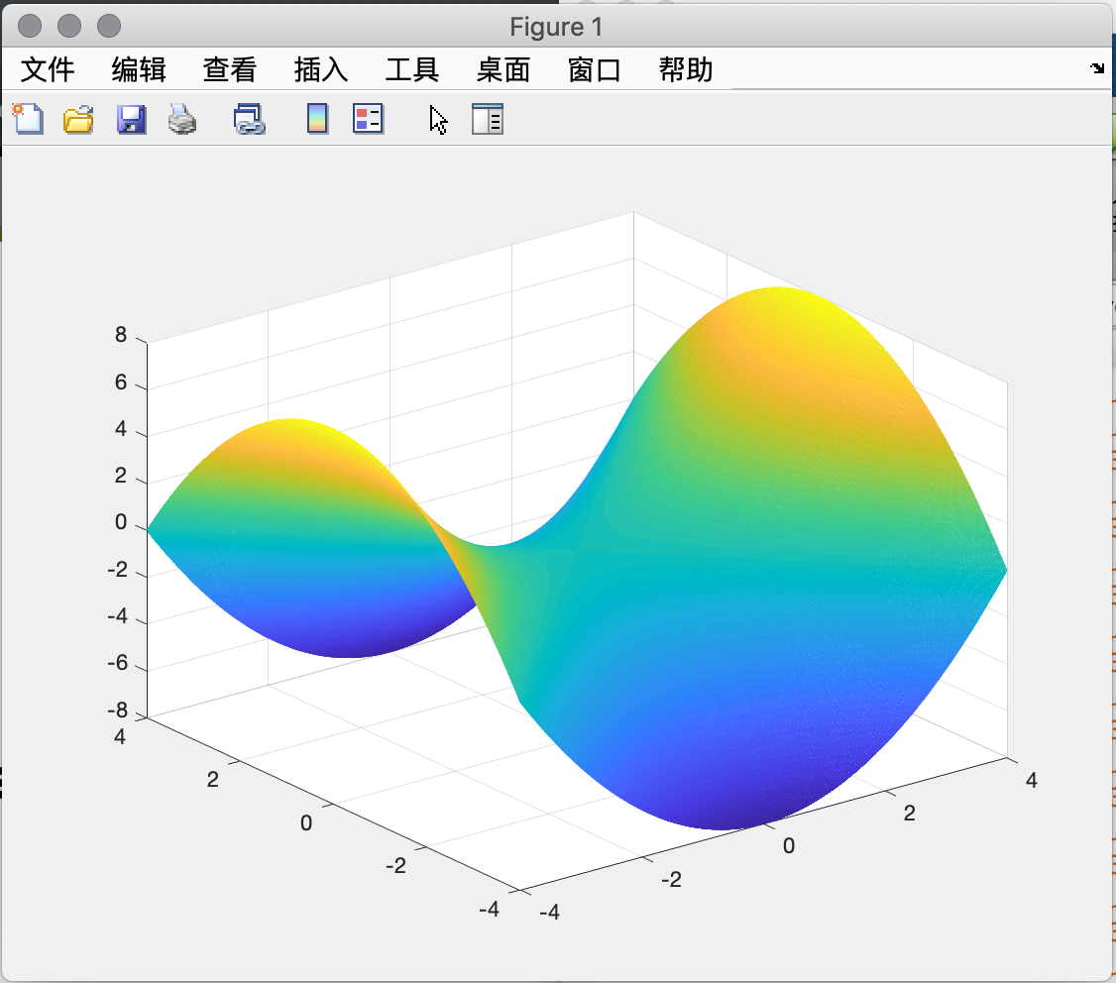

4.

>> a = 2;

>> b = 4;

>> r = 6;

>> u = [a:0.01:b]';

>> v = [0:0.01:2\*pi];

>> x=u\*cos(v);

>> y=u\*sin(v);

>> z = r\*v.\*(u\*0+1);

>> mesh(x, y, z)

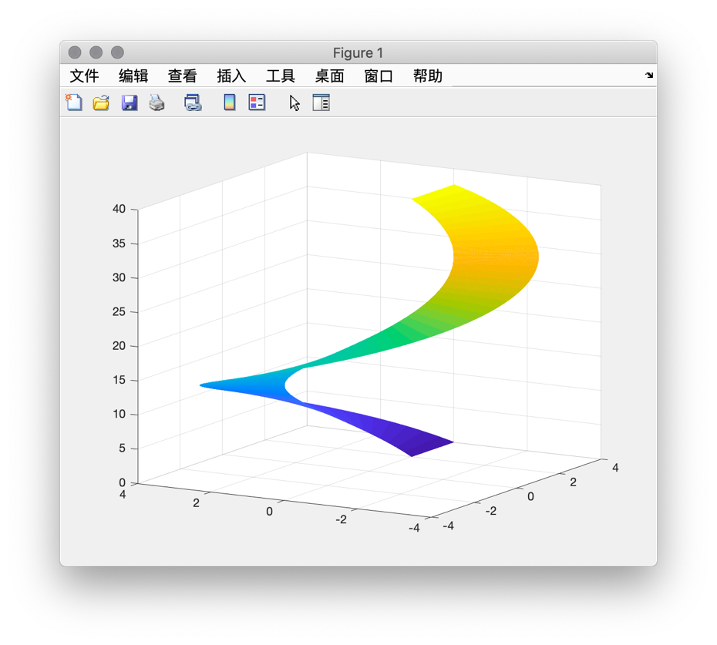

>> a = 1;

>> b = 2;

>> r = 8;

>> u = [a:0.01:b]';

>> v = [0:0.01:2\*pi];

>> x=u\*cos(v);

>> y=u\*sin(v);

>> z = r\*v.\*(u\*0+1);

>> mesh(x, y, z)

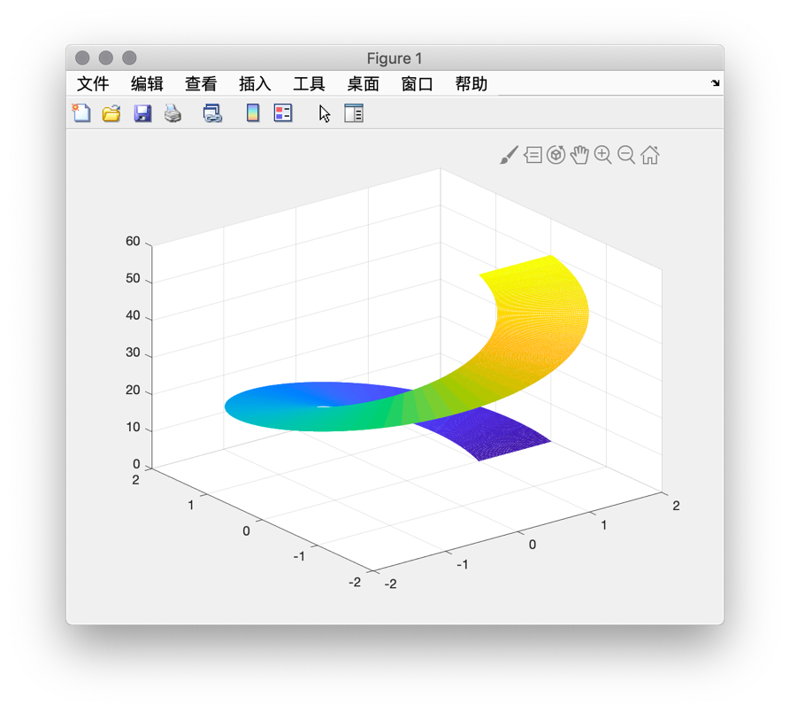

5.

[x,y]=meshgrid(-4:0.01:4);

z=x.^2+y.^2+x\*y;

mesh(x,y,z);

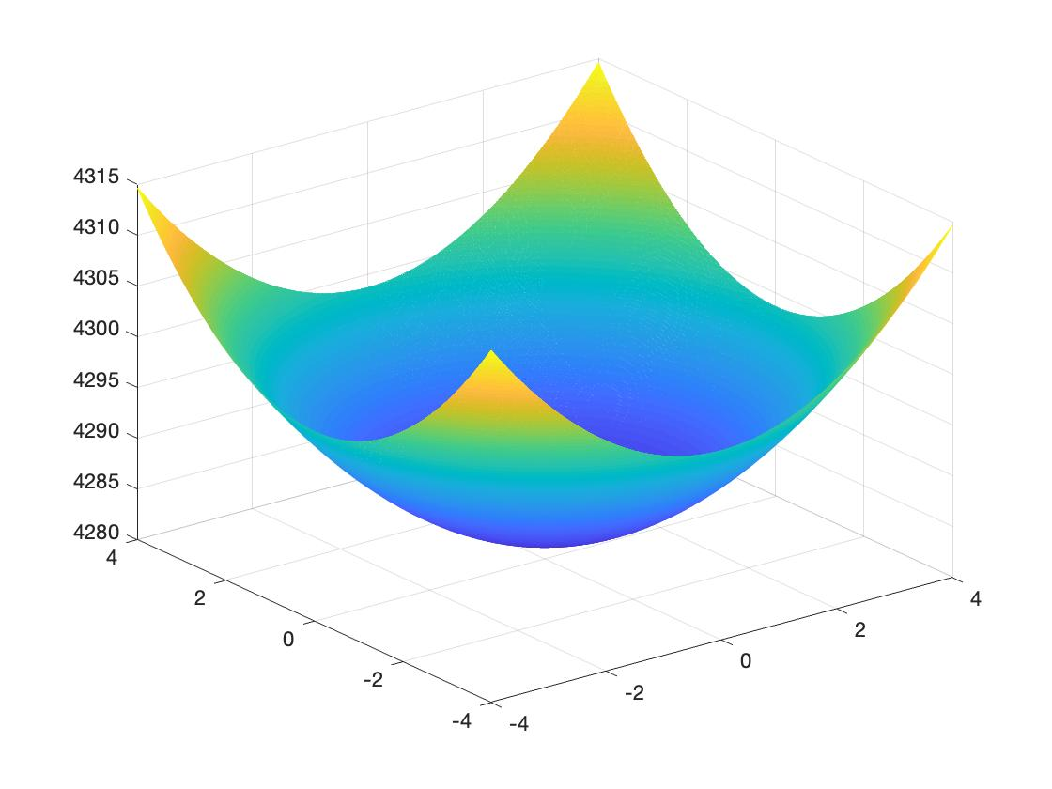

>> [x,y]=meshgrid(-4:0.01:4);

z=x.^2+y.^2-x\*y;

mesh(x,y,z);

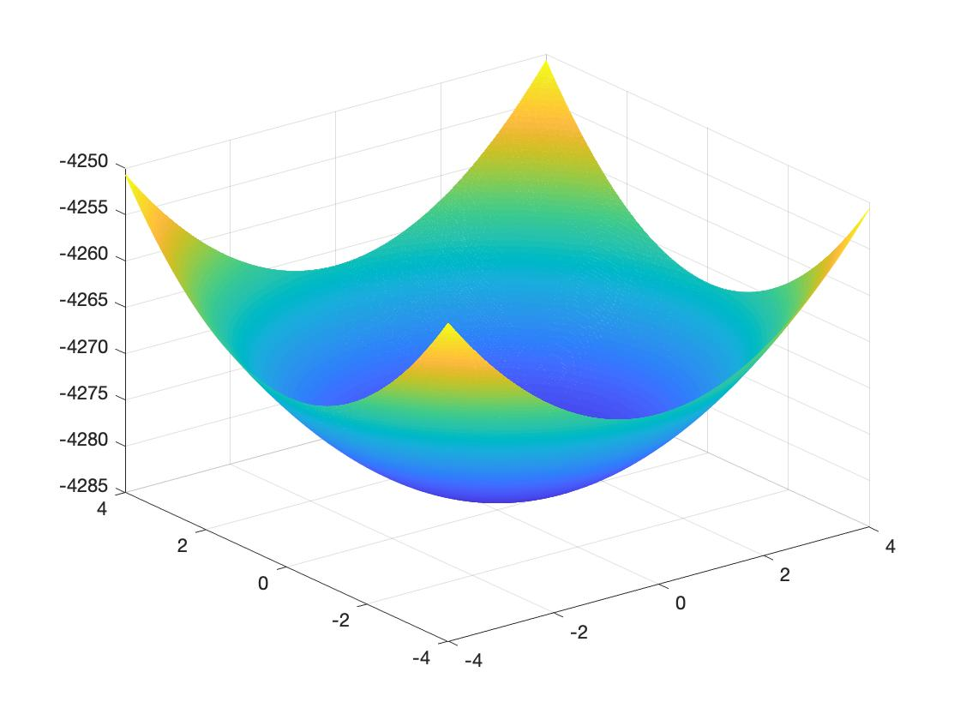

>> [x,y]=meshgrid(-4:0.01:4);

z=x.^2+y.^2+10\*x\*y;

mesh(x,y,z);

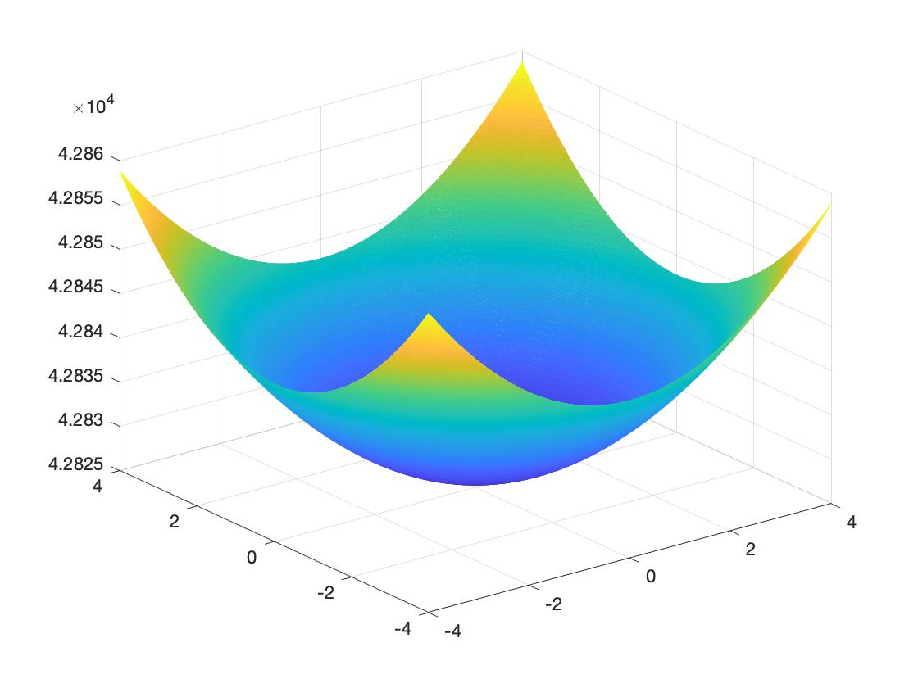

6.

>> syms x y z;

>> f = (x^2 + y^2)^(1/2) - z;

>> u = diff(f,x);

>> v = diff(f,y);

>> x = 1;

>> y = 1;

>> z = 2^(1/2);

>> a = eval(u);

>> b = eval(v);

>> t = -2:0.1:4;

>> x3 = a\*t+1;

>> y3 = b\*t+1;

>> z3 = -t+z;

>> [x,y] = meshgrid(-4:0.1:4);

>> z1 = (x.^2 + y.^2).^(1/2);

>> z2 = a\*(x-1)+b\*(y-1)+z;

>> mesh(x, y, z1)

>> hold on

>> mesh(x, y, z2)

>> hold on

>> plot3(x3, y3, z3)

7.

>> x1 = linspace(-2,2,25);

>> y1 = linspace(-2,2,25);

>> [x, y] = meshgrid(x1, y1);

>> u = x^2 - y^2;

>> mesh(x, y, u)

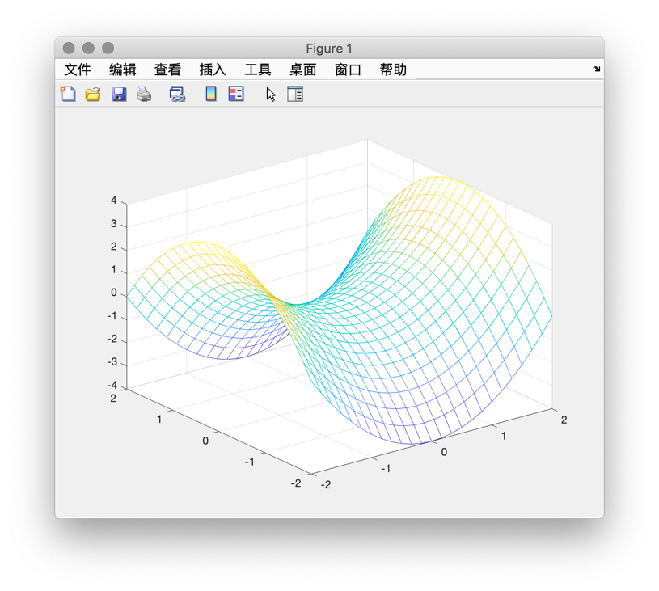

>> h = contour(u);

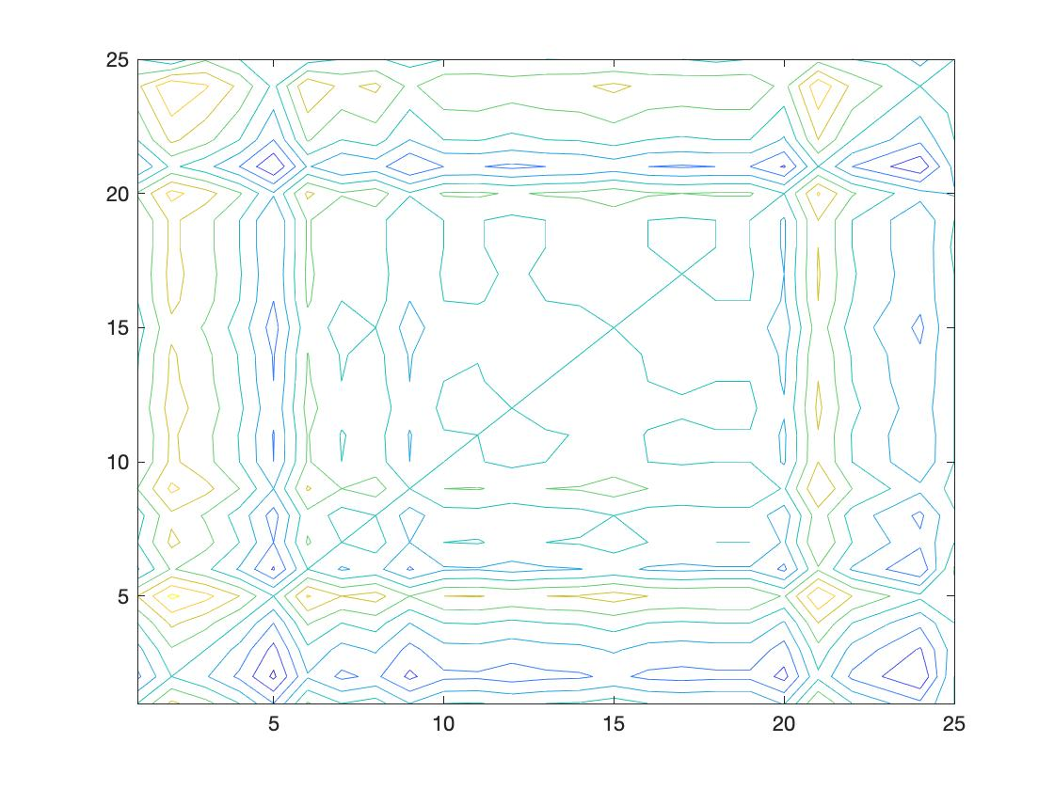

>> v = 2\*x\*y;

>> mesh(x, y, v)

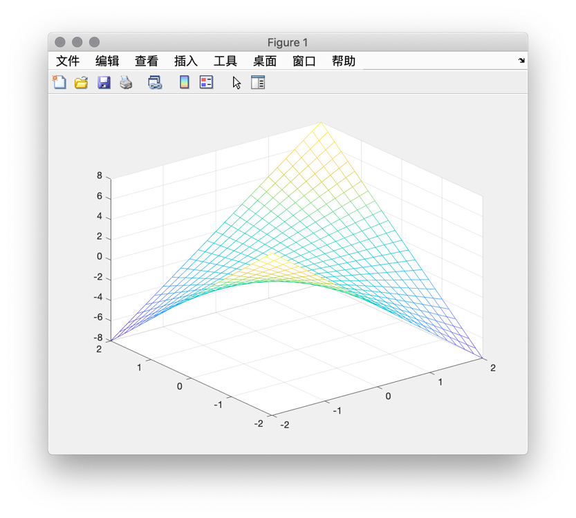

>> h = contour(v);

8.

>> x1=linspace(-2,2,25);

y1=linspace(-2,2,25);

[x,y]=meshgrid(x1,y1);

z=x.^4+8.\*x.\*y+2\*y.^2-3;

h=contour(z);

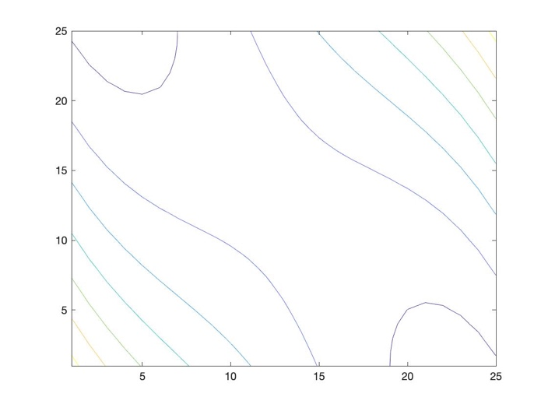

syms x y z;

L=x^4+8\*x\*y+2\*y^2-3-z;

Lx=diff(L,x)

Ly=diff(L,y)

[x,y]=solve('4\*x^3 + 8\*y=0','8\*x + 4\*y=0')

Lx =

4\*x^3 + 8\*y

Ly =

8\*x + 4\*y

x =

0

2

-2

y =

0

-4

4

9.

>> syms x y;

t=4\*int(int(x^2+y^2,y,0,-x+1),x,0,1)

t =

2/3

10.

>> syms r t z;

int(int(int(r^3,z,(1-r^2)^1/2,(4-r^2)^1/2),r,1,2),t,0,2\*pi)

ans =

(45\*pi)/4

11.

>> syms x1 y1 z1 x2 y2 z2;

>> y1=sqrt(1-x1\*x1-z1\*z1);

>> dyx=diff(y1,x1)

dyx =

-x1/(- x1^2 - z1^2 + 1)^(1/2)

>> z2=sqrt(1-x2\*x2-y2\*y2);

>> dzx=diff(z2,x2)

dzx =

-x2/(- x2^2 - y2^2 + 1)^(1/2)

>> int(1\*sqrt(1+1+(-x/(-x^2-x^2+1)^(1/2))^2),x,-sqrt(2/x),sqrt(x)/2)

ans =

int((2 - x^2/(2\*x^2 - 1))^(1/2), x, -2^(1/2)\*(1/x)^(1/2), x^(1/2)/2)

12.

>> syms x z t a r ;

y=sqrt(2\*z-z^2-x^2);

dyx=diff(y,x);

dyz=diff(y,z);

sxz=sqrt(1+dyx^2+dyz^2);

u=r\*cos(t);

v=r\*sin(t)+1;

srt=subs(sxz,[x,z],[u,v])

srt =

(1 - (r^2\*sin(t)^2)/(r^2\*cos(t)^2 + (r\*sin(t) + 1)^2 - 2\*r\*sin(t) - 2) - (r^2\*cos(t)^2)/(r^2\*cos(t)^2 + (r\*sin(t) + 1)^2 - 2\*r\*sin(t) - 2))^(1/2)

>> simplify(srt)

ans =

(-1/(r^2 - 1))^(1/2)

>> int(int(srt\*r,r,sqrt(1-a^2/4),sqrt(1-a^2/16)),t,0,2\*pi)

ans =

pi/(2\*(1/a^2)^(1/2))