RIA POC
PROJECT OVERVIEW
DISCOVERY + DESIGN BRIEF
Reimagining the Registered Investment Advisor experience
Version 0.2 | April 2026
For internal review
[L. Mitchell]
This document is the foundational brief for the RIA POC project. It captures the project purpose, the user we are designing for, the pain points we are addressing, the design principles that will guide our decisions, and the How Might We statements that anchor the work to come.
Additional documents include the Journey Map. This brief is the why.

1.1

Project Purpose
The Registered Investment Advisor (RIA) sits at the intersection of three demanding roles: financial planner, relationship manager, and small business owner. The day is fragmented across multiple disconnected tools, hours of administrative overhead, and a constant tension between scaling a book and staying personally close to every client.
Our project is to design and build a working POC platform that unifies the fragmented RIA tech stack into one seamless workflow — with intelligent assistance layered in where it adds real value, and held back where it shouldn’t. The goal is to lose the operational drag so the advisor can spend their best hours on the work only a human can do: client relationships, judgment, and growth.

THE SHIFT
>> From: a day consumed by prep, follow-up, scheduling, reconciliation, and tool-switching.
>> To: one seamless workflow where the operational baseline runs itself, the advisor engages clients deeply before they ask, and growth becomes systematic instead of reactive.

Time allocation shift
The advisor's day today vs. the advisor's day on platform. Today's day is fragmented across manual admin, tool-switching, and reactive work. On platform: automation and augmentation collapse the operational baseline, returning two kinds of time — open time (for business development, learning, and new client engagement) and enhanced time (the hours they already spend with clients become higher quality, more personal, more prepared).

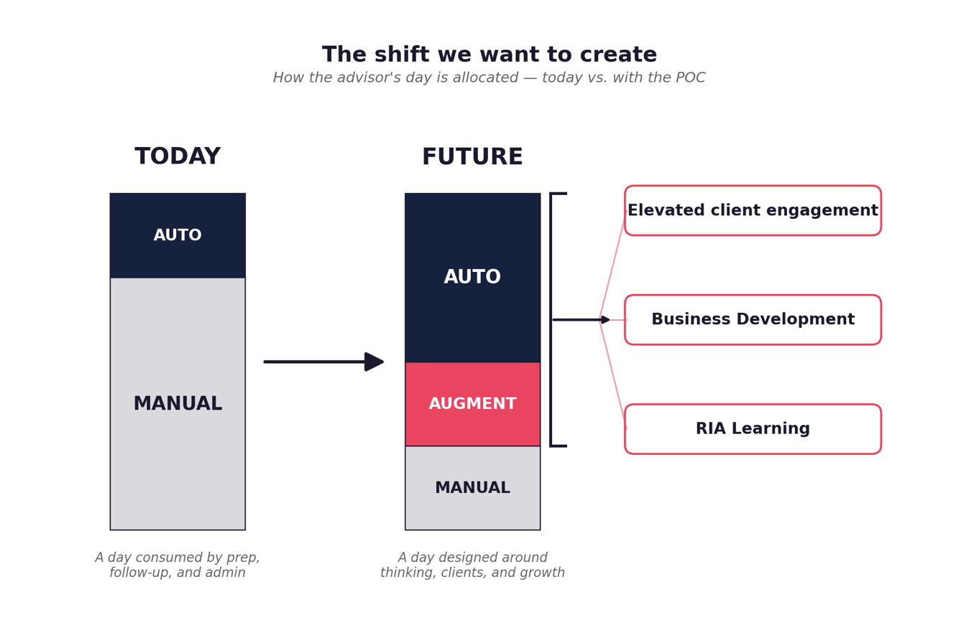

1.2

Project Goals

Primary goals
Five outcomes the POC must deliver to be considered a success — anchored in optimization, quality time, and quality service.
- Create a seamless, one-stop experience — one workflow, one interface, one place where the work lives. Firms that reduce friction win assets.
- Give time back to the advisor — lighten the administrative load (meeting prep, follow-up, note-taking, scheduling, drafting) so hours return to the highest-value work.
- Engage clients before they ask — help the advisor show up prepared, personal, and proactive. Deepen the relationship by anticipating rather than reacting.
- Make growth systematic — turn business development, referral timing, pipeline re-engagement, and practice health into repeatable motions instead of reactive bursts.
- Bring transparency to onboarding — make the multi-week handoff between client, advisor, and custodian visible to everyone, reducing the peak-anxiety window during transfers.

Secondary goals
Outcomes that elevate the platform from useful to differentiated.
- Make the advisor a better advisor — embed learning and skill-building into the daily workflow so junior-to-senior advisors continuously level up on portfolio insight, client communication, and compliance.
- Generate insight, not just data — give the advisor X-ray and MRI views of clients and portfolios. Actionable, anticipatory, and clear — not another PDF report.
- Adapt to the user — RIA firms and the individuals inside them are not alike. The interface should feel custom, dynamic, and personal — shifting with the user’s behavior, priorities, time of day, and schedule rather than presenting a static dashboard to everyone.

1.3

Who We Are Designing For

The RIA — primary user
A Registered Investment Advisor serving the mass affluent segment ($500K–$2M AUM per household). RIAs are fiduciaries — legally bound to act in the client’s best interest — and typically run boutique practices with lean teams managing 80–150 client households across financial planning, portfolio management, tax strategy, business development, and life event response.
The profession skews older than the market it serves. The median RIA is in their mid-to-late 50s; younger advisors (30s–40s) are the fastest-growing cohort but still a minority. Most are fee-only; many are solo or two-to-three-person shops. They are independent by temperament as well as by structure — they left wirehouse or broker-dealer environments to own their book and their standards. What they do for clients spans well beyond investment management: retirement planning, tax optimization, estate coordination with attorneys, cash flow planning, insurance review, family and generational planning, and often the role of chief financial confidant for the whole household.

Three roles, one person
Every RIA is simultaneously playing three roles. The platform must serve all three without forcing the advisor to context-switch between disconnected tools.
Financial planner  Builds plans, models scenarios, allocates portfolios, manages tax strategy. Wants depth and accuracy. | What they share  Time scarcity. Pressure to scale without losing the personal relationship that defines their value. And — behind both — deep reliance on access to data. The messiness of today’s tech stack comes down to this: the data an advisor needs is scattered across custodians, planning tools, CRMs, and spreadsheets, and just getting to it (and trusting it) is most of the work.
Relationship manager
Holds client trust, navigates emotional moments, communicates clearly. Wants context and warmth.
Small business owner
Runs P&L, hires a lean team, drives growth, handles business development and client prospecting, manages compliance, plans succession. Wants leverage and visibility.

The landscape shaping their behavior
The RIA space is not static. Six forces are actively reshaping how RIAs operate, what tools they use, and what they expect as baseline necessities.
- Lean teams are the norm. Most RIAs operate with small staff — founder plus one or two associates. Every new tool or workflow has to pay its way in time and budget saved, not headcount added.
- Acquisition and consolidation are reshaping the industry. Roll-ups, aggregators, and succession-driven acquisitions are changing who RIAs compete with, who they answer to, and what they need from their tech stack.
- Tech-stack fatigue is real. Advisors are tired of assembling their own patchwork of CRM, planning, reporting, and custodial tools and hoping the integrations hold. They want a unified experience, not another vendor — and a break from constantly switching between logins and password books.
- Client book segmentation is going mainstream. RIAs are grouping clients into service tiers so they can leverage junior staff, technology, and scalable touchpoints for the right segments — while preserving white-glove attention where it matters.
- Integrated advice is the direction of travel. Tax planning, investment management, estate, and family-level planning are converging into one conversation with the client. The platform needs to support this convergence, not reinforce silos.
- AI is an accepted tool in the practice. Advisors have moved past the “is this okay?” phase for operational AI — scheduling, note-taking, drafting, meeting summaries, document intelligence. The question is no longer whether AI belongs in the workflow, but which surfaces it earns.

How RIAs view intelligent automation
In our research, RIAs consistently describe AI as central to where the practice is going — but only with clear guardrails. The platform needs to respect those guardrails, not push past them.
Trusted for  • Ingesting and interpreting data from fragmented sources  • X-ray and MRI views of client situations and portfolios  • Actionable insight and anticipation — what changed, what matters  • Predictive analysis and early signal detection  • Summarization, drafting, and prep work  • Scheduling, in-meeting note-taking, follow-up email drafts, reminders  • Document and form intelligence  • Signaling opportunities for internal learning or client growth, and flagging risk | Not trusted for (yet)  • Giving clients direct advice  • Estate planning recommendations  • High-risk or irreversible portfolio decisions  • Anything that replaces the fiduciary judgment the advisor is paid for  • Actions the advisor has not explicitly approved

Spectrum of user maturity
The platform must serve a range from solo junior advisor to senior principal at a multi-advisor firm. This affects autonomy preferences, learning needs, and dashboard configuration.
- Junior advisor (0–3 yrs): still learning the craft. Needs scaffolding, talking points, and embedded education. Lower trust threshold for automation — wants to see the work shown.
- Mid-career advisor (3–10 yrs): running a partial book under a senior. Wants leverage to take on more clients without sacrificing quality. Most receptive to automation.
- Senior advisor / principal (10+ yrs): running their own book and the practice. Wants insight, business intelligence, and time back for high-stakes client work and growth.

The client — secondary user
Mass affluent households ($500K–$2M investable). Often a working professional approaching retirement, a recent inheritor, or a successful business owner. Financially literate but not specialized — they want clarity, transparency, and a relationship that feels personal even as the underlying work becomes more automated.
The client experience is in scope because the advisor’s product IS the relationship. Any automation we add must make human moments better, not rarer.

1.4

Pain Points We Are Addressing
Pain points cluster into five categories. Each represents a place where current tools and workflows actively work against the advisor — costing hours, weakening relationships, or risking the practice itself.
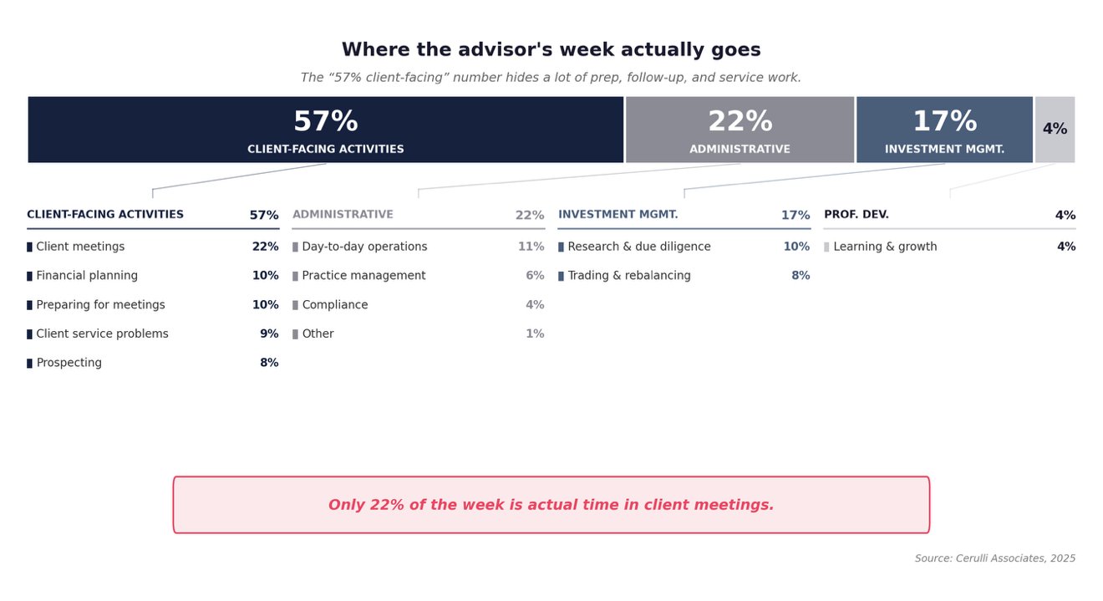

ADMINISTRATIVE DRAG
Meeting prep is often 3+ hours per client per quarter — directionally the single biggest time drain in the practice.
Note-taking and CRM upkeep happens after-hours, often days late, eroding fidelity of the record.
Email drafting, follow-up, and scheduling consume the most cognitively expensive hours of the day.
Briefings and post-meeting actions are inconsistent — important commitments slip through.
Business administration (new client onboarding, billing, HR) competes for the same hours as client work and almost always loses.

TOOL FRAGMENTATION & INTEGRATION FATIGUE
Salesforce, Redtail, Wealthbox, planning software, custodian portals, and document management systems do not share data natively.
The same client information is entered 3–5 times across tools, with reconciliation errors common.
Advisors are exhausted from building and maintaining their own tech stack and integrations.
Switching between tools breaks focus and adds 30–60 minutes per workflow.
Multiple logins, the hidden cost of middleware like Zapier, and the creeping need to hire someone just to manage the IT of the tools themselves all compound the drag.

ONBOARDING FRICTION
Account transfers take 10–30 days. Days 10–20 are peak client anxiety and peak advisor inactivity.
Discovery is treated as a one-time event, but information surfaces continuously over the first 90 days.
Document collection is repetitive and embarrassing for the client (asked for the same forms multiple times).
Lack of transparency for both sides — neither knows where things stand on a given day.
Client latency (delays on the client’s side — finding docs, returning signatures) compounds the timeline, and certain custodians simply don’t play well with others. Transfer length varies widely by account type and institution combination.

LOTS OF DATA, LITTLE INSIGHT
Portfolio data, market data, and client data live in silos — no single layer synthesizes them.
Advisors spend hours pulling reports and almost no time interpreting them for clients.
Drift, rebalancing rationale, and plan updates are communicated in dense PDFs the client rarely reads. Quarterly reports are becoming a relic; clients increasingly want real-time inferences, activities, and portfolio impact.
No systematic way to detect the multiple types of life events that matter — from external signals, behavioral changes, or family and custodial connectors.
Unique signals for opportunities and risks are largely un-surfaced; the platform should make them easier to find and predict.
Opportunities to upskill the RIA — client-engagement craft, knowledge base, and advice — are invisible today.

BUSINESS DEVELOPMENT & RETENTION STARVE
BD work loses to client delivery every week — the urgent crowds out the important.
Referral asks are mostly unsystematic — most advisors miss the moment of peak client satisfaction.
Quiet clients (60+ days no contact, AUM at risk) are detected too late.

1.5

How Might We
Four broad How Might We statements anchor the design work. Each is intentionally wide — and draws on the tools, features, and signals surfaced from early research and documentation. As we move into design principles and UX work, each statement will spawn multiple feature concepts.
01 | How might we lose the operational drag so that both open time and enhanced time return to the RIA — open time for business development, learning, and growth; enhanced time for deeper, more effective, more proactive client engagement?

02 | How might we unify the fragmented advisor tool stack into one seamless workflow that is dynamic and shifting in nature — feeling like the right fit for the RIA using it, neither too overwhelming nor too limited?

03 | How might we give the RIA X-ray clarity on clients and portfolios — with actionable insight, anticipation, and best next steps — while keeping the choice of action and the advice firmly in the advisor’s hands?

04 | How might we make the RIA’s own practice — book, business development, client acquisition, skill development, professional development, business health, and growth — as systematic as the client work it supports?

1.6

Design Principles
Principles that will guide every design and product decision. When we have a tradeoff, these are the tiebreakers.
1. The RIA is in control
The advisor is always the conductor. The platform suggests, drafts, prepares, and flags — but the advisor decides, approves, and acts. Every advisor can set their own autonomy boundaries: information-only, recommend-with-approval, or more. The human is the source of judgment, taste, and relationship.

2. Transparency over magic
Show sources. Show rationale. Show the work. The advisor should always be able to see why the system suggested what it suggested. Black boxes erode trust quickly in a fiduciary context — especially when the suggestion touches anything advice-adjacent.

3. Seamless, not intrusive
The platform enhances the work, it doesn’t get in the way. It fades into the background when not needed and surfaces with precision when it is. One workflow, one interface, no jarring hand-offs between disconnected tools.

4. Quality over quantity
Fewer, better-reasoned signals beat a flood of notifications. A system that alerts on everything trains the advisor to ignore it. The platform earns attention by deserving it — and stays silent when there is nothing useful to say.
The same principle applies to feature surface area: too many options are overwhelming, and ultimately do the opposite of what we set out to do.

5. The human relationship is the product
Intelligent automation exists to deepen human moments, not substitute for them. The advisor’s relationship with the client is what the practice sells. The platform should amplify that — never insert itself between them.

1.7

What Success Looks Like
The POC is a working prototype, not a shipped product. Success is measured in clarity of vision and proof of value — not user counts or revenue.

For the advisor
- Time reclaimed: demonstrable reduction in time spent on the top three administrative tasks (meeting prep, follow-up, note-taking).
- Confidence in the system: advisors trust the platform’s outputs enough to act on them — meaning rationale, sources, and edit paths are clear, and guardrails are visible.
- Better client moments: advisors report walking into client meetings more prepared and more personal than before.
- Visible practice health: advisors can see their own pipeline, capacity, and revenue health without asking ops.
- Continuous learning embedded: advisors report leveling up their craft — client communication, portfolio insight, compliance — through day-to-day use of the platform, not only external training. The tool makes the RIA, and the practice, better.

For the client
- Smoother onboarding: transfers feel guided, not silent. The client knows what is happening and what to expect at every step.
- Personalized engagement: communications reference the client’s actual life — not generic market commentary.
- Understandable plan: plan changes and portfolio rationale are delivered in formats the client can actually absorb.

For the project
- A working prototype: real, demoable, functioning — built on the engineering scaffold, redesigned for human use.
- A repeatable design language: patterns that can extend into Phase II features.
- A coherent UX intent: clear about what the tool is, how it is used, and low-friction to adopt.

