Adaptive Gold/Silver-Bitcoin Hedging Strategy

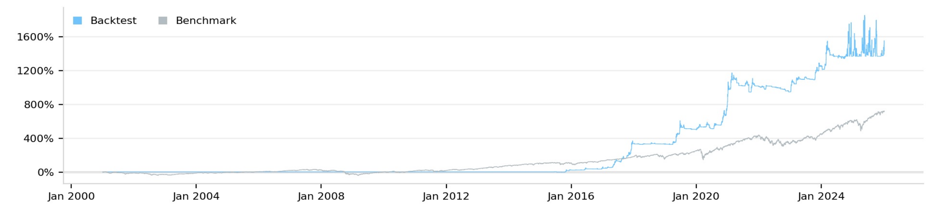

Overview
This strategy exploits the time-varying correlation between precious metals (Gold, Silver) and Bitcoin to generate alpha through adaptive position sizing. The core insight is that Gold-BTC correlation fluctuates significantly across market regimes (ranging from -0.10 to +0.50), and precious metals can serve as a leading indicator for Bitcoin corrections during periods of elevated correlation.

Market Phase Detection
The strategy dynamically classifies Bitcoin into six distinct market phases using multi-dimensional technical indicators:
Phase | Characteristics | Position Approach
Accumulation | Low volatility (<50%), narrow range | High metals weight (60%), moderate position
Early Bull | 20-100% 90-day gains, breaking above MAs | Balanced signals, increased position (70%)
Explosive Bull | >100% 90-day gains, vol >80% | Ignore metals signal, momentum-only (40% cap)
Distribution | High-level consolidation, slowing gains | Defensive, reduced position (30%)
Bear Market | Sustained decline below MAs | Minimal exposure (20%)
Capitulation | Extreme decline >50%, panic selling | Contrarian accumulation (60%)
Phase detection uses: 90-day returns, 30-day annualized volatility, price vs. MA(20/60/120), and drawdown from 120-day high. A 3-day confirmation filter prevents whipsawing between phases.

Signal Generation
- Precious Metals Signal (-1 to +1): Combines 5-day and 20-day returns of Gold and Silver, normalized by typical move magnitudes.
- Momentum Signal (-1 to +1): Combines BTC 5-day return, 20-day return, and price relative to MA(20).
- Composite Signal: Signal = (Metals × Correlation_Factor × Phase_Metals_Weight) + (Momentum × Phase_Momentum_Weight)

Position Sizing & Risk Management
Position sizing incorporates:
- Volatility adjustment: Position scaled by (Vol_Ceiling / Actual_Vol) when volatility exceeds phase threshold
- Breakout modifier: +30% for upside breakouts, -50% for downside breakouts
- VIX filter: Reduced exposure during high VIX (>25), contrarian during extreme VIX (>35)
Risk controls:
- Fixed Stop Loss: Exit at -15% from entry price
- Trailing Stop: Exit if price falls 10% from high after achieving +20% gain
- Precious Metals Warning: Position capped at 30% when metals signal < -0.6
- Phase Limits: Explosive bull phase hard-capped at 40% regardless of signal strength

Rationale
Historical analysis (2014-2024) reveals that Gold-BTC correlation is weak on average (~0.10) but exhibits regime-dependent behavior. During macro risk events (COVID crash, banking crises), correlation spikes to 0.40-0.50 and precious metals lead BTC by 1-2 days. During explosive bull markets (2017, 2020-21), correlation approaches zero as crypto-specific factors dominate. By adapting strategy parameters to detected market phase, we capture the predictive value of precious metals when it exists while avoiding false signals during crypto-driven rallies.

