Modeling Agent
User Guide
Building master-data files for Critical Manufacturing (CMF)
For business users — no technical knowledge required
FabOrchestrator.AI · Version 1.0

Contents

1. What the Modeling Agent does
The Modeling Agent is a chatbot that helps you build a master-data Excel file for CMF (Critical Manufacturing) — without knowing which sheet, which column, or which format CMF expects.
You describe what you want in plain English. The agent finds the right CMF object, tells you which fields are required, writes your data into a correctly-structured Excel file, and gives you a Download button.

The one thing to remember
Important: The chat PREPARES the file. It never loads anything into CMF. When your file is ready, you take it to the Master data loader (in the left sidebar) to actually load it into the MES. This means you can experiment freely in the chat — nothing you type there changes CMF.

What you can do
- Get an empty template to fill in offline (in Excel).
- Have the agent type your data straight into the file.
- Fill data in a small form inside the chat.
- Upload a file you already started and add more rows to it.
- Add a completely different object to a file that already has data — both are kept.
- Look up what already exists in CMF.

2. Before you start

Getting access
The Modeling Agent must be switched on for your role. If you open it and see “Modeling Agent isn’t enabled for your role”, ask an administrator to enable it:
- Fab Admin App → Roles → pick your role → General tab → tick “Modeling Agent” → Save.
Note: You must also be connected to the company VPN. The agent reads live information from CMF (which fields are required, what already exists). Without the VPN some answers will fail — see Troubleshooting.

Opening it
- Sign in to FabOrchestrator.AI.
- On the home screen, find the card “Modeling Agent” (Agent · 03).
- Click it. The chat opens.
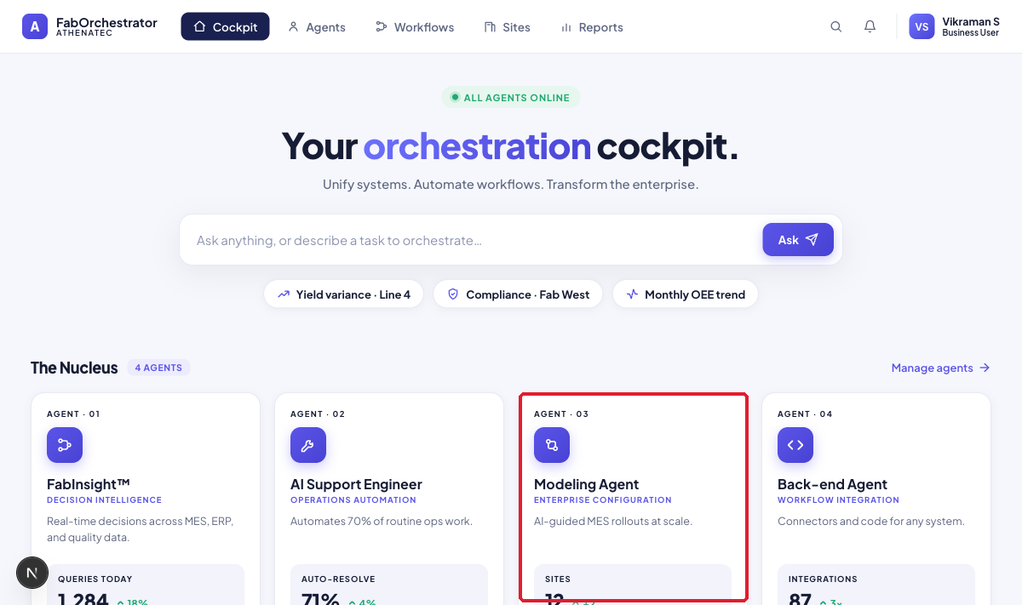
Figure 1 — The Modeling Agent card on the home cockpit.

The screen
Item | What it does
New chat | Starts a fresh conversation. Your old ones stay in the list below.
Projects | Your workspace projects (shared with the rest of FabOrchestrator).
Master data loader | Opens the 4-step wizard that actually loads a file into CMF.
Previous chats | Every conversation you’ve had, so you can pick up where you left off.
Message box | Where you type. You can also attach an Excel file with the + button.  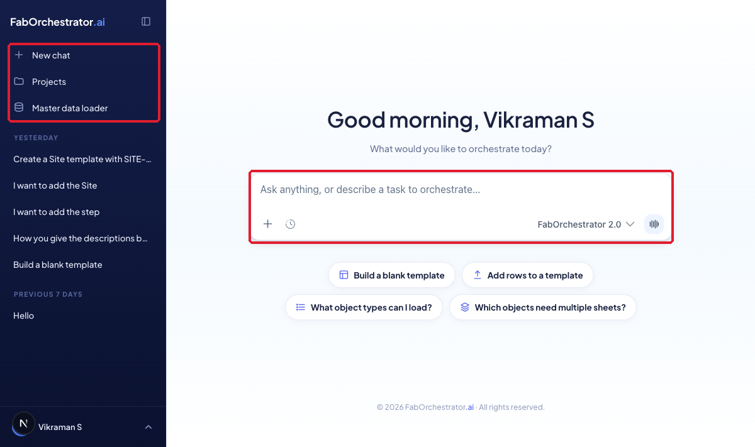  Figure 2 — The Modeling Agent chat: sidebar on the left, suggestions in the middle.

3. The words the agent will ask you
Almost every conversation includes one question. It is worth understanding it once:
“Do you want the Site template only, or the Full template?”
Your answer | What you get
<Object> template only | A file containing just the sheet(s) for that one object. Cleaner and easier to fill in.
Full template | The whole master layout, so you can add other objects to the same file later.
Tip: If you are only loading one thing, choose “<Object> template only”. If you plan to build up one big file covering several objects, choose “Full template”.

4. Scenarios — how to do each task
These examples use data that really exists in your CMF system today, so you can type them exactly as written.

4.1 Get an empty template to fill in offline
What you’ll get: an empty, correctly-structured Site file you can fill in yourself in Excel. Two messages.
Use this when you would rather type the data yourself in Excel.
Step 1 — Type this:
Build a Site template
What you get back:
The agent confirms the object is Site and that it is a single sheet, lists the columns it contains (Name, Description, Enterprise, IsRemote, IsTemplate), and then asks you one question: do you want the Site template only, or the Full template?
Step 2 — Answer that question:
Site template only
What you get back:
A confirmation that Site_Site_template.xlsx is ready and passed validation, and a Download tile at the bottom of the reply. The sheet has the correct headers and no rows.
Click Download, open the file in Excel, type your rows, and then go to Master data loader to load it into CMF.
Tip: Site template only gives you just the Site sheet. Choose Full template instead if you plan to add other objects to the same file later.

4.2 Let the agent type your data into the file
What you’ll get: a Site template with your row already filled in. Two messages.
This is the fastest route. Put your values straight into your first message and the agent writes them into the file for you.
Step 1 — Type this:
Create a Site template with SITE-A description Plant A
What you get back:
The agent confirms Site is a single-sheet object, tells you it will write your two values (Name = SITE-A, Description = Plant A) and leave the remaining columns blank for you to complete offline, and then asks the same one question: Site template only, or Full template?
Step 2 — Answer that question:
Site template only
What you get back — each part of the reply explained:
You’ll see | What it means
✅ Site_Site_template.xlsx ready — validation passed | Your file is built and has been checked against the template.
📄 Site: 1 row added — SITE-A | Your data went in, in the right sheet and the right columns.
⚠ Still to fill in offline (required) | IsRemote and IsTemplate are mandatory but still empty. You must complete them before the file will load.
⚠ Parent references are not verified here | If you fill in the Enterprise column, that Enterprise must already exist in CMF — the chat does not check this for you.
A Download tile at the bottom | Click it to save the file.

The agent then offers to fill in the two missing columns for you right here in the chat, rather than in Excel. That is the next scenario.
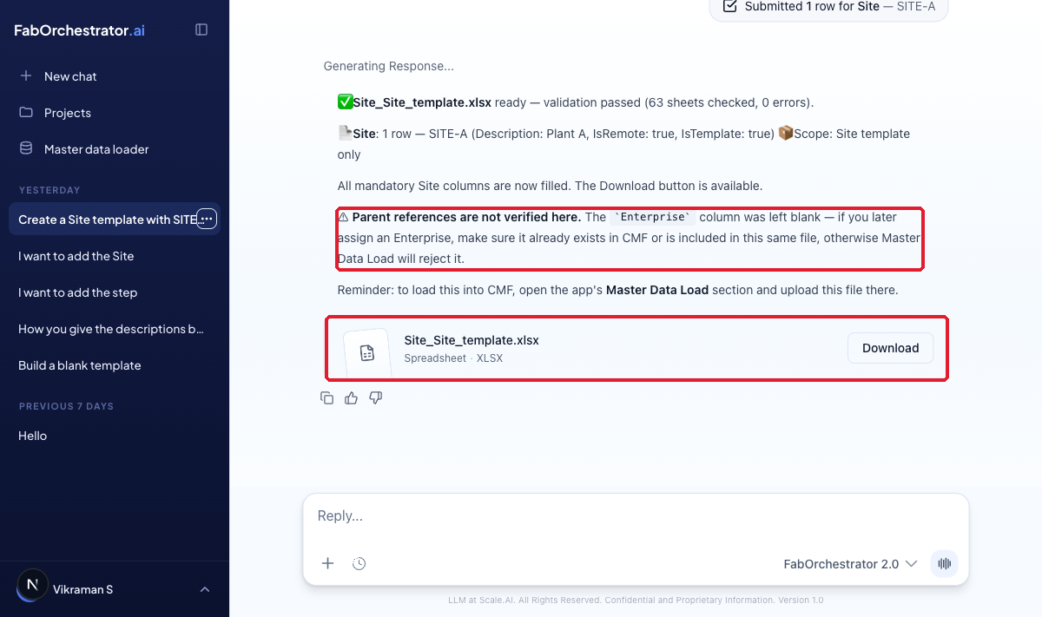
Figure 3 — A finished reply: what was written, what is still missing, and the Download button.
Tip: You do not have to name the columns. “description Plant A” is enough — the agent works out that Plant A belongs in the Description column.

4.3 Fill the data in a form inside the chat
What you’ll get: the missing columns filled in without leaving the chat, and a fresh file. One click plus one Submit.
At the end of 4.2 the agent asked whether you want to fill in the missing columns here or offline. This scenario answers it.
Step 3 — Type this:
Yes, fill it in the form here
What you get back:
A small form opens in the chat, already pre-filled with what you typed earlier (SITE-A / Plant A). The agent tells you which boxes still need values — IsRemote and IsTemplate — and mentions they are Bit fields, so use 0 or 1.
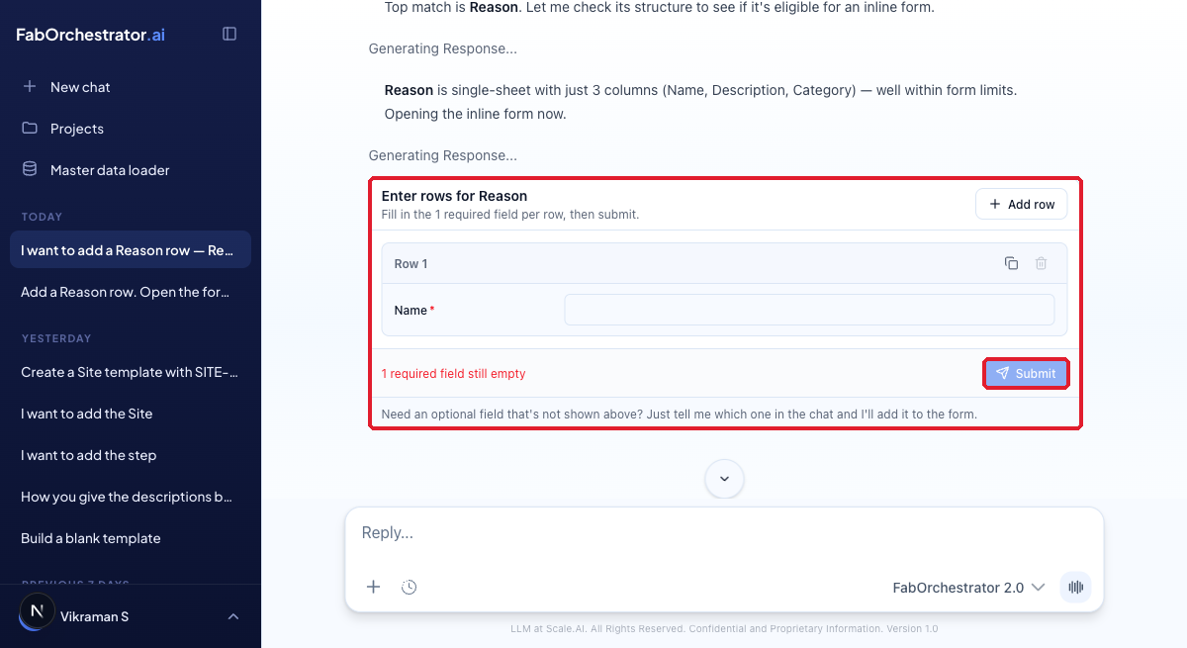
Figure 4 — The inline form for a small object (Reason): one box per column, required fields marked, Submit locked until they are filled.
Step 4 — Fill the empty boxes and click Submit.
What you get back:
You’ll see | What it means
✅ Site_Site_template.xlsx ready — validation passed | The file has been rebuilt with the form values included.
📄 Site: 1 row — SITE-A (Description: Plant A, IsRemote: true, IsTemplate: true) | One row, not two — the form values merged into the row you started in 4.2.
All mandatory Site columns are now filled | Nothing left to do offline.
⚠ Parent references are not verified here | Still shown, because you left Enterprise blank. It applies whenever that column is involved.
A new Download tile | Use this newer one — it is the complete file.

Tip: The form is only offered for small, single-sheet objects (fewer than 11 columns) — Site, Reason, Enterprise, Service and Facility. Bigger objects such as Area, Material or Resource are filled from the message box or offline instead. The agent offers the form; it never opens on its own.

4.4 Finish over several messages
What you’ll get: one row, built up across several messages — not one row per message.
You do not have to give everything at once. Give what you know, then add the rest later in the conversation. The agent keeps track and merges it all into the same row.
Message 1 — Type this:
Add a Site named SITE-B
What you get back:
The agent records SITE-B and asks the template-only / Full question, as always.
Message 2 — Later, add the rest:
Description is Building 2, IsRemote 0, IsTemplate 0
What you get back:
The agent adds these values to the SITE-B row it already had, and rebuilds the file. The reply says 1 row — SITE-B, not two separate half-filled rows.
Tip: This is why 4.3 worked: when the form opened, SITE-A and Plant A were already in the boxes. The agent remembered them from your first message.

4.5 Add rows to a file you already started
What you’ll get: your existing file back, with the new rows added and your original rows untouched.
Illustrative example — the wording of the reply may differ slightly from what you see.
If you already have a part-filled template, you do not need to start again. Attach it and tell the agent what to add.
Step 1 — Attach your file:
Click the + button next to the message box and attach your .xlsx file.
Step 2 — In the same message, type this:
Add a Site named SITE-C, description Plant C
What you get back:
The agent reads the file, sees the rows already in it, appends SITE-C underneath them, and gives you a Download tile for the updated file. Your existing rows are preserved exactly as they were.
Tip: Always work from the newest Download tile. If you download an older one further up the chat, you will lose the rows added since.

4.6 Add a different object to a file that already has data
What you’ll get: one file containing both objects — the one you already had and the new one.
Illustrative example — the wording of the reply may differ slightly from what you see.
A single file can carry several object types. If your file already has Site rows and you now need Reason rows, you do not need a second file.
Step 1 — Attach the file that already has your Site rows.
Step 2 — In the same message, ask for the other object:
Add a Reason called 0005 Scratch to this file
What you get back:
The agent keeps your Site sheet exactly as it is, makes the Reason sheet visible, writes the new row into it, and returns one file containing both. The reply lists both objects so you can confirm nothing was dropped.
Tip: If you plan to combine objects like this, choose Full template at the start (4.1). It saves the agent from having to add sheets later.

4.7 Objects that need more than one sheet
What you’ll get: your values spread across several sheets automatically — you do not have to know which value goes where.
Some CMF objects are not a single sheet. Step, for example, spans seven sheets. You still describe what you want in plain English.
Type this:
I want to add a Step
What you get back:
The agent tells you Step is a multi-sheet object and how many sheets are involved, then asks you for the values it needs. As you supply them, it decides which sheet each value belongs in and writes them across all of the sheets for you.
Tip: The in-chat form is not offered for multi-sheet objects. Give the values in the message box instead — over as many messages as you like, exactly as in 4.4.

4.8 Check what already exists in CMF
What you’ll get: a straight answer from the live CMF database — useful before you invent a new name.
The agent can read CMF to tell you what is already there. This is a read only — it never changes anything.
Type this:
What sites already exist in CMF?
What you get back:
The agent queries CMF and lists what it finds — at the time of writing, KSP-S and Rockrimmon. You can ask the same way about other objects, for example “What reasons already exist?” or “Does Enterprise Entegris exist?”
Tip: This is the best way to settle the parent-reference warning in 5.2. If you are about to set Enterprise = Entegris, ask first and you will know whether the load will be accepted.

4.9 Objects that are not available
What you’ll get: a clear refusal rather than a broken file.
Illustrative example — the wording of the reply may differ slightly from what you see.
Some object types were removed from your company’s template. The agent will not build a file for these.
Type this:
Build a template for an object that was removed
What you get back:
The agent tells you the object is not supported in your template and stops. This is expected behaviour, not an error — building the file anyway would produce something CMF would reject.

5. Understanding the two warnings

5.1 “Still to fill in offline (required)”
This lists the mandatory columns that are still empty. The file will download fine, but CMF will reject it at load time until these are filled. You can fill them in the chat (ask for the form) or in Excel.
Example: for a Site, Name, IsRemote and IsTemplate are required.

5.2 “Parent references are not verified here”
Some columns point at another record that must already exist — for example a Site points at an Enterprise, and an Area points at a Facility.
The agent does NOT check these against CMF. It always reminds you to make sure the parent exists. If the parent is missing, the Master data loader will reject your file.
If you are loading… | Make sure this exists first
Site | The Enterprise it belongs to (today: Entegris)
Facility | The Site it belongs to (today: KSP-S, Rockrimmon)
Area | The Facility it belongs to (today: 4266, Production, Test1)
Resource | The Area it belongs to (e.g. Assembly, Boxing, EUV Assembly)
Two ways to satisfy a parent: Either the parent already exists in CMF, or you include it as a row in the same file. Both work.

6. Loading your file into CMF
When the file is ready, click Download, then open Master data loader in the left sidebar. The sidebar stays visible, so you can jump back to the chat at any time.
- Upload — give the package a name and drop your .xlsx file in.
- Validate — the file is checked against the template and then by CMF itself. No data is written yet.
- Select — tick which object types you want to load.
- Load to MES — writes the data into CMF. You will be asked to confirm.
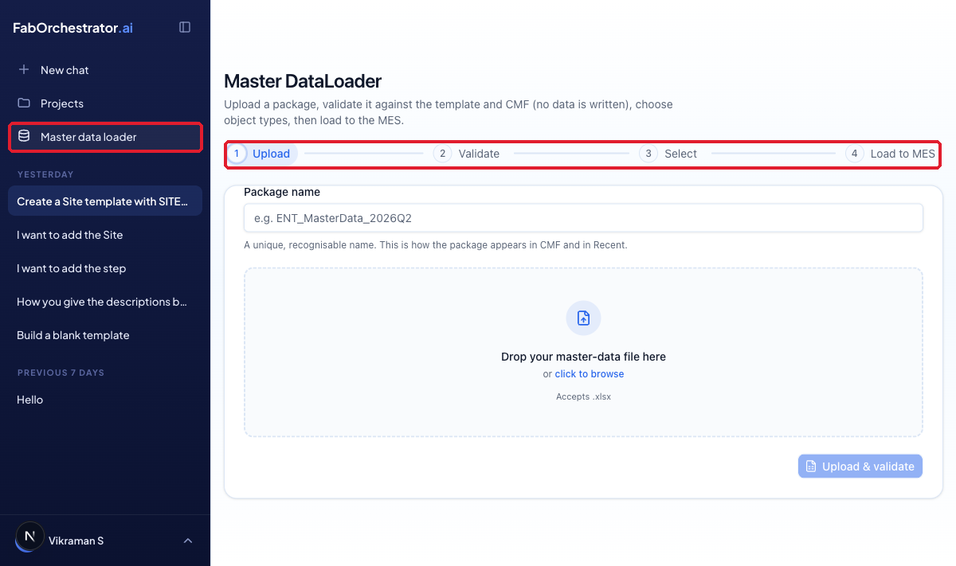
Figure 5 — Master data loader: the four steps. The sidebar stays visible.
Careful: Step 4 writes to the live MES database and cannot be undone from here. Steps 1–3 are safe.

7. Troubleshooting
What you see | What to do
“Modeling Agent isn’t enabled for your role” | Ask an administrator to tick Modeling Agent on your role in Fab Admin App → Roles.
“CMF SQL not configured” or a field fails to load | You are probably off the VPN. Connect and try again.
A drop-down shows “Type a … name (couldn’t reach CMF)” | CMF could not be reached, so you can type the value instead. Make sure it is spelled exactly as it exists in CMF.
The agent will not show a Download button | The file failed validation. The agent lists exactly what is wrong — fix it and ask it to regenerate.
Master data loader rejects the file | Usually a missing parent, or a required column left empty. Check the two warnings in section 5.

8. Quick reference

8.1 Prompts you can copy
- Build a Site template
- Create a Site template with SITE-A description Plant A
- Create a Facility called Test2 in site KSP-S
- Add Reason REASON-X category Scrap to this file
- Yes, fill it in the form here
- Show me the Site called KSP-S
- What object types can I load?
- Build a Step template

8.2 What is already in CMF today
Useful when you need a real parent value.
Object | Examples that exist today | Points at
Enterprise | Entegris | —
Site | KSP-S, Rockrimmon | Enterprise
Facility | 4266, Production, Test1 | Site
Area | Assembly, Boxing, Cleaning, EUV Assembly | Facility
Resource | 0088, AI1100, AI1100_Station_01 | Area
Reason | 0001 Bubbles/Blisters/Voids, 0003 Cold Slug | Category
Material | BOM_Material, Clone 1 | Facility, Product
Remember: This list is a snapshot. Ask the agent “Show me the Site called …” to check the live values at any time.

9. Ready-made examples — build the sample files
Your team has a set of ready-made sample files (in the sample-cmf-inputs folder) covering every kind of load: a single sheet, a parent on its own, a parent with its children, a child that points at data already in CMF, and a multi-sheet object. This section shows the exact prompts that build a file like each one, using real names already in your CMF system — so you can type them and get a realistic result to practise with.
The agent’s exact wording may differ slightly from what is shown here, but the file it produces will match.

9.1 A single sheet of reason codes
What you’ll get: one Reason sheet with five real reason codes filled in.
Step 1 — Type this:
Create a Reason template with these reasons: 0001 Bubbles/Blisters/Voids, 0002 Carbon/Embed Charred Resin, 0003 Cold Slug, 0004 Color/Smoke, 0005 Contamination
What you get back:
The agent confirms Reason is a single-sheet object, says it will add all five rows, and asks the usual question: Reason template only, or Full template?
Step 2 — Answer:
Reason template only
What you get back:
A ready file with five Reason rows and a Download tile. It may note that ReasonType is a required column still to be completed offline before loading.
Produces: 01_single-sheet_Reason.xlsx

9.2 Just the Enterprise (a parent on its own)
What you’ll get: a single Enterprise row — the top of the hierarchy, with no children.
Step 1 — Type this:
Create an Enterprise template with Entegris, description Entegris Enterprise
What you get back:
The agent confirms Enterprise is a single-sheet object, will write the one row, and asks: Enterprise template only, or Full template?
Step 2 — Answer:
Enterprise template only
What you get back:
A ready file containing the single Entegris row, and a Download tile.
Produces: 02_parent-only_Enterprise.xlsx

9.3 An Enterprise with its Sites (parent + child in one file)
What you’ll get: one file with the Enterprise and its two Sites, where each Site points at the Enterprise in the same file.
Because you want two object types in one file, choose the Full template first, then add the second object — exactly like adding a different object to a file you already started (see 4.6).
Step 1 — Type this:
Start a Full template with Enterprise Entegris, description Entegris Enterprise. I’ll add Sites next.
What you get back:
The agent builds a Full template, writes the Entegris row on the Enterprise sheet, and gives you a Download tile. Because you chose Full, other object sheets are ready for you to add to.
Step 2 — Add the Sites to the same file:
Now add two Sites to this file: KSP-S and Rockrimmon, both with Enterprise Entegris
What you get back:
The agent keeps the Enterprise row, fills the Site sheet with KSP-S and Rockrimmon (each with Enterprise = Entegris), and returns one file with both objects. A new Download tile appears — use that one.
Tip: Because the Enterprise is in the same file as the Sites, this load is self-contained — CMF has everything it needs in one package.
Produces: 03_parent+child_Enterprise+Site.xlsx

9.4 Sites that link to an Enterprise already in CMF (child only)
What you’ll get: two Site rows that reference Entegris, without including Entegris in the file — because it already exists in CMF.
Step 1 — Type this:
Create a Site template with SITE-TEST-A and SITE-TEST-B, both with Enterprise Entegris. Make SITE-TEST-B a remote site.
What you get back:
The agent writes two Site rows (SITE-TEST-B marked remote), and shows the parent-reference reminder: Entegris must already exist in CMF. It then asks: Site template only, or Full template?
Step 2 — Answer:
Site template only
What you get back:
A ready file with the two Site rows and a Download tile. Entegris is not in the file — the loader trusts it is already in CMF.
Tip: Not sure Entegris exists? Ask first: “Does Enterprise Entegris exist?” (see 4.8). It does — so this file will load.
Produces: 04_child-only_Site-refs-existing-Enterprise.xlsx

9.5 A multi-sheet Step
What you’ll get: a Step file — the parent Step sheet plus all of its sub-sheets, filled with three real steps.
Step 1 — Type this:
Create a Step template with steps 0088, Acid Fill and AIOResultCheck
What you get back:
The agent tells you Step is a multi-sheet object and how many sheets are involved, writes the three steps into the parent Step sheet, includes the sub-sheets (ready for detail rows if you need them), and gives you a Download tile.
Tip: The in-chat form is not offered for multi-sheet objects — give the values in the message box, over as many messages as you like (see 4.7).
Produces: 05_multi-sheet_Step.xlsx

9.6 The whole plant hierarchy (deep parent + child chain)
What you’ll get: one file with all four levels — Enterprise, Sites, Facilities and Areas — each linked to the level above.
Build this across a few messages, adding one level at a time. Start with the Full template so every level has a sheet ready.
Message 1 — Type this:
Start a Full template and add Enterprise Entegris, description Entegris Enterprise
The agent builds a Full template with the Entegris row and gives you a Download tile.
Message 2 — Add the Sites:
Add Sites KSP-S and Rockrimmon, both with Enterprise Entegris
The agent fills the Site sheet with the two sites and keeps the Enterprise row.
Message 3 — Add the Facilities:
Add Facilities: 4266 under Site KSP-S, Production under Site Rockrimmon, and Test1
The agent fills the Facility sheet, linking each facility to its Site.
Message 4 — Add the Areas:
Add Areas: Assembly, Cleaning, Final Inspection and Packing and Boxing under Facility 4266, and EUV Assembly under Facility Production
The agent fills the Area sheet, linking each area to its Facility, and gives you a final Download tile. The file now holds all four levels, each referencing the one above by name.
Tip: Always download the newest tile — it is the one with everything in it. Loading this whole file creates or updates Entegris and its sites, facilities and areas, so use a test environment.
Produces: 06_hierarchy_Enterprise-Site-Facility-Area.xlsx

