Collin McCarthy

PAVE, 9/25/2013

*BG/Q Module: User Guide*

1. *BG/Q Module Overview*

• BG/Q has a 5D torus interconnect, with dimensions called [a, b, c, d, e]

• BG/Q has a max width of two nodes across for the e-dimension

• View is laid out as side-by-side 4D tori, e = 0 on left, e = 1 on right

• Each 4D tori has 3D slices for each fourth dimension coordinate (i.e. e=0 has slices for d = 0, d = 1, … d = 7 and same for e = 1)

• Each 3D slice is drawn as a 2D plane in the top-left, top-right, and bottom-left views, showing a subset of the links

• One 3D slice (i.e. d = 0, e = 0), shown top-left with a red border around the label, is drawn bottom-right as a 3D torus to show all links/nodes

• User can toggle on/off fourth dimension links in the top-right window

• Each view has it’s own mouse I/O and, currently, keyboard I/O

• Future revisions will have combined keyboard I/O for all views

• Generally, everything with a grey or colored border is a clickable button

• Toolbars for the top right and bottom right views can be clicked and dragged to another location, by clicking the toolbar below the icons

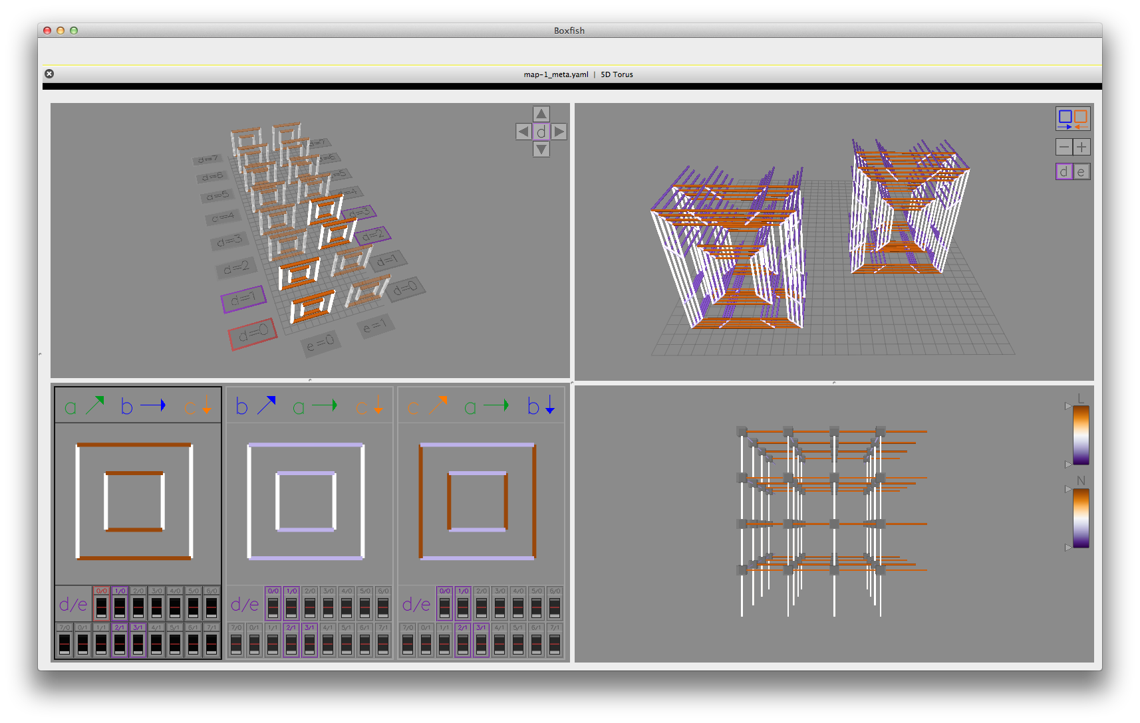

***Top Left: View I, Overview****;* ***Bottom Left: View II, Minimaps***

***Top Right: View III, Slice 4D; Bottom Right: View IV, Slice 3D***

1. *View I: Overview*

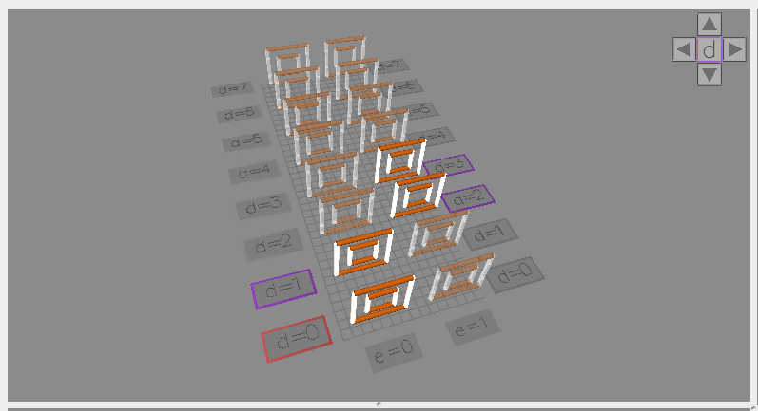

*⮚ Mouse Click:*

*🟁* Fourth-dimension labels (i.e. d= 0, d = 1):

• *Left* *click* to select the plane for the Slice 3D view, *right* *click* to turn that plane on/off

*🟁* Arrows:

• *Left* and *right* arrows change which dimension is mapped to the 4th dimension (i.e. currently ‘d’, can be one of {a, b, c, d})

• *Up* and *down* arrows change how the remaining three dimensions are laid out in the 3D slice. As shown, the 4th dimension is ‘d’ so this switches between the three permutations {abc, bac, cab} for which links correspond to the OpenGL {zxy} dimensions, respectively, in the Slice 3D view shown in the bottom right window.

*⮚ Mouse Wheel:*

*🟁* Wheel Up/Down: Zoom In/Out

*🟁* Wheel Left/Right: Translate Left/Right

*🟁* Shift + Wheel Up/Down:Translate Up/Down

*⮚ Mouse Click & Drag:*

*🟁* Not implemented. The user may not rotate the scene as of now. In the next revision rotation will be allowed, and a reset keystroke will return the view to its default translation and rotation shown here.

1. *View II: Minimaps*

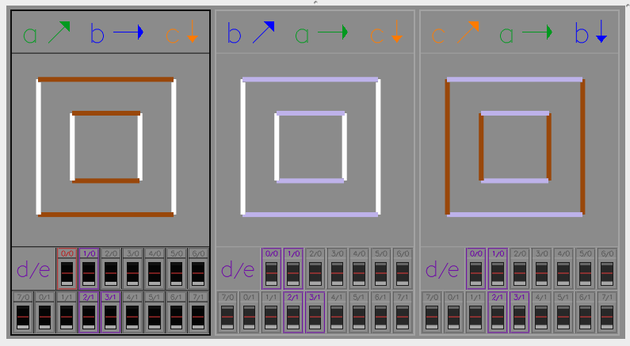

*⮚ Mouse Click:*

*🟁* Top section (i.e. legend (a, b, c) and colored lines)

• *Left* click to select that minimap data to be shown in all views

*🟁* Fourth-dimension labels (i.e. 0/0, 1/0, … 7/1):

• *Left* *click* to select the plane for the Slice 3D view, *right* *click* to toggle that plane on/off (same as overview)

• *Left* *click + drag* to turn *on* the selected planes for the Overview and Slice 4D views

• *Right* *click + drag* to turn *off* the selected planes for the Overview and Slice 4D views

*⮚ Mouse Wheel:*

*🟁* Shift + Wheel Up/Down:Scroll Down/Up

• Note this is tablet/smart-phone style scrolling to “push” the view up (down) translating the window down (up), but can be changed by pressing *r* or *R*.

*⮚ Keyboard:*

*🟁* {1, 2, 3, 4, 5, 6, 7, 8, 9}

• Change how many minimaps are displayed across, L to R

*🟁 {r, R}*

• Reverse scrolling direction

*Note*: When selecting a new minimap, the minimaps that share the same fourth dimension are sorted to be at the top, and the scrolling position is reset back to the top. This is so if the number of minimaps across is 3 or more, when the user selects a new minimap it will always displayed in the view, without needing to scroll down.

1. *View III: Slice 4D*

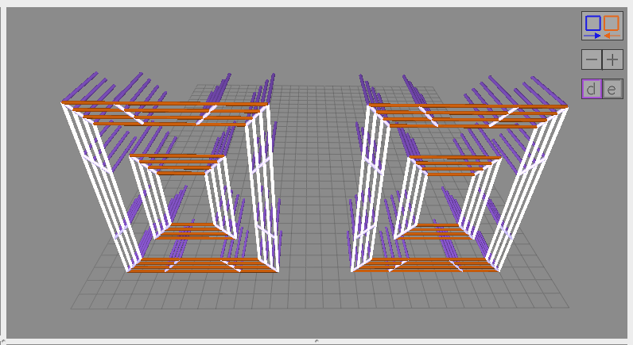

**E-dimension Offset**

By default the two 4D tori, e=0 (left) and e=1 (right) are laid out just as the Overview window shows, but showing more detail on the individual links. All diagonal links, and half of the horizontal and vertical links are shown, but the diagonal links are shorter. Fourth dimension links are shown toggled on here.

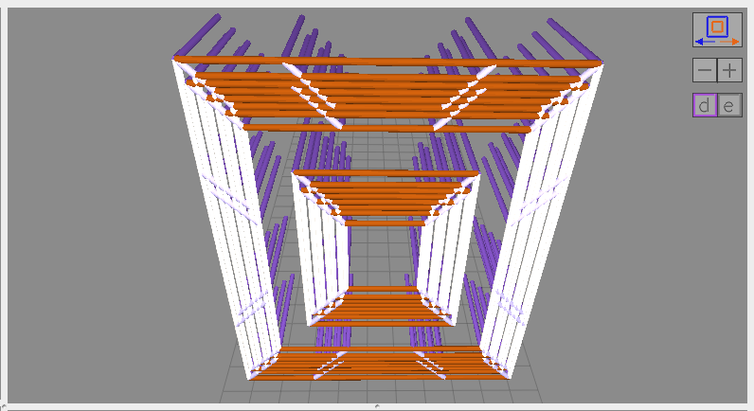

**E-dimension Inset**

Left-clicking the top most button switches from viewing the two 4D tori as offset, to viewing the e=1 tori scaled down slightly and inset inside the e= 0 tori. This is to easily compare corresponding links in the two tori, which are now immediately next to each other in the view.

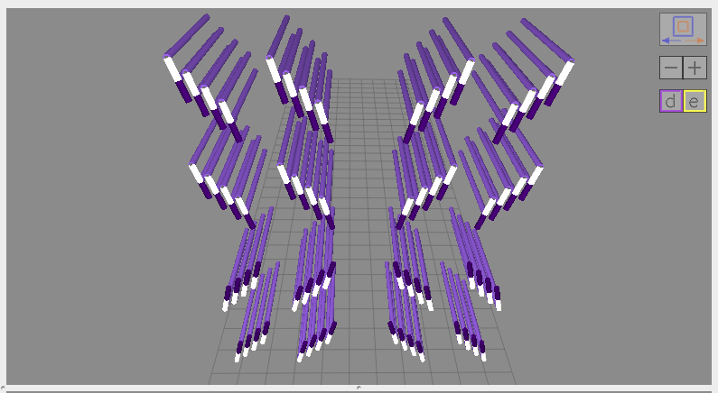

**D-links and E-links On**

*⮚ Mouse Click:*

*🟁* Offset/inset Button:

• *Left* click to switch between the two views. If e-links are shown, e-dimension must be inset so this is grayed out.

*🟁* -/+ Button:

• *Left* click -/+ to decrease/increase plane spacing. Decreasing helps for comparing the outermost links from one plane to the next.

*🟁 d* Button:

• *Left* click to toggle on/off the fourth dimension links (d-links here). Click again to turn off the first through third dimension links.

*🟁 e* Button:

• *Left* click to toggle on/off the fifth dimension links (e-links). Click again to turn off first through third dimension links. The e-links can only be viewed when the 4D tori are inset, so the offset/inset button is grayed out. Also, if already viewing only the fourth dimension links when clicking to turn on the e-links, successive clicks to the *e* button only toggle e-links off again, since the first through third dimension links are already removed. To get the first through third dimension links back, the *d* button would need to be clicked again, since that is what caused them to be turned off in the first place.

• Next revision a separate button will turn off the first through third dimension links to eliminate this seemingly confusing behavior

*⮚ Mouse Wheel:*

*🟁* Wheel Up/Down: Zoom In/Out

*🟁* Wheel Left/Right: Translate Left/Right

*🟁* Shift + Wheel Up/Down:Translate Up/Down

*⮚ Keyboard:*

*🟁 {f, F}*

• Flatten the planes to make them perpendicular to the screen

*🟁 {=, +}*

• Increase plane spacing

*🟁 {-, _}*

• Decrease plane spacing

*🟁 {l}*

• Increase link width

*🟁 {L}*

• Decrease link width

*🟁 {n}*

• Increase node size

*🟁 {N}*

• Decrease node size

1. *View IV: Slice 3D*

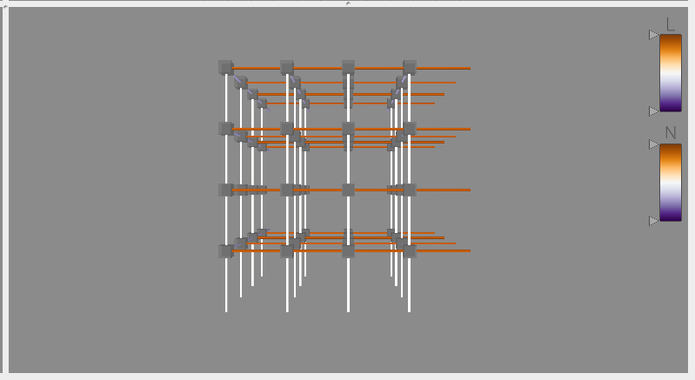

*⮚ Mouse Click:*

*🟁 Left* click any of the sliders to change the range of values shown in all views.

*🟁* *Right* click any node to view only the links having this node as their source in both the Slice 3D view and this view.

*⮚ Mouse Wheel:*

*🟁* Wheel Up/Down: Zoom In/Out

*🟁* Wheel Left/Right: Translate Left/Right

*🟁* Shift + Wheel Up/Down:Translate Up/Down

*⮚ Keyboard:*

*🟁 {r, R}*

• Reset all color bar sliders. This is necessary because if the sliders are dragged onto each other at the absolute min or max it may not be possible to change them without resetting, since one will be in front of the other.

*🟁 {l}*

• Increase link width

*🟁 {L}*

• Decrease link width

*🟁 {n}*

• Increase node size

*🟁 {N}*

• Decrease node size

**Please direct any bugs or suggestions to *Collin Michael McCarthy* on Jira for the PAVE group, or via email at** [**cmccarthy@ucdavis.edu**](mailto:cmccarthy@ucdavis.edu)

This user guide will be re-designed to match current Boxfish documentation after completing all revisions.