**Introduction**

**Purpose of this document**

This document is important as it entails all the requirements gathering procedure and shows how our company meets the client’s requirement needs. The requirements were divided into their functionalities which will be seen later in this documentation.

**Major Problems and Project Goal**

The goal of this project is to build an intelligent marketplace for buyers and sellers in Brookings. This task, however, comes with its challenges which are going to be discussed in this section.

Inadequate documentation on existing processes

There is very poor documentation available about the existing process. In this situation, requirements gathering became a two-step process. Firstly, we backengineered the existing process, and then identified areas for improvement and optimisation.

We also drew business process maps and visualized workflows for the client to better understand.

**Conflicting requirements**

Different priorities for our client, at one point lead to conflicting requirements. We solved this by identifying contradictory requests and let our client decide on priorities.

As experts we had some recommendations about what should be prioritized, but it is still important to hear the client’s opinion.

**Communication problems**

This included language barriers, wrong assumptions, unclearly defined vocabulary, and excessive use of professional terminology that sometimes lead to misunderstandings between the team and the client.

The strategy we adopted to avoid such situation is to communicate often and establish two-way communication. Documents gathered requirements were sent for review and feedback to client and we always verified assumptions before carrying on.

**Proposed System Overview**

**Definitions, Acronyms and Abbreviations**

**LIST OF ABBREVIATIONS**

API Application programming interface

B Bay Brookings Bay

Bid Auction

DB Database

ID Identification number

SS Screenshot

# References

(n.d.). Retrieved from https://www.breadcrumbdigital.com.au/requirements-gathering-challenges-and-solutions/

**Overview of Rest of RD**

Table of Contents

References 4

General Description 6

Product Perspective 6

Major Functions and features 6

User Characteristics 6

General Constraints 7

Assumptions and Dependencies 7

Functional Requirements 8

FR1 User Account Management 8

FR1.1 Creating administrator account 8

FR1.2 Offer login button 12

FR1.3 Creating Buyer and Seller account 19

FR2 I want to sell 23

FR3 Administrator interface 25

FR4 Forming Customer Interface 29

FR4.1 Item search and Recommendation 29

FR4.2,5,6 Notifications, FAQs and Policy 31

FR4.3 Display User’s Wish List 32

FR4.4 Display Cart List 35

FR4.7 Offer “Chat” button 37

FR4.8 Offer “History Purchase” button 39

FR5 Provide Interface for each merchandise 41

FR5.1,3,4,6 Offer “History Purchase” button 41

FR5.2 Offer “Buy” or “Bid” button 44

FR5.5 Offer “Chat with Seller” button 47

Non-Functional Requirements: 49

Log of meetings 51

Change Control 56

Appendix 57

Definitions, Acronyms and Abbreviations 57

Gantt Chart 58

Terms and Conditions 59

Project Acceptance Signatures for Client and Developer………………………………………………………………………………………………..……..75

# General Description

## Product Perspective

B-bay economy system is a system that allow users to buy and sell things. To support this goal, we have two kinds of user interface.

The first interface is buyer/seller interface, it allow users login, and then submit requests of selling to administrator, or search for things they want to buy though a enter box in home page. The search function should return not just key work matched items but recommendations as well.

The second interface is administrator interface, it allow users who are stuff to login, and then allow them to view selling requests mentioned above, return requests and reports.

## Major Functions and features

B-bay economy system should contain the following main functions that support users to sell or purchase items/services on website though PC:

* Account creation/ login
* “I want to sell” button to access selling request information filling and submit
* Administrator user’s button “manage” to view requests and reports
* Home page that provide display of notifications and search box to access recommended shop list of links
* Merchandise detail page that provide information of item that user clicked from the list mentioned above. And purchase buttons as well

The selling request and purchase are related to two different modes: Auction/Consignment.

## User Characteristics

B-bay economy system targets every one who meet the following characteristics:

* Having request to sell self owned items or need to purchase anything B-bay offered.
* Have ability to access B-bay website though PC
* Age above 14
* Educated citizens

## General Constraints

So far we have only planed to build website that supports PC browsing, which means B-bay system is not going to support usage thought phone or other devices.

## Assumptions and Dependencies

B-bay economy system building from Qnet only contains serveis of propose, design and coding website. Human resources management, online server or others are not included. The autual running and maintenance should be done by other company.

# Functional Requirements

## FR1 User Account Management

This is going to allow administrators and users(First time or returning) to create/log into their accounts. This unit consists of 3 different functionalities; creating administrator account, login and creating buyer and seller accounts.

### FR1.1 Creating administrator account

This is going to allow administrators to create their accounts.

                                             Related FWBS

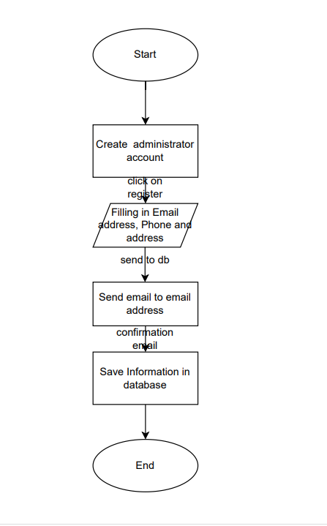

Data flow chart for FR1.1 creatine administrator account

|  |  |  |  |
| --- | --- | --- | --- |
| No | Input | Input Type | Outputs |
| FR1.1.1 | Email, phone, address | Button | See SS2 |
| FR1.1.2 | Send email to email address |  | See SS3 |

User Inputs and Outputs

Input

Pic: SS1

Output

                Pic: SS2

output

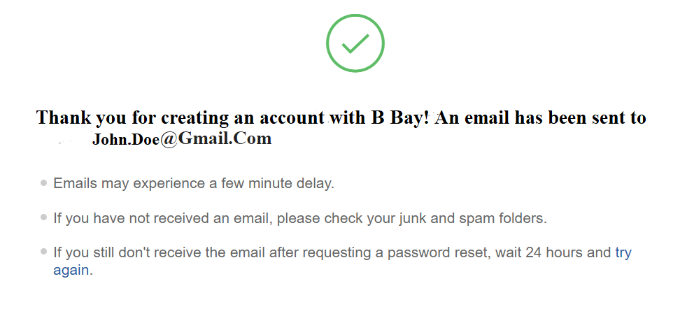

                                    Pic: SS3

### FR1.2 Offer login button

This is going to allow returning users to log into their accounts.

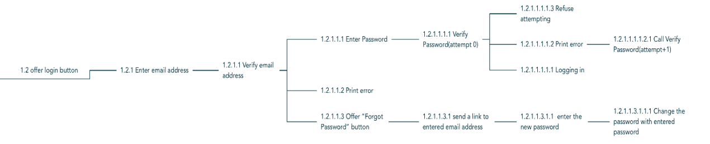

                                                         Related FWBS

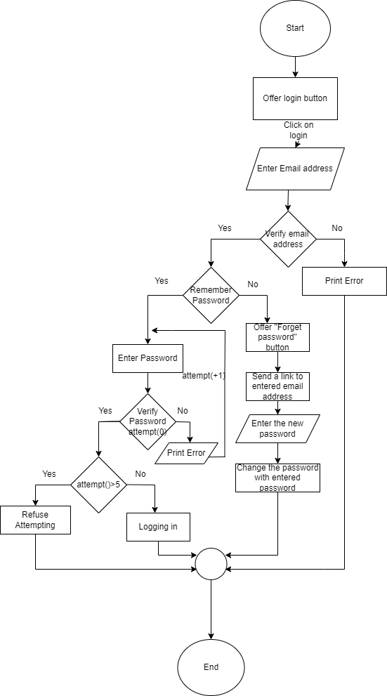

Data Flow chart for FR1.2 offer login button

|  |  |  |  |
| --- | --- | --- | --- |
| No | Input | Input Type | Outputs |
| FR1.3 | User will click on “Login” button | Button | See SS4 |
| FR1.2.1.1 | User will click “Verify Email Address” | Link | See SS5 |
| FR1.2.1.1.1.1 | Password will be verified | Link | See SS6 |
| FR1.2.1.1.3 | User will click “Forget Password Button” | Button | See SS7 |
| FR1.2.1.1.3.1 | Email will be sent to the email address. | Link | See SS8 |
| FR1.2.1.1.1.1.2 | Users will see error. | Link | See SS9 |
| FR1.2.1.1.1.1.1 | Logging in | Link | See SS10 |

User Inputs and Outputs

Input

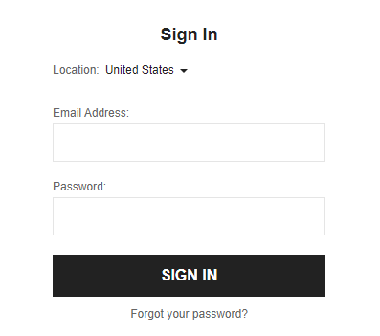

                    Pic: SS4

Output

                   Pic: SS4.1

Input

                      Pic: SS5

Output

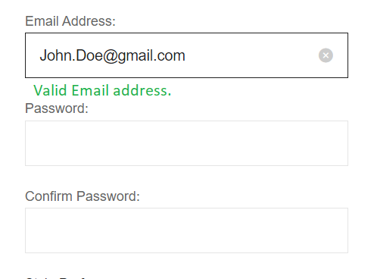

                   Pic: SS5.1

Input

                    Pic: SS6

Output

                     Pic: SS6.1

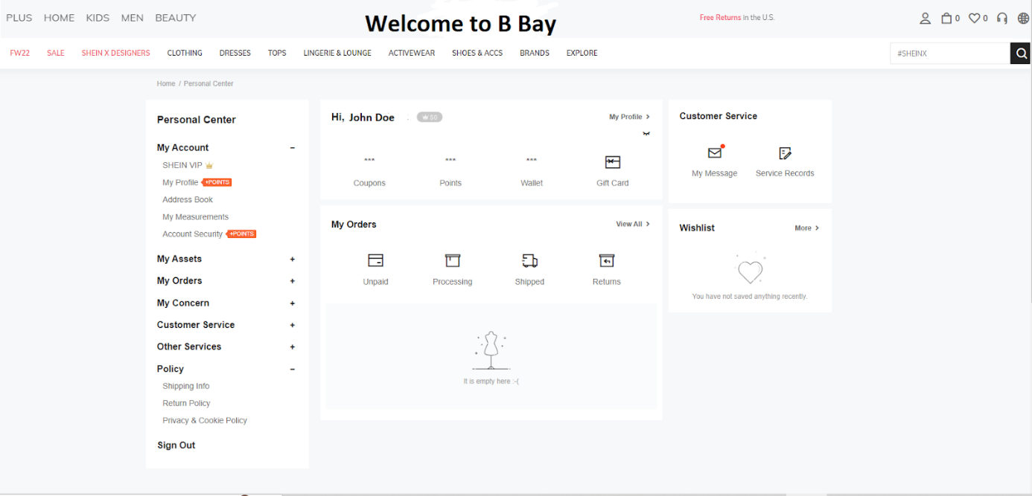

                                     Pic: SS10

Input

                               Pic: SS7

                     Pic: SS7.1

Output

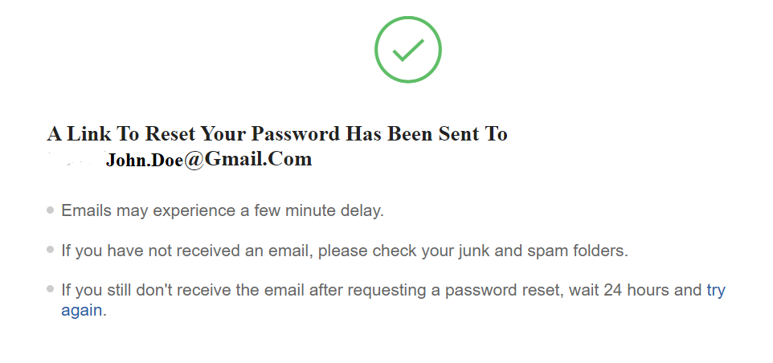

                             Pic: SS8

### FR1.3 Creating Buyer and Seller account

This is going to allow buyers and sellers to create their accounts.

                                                          Related FWBS

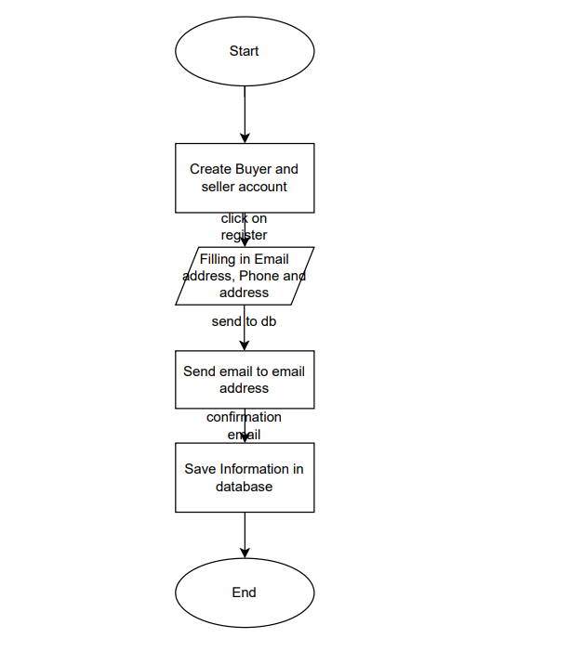

Data flow chart for FR1.3 creating buyer and seller account

|  |  |  |  |
| --- | --- | --- | --- |
| No | Input | Input Type | Outputs |
| FR1.3.1 | Register | Button | See SS11 |
| FR1.3.2 | Email, phone, address | Button | See SS12 |

                               Pic: SS11

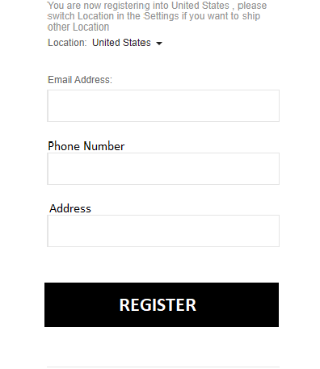

                     Pic: SS12



                                      Pic: SS12.1

## FR2 I want to sell

This cluster contains a request specification of selling. When users try to sell something with B-bay system, they should be able to submit a request of selling by functions in this cluster to the administrator.

Related FWBS

|  |  |  |  |  |
| --- | --- | --- | --- | --- |
| No. | Name&Description | Input | Input Type | Output |
| FR2 | Offer sell options | User click "sell" button in SS10 |  | Navigate to sell request page as I8. Including two buttons: "Consignment" and "Auction" also  including filling boxes of Name, description, price, deadline and a "submit" button |
| FR2.1 | offer "Submit consignment request" page | user click "Consignment" button in SS13 |  | AS I8 but disable input box of deadline and Price(low limit), highlight “consignment” button |
| FR2.1.1 | Submit consignment request | user  click "submit" button, 3 strings | strings | If string not empty, call FR2.1.1.1, or back to FR2.1 |
| FR2.1.1.1 | Save request | Strings of selling detail | Strings | save informations to database |
| FR2.2 | offer "Submit auction request" page | user click "Auction" button in SS13 |  | As I8 that every input box enabled. Highlight “Auction” button |
| FR2.2.1 | Submit auction request | user click "submit" button, 5 strings | strings | If string not empty, call FR2.1.1.1, or back to FR2.2 |



                                            Pic : SS 13

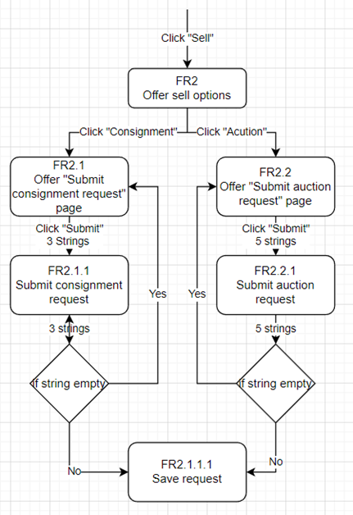Data Flow Chart for FR2 Offer sell options

## FR3 Administrator interface

This cluster contains a request specification of Administrator interface, which allow administrators to manage requests of selling or return, viewing reports and so on…

Related FWBS

 Data Flow Chart for FR Offer Administrator interface

|  |  |  |  |  |
| --- | --- | --- | --- | --- |
| No. | Name&Describe | Input | Input Type | Output |
| FR3 | Offer Administrator interface | User click "manage" button in I7 |  | Navigate to Administrator page as SS14. Including three bottons: "Selling requests", "Returns" and "reports", also show requests or reports in database, each one in list have a check list beside. |
| FR3.1 | Offer selling request list | User click "selling requests" button in SS14 |  | The List in SS14will show selling requests from database |
| FR3.1.1 | Edit item info | User click the any one in list, and change what ever displayed in “Description” area, in SS14 | strings | Save all strings, overwrite the orignal strings |
| FR3.1.2 | Approve unproved reqeust | User click check box and click “Process selected ones” |  | call FR3.1.2.1 with clicked item id, and then reflash the list SS14 |
| FR3.1.2.1 | Change merchandise state to "selling" | item id | integer | overwirete orignal string, if request type is "auction" call FR3.1.2.1.1 |
| FR3.1.2.1.1 | Set timer for auction | item id | integer | Set timer based on data, call FR3.1.2.1.1.1 when times up |
| FR3.1.2.1.1.1 | Get paid and notice seller | item id | integer | if buyer exist, call GetPaid(), then write notice with item seller id to database |
| FR3.2 | Offer error reports list | User click "reports" in SS14 |  | navigate to Error report list, display reports in List and description area in SS14 |
| FR3.3 | View returning request List | User click "Returns" in SS14 |  | As SS14but switch the requests list to return requests list |
| FR3.3.1 | Edit return requests | User click "save" in SS14, all string in list | strings | Save all strings, overwrite the orignal strings |
| FR3.3.2 | Call payback() | User clike any"confirm" button in SS14 |  | Call FR3.3.2.1 with item id |
| FR3.3.2.1 | Save information of return | Item id | integer | Save information to database, call FR3.3.2.1.1 |
| FR3.3.2.1.1 | Update the reputation | item id | integer | save new calculated reputation with seller id |

Pic: SS14

## FR4 Forming Customer Interface

This cluster shows how the user interacts with the website. It will explain what the user sees and how he manages his purchase.

### FR4.1 Item search and Recommendation

This allows users to search for what they are looking for. We use the data to give recommendations in the future.

                                                    Related FWBS

Data flow chart for FR4.1 Item search and recommendation

|  |  |  |  |
| --- | --- | --- | --- |
| No | Input | Input Type | Outputs |
| FR4.1.1 | Search item | Search button | User can see their desired merchandise |
| FR4.1.2 | Save button | Button | Saves history in db |
| FR4.1.3 | Do not save search history | Button | Leads user to the items list |
| FR4.1.4 | Clicks on item from items list | Link | Takes user to merchandise page |

### FR4.2,5,6 Notifications, FAQs and Policy

This cluster merges the notification functionality, FAQs functionality and policy functionality.

                              Related FWBS

Data flow Chart for FR4.2,4.5 and 4.6

|  |  |  |  |
| --- | --- | --- | --- |
| No | Input | Input Type | Outputs |
| FR4.2 | User clicks on notification | Link | Notifications will be showed |
| FR4.5 | User clicks on FAQs button | Button | FAQs are displayed |
| FR4.6 | User clicks on policy button | Button | Policy information is displayed |

### FR4.3 Display User’s Wish List

This allows users to show the wish list and also allows them to edit the wish list. And this will offer adding to cart options.

                                                Related FWBS

Data Flow Chart for FR4.3 display user’s wish list

|  |  |  |  |
| --- | --- | --- | --- |
| No | Input | Input Type | Output |
| FR4.3 | User clicks wish list | Button | See SS 15 |
| FR4.3.2 | User clicks add to cart button | Button | Items go to cart list |

Input

                                                 Pic: SS15

Output

                                           Pic: SS 15.1

### FR4.4 Display Cart List

This will show the user list of products they bought and it will also allow the user to edit the cart list .

Related FWBS

Data Flow Chart for FR4.4 display cart list

|  |  |  |  |
| --- | --- | --- | --- |
| No | Input | Input Type | Output |
| FR4.4 | User will click to cart list | Button | See SS16 |
| FR4.4.1 | User will call Buy() to buy items | Button | See SS17 |

Input

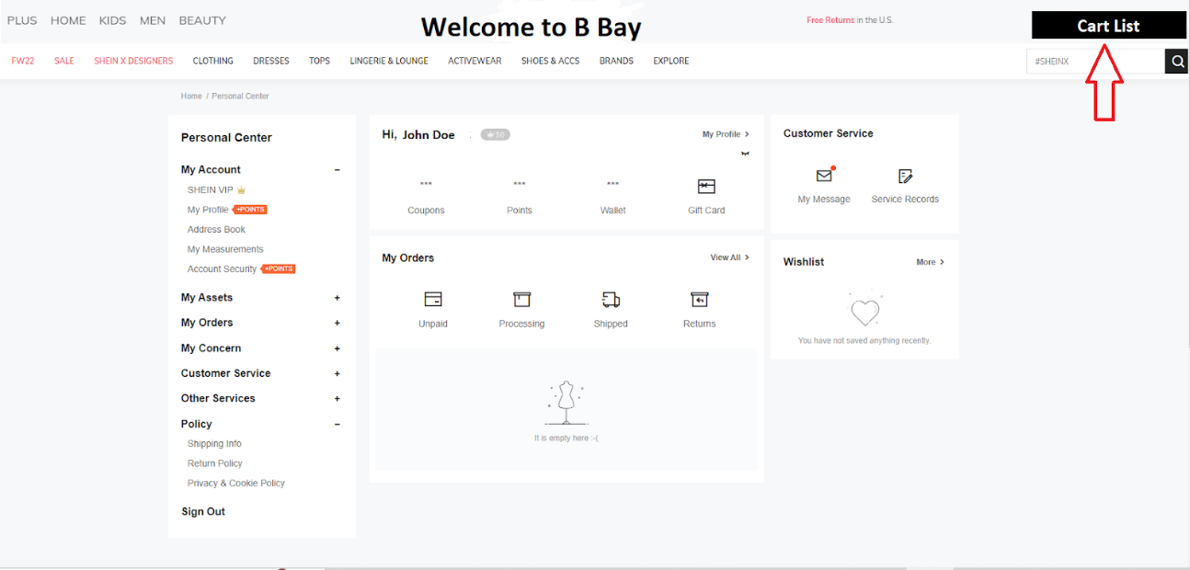

                                             Pic: SS16

Output

                                       Pic: SS17

### FR4.7 Offer “Chat” button

This enables the user to send and receive messages. It also shows message history.



                                                     Related FWBS

Data Flow Chart for FR4.7 Offer “Chat” button

|  |  |  |  |
| --- | --- | --- | --- |
| No | Input | Input Type | Output |
| FR4.7.1 | User will click on chat button | Button | Chat box will open |
| FR4.7.2 | User types message | Text box | Send option is displayed |
| FR4.7.3 | User clicks on chat list | link | List of people with contacts populates |
| FR4.7.4 | User clicks on display message history | link | Old messages populate in a list |

### FR4.8 Offer “History Purchase” button

This will show the user's purchase history and return policy.

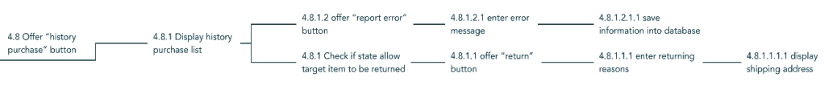

                                                       Related FWBS

Data Flow Chart for FR4.8 Offer “History Purchase” button

|  |  |  |  |
| --- | --- | --- | --- |
| No | Input | Input Type | Output |
| FR4.8 | User will click “History purchase” button | Button | See SS |
| FR4.8.1.2 | User Will click “report Error” button | Button | See SS |
| FR4.8.1.1 | User will click “Return” button | Button | See SS |

## FR5 Provide Interface for each merchandise

This cluster shows how merchandise is organized within the website. It also explains how bid and payment systems operate.

### FR5.1,3,4,6 Offer “History Purchase” button

This is a merged cluster consisting of the user's purchase history, user’s reputation and functionalities that will allow users to view items information and add to cart.

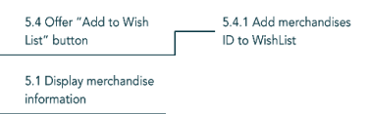

                   Related FWBS

Data Flow Chart for FR 5.1, 5.3, 5.4 and 5.6

|  |  |  |  |
| --- | --- | --- | --- |
| No | Input | Input Type | Output |
| FR5.1 | User will click merchandise info | Link | Merchandise’s informations will be seen |
| FR5.3 | User will click “Add to Cart” button | Button | See SS18 |
| FR5.4 | User will click “Add to Wish-List” button | Button | See SS19 |
| FR5.6 | User will click display reputation | Link | Reputation will be seen |

Inputs and outputs

Input

                                                      Pic: SS 18

Input

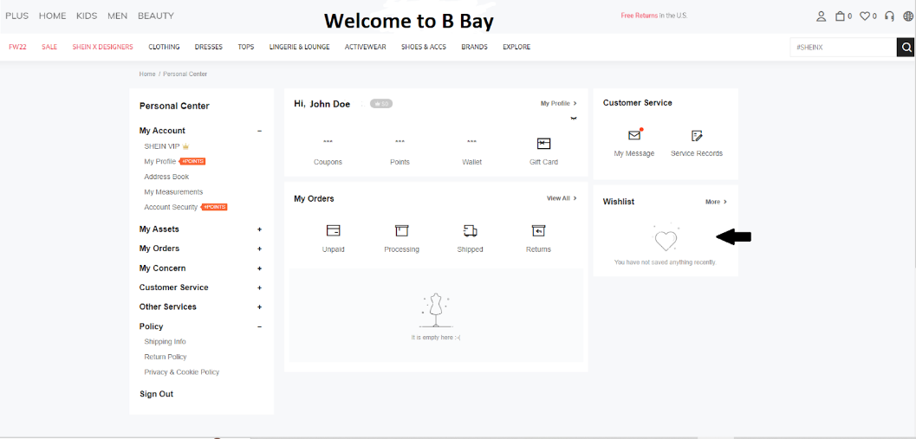

                                                Pic: SS 19

### FR5.2 Offer “Buy” or “Bid” button

This will show user buy and auction options and show payment interface.

                                                      Related FWBS

Data Flow Chart for FR5.2 Offer ”Buy” or “Bid” button

|  |  |  |  |
| --- | --- | --- | --- |
| No | Input | Input Type | Output |
| FR5.2 | User will click “Buy” or “Bid” button | Button | User gets asked “new user or returning” |
| FR5.2.1 | User clicks yes or no | Button | If “no” see input for FR5.2.2 |
| FR5.2.2 | User will click enter shipment info | Button | See SS20 |
| FR5.2.1.1 | User will click payment info | Button | See SS21 |
| FR5.2.1.2 | User will click old payment button | Button | User will see “pay” button |
| FR5.2.1.1.1 | User will click on pay | Link | Payment will be done |

Pic: SS20

Pic: SS21

### FR5.5 Offer “Chat with Seller” button

This will show the user messaging interface.



                                                             Related FWBS

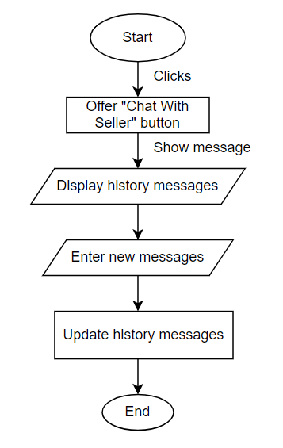

Data Flow Chart for FR5.5 Offer “Chat with Seller” button

|  |  |  |  |
| --- | --- | --- | --- |
| No | Input | Input Type | Output |
| FR5.5 | User clicks on”Chat with Seller” button | Button | Message history will be displayed. |
| FR5.5.1.1 | Enter new message button | Button | User will be able to type new message. |

# Non-Functional Requirements:

|  |  |  |
| --- | --- | --- |
| No. | Non-functional Requirement | Quality Attributes |
| NFR 1. | Performance | Supporting **5000** users per hour must provide **6 seconds** or less response time. |
| NFR 2. | Scalability | Scalable enough to support **1,000,000** visits. |
| NFR 3. | Portability | Program running on **Windows 10** must run on **Windows 11**. |
| NFR 4. | Compatibility | iOS application must support iPhone devices running on OS versions such as **3.6,3.3,3.4,4.3 and 2.3** |
| NFR 5. | Reliability | System must perform without failure in **95%** of use case. |
| NFR 6. | Maintainability | The mean time to restore the system (MTTRS) following a system failure must not be greater than **10 minutes**. |
| NFR 7. | Availability | Dashboard is available **99.98%** of the time every month during business hours EST. |
| NFR 8. | Security | The payment processing gateway is **90%** secure. |
| NFR 9. | Localization | The date format must be as follows: month.date.year. |
| NFR 10. | Usability | The error rate of users submitting their payment details at the checkout page mustn’t exceed **10%** |

# Log of meetings

Meeting 8/24 12:00 PM

Goal: To form a team

Members: Linsong, Maryam, Eva, Farzaneh, Habiba. Fatoumata

Location: Zoom

Context: Discussed about advantage of each person, based on the needs of project.

Listed needs of project:

Show management : meeting notes, calendars, reports,progress

UI: website,Mobile App,Unity:make samples,what it looks like

Art needed.

System design using flowchart, UML

Debug: set testing data with many considerations

Codling with C family, python, since we are learning PL, many…

Debug: testing with many considerations

Documentation:

1. What ever needed to help customer understand system

2. accurate is what matters, no thing should be ambiguous

Result, team of 3 with Linsong, Habiba, Fatoumata

Meeting 8/25 1:30 PM

Goal: Team leader decision， How to contact each other, decide the way of future meeting

Members: Linsong, Habiba and Fatoumata

Context: Team leader: LInsong Li

Contact: discord

Meeting time and location: 1:00PM Tuesday At room 128

Meeting 8/30 1:00 PM

Goal: Discuses about schedule

Members: All three

Context: Linsong suggest: assign work: learning about proposal, build the outline, framework of proposal in that Thursday.

Result: UI: web-site, Fatoumata create a google doc for proposal 12:00AM, and the Schedule based on meeting result. FWBS by Linsong before Friday 4:00 PM, Habiba will write out the Cost Thu 11:59PM

Meeting 8/30 5:00 PM

Goal: FWBS

Members: ALL

Result: Update: FWBS, Sep 1 Thursday before meeting- by Linsong

Proposal 6, Sep 6 before 12:30 PM -by Habiba

Half of Proposal 7, Sep 6 before 12:30 PM-by Fatoumata

Meeting 9/1 1:00 PM

Goal: meet Professor about FWBS

Members: ALL

Result: Need to update the FWBS into tree version, more detail needed, market research needed, each person do a review and function note of a website

Meeting 9/2 10:50 AM

Goal: Make sure the basic FWBS’s format, direction is right and then expand it

Members: ALL and professor

Result: 1. Change objects into functionalities 2. Manager into administrator. 3. Selling object evaluation. 4. Login can have as detail as validity account&Password 5. Move item page to “Offer Buyer UI interaction LIst”->”Offer Search Box”->”Offer Searched List”->”Offer page of selected single selling item”

Meeting 9/5 3:00 PM

Goal: Decide the Version 1 of FWBS, Expand FWBS to version 2, checking Proposal 6, 7 and decide the week work

Members: All members

Result: Fatoumata: proposal 7 is 20% done, 7.1 is 100% done, 7.2 is 20% done

Linsong: FWBS is 50% done

Habiba: Cost is 20% done

Fatoumaa: 1. No. have to use unique

2. Member, who take what

3. Add deliverables

Linsong: 1. Add discussed Functions

Habiba: 1. Unique No.

2. Help on milestone.

Meeting 9/6 1:00 PM

Goal: Decide the meeting time with professor. Check basic FWBS version 3.

Members: ALL

Result: Zoom meeting Thursday with professor, change regular meeting time to 1:30PM. FWBS

Meeting 9/8 1:30PM

Goal: Get advice from professor about New FWBS. discuss the work of AG, and Risk Table, Risk management table.

Wait List: Critical Path, Project Schedule, responsibility, data management plan, security plan, deliverables. Gaunt Chart, Plan&Actual compare chart

Member:ALL and Professor Shin

Result: 1. Check dependencies between FWBS functions. 2. About 20 miles stone 3. Not duration, put any deadline date.

Linsong: On to AG

Habiba: Risk table, Risk management

Fatoumata: Data management plan and security plan

Due data: 9/14 5:00PM

Deadline work of 9/14 checking:

Result: 1 day delayed.

Meeting 9/16 2:30PM to 5:00PM

Goal: get activities table, graph and cpa done, then gantt chart, project team organization, server selection anything left goes to 9/17

Member: Linsong, Fatoumata

Result: 80%done, the rest of it will be done at 9/17

Meeting 9/17 1:00PM to 5:00PM

Goal: proposal , letter of proposal, title page, and intro

Member: ALL

Result: Proposal done

Meeting 9/24 4:00PM

Goal: RD work split, template of request and overview

Member: ALL

Result: Fatou and Habiba: request template, Linsong: overview

Due 9/27

Meeting 9/27 1:00PM

Goal: template checking with client

Member: Linsong, Professor Shin

Result: No check box for every request but one page of acceptance, need to add Data flowing chart.

Meeting 10/1 4:00PM

Goal: RD work split detail specification

Member: ALL

Result: Fatou: Intro and FR 5 and Gantt chart from appendix

Linsong: Meeting Log, General, FR 2,3, and appendix, system overview from intro

Habiba: Non-Functional Requerment, FR 1

Fatou and Habiba Work together: FR 4.

Due 10/2 3:00PM

Change of Due date since deadline extended. New due date is 10/6 3:00PM

# Change Control

There are three basic elements to communications in the context of change management for QNet.

Identify the stakeholders and those impacted by the change.

Next, schedule regular face to face interactions and email communications to keep stakeholders updated on progress.

Finally, communications should be consistent, thorough, and regular. Communications should also clearly explain the change, define the reasons for change, present the benefits of the change, and always include change owner’s contact information

# Appendix

## Definitions, Acronyms and Abbreviations

LIST OF ABBREVIATIONS

API Application programming interface

B Bay Brookings Bay

Bid Auction

DB Database

ID Identification number

SS Screenshot

## Gantt Chart

## Terms and Conditions

Terms1. Introduction

This User Agreement, the Mobile Application Terms of Use, and all policies and additional terms posted on and in our sites, applications, tools and services (collectively "Services") set out the terms on which eBay offers you access to and use of our Services. You can find an overview of our policies here. The Mobile Application Terms of Use, all policies and additional terms posted on and in our Services are incorporated into this User Agreement. You agree to comply with all terms of this User Agreement when accessing or using our Services.

The entity you are contracting with is: eBay Inc., 2025 Hamilton Ave., San Jose, CA 95125, if you reside in the United States; eBay (UK) Limited, 1 More London Place, London, SE1 2AF, United Kingdom, if you reside in the United Kingdom; eBay GmbH, Albert-Einstein-Ring 2-6, 14532 Kleinmachnow, Germany, if you reside in the European Union; eBay Canada Limited, 240 Richmond Street West, 2nd Floor Suite 02-100, Toronto, Ontario, M5V 1V6, Canada, if you reside in Canada; eBay Singapore Services Pte Ltd., 10 Collyer Quay, #10-01 Ocean Financial Centre, Singapore 049315, if you reside in India; and eBay Marketplaces GmbH, Helvetiastrasse 15/17, 3005, Bern, Switzerland, if you reside in any other country. In this User Agreement, these entities are individually and collectively referred to as "eBay," "we," or "us."

Please be advised that this User Agreement contains provisions that govern how claims you and we have against each other are resolved (see "Disclaimer of Warranties; Limitation of Liability" and "Legal Disputes" provisions below). It also contains an Agreement to Arbitrate which will, with limited exception, require you to submit claims you have against us or our agents to binding and final arbitration, unless you opt out of the Agreement to Arbitrate (see Legal Disputes, Section B ("Agreement to Arbitrate")). If you do not opt out: (1) you will only be permitted to pursue claims against us or our agents on an individual basis, not as a plaintiff or class member in any class or representative action or proceeding and (2) you will only be permitted to seek relief (including monetary, injunctive, and declaratory relief) on an individual basis.

Terms 2. About Brookings eBay

eBay is a marketplace that allows users to offer, sell and buy goods and services in various geographic locations using a variety of pricing formats. eBay is not a party to contracts for sale between third-party sellers and buyers, nor is eBay a traditional auctioneer.

Any guidance eBay provides as part of our Services, such as pricing, shipping, listing, and sourcing is solely informational and you may decide to follow it or not. We may help facilitate the resolution of disputes between buyers and sellers through various programs. Unless otherwise expressly provided, eBay has no control over and does not guarantee: the existence, quality, safety or legality of items advertised; the truth or accuracy of users' content or listings; the ability of sellers to sell items; the ability of buyers to pay for items; or that a buyer or seller will actually complete a transaction or return an item.

Terms 3. Using B Bay

In connection with using or accessing our Services you agree to comply with this User Agreement, our policies, our terms, and all applicable laws, rules, and regulations, and you will not:

• breach or circumvent any laws, regulations, third-party rights or our systems, Services, policies, or determinations of your account status;

• use our Services if you are not able to form legally binding contracts (for example, if you are under 18 years old), or are temporarily or indefinitely suspended from using our Services, or are a person with whom transactions are prohibited under economic or trade sanctions;

• fail to pay for items purchased by you, unless you have a valid reason as set out in an eBay policy, for example, the seller has materially changed the item's description after you bid (see our Unpaid item policy);

• fail to deliver items sold by you, unless you have a valid reason as set out in an eBay policy;

• manipulate the price of any item or interfere with any other user's listings;

• take any action that may undermine the feedback or ratings systems (our Feedback policies);

• transfer your eBay account (including feedback) and user ID to another party without our consent;

• share your log in credentials with any third parties. If you require that authorized third parties (employees, agents, etc) have access to your account we offer a Multi-User Account Access program for that purpose.

• create listings, post, or upload content in inappropriate categories or areas on our sites;

• post false, inaccurate, misleading, deceptive, defamatory, or libelous content;

• distribute or post spam, unsolicited or bulk electronic communications, chain letters, or pyramid schemes;

• distribute viruses or any other technologies that may harm eBay or the interests or property of users;

• use any robot, spider, scraper, data mining tools, data gathering and extraction tools, or other automated means to access our Services for any purpose, except with the prior express permission of eBay;

• circumvent any technical measures used to provide our Services.

• interfere with the functioning of our Services, such as by imposing an unreasonable or disproportionately large load on our infrastructure;

• export or re-export any eBay application or tool, except in compliance with the export control laws, and rules and policies of any relevant jurisdictions;

• infringe the copyright, trademark, patent, publicity, moral, database, and/or other intellectual property rights (collectively, "Intellectual Property Rights") that belong to or are licensed to eBay. Some, but not all, actions that may constitute infringement are reproducing, performing, displaying, distributing, copying, reverse engineering, decompiling, disassembling, or preparing derivative works from content that belongs to eBay or someone else;

• infringe any Intellectual Property Rights that belong to third parties affected by your use of our Services or post content that does not belong to you;

• commercialize any eBay application or any information, data or software associated with such application, except with the prior express permission of eBay; or

• harvest or otherwise collect or use information about users without their consent.

Sellers must meet eBay's minimum performance standards. Failure to meet these standards may result in eBay charging sellers additional fees, and/or limiting, restricting, suspending, or downgrading your seller account.

If we believe you are abusing eBay and/or our Services in any way, we may, in our sole discretion and without limiting other remedies, limit, suspend, or terminate your user account(s) and access to our Services, delay or remove hosted content, remove any special status associated with your account(s), remove, not display, and/or demote listings, reduce or eliminate any discounts, and take technical and/or legal steps to prevent you from using our Services.

If we believe you are violating our policies prohibiting Offers to buy or sell outside of B Bay, you may be subject to a range of actions, including limits on your buying and selling privileges, restrictions on listings and account features, suspension of your account, application of fees, and recovery of expenses for policy monitoring and enforcement. Also, as provided below in the Fees and Taxes section, if we believe you are violating our policy on buying or selling outside of B Bay, you may be charged final value fees.

We may cancel unconfirmed accounts or accounts that have been inactive for a substantial period of time. Additionally, we reserve the right to refuse, modify, or terminate all or part of our Services to anyone for any reason at our discretion.

Terms 4. Policy Enforcement

When a buyer or seller issue arises, we may consider the user's performance history and the specific circumstances in applying our policies. We may choose to be more lenient with policy enforcement in an effort to do the right thing for both buyers and sellers. The foregoing does not limit or impair our right to refuse, modify, or terminate all or part of our Services to anyone, or to terminate this agreement with anyone, for any reason at our discretion.

Terms 5. Fees and Taxes

We charge sellers for the use of our Services. In some cases, where a buyer receives supplemental Services such as authentication Services for items in certain categories, we may also charge the buyer for such supplemental Service.

The fees we charge sellers for using our Services are listed on our Selling fees pages. We may change our selling fees from time to time by posting the changes on the eBay site fourteen (14) days in advance, but with no advance notice required for temporary promotions or any changes that result in the reduction of fees.

If you are a seller, you are liable for fees arising out of all sales made using some or all of our Services, even if sales terms are finalized or payment is made outside of eBay. In particular, if you offer or reference your contact information or ask a buyer for their contact information in the context of buying or selling outside of eBay, you may be liable to pay a final value fee applicable to that item, even if the item doesn't sell, given your usage of our Services for the introduction to a buyer.

You must have a payment method on file when using our selling Services and pay all fees and applicable taxes associated with your use of our Services by the payment due date. If your payment method fails or your account is past due, we may place restrictions on your account, or the eBay Payments Entities (as defined below) may collect amounts owed in the manner described in the Payments Terms of Use. In addition, you will be subject to late fees. eBay, or the collection agencies we retain, may also report information about your account to credit bureaus, and as a result, late payments, missed payments, or other defaults on your account may be reflected in your credit report. If you wish to dispute the information eBay reported to a credit bureau (i.e., Experian, Equifax or TransUnion) please contact us at eBay Inc., C/O Global Collections, 7700 West Parmer Lane, Building D, Austin, TX 78729. If you wish to dispute the information a collection agency reported to a credit bureau regarding your eBay account, you must contact the collection agency directly.

In any jurisdiction where B Bay has an obligation to collect sales taxes on sales you make using our Services, we or the eBay Payment Entities may collect such sales taxes from you via the payment method on file.

Selling fees don't purchase exclusive rights to item exposure on our Services. We may display third-party advertisements (including links and references thereto) or other content in any part of our Services, including your listing, in our sole discretion and without consent from, or payment, fee reduction, or other credit to, sellers.

Terms 6. Listing Conditions

When listing an item for sale on our Services, you agree to comply with B Bay's Listing policies and Selling practices policy and also agree that:

• You assume full responsibility for the item offered and the accuracy and content of the listing,

• Your listing may not be immediately searchable by keyword or category for several hours (or up to 24 hours in some circumstances). eBay can't guarantee exact listing duration,

• Your fixed-price listings may renew automatically every calendar month, based on the listing terms at the time, until all quantities sell or the listing is ended by you or eBay, in its sole discretion,

• The content you provide complies with all of our listing policies, including the Images, videos and text policy,

• Content that violates any of eBay's policies may be modified, obfuscated or deleted at B Bay's sole discretion,

• We may revise product data associated with listings to supplement, remove, or correct information,

• We strive to create a marketplace where buyers find what they are looking for. Therefore, the appearance or placement of listings in search and browse results will depend on a variety of factors, including, but not limited to:

• buyer's location, search query, browsing site, and history;

• item's location, listing format, price and shipping cost, terms of service, end time, history, and relevance to the user query;

• seller's history, including listing practices, Detailed Seller Ratings, eBay policy compliance, feedback, and defect rate; and

• number of listings matching the buyer's query,

• To drive a positive user experience, a listing may not appear in some search and browse results regardless of the sort order chosen by the buyer,

• Some advanced listing upgrades will only be visible on some of our Services,

• eBay's Duplicate listings policy may also affect whether your listing appears in search results,

• Metatags and URL links that are included in a listing may be removed or altered,

• We may provide you with optional recommendations to consider when creating your listings. Such recommendations may be based on the aggregated sales and performance history of similar sold and/or current listings; results may vary for individual listings. To drive the recommendations experience, you agree that we may display the sales and performance history of your individual listings to other sellers,

• For items listed in certain categories, subject to certain programs, and/or offered or sold at certain price points, B Bay may require the use of certain payment methods, subject to our Payments methods policy. For example, for inventory covered by authentication services, buyer and sellers may be subject to escrow and/or payment handling requirements,

• You will not sell and will promptly remove all listings for any product recalled by a manufacturer or governmental agency if the sale of the product is prohibited by law or regulation or the product poses a health or safety hazard as specified by any governmental agency. eBay has no responsibility or liability for the safety or performance of any product that you list or sell using our Services, including any product that is subject to a recall. You are solely responsible for any non-conformity or defect in, or compliance with any public or private recall of any product you list or sell using our Services,

• B Bay may publish and promote your listings, including related content such as username, product reviews and feedback on the websites or in the applications, services and tools of other B Bay Inc. corporate family members or cooperating third-party operators of websites, applications, services and tools.

Terms 7. Purchase Conditions

When buying an item using our Services, you agree to the Rules and policies for buyers and that:

• You are responsible for reading the full item listing before making a bid or offer, buying, or committing to buy,

• You enter into a legally binding contract to purchase an item when you buy, commit to buy an item, your offer for an item is accepted, or if you have the winning bid (or your bid is otherwise accepted),

• For motor vehicles and real estate, a bid or offer initiates a non-binding transaction representing a buyer's serious expression of interest in buying the seller's item and does not create a formal contract between the buyer and the seller,

• We do not transfer legal ownership of items from the seller to you,

• Utah Code Annotated § 70A-2-401(2) and Uniform Commercial Code § 2-401(2) apply to the transfer of ownership between the buyer and the seller, unless the buyer and the seller agree otherwise.

Terms 8. International Buying and Selling; Translation

Given the nature of B Bay's global marketplace, listings may be viewed and purchased by, and shipped to, buyers around the world. Many of our Services are accessible internationally. We offer certain programs, tools, and site experiences of particular interest to international sellers and buyers, such as estimated local currency conversion and international shipping calculation tools. Sellers and buyers are responsible for complying with all laws and regulations applicable to the international sale, purchase, and shipment of items.

If you purchase an item on an eBay site that is different from your registration site, you are subject to the User Agreement and applicable policies of that other eBay site with respect to that particular purchase, as detailed in the International selling policy.

For sellers, you agree that we may display your listing for sale on an eBay site other than the site where you listed your item for sale, based on your shipping settings. You may adjust these settings as detailed in the International selling policy. If you list your items with an international shipping option, the appearance of your listings on sites other than the listing site is not guaranteed. If you sell an item on an eBay site that is different from your registration or listing site, you are subject to the User Agreement and applicable policies, including any buyer protection programs, of that other eBay site with respect to that particular sale, as detailed in the International selling policy.

You authorize us to use automated tools to translate your B Bay content and member-to-member communications, in whole or in part, into local languages where such translation solutions are available. We may provide you with tools which will enable you to translate content at your request. The accuracy and availability of any translation are not guaranteed.

One of the ways that we may make B Bay.com listings available to international buyers on B Bay.com and on B Bay's international sites is through the Global Shipping Program. For eligible items located in the United States and purchased by an international buyer through the Global Shipping Program, you (as seller) will simply ship the item to a parcel processing facility located in the United States after receiving notification of payment from the buyer. Pitney Bowes Inc., a third-party global shipping provider, will oversee the processing, customs clearance, and international shipment of the item on behalf of your international buyer. To the extent a buyer has a question about your Global Shipping Program listings, eBay may respond directly to the buyer if the question pertains to the services overseen by Pitney Bowes Inc. (for example, customs or international shipping). Sellers pay no additional fees for selling through the Global Shipping Program.

Pursuant to a routed export transaction under the U.S. Export Administration Regulations and Foreign Trade Regulations, the buyer, as the Foreign Principal Party in Interest, will agree to assume responsibility for the export shipment, with Pitney Bowes Inc. acting as your buyer's forwarding agent. You remain liable for the accuracy of information you provide about items, and you agree to provide timely responses to requests for additional information.

You consent to the disclosure of certain personally identifiable information, as well as listing and order information, by B Bay to Pitney Bowes Inc., and by Pitney Bowes Inc. to its affiliates, service providers, and other third parties (such as customs and revenue authorities, as well as other government agencies), in connection with the processing, export and customs clearance, and international transportation of any item. B Bay does not control the privacy policies of Pitney Bowes Inc., its affiliates, or its service providers, and you are subject to the privacy policies of those parties, as applicable.

Additional information about the program, including policies governing feedback, the handling of lost, damaged, and undeliverable items, returns, and the resolution of buyer protection claims for items that you sell through the program, can be found on our Global Shipping Program and Global Shipping FAQs pages.

Terms 9. Content

When you provide content using our Services (directly or indirectly), you grant us a non-exclusive, worldwide, perpetual, irrevocable, royalty-free, sublicensable (through multiple tiers) right to exercise any and all Intellectual Property Rights you have in that content in connection with our provision, expansion, and promotion of our Services, in any media known now or developed in the future. To the fullest extent permitted under applicable law, you waive your right to enforce your Intellectual Property Rights in that content against eBay, our assignees, our sublicensees, and their assignees in connection with our, those assignees', and those sublicensees' use of that content in connection with our provision, expansion, and promotion of our Services.

You represent and warrant that, for all such content you provide, you own or otherwise control all necessary rights to do so and to meet your obligations under this User Agreement. You represent and warrant that such content is accurate. You represent and warrant that use of any such content (including derivative works) by us, our users, or others in contract with us, and in compliance with this User Agreement, does not and will not infringe any Intellectual Property Rights of any third party. eBay takes no responsibility and assumes no liability for any content provided by you or any third party.

We offer product data (including images, descriptions and specifications) that are provided by third parties (including eBay users). You may use that content solely in your eBay listings. eBay may modify or revoke that permission at any time in our sole discretion. The product data includes copyrighted, trademarked and other proprietary materials. You agree not to remove any copyright, proprietary, or identification markings in the product data and not to create any derivative works based on that data (other than by including the data in your listings).

We try to offer reliable product data, but cannot promise that the content provided through our Services will always be available, accurate, complete, and up-to-date. You agree that eBay is not responsible for examining or warranting the listings or content provided by third parties through our Services, and that you will not attempt to hold us or our data providers liable for inaccuracies.

The name "B Bay" and other B Bay marks, logos, designs, and phrases that we use in connection with our Services are trademarks, service marks, or trade dress of B Bay in the U.S. and other countries. They may not be used without the express written prior permission of B Bay.

Terms 10. Notice for Claims of Intellectual Property Violations and Copyright Infringement Pursuant to Section 512(c) of Title 17 of the United States Code

We respond to notices of alleged copyright infringement under the United States Digital Millennium Copyright Act. B Bay's Verified Rights Owner (VeRO) program works to ensure that items and content using our Services do not infringe upon the copyright, trademark, or certain other intellectual property rights of third parties. If you believe that your intellectual property rights have been infringed, please notify our VeRO team and we will investigate. Learn how to submit a notice to B Bay.

Terms 11. Holds and Restricted Funds

To protect eBay from risk of liability for your actions as a seller, B Bay Payments Entities may restrict access to your funds as described in the Payments Terms of Use.

Terms 12. Authorization to Contact You; Recording Calls; Analyzing Message Content

B Bay may contact you using autodialed or prerecorded calls and text messages, at any telephone number that you have provided us, to: (i) notify you regarding your account; (ii) troubleshoot problems with your account; (iii) resolve a dispute; (iv) collect a debt; (v) poll your opinions through surveys or questionnaires; or (vi) as otherwise necessary to service your account or enforce this User Agreement, our policies, applicable law, or any other agreement we may have with you. eBay may also contact you using autodialed or prerecorded calls and text messages for marketing purposes (e.g., offers and promotions), if you consent to such communications. Our collection, use, disclosure, retention, and protection of your personal information is governed by our User Privacy Notice. As described in our User Privacy Notice, eBay may collect other telephone numbers for you and may place manual non-marketing calls to any of those numbers and autodialed non-marketing calls to any landline. Standard telephone minute and text charges may apply and may include overage fees if you have exceeded your plan limits. You may change your marketing communications preference for calls at any time, including through the Communication Preferences section of your My B Bay. You may also opt-out of a specific text marketing campaign by replying "STOP" to such marketing text message.

eBay may share your telephone number with its authorized service providers as stated in our User Privacy Notice. These service providers may contact you using autodialed or prerecorded calls and text messages, only as authorized by eBay to carry out the purposes identified above.

eBay may, without further notice or warning and in its discretion, monitor or record telephone conversations you or anyone acting on your behalf has with eBay or its agents for quality control and training purposes, or for its own protection.

B Bay's automated systems scan and analyze the contents of every message sent through its messages platform, including messages between users, to detect and prevent fraudulent activity or violations of B Bay's User Agreement, including the incorporated terms, notices, rules, and policies. This may result in a manual review of messages sent through our messaging tools. This scanning and analysis may occur before, during, or after the message is sent, or while in storage, and may result in your message being delayed or withheld. eBay may store message contents, including to conduct this scanning and analysis.

Privacy of Others; Marketing

If B Bay provides you with information about another user, you agree you will use the information only for the purposes that it is provided to you. You may not disclose or distribute a user's information to a third party for purposes unrelated to our Services. Additionally, you may only send marketing communications to users who have consented to receive them in accordance with applicable laws, and only using B Bay Services.

Terms 13. Additional Terms

Returns and cancellations for sellers

Sellers can create rules to automate replacements, returns, and refunds under certain circumstances. For all new sellers, in listings where returns are accepted, B Bay will set a default rule that automates the return process. Sellers may remove or customize their return preferences in their account settings within My B Bay. Where settings have been set to automatically accept requests for returns or replacements, an B Bay-generated return shipping label will be provided to your buyer. You agree to comply with our returns policy.

When an item is returned or if a transaction is cancelled after payment has been completed, B Bay may issue a refund to the buyer on the seller's behalf and charge the seller for the amount of the refund.

Additionally, B Bay may charge sellers for the cost of return shipping labels and/or other reasonable fees from sellers when:

• An B Bay-generated return shipping label is used, and the seller is responsible for its cost;

• Returns have been automated;

• The seller fails to send the buyer a return shipping label and, instead, an B Bay-generated shipping label is used; and/or

• The item is not as described in the listing and is returned in accordance with B Bay Money Back Guarantee or other applicable terms.

B Bay or B Bay Payment Entities may invoice sellers for these charges and collect such charges as described in the Payments Terms of Use.

All seller cancellations of orders must be in accordance with our Order cancellation policy.

Returns and cancellations for buyers

Buyers generally do not have the right to cancel an order. Buyers can request to cancel an order on B Bay within the time period and as provided in our Order cancellation policy, and the seller will have 3 days to accept or decline the request. If the order cannot be cancelled, buyers may still be permitted to return the item if the item is eligible for return.

In certain instances, a buyer may be responsible for the cost of return shipping for an item returned to a seller. If the buyer is responsible for the return shipping costs, the buyer may elect to use an B Bay-generated shipping label or purchase a shipping label directly from a carrier. By choosing to use an eBay-generated shipping label, you (as a buyer) agree that B Bay may deduct the cost of the shipping label from the refund owed to you.

B Bay Money Back Guarantee

Most eBay sales go smoothly, but if there's a problem with a purchase covered by B Bay Money Back Guarantee, buyers can get their money back if an item didn't arrive, is faulty or damaged, or doesn't match the listing. You agree to comply with the policy and permit us to make a final decision on any eBay Money Back Guarantee case.

If you (as seller), choose to reimburse a buyer, or are required to reimburse a buyer or eBay under the eBay Money Back Guarantee, eBay or eBay Payments Entities may invoice you in the amount of the reimbursement, or collect the amount of the reimbursement from you as described in the Payments Terms of Use. If we cannot get reimbursement from you, we may collect the outstanding sums using other collection mechanisms, including retaining collection agencies.

We may suspend the B Bay Money Back Guarantee in whole or in part without notice if we suspect abuse or interference with the proper working of the policy.

Terms 14. Payment Services

Payments for goods and services sold using our Services are facilitated by designated B Bay entities (each, an "eBay Payment Entity") pursuant to the Payments Terms of Use. You agree to the Payments Terms of Use to the extent applicable to you. To receive payment for an item sold using our Services, you must accept and comply with the Payments Terms of Use, including the requirements to provide to eBay Payment Entities information about you, your business, and the financial account you will use to receive payments.

If you are a buyer:

• You may pay for items and services using the payment methods that the eBay Payment Entities make available, and the eBay Payment Entities will manage settlement of the payment to sellers. When buying on our Services, you authorize the eBay Payment Entity to initiate payments using your selected payment method and collect the transaction amounts on behalf of the seller. Accordingly, payments received by the eBay Payment Entity from you will satisfy your obligations to pay the seller in the amount of payments received.

• In certain instances, your transaction may be declined, frozen, or held for any reason including for suspected fraud, AML compliance, compliance with economic or trade sanctions, in connection with eBay's internal risk controls or due to potential violations of any policy of eBay or the eBay Payment Entity, or a policy of one of the Payment Entity's third-party payment services providers.

• eBay, the eBay Payment Entity or its affiliates may save payment information, such as credit card or debit card numbers, and card expiration dates, entered by you on our Services when you make a purchase, redeem a coupon, or make any other transaction on our Services where card information is entered. Such stored payment information may be used as your default payment method for future transactions on our Services. At any time, you can update your card information or enter new card information, at which point the new card information shall be stored as your default payment method. You may make changes to your default payment method through the Personal Information section under the Account tab in My eBay. You are responsible for maintaining the accuracy of information we have on file, and you consent to eBay updating such stored information from time to time based on information provided by you, your bank or other payments services providers. You will only provide information about payment methods that you are authorized to use.

• You may seek returns or cancellations on our Services, or file eBay Money Back Guarantee claims on our Services. If you are entitled to a refund, the eBay Payment Entities will issue the refund if the eBay Payment Entities processed the original payment. Refund timing may vary in accordance with the rules of third parties, such as credit and debit card networks.

• You agree to comply with, and not cause a third party to violate, all applicable laws, regulations, rules and terms and conditions in connection with the use of the services provided by the bBay Payment Entities. You understand that some third parties, such as credit and debit card issuers, credit and debit card networks and payments services providers, may have their own terms and conditions for the payment or settlement methods you choose to use in connection with managed payments transactions. Failure to abide by third party terms and conditions may result in fees assessed to you (for example, currency conversion fees from your credit card issuer if the transaction currency is different from your credit card currency) or other actions taken by such third parties, and you agree that the eBay Payment Entity has no control over, or responsibility or liability for, such fees or actions.

Terms 15. Release

If you have a dispute with one or more users, you release us (and our affiliates and subsidiaries, and our and their respective officers, directors, employees and agents) from claims, demands and damages (actual and consequential) of every kind and nature, known and unknown, arising out of or in any way connected with such disputes. In entering into this release, you expressly waive any protections (whether statutory or otherwise) that would otherwise limit the coverage of this release to include only those claims which you may know or suspect to exist in your favor at the time of agreeing to this release.

Terms 16. Indemnity

You will indemnify and hold us (including our affiliates and subsidiaries, as well as our and their respective officers, directors, employees, agents) harmless from any claim or demand, including reasonable legal fees, made by any third party due to or arising out of your breach of this User Agreement, your improper use of our Services or your breach of any law or the rights of a third party.

Terms 17. Legal Disputes

PLEASE READ THIS SECTION CAREFULLY. IT AFFECTS YOUR RIGHTS AND WILL HAVE A SUBSTANTIAL IMPACT ON HOW CLAIMS YOU AND EBAY HAVE AGAINST EACH OTHER ARE RESOLVED.

In this Legal Disputes Section, the term "related third parties" includes your and eBay's respective affiliates, subsidiaries, parent companies, predecessors, successors, assigns, as well as your, eBay's, and these entities' respective employees and agents.

You and eBay agree that any claim or dispute at law or equity that has arisen, or may arise, between you and eBay (or any related third parties) that relates in any way to or arises out of this or previous versions of this User Agreement, your use of or access to the Services, the actions of eBay or its agents, or any products or services sold or purchased through the Services, will be resolved in accordance with the provisions set forth in this Legal Disputes Section.

A. Applicable Law

You agree that, except to the extent inconsistent with or preempted by federal law, the laws of the State of Utah, without regard to principles of conflict of laws, will govern this User Agreement and any claim or dispute that has arisen or may arise between you and B Bay, except as otherwise stated in this User Agreement.

B. Agreement to Arbitrate

You and B Bay each agree that any and all disputes or claims that have arisen, or may arise, between you and eBay (or any related third parties) that relate in any way to or arise out of this or previous versions of the User Agreement, your use of or access to our Services, the actions of eBay or its agents, or any products or services sold, offered, or purchased through our Services shall be resolved exclusively through final and binding arbitration, rather than in court.

Alternatively, you may assert your claims in small claims court, if your claims qualify and so long as the matter remains in such court and advances only on an individual (non-class, non-representative) basis. The Federal Arbitration Act ("FAA"), and to the extent not inconsistent with the FAA, the laws of the State of Utah, without regard to principles of conflict of laws, governs the interpretation and enforcement of this Agreement to Arbitrate.

1. Prohibition of Class and Representative Actions and Non-Individualized Relief

YOU AND EBAY AGREE THAT EACH OF US MAY BRING CLAIMS AGAINST THE OTHER ONLY ON AN INDIVIDUAL BASIS AND NOT AS A PLAINTIFF OR CLASS MEMBER IN ANY PURPORTED CLASS, OR REPRESENTATIVE OR PRIVATE ATTORNEY GENERAL ACTION OR PROCEEDING. UNLESS BOTH YOU AND EBAY AGREE OTHERWISE, THE ARBITRATOR MAY NOT CONSOLIDATE OR JOIN MORE THAN ONE PERSON'S OR PARTY'S CLAIMS, AND MAY NOT OTHERWISE PRESIDE OVER ANY FORM OF A CONSOLIDATED, REPRESENTATIVE, CLASS, OR PRIVATE ATTORNEY GENERAL ACTION OR PROCEEDING. ALSO, THE ARBITRATOR MAY AWARD RELIEF (INCLUDING MONETARY, INJUNCTIVE, AND DECLARATORY RELIEF) ONLY IN FAVOR OF THE INDIVIDUAL PARTY SEEKING RELIEF AND ONLY TO THE EXTENT NECESSARY TO PROVIDE RELIEF NECESSITATED BY THAT PARTY'S INDIVIDUAL CLAIM(S). ANY RELIEF AWARDED CANNOT AFFECT OTHER USERS. If a court decides that applicable law precludes enforcement of any of this paragraph's limitations as to a particular claim or a particular request for a remedy (such as a request for injunctive relief), then that claim or that remedy request (and only that claim or that remedy request) must be severed from the arbitration and may be brought in court (pursuant to Section 18.C below), subject to your and eBay's right to appeal the court's decision. All other claims will be arbitrated.

2. Arbitration Procedures

Arbitration is more informal than a lawsuit in court. Arbitration uses a neutral arbitrator instead of a judge or jury, and court review of an arbitration award is very limited. However, an arbitrator can award the same damages and relief on an individualized basis that a court can award to an individual. An arbitrator should apply the terms of the User Agreement as a court would. All issues are for the arbitrator to decide, except that issues relating to arbitrability, the scope or enforceability of this Agreement to Arbitrate, or the interpretation of Section 1 of this Agreement to Arbitrate ("Prohibition of Class and Representative Actions and Non-Individualized Relief"), shall be for a court of competent jurisdiction to decide.

The arbitration will be administered by the American Arbitration Association ("AAA") under its rules and procedures, including the AAA's Consumer Arbitration Rules and the AAA's Commercial Arbitration Rules, and the AAA's International Centre for Dispute Resolution Rules (as applicable), as modified by this Agreement to Arbitrate. Absent agreement of the parties, the AAA shall decide which AAA rules apply to the arbitration. The AAA's rules are available at www.adr.org and www.icdr.org. In the event that the AAA is unavailable to administer the arbitration, another administrator will be selected by the parties or, if the parties cannot reach the agreement, the court (pursuant to Section 18.C below) shall select the administrator.

A party who intends to seek arbitration must first send to the other, by certified mail, a valid Notice of Dispute ("Notice"), which may be downloaded at this link. The Notice to eBay must be sent to eBay Inc., Attn: Litigation Department, Re: Notice of Dispute, 583 W. eBay Way, Draper, UT 84020. eBay will send any Notice to you to the physical address we have on file associated with your eBay account; it is your responsibility to keep your physical address up to date. To be valid, you must personally sign the Notice and complete all information on the Notice form, including a description of the nature and basis of the claims you are asserting, the specific relief sought, and the email address and phone number associated with your account.

If you and eBay are unable to resolve the claims described in a valid Notice within 30 days after B Bay receives that Notice, you or eBay may initiate arbitration proceedings. A form for initiating arbitration proceedings is available on the AAA's site at www.adr.org. In addition to filing this form with the AAA in accordance with its rules and procedures, the party initiating the arbitration must mail a copy of the completed form to the opposing party. You may send a copy to eBay at the following address: eBay, Inc. c/o CT Corporation System, 1108 E South Union Ave., Midvale, UT 84047. In the event eBay initiates an arbitration against you, it will send a copy of the completed form to the physical address we have on file associated with your eBay account. Any settlement offer made by you or eBay shall not be disclosed to the arbitrator.

If you are a resident of the United States, then the arbitration hearing shall be held in the county in which you reside or at another mutually agreed location. If you are not a resident of the United States, then the arbitration hearing will be held in Salt Lake County, Utah, United States, or another mutually agreed location. Where no disclosed claims or counterclaims exceed $25,000, the dispute shall be resolved by the submission of documents only, subject to the arbitrator's discretion to require an in-person hearing, if the circumstances warrant. In cases where an in-person hearing is held, you and/or eBay may attend by telephone, unless the arbitrator requires otherwise. The language of the arbitration will be English.

The arbitrator will decide the substance of all claims in accordance with applicable law, including recognized principles of equity, and will honor all claims of privilege recognized by law. The arbitrator shall not be bound by rulings in prior arbitrations involving different users, but is bound by rulings in prior arbitrations involving the same eBay user to the extent required by applicable law. The arbitrator's award shall be final and binding and judgment on the award rendered by the arbitrator may be entered in any court having jurisdiction thereof.

3. Costs of Arbitration

Payment of all filing, administration and arbitrator fees will be governed by the AAA's rules, unless otherwise stated in this Agreement to Arbitrate. If you complied with the Notice of Dispute procedures of Section 2 of this Agreement ("Arbitration Procedures") and the value of the relief sought is $10,000 or less, at your request, eBay will pay all administration and arbitrator fees associated with the arbitration. Any request for payment of fees by eBay should be submitted by mail to the AAA along with your Demand for Arbitration and eBay will make arrangements to pay administration and arbitrator fees directly to the AAA. In the event the arbitrator determines the claim(s) you assert in the arbitration to be frivolous, you agree to reimburse eBay for all fees associated with the arbitration paid by eBay on your behalf that you otherwise would be obligated to pay under the AAA's rules.

4. Severability

With the exception of any of the provisions in Section 1 of this Agreement to Arbitrate ("Prohibition of Class and Representative Actions and Non-Individualized Relief"), if an arbitrator or court decides that any part of this Agreement to Arbitrate is invalid or unenforceable, the other parts of this Agreement to Arbitrate shall still apply.

5. Opt-Out Procedure

IF YOU ARE A NEW USER OF OUR SERVICES, YOU CAN CHOOSE TO REJECT THIS AGREEMENT TO ARBITRATE ("OPT-OUT") BY MAILING US A WRITTEN OPT-OUT NOTICE ("OPT-OUT NOTICE"). THE OPT-OUT NOTICE MUST BE POSTMARKED NO LATER THAN 30 DAYS AFTER THE DATE YOU ACCEPT THE USER AGREEMENT FOR THE FIRST TIME. YOU MUST MAIL THE OPT-OUT NOTICE TO EBAY INC., ATTN: LITIGATION DEPARTMENT, RE: OPT-OUT NOTICE, 583 WEST EBAY WAY, DRAPER, UT 84020.

For your convenience, we are providing an Opt-Out Notice form. You must complete and mail that to us in order to opt out of the Agreement to Arbitrate. You must complete the Opt-Out Notice form by providing the information called for in the form, including your name, address (including street address, city, state and zip code), and the user ID(s) and email address(es) associated with the eBay Service account(s) to which the opt-out applies. You must sign the Opt-Out Notice for it to be effective. This procedure is the only way you can opt out of the Agreement to Arbitrate. If you opt out of the Agreement to Arbitrate, all other parts of this User Agreement and its Legal Disputes Section will continue to apply to you. Opting out of this Agreement to Arbitrate has no effect on any previous, other, or future arbitration agreements that you may have with us.

6. Future Amendments to the Agreement to Arbitrate

Notwithstanding any provision in the User Agreement to the contrary, you and we agree that if we make any amendment to this Agreement to Arbitrate (other than an amendment to any notice address or site link provided herein) in the future, that amendment shall not apply to any claim that was filed in a legal proceeding against eBay prior to the effective date of the amendment. The amendment shall apply to all other disputes or claims governed by the Agreement to Arbitrate that have arisen or may arise between you and eBay. We will notify you of amendments to this Agreement to Arbitrate by posting the amended terms on www.eBay.com at least 30 days before the effective date of the amendments and by providing notice through the eBay Message Center and/or by email. If you do not agree to these amended terms, you may close your account within the 30-day period and you will not be bound by the amended terms.

C. Judicial Forum for Legal Disputes

All claims or disputes that are not subject to the Agreement to Arbitrate above is found not to apply to you or to a particular claim or dispute, either as a result of your decision to opt out of the Agreement to Arbitrate and all matters brought pursuant to and in aid of the Agreement to Arbitrate will be resolved exclusively by a state or federal court located in Salt Lake County, Utah. You and eBay agree to submit to the personal jurisdiction of the courts located within Salt Lake County, Utah for the purpose of litigating all such claims, disputes, or matters.

19. General

Except as otherwise provided in this User Agreement, if any provision of this User Agreement is held to be invalid, void or for any reason unenforceable, such provision shall be struck out and shall not affect the validity and enforceability of the remaining provisions. In our sole discretion, we may assign this User Agreement, and in such event, we will post notice on www.Bbay.com.

Headings are for reference purposes only and do not limit the scope or extent of such Section. Our failure to act with respect to a breach by you or others does not waive our right to act with respect to subsequent or similar breaches. We do not guarantee we will take action against all breaches of this User Agreement.

We may amend this User Agreement at any time by posting the amended terms on www.eBay.com. Our right to amend the User Agreement includes the right to modify, add to, or remove terms in the User Agreement. We will provide you 30 days' notice by posting the amended terms. Additionally, we will notify you through the eBay Message Center and/or by email. Your continued access or use of our Services constitutes your acceptance of the amended terms. We may also ask you to acknowledge your acceptance of the User Agreement through an electronic click-through. This User Agreement may not otherwise be amended except through mutual agreement by you and an eBay representative who intends to amend this User Agreement and is duly authorized to agree to such an amendment.

Without limiting eBay's ability to refuse, modify, or terminate all or part of our Services, eBay may also terminate this Agreement with anyone at any time for any reason, at our sole discretion, by giving notice of such termination.

The policies and terms posted on our Services may be changed from time to time. Changes take effect when we post them on the eBay Service.

If you create or use an account on behalf of a business entity, you represent that you are authorized to act on behalf of such business and bind the business to this User Agreement. Such account is owned and controlled by the business entity. No agency, partnership, joint venture, employee-employer or franchiser-franchisee relationship is intended or created by this User Agreement.

The User Agreement and all terms and polices posted through our Services set forth the entire understanding and agreement between you and eBay, and supersede all prior understandings and agreements of the parties.

The following Sections survive any termination of this User Agreement: Fees and Taxes, Content, Holds and Restricted Funds, Payment Services, Additional Terms, Disclaimer of Warranties; Limitation of Liability; Release, Indemnity, Legal Disputes, and General.

If you are a California resident, in accordance with Cal. Civ. Code §1789.3, you may report complaints to the Complaint Assistance Unit of the Division of Consumer Services of the California Department of Consumer Affairs by contacting them in writing at 400 R Street, Sacramento, CA 95814, or by telephone at (800) 952-5210.

Pursuant to 815 ILCS 414/1.5(c), for transactions involving tickets to events in Illinois, buyers and sellers may elect to submit complaints against one another to the American Arbitration Association ("AAA") under its rules and procedures. The AAA's rules are available at www.adr.org. Such complaints shall be decided by an independent arbitrator in accordance with this User Agreement. Buyers and sellers further agree to submit to the jurisdiction of the State of Illinois for complaints involving a ticketed event held in Illinois.

Project Acceptance Signatures for Client and Developer

Client Info

# Project Acceptance Signatures for Client and Developer

**Company** ____________________________ **City** ______________________________________

**State** ________________________________ **Postal Code** _______________________________

**Phone** _______________________________

Acceptance of Agreement:

I certify that I have received all project deliverables from Qnet Company and that all deliverables have been demonstrated, delivered or otherwise completed to my satisfaction. I further certify and release Qnet Company, from any further obligation, support or duty concerning this project, including any and all continued support services. I understand that by signing this agreement, I release Qnet Company from any and all liability, tort or claim concerning this project, its files, source code, object code, programming or other materials, whether printed or digital, provided to the client. I further understand that all files provided to me under this or any other agreement are to be used at my sole risk and responsibility and all files should be tested prior to publication or any mass distribution in any format.

Qnet Company is not responsible for any results obtained from the use of any software, materials, presentation or products provided to the client under this agreement.

**Client’s Signature** ______________________________________________________________

**Developer Signature** ____________________________________________________________