Introduction

Purpose of ATP:

ATP is a testing technique performed to determine whether or not the software system has met the requirement specifications. The main purpose of this test is to evaluate the system's compliance with the business requirements and verify if it is has met the required criteria for delivery to end users. It is a level of software testing where a system is tested for acceptability. ATP is intended to get “written statement” from the user that the product was delivered as promised.

Proposed System Overview:

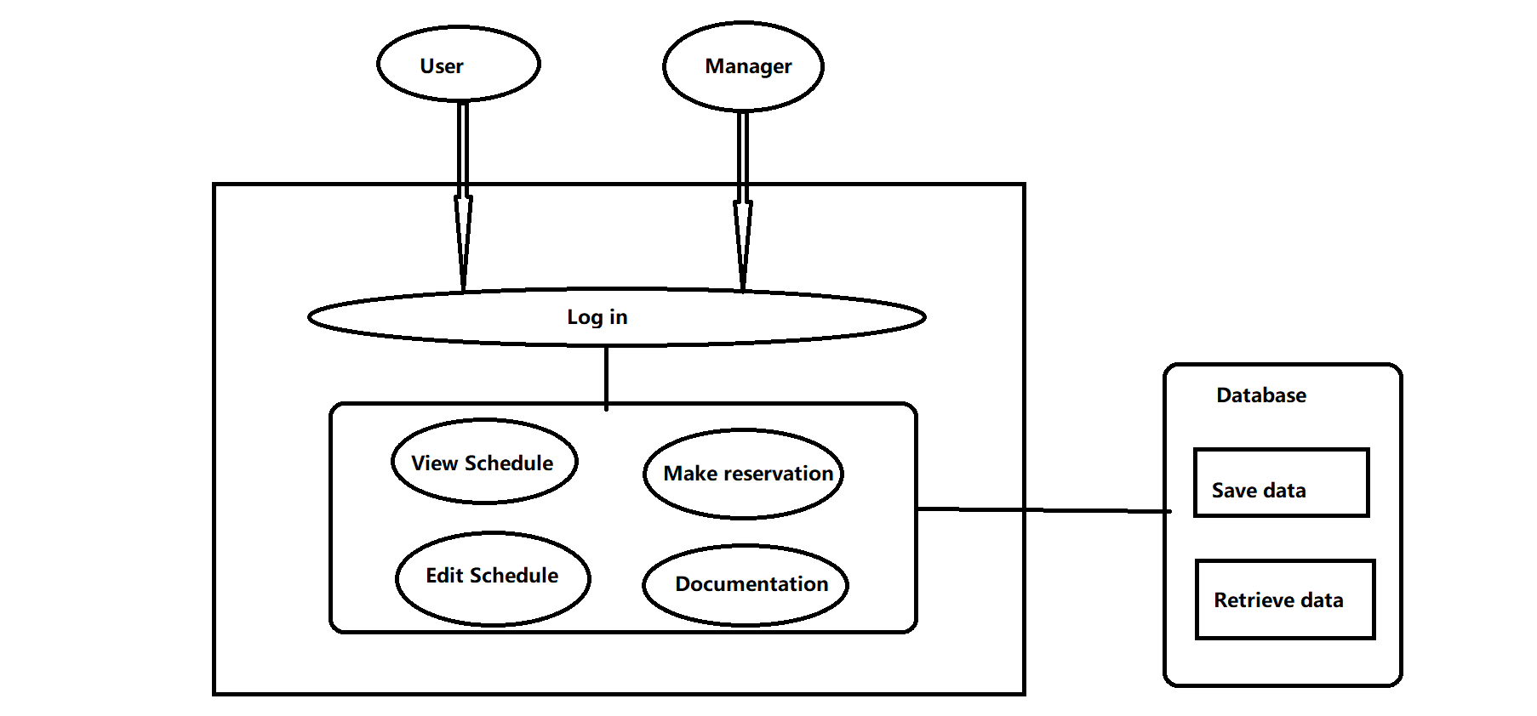

Definitions, Acronyms, and Abbreviations

Acronyms:

ATP: Acceptance Test Plan

Testing Principles Used:

Designated staff will demo the product to the user. Meanwhile, he (she) is going to demonstrate the user requirements along with the expected outputs to the user using a computer.

Overview of Rest of ATP:

The rest of ATP will clarify hardware and software used for testing, test schedule, error handling policy, test sets, individual test cases, log of meetings, project acceptance signatures for client and developer and appendix.

Error handling policy:

Error type 1: catastrophic

Error type 2: impact major functionalities

Error type 3: non-functional errors

Error type 4: neglectable

|  |  |
| --- | --- |
| Error type | Remedy |
| 1 | 25 working days |
| 2 | 20 working days |
| 3 | 10 working days |
| 4 | 5 working days |