

**Acceptance Test Plan**

**Company: Unlimited**

**Company member: Linsong Li, Kehan Meng, Shixian Jing, Nicholas Boanca**

**Date of submission: Feb 19th, 2020**

**Version: 2.4**

**Table of content**

1. Introduction ................................................................................................................................3
   1. Purpose of Acceptance Test .................................................................................................3
   2. Proposed System overview or Configuration Chart ............................................................4
   3. Definitions, Acronyms, and Abbreviations ...........................................................................5
   4. Testing Principles Used .......................................................................................................5
   5. Overview of Rest of ATP .....................................................................................................5
2. Hardware and Software used for testing ..............................................................................5
3. Test Schedule and Test Sets ...........................................................................................................6
4. Error Handling Policy .....................................................................................................................7
5. Individual Test cases ......................................................................................................................7
   1. Name of module, WBS reference Number
   2. Purpose of module
   3. Setup
   4. Action result
   5. Date ana signatures for client and developer
6. Log of Meetings, Reviews and meetings ..............................................................................13
7. Project Acceptance Signatures for client and Developer ....................................................14
8. Appendix .......................................................................................................................................15

**Introduction**

**Purpose of ATP**

ATP is a testing technique performed to determine whether or not the software system has met the requirement specifications which the requirements include functional requirements and non-functional requirements. ATP is supposed to provide test sets that describe the clusters of the system and demonstrate the main functionalities of the system.

The main purpose of this test is to evaluate the system's compliance with the business requirements and verify if it is having met the required criteria for delivery to end-users. It is a level of software testing where a system is tested for acceptability. ATP is intended to get “written statement” from the user that the product was delivered as promised.

**Proposed System Overview**

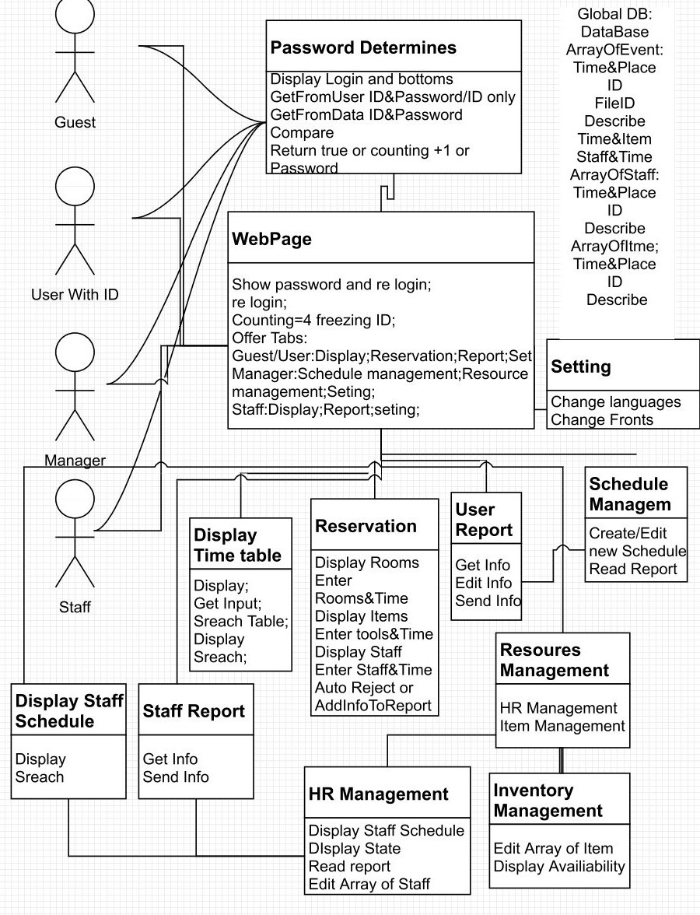

**Definitions, Acronyms, and Abbreviations**

Acronyms

ATP: Acceptance Test Plan

CPU: Central processing unit

OS: Operating system

Definitions

Working days = Mon 8am-5pm, Tue 8am-5pm, Wed 8am-5pm, Thur 8am-5pm.

**Testing Principles Used**

Designated staff will demo the product to the user. Meanwhile, he (she) is going to demonstrate the user requirements along with the expected outputs to the user using a computer.

**Overview of Rest of ATP**

The rest of ATP will clarify hardware and software used for testing, test schedule, error handling policy, test sets, individual test cases, log of meetings, project acceptance signatures for client and developer and appendix.

**Hardware Requirements and Software Requirements**

CPU:

* Dual-core 1.8GHz processor or Quad-core 2.4-3.5GHz CPU, (3.Intel - Core i9-9900X recommended.
* Must 64-Bit CPU and required for VMWare Workstation 8

RAM:

* 4GB DDR3 (32GB recommended)

Network Interface:

* Network interface for BACSS test software port 1(must be wired to connect to the DUT)

OS:

* Windows 10 Version (1903.18362.592)

Web Browser:

* Google Chrome (Version 80.0.3987.87)

**Test Schedule and Test Sets**

|  |  |  |  |  |  |
| --- | --- | --- | --- | --- | --- |
| No. | FWBS No. | Test description | Executor | Date | P/F |
| T1 | 2.1 | Create/edit ID | Linsong | 04/6/2020 |  |
| T2 | 1.1.1 | Getting ID & Password and compare, return | Nicholas | 04/07/2020 |  |
| T3 | 1.1.2 | Getting ID & Question, return password | Nicholas | 04/07/2020 |  |
| T4 | 1.1 | Check the routing of  Login fail times, or Login. Check if giving the Password | Nicholas | 04/07/2020 |  |
| T5 | 1.2.1.1 1.2.1.1.1 1.2.1.1.2 | Check display & Search | Shixian | 04/11/2020 |  |
| T6 | 1.2.1.2 1.2.2.1.1 | Check output Check if input (Enter staff & time) auto form a report to manager Check if Auto rejection works | Linsong | 04/10/2020 |  |
| T7 | 1.2.2.1.2 | Check if got a report Check create/edit schedule | KeHan | 04/08/2020 |  |
| T8 | 1.2.2.2.1.1 1.2.2.2.1.4 | Check the display of schedule Check the display of staff availability | Shixian | 04/11/2020 |  |
| T9 | 1.2.2.2.1.2 | Check if get report | Shixian | 04/11/2020 |  |
| T10 | 1.2.2.2.1.3 | Check edit staff schedule | KeHan | 04/08/2020 |  |
| T11 | 1.2.2.2.2.1 1.2.2.2.2.2 1.2.2.2.2.3 | Check if Edit items schedule | KeHan | 04/08/2020 |  |
| T12 | 1.2.2.2.2.4 | Check the display of items availability | Linsong | 04/10/2020 |  |
| T13 | 1.2.1.3 1.2.3.2 | Check if from a report to the manager | Linsong | 04/10/2020 |  |
| T14 | 1.2.3.1 | Check the display of staff time table Check if able to search time table | Linsong | 04/10/2020 |  |
| T15 | 1.2.4 | Check if changes the languages and Fronts | KeHan | 04/12/2020 |  |
| T16 | 2.2 | Check the back up | Linsong | 04/10/2020 |  |

**Error handling policy**

|  |  |  |
| --- | --- | --- |
| Error Type | Category | Action |
| 1 | Major functionalities errors: 25 working days to fix | Talk to the client and rebuild system functionalities |
| 2 | Minor functionalities errors: 20 working days to fix | Revise code and validate such errors using more test cases |
| 3 | Non-functional errors: 10 working days to fix | Optimize code to improve efficiency |
| 4 | Neglectable errors: 5 working days to fix | Talk to the client regarding neglectable errors and fix the errors based on the feedback |

**Individual Test Cases**

**T1**

|  |  |
| --- | --- |
| **Test Number** | T1 |
| **FWBS Module** | Create accounts |
| **FWBS Number(s)** | 2.1 |
| **Purpose** | Allow a user to create an account. |
| **Interactive Demo** | <https://xd.adobe.com/view/9208aa1d-d2e6-4dde-59ca-efd716b9d8ff-e439/?fullscreen&hints=off> |

**T1 Action**

|  |  |
| --- | --- |
| **Case:** Correct username and password. | |
| **User Action** | **Input** |
| type username in appropriate field | ValidGuy39 |
| type password in appropriate field | validPhrase1 |
| type email in appropriate field | ValidGuyMail@Yoohoo.ocm |
| button click | Click ‘Create Account’ |
|  | |
| **Output** | |
| system message | Display confirmation message. |
|  | |
| **Signatures**  User: ________________________ Company: ________________________ Date: _______________ Comments: | |

**T2**

|  |  |
| --- | --- |
| **Test Number** | T2 |
| **FWBS Module** | Login |
| **FWBS Number(s)** | 1.1, 1.1.1 |
| **Purpose** | Input correct and incorrect data to test login. Correct data means a valid username and valid password. Incorrect data means an invalid username and/or invalid password. |
| **Interactive Demo** | <https://xd.adobe.com/view/9208aa1d-d2e6-4dde-59ca-efd716b9d8ff-e439/?fullscreen&hints=off> |

**T2 Action**

|  |  |
| --- | --- |
| **Case:** Valid and correct user data is input. A valid login will navigate the user to the home page with user privileges enabled. | |
| **User Action** | **Input** |
| username field | Crrct_Usr68 |
| password field | validpassword1 |
| button | ‘Login’ |
| **Input** | |
|  | |
| **Output** | |
| user page | Navigates users to the home page with login privileges. |
|  | |
| **Signatures**  User: ________________________ Company: ________________________ Date: _______________  Comments: | |

**T2 Action**

|  |  |
| --- | --- |
| **Case:** Wrong username and/or password. Must display a message to the user stating the expected error. | |
| **User Action** | **Input** |
| type username in appropriate field | LoserUser123 |
| type password in appropriate field | _ |
| button click | click ‘Login’ |
|  | |
| **Output** | |
| system message | Display the expected error message of invalid login. |
|  | |
| **Signatures**  User: ________________________ Company: ________________________ Date: _______________ Comments: | |

**T3**

|  |  |
| --- | --- |
| **Test Number** | T3 |
| **FWBS Module** | Recover password |
| **FWBS Number(s)** | 1.1.2 |
| **Purpose** | Allow a user to set a new password by answering a valid recovery question |
| **Interactive Demo** | <https://xd.adobe.com/view/9208aa1d-d2e6-4dde-59ca-efd716b9d8ff-e439/?fullscreen&hints=off> |

**T3 Action**

|  |  |
| --- | --- |
| **Case:** User forgot password button. System ask’s user for recovery questions and if valid allows the user to input a new password. | |
| **User Action** | **Input** |
| email | validJohnSmith@Yoohoo.com |
| button click | click ‘Recover Password’ |
|  | |
| **Output** | |
| system message | Display expected message. |
|  | |
| **Signatures**  User: ________________________ Company: ________________________ Date: _______________ Comments: | |

**T3 Action**

|  |  |
| --- | --- |
| **Case:** Invalid recovery question for password recovery. Error messages stating the recovery question was invalid. | |
| **User Action** | **Input** |
| email | notAnEmail@whooops.com |
| button click | Click ‘Recover Password’ |
|  | |
| **Output** | |
| system message | Display the expected error message. |
|  | |
| **Signatures**  User: ________________________ Company: ________________________ Date: _______________  Comments: | |

**Log of Meetings, Reviews, and Meetings**

1st Meeting:

Date: Daktronics Room 112 3pm. Feb 5rd

Attendees: Kehan M, Linsong L, Nicholas B, Shixian J.

Objective: Review proposal and assign tasks

Detail: assign tasks: Kehan M (Introduction, Error Handling Policy)

Linsong L (Test Schedule, Test Set, System Overview)

Nicholas B (Individual Test Cases)

Shixian J (Hardware and Software used for testing, Log of meeting, Project Acceptance Signature for Client and Developer, Appendix)

2nd Meeting:

Date: Daktronics Room Lab 4.15pm-6.00pm. Feb 7rd

Attendees: Kehan M, Linsong L, Nicholas B, Shixian J.

Objective: Review work and problems solve.

Detail: Shixian J 50% work completed

Nicholas B 70%

Kehan M 60%

Linsong L 100%

Problem: Shixian J has a problem whih what the Appendix is.

3rd Meeting:

Data: Daktronics Room 112 4.15pm-4.30pm. Feb 12th

Attendees: Kehan M, Linsong L, Nicholas B, Shixian J.

Objective: Review work and discuss the part of Error Handling Policy

Detail: We discussed some issues of “Error Handling Policy”)

4th Meeting

Date: Daktronics Room 112 4.15pm-5.00pm. Feb 14th

Attendees: Kehan M, Linsong L, Nicholas B, Shixian J.

Objective: Problems discuss and say the working deadline.

Detail: Discussed when is the deadline and how we integration all items.

**Project Acceptance Signatures for Client and Developer**

**Client Info**

**Company** ____________________________ **City** ______________________________________

**State** ________________________________ **Postal Code** _______________________________

**Phone** _______________________________

Acceptance of Agreement:

I certify that I have received all project deliverables from Unlimited Company and that all deliverables have been demonstrated, delivered or otherwise completed to my satisfaction. I further certify and release Unlimited Company, from any further obligation, support or duty concerning this project, including any and all continued support services. I understand that by signing this agreement, I release Unlimited Company from any and all liability, tort or claim concerning this project, its files, source code, object code, programming or other materials, whether printed or digital, provided to the client. I further understand that all files provided to me under this or any other agreement are to be used at my sole risk and responsibility and all files should be tested prior to publication or any mass distribution in any format.

Unlimited Company is not responsible for any results obtained from the use of any software, materials, presentation or products provided to the client under this agreement.

**Client’s Signature** ______________________________________________________________

**Developer Signature** ____________________________________________________________

**APPENDIX**

CPU- Central processing unit, or CPU, is arguably the most important component of any computing device. It handles basic instructions and allocates the more complicated tasks to other specific chips to get them to do what they do best. It’s the core of your PC, smartphone, or tablet. and it’s what makes the whole device run as it should.

RAM- RAM (pronounced ram) is an acronym for random access memory, a type of computer memory that can be accessed randomly; that is, any byte of memory can be accessed without touching the preceding bytes. RAM is found in servers, PCs, tablets, smartphones and other devices, such as printers.