

XJTLU Entrepreneur College (Taicang)
Module Code and Title | ENT208TC Industry Readiness
School Title | XJTLU Entrepreneur College (Taicang)
Assignment Title | Technical Documentation
Submission Deadline | Friday 15 May, 2026 before 23:59 (Beijing Time, GMT+8)
Session and Group | [Session 3 — Group 9]
Student IDs | 2363487, 2360947, 2363117, 2364001, 2363260, 2364144, 2359945, 2363916
Final Word Count | 2693
If you agree to let the university use your work anonymously for teaching and learning purposes, please type “yes” here. | yes
I certify that I have read and understood the University’s Policy for dealing with Plagiarism, Collusion, and the Fabrication of Data (available on Learning Mall Online). With reference to this policy, I certify that:
- My work does not contain any instances of plagiarism and/or collusion. My work does not contain any fabricated data.
By uploading my assignment onto Learning Mall Online, I formally declare that all of the above information is true to the best of my knowledge and belief.
Scoring — For Tutor Use
Student ID | 2363487, 2360947, 2363117, 2364001, 2363260, 2364144, 2359945, 2363916
Stage of Marking | Marker Code | Learning Outcomes Achieved (F/P/M/D) |  |  |  |  | Final Score
 |  | A | B | C | D | E
1st Marker — red pen
Moderation — green pen | IM Initials | The original mark has been accepted by the moderator: Y / N |  |  |  |  | Y / N
2nd Marker if needed
Comprehensive technical reference enabling another developer to understand, maintain, and deploy your product. Includes a strategic IP analysis section. Target length: 6–9 pages (excluding references and cover page). File name: Session[X]Group[Y]_TechnicalDoc.docx

Section 1 — System Architecture
Component Description：
The system is divided into 5 layers: Hardware Sensors, MQTT Cloud Broker, Android Application Layer, Local Storage Layer, and External Services.
Hardware Sensors — 5 environmental sensors (Temperature/Humidity/Light/Soil Moisture/CO₂) and 5 actuator types (Fan/Humidifier/Water Pump/Alarm/Grow Light). Sensors report 15 data fields to the cloud broker via MQTT protocol.
MQTT Cloud Broker — Deployed at 47.109.89.8:1883, using the Paho Java client. The APP subscribes to sub_topic to receive sensor data and publishes control commands to pub_topic. Auto-reconnect is supported (check every 10 seconds).
Android Application Layer — 6 Activities, with MainActivity as the entry point, integrating the MQTT client and handling all device control logic; the other 5 Activities are launched via Intent, each independently responsible for a specific function.
Local Storage Layer — All using SharedPreferences, no database. Login credentials, current sensor snapshot, and historical records (JSON array, max 50 entries) are stored separately.
External Services — DeepSeek API (deepseek-v4-pro) provides AI agricultural Q&A; the system camera/gallery provides image sources for the image recognition module.
Component Diagram — System Modules & Connections：(The detailed figures are shown in Appendix Figure1 )
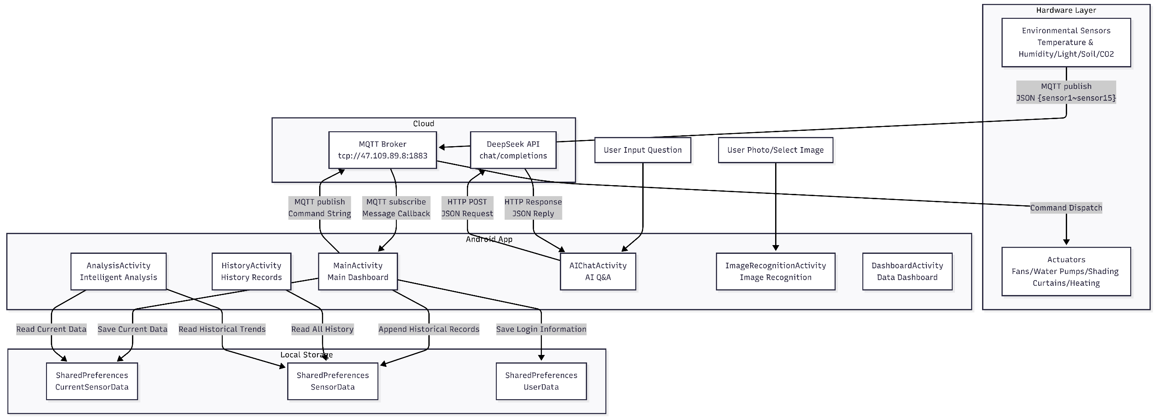
Data Flow Diagram — Data Movement Through the System：(We have three parts to exactly displays the complete data flowing, Shows in the appendix Figure2 Figure3 Figure4)
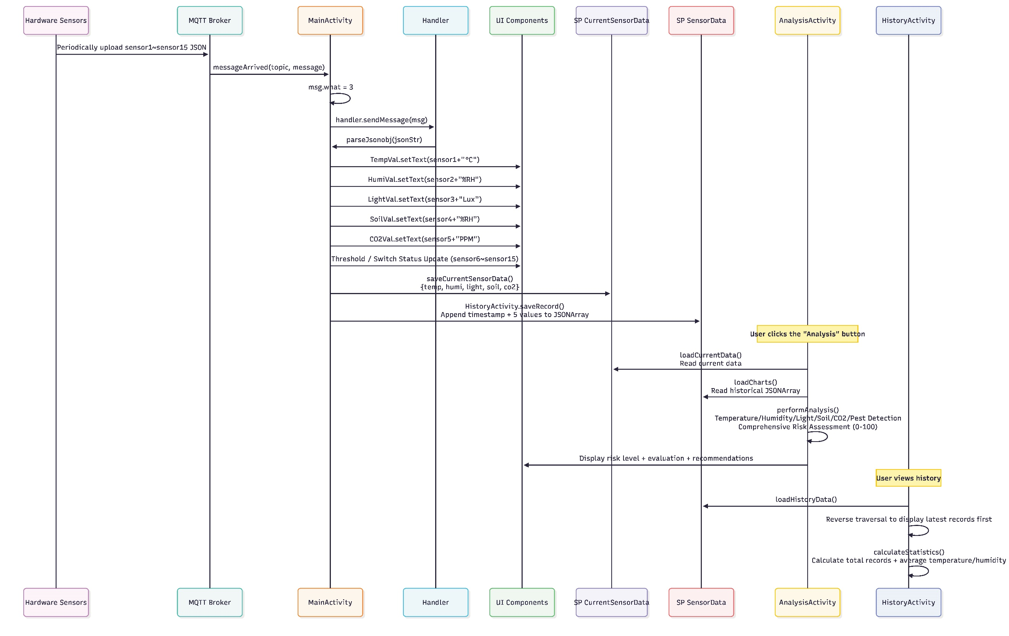
Data Flow Path | Trigger Source | Key Components / Actions | Endpoint/Output
Sensor Data Flow  Hardware → Cloud → App | 5 sensors | MQTT publish→messageArrived()callback→parseJsonobj() parses15 fields→UpdateUl→ Write to CurrentSensorData & SensorData.history_data→AnalysisActivity executes expert rules engine→HistoryActivity calculates statistics | DashboardActivity WebView + Chart.js charts / RecyclerView history data / Risk assessment report
Control Command Flow  User → App → MQTT → Actuators | User action Mode / Switch /Threshold controls | Mode/Switch/Threshold controls trigger OnCheckedchangeListener → publishmessageplus() sends text commands → Hardware receives and drives relays | Fans, pumps, and other actuators
AI Chat Flow  User → App → DeepSeek API → Reply | User input | AIChatActivity builds JSON request → OKHttp async POST→ Parse choices[0].message.content → Display in RecyclerView | Agricultural expert system response
Image Recognition Flow  User → Photo/Capture → App → Mock Result | User takes photo or selects from gallery | startActivityForResult() gets Bitmap Preview → Click "Start Recognition" → 2-second simulated delay → Display 5 fields | Confidence/Symptoms/Causes/Treatment suggestions / Prevention measures
Data Flow Explanation：
Technology Stack Overview：
The table below summarizes all technology components, frameworks, and tools used in the project:
Architecture Design Highlights：
Unidirectional Data Flow — Sensor data only flows MQTT → APP; control commands flow APP → MQTT; no two-way binding
Loose Coupling Between Activities — 6 Activities communicate via Intent navigation; shared data through SharedPreferences (no EventBus / LiveData)
Network-Independent Design — Core device control functions do not depend on external APIs; MQTT disconnection only shows a Toast warning without affecting UI operations
Hybrid UI Rendering — Native Android View system + WebView static HTML dual-track, dashboard is a pure frontend implementation
Simulated Recognition Phase — ImageRecognitionActivity currently uses Mock data (predefined root rot + spider mites), can be upgraded to a real CV model later
Local-First Strategy — Historical records capped at 50 entries stored locally; analysis engine uses client-embedded expert rules (no cloud computation needed)
Component overview
The component overview above shows how the hardware sensors, MQTT broker, Android application, local storage, and external services cooperate to support real-time monitoring, device control, AI Q&A, and simulated image recognition.
Typical User Interaction Data Flow
A typical user journey starts when the user opens the Android application and logs in with the MQTT subscription and publish topics. After the hardware sensors collect environmental data such as temperature, humidity, light intensity, soil moisture, and CO₂, the device publishes these readings to the MQTT broker. The Android app subscribes to the relevant topic and receives the incoming message through the messageArrived() callback. The received JSON data is parsed into sensor fields, displayed on the dashboard, and saved locally in SharedPreferences as the current sensor snapshot and historical records.
When the user checks the dashboard, the app presents real-time values, historical charts, and risk analysis results. If the user changes a control setting, such as turning on the fan or water pump, the app publishes a command to the MQTT topic. The hardware receives the command and activates the corresponding actuator. For AI chat, the user sends a question to the DeepSeek API, and the returned agricultural advice is displayed in the chat interface. For image recognition, the current prototype uses a simulated recognition result after the user uploads or captures a plant image, and this can be replaced by a real computer vision model in future development.

Section 2 — Technology Justification
Tool | What we chose | Alternatives considered | Why we chose this
Hardware Platform Selection | Version 2.0 with Wi-Fi module and extended sensor support  We therefore selected Version 2.0 with an integrated Wi-Fi module. The Wi-Fi capability enables: ①Real-time remote data transmission; ②Cloud data storage; ③Remote monitoring through a mobile or web application; ④Future AI-based analysis using uploaded sensor data; ⑤Integration with online dashboards and notifications; ⑥Scalability for future smart farming features | Version 1.0 without Wi-Fi module  At the beginning of the project, we considered using a simpler Version 1.0 hardware design without Wi-Fi connectivity. This design focused only on local sensor monitoring and basic display functions. The main advantages of Version 1.0 were lower cost, easier assembly, reduced power consumption, and fewer hardware compatibility issues. However, the limitations of Version 1.0 became clear during requirement analysis. Since the project objective is to build an intelligent smart agriculture monitoring system, local-only monitoring would significantly reduce the usefulness of the platform. Without Wi-Fi communication, sensor data could only be viewed directly on the device, meaning users could not remotely access environmental conditions or perform cloud-based analysis. | Version 2.0 allows real-time data transmission, remote monitoring, cloud connectivity, and supports more sensors. Although it is more expensive and slightly more complex to assemble, it greatly improves the scalability and practical value of the project.
Software System Design | Multi-functional intelligent platform with multiple pages and AI-assisted features  Therefore, we selected a more advanced software platform containing:①Historical data records and trend visualization; ②AI assistant analysis; ③Current environmental condition analysis; ④Photo-based plant disease and pest recognition; ⑤Multiple user interface pages; ⑥Intelligent recommendations for plant management; ⑦Real-time environmental monitoring  This design improves usability and demonstrates stronger alignment with real-world agricultural applications.  One of the most important reasons for this decision is scalability. By designing a multi-page intelligent platform, future functions such as predictive analysis, automatic irrigation recommendations, or cloud-based machine learning models can be added more easily.  The main trade-offs include:①Increased software complexity; ②More development and testing time; ③Higher memory and processing requirements; ④Greater need for UI/UX design consistency; ⑤Increased integration challenges between hardware and software | Basic monitoring interface with only real-time sensor display and manual controls  The first option was a lightweight monitoring interface focused only on core functionality. This version would display real-time sensor readings such as temperature, humidity, soil moisture, and gas concentration. It would also support simple threshold settings and manual control functions.  The advantages of this simpler software design included:①Faster development time; ②Lower system resource usage; ③Easier debugging and maintenance; ④Reduced UI complexity; ⑤Lower hardware performance requirements  However, this design lacked intelligent interaction and long-term data analysis capabilities. Since modern smart agriculture systems rely heavily on data-driven decision making, a basic interface would not fully demonstrate the value of the project | The advanced platform better supports real-world agricultural scenarios by integrating AI analysis, historical records, disease detection, and data visualization, making the system more practical and user-friendly.
Hardware Platform Selection
During development, several technical risks affected our technology choices. Wi-Fi instability could interrupt real-time data transmission, so we ensured the system could still display sensor data locally without internet access. Integrating multiple sensors also created challenges such as calibration issues and inaccurate readings, which we addressed through repeated testing and calibration.
In addition, the platform’s advanced features increased software complexity, memory usage, and debugging difficulty. To manage this, we used a modular software design with separate components and pages. AI-based disease detection also carried accuracy risks, so it was designed as an assistive recommendation tool rather than a fully automatic diagnosis system. Finally, to balance cost and scalability, we focused on features with the highest practical value while keeping the system expandable for future upgrades. Some additional technology choices are shown in Appendix.
Section 3 — Deployment Guide
Environment requirements
Requirement | Version / Notes
Android Studio | Hedgehog (2023.1.1) or later
Gradle | 8.0+ (bundled wrapper)
Android SDK | compileSdk 33, minSdk 28
Java | 1.8+
Device / Emulator | Android 9.0 (API 28) or higher
Internet | Required for MQTT & DeepSeek API
Setup steps
- Clone the repository:
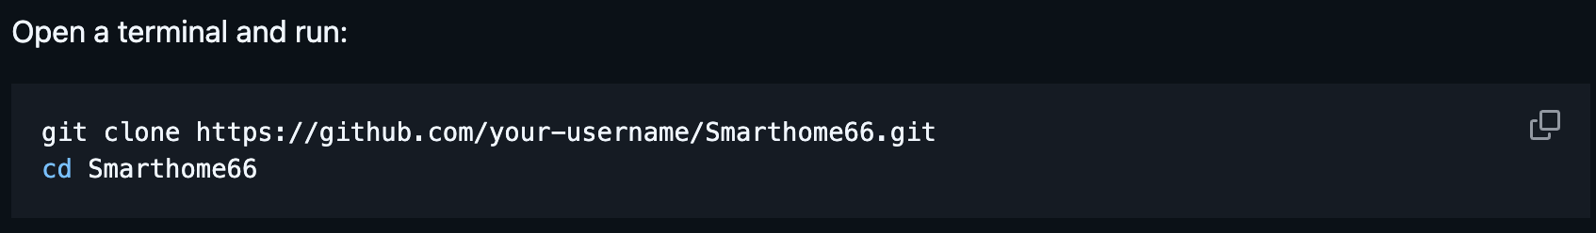
- Install dependencies:
We have released the android app apk on the GitHub (https://github.com/iuany7/Greenhome). Normal users can download and install the APK directly on an Android device without configuring additional development dependencies. Developers who want to modify the source code can open the project in Android Studio and follow Method B below.
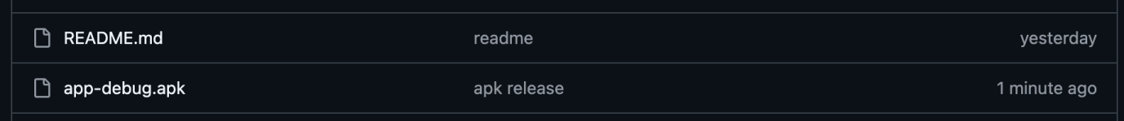

- Configure environment variables:
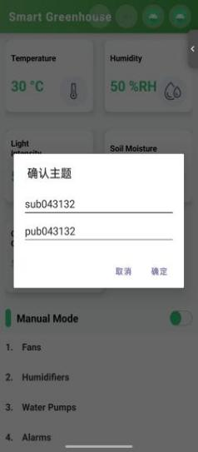
When you first open the app, a login dialog appears:
Username → This becomes your MQTT subscription topic (the app listens for sensor data on this topic).
Password → This becomes your MQTT publish topic (the app sends equipment commands on this topic).
Credentials are saved locally in SharedPreferences and auto-filled next time.
- Run the application:
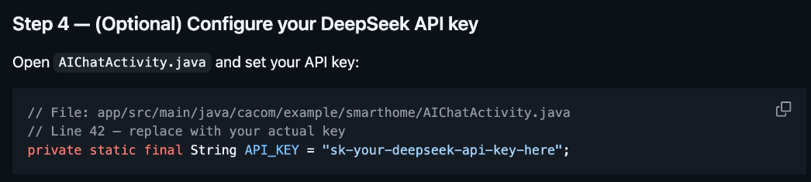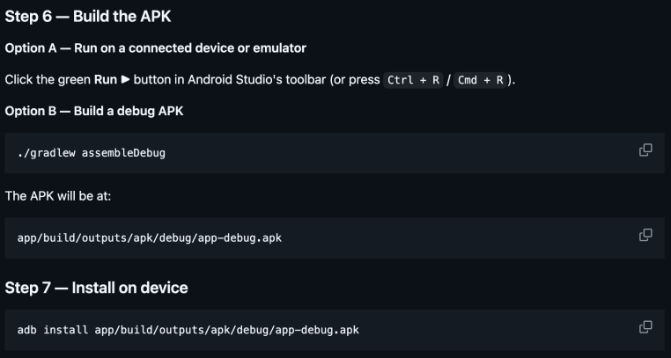

- Verify it is working:
After enabling your mobile hotspot with the name "abcd" and password "12345678" and connecting to the real-time hardware, the displayed data will begin to change to true real-time data.
Common issues and solutions
Problem 1：The app keeps saying "Image too blurry" or fails to recognize a plant disease even on a clear photo
Likely cause | Solution
Low image quality or mismatch between real field conditions and training data. The user may have taken a photo under poor lighting, with motion blur, or of an early-stage symptom that the mock (or real) model hasn't been trained well on. | 1. Retake the photo in good lighting, holding the camera steady. 2. Ensure the leaf fills most of the frame and is not overlapping with other leaves. 3. If using the mock version, note that results are simulated; for actual deployment, the team will integrate a quality assessment module to prompt retakes. 4. Check that the disease is among the currently supported list (e.g., root rot, spider mites).
Problem 2: I turned on a switch in the app, but the fan/pump didn't start, and there's no error message.
Likely cause | Solution
MQTT command not successfully published or hardware not connected. The likely cause is that the MQTT broker address or topic is misconfigured, the device is offline, or the command string format is incorrect (e.g., missing "Switch1ON"). Also, the app may not have received a publish acknowledgement. | 1. Check that the hardware is powered on and connected to Wi-Fi. 2. In the app, verify that the MQTT connection status shows "Connected". 3. Try toggling the switch again while watching the logs. 4. For debugging, the development team should implement a simple acknowledgement mechanism (e.g., hardware publishes a "received" message). 5. As a workaround, restart the app and re-power the device.

Section 4 — IP Strategy
Novelty analysis
Unlike the prior art above, this project uses a lightweight cloud-native architecture with a public MQTT broker and an Android client. The system prioritises rapid UI/UX prototyping by using a mock image recognition module that simulates disease detection results without requiring a real AI model. This approach allows the team to validate the complete user workflow (photo capture → analysis display → treatment suggestions) before investing in model training or API integration.
Key difference summarized in one table:
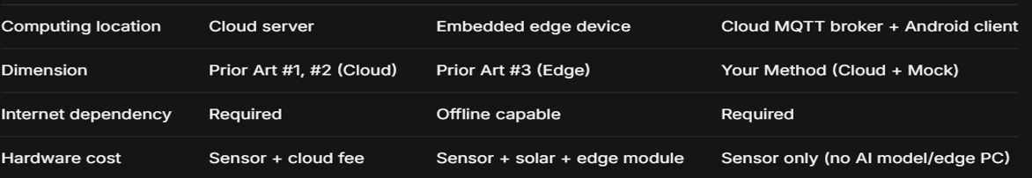
Prior art (2–3 examples)
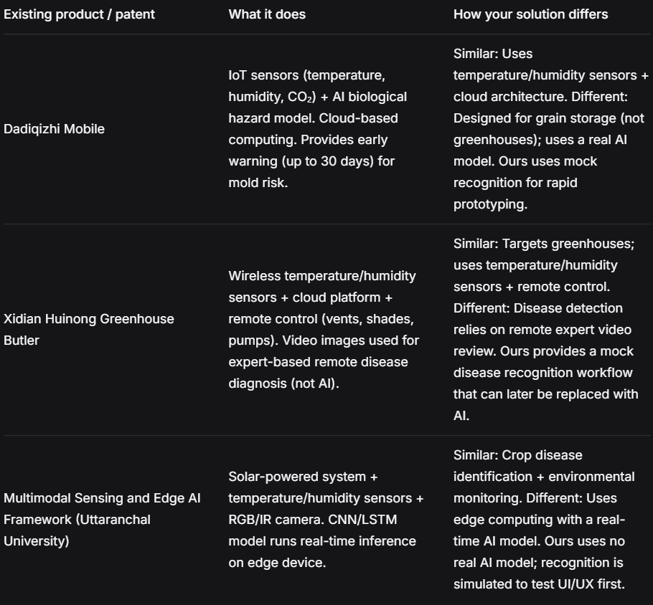
Patent decision
Decision: NO (do not file a patent at this stage)
- Cost：A Chinese Utility Model costs ¥500-2,000 (filing + basic attorney fees), plus annual maintenance fees. An Invention Patent costs significantly more (¥3,000-10,000+).
- Time：Utility Model: 6-12 months to grant. Invention Patent: 2-4 years. Our project timeline (10 weeks) does not align with patent prosecution. Also, we still need some time to improve our work.
- Novelty：The core idea ("sensor → MQTT cloud broker → Android app → mock recognition") is a combination of existing standard technologies, not a novel invention. The image recognition is currently simulated (mock), not a working AI model. Utility Models do not cover methods (only structures). An Invention Patent would be required, but the approach is incremental over prior art 2 and 3. A patent examiner would likely reject for obviousness.

Alternative protection
Recommendation: Open source the Android app code, APK deployment instructions, and non-sensitive prototype documentation. Keep hardware calibration rules, MQTT topic configuration, threshold settings, supplier notes, and future dataset/model-training plans as internal know-how.
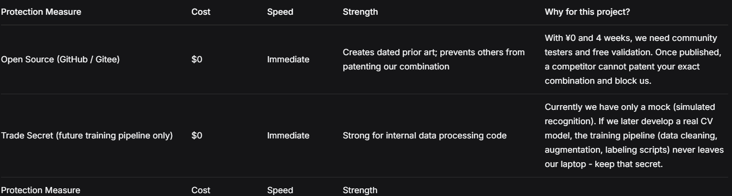
Section 5 — Limitations & Future Work
Known limitations
Limitation | Why it exists | Impact on users
Low-quality input images lead to unreliable inference results | When using low-end cameras, low light, motion blur, or improperly exposed mobile images as input, the model's prediction accuracy decreases significantly. | Low-end mobile phone users are prone to unreliable results, requiring multiple retakes and increasing time costs; some users may therefore abandon the tool, limiting the spread of the technology.
Mock image recognition (simulated results, not a real AI model) | Prototype prioritised UI/UX and sensor integration; real CV model requires training data and time, which were outside the 10-week project scope. | Users cannot obtain real disease diagnosis; the recognition feature serves only as a workflow demonstration. Multiple retakes do not improve accuracy, limiting the practical value of the tool
The current hardware devices (such as edge computing nodes and image acquisition terminals) are not designed and installed with physical protective enclosures and are used directly exposed in the field environment. | Prototype development prioritizes the verification of core algorithms and software functions, while the hardware casing design has been postponed; due to project time and budget constraints, mold making or custom processing for the casing has not yet been implemented; | Field equipment is exposed to the external environment; it lacks anti-collision design and is easily damaged by collisions during transportation and operation. The consequences include increased failure rates, higher maintenance costs, and shortened service life.
Future work
Based on the previously mentioned limitations, we will continue to make a series of improvements in the future.
• Planned features or improvements
1. Replace the current mock image-recognition module with a real computer vision model trained on plant-disease images.
2. Add an image-quality check before recognition, so users are asked to retake blurry or poorly lit photos.
3. Improve sensor calibration and threshold settings for temperature, humidity, soil moisture, light intensity, and CO₂.
4. Add an acknowledgement mechanism for MQTT control commands, so the app can confirm whether the hardware actually received and executed a command.
5. Design a protective hardware enclosure to improve safety, waterproofing, cable management, and prototype durability.
• Technical debt to address
Image preprocessing: Logic scattered across frontend, backend, and edge scripts causing inconsistent results; quality assessment not integrated into main pipeline; no unified exception handling, leading to obscure errors.
Inference system: Based on synchronous request-response model, no batch/async support; duplicate loop code across notebooks; no task persistence or checkpoint resumption.
Disease mappings: Hard-coded across four files; augmentation parameters as magic numbers in three notebooks, making experiments irreproducible; model architecture coupled with hyperparameters, preventing flexible configuration.
Hardware: Development boards connected with exposed flying wires on temporary acrylic brackets; no standardized mounting holes or interface orientations, causing inconsistent layouts and preventing reusable enclosure molds.
• Open research question
Is there a universal, computationally efficient image enhancement method that adaptively improves recognition of any low-quality input without retraining?
How to implement efficient batch inference scheduling on resource-constrained edge devices to ensure throughput while meeting latency requirements?
Can self-supervised or few-shot learning achieve zero-shot recognition of novel/rare diseases with only a few labeled samples?
How to design an enclosure for low-cost, low-power edge devices that balances heat dissipation, waterproofing, and dustproofing while reflecting project and environmental themes?
References
Android Developers. (n.d.). SharedPreferences. Retrieved May 14, 2026, from https://developer.android.com/reference/android/content/SharedPreferences
DeepSeek. (n.d.). DeepSeek API docs. Retrieved May 14, 2026, from https://api-docs.deepseek.com/
Eclipse Foundation. (n.d.). Eclipse Paho Java client. GitHub. Retrieved May 14, 2026, from https://github.com/eclipse-paho/paho.mqtt.java
Hughes, D. P., & Salathé, M. (2015). An open access repository of images on plant health to enable the development of mobile disease diagnostics. arXiv. https://arxiv.org/abs/1511.08060
Mohanty, S. P., Hughes, D. P., & Salathé, M. (2016). Using deep learning for image-based plant disease detection. Frontiers in Plant Science, 7, Article 1419. https://doi.org/10.3389/fpls.2016.01419
Python Software Foundation. (2023). Python language reference (Version 3.11). https://www.python.org/

APPENDIX
Section 2:
Additional Technology Choices:
1. Communication Protocol: MQTT instead of HTTP polling;
2. MQTT was selected instead of HTTP polling because sensor data needs to be transmitted continuously with low latency. HTTP polling would require the app to repeatedly request updates, which increases delay, network traffic, and power consumption. MQTT is more suitable for IoT-style communication because the hardware can publish new readings when they are available, while the Android app subscribes to the relevant topic and receives updates automatically. The trade-off is that MQTT requires correct topic configuration and broker stability, but it better supports our real-time monitoring and control workflow.
3. Local Storage: Shared Preferences instead of SQLite or Firebase;
4. Shared Preferences was selected instead of SQLite or Firebase because the current prototype only needs to store MQTT login topics, the latest sensor snapshot, and a limited number of historical records. This keeps the app lightweight, simple to debug, and suitable for a 10-week prototype. SQLite or Firebase would be more powerful for long-term multi-user storage, but they would also increase development complexity. The trade-off is limited scalability, so a real database would be more suitable if the system later expands to multiple users, long-term cloud storage, or larger historical datasets.

Section 3 overall:
The two deployment methods can be described as:
Deployment Method A — Install the APK
1. Open the GitHub repository:
https://github.com/iuany7/Greenhome
2. Download the released APK file from the repository.
3. Transfer the APK to an Android phone running Android 9.0 or above.
4. Allow installation from unknown sources if the phone system blocks the APK installation.
5. Install and open the app.
6. When the login dialog appears:
Username = MQTT subscription topic used to receive sensor data.
Password = MQTT publish topic used to send hardware control commands.
7. Turn on the mobile hotspot using:
SSID: abcd
Password: 12345678
8. Power on the hardware device and connect it to the hotspot. If the MQTT connection succeeds, real-time sensor data should begin updating in the app.
Deployment Method B — Run from Android Studio
1. Clone the repository from GitHub.
2. Open the project in Android Studio Hedgehog 2023.1.1 or later.
3. Make sure Android SDK compileSdk 33, minSdk 28, Gradle 8.0+, and Java 1.8+ are installed.
4. Sync Gradle and wait until all dependencies are resolved.
5. Connect an Android phone or start an emulator with Android 9.0 or above.
6. Build and run the app from Android Studio.
7. Use the same MQTT topic login and hotspot setup described in Method A.

Since the previous images were too blurry, you can view the images used earlier here to assist your understanding:
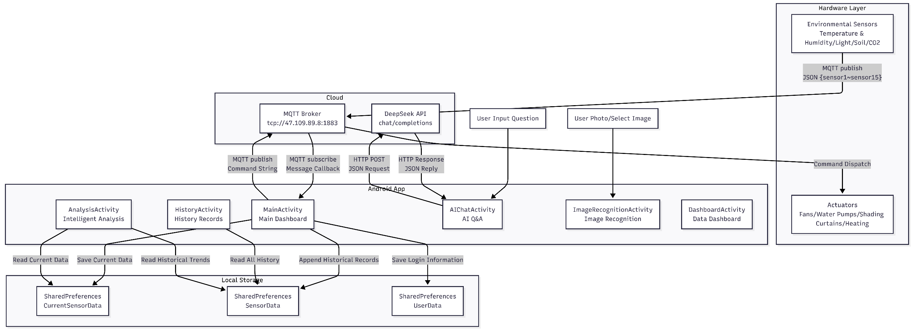
Component Diagram — System Modules & Connections：
Figure 1. Component Diagram — System Modules & Connections
Data Flow Diagram — Data Movement Through the System:
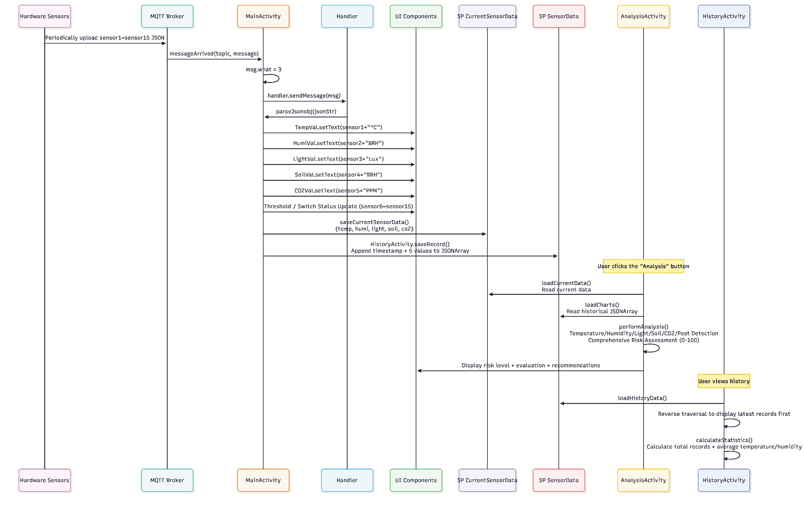
//We divide the data flow diagram into three parts to exactly display the data flowing
Figure 2. Data Flow Diagram - Overall Data Interaction
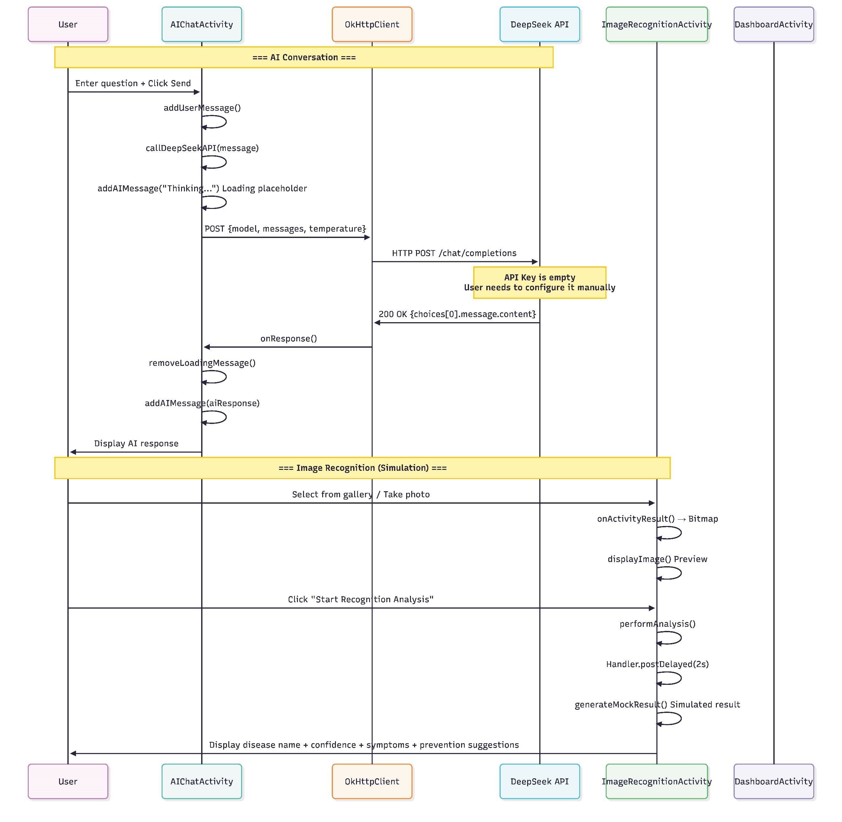
Figure 3. Data Flow Diagram - Software control

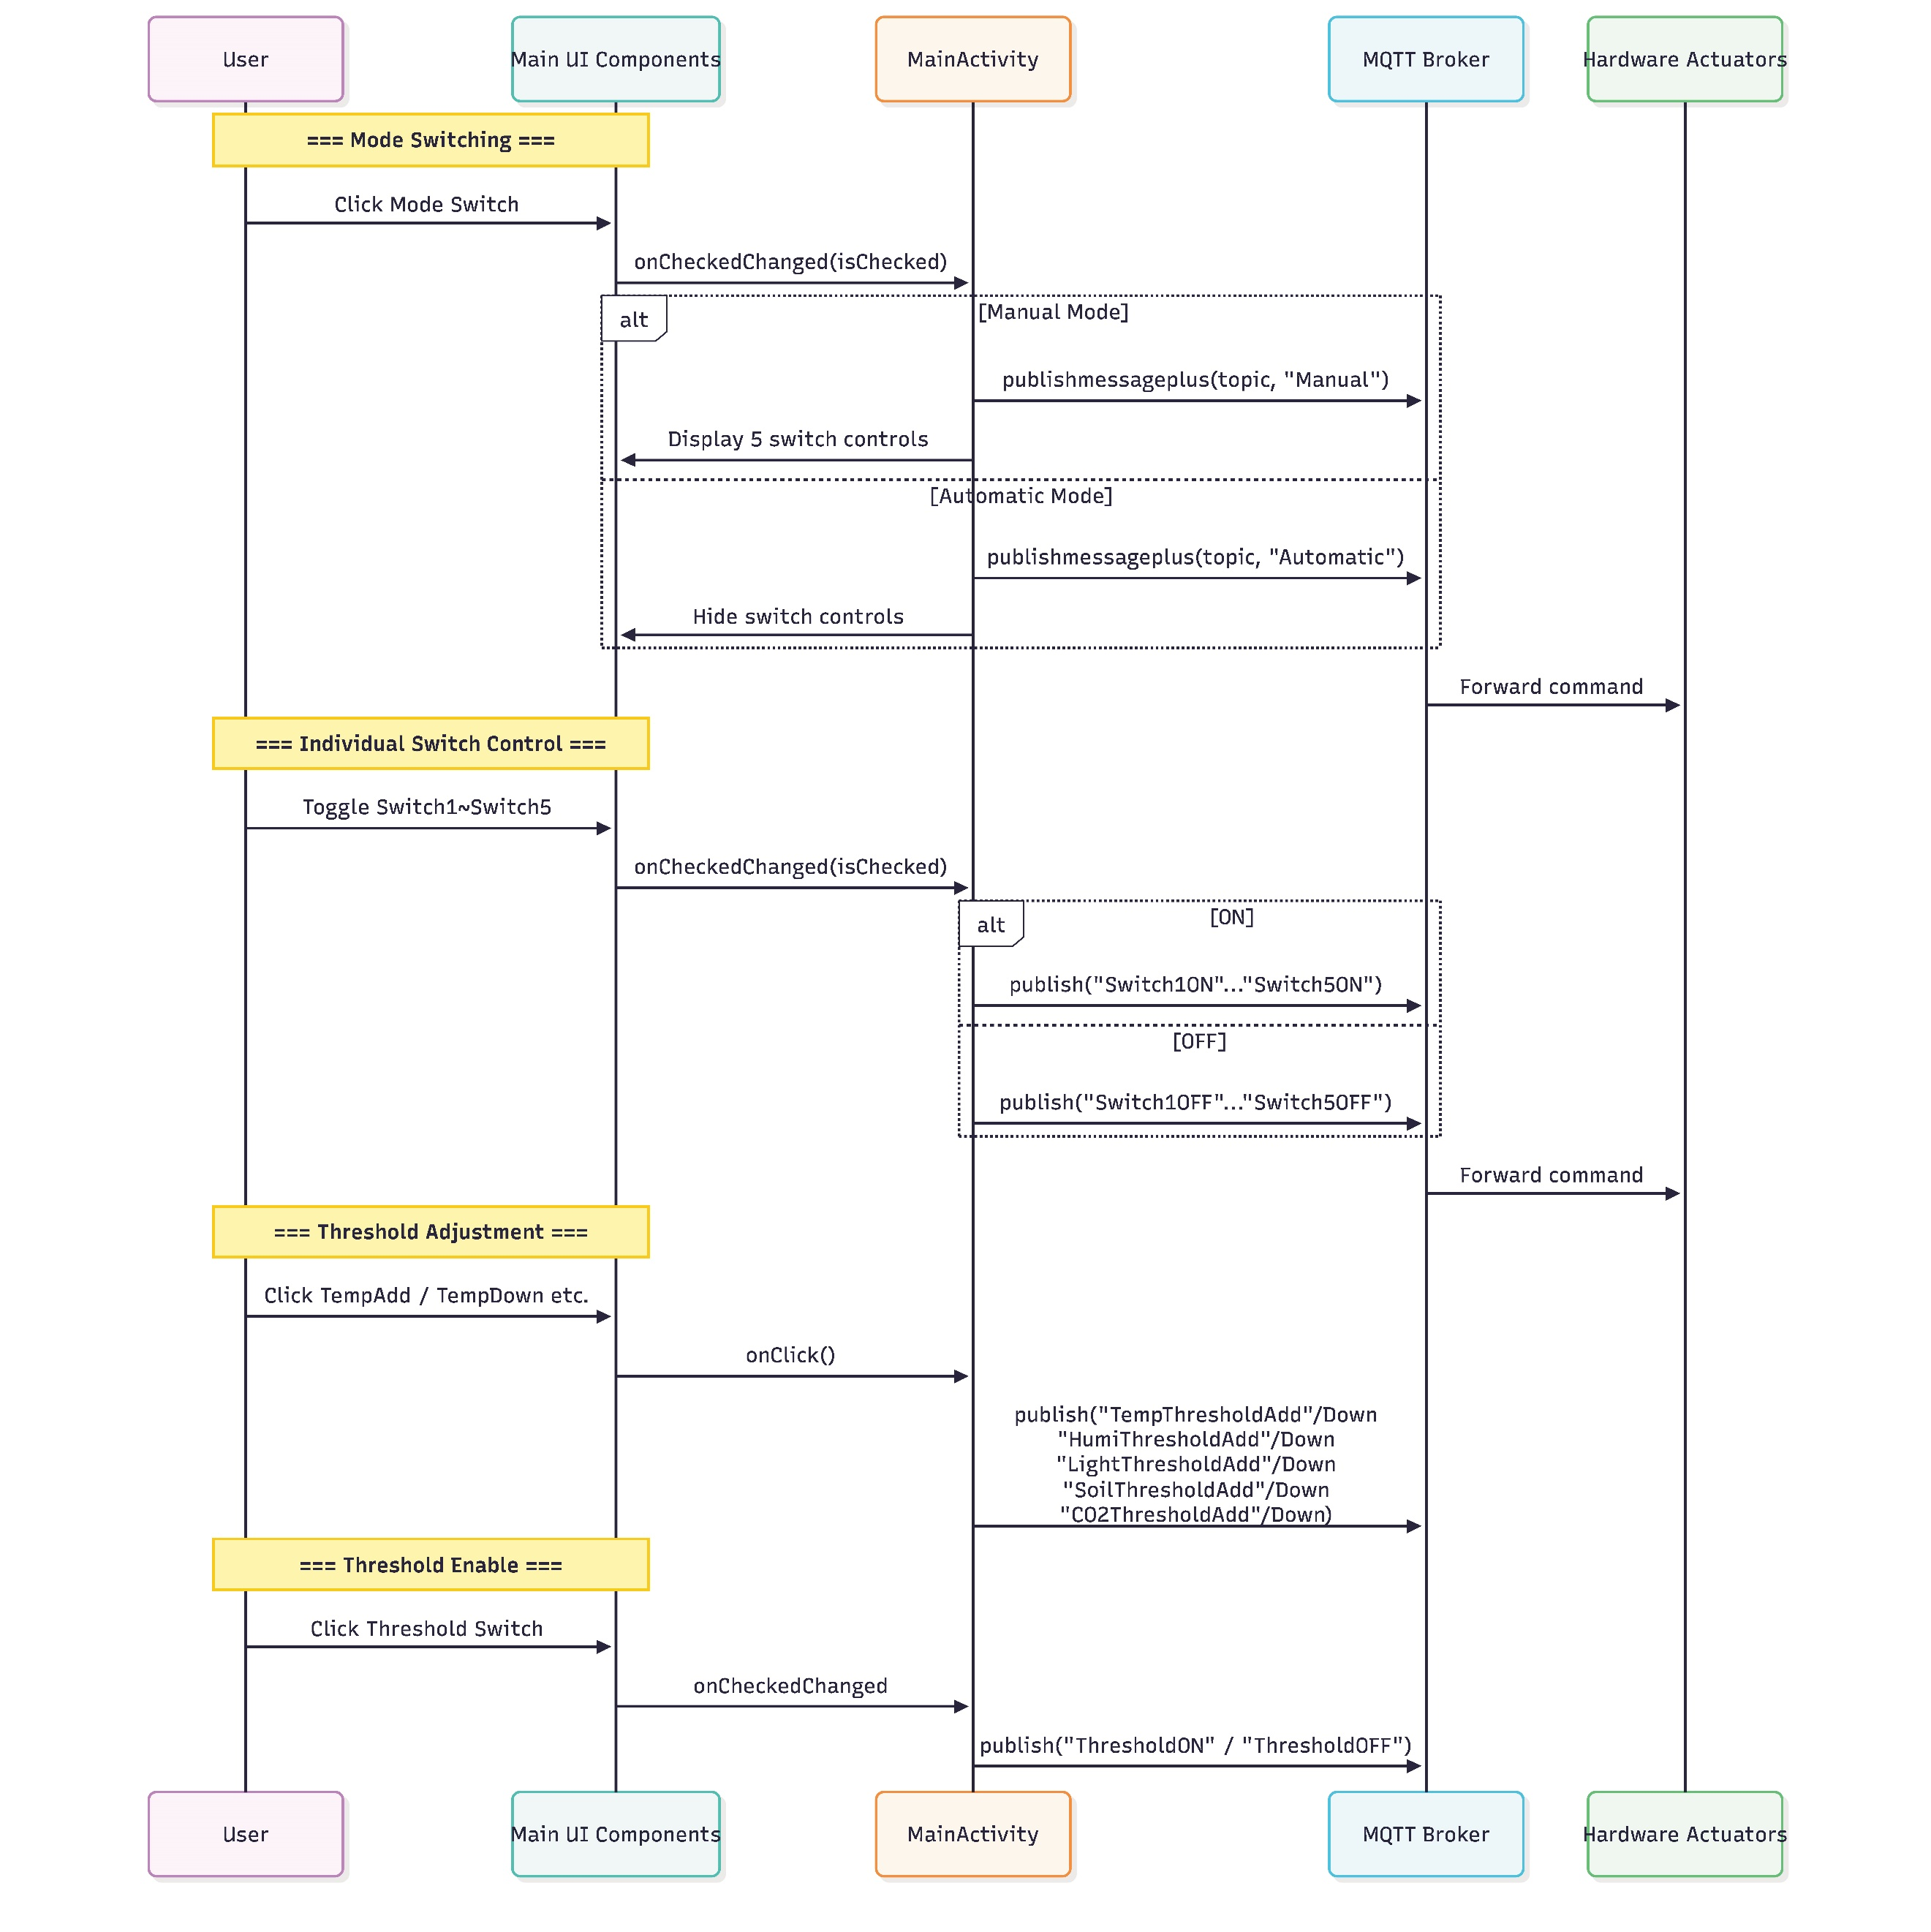
Figure 4. Data Flow Diagram - Hardware control

