ENT303TC Team Charter — Week 1
Date: 2026-09-09
Team name: GreenSight_AI

Evidence hub: https://github.com/LLX-233/ENT-Y4S1
Communication: 👑 冯恺 2360947 nb666 | Expected reply: 24 hours on weekdays
Members (roles from ENT208 DevLog; continued into ENT303)
Name | Student ID | Role | This semester responsibility
Yufan Shi | 2363487 | Product Manager (group leader) | Overall progress, task assignment, supervision pack, Charter/Baseline
Kai Feng | 2360947 | User Researcher | Fresh user interviews/tests; validate App UX and scientific-control value
Peile Yu | 2363117 | Technical Lead | Software–hardware integration; architecture for model → actuator path
Jiahao Liu | 2364001 | Frontend Developer | App UI upgrade (user-friendly dashboard/control)
Guangyao Shen | 2363260 | Backend Developer | Data/control backend; support model inference path and logging
Qizhe Tang | 2364144 | Hardware / Technical Support | Sensors/actuators, device reliability, safety fixes, appearance-related build support
Kexu Chen | 2359945 | Documentation & IP | Evidence register, docs, claim–evidence map, IP notes
Haoyi Xu | 2363916 | UX/UI Designer & QC | App interaction/visual QC; hardware appearance direction for demo
Working norms
- Decisions: discussion then majority; if tied, Product Manager decides and records.
- Conflict: raise in group chat within 24h; if unresolved, escalate to Project Supervisor.
- Meeting: Hold ad hoc meetings as needed outside of class time

We confirm team continuity from ENT208TC Session 3 Group 9.
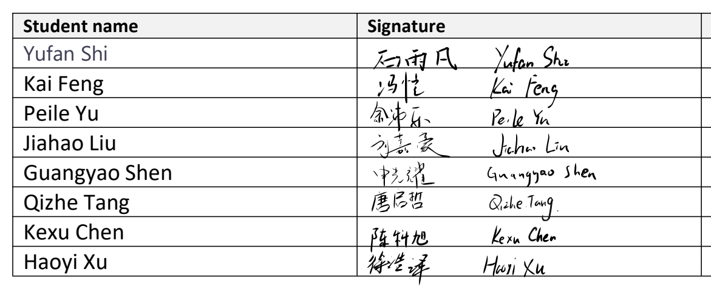
Signatures

