F4 Interface Manager
User Manual

Prepared by:
Beta Innovations Inc.
8754 Blvd. Viau
Montreal, Québec
H1R 2V3
Canada

APPROVALS
Originator |  | Leo Lacava |  |  |  |  |  | May 25, 2007
Originator
Director
 |  | Name |  |  | Signature |  |  | Date
REV. NO. | APPROVAL DATE |  | PAGES MODIFIED |  |  | DESCRIPTION
00 | May 25, 2007 |  |  |  |  | Initial write-up.
01 | Mar 25, 2008 |  |  |  |  | Added details for new supported modes and features. SPI, DACs and Dot Matrix Displays.

Table of Contents
Introduction 6
What is F4 Interface Manager? 6
Installing the F4 Interface Manager 6
F4 Interface Manager Overview 6
Using F4 Interface Manager 8
Device Tree Management 8
Refreshing Device Tree List 8
Transferring Settings 8
Removing Unused Devices 9
Clearing Device Settings 10
F4 Interface Manager Settings 10
Device Item Management 12
Enabling/Disabling Items 12
Hiding Unused Items 12
Clearing Item Settings 13
Hiding Inactive Ports 13
Hiding Inactive Modes 14
Notes Tab 14
Input Port Modes 15
Input Flags Tab 15
Keys Tab 15
Output Port Modes 18
Output Conditions Tab 18
Direct Output Tab 19
7-Segment Displays Tab 20
Multiplexed Output Tab 22
CRT RWR Tab 24
DAC Output Tab 25
Graphical LCD Tab 30
Dot Matrix Display Tab 31
SPI Output Tab 32

Introduction

What is F4 Interface Manager?

F4 Interface Manager (F4IM) is a Falcon 4 Simulation interface software, which allows you to integrate and program compatible USB interface devices through direct access to F4 internal data or “sharedmem”. The F4 Interface Manager currently allows automatic and seamless detection of various flavors of Falcon including BMS, AF, OF and FF installations.

Programming is achieved through a very simple, clear and comfortable point-and-click interface with program settings saved as user defined “.f4c” files. A default configuration file can be selected and automatically launched on program startup.

New to version 2, F4IM can now be used as a standalone keyboard emulation utility for all input class modules for use with any application or simulation program.

Visit the support section at http://www.betainnovations.com/ to check for updates.

Installing the F4 Interface Manager

F4IM includes an automated installer. Simply run the installer and follow the instructions.

Once the F4 Interface Manager has been installed, simply start F4IM to begin programming your devices. Falcon 4 does not need to be running but can be useful for real-time feedback and testing of configuration settings.

F4 Interface Manager Overview

The F4IM can be started in windowed or minimized mode in the taskbar. If minimized in the taskbar, double click the icon to restore the main F4IM window or right mouse click to bring up the menu and selecting “Restore”.

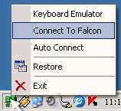

This will call up the main F4IM dialog displaying a list of currently detected modules and the default “Applications Settings” tab.
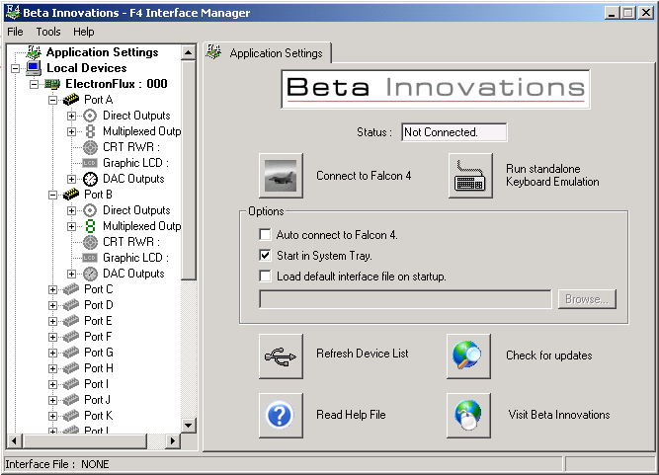

The simulator can be paused while I/Os are being programmed or left running for real-time updates. Clicking on “Cancel”, “X” on the upper right corner of the dialog or by pressing the “Esc” key on your keyboard will exit the dialog.

Clicking anywhere in the tree list window will popup a context sensitive menu providing additional useful options.
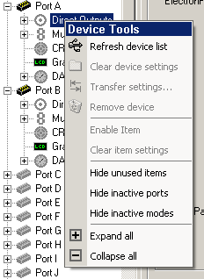

Using F4 Interface Manager

Device Tree Management

Refreshing Device Tree List

If you have connected or disconnected a device, clicking the “Refresh device list” item in the popup menu will update the device list and mark devices as present or missing.

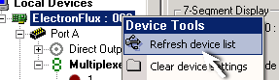

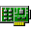 Indicates device is present and functioning properly.
 Indicates device is not present.

Undetected devices can be left in the list and programmed for later use or they can be removed entirely.

Transferring Settings

The “Transfer settings…” item in the popup menu can be used to copy all programmed item functions to a similar device class.

When non-serialized devices are plugged into a different USB port, the OS will assign an entirely new unique ID to this device. As such, F4IM will not be able to locate this device since the new ID will not match the ID stored in the configuration file resulting in orphaned programmed functions.

To get around this problem, the application will look for a similar device that matches the stored device class information and assign the first matching device to the orphaned functions. If no device is found, the programmed functions will be listed as orphaned as illustrated below.

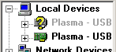

To transfer the old programmed settings to the new device location, right mouse click on the orphaned device and click on the “Transfer settings…” option, which will call up the transfer dialog.
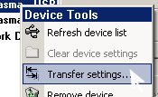

Select the device from the list. Only devices belonging to the same device class will be listed.
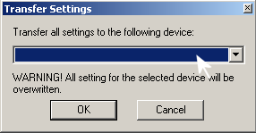

The orphaned device can now be safely removed if desired.
In order to avoid having to go through this procedure every time a non-serialized device is plugged into a different USB port, the application will automatically search for and assign matching devices to orphaned settings. If several devices belonging to the same device class are present, the first device will be assigned to the orphaned settings.

Removing Unused Devices

To remove a device from the list, right mouse click on the item to bring up the context menu and click on “Remove device” from the list.

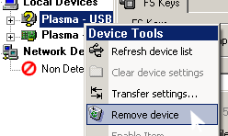

Note: Only devices listed as orphaned (not detected) can be removed.

Clearing Device Settings

To clear all programmed functions from a device, right mouse click on the device to bring up the context menu and click on “Clear device settings” from the list.

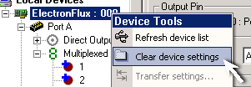

All item items with a “+” symbol will be cleared.

F4 Interface Manager Settings
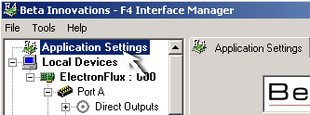
Application options can be set by left mouse clicking on the first item “Applications Settings” in the device tree window to bring up the settings tab.

From the settings tab, several options can be selected.

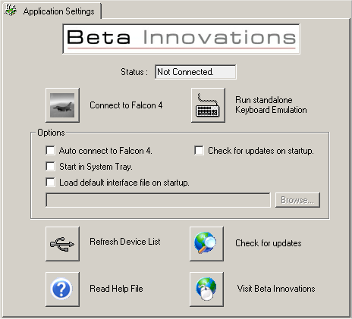

“Connect to Falcon 4” – Manually connect to Falcon 4 by clicking button. Will auto detect which version is currently running, SP4:BMS or AF. All other flavors of Falcon will be detected as either BMS or AF compatible. “Auto connect” will override this button and must be unchecked. Keyboard Emulation is automatically activated if any input class devices as in use.

“Run standalone Keyboard Emulation” – Activate the keyboard emulation feature of F4IM. When this feature is activated, F4IM will run as a keyboard emulator for use with input class devices such as Plasma, GammaRay, etc. This feature replaces the Keyboard Studio utility and Falcon 4 does not need to be installed or running allowing F4IM to be used with any application or simulation running in Windows. “Auto connect” & “Connect to Falcon 4” will override this button and must be unchecked.

“Auto connect.” – When checked, F4IM will automatically detect if Falcon 4 is running and begin executing currently assigned settings. Once Falcon 4 simulator is terminated, F4IM will automatically cease execution and will continue to monitor for any new Falcon 4 simulation activity.

“Start in System Tray.” – When checked, F4IM will automatically start minimized in the system tray located on the lower right hand side on the desktop.

“Load default interface file at startup.” – When checked, F4IM will automatically load the selected interface file when it is launched. Automatic execution of the interface file will result if Falcon 4 is running and “Auto connect” has been checked.

“Check for new version on startup” – Will check online for new versions of F4IM when programs starts. Note: Firewall settings may need to be set to allow F4IM permission to access the Internet.

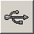 Refresh Device List: Detects all compatible devices connected to the PC.

 Read Help File: Launches this help file.

 Check for updates: Will verify if a new version of F4IM is available online.

 Visit Beta Innovations: Launches Beta Innovations web site in default Internet browser.

Device Item Management

Enabling/Disabling Items

Individual device items can be enabled or disabled by double clicking on the item in the tree list or right mouse click to bring up the context menu and click on “Enable item” from the list. A check mark will indicate that the item is enabled.

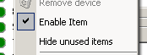

Item icons will change according to their state:
Input item is enabled
Output item is enabled
Item is disabled

Hiding Unused Items

Working with long item lists can be simplified by hiding unused items. Only items with programmed functions will be listed whether they are enabled or disabled. Items with assigned programmed functions will be indicated by a “+” symbol for enabled items and for disabled items.

INPUTS
Enabled input items
Disabled input items

OUTPUTS
Enabled direct or multiplexed output items
Disabled direct or multiplexed output items
Enabled 7-segment display output items
Disabled 7-segment display output items
Enabled DAC output items
Disabled DAC output items
Disabled RWR output item
Enabled RWR output item
Disabled GLCD output item
Enabled GLCD output item
Disabled SPI output item
Enabled SPI output item
Disabled Dot Matrix Display output item
Enabled Dot Matrix Display output item

In order to program an unused input item, there is no need to unhide the entire list. Simply activate the input on your device and it will appear in the list and will remain visible even if deactivated. The item can then be selected and configured as needed. This applies to input items only. All output items must be visible in order to be configured.

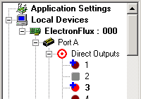
Once programmed, the item will remain visible and a red “+” symbol will appear in the upper left hand corner for inputs and blue for outputs.

In the example illustrated above, items 1 and 3 have programmed functions assigned to them. Item 2 is an unused output which is currently disabled.

Clearing Item Settings

Click on “Clear Item Settings” to remove any programmed functions for the selected item. This function cannot be undone.

Hiding Inactive Ports
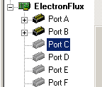
Port items that are unavailable or disabled will appear as gray port icons . This can make navigating long lists of IOs cumbersome.

Unused or disabled ports on devices with configurable ports can be hidden from the list. This option is available in the popup menu by right mouse clicking anywhere in the tree list. A check mark indicates the current state of this option.

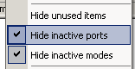

Hiding Inactive Modes

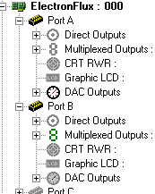
Each port consists of several modes of operation. Only one mode can be active at any one time per port. As such, the remaining modes are displayed grayed out and inactive.

Mode icons:
Active input mode
Inactive input mode
Active direct output mode
Inactive direct output mode
Active multiplexed mode
Inactive multiplexed mode
Active CRT RWR mode
Inactive CRT RWR mode
Active Graphic LCD mode
Inactive Graphic LCD mode
Active DAC Outputs mode
Inactive DAC Outputs mode
Active Latched Outputs mode
Inactive Latched Outputs mode
Active SPI Outputs mode
Inactive SPI Outputs mode
Active SPI Outputs mode
Inactive SPI Outputs mode

IMPORTANT: Activating or deactivating modes must be done through the Device Manager utility and cannot be changed within F4IM.
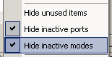
These inactive modes can be hidden from view if desired, by selecting “Hide Inactive Modes” from the context menu.

Notes Tab

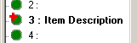
Each item provides a Notes tab, which can be used to enter user specific information about the selected item. This can simplify locating a specific item in a long list of IOs by its description.

Description: Item description to display next to the item in the tree list.

Notes: Text field for item specific information.

Clear All: Clears all page settings.

Input Port Modes

Input Flags Tab

The Input Flags tab can be used to assign inputs to variables in order to control output conditions. As of this writing, F4IM supports up to 20 flags. These flags can be assigned to any of the inputs on modules that support them.

To assign a flag to the selected input, simply click on the check box under the Assign column and the Input ID will change to display the index of the input and the module to which it belongs. To clear the assignment, uncheck the Assign box. Multiple flags can be assigned to a single input.

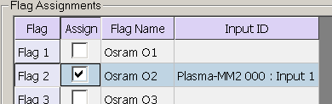

The first few flags have default names assigned for convenience only and are not hard coded functions. All flag names can be changed as desired. Click in the Flag Name field to enter a custom name for the selected flag.

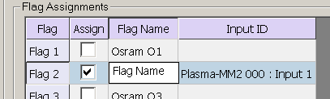

Keys Tab

The Keys tab can be used to emulate keyboard key press and macros. Up to 8 macros can be defined for On Press and On Release for each input item.

There are two methods to define key macros. One method presses and releases each macro in turn in the list. “Hold Keys while ON” option must be unchecked.

The second method holds the key down until the input toggles OFF at which time the key is released. The “Hold Keys while ON” option must be checked. This option emulates real physical keys on a keyboard as they would be pressed and released by the user and is not recommend for use with toggle switches since the active macro will affect all other key macros that might be activated while it remains pressed. An example would be physically pressing the “A” key on your keyboard and holding it down while other keys are pressed at the same time. This may lead to unpredictable results in applications reading these key inputs. This type of macro should only be used with momentary switch.

Grid Controls

Record. Press to record key macros.

Clear Row. Clears the selected row settings.

Add Row. Click to add a new macro.

Remove Row. Click to remove the selected macro.

Grid Macros

On Press macros get called when the input toggles ON and On Release macros are called when the inputs toggle OFF.

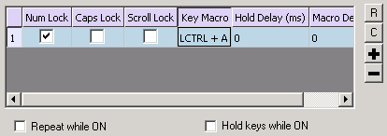

Num Lock: Set to activate Num Lock key.

Caps Lock: Set to activate Caps Lock key.

Scroll Lock: Set to activate Scroll Lock key.

Key Macro: Click on the Record button to record the macro into this field.

Hold Delay (ms): Enter a value in milliseconds to hold or press the key macro before releasing. Ignored if Hold Keys while ON is checked.

Macro Delay (ms): Enter a value in milliseconds that must elapse before activating the next macro in the list.

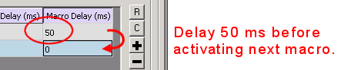

Repeat While ON: If this option is checked, the On Press macros will be continuously repeated while the input remains in an ON state. Disabled if Hold Keys while ON is checked.

Hold Keys While ON: If this option is checked, the On Press macros will remain pressed until the input toggle to an OFF state. Repeat While ON will be disabled and the Hold Delay (ms) will be ignored.

Notes: A short description can be entered as reference.

Clear All: Clears all page settings.

Output Port Modes

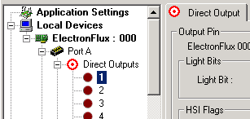
Direct Outputs functions are executed when Falcon output data changes states. Device ports must be set to Direct Output mode and active in order to function. Refer to Device Manager help file for details on Port configuration options.

Output Conditions Tab

The Output Conditions tab can be used to assign inputs as logic conditions for controlling the status of the output item. As of this writing, F4IM supports up to 20 flags for this purpose. Any number of these flags can be assigned as logic conditions to any of the outputs on modules that support them.

To assign one or more flags to the selected output, simply click on the check box under the Monitor column. The status of the output item will now depend on the logic status of the assigned input(s). All assigned input flags must be at logic 1 (ON) in order for the output to be active and the output status will depend on the configuration settings of all other tabs associated with that item.

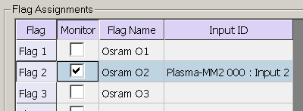

In addition to the aforementioned flags, there is Monitor Main Power flag, which can be activated allowing the output to be controlled by the master power status of the sim. If the main power in the sim is OFF, the output will remain inactive.

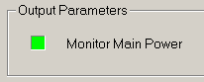

If activated, the Monitor Main Power flag along will all other assigned flags must be true (ON) in order for the output to be active.

Direct Output Tab

Individual output pins can be configured by customizing the associated Direct Output tab.

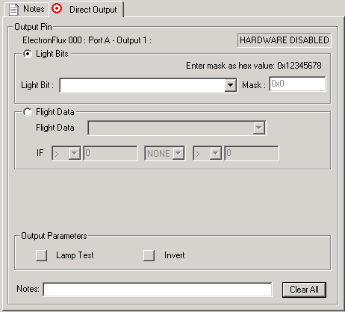

Light Bits: Will turn ON or OFF the output pin depending on the state of the selected Falcon 4 simulation output selected from the list.

The bit Mask is available only when selecting any one of the User Defined LightBits in the pull down list. The bit mask can be used to verify the state of a specific bit not available from the predefined list. This provides forward compatibility with any future updates of Falcon.

The bit mask must be entered in hexadecimal format.

Flight Data: Will turn ON or OFF the output pin depending on the state of the selected Falcon 4 simulation variable and conditions.

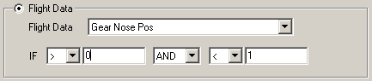

In the above example, the Nose Gear output will turn ON if the value of Gear Nose Pos is greater than 0 and less than 1. Negative and fractional values can be entered in the appropriate field.

Conditions include:
- Greater than: >
- Greater than or Equal to: >=
- Less than: <
- Less than or Equal to: <=
- Equal to: =
- Not Equal to: !=

Conditional branches include:
- NONE: second condition is ignored. Fields will be disabled.
- AND: Both conditions must be met for output to turn ON
- OR: If either condition is true, the output will turn ON.

Lamp Test: Will force the output pin to ON when checked. This function is affected by the state of the Invert button.
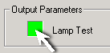

Invert: Will invert any output signal sent to the output pin. This option is useful when controlling negative logic circuitry.
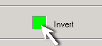

Notes: A short description can be entered for reference.

Clear All: Resets all page settings.

7-Segment Displays Tab

To configure 7-Segment displays on a specific output port, click on the “Multiplexed Outputs” item in the device tree. This will bring up the “7-Segment Displays” tab on the right.

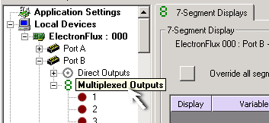

Each port can control up to 7 individual digits and these can be grouped as needed from one 7 digit display up to 7 individual digits. The example below shows 2 display groupings each comprising of 2 digits. These will display Chaff and Flare count. More display groups can be added until all 7 digits available are used up. In this case, the 3 remaining digits remain unassigned and unused.

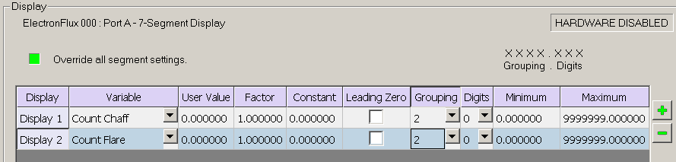

All assigned variables that exceed the number of available characters will be truncated. No rounding will be done. Character assignment is from the right beginning with Digits and proceeds to the left with Grouping up to available number of displays, in this case 7 characters maximum.

Override all segment settings: Each multiplexed output port is comprised of 56 individual outputs. These can be individually controlled if needed but must be overridden when the port is to be used for 7-Segment displays. Activating this option will override all 56 segment settings if any are assigned and the port will now function as a 7-Segment LED Display driver.

Display: Lists the currently assigned display groupings. Up to 7 display groups are supported.

Variable: Assigns a simulation variable to be displayed on the selected character group. These variables can be simple integers or real values with whole and fractional parts including negative values.

User Value: User defined fixed value to be displayed on the selected character group. The Variable field will override this value if assigned. Clear the Variable field if you wish to display the value entered in the User Value field.

Factor: Value to be multiplied with the selected Variable or User Value. Can be any float value.

Constant: Value to be added to the result of the Variable or User Value multiplied by the Factor. Can be any float value.

Result = ( [Variable or User Value] * [FACTOR] ) + [CONSTANT]

Leading Zero: Will display leading zeros on blank grouping (characters before the decimal).

Grouping: Number of characters to be displayed before the decimal. If the number of Digits is set to 0, no decimal point will be displayed. Maximum number of grouping is 7 characters. Note that any values will use 1 character space for displaying the negative sign.

Digits: Number of characters to be displayed after the decimal. If the Grouping is set to 0, setting this value to any number other than 0 will automatically use 1 character on the left of the decimal position as “0.”.

Minimum: Sets the lower limit of the simulation variable to be displayed. Values can be positive or negative. Simply click in the item box and type the value desired. Default is 0.

Maximum: Sets the upper limit of the simulation variable to be displayed. Values can be positive or negative. Simply click in the item box and type the value desired.

Adds a new row with a blank display group. If the number of allotted characters equals to or exceeds 7 digits, no additional rows will be added.

Removes a selected display group.

Lamp Test: Will force the display to turn on all segments when checked.

Level: Adjusts the output pulse duty cycle. Used to set the desired output brightness level.

Notes: A short description can be entered for reference.

Clear All: Resets all page settings.

Multiplexed Output Tab

Each port configured for Multiplexed Output mode consists of 56 individually controlled outputs. To set an individual output, click on the item in the device tree list, which will display the selected “Multiplexed Output” tab.

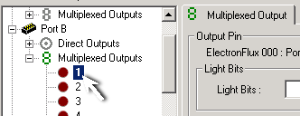

Individual multiplexed outputs can be configured using the associated Multiplexed Output tab displayed.

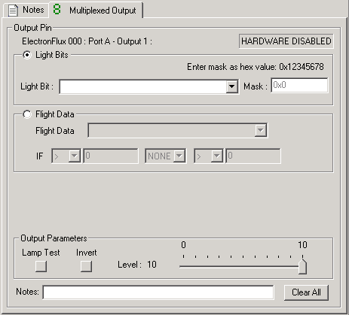

Light Bits: Will turn ON or OFF the output pin depending on the state of the selected Falcon 4 simulation output selected from the list.

The bit Mask is available only when selecting any one of the User Defined LightBits in the pull down list. The bit mask can be used to verify the state of a specific bit not available from the predefined list. This provides forward compatibility with any future updates of Falcon.

The bit mask must be entered in hexadecimal format.

Flight Data: Will turn ON or OFF the output pin depending on the state of the selected Falcon 4 simulation variable and conditions.

In the above example, the Nose Gear output will turn ON if the value of Gear Nose Pos is greater than 0 and less than 1. Negative and fractional values can be entered in the appropriate field.

Conditions include:
- Greater than: >
- Greater than or Equal to: >=
- Less than: <
- Less than or Equal to: <=
- Equal to: =
- Not Equal to: !=

Conditional branches include:
- NONE: second condition is ignored. Fields will be disabled.
- AND: Both conditions must be met for output to turn ON
- OR: If either condition is true, the output will turn ON.

Lamp Test: Will force the output pin to ON when checked. This function is affected by the state of the Invert button.

Invert: Will invert any output signal sent to the output pin. This option is useful when controlling negative logic circuitry.

Level: Adjusts the output pulse duty cycle. Used to set the desired output brightness level.

Notes: A short description can be entered for reference.

Clear All: Resets all page settings.

CRT RWR Tab

If the port is configured for CRT based RWR, only one port per node will function in this mode. To enable the RWR, click on the item in the device tree list, which will display the selected “CRT RWR” tab.

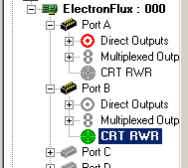

There are currently no configuration options for the RWR.

Enable CRT RWR: Will activate/deactivate the RWR display.

Test Pattern: Will generate a test pattern for calibrating the CRT display. Adjust the focus and intensity as well as the vertical and horizontal gain so that the pattern fills the screen.

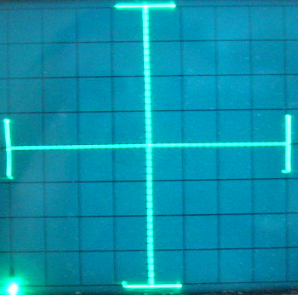

Notes: A short description can be entered for reference.

Clear All: Resets all page settings.

DAC Output Tab
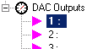
Configuration settings for individual DACs can be set by selecting the single triangle icon found under the DAC Outputs icon. The DAC Output tab can be used to customize configuration settings for the selected DAC.

One of the possible uses of DAC outputs is to drive Air-Core movements for use as gauges. Up to 8 sections can be individual configured providing complete control over pointer behavior. As illustrated below, the RPM gauge has 2 sections each using a different scale.

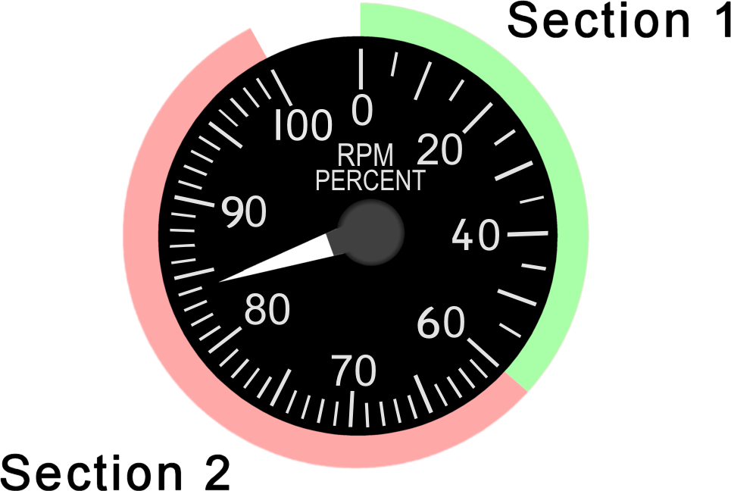

Each section must be individually calibrated and defined, insuring that the needle will properly move across the various scales.

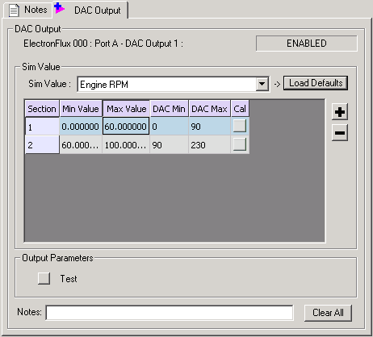

Sim Value: Select Falcon 4 simulation value to be used to control the DAC output or gauge.

Load Defaults: Loads default settings for predefined Sim Values. Selecting Sim Values with predefined settings from the drop down list will enable this button. Once loaded, adjust the DAC values to match your gauge.

Section: Identifies the scale regions on the gauge.

Min Value: Click to enter the minimum value of the selected Sim Value. This will correspond to the calibrated min position on the gauge.

Max Value: Click to enter the maximum value of the selected Sim Value. This will correspond to the calibrated max position.

DAC Min: Click to enter the minimum value of the DAC that corresponds to the Min Value entered for the section or click on the Cal button for automatic calibration.

DAC Max: Click to enter the maximum value of the DAC that corresponds to the Max Value entered for the section or click on the Cal button for automatic calibration.

Cal: Activates DAC calibration popup.

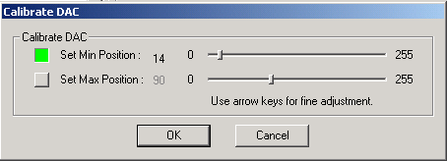

Set Min Position: Activates calibration mode. Adjust the slider on the right to set the DAC or needle to the minimum position for the selected section on the Gauge. Deactivate the button when done.

Set Max Position: Activates calibration mode. Adjust the slider on the right to set the DAC to the maximum position for the selected section on the Gauge. Deactivate the button when done.

NOTE: The Air-Core must be hardware calibrated prior to use. Refer to the device user manual for calibration details.

Test: Will move the Air-Core meter between the Min and Max calibration positions.

Notes: A short description can be entered for reference.

Clear All: Resets all page settings.
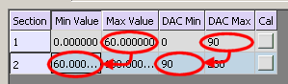
Adds a new row (section). The Max Value and DAC Max values from the previous section will automatically be entered into the new section Min Value and DAC Min respectively.

Removes a selected section row.

Gauge Calibration Example

The following example will illustrate how to setup an RPM gauge:

- Select “Engine RPM” from the pull down list Sim Value.

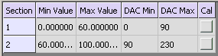
- The Load Defaults button will be enabled indicating that a predefined list exists for this value. Click the button to load the default sections.

- Click on the Cal button on row section 1 which will bring up the calibration popup.

- Click the Set Min button, which will turn green.

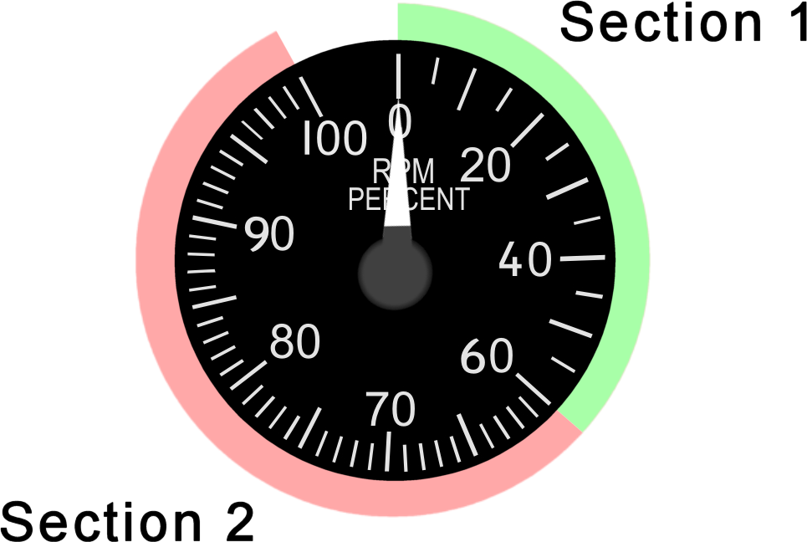
- Move slider so that the needle is at the min position for section 1.

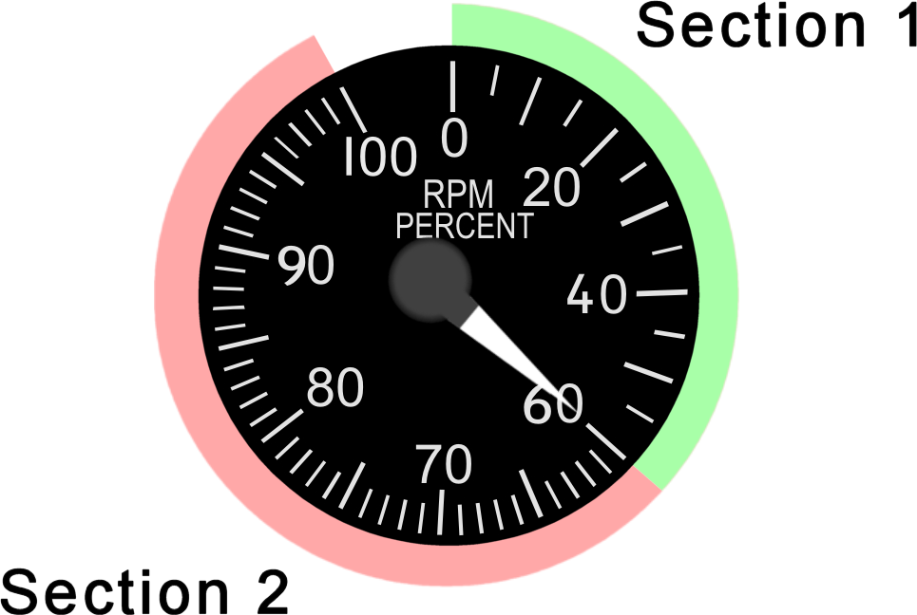
- Click the Set Max button, which will turn green and move the slider so that the needle is at the max position for section 1.

- Click OK. The DAC Min and DAC Max values for section 1 will be updated.

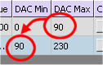
- Click in the DAC Min field on section 2 and enter the DAC Max value. This insures that needle will start at the exact same position in section 2 where it ended in section 1 eliminating any jumps or gaps in the movement.

- Click on the Cal button in section 2 which will bring up the DAC calibration popup for section 2.

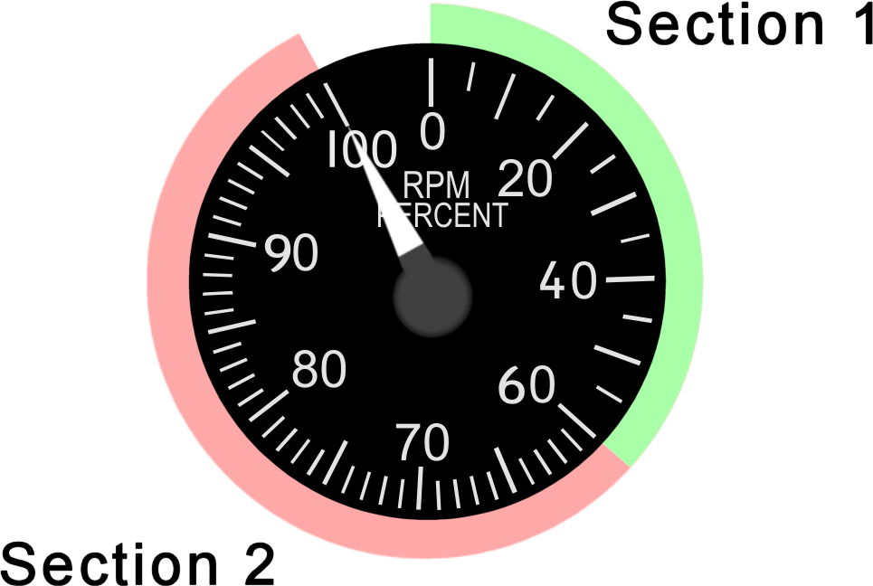
- Click on the Set Max button and move the slider so that the needle is at the max position of section 2 on the gauge.

- Click OK when done which will update the DAC Max field to the new value. The gauge has now been calibrated. Click the test button to verify the needle movement across the various sections. Make sure that F4IM is set to test mode on the Applications Settings tab.

Calibrating FTIT Gauge

The FTIT (Forward Turbine Inlet Temperature) gauge presents a particular problem when using the method describe above and cannot be used. The FTIT values in the sharedmem do not directly correspond to the temperature values on the gauge and are calculated based on the RPM value.

Loading the defaults will result in a list of 6 sections as follows:

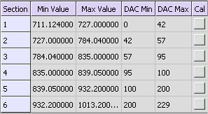

The corresponding FTIT sections will look as follows:

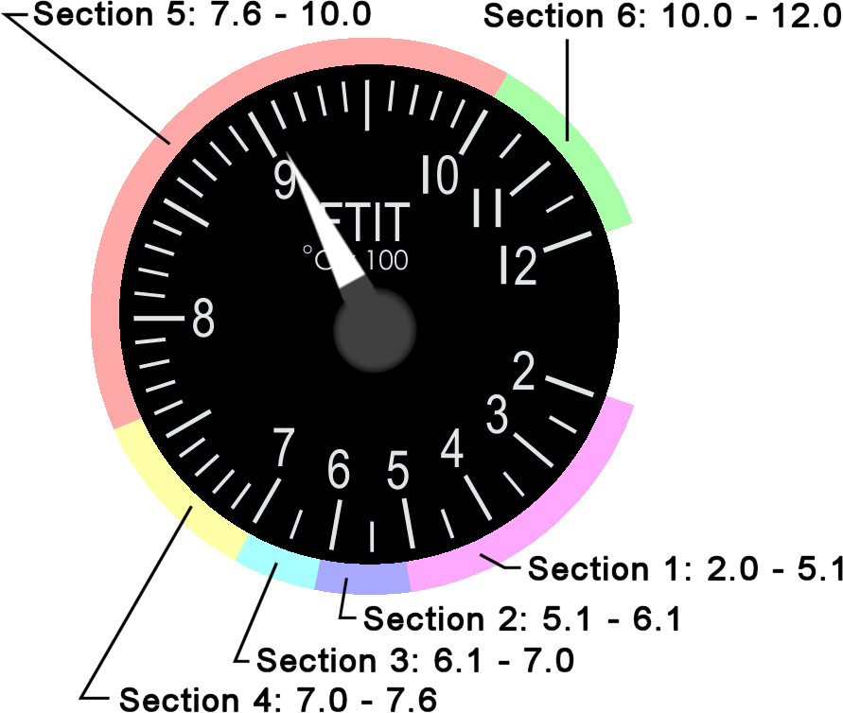

Adjust the DAC calibrated values to match your gauge according to the colored sections above.

Graphical LCD Tab

Ports configured for graphical LCD mode can support either a DED or PFD display.

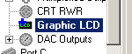

Select the “Graphic LCD” icon in the list. On the right tab, activate the desired function either DED or PFL.

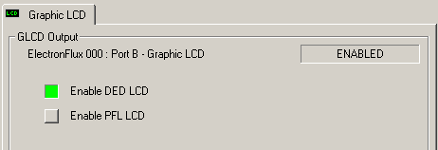

Test: Will display a test message on the LCD ensuring that the connection is working.

Invert: Will display the negative image on the LCD.

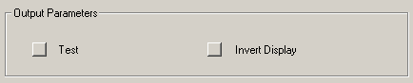

Notes: A short description can be entered for reference.

Clear All: Resets all page settings.

Dot Matrix Display Tab

Each port can control up to 4 individual Dot Matrix IC packages of 4 digits each and these can be grouped as needed from one 4 digit display up to 4 individual digits. The example below shows 1 display grouping comprised of 2 digits. These will display Chaff count. More display groups can be added until all 4 digits available are used up. In this case, the 2 remaining digits remain unassigned and unused.

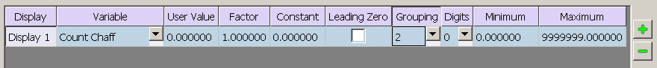

All assigned variables that exceed the number of available characters will be truncated. No rounding will be done. Character assignment is from the right beginning with Digits and proceeds to the left with Grouping up to available number of displays, in this case 4 characters maximum.

Four new Variables have been added to the list, which include: “OSRAM Display O1”, “OSRAM Display O2”, “OSRAM Display O3 - Chaff”, “OSRAM Display O4 - Flare”.

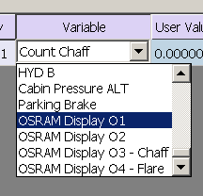

Selecting these variables will display preformatted characters and values mimicking the Dot Matrix displays found on the CMDS panel. Grouping should be set to 4 for each assigned OSRAM Variable. All other setting should be set to default values.

Display: Lists the currently assigned display groupings. Up to 4 display groups are supported.

Variable: Assigns a simulation variable to be displayed on the selected character group. These variables can be simple integers or real values with whole and fractional parts including negative values.

User Value: User defined fixed value to be displayed on the selected character group. The Variable field will override this value if assigned. Clear the Variable field if you wish to display the value entered in the User Value field.

Factor: Value to be multiplied with the selected Variable or User Value. Can be any float value.

Constant: Value to be added to the result of the Variable or User Value multiplied by the Factor. Can be any float value.

Result = ( [Variable or User Value] * [FACTOR] ) + [CONSTANT]

Leading Zero: Will display leading zeros on blank grouping (characters before the decimal).

Grouping: Number of characters to be displayed before the decimal. If the number of Digits is set to 0, no decimal point will be displayed. Maximum number of grouping is 4 characters. Note that any values will use 1 character space for displaying the negative sign.

Digits: Number of characters to be displayed after the decimal. If the Grouping is set to 0, setting this value to any number other than 0 will automatically use 1 character on the left of the decimal position as “0.”.

Minimum: Sets the lower limit of the simulation variable to be displayed. Values can be positive or negative. Simply click in the item box and type the value desired. Default is 0.

Maximum: Sets the upper limit of the simulation variable to be displayed. Values can be positive or negative. Simply click in the item box and type the value desired.

Adds a new row with a blank display group. If the number of allotted characters equals to or exceeds 7 digits, no additional rows will be added.

Removes a selected display group.

Lamp Test: Will force the display to turn on all displays when checked.

Level: Adjusts the output pulse duty cycle. Used to set the desired output display brightness level.

Notes: A short description can be entered for reference.

Clear All: Resets all page settings.

SPI Output Tab

Not currently supported.

