阅读题

1.题目：This is me；

2.内容：

Hello, I am Millie. A new student at Sunshine middle school. I am 12 years old. I have short hair. I love reading. Now, let’ s meet my new classmates. Hello, my name is Simon. I am tall. I like sports. I often play football after school. I'm Daniel. I come from Nanjing. I am good at math.

3.要求:

（1）朗读所给材料；

（2）配合教学内容适当板书；

（3）针对所给材料内容，设置理解细节教学活动；

（4）用英文试讲；

（5）试讲时间：10分钟。

《This is me》简案

1. Teaching aims

Knowledge aim: Students can understand the main idea and detail information of the material. (key points)

Ability aim: Students can improve their reading and writing skills and cultivate learning strategies. (difficult points)

Emotional aim: Students can arouse their interest in learning English and build confidence to communicate with others.

2. Teaching methods

situational method, TBLT, communicative approach

3. Teaching procedure

Step1. Warm-up and Lead-in

1. Sing a song

2. The teacher makes a brief introduction.

Step2. Pre-reading

Show a picture：Millie and her new classmates.

Step3. While-reading

1. Read the text briefly and conclude the main idea.

2. Do True/False exercises.

Step4. Post-reading

Write a brief introduction about yourself.

Step5. Summary & Homework

Summary: Make a summary about the whole class.

Homework: Write a brief introduction about your new class.

Step6. Blackboard Design

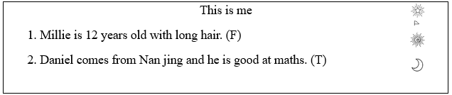

《This is me》逐字稿

Good morning, dear judges. Today, my topic is This is me. Now I will begin my teaching.

Class begins! Hello, boys and girls, how are you today? Well, some of you look a little bit tired. How about saying a tongue twister to cheer you up? Let’ s say: I scream, you scream, we all scream for ice cream. Pretty easy, right? Let's speed up, I scream, you scream, we all scream for ice cream. Feel better now? Great, let’s start this lesson. At the beginning of this lesson, I will show you a picture, please look at the screen. Who is she? Right, is a picture of me. Now I will introduce myself. I am an English teacher. I love reading books and traveling. Do you want to learn how to introduce yourself and your classmates? Today, we are going to learn a new lesson: this is me. I will divide you into three groups, group Mars, group sun, and group moon. We will have group competitions together.

Okay, boys and girls. Now please open your books. Here are some pictures, right？I will give you five minutes to describe the pictures in our textbook. I will give you an example: This is Millie. She is in Class 1, Grade 7. Now, please start. Boys and girls, stop here! You all have got your own ideas. Let’ s find more details. I will read this passage to you. After reading, you need to tell me what’s the idea of this passage. Now, I will start.

Hello, I am Millie. A new student at Sunshine middle school. I am 12 years old. I have short hair. I love reading. Now, let’ s meet my new classmates. Hello, my name is Simon. I am tall. I like sports. I often play football after school. I'm Daniel. I come from Nanjing. I am good at math.

Well, boys and girls, do you know the answer: what’s the main idea of this passage? Yes, the passage is about the introduction of Class1, Grade7 in Sunshine Middle School.

Boys and girls, it’s time to find more details about this passage. Now, please read this passage for the second time. This time you need to finish the true or false exercise on the blackboard.

1. Millie is 12 years old with long hair. (F)

2. Daniel comes from Nan jing and he is good at maths. (T)

Let’s go! OK, the time is over now. Who can tell me the answer? The first one, Bob has a try. Great. the first one is false. Can you correct it? Next Alice. Have a try. Great, next one is true.

Boys and girls so much for this! It’s time to have a writing exercise. Now you need to write a brief introduction of yourself. Later, I will invite some of you to show us clear? Let’s start! Stop here! Who can show us your introduction? Well, Zoey. Have a try! You did a very good job. I am so proud of you. I will give your group one point. OK, next one, Kevin. Have a try, please. You also did a very good job, I love your pronunciation! I will give your group one point, too.

Boys and girls, how time flies! It comes to the end of this class. Let’s review what we have learned today. Great, I heard most of you say that we have learned how to introduce ourselves and our classmates. Let’s see, who is the winner today? Well, group sun, congratulations. Other groups, don’t lose your heart, you will do better next time. I believe you!

OK, boys and girls. Class is almost over. And there is one last thing, what is it? Right, our homework! When you go home, please finish the exercise book first and write a brief introduction about your class. We will share them in the next class. So much for today, goodbye everyone!

答辩1：你设计的是什么口语活动？

答案：

本节课是一节阅读课，主题是自我介绍，所以我在post-reading环节，设计的是自我介绍的口语表达活动，每个同学先自己按范文写一个自我介绍，再同桌交流，展示介绍，最后再邀请一些同学自愿上讲台面对全班同学进行介绍。

答辩2：如何更好提升学生阅读能力？

答案：

题本的阅读篇目来自于七年级上册，按照新课程标准的要求来看，这个阶段的学生需要在阅读方面达到四级标准：即能连贯、流畅地朗读课文；能理解简易读物中的事件发生顺序和人物行为；能从简单的文章中找出有关信息，理解大意等。为了帮助学生提升阅读能力，达到课标要求，我会在课堂教学中，通过读前的预测、读中的寻读扫读等、读后的复述等活动，并在教学过程中不断渗透阅读策略，逐渐提升学生的阅读能力。

1.题目：Went to a trip；

2.内容：

Class 9 had a great time on the school trip. They went to Blue Water Aquarium (水族馆) for the day. First they visited the Visitors’ Center and watched a movie about sharks. Then they watched a dolphin show. After that,they went to the Outdoor Pool and saw a big octopus (章鱼). After lunch, they went to the Gift Shop and bought lots of gifts. Finally, tired but happy, they took the bus back to school. At the end of the day, the science teacher was very happy because the class monitor cleaned the bus after the trip.

3.要求：

（1）朗读所给材料；

（2）配合教学内容适当板书；

（3）针对所给材料内容，设置理解细节教学活动；

（4）用英文试讲；

（5）试讲时间:10分钟；

《阅读课-Class 9 went to a trip》简案

1. Teaching aims

(1) Understand the main idea and detail information of the material. (Key points)

(2) Improve their reading and writing skills and cultivate learning strategies. (Difficult points)

(3) Arouse their interest in learning English and build confidence to communicate with others.

2. Teaching methods

Situational method, TBLT and communicative approach.

3. Teaching procedure

Step1. Warm-up and Lead-in

1. Say a tongue twister.

2. Show a video. Teacher plays a video of “A school trip”. Ask students to answer some questions.

Step2. Pre-reading

Prediction: What happened in the trip?

Step3. While-reading

1. Fast reading. Read the text briefly and conclude the main idea.

2. Careful reading. Do exercises: True/False, Fill in the blanks

Step4. Post-reading

Survey: Where did you go on your school trip?

Step5. Summary & Homework

Summary: Make a summary about the whole class.

Homework: Do the exercise book and share your trips with your parents.

Step6. Blackboard Design

《阅读课-Class 9 went to a trip》 板书

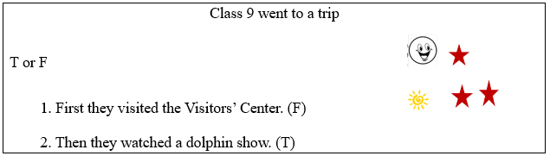

《阅读课-Class 9 went to a trip》逐字稿

Good morning, dear judges. My topic is Went to a trip. Next, I will start my lesson.

Good morning, boys and girls. How are you today? You look so tired. How about saying a tongue twister to cheer you up? Let’s begin. <Few free fruit flies fly from flames>. It’s so easy. How about speed up. Let’s have a try. <Few free fruit flies fly from flames>. How are you feeling now? Feel better? Next, let’s begin our class.

At the beginning of the class, I’d like to show you a video. Please look at the screen. After the video, I have some questions for you. Please listen carefully. Do you know this movie? Yes, it’s called “ school trip”. What else? Great, it’s about Class nine’s interesting school trip. Do you want to learn something more? Today we are going to learn a new lesson: Went to a trip.

First of all, you will be divided into two groups: group happy and group sunshine. Then you will have a competition. Let’s see which group can answer my question quickly and correctly.

Then, let’s have a prediction. Please take a guess: Where did they go on their trip? Please use your imagination to think of as many answers as you can. 5 minutes for you. Stop here. Who wants to share your ideas with us? Yes, Justin you please. Well done! You think there maybe they went to a park? One point for you. What else? Good! Jack, you please. You think that they maybe went to a mountain. Great! I will give you one point. Who is correct? Let’s find out the truth in the passage.

Next, please read this passage for the first time, and find out the main idea of this passage. 5 minutes for you. Stop here! Who wants to share your idea with us? Yes, Jenny you please. Great, this passage is talking about what we should do to build a hotel on the moon. Your pronunciation has a great progress. One point for you.

Next, we need to find out more details in this passage. So please read this passage for the second time and there will be some T/F exercises on the blackboard. 5 minutes for you. Time’ I like your voice! s up！Please look at the blackboard. How about the first one? Who can tell me it’s true or false? Yes, Lily you Please. Well done! It’s true! I like your voice! I will give you one point. How about the second one? Yes, Tom you please! Right! It’s false. Can you correct that? Well done. One point for you.

Practice makes perfect. So let’s do more exercises. Since we have read this passage, let’s retell this story by filling the blanks. Please finish them as quickly as you can. 5 minutes for you. Stop here! Excellent, I believe you all master them.

Boys and girls, we have done so many exercises. It’s time for fun. Let’s do a survey. You can think of the topic as follows: What did you do on your school trip? Please think of this topic for a while, then share our ideas with your partner. I will give you 5 minutes. Who wants to share your idea with us? Group sunshine, you please. Well done. Let’s clap for them. All of you have a logical thinking. I’m so proud of you. I will give you points.

How time flies. Who’s the winner today? Yes, group sunshine. Also group happy did a good job, too. Who can tell me what we have learned today? Yes, we have read a passage about Class nine’s interesting school trip and we also learned how to talk about our trip. There is one last thing, who can tell me what it is? Yes, our homework. When you go back home please finish the exercise book first. And then check more information on the Internet. Next class let’s share them. So much for today. Goodbye.

答辩1：During this class, how do you design to practice students' reading ability？

答案：In this class, I designed some students’ orientated activities to practice students’ reading ability. In pre-reading, I presented a picture of a school trip and let students to predict what the passage would talk about. This can help students improve the predicting ability, which is important for reading. In while-reading, firstly students would read it quickly and silently to find out the main idea of this passage. Secondly students would read it carefully and finisha true or false task. Those statements are all about the details of Class 9’s school trip. With it, students can not only get the detailed information, but also improve their reading ability.

答辩2：假期里，家长组织班级家长们一起出游，邀请你参加，你怎么办？

答案：

和家长关系过密会影响教师公平对待学生。我会感谢家长，婉言拒绝。

一方面，出游的目的是为了休闲放松，如果和学生、家长一起出游，老师可能会时时刻刻想到教育问题，无法休息；家长也会觉得拘谨，无法放松；另一方面，出游期间难免会涉及金钱往来，出游过程中容易出现利用物质达到讨好老师的目的，不利于后续家校间平等往来，更不利于教师公平对待每位学生。

我会用诚恳的语言、适当的措辞拒绝家长：第一，我理解家长想与老师加强交流的用心。家长想通过出游与老师增进了解，虽然五一我不能同游，但学校后续也会开展一些家校活动，到时候家长也可以和老师沟通交流；第二，向家长说明五一本身就是放松身心的，有老师在场会让家长和学生感到压力，达不到放松的效果。第三，告诉家长我本身已有五一安排，和家长邀请的时间冲突。我会预祝家长和孩子五一出游快乐，会关注他们的朋友圈动态。为他们点赞。

通过这件事，我也应反思自己的日常工作。一是在今后应该多开展一些活动，加强家校间的沟通交流，加强与家长的联系；二是在今后继续贯彻教育理念，平等公正对待每一位学生，让家长对我多一份满意，多一份放心。

1.题目：The four seasons

2.内容：

In spring, the weather starts to get warm. The wind blows gently. It often rains. Plants start to grow. Everything turns green. It is exciting to take a trip in spring.

The weather is hot in summer.The sun shines brightly. Many people like to go to the beach and swim in the sea. It is nice to eat ice cream in the hot weather.

In autumn, everything changes. Leaves turn brown, red or yellow and start falling from the trees. It is nice to go on a picnic at this time of year because the weather is cool and dry.

Winter is often cold and snowy. Children love winter because they love to play in the snow. It is interesting to make snowmen. People usually spend time with their relatives during the Spring Festival.

3.要求：

（1）朗读所给材料

（2）配合教学内容适当板书

（3）针对所给材料内容，设置理解细节教学活动

（4）用英文试讲

（5）试讲时间：10分钟

《阅读课-The four seasons》简案

1. Teaching aims

Knowledge aim: Students can understand the main idea and detail information of the material. (key points)

Ability aim: Students can improve their reading and writing skills and cultivate learning strategies. (difficult points)

Emotional aim: Students can arouse their interest in learning English and build confidence to communicate with others.

2. Teaching methods

situational method, TBLT, communicative approach

3. Teaching procedure

Step1. Warm-up and Lead-in

1.Sing a song: London bridge is falling down

2.Showing a video: Seasons of China

Step2. Pre-reading

Picture description: What can you see in the four seasons?

Step3. While-reading

1. Read the text briefly and conclude the main idea.

2. Fill in the blanks.

Step4. Post-reading

Discussion: Which season do you like best? Why?

Step5. Summary & Homework

Summary: Make a summary about the whole class.

Homework: Finish the exercise book；talk about different seasons with your parents.

Step6. Blackboard Design

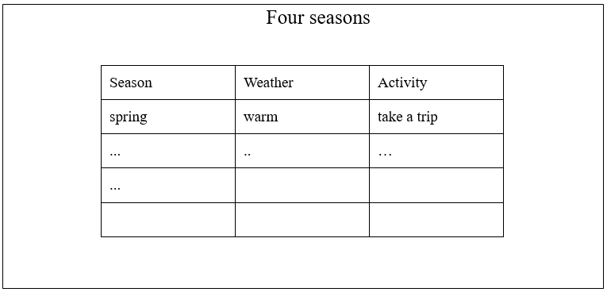

《The four seasons》逐字稿

Good morning dear judges, today, my topic is The four seasons. Now I will begin my teaching. Class begins! Hello boys and girls, how are you today? Well, some of you look a little bit tired, how about singing a song to cheer you up. Let’s sing London bridge is falling down. Feel better? Great! Let’s start this lesson. At the beginning of today’s lesson. I’d like to show you a video, please look at the screen. What can you see in this video? It’s about different traditional activities in China. You know so much about this video. Would do you like to learn something more? Today, we are going to learn a new lesson: seasons. I will divide you into two groups: group Mars and group moon. We will have group competitions together.

Guys, please open your books, here are some pictures, right? I will give you five minutes to describe these pictures. All of you have got your own ideas. Now, it’s time to read this passage. I will read this passage to you after listening, you need to tell me, what’s the main idea of this short passage? Let’ start. Who can tell me the main idea of this passage? Lily, have a try please. Excellent! It’s about different activities and weathers in different seasons. I will give your group one point.

Now, it’s time to find more details about this passage. You need to read this passage for the second time. This time you need to fill in the blanks on our blackboard. I will give you eight minutes, clear? Let’s start. Boys and girls, stop here! Who can tell me the answer? Bob, have a try. Great! In spring, the weather gets warmer, and we can take a trip. Sit down, please. I will give your group one point. How about summer? Kevin, have a try, please. We can eat ice cream in summer, because the weather is too hot. Right? I will give your group one point. And how about the autumn and winter？ I think you all have mastered the details of this passage, right? It’s time to have a discussion. Now, you need to work in groups and discuss it with your group members. Which season do you like best and why. Later, I will invite some of you to show us your ideas clear? Okay, now let’s start. Stop here! It’s your show time now, which group goes first? You first, you like summer best because you can go swimming every day. Fantastic! I will give your group one point. Group mars, it is your turn now! You like autumn best. Well, you also did a very good job. I will give you two points.

How time flies! Who can tell me what we have learned today? OK, I heard most of you say that we have learned a passage of the four seasons. Great! And I also heard that we have learned how to talk about our favorite seasons. Exactly! And don’t forget: Learning English is fun; don’t be shy to open your mouth. Let’s see who is the winner today? Group moon, congratulations! And group Mars don’t lose your heart. I believe you can do better next time!

OK, boys and girls. Class is almost over. And there is one last thing, what is it? Right, our homework! When you go home, please finish the exercise book first and talk about different seasons with your parents. We will share them in the next class. So much for today, goodbye everyone!

答辩1:你最喜欢的一部电影是什么？

我最喜欢的电影是一部经典电影《放牛班的春天》，看完这部电影后，我始终提醒自己，要以发展的眼光去看待学生，以孩子角度去思考问题，把每个学生都当作活生生的人去看待，平等关爱每一个学生。

答辩2：针对教学重难点，你怎么处理？

本节课是阅读课，其重点是通过理解文意，提升学生的阅读能力，难点是理解文章细节信息，文章讲的是四个季节的天气、景象、活动等。所以我设计的是，在while-reading环节，先让学生快速阅读全文，并将四个段落和多媒体课件上的四张图片连线；再让学生仔细阅读文章，逐字逐句研究，并完成一个表格，对比四个季节的不同点。这样，既可以确保学生能理解文意，又能在阅读活动中提升阅读能力。

1.题目: Hotels on the Moon?

2.内容:

At the moment, there are no hotels on the Moon. But all this will change. If we can solve some problems, we will be able to build hotels there in the future. The Moon is very cold, so the hotels will have to be warm. They will also need a large amount of air so that people there can breathe.

3.要求:

（1）朗读所给材料。

（2）配合教学内容适当板书。

（3）针对所给材料，设计理解细节教学活动。

（4）用英文试讲。

（5）试讲时间：10分钟。

1.题目: Hotels on the Moon?

2.内容:

At the moment, there are no hotels on the Moon. But all this will change. If we can solve some problems, we will be able to build hotels there in the future. The Moon is very cold, so the hotels will have to be warm. They will also need a large amount of air so that people there can breathe.

3.要求:

（1）朗读所给材料。

（2）配合教学内容适当板书。

（3）针对所给材料，设计理解细节教学活动。

（4）用英文试讲。

（5）试讲时间：10分钟。

《阅读课-Hotels on the moon》简案

1. Teaching aims

（1）Learn the new words, such as solve and breathe; get the main idea of the passage. （Key points）

（2）Develop reading skills, skimming and scanning. (Difficult points)

（3）Realize the importance of environmental protection.

2. Teaching methods

Situational method, TBLT and communicative method.

3. Teaching procedure

Step1. Warm-up and Lead-in

Say a tongue twister

Show the video of the movie The wandering earth.

Step2. Pre-reading

Prediction: What’s the moon like?

Step3. While-reading

1. T/F

a. The moon is very warm. (F)

b. There is no air on the moon. (T)

2. Retell the story by filling the blanks.

Step4. Post-reading

Survey: What can you do on the moon for your holiday?

Step5. Summary & Homework

Summary: Make a summary with the whole class.

Homework: Finish the exercise book；Search for more information about the Moon and share it next class.

Step6. Blackboard Design

《阅读课-Hotels on the moon》 板书

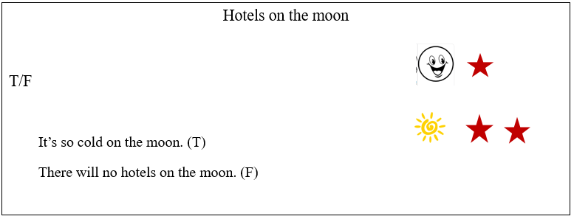

《阅读课-Hotels on the moon》逐字稿

Good morning, dear judges. My topic is Hotels on the moon. Next, I will start my lesson.

Good morning, boys and girls. How are you today? You look so tired. How about saying a tongue twister to cheer you up? Let’s begin. <Few free fruit flies fly from flames>. It’s so easy. How about speed up. Let’s have a try. <Few free fruit flies fly from flames>. How are you feeling now? Feel better? Next, let’s begin our class.

At the beginning of the class, I’d like to show you a video. Please look at the screen. After the video, I have a question for you. Please listen carefully. Do you know this movie? Yes, it’s called “The wondering earth”. What else? Great, there are serious problems and people are trying to escape from the disasters. Do you want to learn something more? Today we are going to learn a new lesson: Hotels on the moon.

First of all, you will be divided into two groups: group happy and group sunshine. Then you will have a competition. Let’s see which group can answer my question quickly and correctly.

Then, let’s have a prediction. Please take a guess: What’s the moon look like? Please use your imagination think of as many answers as you can. 5 minutes for you. Stop here. Who wants to share you ideas with us? Yes, Justin you please. Well done! You think maybe there is so cold? One point for you. What else? Good! Jack, you please. You think that maybe there is so many aliens. Great! I will give you one point. Who is correct? Let’s find out the truth in the passage.

Next, please read this passage for the first time, and find out the main idea of this passage. 5 minutes for you. Stop here! Who wants to share you idea with us? Yes, Jenny you please. Great, this passage is talking about what we should do to build a hotel on the moon. Your pronunciation has a great progress. One point for you.

Next, we need to find out more details in this passage. So please read this passage for the second time and there will be some T/F exercises on the blackboard. 5 minutes for you. Time’s up! Please look at the blackboard. How about the first one? Who can tell me it’s true or false? Yes, Lily you Please. Well done! It’s true! I like you voice! I will give you one point. How about the second one? Yes, Lucy you please! Right! It’s false. Can you correct that? Well done.One point for you.

Exercise makes perfect. So let’s do more exercises. Since we have read this passage, let’s retell this story by filling the blanks. Please finish them as quickly as you can. 5 minutes for you. Stop here! Excellent, I believe you all master them.

Boys and girls, we have done so many exercises. It’s time for fun. Let’s do a survey. You can think of the topic as following: What can you do on the moon for your holiday? Please think of this topic for a while, then share our ideas with your partner. I will give you 5 minutes. Who wants to share your idea with us? Group sunshine, you please. Well done. Let’s clap for them. All of you have a logical thinking. I’m so proud of you. I will give you points.

How time flies. Who’s the winner today? Yes, group sunshine. Also group happy did a good job, too. Who can tell me what we have learned today? Yes, we have read a passage about the hotels on the Moon. There is one last thing, who can tell me what it is? Yes, our homework. When you go back home please finish the exercise book first. And then check more information on the Internet. Next class let’s share them. So much for today. Goodbye！

答辩1：你的教学设计，锻炼了学生什么阅读技能？

根据新课程标准，我的这节课里，主要锻炼里学生预测、寻读、扫读等阅读既能。具体来说，能够让学生更流畅、连贯地朗读课文；能理解文中的事件发生顺序和人物行为，能够根据上下文理解生词意义。

答辩2:读前环节，还可以设计什么样的活动？

本节课，我在读前环节，设计的是学生根据标题，猜测文章内容，这样可以锻炼学生的预测能力，扩展学生思维。另外，还可以其他方法来预测，例如：根据文中提取的几个关键词，如hotel, moon, warm, cool等，学生据此猜测文章大意；还可以通过讨论Will us have hotels on moon?来预测；更可以给学生一张月亮上的旅馆照片，让学生描述图片内容来预测文章内容。当然，在读前环节，除了预测活动，还可以讲解生难词汇等来扫清阅读障碍。

1.题目：阅读教学；

2.内容：

Teaching high school students in a poor mountain village in Gansu Province may not sound like fun to you. However, it changed the life of Yang Lei from Beijing. The Peking University graduate first went there as a volunteer on a one-year program. The program was started by the Ministry of Education and the Chinese Young Pioneers. Every year they send 100 volunteers to teach in China's rural areas.

Life in the mountains was a new experience for Yang Lei. Her village was 2,000 meters above sea level, and at first the thin air made her feel sick. The food was very simple—teachers ate porridge three times a day. Fortunately, Yang Lei's mother agreed with her. She said that both she and her husband thought this was a good idea. “Young people today need to experience different things,”she said.

Most of the pupils live in school dormitories. They work very hard. They get up at 5 am and read books until 11 pm. They love having the volunteer teachers there. Yang Lei enjoyed her time as a volunteer very much. When her year was over, she said that she would return to the area after finishing her studies. She now works as a math teacher at a high school in the city of Pingliang, Gansu Province.

3.要求：

（1）阅读所给文段；

（2）英文试讲；

（3）设计相应阅读理解教学；

（4）进行板书设计，试讲时间10分钟。

Yang Lei’s experience

1.Teaching Objectives

1)Knowledge objective

Students will be able to understand the main idea and detailed information of the material.

2)Ability objective

Students will improve their reading skills and cultivate learning strategies.

3)Emotional objective

Students can realize that “Life is colorful. Love life and enjoy it”.

2.Important and difficult points

1) Important point

Help students understand the main idea and detailed information of the material.

2) Difficult point

Guide students to improve their reading ability.

3. Teaching and learning methods

Task-based language teaching method, question & answer teaching method, independent learning method, group work learning method.

4.Teaching Procedures

Step 1 Warm-up & Lead-in

(1) Daily greeting.

(2)Lead in: Show a video about Gansu province.

Q1:Have you ever been to Gansu?

Q2: What was it like there?

(3) Groups: Sun vs Moon vs Star.

Step 2 Pre-reading

Show a picture: What can you see in the picture?

Step 3 While-reading

1.Fast reading

Listen to the tape and get the main idea.

2.Careful reading: Finish True or False exercise.

(1)Lei's mother agreed with her to be a volunteer in Gansu Province . (T)

(2)When Yang Lei’s year was over, she wouldn’t return to the area. (F)

3.Listen and imitate.

Step 4 Post-reading

Discussion:Volunteer experience

Step 5 Summary&Homework

1.Students will make a conclusion about the class together.

2.Homework:

(1) finish the exercise book.

(2) do a survey about their friends’ volunteer experience.

5.Blackboard Design

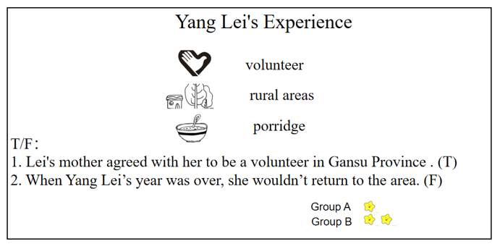

答辩1: What’s the important and difficult points of this class？

My important point is to help students understand the main idea and detailed information of the material. And the difficult point is to guide students to improve their reading ability.

答辩2:为什么要让学生做Summary ？

学生始终是课堂的主体，Summary是一节课的总结环节，学生进行总结有利于发挥学生的课堂能动性和主体作用，进一步巩固本节课所学内容。

1. 题目：阅读教学试讲；

2. 内容：

The tower of Pisa is one of the most beautiful bell towers in Italy. It is not only beautiful, but also strange-it leans to one side. Today it is known as “the leaning Tower of Pisa.”

The building of the tower began in 1173. It looks nearly 200 years to complete. In 1178, when the building got to the third floor, it started to lean. The builders tried to make the tower straight again when they built the upper floors, but failed.

Over the years, the tower has continued to lean further. The experts have done a lot of studies and tried to “rescue” the tower. In 1990, it was closed to the public for safety reasons. After a lot of effort, it reopened in 2001.Hopefully it will be safe for at least the next 300 years.

3. 要求：

(1) 朗读部分内容；

(2) 针对所给材料，设计引导学生理解细节的阅读教学活动；

(3) 进行10分钟英语教学，全英试讲，适当设计板书。

简案

Teaching Objectives

Knowledge objective: Students can master some new words: lean, straight; understand the main idea of this passage.

Ability objective: Students will improve their reading and speaking ability.

Emotional objective: Students will learn the culture of Italy.

Teaching key points and difficult points: Students can use the new words in the real situation and find out the detailed information of this passage.

Teaching Methods

Task-based language teaching method, situational teaching method, communicative approaches and computer-aided instruction.

Teaching Procedures

Step 1 Warm-up & Lead-in

After daily greeting, teacher will ask students a question: Do you know some famous buildings in other countries? Then students will answer as: Eiffel Tower, Sydney Opera House, Louvre. Teacher will tell students today they will learn a new famous building of Italy.

Step 2 Pre-reading

Teacher draws “the leaning Tower of Pisa” on the blackboard and ask students what it is. Then students will guess it is “the leaning Tower of Pisa”. At the same time, some new words will be taught.

Step 3 While reading

Teacher will read the passage for students and ask them to find out the new words of this passage.

Students need to read the passage for the first time and they need to find out the main idea of this passage - the history of the leaning Tower of Pisa.

Teacher will ask students fill in the table and summarize the structure of the passage.

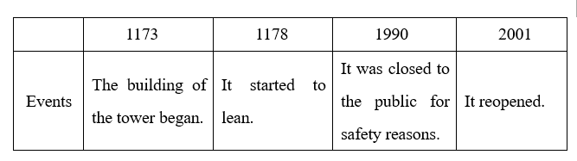

Step 4 Post reading

The teacher will organize the class to do a survey in groups in this step. The topic is introduction of your favorite building in China. . When they finish this task, some students will show their work and the teacher will give some feedbacks and stars according to their performance.

Step 5 Summary & Homework

Summary: Students will make a conclusion about the class together.

Homework: Finish the exercise book and find out more information about “the lean Tower Pisa” on the Internet.

Blackboard Design

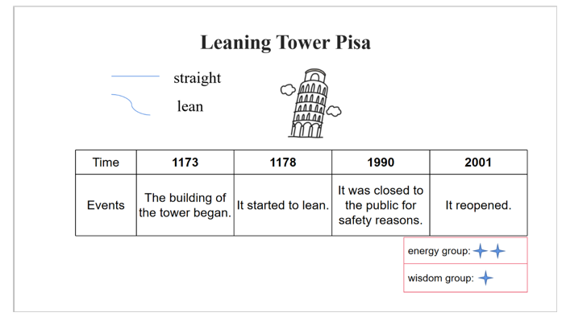

详案

Step 1 Lead-in

Good morning, class. Nice to see you today. Before the class, I would like you to enjoy several pictures on the PowerPoint. Do you know what are they? Lily please. You see the Eiffel Tower. Have you ever been visited it? Em, marvelous. You have been to many places. How about the second picture? Em, Sydney Opera House, and the third one is Louvre. You all have done a good job. Today we will learn a new famous building of Italy.

Step 2 Pre-reading

Now, please look at the blackboard. What am I drawing here? Could you guess? Em, drawing a house? No. A Rocket? No. How about this time? Could you give me the right answer? Exactly, it is “the Leaning Tower of Pisa”, a famous building in Italy. And do you know what happened to it?

Peter please. Yes, when being built, the tower leaned to one side. Please pay attention to this word lean, which means move into a sloping position. In other words, it means the tower is not straight. Ok. Read after me lean, straight.

Step 3 While reading

Let’s move on. I will read a passage for you. During reading, try to find out the main idea of the passage. Later some students will be invited to share your ideas. You can use the skill of skimming to help you locate some key words. Are you clear? Let’s start. Time’s up. Who would like to summarize the main idea? The boy in the corner. Yeah, it introduces the history of the leaning Tower of Pisa. You are very good at concluding. Sit down, please.

In order to have a better understanding of the passage, please go through the passage for the second time and fill in the table below. For example, you have to find out what happened during different periods of time. Ten minutes for you. Begin. Here we go. Ok, we stop here. Question one, in 1173, what happened? Eason, I see you raise your hand very high! You please. Em, the building of the tower began. How about in 1178? All together. Yes, it began to lean. And in 1990? Em, it was closed to the public for safety reasons. Totally right! You all did a very good job!

Step 4. Post-reading

Until now, I believe you have mastered the passage. Now let's put what we have learned into practice. You are supposed to work in groups and do a survey, asking your group members what is your favorite building in China? Later some groups will be asked to show your reports in front of the class. Ten minutes for you, am I clear? Great! Let’s do it! All right, I see most of you have finished your work! Which group is brave enough to the first? Group one, please. Who is your reporter? Wow, your group have set a good example for us! Big hands for you, guys. Thank you!

I true believe you all have done a great job! Next time, I hope more students will come to the stage and perform yourselves bravely!

Step 5. Summary and homework

1) At last, who wants to help me to summarize what we’ve learned today? Ok. How about the girl in red? Do you agree with her? Pretty good! We learned a passage about the leaning pisa tower and learned some new words. Good conclusion. I think learning English is for life and for fun. Everyone should learn more about different culture in other countries.

2) And now, it’s your afterschool task. Search more information about famous tourist attractions in foreign countries. Then introduce them to your parents. Then we will share it next class. That’s all for today’s lesson. Thank you for listening! Good-bye！

答辩1:如何帮助学生学习英语？

作为老师，帮助学生提高英语语言表达能力是我们的职责所在，但英语作为第二语言的学习，对于初中学生来说会遇到很多困难，比如说学生可能会记不住单词，发音不标准，因缺乏信心不敢说英语，以及表达中会出现中式英文等等。为了解决这些问题，帮助学生提高英语素养，我主要会从以下几个方面入手：首先兴趣是最好的老师，要让学生在英语方面有所长进就要吸引他们的注意力，在课堂上我会使用多种教具，设置多种游戏等方法达到这一目的，其次，打好基础是关键，语音，语法的学习，词汇的积累就变得很重要，我会开展读书小组，互相推荐适合他们年龄阶段的书籍，拓宽知识面，为语言的积累打下基础。最后，要鼓励学生开口说英语，不管说得如何都要对他们的勇气感到骄傲，以增强学生练习口语的自信。我相信通过这些方法，学生的英语水平会得很大提高。

答辩2:如何帮助学生学习语法？

语法的学习过程其实是学生发现英语语言规律的过程，而不是让学生被动地死记硬背。为了帮助学生去理解语法知识并对英语语法产生兴趣，我不会直接告诉学生语法规则，而是给出体现语法点的几组句子或情境，让学生去发现，当学生有了一定自己的认识的时候，提出奖励并引导学生完善出完整准确的语法点。学习语法的最终目的是要将其运用到实际的语言运用当中，所以引出规则后鼓励学生大胆创新，通过让他们造句或编故事等有趣的方法让他们真正学会运用语法并感受到语法知识的实用性。

1.题目：阅读教学试讲；

2.内容：

My grandma was a short woman with gray hair. She was always cheerful. She was a very good cook. Her dishes were probably the best in the World. I will never forget the taste, and the smell as well.

Grandma took care of my family: She was really kind and patient. She died two years ago and I miss her very much.

3.要求：

(1)阅读所给文段；

(2)英文试讲；

(3)设计相应阅读理解教学；

(4)进行板书设计，试讲时间10分钟。

My grandma

1.Teaching Objectives

1)Knowledge objective:

Students will be able to understand the main idea and detailed information of the material.

2)Ability objective:

Students will improve their reading skills and cultivate learning strategies.

3)Emotional objective:

Students can realize that “Our family is important for us. We should love them and love our home”.

2.Important and difficult points

1) Important point

Help students understand the main idea and detailed information of the material.

2) Difficult point

Guide students to improve their reading ability.

3. Teaching and learning methods

Task-based language teaching method, question & answer teaching method, independent learning method, group work learning method.

4.Teaching Procedures

Step 1 Warm-up & Lead-in

1.Daily greeting.

2.Tongue twister: Susan shines shoes and socks; she ceased shining shoes and socks for shoes and socks shock Susan.

3. Introduce family members.

Step 2 Pre-reading

Predict and guess by reading the title of the passage.

Step 3 While-reading

1.Fast reading:

Read quickly the first time and answer the question: How does the writer describe his/her grandma?

2.Careful reading: Finish the T/F exercise.

(1) My grandma’s dishes are probably the best in the World. (T)

(2) She was really strict and patient. (F)

3.Listen and imitate.

Step 4 Post-reading

Imitate the style of the article and introduce a member of your family.

Step 5 Summary&Homework

1.Make a summary about the whole class.

2.(1) Finish the exercises in the book.

(2) Write a short passage about your grandma.

Blackboard Design

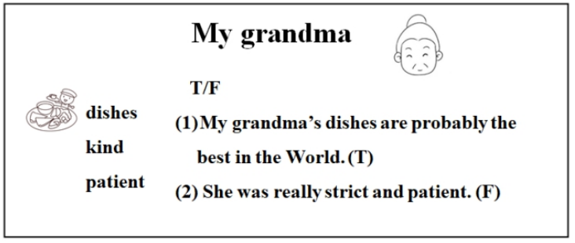

逐字稿

Step 1 Warm-up & Lead-in

Class begins! Boys and girls, how are you today? You all look tired. How about saying a tongue twister to cheer up? Let’s start! Susan shines shoes and socks; she ceased shining shoes and socks for shoes and socks shock Susan. OK, are you excited now? It’s time for class.

At the beginning of the class, I’d like you to know my family members. Look at this, who is he? He is my father. See? Oh, who is she? She is my sister. She is young and cute, Now, would you like to introduce your family to us? Who can have a try? Jim, you, please. You’re so brave and excellent! Thanks for your introduction! Today we’re going to learn the topic about our family: My grandma.

Before we get started, I'll divide you into 3 groups. You are group Sun. You are group Moon. And you are group Star. Each time you get a correct answer I'll give you one point. Let's see which group performs better today.

Step 2 Pre-reading

Before reading, pay attention to the title of the passage. What’s the title? Yes, it is my grandma. So can you predict the main idea of this passage by reading the title? I heard most of you said yes. Sometimes the title of a passage can help us know the idea of the passage. Am I clear? Good! Now let’s go on to read this passage.

Step 3 While-reading

1.Fast reading:

Next, please read the passage and then I have one question: How does the writer describe his/her grandma? OK, Lets begin! Now, we stop here. So what’s your answer? Who wants to share your answer with us? The girl in red please. Yeah, The writer describes grandma from “what she looks like, what she does and how is she” to introduce her. Excellent! One point for you! Let’s find out more details about grandma.

2.Careful reading:

Now, please read this passage again and finish the True or False task.

(1) My grandma’s dishes are probably the best in the World.(T/F)

(2) She was really strict and patient. (T/F)

Have you finished? How about the first one? True or false? Lucy, OK, it’s true. Smart girl. And the second one? I heard Leo said it’s false. Can you correct it? OK, She was really kind and patient. Genius. One point for you! I believe you all have mastered it.

OK, boys and girls. After reading the passage so many times, let's listen to the tape and read after it. You should imitate the pronunciation and intonation. Read aloud, please.

My grandma was a short woman with gray hair. She was always cheerful. She was a very good cook. Her dishes were probably the best in the World. I will never forget the taste, and the smell as well.

Grandma took care of my family: She was really kind and patient. She died two years ago and I miss her very much.

Step4 Post-reading

Since we have mastered the knowledge well, let’s do a more challenging task-Brainstorming. Imitate the style of the article and introduce a member of your family.

Work in groups and and have a discussion. Then choose one student to give a report on the stage. Use your imagination to think up as many ideas as possible. You have 3 minutes to prepare. Are you ready? Go!

OK, you really had a hot discussion. Which group wants to be the first? Group 2, please. Linda is your leader. Good ideas. Thanks for your sharing.

Step5 Summary & Homework

How time flies! Who can tell me what we have learned today? OK, I heard most of you say we have learned some new expressions and how to get more information we need in reading. Great! And I also heard that we have learned how to introduce our family. Exactly! And don’t forget our family is important for us. We should love them and love our home.

OK, boys and girls. Class is almost over. And there is one last thing. What is it? Right, our homework! When you go home, please finish the exercises in the book. Besides you need to write a passage of your grandma. So much for today, goodbye everyone!

答辩1:你怎么培养学生的英语兴趣？

通过激发学生已有知识与本节课需要掌握的知识之间的有效衔接，从学生相关的生活情景入手，设置学生可讨论的话题从而引起他们的学习兴趣。

答辩2:你这堂课想要培养学生什么能力？

这节课我想培养学生阅读文章时篇章结构分析的能力，通过阅读相关信息（文章标题），能够预测、了解文章大意，同时培养对文章内容的阅读能力和思考能力。

1.题目：France；

2.内容：

Paris is the capital of France. It is one of the most popular tourist destinations in the world. With its world-famous landmarks such as the Eiffel Tower and the Arc de Triomphe, and its wide, tree-lined streets. The Louvre is the largest museum in France. Paris is one of the most beautiful cities in the world.

3.要求：

(1) 朗读部分内容；

(2) 设计引导学生理解细节的阅读教学活动；

(3) 进行10分钟英语教学，全英试讲，适当设计板书。

France

1.Teaching aims

1) Knowledge aim

Students will be able to understand the main idea and detailed information of the material.

2) Ability aim

Students will improve their reading skills and cultivate learning strategies.

3) Emotional aim

Students can realize that “Learning English is not just inside the class. It’s for life, for fun.”.

2.Important and difficult points

1) Important point

Help students understand the main idea and detailed information of the material.

2) Difficult point

Guide students to improve their reading ability.

3.Teaching and learning methods

Task-based language teaching method, question & answer teaching method, independent learning method, group work learning method.

4.Teaching procedure

Step1. Warm up & Lead-in

(1) Daily greeting.

(2) Warm up：sing a song named “London Bridge is Falling Down”.

(3) Lead in：Show a video:

Q1:Do you like travelling?

Q2:Where have you ever been to?

(4) Groups: Sun vs Moon vs Star.

Step2. Pre-reading

Show a picture: What can you see in the picture?

Step3. While-reading

1.Fast reading

The main idea: It’s about introduction of Paris.

2.Careful reading: Finish True or False.

(1)Paris is the capital of France.(T/F)

(2)The Leaning Tower of Pisa is in Paris. (T/F)

3. Listen and imitate.

Step4. Post-reading

Discussion:Which places of interest would you like to visit and Why?

Step5. Summary & Homework

(1) Summary: make a summary together.

(2) Homework: finish the exercise book and write a passage about your favorite city.

5. Blackboard Design

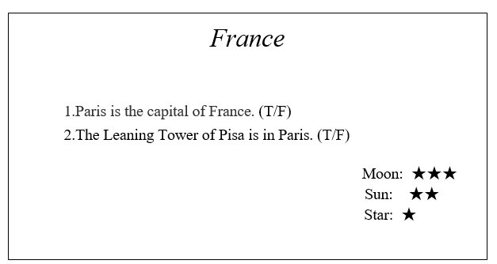

逐字稿

Step1: Warming-up and Lead-in

Class begins! Boys and girls, how are you today? You all look tired. How about singing a song to cheer up? Let’s sing “London Bridge is Falling Down”, ready? London Bridge is falling down, falling down, falling down. London Bridge is falling down. My fair lady. OK, are you happy now? It’s time for class.

At the beginning of the class, I’d like to show you a video named “Travel around the World”. Please look at the screen. I have some questions for you. Listen carefully: Do you like travelling? Oh, you like travelling. Which country have you ever been to? OK, you have ever been to England. Great! Have you ever been to France? No, you haven’t been to France. It doesn’t matter. We are going to learn a new passage about France and let’s get close to it.

Before we get started, I'll divide you into 3 groups. You are group Sun. You are group Moon. And you are group Star. Each time you get a correct answer I'll give you one point. Let's see which group performs better today.

Step2 Pre-reading

First of all, let’s look at the picture. What can you see in this picture? For example, “I can see a tower” and “I can see a colorful park.” You will have 5 minutes to think about it and share your answers with your partners. OK, let’s stop here. I find everyone has got your own idea. Let’s go on to read a passage.

Step3 While-reading

1.Fast reading

Next, please read the passage and then tell me the main idea of this passage. OK, Let’s begin! Now, we stop here. So what does this passage mainly talk about? Who wants to share your answer with us? The girl in red please. Yeah, the passage is about travel to France. Excellent! One point for you! What are the places of interest in France? Let’s find out more details.

2.Careful reading

Now, please read this passage again and finish the True or False task.

1.Paris is the capital of France. (T/F)

2.The Leaning Tower of Pisa is in Paris. (T/F)

Have you finished? How about the first one? True or false? Lucy, OK, it’s true. Smart girl. And the second one? I heard Leo said it’s false. Can you correct it? OK, the Eiffel Tower is in Paris and the Leaning Tower of Pisa is in Italy. Genius. One point for you! I believe you all have mastered it.

OK, boys and girls. After reading the passage so many times, let's listen to the tape and read after it. You should imitate the pronunciation and intonation. Read aloud, please.

Paris is the capital of France. It is one of the most popular tourist destinations in the world. With its world-famous landmarks such as the Eiffel Tower and the Arc de Triomphe, and its wide, tree-lined streets. The Louvre is the largest museum in France. Paris is one of the most beautiful cities in the world.

Step4. Post-reading

Since we have mastered the knowledge well, let’s do a more challenging task-Brainstorming. The topic is: If you take a holiday to Paris in France, which places of interest would you like to visit and Why? Work in groups and and have a discussion. Then choose one student to give a report on the stage. Use your imagination to think up as many ideas as possible. You have 3 minutes to prepare. Are you ready? Go!

OK, you really had a hot discussion. Which group wants to be the first? Group 2, please. Linda is your leader. Good ideas. Thanks for your sharing.

Step5. Summary & Homework

How time flies! Who can tell me what we have learned today? OK, I heard most of you say we have learned some new expressions and how to get more information we need in reading. Great! And I also heard that we have learned how to introduce a city. Exactly! And don’t forget learning English is for fun. Don’t be too shy to open your mouth.

OK, boys and girls. Class is almost over. And there is one last thing. What is it? Right, our homework! When you go home, please finish the exercises in the book. Besides you need to write a passage about your favorite city and introduce it next class. So much for today, goodbye everyone!

答辩1:你的教学过程中设计了哪些活动？

在本次教学设计中，我在教学过程的pre-reading，while-reading和post-reading环节分别设计了如下活动：读前我通过展示一张图片，让学生说出看到的内容是什么，引起学生的兴趣和关注，从而过渡到这节课即将学习的相关文本。阅读过程中fast-reading环节通过速读引导学生总结文章大意，了解文章内容。Careful-reading环节分别让学生完成对文本内容的判断正误题和填空题，进一步理解文章细节。

Post-reading环节我设计了话题讨论活动，旨在让学生在读后有进一步的思考和思延伸。

答辩2:你认为你的学生上完你的阅读课后可以学到什么reading skills？

Skimming(略读)，scanning（扫读），besides,they can look for the key words or sentences to understand the detailed information in given time.