江苏行测题量分布

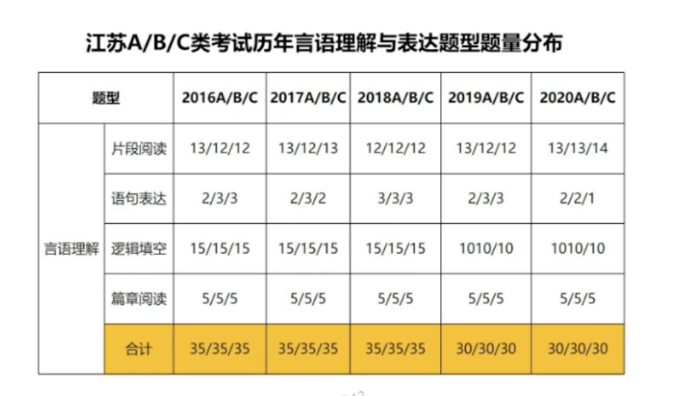

江苏A/B/C类考试历年言语理解与表达题型题量分布

|  |  |  |  |  |  |  |  |
| --- | --- | --- | --- | --- | --- | --- | --- |
| 题量 | | 2016A/B/C | 2017A/B/C | 2018A/B/C | 2019A/B/C | 2020A/B/C | 2021A/B/C |
| 言语理解 | 片段阅读 | 13/12/12 | 13/12/13 | 12 | 13/12/12 | 13/13/14 |  |
| 语句表达 | 2/3/3 | 2/3/2 | 3 | 2/3/3 | 2/2/1 |  |
| 逻辑填空 | 15 | 15 | 15 | 10 | 10 |  |
| 篇章阅读 | 5 | 5 | 5 | 5 | 5 |  |
| 合计 | 35 | 35 | 35 | 30 | 30 |  |