UNIVERSIDADE DO ESTADO DO RIO GRANDE DO NORTE

FINAL EXAM – TIME SERIES

Luiz Eduardo Fernandes Junior

October 14, 2021

1. Question: Do prices look like a stationary process? Why? What about the returns? Why?

*Prices do not appear to have a stationary process because they are trending and don’t seem to vary along the mean. This indicates that its unit root is greater than one, considering that its no-contemporaneous covariances are non-zero, when is very large, the process will be explosive. While the returns apparently are stationary processes, since it has constant variance around the mean. The first graph is prices, while second is returns.*

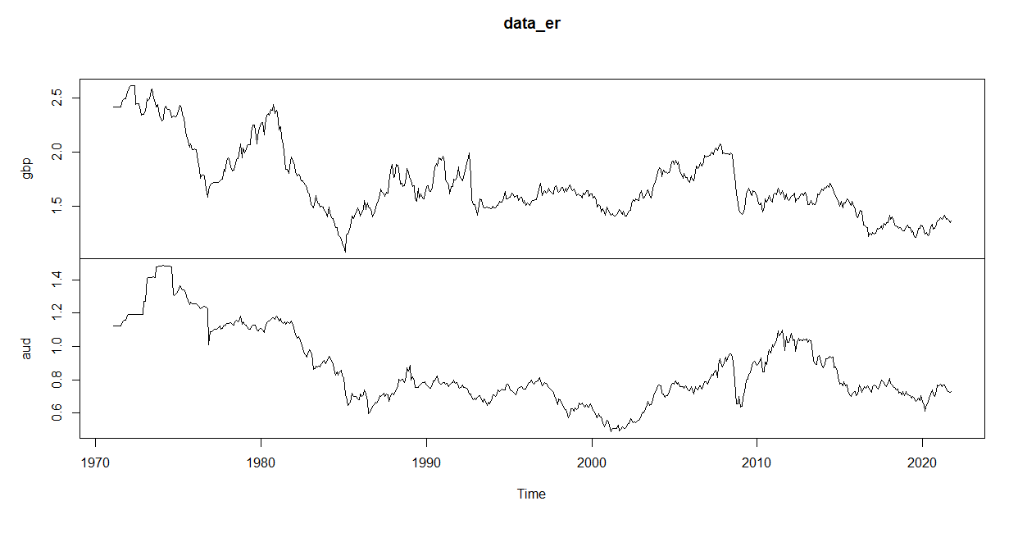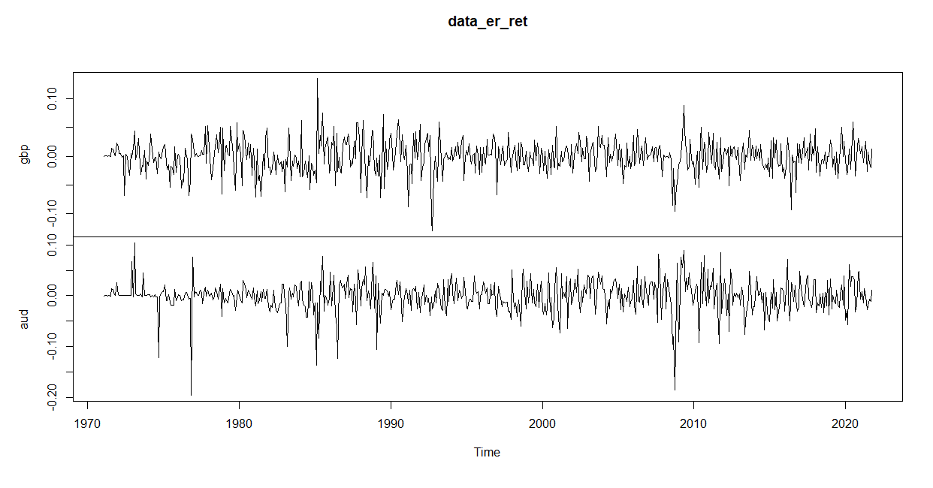

1. Then, based on a 5% level test, can you conclude that prices are stationary processes? Are exchange rate returns stationary?

*Evaluating the results, we can see that prices are not stationary processes while the returns are because their probabilities are 99% as shown in the table below:*

|  |
| --- |
| data_er.aud is a non-stationary process because it has P-valor 0.61 |
| data_er.gbp is a non-stationary process because it has P-valor 0.18 |
| data_er_ret.aud is a stationary process because it has P-valor 0.0 |
| data_er_ret.gbp is a stationary process because it has P-valor 0.0 |

1. Johansen’s Cointegration Test.
   1. We chose “ML” because the Johansen’s test relies on the maximum likelihood estimator (why?). Would you choose a specification for the deterministic component other than an unrestricted constant? Why?
   2. What do you have to say about your choice of the deterministic components?

*The Johansen test consists of performing the market efficiency test, this procedure is based on the autoregressive vector model that allows the determination of values in the short and long term, that is, the test consists of verifying whether there is a long-term balance between the variables. Furthermore, it is necessary to estimate the likelihood ratio test to determine the number of cointegration vectors. Once the (normalized) vectors are given, the errors correlation model is estimated using a maximum likelihood estimator.*

*It was not necessary choose a restrict constant because according to the estimation results, it can be evaluated the series are stationary and also cointegrated, with the presence of a long-term relationship between the variables.*

*For this estimation of the VECM model, it was necessary to assign a K equal 2, since the selection criterion for the number of the lags to VAR model was equal 1. Otherwise, this K-1 would be 0. It was evaluated that the series (price returns) are cointegrated at 1%.*

* 1. Is there cointegration at the 5% level? Which test statistic has superior power in a small sample? and why?

*Yes. Is there cointegration at 1% according the trace statistic and the maximum eigenvalue statistic.*

|  |  |  |  |  |  |  |
| --- | --- | --- | --- | --- | --- | --- |
|  | **r** | **trace** | **Trace_pval** | **Trace_pval_T** | **Eigen** | **Eigen_pval** |
| 1 | 0 | 468.9158 | <0.001 | <0.001 | 259.2702 | <0.001 |
| 2 | 1 | 209.6456 | <0.001 | <0.001 | 209.6456 | <0.001 |

*In general, to large samples there is no big differences between the models, both the trace test for cointegration of a VAR process and the maximum eigenvalue tests have similar properties. However, in some situations the trace tests tend to have more distorted size, while their power performance is superior to the maximum eigenvalue tests. In particular, trace tests are advantageous if there are at least two more relationships in the process then specified in the null hypothesis.*

1. Forecasting and Trading Models.

*We have the forecasts for each return. Apparently the VECM model has good prediction.*

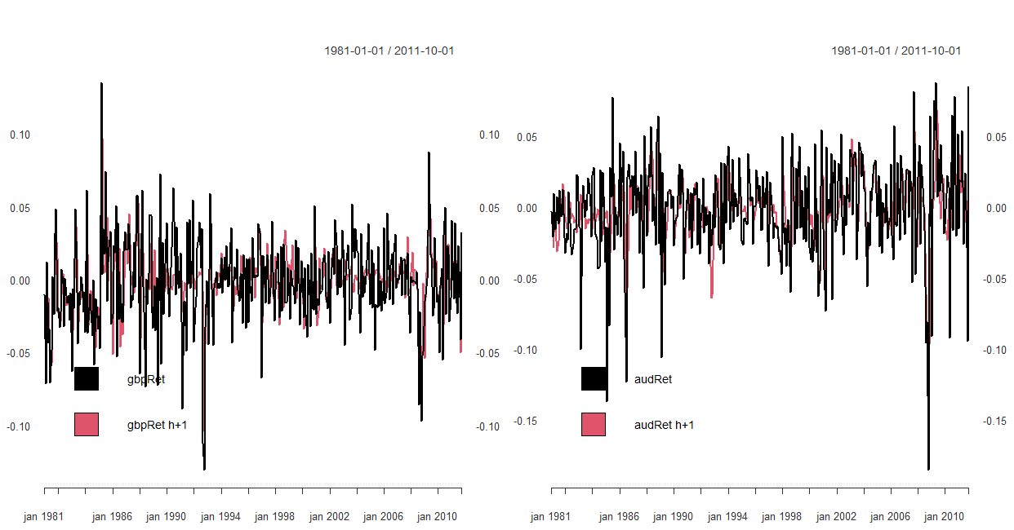

*With these prices in , we have the decisions as we need. Thus, taking the initial proposal decision as ‘decision 1’ and applying a new approach as ‘decision 2’ which depends on the series relationship to add one more condition in order to improve the results.*

*To build the ‘decision 2’ it was created a price ratio that evaluates the 5-days moving average. Then, when the ratio is above or below the MA, it will inform whether one currency is overvalued or undervalued against another, adding this condition to the initial proposal.*

*The first graph is the price ratio and the second graph is the decisions for each currency and each scenario.*

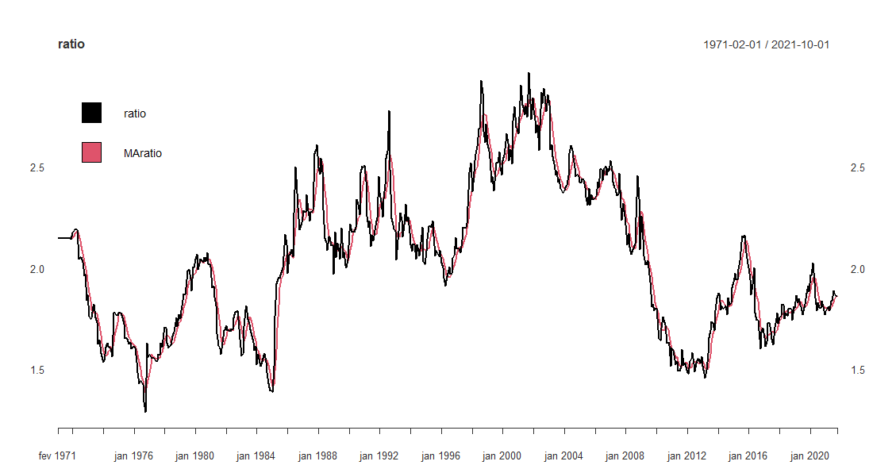

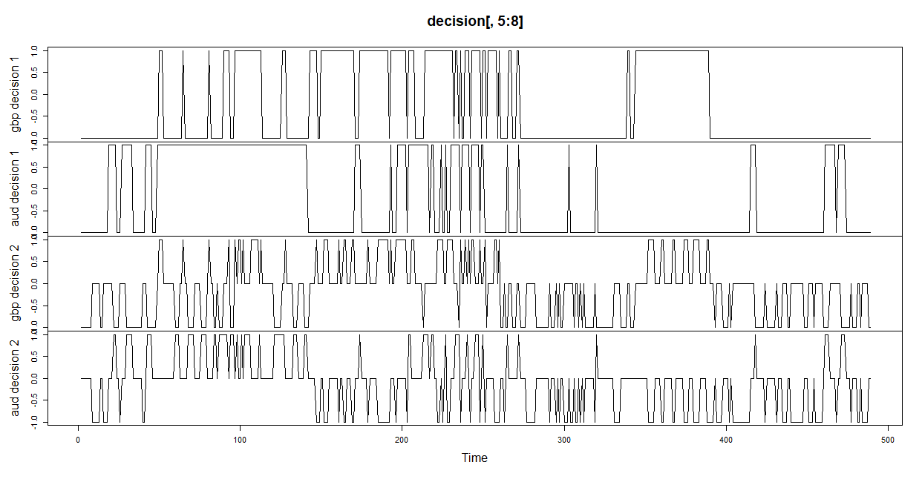

*In the decision 2, there are more operations due to a new condition added. Note that in ‘decision 1’ there is no ‘non-position’ while ‘decision 2’ does at in various moments. This could mean that the set decisions can be improved as the ‘no-positions’ would be converted to a winning position.*

*So now, there are the decisions and the measure of returns for each set. Note that the second decision generates more positive returns than negative, which means it will be better than ‘decision 1’.*

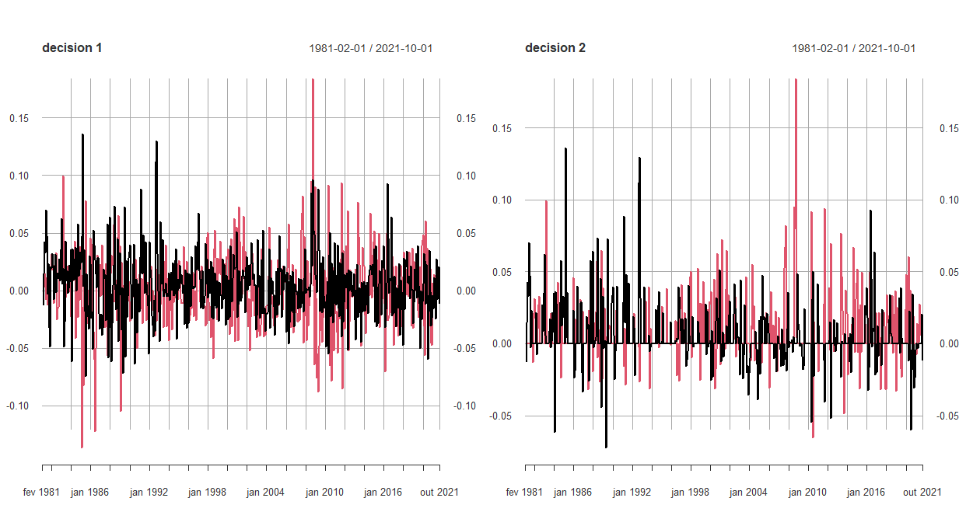

*Finally, we have the calculated returns for each currency and the total returns. Decision 2 generates 452% higher returns than decision 1.*

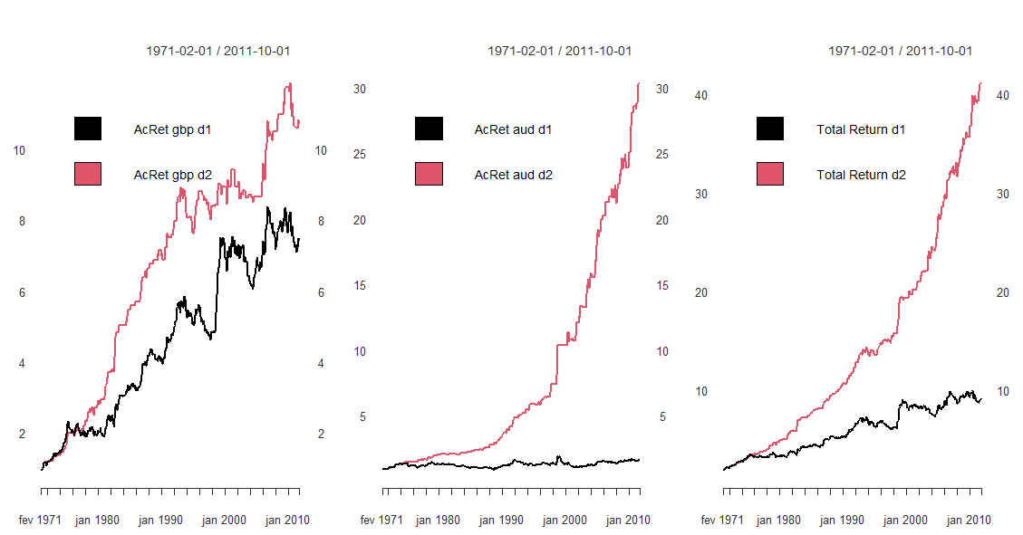

|  |  |  |  |
| --- | --- | --- | --- |
|  | **Accumulated Return gbp** | **Accumulated Return aud** | **Total Return** |
| Decision 1 | 7.42 | 1.67 | 9.09 |
| Decision 2 | 10.71 | 30.44 | 41.16 |
| ∆% | 144.33% | 1,822.75% | 452.8% |

*Therefore, we can conclude that artificial intelligence has a great possibility to maximize returns using the available data with a good model that has the capacity to measure the data dynamics.*

*A misspecified econometrics model or an inefficient decision rule can bring bad results, as it can generate a sequence of mistaken decisions and, consequently, systemic errors, compromising performance. As seen previously, the VECM model had a good specification, but the isolated decision rule generated a lower result compared to another condition implemented in our decision model.*

*As mentioned earlier, the set decisions could be improved by finding the points that the algorithm did not take position and converting them into a decision that generates gain.*